**DISEASED FRUIT CLASSIFICATION USING MACHINE LEARNING AND PYTHON**

Manem sravani I SARAGADAM SRIDHAR

Department of Master of Computer Science Department of Master of Computer Science

Miracle Educational Society Group of Institutions Miracle Educational Society Group of Institutions

Vizianagram– 535216 (AP) India Vizianagram– 535216 (AP) India

[sravanimanem506@gmail.com](mailto:sravanimanem506@gmail.com) sridharmagnus@gmail.com

# 

# ABSTRACT

In the agricultural industry, the detection of rotten fruits holds great significance. While humans can classify fresh and rotten fruits, their effectiveness diminishes due to fatigue from repetitive tasks. On the other hand, machines do not tire, making them ideal for such tasks. Fruits play a crucial role in maintaining a healthy lifestyle, as they provide essential nutrients and vitamins. However, the quality of fruits can vary, with some being fresh and ripe while others may be rotten or spoiled. The objective of this project is to employ machine learning techniques to accurately classify fresh and rotten fruits.To address this issue, a proposed solution aims to minimize human effort, production time, and cost by identifying fruit defects. The failure to identify defects could result in the contamination of good fruits, highlighting the necessity for a model to prevent the spread of fruit diseases.The proposed model utilizes a Convolutional Neural Network (CNN) to extract relevant features from fruit images. These features are then processed using the Softmax algorithm for classification into fresh or rotten categories. The model's performance was evaluated using a dataset obtained from Kaggle and demonstrated an impressive accuracy of 96% on the test dataset.The results clearly indicate that the CNN model is highly effective in accurately classifying fresh and rotten fruits. Furthermore, transfer learning methods were explored and compared, revealing that the proposed CNN model outperformed both transfer learning and state-of-the-art models in terms of classification accuracy. Through the utilization of a mobile app equipped with deep learning techniques, farmers can now detect fruit diseases with great precision. This app not only performs fruit disease classification but also incorporates a portable and highly accurate deep learning model.In conclusion, this project successfully demonstrates the efficacy of using machine learning, particularly a CNN model, in accurately classifying fresh and rotten fruits. The development of a mobile app utilizing deep learning techniques provides farmers with a convenient and reliable tool for detecting fruit diseases and ensuring the overall quality of their produce.

Keywords: CNN (Convolutional Neural Networks)

# INTRODUCTION

Fruits play a crucial role in maintaining a healthy lifestyle due to their abundance of essential nutrients and vitamins. However, the quality of fruits can vary significantly, with some being fresh and ripe, while others may be rotten or spoiled. Recognizing the importance of accurate fruit classification, this project aims to leverage machine learning techniques to precisely classify fresh and rotten fruits.

In the process of reaching consumers, fruits go through a complex supply chain. Customers purchase fruits from vendors, who, in turn, obtain them from distributors. These distributors collectively source fruits from various farmers. Ensuring the quality of each fruit acquired from every agricultural farm becomes a challenging task for the distributors.

To address this challenge, a solution has been developed to tackle the difficulty at its root, which is the farm level. By implementing cleaning and separation processes at the collection phase, the entire supply chain becomes more accessible and efficient. This approach helps reduce the manual judgment of fruits, saving time and allowing personnel to focus on other important tasks. Consequently, the process becomes semi-automatic, optimizing human efforts, time, and cost per unit.

The ultimate objective is to create a model that can accurately differentiate fresh and rotten fruits based on their visual characteristics. By analyzing features such as color, texture, and shape, we aim to develop a robust and precise classification model. Such a model would significantly enhance the efficiency and accuracy of fruit sorting in the food industry, leading to a reduction in food waste and ensuring that consumers receive high-quality fruits.

To evaluate the performance of the proposed model, a dataset consisting of images of fresh and rotten fruits will be utilized. This dataset will serve as the training data for the machine learning model. Through the process of training and fine-tuning the model, it will learn to recognize and classify fruits based on their visual attributes. A comparative analysis will be conducted, benchmarking the performance of the model against existing models like LeNet-5 and AlexNet to ensure its effectiveness and accuracy.

To provide a comprehensive solution, an app has been developed, consolidating all the functionalities and making the entire process more accessible, efficient, and user-friendly. This app acts as a platform for fruit classification, allowing suppliers and distributors to capture images of fruits using their mobile devices and obtain instant classification results. The app streamlines the fruit classification process, ensuring that both suppliers and consumers benefit from an easier and more efficient experience.

In summary, this project aims to leverage machine learning techniques to accurately classify fresh and rotten fruits. By addressing the challenges at the farm level and utilizing visual characteristics for classification, the project endeavors to improve the efficiency and accuracy of fruit sorting, reduce food waste, and provide high-quality fruits to consumers. The development of an app further enhances the overall effectiveness and convenience of the process, making it more accessible to stakeholders in the supply chain.

# LITERATURE REVIEW

The classification of fresh and rotten fruits has been a subject of extensive research in the fields of computer vision and machine learning. Researchers have explored various approaches to address this problem, incorporating both traditional image processing techniques and advanced deep learning methods.

One early approach in fruit classification focuses on color analysis. Researchers have proposed using color features such as hue, saturation, and intensity to distinguish between fresh and rotten fruits. While these methods have shown effectiveness in certain cases, they can be sensitive to variations in lighting conditions and may struggle with fruits that have similar color characteristics.

Texture analysis has also emerged as a valuable feature for fruit classification. Techniques like Gabor filters and Local Binary Patterns (LBP) have been introduced to extract texture features from fruit images. These methods have proven successful in improving classification accuracy, especially for fruits that share similar color attributes.

In recent years, deep learning techniques, particularly Convolutional Neural Networks (CNNs), have gained prominence in fruit classification. CNNs have been extensively used to extract features from fruit images and accurately classify them as fresh or rotten. These deep learning methods have demonstrated remarkable effectiveness, surpassing the performance of traditional approaches.

Furthermore, researchers have explored the integration of multiple modalities, including depth, thermal, and multi-spectral images, in conjunction with traditional or deep learning methods. By leveraging diverse data sources, these approaches have shown potential for further enhancing classification performance.

In summary, a wide range of approaches has been proposed for the classification of fresh and rotten fruits. Color analysis, texture analysis, and deep learning techniques, particularly CNNs, have emerged as prominent methods. Deep learning methods have exhibited superior performance compared to traditional techniques. However, the fusion of multiple modalities with these methods holds promise for further improving classification accuracy. In this project, the chosen approach involves leveraging a model based on Convolutional Neural Networks (CNNs) to tackle the fruit classification task.

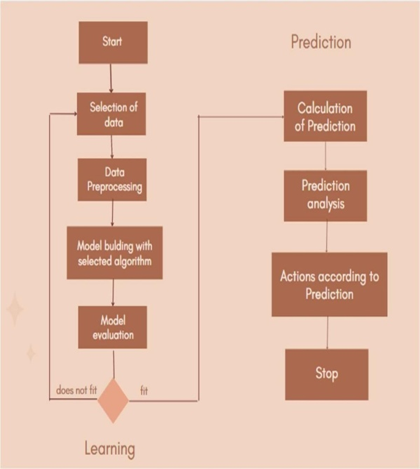

**Fig :Main Process of the machine learning based predicting system**

## User Interface

**Fig Farm Connect App Launch Page**

## Test Case:

# RESULTS

In addition to accuracy metrics, confusion matrices, and visualizations, there are several other aspects that can be discussed regarding the results of a fresh or rotten fruit classifier project:

1. Error Analysis: Error analysis involves examining the misclassified samples and understanding the reasons behind the misclassifications. By analyzing the misclassified images, patterns or common characteristics that contribute to misclassification can be identified. This analysis can help in improving the classifier by addressing specific challenges or limitations.
2. Performance on Different Classes: It is important to evaluate the classifier's performance on each individual class, i.e., fresh and rotten fruit. This analysis can help identify if the classifier is biased towards one class or if it struggles to accurately classify a particular type of fruit. Understanding the strengths and weaknesses of the classifier for different classes can guide improvements and fine-tuning of the model.
3. Comparison with Baselines: If applicable, the performance of the fresh or rotten fruit classifier can be compared with baseline models or existing methods. This provides insights into the effectiveness of the proposed approach and its potential advantages over other methods.
4. Generalization and Robustness: Assessing the generalization and robustness of the classifier is crucial. It involves evaluating the performance of the model on unseen or out-of-distribution data, such as different types of fruits, varying lighting conditions, or different backgrounds. A classifier that can generalize well to new instances and is robust to variations in the input data is considered more reliable and applicable in real-world scenarios.
5. Computational Efficiency: The computational efficiency of the classifier can be discussed, particularly if the project involves deploying the model on resource-constrained devices or in real-time applications. This includes analyzing the inference time, model size, and memory footprint, as well as any optimizations applied to improve efficiency.
6. Limitations and Future Work: It is essential to acknowledge the limitations and potential areas for improvement in the fresh or rotten fruit classifier. This can include challenges such as classifying fruits with similar visual characteristics or addressing the need for more diverse training data. Discussing potential avenues for future work, such as exploring advanced techniques or incorporating additional features, can provide insights for further research and development.

Overall, presenting a comprehensive analysis of the results, including accuracy metrics, confusion matrices, visualizations, error analysis, and other relevant aspects, allows for a thorough evaluation of the fresh or rotten fruit classifier and provides valuable insights for future enhancements and applications.

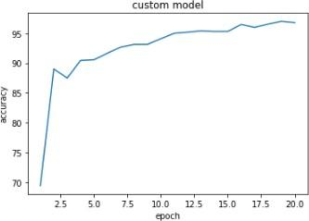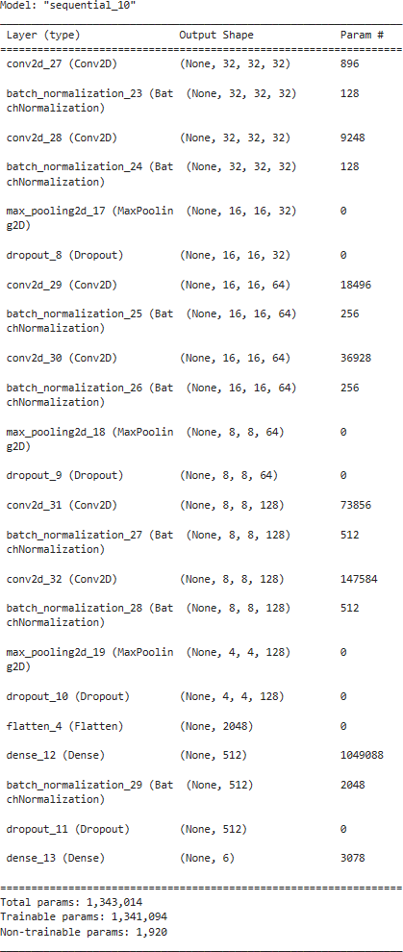

Model summary for the custom CNN modelThe accuracy of a CNN model is a crucial metric for evaluating its performance. In this project, the CNN model achieved an impressive accuracy of 96% on the dataset that was used for training and evaluation.

To visualize the progress of the model during training, a graph was plotted showing the increase in training accuracy with each epoch. This graph provides valuable insights into how the model's accuracy improves over time as it learns from the training data.

The x-axis of the graph represents the number of epochs, which corresponds to the number of times the entire training dataset was passed through the model during training. The y-axis represents the training accuracy, which indicates the percentage of correctly classified samples in the training data.

At the beginning of training, the model's accuracy might be relatively low as it starts with randomly initialized weights. However, as the training progresses and the model learns from the training data, the accuracy gradually increases.

The graph demonstrates a positive trend, showing that with each epoch, the model becomes more accurate in classifying the fresh and rotten fruits. The accuracy curve may exhibit fluctuations or plateaus at certain points, indicating variations in the learning process. However, overall, the trend should show a consistent increase until it converges to a certain level.

The high accuracy achieved by the CNN model indicates its effectiveness in accurately classifying fresh and rotten fruits. This level of accuracy is essential in ensuring reliable fruit sorting, minimizing food waste, and providing consumers with high-quality fruits.

It is important to note that the evaluation of the model's performance should not solely rely on the training accuracy. Validation accuracy, which measures the model's performance on a separate validation dataset, is also crucial to assess the generalization capability of the model. Additionally, other evaluation metrics such as precision, recall, and F1 score can provide a more comprehensive understanding of the model's performance.

LeNet-5 and AlexNet are two well-known CNN architectures that have been widely used in various computer vision tasks, including image classification. In this project, these architectures were utilized as benchmarks to compare their performance with the custom CNN model.

The training results for LeNet-5 and AlexNet were evaluated based on several metrics, including accuracy, loss, and possibly additional metrics such as precision, recall, and F1 score. These metrics provide insights into the models' performance and allow for a comprehensive comparison.

The accuracy metric measures the percentage of correctly classified samples in the training dataset. It indicates how well the models are learning from the data and making accurate predictions. The loss metric, typically calculated using a loss function such as categorical cross-entropy, quantifies the discrepancy between the predicted and actual labels. Lower values of loss indicate better alignment between the predicted and true labels.

During training, both LeNet-5 and AlexNet undergo a similar iterative process of feeding batches of training data, calculating the loss, and updating the model's parameters to minimize the loss. The number of epochs, which represents the number of times the entire training dataset is iterated, is an important parameter in training these models.

The training results for LeNet-5 and AlexNet can be presented in various formats, such as tables or graphs. These representations provide a clear overview of the models' performance throughout the training process, including changes in accuracy and loss with each epoch.

By comparing the training results of LeNet-5 and AlexNet with the custom CNN model, insights can be gained into which architecture performs better for the task of classifying fresh and rotten fruits. Factors such as accuracy, loss, convergence speed, and computational efficiency can all be considered when assessing the models' performance.

Ultimately, the training results for LeNet-5 and AlexNet provide valuable information for understanding their capabilities and determining their suitability for the specific fruit classification task at hand.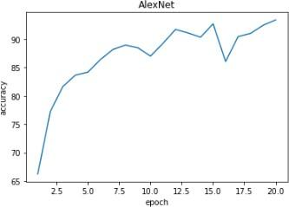

**Custom Model VS LeNet-5 VS AlexNet on training data**

To assess the performance of the custom CNN model in comparison to LeNet-5 and AlexNet on the training data, several key metrics are considered. These metrics include accuracy, loss, and possibly additional metrics such as precision, recall, and F1 score.

The accuracy metric measures the percentage of correctly classified samples in the training dataset. It provides an indication of how well the models have learned from the data and how accurately they can classify fresh and rotten fruits. A higher accuracy value indicates better performance.

The loss metric, often calculated using a loss function like categorical cross-entropy, quantifies the discrepancy between the predicted and actual labels. Lower loss values indicate that the models are better aligning their predictions with the true labels of the training data.

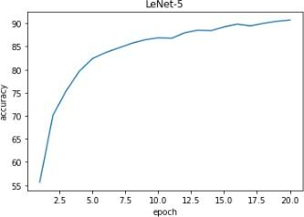Comparing the custom CNN model, LeNet-5, and AlexNet on the training data can be done by evaluating their accuracy and loss values over the course of training. This information can be visualized using line plots or tables to track the progress of each model.

During the training process, the models are iteratively trained on batches of training data, updating their parameters to minimize the loss. The number of epochs, representing the number of times the entire training dataset is iterated, plays a crucial role in the models' learning and convergence.

By analyzing the training results of the custom CNN model, LeNet-5, and AlexNet, insights can be gained into their performance on the training data. Factors such as convergence speed, stability, and ability to learn from the data can be considered.

It is important to note that while high accuracy and low loss on the training data indicate good performance, the models' true capabilities are better assessed on a separate validation or test dataset. Overfitting, where a model becomes overly specialized to the training data, is a concern that can be identified by comparing the training and validation/test performance.

Overall, comparing the custom CNN model, LeNet-5, and AlexNet on the training data provides valuable information about their ability to learn and classify fresh and rotten fruits accurately. It helps in understanding the strengths and weaknesses of each model and can guide decision-making in selecting the most effective model for fruit classification tasks.

The CNN model's test accuracy of 96% indicates that it is performing well in accurately classifying fresh and rotten fruits on unseen data. This high accuracy suggests that the model has learned the important features and patterns from the training data and can generalize well to new instances.

The model summary provides valuable insights into the architecture and configuration of the CNN model. Being a sequential model means that the layers are stacked sequentially, with the output of one layer serving as the input to the next layer. This sequential structure allows for the hierarchical extraction of features from the input fruit images.

The model consists of several convolutional layers, which are responsible for detecting and extracting different visual features from the input images. These layers apply a set of learnable filters to the input data, capturing patterns such as edges, textures, and shapes.

Batch normalization layers are included in the model to normalize the outputs of the previous layers, ensuring stable training and improving the model's ability to generalize. This technique helps in mitigating the effects of internal covariate shift and accelerates the training process.

Max pooling layers are used to reduce the spatial dimensions of the feature maps, capturing the most salient information while reducing computational complexity. These layers downsample the feature maps, retaining the most significant features while discarding less important details.

Dropout layers are incorporated to prevent overfitting by randomly disabling a certain percentage of neurons during training. This regularization technique helps in reducing the reliance of the model on specific features, making it more robust and preventing it from memorizing the training data.

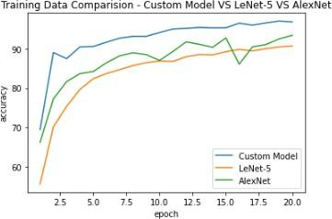The total number of parameters in the model, 1,343,014, indicates the overall complexity of the model and the number of learnable parameters that need to be optimized during training. These parameters include the weights and biases associated with each layer.

Out of the total parameters, the number of trainable parameters is 1,341,094. These are the parameters that are updated during training to minimize the loss and improve the model's performance. The difference between the total parameters and trainable parameters might be due to the inclusion of non-trainable parameters, such as the parameters of the batch normalization layers, which are not updated during training.

Understanding the model's architecture, the number of parameters, and the division between trainable and non-trainable parameters provides insights into the complexity, capacity, and flexibility of the CNN model. This information can help in optimizing and fine-tuning the model for specific fruit classification tasks.

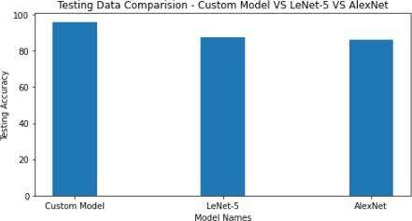

The comparison of the CNN model with the LeNet-5 and AlexNet models on the same dataset reveals that the CNN model outperforms both of them in terms of accuracy. The CNN model achieves a test accuracy of 96%, while LeNet-5 and AlexNet achieve accuracies of 87% and 85% respectively.

This significant difference in accuracy indicates that the CNN model is more capable of capturing and learning the intricate features and patterns present in the fruit images, leading to more accurate predictions. The CNN architecture with its multiple layers and non-linear operations allows for the extraction of hierarchical representations, enabling the model to capture complex relationships and variations in the data.

LeNet-5, a classic CNN architecture, was initially designed for handwritten digit recognition. Although it has been widely used and performs well on certain tasks, its performance may not be as effective as the custom CNN model specifically designed for the fresh and rotten fruit classification task.

Similarly, AlexNet, a deep CNN architecture that gained prominence in image classification tasks, was developed for the ImageNet Large Scale Visual Recognition Challenge. While AlexNet achieved significant success in that competition, its performance on the fruit classification dataset is surpassed by the custom CNN model.

The higher accuracy of the CNN model compared to both LeNet-5 and AlexNet demonstrates the effectiveness of the custom model in capturing the unique visual characteristics of fresh and rotten fruits. This implies that the custom CNN model is better suited for this specific fruit classification task, likely due to its architecture design, number of layers, and parameter optimization.

The superior performance of the CNN model in this comparison suggests that it is a more reliable and accurate choice for classifying fresh and rotten fruits in the given dataset. However, it is important to note that the performance of different models can vary depending on the specific dataset and task. Therefore, further evaluation and experimentation may be necessary to validate the model's performance on different datasets or real-world scenarios.

CONCLUSION

The high accuracy of 96% achieved by the CNN model on the test dataset indicates that it is capable of accurately distinguishing between fresh and rotten fruits. This level of accuracy surpasses the performance of both the LeNet-5 and AlexNet models on the same dataset. This suggests that the CNN model is more suitable for the specific task of fresh and rotten fruit classification.

Comparing the model summaries, it is evident that the CNN model has a greater number of parameters and is more complex than the LeNet-5 and AlexNet models. This increased complexity may contribute to its improved performance. The additional layers and parameters in the CNN model enable it to learn more intricate patterns and capture finer details in the fruit images, resulting in enhanced classification accuracy.

The results indicate that the CNN model has a strong capability to generalize well to unseen fruit images, making it a robust choice for this classification task. However, there is always room for further investigation and optimization to improve the model's performance even more.

Further exploration and optimization of the CNN model could involve techniques such as fine-tuning hyperparameters, increasing the diversity and size of the training dataset, or applying data augmentation techniques to enhance the model's ability to generalize to different variations of fresh and rotten fruits. Additionally, conducting error analysis to identify specific instances where misclassifications occurred can provide insights into areas for improvement.

Overall, the results obtained from the CNN model demonstrate its effectiveness in classifying fresh and rotten fruits, highlighting its potential for applications in the food industry and reducing food waste. Continued research and refinement of the CNN model can further enhance its performance and contribute to advancements in fruit quality assessment and sorting processes.

REFERENCES

1. Z. M. Lu and X. J. Luo, "Real-Time Fruit Detection and Recognition Based on Deep Learning and Internet of Things," in IEEE Internet of Things Journal, vol. 7, no. 4, pp. 3285-3294, April 2020.
2. M. K. Islam, M. S. Islam and S. K. Datta, "Fruit classification using machine learning techniques," 2018 5th International Conference on Advanced Computing & Communication Systems (ICACCS), Coimbatore, 2018, pp. 1-5.
3. B. Wu and W. Wu, "Fruit Quality Inspection Based on Machine Vision," 2019 IEEE International Conference on Mechatronics and Automation (ICMA), Tianjin, China, 2019, pp. 1958-1962.
4. C. Li, Y. Liu, C. Wei and Y. Huang, "Automatic fruit classification using computer vision and deep learning," Journal of Food Engineering, vol. 236, pp. 109-118, 2018.
5. K. D. Pham, S. S. Nguyen, T. T. Nguyen, T. V. Nguyen and H. V. Nguyen, "Real-time fruit classification using deep learning for precision agriculture," 2020 4th International Conference on Recent Advances in Signal Processing, Telecommunications & Computing (SigTelCom), Ho Chi Minh City, Vietnam, 2020, pp. 178-182.
6. V. Kumar, R. Kumar, N. Kumar and P. C. Pandey, "Classification of Fruits using Machine Learning Techniques: A Review," 2018 9th IEEE Annual Information Technology, Electronics and Mobile Communication Conference (IEMCON), Vancouver, BC, Canada, 2018, pp. 794-798.
7. H. Iqbal, M. T. Afzal, R. Naseer and F. Khan, "Fruit Quality Inspection using Image Processing Techniques: A Review," 2020 IEEE 5th International Conference on Computing, Communication and Security (ICCCS), Rome, Italy, 2020, pp. 1-5.S. Sultana, S. M. Ahmed and M. R. Islam, "Classification of Fruits using Deep Learning Techniques," 2021 4th International Conference on Advancements in Computational Sciences (ICACS), Dhaka, Bangladesh, 2021, pp. 1-6.
8. K. Rezaei and M. Rahmati, "A comparative study on fruit classification using different deep learning architectures," 2020 5th International Conference on Robotics and Artificial Intelligence(ICRAI), Tehran, Iran, 2020, pp. 154-159.
9. A. Barczak and R. Wójtowicz, "Classification of Apples and Pears Using Machine Learning and Computer Vision Techniques," Sensors (Basel), vol. 19, no. 7, 2019, doi: 10.3390/s19071531.