**SYNTHESIS OF RIGID POLYURETHANE FOAMS WITH PALM OIL BASED FLAME RETARDANT POLYOLS**

**Gnanaprakash Kanagaraj1*, Sekar Tamilperuvalathan2, Daniel Antony Arokiyasamy3, Sakthi Kumar Arumugam4, Surendran Ramakrishnan5**

1,4 PG Scholar, Department of Manufacturing Engineering, Government College of Technology, Coimbatore-641013.

2,5 Faculty, Department of Manufacturing Engineering, Government College of Technology, Coimbatore-641013.

3 Ph.D Scholar, Department of Manufacturing Engineering, Government College of Technology, Coimbatore-641013.

* Corresponding author

Gnanaprakash Kanagaraj

+91-9942929769

[gnanaprakashkanagaraj769@gmail.com](mailto:gnanaprakashkanagaraj769@gmail.com)

**Abstract**

A new method of introducing Palm oil based flame-retardant polyols (POFPL) into polyurethane foams was explored in this paper. Palm oil was alcoholyzed with glycerol. And epoxidation of glycerolysis Palm oil was carried out by formic acid and hydrogen peroxide (H2O2). The flame-retardant polyols were gotten though ring-opening reaction with diethyl phosphate. A novel Palm oil-based polyurethane foam has been prepared by a one-shot process with and without POFPL. The structure of POFPL was characterized by FT-IR and 1HNMR and the two studies exhibited characteristic peaks for POFPL. The thermal degradation and fire behaviour of polyurethane foams were investigated by limiting oxygen index (LOI), cone calorimetry test and thermogravimetry analysis. It has been shown that although the content of P element is only about 3%, the fire retardant incorporated in the Palm oil molecule chain increased thermal stability and LOI value of polyurethane foam can reach to 24.3% without any other flame retardant. The compression strength of polyurethane foam was also improved with the increase of flame-retardant polyols. Morphology of polyurethane foams was examined by scanning electron microscope(SEM) and found to be displayed the regular size and high percentage of close area of the cell. Therefore, rigid foams from Palm oil-based flame retardant polyols appear suitable for a wide range of applications.

**Keyword**: Palm oil, Polyol, Epoxidation, Flame-retardant, Polyurethane foam

**Introduction**

The main aim of this research was to form flame-retardant polyols with palm oil. The rapid depletion of fossil and petroleum resources is encouraging current and future chemists to orient their research toward designing safer chemicals, products, and processes from renewable feedstock. In this way the replacement of petroleum-based raw materials by renewable resources has become a major contemporary challenge in terms of both economical and environmental aspects The chemical industry is increasingly looking toward sustainable technology to reduce the environmental impact. Palm oil (CO) which is obtained from extracting or expressing the seed of a plant which has the botanical name Arecaceae is a versatile vegetable oil due to its unique composition in which the main component is the 12-hydroxy-9-cis-octadecenoic acid. The rich chemistry of raw CO is attributed to its structure (one double C=C and one –OH group per fatty acid chain), which makes it a good starting material for a wide range of applications Due to its unusual structure, this oil is very versatile in its applications. Palm oil is a raw material used extensively in varnishes, paints, coatings, inks, lubricants and a wide variety of other products. Because of its hydroxyl functionality, the oil is suitable for use in isocyanate reactions to make polyurethane mill able, polyurethane elastomers, coatings, and adhesives, interpenetrating polymer network from palm oil-based polyurethane and polyurethane foam.

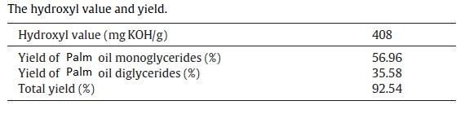

Table 1: The hydroxyl value and yield.

A recent work reported the synthesis of crosslink-able and biodegradable crosslink-able poly (palm oil fumarate)/poly (propylene fumarate) composite adhesive as a potential injectable and for orthopaedic applications. The improvement of the thermal stability and fire behaviour of polyurethane is today the aim of numerous studies, as there area number of important issues that need to be solved. So far, the application of polyols is limited by their high flammability. Any solution of this problem will increase their application in industry. For these reasons, studies to find effective flame retardants have been carried out by many researchers in industry and universities over a long period of time, but so far there is a limited success. Polyurethane generated from reactive flame-retardant monomer exhibit more excellent flame-retardant properties than those with additive flame retardants, for the flame retardants molecule linked to the polyurethane by covalent bond. The covalent bond makes it more stable while additive flame retardants in the polyurethane were easier to infiltrate out. The flame retardant compounds which have good flame retardant property, but hardly pollute the environment are particularly needed.

In our work, palm oil was first time to convert to flame-retardant polyols by reaction with glycerol, H2 O2 and diethyl phosphate. The flame-retardant polyols can be used to polyurethane foams, polyurethane elastomer, polyurethane film sand polyurethane coating. With the P element, the flame retardant properties can be improved and the application of palm oil will be enlarged. The structure of the palm oil-based flame retardant polyols was confirmed by spectroscopic techniques like FT-IR and1HNMR spectroscopy and thermal properties were determined by TGA. The thermal degradation and fire behaviour of polyurethanes prepared from POFPL have been studied by Thermogravimetric analysis, limiting oxygen index (LOI) and cone calorimetric measurement.

**Experimental**

**Materials**

Palm oil (industrial grade) was purchased from Sakthi Chemical Reagent Coimbatore- 69. Glycerol, hydrogen peroxide, phosphoric acid and thriethylamine were obtained from Scientific Chemical Reagent Co. Ltd Coimbatore-18. Triphenylphosphine and sodium methoxide was from Covai seenu and company, Coimbatore- 12.

**Preparation of glycerolysis palm oil (GCO)**

A reaction kettle equipped with a mechanical stirrer, condenser pipe, thermometer and provision for nitrogen flushing was charged with dry palm oil 500 g (0.54 mol) and catalyst 3.75 g. The temperature was raised quickly with continued stirring and maintained at200°C after continuous nitrogen for 30 min. Then 123.3 g (1.34 mol) of glycerol was taken in the reaction kettle. The temperature was maintained at 180°C for 3 h. Finally, polyol was cooled to 40°Cand was washed three times with distilled water. Hydroxyl value of GCO was determined by the acetic anhydride-pyridine method. The properties of the polyols such as hydroxyl value, total yield of GCO are presented in Table 1. The conversion rate was obtained by area normalization. The chemical reaction between palm oil and glycerol producing GCO is shown in Fig. 1.

**Synthesis of epoxidized glycerolysis palm oil (EGCO)**

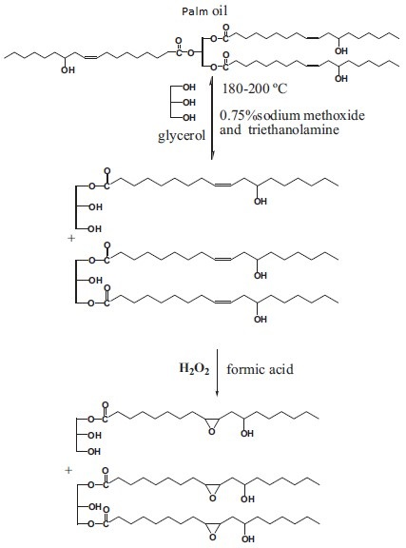

Fig. 1. The alcoholysis reaction and epoxy reaction of palm oil.

GCO (100 g), formic acid (7.75 g) and phosphoric acid (0.25 g) were mixed in a four-necked round-bottom flask equipped with a tetrafluoroethylene stirrer, a thermometer and a condenser pipe. This was heated to 40°C in a water bath. After that, hydrogen per-oxide was dropped to the reaction flask in 30 min. The mixture was then heated to 60°C and stirred for 6 h. And then the reaction mixture were cooled to room temperature and washed to pH = 7 with sodium hydroxide solution. The resulting product was dried over a hydrous sodium sulphate. The epoxidation reaction is shown in Fig. 1.

**Synthesis of POFPL**

Amounts of 100 g EGCO and toluene (75 g) were taken in a500 ml four-necked round bottom flask provided with a mechanical stirrer, thermometer and a water condenser. The mixture was then heated to 40°C and the mixture of diethyl phosphate (40 g), toluene (75 g) and triphenylphosphine (0.5 g) were dropped to the reaction flask in 30 min. Then the reaction proceeded with continuous stirring at 70–75°C for 4 h. The reaction mixture was cooled to room temperature and washed to pH = 7 with sodium hydroxide solution and then washed three times with distilled water. After that it was dried over rotary evaporator under the condition of vacuum. The chemical reaction between EGCO and diethyl phosphate producing POFPL is shown in Fig. 2.

**Preparation of PU foams**

The PU foams were prepared by a one-shot process, where all the ingredients were mixed simultaneously and allowed to cure at 80°C for 24 h. First, a small amount of silicone oil AK8804 (surfactant), N,N- dimethylcyclohexylamine (catalyst),141B, and water were mixed with POFPL and GCO. And then the mixture were stirred with a propeller stirrer for 2 min at approximately 1500 rpm to ensure a homogeneous mix, followed by addition of MDI to the mixture.

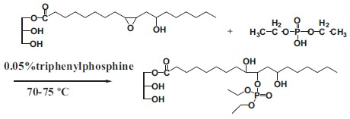

Fig. 2. The chemical reaction between EGCO and diethyl phosphate.

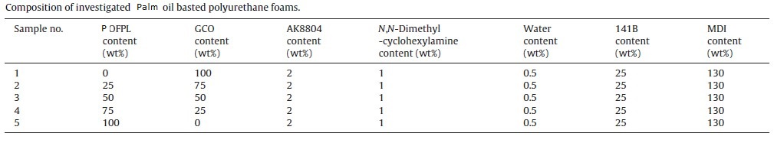

Table 2: Composition of investigated palm oil basted polyurethane foams.

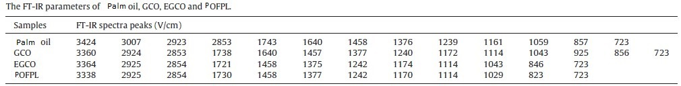

Table 3: The FT-IR parameters of palm oil, GCO, EGCO and POFPL.

The mixture were stirred for 10 s, before it was poured into a larger container and allowed to rise at room temperature. The obtained PU foams were left for complete cure for 24 h at 80°C. The compositions of investigated palm oil basted polyurethane foams are shown in Table 2.

**Measurements**

Molecular weight was measured by using an Efficient gel chromatograph made by Waters, USA at 30°C (flow rate: 1 ml/min, column: mixed PL gel 300 × 718 mm, 25 mm) using THF as solvent. The molecular structures of GCO, EGCO and POFPL were analysed by1H nuclear magnetic resonance (1HNMR) spectroscopy and Fourier transform infrared (FT-IR) spectrometer, respectively. For1HNMR inspection, the samples were prepared by dissolving approximately 5–6 mg of product in 0.5 ml of deuterated chloroform. This solution was then analysed by a BRUKER AV-300Advance spectrometer at 300 MHz. FT-IR spectra were collected by a Nicolet iS10 spectrometer within the wave number range of400–4000 cm−1.

Compression test: The compressive properties were tested with a CMT4000 universal testing machine according to GB/T8813-2008. At least three samples were tested to obtain average values. Size of the specimens were 50 × 50 × 50 mm (width × length × thickness) Scanning electron microscopy (SEM) study: PU foams were investigated with a scanning electron microscope (SEM) 3400N. The specimens were mounted on an aluminium stub and sputter coated with a thin layer of gold to avoid electrostatic charging during examination. Fire retardancy test: Limiting oxygen index (LOI) test was carried out according to the GB/T2406-1993 to determine the relative flammability of foam. Test specimen dimensions used were100 × 10 × 10 mm (length × width × thickness). Thermogravimetry: Thermogravimetry analysis was carried out using STA 409PC/PG. Small amount of sample was placed in the platinum pan before it was put in the furnace.

Then, the sample was heated from 30 to 800°C with a heating rate of10°C/min. Cone Calorimetry Test (CCT): The cone calorimetry test was carried out by using a cone calorimeter FTT2000 according to ISO5660-1. Each specimen, with the dimensions of 20 mm × 100 mm × 100 mm, was wrapped in aluminium foil and exposed horizontally to an external heat flux of 35 kW/m2. All samples were run in duplicate and the average value was reported.

**Results and discussion**

**FT-IR spectra of palm oil, GCO, EGCO and POFPL**

FT-IR spectra of palm oil, GCO, EGCO, POFPL are compared in Fig. 3 and the parameters are summarized in Table 3. In the FT-IR spectra, shown in Fig. 3, a peak around 1043 cm−1, associated with C–OH vibrations, was observed in the spectra of palm oil, GCO, EGCO and POFPL whilst no absorptions arising from the palm oil, implying that a reaction of –COO– of palm oil with –OH of glycerol had occurred. Peaks relating to –C–OH (at 1114 cm−1) could be identified in the spectra of palm oil, GCO, EGCO, POFPL.

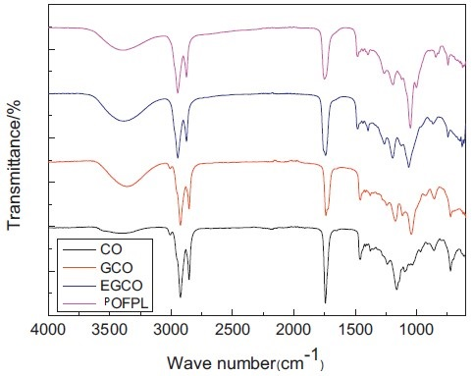

Fig. 3. FT-IR spectra of palm oil, GCO, EGCO and POFPL.

To epoxy group (at 846 cm−1) of EGCO, introduced by reaction with H2O2and formic acid, could be identified in the spectra of EGCO, while the –C=C– double bond (3007 cm−1) of palm oil and EGCO disappeared. These data may indicate that the–C=C–double bond were fully expended in the formation of the epoxy groups. The FT-IR spectra of POFPL are also presented in Fig. 3.

The peak at 1029 cm−1was assigned to P–O–C symmetric bending vibration, and P–O–CH2CH3 was observed. The POFPL spectrum shows that the absorbance of epoxy group of EGCO at 846 cm−1disappearedwhile the absorbance of P–O–C groups at 1029 cm−1had appeared, implying that a complete reaction of P–OH of diethyl phosphate with EGCO had occurred.

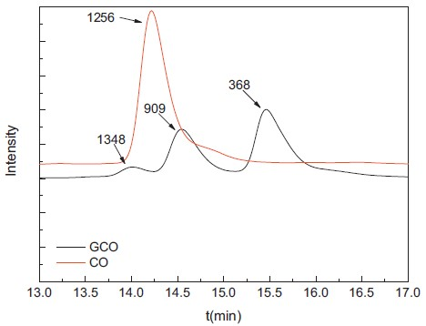

Fig. 4. The GPC spectra of palm oil and GCO.

**The molecular weight study of palm oil, GCO**

The resulted GCO had a content of 92.54%, a transparent yellow colour with Gardner value of 0.8, and a high viscosity of 16,400 cps. The GPC spectra of palm oil and GCO are depicted in Fig. 4.

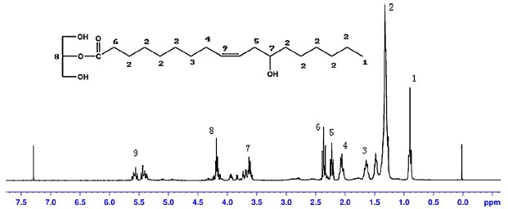

Fig. 5. 1HNMR spectra of GCO.

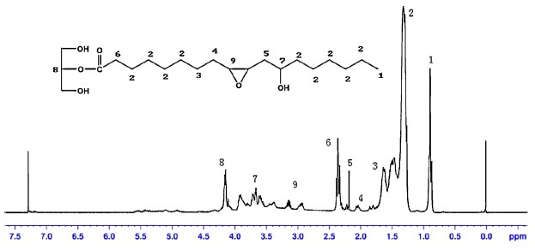

Fig. 6. 1HNMR spectra of EGCO.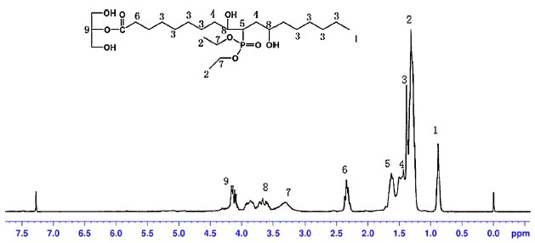

Fig. 7. 1HNMR spectra of POFPL.tif.

In the curve of GCO, the molecular weights of 368 and 909 rep-resented mono-glyceride and di-glyceride, while there was only a single peak 1256 in palm oil spectra. This result indicated the alcoholises reaction of palm and glycerol had occurred.

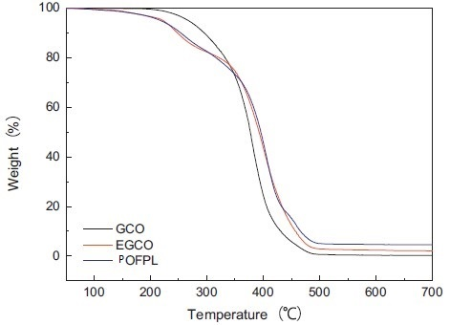

Fig. 8. TGA curves of GCO, EGCO and POFPL.

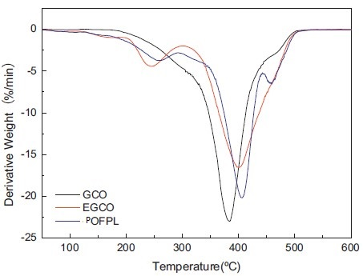

Fig. 9. DTG curves of GCO, EGCO and POFPL.

**1HNMR analysis of GCO, EGCO and POFPL**

Fig. 5 illustrates the1HNMR spectrum of GCO synthetized in this work with peak assignments. The fatty acid proton [(–CH2)–CO–] (peak 6) were in the range of ı = 2.4 ppm, while the methyl protons were at ı = 0.9 ppm (peak 1) and the methylene protons of glycerol were in the range of ı = 4.2–4.4 ppm (peak 8). These peaks could be used as internal standards to quantitatively characterize the con-tent of certain groups because they remained unchanged during the reaction. Methylene proton attached to hydroxyl (–CH–OH) arose at ı = 3.6–3.8 ppm (peak 7) while the methylene protons of glycerol was at ı = 4.15–4.30 ppm.

The –CH–OH in fatty acid chain is in the range of ı = 3.6–3.8 ppm (peak 7) while the peak ı = 2.2–2.4 ppm was contributed to –CH2–of–CH2–C–OH and the range of ı = 1.4 ppm (peak 2) was contributed to other –CH2–. The epoxidation of palm oil was followed by1HNMR as shown in Fig. 6. The proton signals in the 5.30–5.5 ppm (peak 9) region of the spectrum of GCO (ringed in Fig. 5) associated with the –CH=CH–bonds were replaced in the spectrum of EGCO by two resonances at 3.0–3.2 ppm (peak 9) (ringed in Fig. 6) corresponding to protons on the epoxy groups, indicating the –CH= CH– bonds of GCO was reacted with H2O2.The region 1.6 ppm (peak 5) in the1HNMR spectra as shown in Fig. 7 is associated with the –P–O–CH– at the middle of the POFPL while there are peaks in the range of 3.0–3.2 ppm (peak 9) shown in Fig. 6, which belong to the epoxy groups.

It was possible to be observed from the 1HNMR spectra that the signal at 3.60–3.9 ppm (peak 8) was shifted in the EGCO spectrum owing to the presence of the epoxy groups, and was broadened indicating that ring opening may have occurred following epoxidation with diethyl phosphate. Compared to the 1HNMR, we can draw a conclusion that POFPL was gotten.

**Thermogravimetric analysis (TGA and DTG) of GCO, EGCO and POFPL**

The TGA and DTG analyses of GCO, EGCO and POFPL are illustrated in Fig. 8 and Fig. 9, respectively, and the parameters are summarized in Table 4. The thermal degradation of GCO could be divided into one stage. The lowest onset temperature of 335.1°C was observed. Thermal decomposition of EGCO occurs with two stages near maximum temperatures 245.1°Cand 400.9°C with an onset temperature of 210.1°C and 320°Cin each stage. POFPL has onset temperatures near 340°C in the second stage while EGCO has decomposition onset temperature in 320°C.

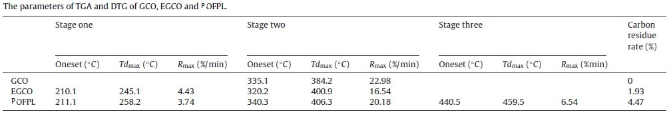

Table 4: The parameters of TGA and DTG of GCO, EGCO and POFPL.

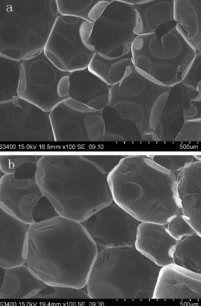

Fig. 10. SEM micrograph for PU foam prepared from GCO (a). SEM micrograph forPU foam prepared from POFPL (b).

The maximum temperature of POFPL had similar result406.3°C, while that of EGCO is 400.9°C. Maybe the three decom-position stages were contributed to the diethyl phosphate linked with P–O–C. When it was reached to 440°C, the diethyl phosphate had degraded and phosphinic acid was generated. Phosphinic acid make POFPL dehydrate to produce carbonization zone and O2 and heat were prevented, making POFPL more stable. Carbon residue rate of GCO, EGCO and POFPL are 0%, 1.93% and 4.47%, illustrating more carbonization zone was formed on the surface of POFPL, which makes it more stable and more flame-retardant.

**Effect of POFPL content on cell size and percentage of close area**

Fig. 10 depicts the SEM micrograph for PU foam prepared from GCO and POFPL. By comparing the SEM micrograph, it can be seen that the size of the PU foam cell increases when POFPL is incorporated. This could be attributed to the presence of diethyl phosphate which is believed to act as plasticizer or foam stabilizer because of –POO–. In addition, the formation of PU cell could be linked by the presence of POFPL, thus resulting in the regular size and high percentage of close area of the cell.

**Compression strength**

Table 5 shows that the compressive strength of palm oil basted polyurethane foam prepared from POFPL significantly increases compared to that of neat polyurethane foam from GCO. This significant improvement may be attributed to the increased hydroxyl value from the opened epoxy bond, which makes the hydroxyl value and degree of functionality increased.

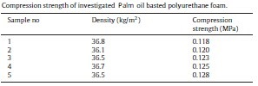

Table 5: Compression strength of investigated palm oil basted polyurethane foam.

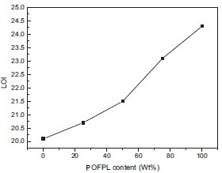

Fig. 11. LOI curves of the foam systems.

The enlargement of degree of functionality makes crosslink density increased. The increased compressive strength of POFPL/GCO systems indicated that the addition of POFPL improved the stiffness of POFPL/GCO systems significantly. It was confirmed that crosslinking system is formed and the degree of crosslinking is increased. The dominant effect is the extremely high crosslink density (caused by the reaction between increasing hydroxyl and isocyanate groups of polyurethane foam). These results indicate that the foams have improved stiffness through the chemical modification.

**Flammability tests**

The flammabilities of polyurethane foam are shown in Fig. 11. The flammability of the different samples was characterized using the LOI test, the LOI determines the minimum oxygen concentration that supports the combustion of polymer, the LOI was determined according to ISO 4589, as shown in Fig. 11. The original polyurethane foam had LOI value 20.1 and the LOI value increased to 20.7 with 25 phr POFPL and its value slowly reached to 21.5 and23.1 after treatment with 50 and 75 phr POFPL of polyols of PU system. The LOI value of PU prepared from POFPL is 24.3 that consist of about 3% phosphorus, indicating the polyurethane foams remain the good flame retardance with small phosphorus content. The existence of phosphorus grafted in the polyol’ molecule performs a good effect on flame retardation behaviour of this self-cured PU system. Therefore, POFPL functioned as a phosphorus-containing reactive flame retardant polyol for this self-curing PU system with-out any other flame retardant.

During the LOI test one could observe the formation of a certain char residue for the PUFs. Such kind of residue formation is reported in literature and can be composed of degradation products of polyol. In this study the addition of POFPL increased the formation of such residues. The increase of LOI can be contributed to the diethyl phosphate and the increase of crosslink density. When it was lighted, diethyl phosphate decomposed to produce phosphinic acid, which made PUFs dehydration and produced phosphorous-rich layer. This phosphorous-rich layer prevented oxygen and heat, making PUF more stable. And as we all know that increase of crosslink density can improve the modulus and stability of polymer. So these two facts make PUF prepared from POFPL more flame-retardant.

**Cone calorimetric measurement**

The cone calorimeter results are reported in Fig. 12, Fig. 13 and Table 6. After ignition, occurring in a very short range of time, all materials exhibited a sharp increase in the HRR until a first maxi-mum was reached (PHRR).

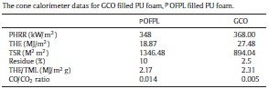

Table 6: The cone calorimeter data for GCO filled PU foam, POFPL filled PU foam.

The first PHRR of GCO was followed by a second peak, with intensity almost in the same. The second peak was ascribed to the combustion process of an intermediary decom-position product or intermediary char When POFPL was added, a decrease (10%) in the PHRR was observed, while with the use of GCO. The significant lowering of the peak of HRR can be assigned to the formation of a protective charred layer when POFPL was used, and the extent of such decrease may be related to the quality of the char layer formed upon heating.

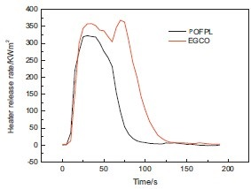

Fig. 12. HRR curves for GCO filled PU foam, POFPL filled PU foam.

The char residue for PU foam prepared from GCO showed many holes resulting in a not very effective barrier layer. Polyurethane foams prepared from POFPL formed a more compact and thick char. Diethyl phosphate formed the most compact char responsible for the greater reduction observed in the HRR. POFPL in the PUFs decreases their burning rates and thus can be considered to offer better flame protection for the foams.

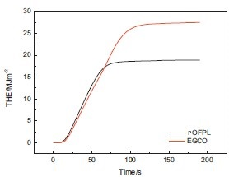

Fig. 13. Total heat evolved (THE) for GCO filled PU foam, POFPL filled PU foam.

The total heat evolved per total mass loss (THE/TML) is a measure of the heat of combustion of volatiles. Its significant reduction indicated a flame inhibition effect whereas fuel dilution results in moderate reduction of THE/TML For PU foams prepared from POFPL, THE/TML decreased for organic phosphinate containing foams, thus indicating effective flame inhibition in the gas phase due to the release of phosphorus containing molecules.

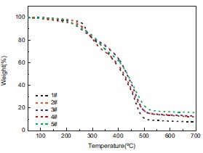

Fig. 14. TGA curves of polyurethane foams.

The decomposition of diethyl phosphate led to the formation of phosphine that further decomposed to dimer and tetramer of phosphorus, showing flame inhibition effect. PU foams prepared from POFPL, based on an organic phosphinate compound showed not only a flame inhibition effect but also a fuel dilution effect, as confirmed by the slight decrease of TSR. Another two parameters which can be detected by the cone calorimeter are CO/CO2ratio and the total smoke release, shown in Table 6. With 100% POFPL content the total smoke release of the samples increased from 894.04 to 1346.48. Because effective char layer was formed, the flame inhibiting effect of POFPL in the gas phase (radical chain interception) caused an incomplete combustion by the removal of •H and •OH radicals.

The CO/CO2ratio of PUF with 100% POFPL was 0.014 while that was 0.005 without POFPL. The increase of the ratio is caused by the release of the low molecular weight PO, PO2, etc, which are able to scavenge the H• and OH• species. Because there are less OH• radicals available for an oxidation of CO to CO2, the ratio increases.

**Thermogravimetric analysis (TGA and DTG) of polyurethane foams**

The corresponding values of thermogravimetric curves are shown in Table 7. Fig. 14 and Fig. 15 show the TGA and DTG curves of polyurethane foams with various contents of POFPL at the linear heating rate of 10°C/min under N2atmosphere, and the corresponding values are listed in Table 7. The initial decomposition temperature can be considered as the temperature at which the weight loss is about 5%. summarized the four possible types of reactions that may take place in the thermal decomposition of urethanes. The tendency for a particular mechanism depends on the chemical nature of the groups, adjacent to the urethane linkage, and the environ-mental conditions.

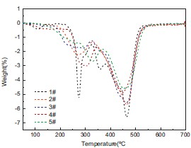

Fig. 15. DTG curves of polyurethane foams.

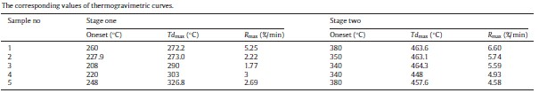

Table 7: The corresponding values of thermogravimetric curves.

Polyurethane degradation usually starts with dissociation of the urethane bonds, carbon dioxide and isocyanate evaporation. In Fig. 15, it is clearly seen that the pure foam begins to decom-pose around 260°C and its thermal degradation is composed of two main steps with a maximum weight loss temperature of 463.6°C.

Compared with neat polyurethane foams prepared from GCO, the modified polyurethane foams with different contents have slightly lower one set degradation temperatures and the temperature of the maximum DTG peaks is also slightly shifted to lower temperature. Firstly, the weight loss between 217 and 336°C was attributed to the breaking of urethane bond The degradation of diethyl phosphinate can occur by means of two competing pro-cesses: decomposition or vaporization. The scission to phosphinic acid is energetically preferred; the first step was most probably related to the decomposition of urethane bond while the slightly lower one set degradation temperatures of polyurethane foam pre-pared from POFPL, related to the diethyl phosphite, already shown for decomposition of diethyl phosphate. The decomposition stage of polyurethane lies in the range from 336 to 480°C resulted from a faster weight loss of palm oil molecules, which was accorded with the literature The last stage (>475°C) corresponds to further oxidation of the cross linked network and gradual oxidation of the char residue.

Thus it is possible that the P–O–C bond may break and the majority of diethyl phosphate may get vaporized earlier for possible flame-poisoning at about 180°C–250°C, while the remaining P–O–C would be retained in the POFPL, exhibiting subsequently condensed or gas phase activity. It could be attributed to phosphonic acid derivatives formed during the thermal decomposition of the phosphonates which accelerating the depolymerization of the urethane bond. As a result, the combined effect may help extinguish the fire. From the DTG curve, it can be seen that there are two DTG peaks located, which are mainly due to the dehydration of further curing and the degradation of polyurethane, respectively.

When compared with polyurethane foam prepared from GCO, the maximum decom-position rate of polyurethane foam with POFPL were reduced to 5.74, 5.59, 4.93 and 4.58, and carbon residue rate at 700°C were improved to 12.68%, 13.05%, 12.15% and 15.97%, respectively. In pure polyurethane, the specimen surface gradually degrades to volatile oligomers, monomer, and some molecules, whereas the presence of phosphorous flame retardant additive causes delay in degradation of polymer matrix. As compared to the virgin foam, POFPL containing foams showed slower weight loss in the temperature range of 300–700°C. Increased stability of POFPL containing foams at this stage could be attributed to the formation of more thermally stable intermediates induced by phosphorus acid derivatives.

Chars at elevated temperatures (>400°C) still exist, which indicates that these intermediates are thermally stable enough. It is the result of this fact that diethyl phosphate with low thermal decomposition temperature is decomposed earlier, and protect underlying polyurethane matrix. From the combustion point of view, decomposition of PU and diethyl phosphate causes formation of a phosphorous-rich layer. This stable physical protective barrier on the surface of polyurethane may insulate the underlying polyurethane matrix from the heat and thus provide barrier properties in case of fire.

**Conclusions**

POFPL-based polyurethane foams were prepared by a one-shot process with and without POFPL. According to the synthesis above, POFPL derived from palm oil can be considered as a very compatible flame-retardant polyol for polyurethane foam. The SEM images of the foams showed that the foams have similar internal cell morphology, and with the addition of POFPL, the over-all cell structure became more uniform, the cell walls became thinner and the amount of broken cells decreased. The thermogravimetric analysis showed that the decomposition of the foam begins at approximately 248°C and carbon residue rate at 700°Cwas improved to 15.97%. Compared with the pure polyurethane foam, the LOI value increased to 24.3%. It can be concluded that the polyurethane foam prepared from POFPL has excellent fire resistance even though containing only about 3% phosphorus.

**References**

1. Athawale, V., Kolekar, S., 2022. Interpenetrating polymer networks based on polyolmodified palm oil polyurethane and polymethyl methacrylate. Eur. Polym. J.l10, 1447–1451.
2. Bozell, J.J., Patel, M.K., 2022. Feedstocks for the future: renewables for the productionof chemicals and materials.
3. In: ACS Symposium, Washington.Braun, U., Bahr, H., Sturm, H., Schartel, B., 2021. Flame retardancy mechanisms of metal phosphinates and metal phosphinates in combination with melaminecyanurate in glass-fiber reinforced poly(1,4-butylene terephtalate): the influence of metal cation. Polym. Adv. Technol. 19, 680–692.
4. Cassidy, P.E., Schwank, G.D., 2021. Copolymerization of dehydrated palm oil withstyrene: determination of reactivity ratios. J. Appl. Polym. Sci. 18, 2517–2526.
5. Chang, C.W., Lu, K.T., 2020. Natural palm oil based 2-package waterbornepolyurethane wood coatings. Prog. Org. Coat. 75, 435–443.
6. Cocks IV, L.V., Vanredew, C., 2020. Laboratory Hand Book for Oil and Fat Analysis.
7. Academic Press, London.Fiorelli, J., Curtolo, D.D., Barrero, N.G., 2020. Particulate composite based on coconutfiber and palm oil polyurethane adhesive: An eco-efficient product. Ind. CropsProd. 40, 69–75.
8. Gaan, S., Sun, G., Hutches, K., Engelhard, M.H., 2020. Effect of nitrogen additives onflame retardant action of tributyl phosphate: phosphorus-nitrogen synergism.Polym. Degrad. Stab. 93, 99–108.
9. Gallo, E., Braun, U., Schartel, B., Russo, P., Acierno, D., 2020. Halogen-free flameretarded poly(butylene terephthalate) (PBT) using metal oxides/PBT nanocom-posites in combination with aluminium phosphinate. Polym. Degrad. Stab. 94,1245–1253.
10. Gao, Z.Z., Peng, J., Zhong, T.H., Sun, J., Wang, X.B., Yue, C., 2020. Biocompatible elas-tomer of waterborne polyurethane based on palm oil and polyethylene glycolwith cellulose nanocrystals. Carbohydro Polym. 87, 2068–2075.
11. Kirk-Othmer, 2020. Encyclopedia of Chemical Technology, vol. 5. John Wiley & Sons,New York.Jasin’ska, L., Haponiuk, J.T., Balas, A., 2019. Dynamic mechanical properties andthermal degradation process of the compositions obtainedfrom unsaturatedpoly (ester urethanes) cross-linked with styrene. J. Therm. Anal. Calorim. 93,777–781.
12. Liu, Y.L., Hsiue, G.H., Lan, C.W., Chiu, Y.S., 2019. Flame–retardant polyurethanes from phosphorus–containing isocyanates. J. Polym. Sci., Part A: Polym. Chem.35, 1769–1780.
13. Luca, M.A., Martinelli, M., Jacobi, M.M., Becker, P.L., Ferrão, M.F., 2019. Ceramercoatings from palm oil or epoxidized palm oil and tetraethoxysilane. J. Am.Oil Chem. Soc. 83, 147–151.
14. Maria, A., Luca, D., Márcia, M., Cláudia, C.T., 2019. Hybrid films synthesised fromepoxidised palm oil. -glycidoxypropyltrimethoxysilane and tetraethoxysi-lane. Prog. Org. Coat. 65, 375–380.
15. Mitha, M.K., Jayabalan, M., 2019. Studies on biodegradable and crosslinkablepoly(palm oil fumarate)/poly(propylene fumarate) composite adhesive as a potential injectable biomaterial. J. Mater. Sci. Mater. Med. 20, 203–211.
16. Mülazim, Y., akmakc, E.C., Kahraman, M.V., 2018. Preparation of photo curable highly hydrophobic coatings using a modified palm oil derivative as a sol–gel component. Prog. Org. Coat. 72, 394–401.
17. Ravey, M., Pearce, E.M., 2018. Flexible polyurethane foam. I. Thermal composition of a polyether-based, water-blown commercial type of flexible polyurethane foam. J. Appl. Polym. Sci. 63, 47–74.
18. Saunders, J.H., Frisch, K.C., 2018. Polyurethane: Chemistry and Technology. Wiley-Interscience, New York, pp. 106–121.
19. Semenzato, S., Lorenzetti, A., Modesti, M., Ugel, E., Hrelja, D., Besco, S., 2018. A novelphosphorus polyurethane FOAM/montmorillonite nanocomposite: preparation,characterization and thermal behavior. Appl. Clay. Sci. 44, 35–42.
20. Shen, Z., Simon, G.P., Cheng, Y.B., 2018. Nanocomposites of poly(methyl methacry-late) and organically modified layered silicates by melt intercalation. J. Appl.Polym. Sci. 92, 2101–2115.
21. Simon, J., Feurer, R., Reynes, A., Morancho, R., 2018. A mass spectrometry study ofthe gas pyrolysis of PH3and a PH3/Si2H6mixture. J. Anal. Appl. Pyrolysis 26,27–36.
22. Somani, K.P., Kansara, S.S., Patel, N.K., Rakshit, A.K., 2018. Palm oil basedpolyurethane adhesives for wood-to-wood bonding. Int. J. Adhes. Adhes. 23,269–275.
23. Song, L., Hu, Y., Tang, Y., Zhang, R., Chen, Z.Y., Fan, W.C., 2018. Study on the proper-ties of flame retardant polyurethane/organoclay nanocomposite. Polym. Degrad.Stab. 87, 111–116.
24. Stefan, O., 2018. Dependence of fungal biodegradation of PEG/palm oil-basedpolyurethane elastomers on the hard-segment structure. Polym. Degrad. Stab.95, 2396–2404.
25. Thirumal, M., Khastgir, D., Nando, G.B., Naik, Y.P., Singha, N.K., 2017. Halogen-free flame retardant PUF: Effect of melamine compounds on mechan-ical, thermal and flame retardant properties. Polym. Degrad. Stab. 95,1138–1145.
26. Tibério, C.G., Claro, N.S., Vecchia, F., 2017. Rigid foam polyurethane (PU) derivedfrom palm oil (Ricinus communis) for thermal insulation in roof systems. Front.Archit. Res. 1, 348–356.
27. Trevino, A.S., Trumbo, D.L., 2017. Acetoacetylated palm oil in coatings applications.Prog. Org. Coat. 44, 49–54.
28. Yeganeh, H., Mehdizadeh, M.R., 2016. Synthesis and properties of isocyanate curablemillable polyurethane elastomers based on palm oil as a renewable resourcepolyol. Eur. Polym. J. 40, 1233–1238.
29. Zhang, L., Huang, J., 2016. Effects of nitrolignin on mechanical properties ofpolyurethane–nitrolignin films. J. Appl. Polym. Sci. 80, 1213–1219.