## **Experimental Investigations of glass Fiber Reinforced High Performance Concrete with Admixtures**

**Kalasapati Rangaswami chandrudu1 and K .Shammad basha 2**

1PG student in SVR Engineering College, Nandyal, Andhra Pradesh, India

2Assistant Professor in SVR Engineering College, Nandyal, Andhra Pradesh, India

**ABSTRACT (Font-Times New Roman, Bold, Font Size -12)**

The building industry has been making extensive use of high-strength, high-performance concrete (HPC) for a significant amount of time. The production of a product that is more cost-effective, the provision of a technically viable solution, or a combination of the two are the key drivers for the selection of HPC. The creation of high-strength concrete often requires the addition of fly ash, silica fume, or slag. The strength improvement that may be achieved with these extra cementing ingredients cannot be achieved by adding more cement on its own. In most cases, the dose rates for include these extra cementing ingredients range from 5 percent to 20 percent or greater based on the mass of the cementing material. Some specifications only allow the use of up to 10 percent silica fume, unless there is evidence available indicating that concrete produced with a larger dosage rate will have satisfactory strength, durability, and volume stability. The evidence must be available before the specification can be changed. The incorporation of supplemental cementitious materials (SCM) into the HPC mix will not only contribute to a reduction in energy consumption and improved waste management, but it will also bring about greater sustainability.

**Keywords:** Analysis, investigation, research (5-6 Keywords, Font-Times New Roman, Font Size – 10).

1. **INTRODUCTION**

When volume is taken into account, it can be said that concrete is the most widely utilised construction material in the world. More than one cubic metre, or more than ten billion tonnes, is created for every individual on the planet every single year (Scrivener 2008). Concrete's popularity in the building sector may be attributed to how readily it can be moulded into many useful shapes. In addition to this, it is a low-cost and low-energy material that is manufactured from the elements that are the most readily accessible on earth. Concrete has outstanding mechanical and long-lasting characteristics if it is designed and manufactured in the correct manner. It can be shaped and moulded, and it has a fair amount of resistance to fire. The fact that it is an engineered material, which implies that it can be developed to fulfil practically any realistic set of performance standards, more than any other material that is now accessible, is perhaps the most alluring attribute that it has. Concrete is a material for building that is used on a massive scale all over the globe, and its qualities are experiencing changes as a result of technological improvement. In order to improve the variety of features that concrete has, several varieties of concrete have been produced. This progression may be broken down into four sections as it now stands. Cement, water, fine aggregates, and coarse aggregates are the sole components of the conventional normal strength concrete, the oldest kind of concrete. This type of concrete is constructed of just four basic ingredients. Along with recent advancements in civil engineering, such as high-rise structures and long-span bridges, the need for greater compressive strength concrete arose as a result of rapid population expansion and an increased need for housing and infrastructure. At first, the most straightforward approach to increasing the compressive strength of the material was to lower the amount of water to cement. After that, the fifth component, which may either be a water-reducing agent or a super plasticizer, was required. On the other hand, there were occasions when the compressive strength was not as significant as some of the material's other attributes, such as its low permeability, durability, and workability. At the tail end of the 20th century, high performance concrete was a concept that was floated and subjected to extensive research. Because of the many practical and financial benefits it offers, high-performance concrete is already used in very large quantities. These types of materials are distinguished by enhanced mechanical and long-lasting qualities, which are the direct consequence of the incorporation of chemical and mineral admixtures as well as the use of specific manufacturing techniques.

1. **METHODOLOGY**

**2.1 CEMENT**

OPC of 53 Grade that was manufactured in accordance with IS: 12269 – 1987 was used. In order to determine the compressive strength of cement mortar, a cube specimen with dimensions of 70.7 millimetres on each side and a cement to sand ratio of 1:3 is used. The dimensions of this specimen are in accordance with IS: 4031. In addition, every additional test is performed in accordance with the many Indian Standards.

**2.2 Fly Ash**

FA is often more finely ground than cement, and it is composed mostly of glassy spherical particles as well as residue of hematite and magnetite, which are both crystalline phases that emerge during the cooling process

**2.3 Silica Fume**

In the manufacturing of silicon and silicon alloys, SF is a waste by-product that is produced. There are other ways in which SF may be obtained; however, the densified version is the one that is employed the most often nowadays. It is already abundantly accessible, combined with cement, in the nations that have developed their economies.

**2.4 GGBS**

In most cases, slags are used as extra cementitious materials with the primary purpose of increasing compressive strength. There is a possible range of 60 MPa to 120 MPa for the compressive strength. In most cases, slags are used instead of cement for 15–30 percent of the whole mix. Granular GGBS is the product obtained when liquid iron blast furnace slag is quickly cooled (quenched) by being submerged in water.

**2.5 GLASS FIBRES**

A material known as glass fibre is one that is made up of several different types of very fine glass fibres. Insulation may be accomplished with the use of glass fibre rather often. To make an extremely strong and lightweight fibre reinforced polymer composite material, fibre is utilised as a reinforcing material for many different types of polymer goods..

**2.6 Fine Aggregate**

For the purpose of this experiment, clean and dry river sand that was readily accessible in the area was employed. FAs that are transiting through IS All of the specimens were cast using a sieve with a 4.75mm opening. Because of the large quantity of cementitious material in HSC, the function of the FAs (sand) in providing workability and excellent finishing qualities was not as critical as it was in Controlled concrete mixes. This was due to the fact that HSC had a higher cementitious material content.

**2.7 Coarse Aggregate (CA)**

When it comes to HPC, the strength of the aggregate itself, as well as the binding or adhesion that exists between the paste and the CAs, become crucial elements. Crushed stone coarse aggregates (CAs) produce concrete with a higher compressive strength than gravel aggregates when using the same size coarse aggregates and the same amount of cementing materials in the mix. This is likely due to a superior aggregate-to-paste bond when using rough, angular, crushed material.

**2.8 WATER**

Water is an essential component of concrete since it not only plays an active role in the hydration of cement but also helps to the workability of new concrete. Water also actively participates in the hydration of cement.

1. **RESULTS AND DISCUSSION**

**3.1 Compressive strength**

It has been determined via measuring the compressive strength values of a cube for each of the HPC mixes that the strength at 28 days is greater than the strength of the HPC mixes at 7 and 14 days. This is because cement and concrete undergo constant hydration during the process. The compressive strength of a cube is shown in Figure 1 for both group A and group B mix accordingly. According to the findings of the tests, it is abundantly obvious that the group B mixes have a greater compressive strength in comparison to both the group A mixes and the CC mix. The BM2 blend has the greatest compressive strength compared to the other mixtures.

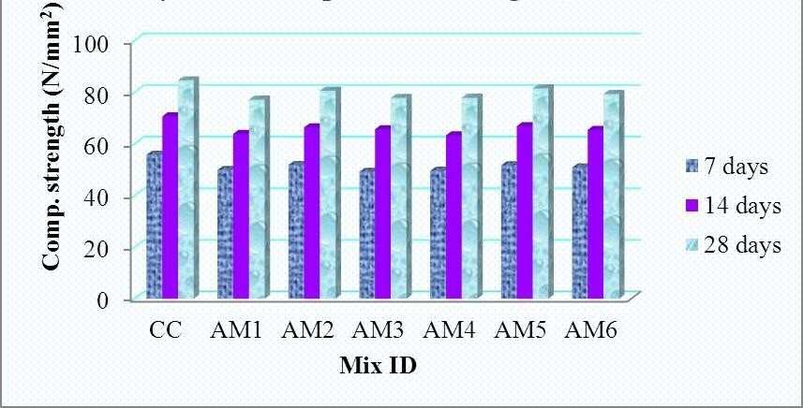

Figure 1 Cube compressive strength for group A HPC mixes

**3.2 Split tensile strength**

In accordance with IS: 516-1959, the split tensile strength of a concrete cylinder that measured 100 millimetres in diameter and 300 millimetres in length was measured. Figure 2 depicts the orientation of the cylinder in relation to the testing device. The research took into consideration a number of different HPC mixtures in which cement was substituted with one of two groups of SCM (Group A or Group B). The values of split tensile strength for different combinations are shown in Table 2 at 7, 14, and 28 days, respectively.

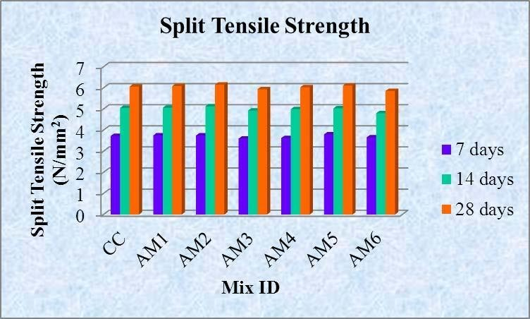

Figure 2 Split tensile strength for group A HPC mixes

**3.3 Flexural test**

In accordance with IS: 516-1959, flexural tests were performed on concrete prisms at 28 days of age measuring 500 millimetres by 100 millimetres by 100 millimetres (Figure 3).

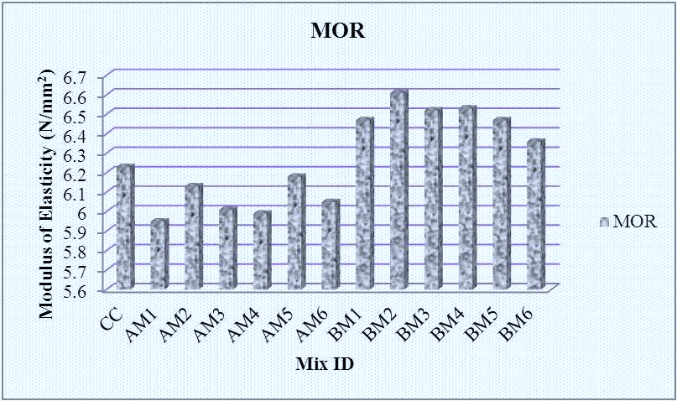

Figure 3 Modulus of rupture for all HPC mixes

1. **CONCLUSION**
2. For each of the 13 mixtures, the fresh qualities such as slump, compacting factor, and flow were measured and analysed. It was discovered that the fresh characteristics of the Group B (BM1 to BM6) mix had a greater workability than those of the Group A mix.
3. According to the findings of the compressive strength investigations, mix BM2 has a greater strength, namely 1.19 times higher compressive strength than mix AM5, which is the mix with the highest strength among group A mixes, and 1.14 times higher than the mix that served as the control (CC). In terms of cylinder compressive strength, AM2 demonstrated a greater level in group A mix, but BM2 shown a higher level in group B mix. At the 91-day strength, BM2 has a potency that is 1.23 times greater than CC and 1.27 times higher than AM2. The BM2 blend had a greater split tensile strength compared to all of the other mixtures.
4. The modulus of elasticity of BM2 is 1.06 times greater than that of CC, and it is 1.07 times higher than that of AM5, which is the group A mix with the highest modulus of elasticity. The modulus of rupture of BM2 demonstrated superior performance as compared to that of both CC and group A HPC mixtures.
5. It can be seen rather plainly from the mechanical and elastic characteristics that the strength of group mixes is directly connected to the components that make them up. In a manner analogous to that of FA concrete, the early strength gain with GGBS is slower than that of the ordinary Portland cement concrete. This may be the result of a slower hydration process and a higher amount of slag content; however, the long-term strength is higher than that of ordinary concrete if moisture remains available for further reaction between the primary hydration product Ca(OH)2and GGBS. The use of mineral admixture as a partial substitute for cement results in an improvement in the microstructure of the concrete (namely, the porosity and pore size distribution) as well as an increase in the mechanical properties of the concrete.
6. **REFERENCES**
7. Barbosa, AF & Gabriel O Ribeiro 1998, „Analysis of reinforced concrete structures using ANSYS nonlinear concrete model‟, Federal University of Minas Gerais.
8. Barbosa, AF 1997, „A Study of Models for Nonlinear Finite Element Analysis of Concrete Structures‟, Federal University of Minas Gerais.
9. Basheer, L, Kropp, J & Cleland, DJ 2001, „Assessment of the durability of concrete from its permeation properties: a review‟, Construction and Building Materials, vol.15, pp.93-103.
10. Basheer, PAM 1991, „Clam permeability tests for assessing the durability of concrete‟, Ph. D Thesis, Queen‟s University Belfast.
11. Bentur, A & Jaegermann, G 1991, „Effect of curing and composition of the outer skin of concrete‟, Materials in Civil Engineering, vol.3, no.4, pp.252-262.
12. Bharat Kumar, BH, Narayanan, R, Raghuprasad, BK & Ramachandramurthy, DS 2001, „Mix Proportioning of High Performance Concrete‟, Cement & Concrete composites, vol.23, pp.71-80.
13. Bijen, JM & De Roij, M 1999, „Aggregate – Matrix Interfaces‟, International Conference on Concretes, Dunde, Scotland.