## **Performance of Self-Compacting Concrete Using a Variety of Admixture**

**Vinay Nees1 and M.Mallikarjuna2**

1PG student in SVR Engineering College, Nandyal, Andhra Pradesh, India

2Assistant Professor in SVR Engineering College, Nandyal, Andhra Pradesh, India

**ABSTRACT**

Self-Compacting Concrete (SCC) is a high-performance concrete that flows under its own weight, allowing the filling of forms with crowded reinforcing without the need for mechanical vibration during installation. A High Performance Concrete element is one that is intended to provide optimal performance characteristics for a specific set of load, use, and exposure circumstances, in accordance with cost, service life, and durability requirements. The use of additives and the use of a low water-to-binder ratio may enhance the performance of SCC. Utilizing mineral admixtures such as Ground Granular Blast Furnace Slag (GGBFS), Fly Ash (FA), and Silica Fume (SF) in conjunction with chemical admixtures such as Superplasticizers (SP) and Viscous Modifying Agent (VMA) may considerably increase the performance of SCC.

**Keywords:** Self -Compacting Concrete. GGBFS, Fly Ash , Silica Fume

1. **INTRODUCTION**

Population expansion, industrialisation, urbanisation, and globalisation all contribute to an increase in infrastructure demand. In the 20th century, concrete has become the material of choice for contemporary infrastructure requirements. In the preceding decade, nearly 10 billion tonnes of concrete were manufactured annually around the globe (Mehta & Kumar 2002, Lafarge 2005). Now, more than 10,000 m3 of concrete are produced annually (Flatt R, Roussel R & Cheeseman C, 2012). Concrete offers a great deal of latitude in shaping structural components into the required shapes or forms. Mehta and Monteiro (2006) anticipated that by 2050, the annual demand for concrete would increase to around 18 billion tonnes. The extraction, processing, and transport of vast amounts of aggregate, as well as the billions of tonnes of raw materials required for the production of concrete, have a negative impact on the ecosystem of virgin areas. In urban regions where the demand for natural resources is quickly surpassing the availability, massive development projects are now underway in both established and developing nations. Furthermore, the consequences of human growth on the environment are substantial and growing.

Concrete is a remarkable and essential building material in human history. According to Brunauer and Copeland (1964), "man consumes no other substance in such vast amounts as water." With the advancement of human civilisation, concrete will continue to be the predominant building material in the future. However, the modernization of the concrete industry has introduced several environmental issues, such as pollution, waste disposal, the production of hazardous gases, and the depletion of natural resources.

Self-Compacting Concrete (SCC) has become a term in the construction industry and is regarded as one of the most significant technological advancements of the previous two decades. With its capacity to flow without separating, SCC has become a valued asset. SCC's ability to flow through complicated structural sections under its own weight, leaving no holes and removing the need for vibration or any form of compacting effort, is one of its major features.

The introduction must be written in Times New, size 10 font. In this part, emphasise the topic's significance by making broad generalisations about it and providing an overview of current research on the issue. The easiest method is to just change the information with your own. Your opening should identify the topic of interest explicitly.

1. **METHODOLOGY**

# **2.1 Cement**

Cement is the most essential component of concrete. One of the most significant selection factors for cement is its capacity to make concrete with an enhanced microstructure. SCC, unlike CC, has chemical or mineral additives.

# **2.2 Fly Ash**

FA is a finely split byproduct of crushed or pulverised coal. In general, they are finer than cement and are composed mostly of glassy spherical particles, as well as hematite and magnetite residue, char, and crystalline phases generated after cooling.

# **2.3 Silica Fume**

SF is a waste byproduct of silicon and silicon alloy manufacturing. There are several kinds of SF, the most common of which is the densified variety. In wealthy nations, it is already commercially accessible as a cement additive.

# **2.4 GGBS**

At dosages between 15 and 30 percent, slags are viable for use in high-strength concrete. However, for very high strengths over 98 MPa, the GGBS must be used in combination with SF.

# **2.5 Superplasticisers**

Without SP, it is difficult to produce high performance concrete (including high strength concrete) with appropriate workability in the field. Unfortunately, certain SPs will perform differently with various cements.

# **2.6 Viscous Modifying Agents**

VMA is used to satisfy demands and eliminate performance changes in concrete. VMA make concrete more tolerant to fluctuations in the water content in the mix, hence maintaining plastic viscosity and preventing segregation.

# **2.7 Fine Aggregates**

Local river sand that is clean and dry is utilised. Fine aggregates passing an IS 4.75mm filter are utilised to cast each specimen. Due to the high cementitious content of high strength concrete, the job of the Fine Aggregate in providing workability and excellent finishing qualities is not as challenging as it is in CC mixes.

# **2.8 Coarse Aggregates**

Important aspects in high-performance, high-strength concrete are the aggregate's strength and the link or adhesion between the paste and coarse particles.

# **2.9 Water**

Water is an essential component of concrete, since it not only participates actively in the hydration of cement but also helps to the workability of new concrete.

1. **RESULTS AND DISCUSSION**

# **3.1 Compressive strength**

Mix C's binary mixed concrete has superior compressive strength compared to the other two mixes. Figure 1 demonstrates that the binary blended mixture C has a high compressive strength up to 20 percent replacement level. However, Figure 6 shows that the greatest compressive strength is attained at 50 percent replacement level for group B mix IDs after 28 days and 56 days. After 30% replacement level, 20 B binary mixed SCC has increased strength.

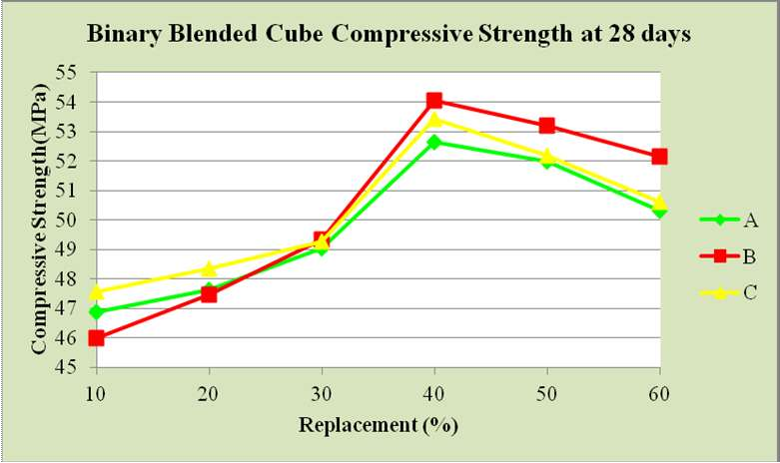

# Figure 1 Compressive strength of a Binary mixed cube after 28 days.

# **3.2 Split tensile strength**

The nominal load rate must be between 1.2 N/ (mm2/min) and 2.4 N/ (mm2/min). Figure 1 depicts the binary blended split tensile strength at 28 days for SCC, which indicates that the 40 percent of replacement group B binary split tensile strength increases from 20 percent to 40 percent of replacement of OPC, and then decreases, indicating that the packing density of SCC concrete is high after 40 percent of OPC replacement, and then decreases for SF.

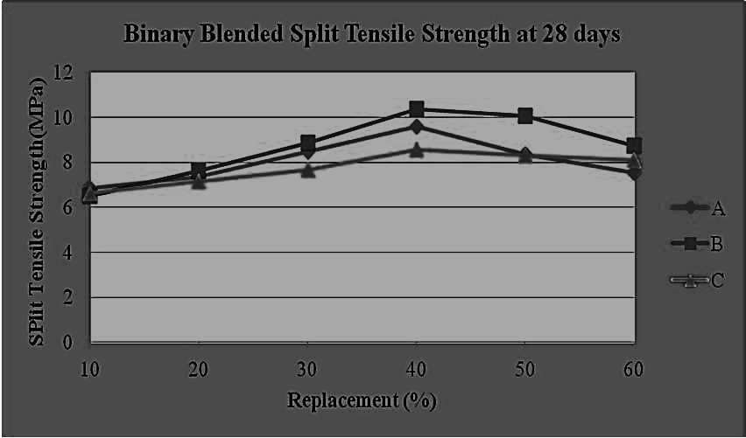

Figure 2 shows the split tensile strength at 28 days

1. **CONCLUSION**
2. Various SCC mixtures have been investigated for their mechanical qualities. Cube compressive strength of BM4 (60 percent cement + 40 percent SF) was discovered to be the highest among the binary blended SCC mixes. The figure on the 28th day is 54.06 MPa and on the 112th day it is 61.69 MPa. For the ternary SCC group, the mix LM2 (40 percent cement, 30 percent SF, and 30 percent GGBS) has the highest cube strength. The value on the 28th day is 54.56 MPa .
3. BM4 (60 percent cement + 40 percent SF) and (40 percent cement + 30 percent fly ash + 30 percent silica fume) exhibited the highest split tensile strength in the case of binary mixes. The modulus of elasticity for all binary mixed SCC mixtures increases by up to 40 percent, and then begins to decrease. Identical trends are found for ternary SCC blends.
4. . **REFERENCES**
5. Aitcin, PC & Neville, A 1993, ‘High-performance Concrete Demystified’, Concrete International, ACI, vol. 15, no. 1, pp. 21-26.
6. Aitcin, PC 2000, ‘Cements of yesterday and today. Concrete of tomorrow’, Cement & Concrete Research, vol. 30, issue 9, pp. 1349-1359.
7. Aitcin, PC, Shirlaw, M & Fines, E 1992, ‘High performance concrete: removing the myths, in Concrescere’, Newsletter of the High-Performance Concrete Network of Centres of Excellence, Canada, pp. 6.
8. Akbar Ghanbari & Bhushan L Karihaloo 2009, ‘Prediction of the plastic viscosity of self-compacting steel fibre reinforced concrete’, Cement and Concrete Research, vol. 39, pp. 1209-1216.
9. Ali Nazari & Shadi Riahi 2011, ‘Splitting tensile strength of concrete using ground granulated blast furnace slag and SiO2 nanoparticles as binder’, Energy and Buildings, vol. 43, pp. 864-872.
10. Anne Mieke Poppe & Geert De Schutter 2005, ‘Creep and Shrinkage of Self-Compacting Concrete’, International conference on Advances in Concrete, Composites and Structures, held at SERC, Chennai, pp. 329-336.
11. Assie, S 2004, ‘Durabilite Des Beton Autoplacants, in Laboratoire Matériaux et Durabilité des Constructions’, L’Institut National Des Sciences Appliquees De Toulouse, pp. 249.