**Behaviour of fibrous high performance concrete containing recycled concrete**

**Chella Lokesh1 and M.Mallikarjuna2**

1PG student in SVR Engineering College, Nandyal, Andhra Pradesh, India

2Assistant Professor in SVR Engineering College, Nandyal, Andhra Pradesh, India

**ABSTRACT**

In the construction industry, high-strength, high-performance concrete (HPC) has been used for many years. The basic motivations for choosing HPC are to generate a more cost-effective product, give a technically possible solution, or a combination of the two. Frequently, fly ash, silica fume, or slag are required for the manufacturing of high-strength concrete; the strength increase gained with these added cementing elements cannot be achieved by adding more cement alone. Typically, these supplemental cementing elements are applied at dose rates between 5 and 20 percent by mass of cementing material. Some requirements only allow the use of up to 10 percent silica fume, unless there is proof that concrete produced with a higher dose rate would have adequate strength, durability, and volume stability.

**Keywords:** Recycled concrete, Compressive strength , flexure strength , high performance concrete.

1. **INTRODUCTION (Font-Times New Roman, Bold, Font Size -12)**

Cement and concrete production consumes vast amounts of natural resources and materials, as well as a great deal of energy and affects the environment. Additionally, the output of carbon dioxide, a naturally occurring greenhouse gas, has grown dramatically. To resolve these environmental and economical problems, it is essential to modify and improve the present concrete manufacturing methods. The energy-intensive production of cement and the emission of carbon dioxide during the production of concrete are environmental problems. This has encouraged professionals in the area of concrete technology to investigate and identify alternative byproduct materials that may be used in lieu of cement's component ingredients. The positive effects of certain of these components on the properties of concrete have also supported these efforts. Due to the environmental effect associated with aggregate mining, great efforts have also been undertaken to employ local and waste resources in the production of cement. Concrete is a versatile, long-lasting construction material that is not only strong and cost-effective, but also aesthetically pleasing. Experience has shown, however, that concrete is susceptible to degradation if no safeguards are taken during its design and manufacture. To solve this, it is vital to comprehend how various components influence the behaviour of concrete and to formulate a concrete mixture with carefully regulated specifications. Superior Performance Concrete is any concrete that meets certain specifications designed to surpass the limitations of standard concrete (HPC). It may consist of concrete with greatly increased structural strength or concrete with significantly enhanced resilience to environmental impacts while preserving adequate durability. Additionally, it may incorporate cement, which substantially reduces construction time and permits rapid closing or opening of roads without compromising long-term performance. HPC has mostly been used for permanent structures such as parking garages, long-span bridges, and oil platforms. In contrast to conventional concrete, the addition of fibres to the concrete mixture increases its ductility and resistance to cracking. In many countries, the manufacturing of high-performance concrete (HPC) remains hampered due to the shortage or poor availability of appropriate concrete resources, such as fine aggregate, gravel, or hard crushed aggregates. In order to lessen the environmental effect of aggregate mining, considerable efforts have been made to employ recycled and local resources in the production of concrete.

1. **METHODOLOGY**

**2.1 Cement**

Among all the materials that influence the performance of concrete, cement is the most important constituent material since it is used to bind sand and aggregate and it resists the atmospheric action. OPC 53 grade conforming to BIS: 12269-1987 was used.

**2.2 Silica Fume**

The ferrosilicon and silicon alloy industries produces silica fume, also known as microsilica or condensed silica fume. Due to its great fineness, silica fume must be removed from the furnace effluent gases using a complex dust collection system. Silicon dioxide produced by this method is a solid composed of glassy spheres with a particle size about one-hundredth that of conventional Portland cement.

2.3 Fine Aggregates

Fine aggregate used for High Performance Concrete (HPC) should be properly graded to give minimum void ratio and free from deleterious materials like clay, silt content and chloride contamination etc. In the present investigation, locally available Karur river sand was used as fine aggregate.

**2.4 Quarry Dust**

Quarry dust is crushed sand less than 4.75 mm is produced from hard granite rock using state of the art JAW CONE, VSI Crushing plants. Production of quarry fines is a consequence of extraction and processing in a quarry

**2.5 Recycled Fine Aggregate**

Recycled fine aggregates also known as crushed concrete aggregates, waste concrete aggregates, comes from the demolition of concrete elements of building, roads and other infrastructures. Waste concretes are crushed and ground by means of different methods so that they could be used as concrete fine aggregates.

**2.6 Coarse Aggregate**

The coarse aggregate is the strongest and the least porous component of concrete. Coarse aggregate contributes to impermeability of concrete, provided that it is properly graded and the mix is suitably designed. Coarse aggregate in cement concrete contributes to the heterogeneity of the cement concrete and there is a weak interface between cement matrix and aggregate surface in cement concrete.

**2.7 Water**

Potable water available in the laboratory with permissible pH value and satisfying the conditions of BIS: 456-2000 is taken for making of concrete and also for curing of specimens.

**2.8 Superplasitcizer**

For producing HPC, the most important chemical admixture is the superplasticizer, which is a High-range water-reducing admixture (HRWRA). There are four types of superplasticizers.

**2.9 Fibers**

Typically, fibres will be used to improve the ductility and tensile strength of the member/structure. In the current study, both steel and polypropylene fibres are used.

1. **RESULTS AND DISCUSSION**

**3.1 Compressive Strength**

Compressive strength for concrete was observed for mix QDA 03 at all ages for quarry dust. The increase in strength is varying from 1% to 5% compared to control concrete (CC) till the replacement percentage is up to 60% and there after the strength starts to decreases. From Figure 1 and 2 it can conclude that the optimum compressive strength is obtained for QDA 03 when compared to CC on 28th day.

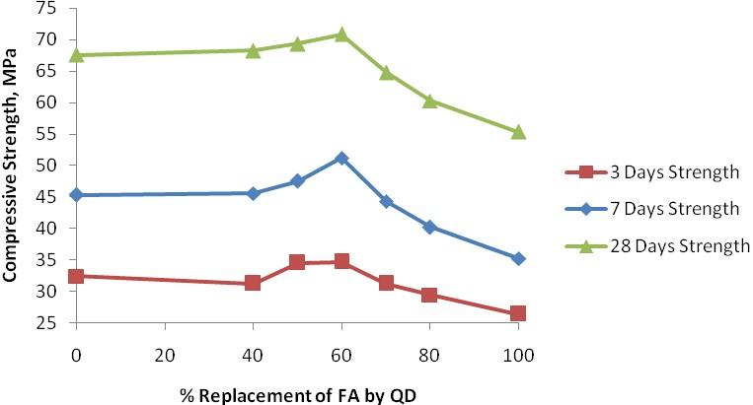

**Figure 1** Variation of Compressive Strength with % Replacement of FA by QD

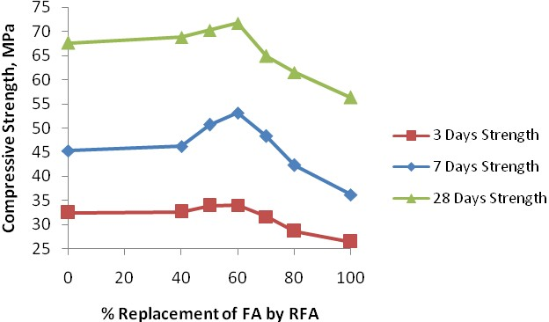

**Figure 2** Variation of Compressive Strength with % Replacement of FA by RFA

Recycled aggregate posses relatively lower bulk density, crushing and impact values and higher water absorption as compared to natural aggregate. The compressive strength of recycled aggregate concrete is relatively higher than natural aggregate concrete. The variation also depends on the original concrete from which the aggregates have been obtained. Initially, the strength may slightly increase and further the decrease in strength could be due to the more quantity of attached matrix to the fine aggregate.

**3.2 Split Tensile Strength**

From the Table 3 it was observed that the maximum splitting tensile strength was obtained for the mix with 60% replacement of fine aggregate with quarry dust and beyond that the strength starts to decreases. The minimum strength is obtained from maximum replacement level (100%) of fine aggregate by quarry dust, which was found to be 15% lesser when compared with CC.

The strength gain percentage may vary from 2% to 8% in case of quarry dust and 2% to 6% in case of recycled fine aggregate when compared to CC. The split tensile strength of replacement of fine aggregate by quarry dust is 8% more compared to CC on 28th day and 6% larger compared to CC on 28th day in case of recycled fine aggregate. From Figures 4.17 and 4.18, it can conclude that QDA 03 and RFA 03 are the optimum mixes.

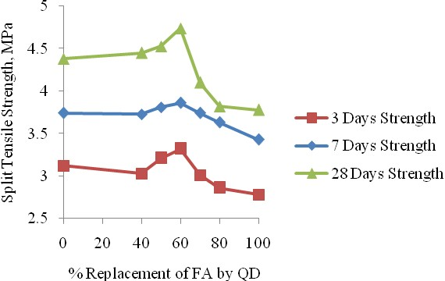

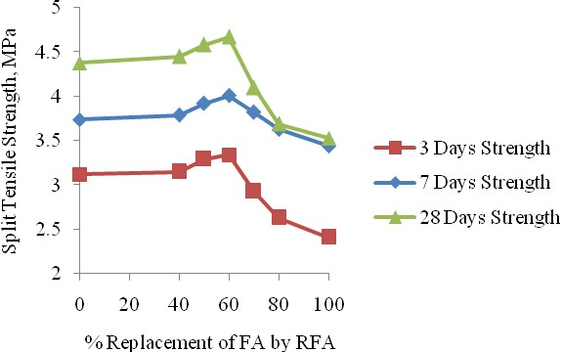

**Figure 3** Variation of Split Tensile Strength with % Replacement of FA by RFA

**3.2 Flexural Strength**

The flexural strength results of quarry dust based and recycled fine aggregate based concrete for various ages with different combinations are presented in the form of Tables and Charts.

The strength gain percentage may vary 2% to 5% in case of quarry dust compared to control mix at 28 days. It was also observed that the strength of concrete in compression and in flexure is closely related and the ratio of these two strengths depends on the general level of strength. From Figure 4 maximum split tensile strength is obtained for the mix (QDA 03).

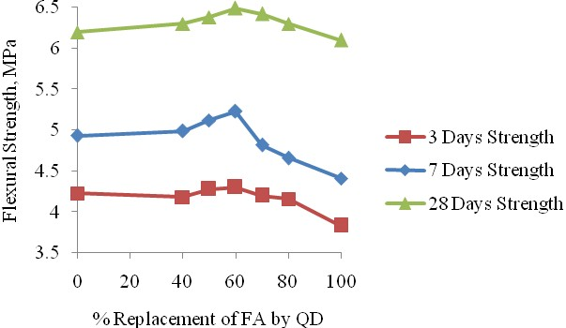

**Figure 4**.Variation of Flexural Strength with % Replacement of FA by RFA

1. **CONCLUSION**
2. From the findings of the experiment, it was determined that concrete containing 60 percent quarry dust and 40 percent fine aggregate had superior strength performance at all ages. The strength accomplishments are raised up to the replacement level of 60% quarry dust. In excess of this percentage, there is no enhancement in strength owing to the presence of a high quantity of small particles.
3. 60 percent substitution of fine aggregate with quarry dust or recycled fine aggregate produced the optimal split tensile strength at all ages of specimens.
4. At all ages of concrete, 60:40 (quarry dust/recycled fine aggregate: fine aggregate) was shown to be the optimal replacement level of fine aggregate with quarry dust/recycled fine aggregate for achieving maximum strength in concrete.
5. **REFERENCES**
6. Bo-Suk Yang 2011, „Application of Relevance Vector Machine and Survival Probability to Machine Degradation Assessment‟, vol. 38, no. 3, pp. 2592-2599.
7. Burak Felekoglu 2007, „Utilization of High Volumes of Limestone Quarry Wastes in Concrete Industry‟, Resources, Conservation and Recycling‟, vol. 51, pp.770-791.
8. Cabrera, O & Donza, H 2002, „High Strength Concrete with Crushed Fine Aggregate‟, Cement and Concrete Research, vol. 32, pp. 1755- 1761.
9. Cagatay, IH 2005, „Failure of an Industrial Building During a Recent Earthquake in Turkey‟, Engineering Failure Analysis, vol. 12, pp. 497- 507.
10. Celik, T & Marar, K 1996, „Effects of Crushed Stone Dust on Some Properties of Concrete‟, Cement and Concrete Research, vol. 26, no.7, pp. 1121-113.