##### ELECTROCHEMICAL DISCHARGE MACHINING STUDIES ON HSS MILLING CUTTER

**Sakthi Kumar Arumugam1*, Sekar Tamilperuvalathan2, Daniel Antony Arokiyasamy3, Gnanaprakash Kanagaraj 4, Surendran Ramakrishnan5**

1,4 PG Scholar, Department of Manufacturing Engineering, Government College of Technology, Coimbatore-641013.

2,5 Faculty, Department of Manufacturing Engineering, Government College of Technology, Coimbatore-641013.

3 Ph.D Scholar, Department of Manufacturing Engineering, Government College of Technology, Coimbatore-641013.

* Corresponding author

Sakthi Kumar A

+91-96295 85525

Sakthimech885@gmail.com

**ABSTRACT**

Recently, the Electrochemical Discharge Machining (ECDM) process has become increasingly important in the machining of materials that are electrically conductive and non-conductive, brittle and of high hardness. This research aims to examine how well ECDM performs while drilling tiny holes in HSS milling cutters. Based on a survey of the literature, the three main affecting factors voltage, electrolyte concentration and duty cycle have been chosen. Utilizing Design Expert System 13, the Box-Behnken method of surface approach was used to create the experiment design.

The experiments have been conducted by the combination of Sodium Hydroxide (NaOH) and Sodium Nitrate (NaNO3) each 50% by weight basis and measured outcomes are: (i) Metal removal rate (MRR) (ii) Tool wear rate (TWR). The selected objective functions of maximization of MRR and minimization of TWR. The created multi objective optimization models feature highly interdependent chosen parameters. The confirmatory trials demonstrated that there is a less than 5% difference in results between the experimental and theoretical model values.

**Keywords;** Electrochemical Discharge Machining, HSS milling cutters, Box-Behnken, Metal removal rate (MRR) (ii) Tool wear rate (TWR)

**INTRODUCTION**

Electrochemical discharge machining (ECDM) is an advanced hybrid machining process comprising the techniques of (EDM). The process is also referred as electrochemical spark machining (ECSM) process. The Electro Chemical Discharge Machining (ECDM) process is a popular non-conventional machining technique primarily used in cutting, grooving and drilling of non-conductive materials and ceramics. It is an emerging field of research and thus finds wide acceptance in machining electrically non-conducting materials, due to its prime advantages in terms of good surface finish and economy. Through Electrochemical Discharge Machining, now days it is easy to fabricate miniaturized parts including micro chemical, micro electromechanical systems etc. The whole process of ECDM, mainly depends on the type of electrolyte, tool electrode material, work piece material, applied voltage, pulse on/off time, electrolyte concentration etc. Initially the work materials are submerged in the electrolyte as NaOH & NaNO3 beneath the tool electrode.

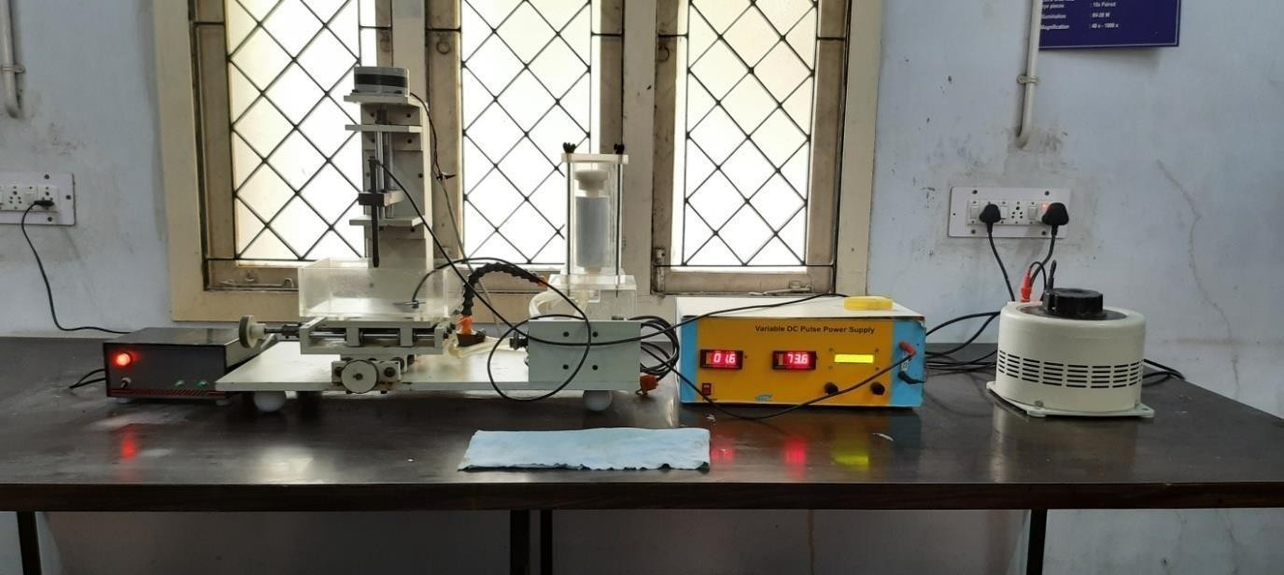

VOLTAGE METER

VARIAC RESISTOR

TOOL ADJUSTOR

ECDM MACHINE

PLUG POINT

Fig 1 (ECDM setup)

**HSS MILLING CUTTER**

It is often used in power-saw blades and drill bits. It is superior to the older high-carbon steel tools used extensively through the 1940s in that it can withstand higher temperatures without losing its temper (hardness). The alloying elements raise the temperature at which tempering occurs, allowing HSS to be used at temperatures up to about 650°C. A common type of high-speed steel contains 18% tungsten, 4% chromium, 1% vanadium, and only 0.5–0.8% carbon. The milling cutter is cut with the help of the wire cut EDM for studying the metal removal and tool wear.

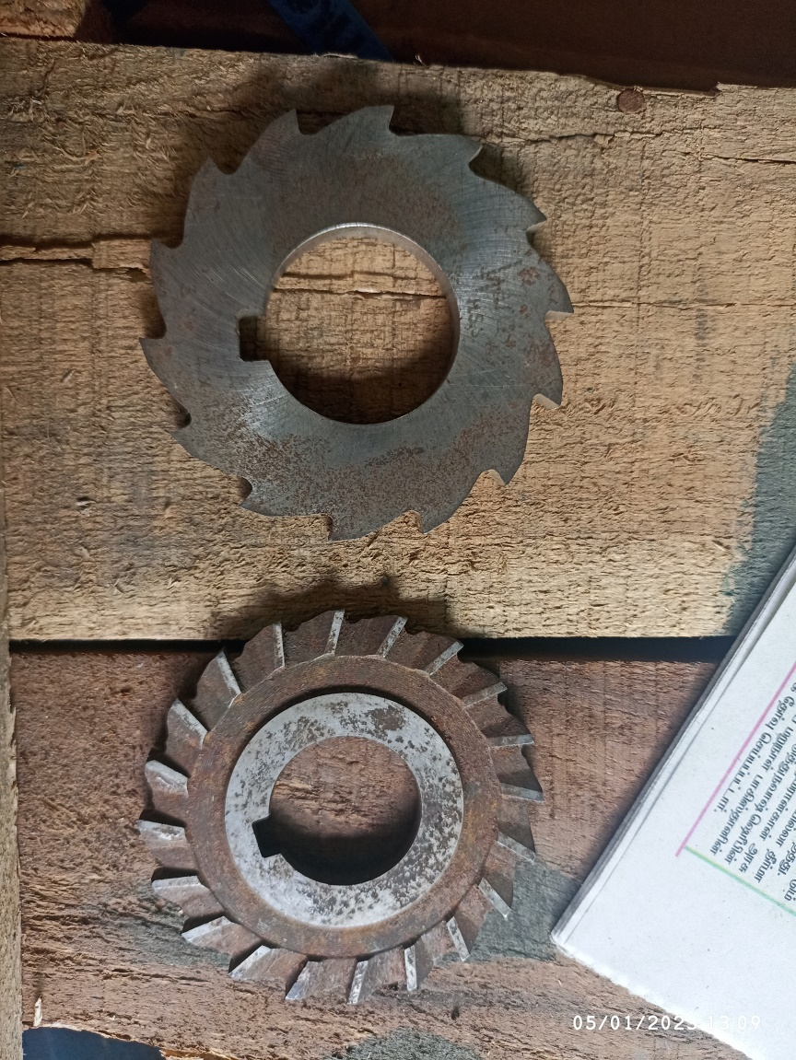

Fig 2 (HSS milling cutter)

PARAMETER SELECTION

The following parameters are considered for electrochemical discharge machining,

* + 1. Input voltage
    2. Electrolyte concentration
    3. Duty cycle

Table 1 Process parameters and experimental level

|  |  |  |  |  |  |  |
| --- | --- | --- | --- | --- | --- | --- |
| Variable name | Parameters | Levels | | | | |
| -1 | 0 | | 1 | |
| A | Voltage (V) | 90 | | 100 | | 110 |
| B | Electrolyte concentration (%) | 15 | | 20 | | 25 |
| C | Duty cycle | 40 | | 50 | | 60 |

**EXPERIMENTAL PROCEDURE**

The EDM and ECM processes are combined to create the ECDM process. Fig. 1 illustrates the fundamental idea behind this procedure, showing a tool that serves as a cathode and an auxiliary electrode that serves as an anode, both of which are submerged in an electrolyte solution. The positive and negative terminals of the DC power source are connected, respectively, to the auxiliary anode and cathodes. When the DC supply voltage exceeded a certain threshold, hydrogen bubbles started to form close to the tool electrode (cathode) and oxygen bubbles started to form surrounding the anode. Electric discharge occurs around the tool surface when the applied voltage approaches the critical voltage (depending on the work piece's material and the electrolyte concentration). In ECDM, thermal effects and chemical etching are vital parameters that play an important role on output characteristics. ECDM working process is shown in figure 3. The HSS milling cutter during milling in the ECDM machine. At a moderate DC supply voltage, cutting ceramic causes a significant electrical spark to occur, which dissolves metals off the work piece's surface. ECDM technique is often used to mill high-tech materials like silicon nitride ceramics, glass, and others that are both electrically conductive and non-conductive. Cutting and slicing of high-strength non-conductive materials like optical glass and quartz bars is a key additional use of the ECDM technology. Examine the many features of the ECDT process. The effect of major process parameters of voltage, electrolyte concentration, and Nitrogen gas flow rate has been studied.

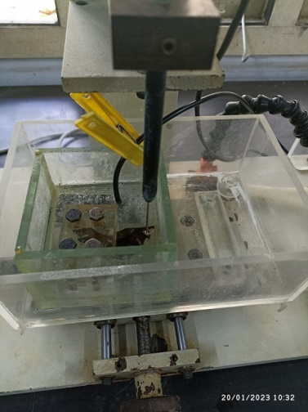

Fig 3 ECDM Working Process

**EXPERIMENTAL APPARATUS**

* + 1. ECDM setup
    2. Sodium Nitrate (NaNO3)
    3. Distilled water
    4. Electrode
    5. HSS Milling cutter

Results and Discussion

Tables 4.1 and 4.2 explain the process parameter and experimental value, Based on run order and the voltage (V). Then to find the metal removal and the tool wear by their experimental values. Nitrogen flow will be changed by their relative values. Above the before and after material removal and tool wear. These all factors are selected by the optimized results.These could be finalized results should be calculated by the given factors and mathematical for the Response surface method. According to the experimental results along the following substance. Based on the response surface methodology, 17 experiments work pieces and tools. The resultant pieces are individually sorted.

Table 2 Experimental Results with ECDM output parameters

|  |  |  |  |  |  |  |
| --- | --- | --- | --- | --- | --- | --- |
| **S.NO** | **WORKPIECE** | | | **TOOL** | | |
| **BEFORE MACHININGOF WORKPIECE**  **(gms)** | **AFTER MACHINING OF WORKPIECE**  **(gms)** | **Metal removal** | **BEFORE MACHINING OF**  **TOOL**  **(gms)** | **AFTER MACHINING OF TOOL**  **(gms)** | **Tool wear** |
| 1 | 27.34 | 27.32 | 0.02 | 1.194 | 1.052 | 0.142 |
| 2 | 26.887 | 26.846 | 0.041 | 1.185 | 1.012 | 0.173 |
| 3 | 27.243 | 27.208 | 0.035 | 1.182 | 1.031 | 0.151 |
| 4 | 26.846 | 26.808 | 0.038 | 1.186 | 1.003 | 0.183 |
| 5 | 26.808 | 26.772 | 0.036 | 1.179 | 1.021 | 0.158 |
| 6 | 27.32 | 27.29 | 0.03 | 1.178 | 1.068 | 0.11 |
| 7 | 27.208 | 27.175 | 0.033 | 1.18 | 1.002 | 0.178 |
| 8 | 27.29 | 27.265 | 0.025 | 1.213 | 1.011 | 0.202 |
| 9 | 27.139 | 27.107 | 0.032 | 1.212 | 1.08 | 0.132 |
| 10 | 27.107 | 27.007 | 0.1 | 1.191 | 1.03 | 0.161 |
| 11 | 27.265 | 27.243 | 0.022 | 1.185 | 1.008 | 0.177 |
| 12 | 27.077 | 27.048 | 0.029 | 1.188 | 1.011 | 0.177 |
| 13 | 27.048 | 27.019 | 0.029 | 1.189 | 1.021 | 0.168 |
| 14 | 27.019 | 26.981 | 0.038 | 1.183 | 1.01 | 0.173 |
| 15 | 26.772 | 26.738 | 0.034 | 1.184 | 1.023 | 0.161 |
| 16 | 26.981 | 26.95 | 0.031 | 1.186 | 1.001 | 0.185 |
| 17 | 26.917 | 26.887 | 0.03 | 1.189 | 1.032 | 0.157 |

**RESPONSE SURFACE METHODOLOGY (RSM)**

Response Surface Regression: Metal Removal versus Voltage (V), the analysis was done using coded units. Estimated Regression Coefficients for Metal Removal (mg). The relationship between the voltage and the Electrolyte concentration is displayed in this material removal contour plot. The peak value of the value is then displayed as a function of the variables, and the voltage hold limits were 110v.The relationship between the voltage and the electrolyte concentration can be seen in this material removal contour map shows the predication after machining is 27.35.

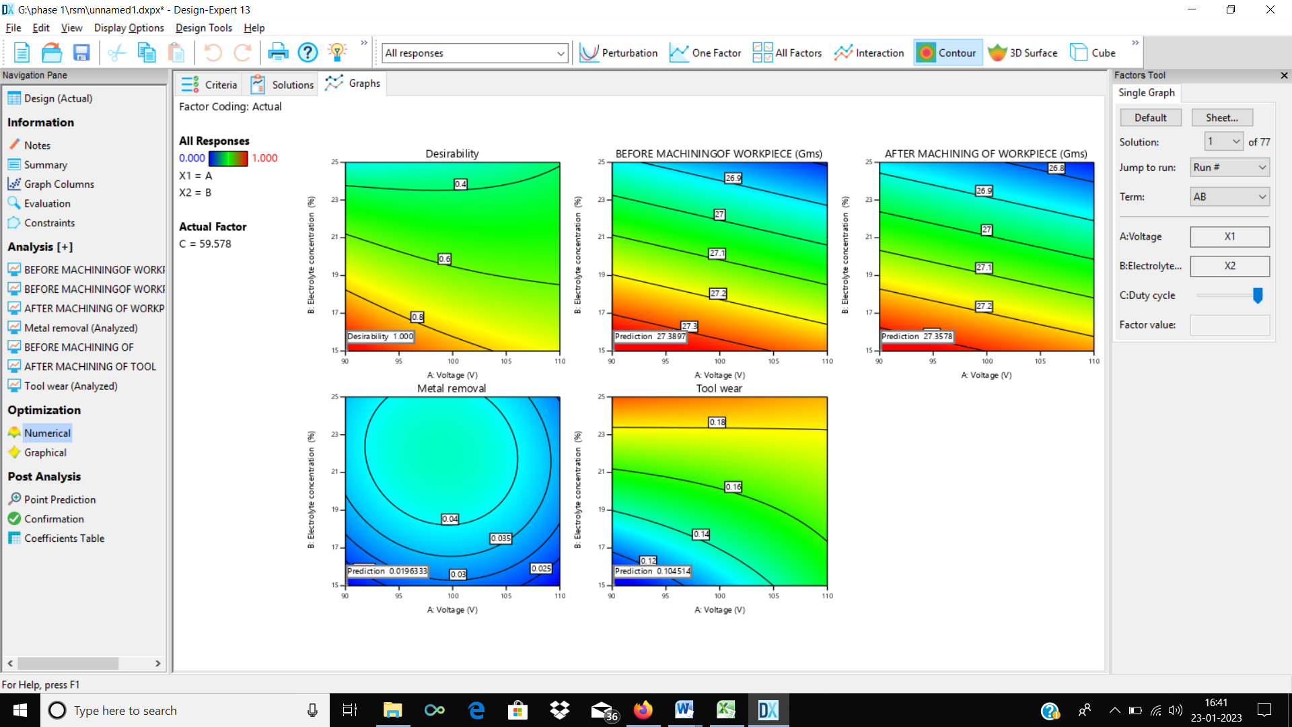

Figure 4 Before machining and after machining of work piece with respect to Voltage and Electrolyte concentration

The relationship between the voltage and the Electrolyte concentration is displayed in this tool wear contour plot. The peak value of the value is then displayed as a function of the variables, and the voltage hold limits were 110v.The relationship between the voltage and the electrolyte concentration can be seen in this material removal contour map shows the predication after machining is 0.107.

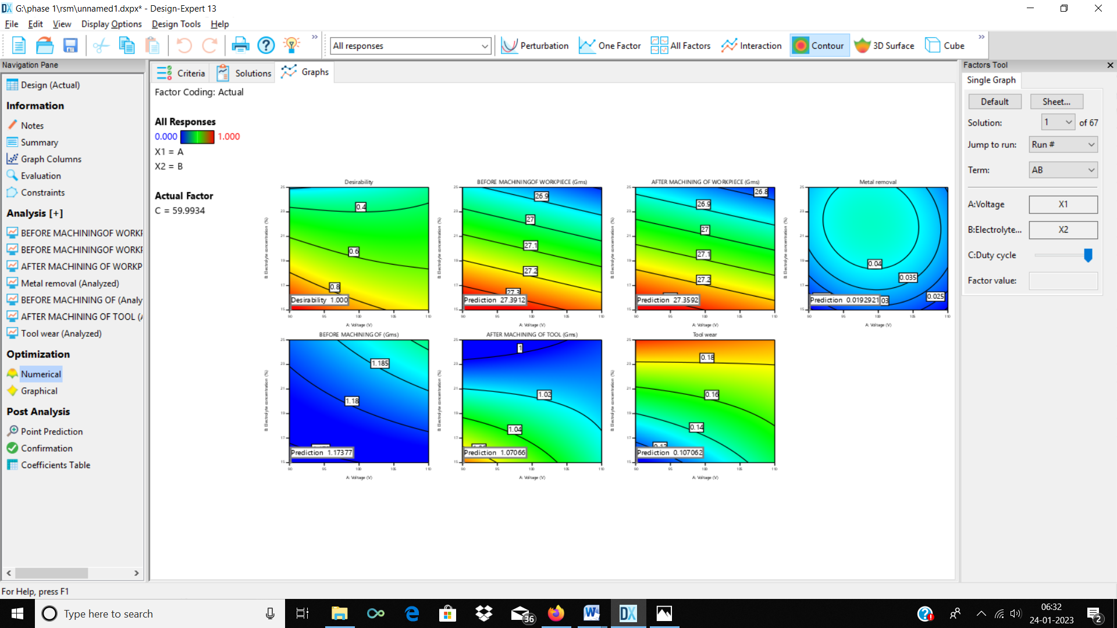

Figure 5 Before machining and after machining of Tool with respect to Voltage and Electrolyte concentration

It accurately computes the variation in voltage, Duty cycle, and electrolyte concentration from the hold values. They exhibited the removal of metal from plot 1 and 2, respectively, HSS milling cutter as shown in figure 6.

The normal probability plot is a graphical technique for assessing whether or not a data set is approximately [normally](https://www.itl.nist.gov/div898/handbook/eda/section3/eda3661.htm) distributed for metal removal in the HSS milling cutter. All experiments were near by probability line. Figure 5.1 shows the plot of the predicted versus actual experimental values showing that the actual metal removal values are distributed relatively near the straight line. The versus order plot shows the experiment variation depends upon observation order. This indicates that the models are adequate for predicting the efficiency within the range of the variables. The voltage and electrolyte concentration increases the metal removal rate from HSS milling cutter also increases.

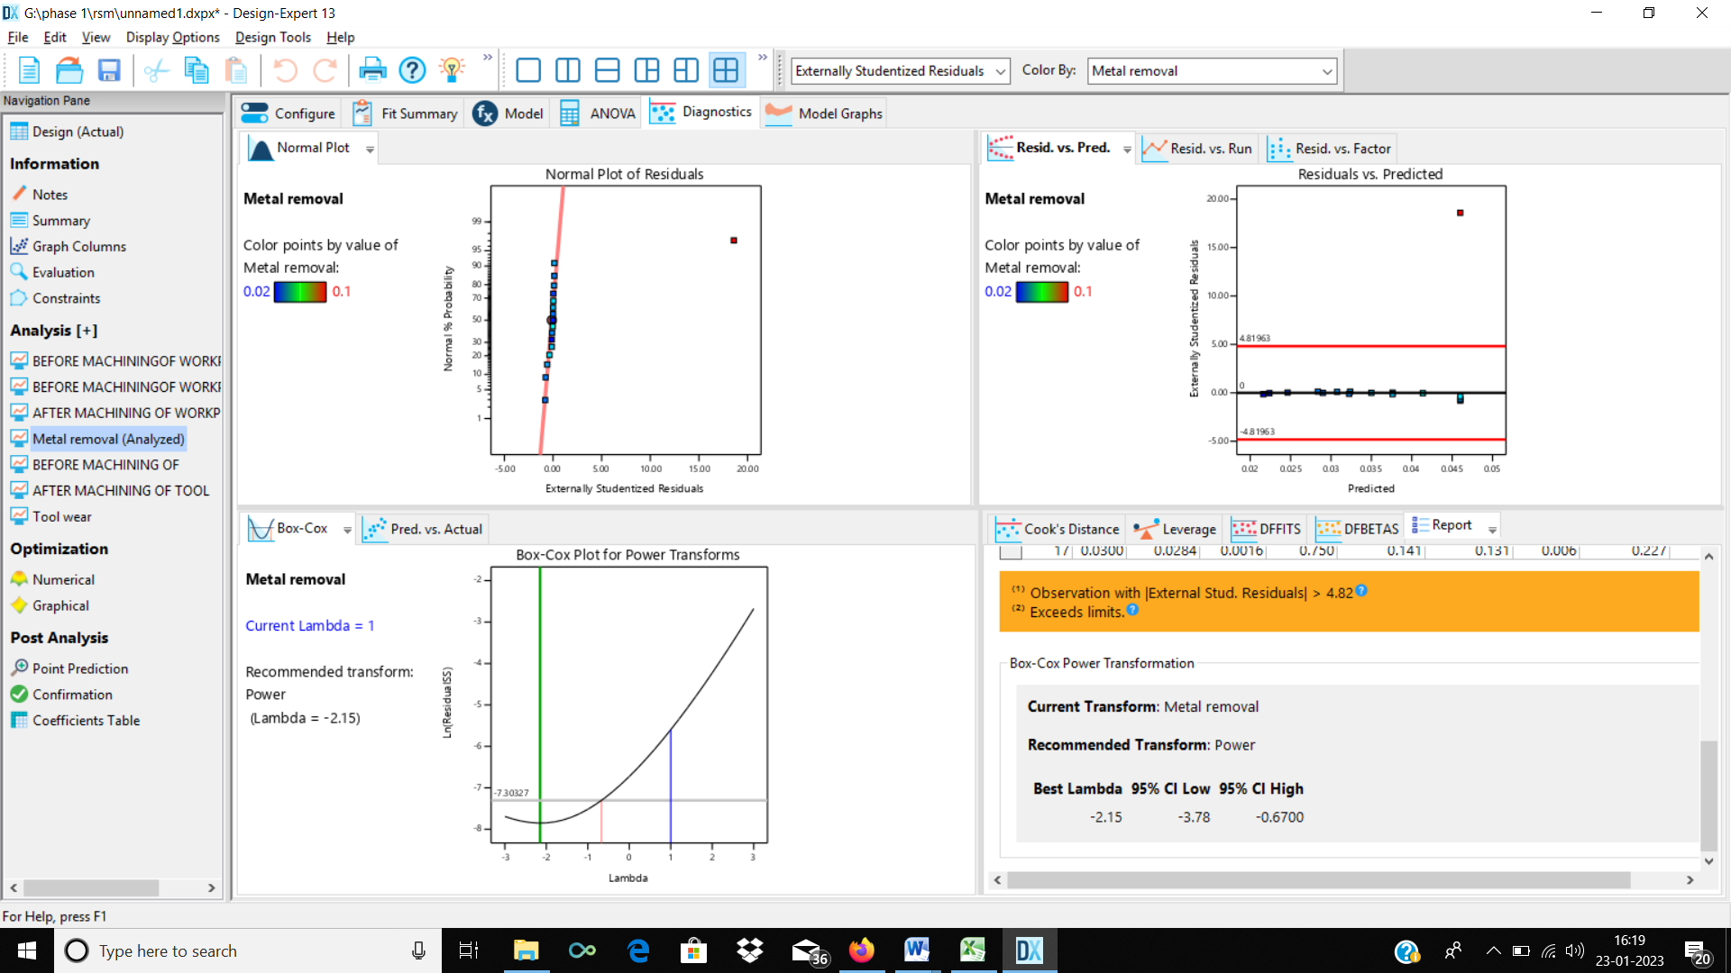

Figure 6 Residual plot MR

They exhibited the removal of metal from plot 1 and 2, respectively, HSS milling cutter as shown in figure 7.

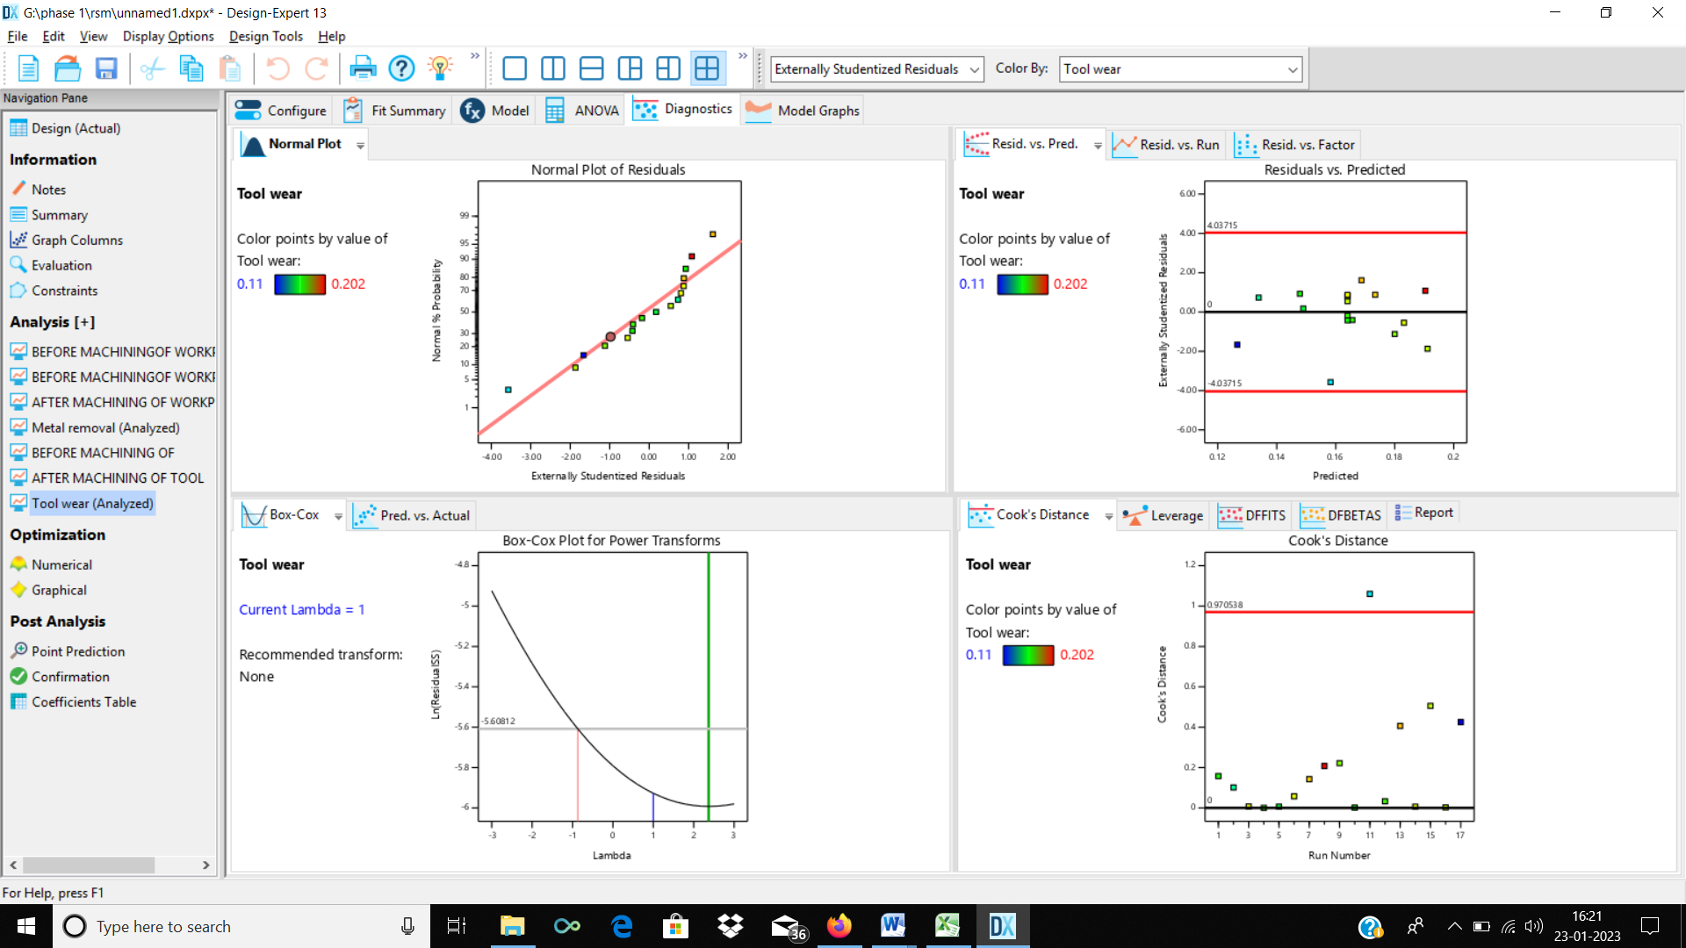

Figure 5.7 Residual plot TW

The figure 7 shows the value of residual tool wear. The first plot is the Normal plots of residuals. Then the second plot is the values of Residuals vs the Predicated one. The residual value falls between the upper and the lower limits.

# CONCLUSION

This work is performed for material removal in drilled holes by ECDM processing. The effect of major process parameters of voltage, electrolyte concentration, and Duty cycle has been studied. Parametric optimization is done through Response Surface Methodology using Design expert 13. The material removal and tool wear were analyzed and results have been reported.

The maximum concentration and maximum voltage level gives maximum level material removal in the HSS milling cutter. The electrolyte concentration below 15% the metal removal in the HSS milling cutter is decreased. When the duty cycle of the experiment in increased it has high metal removal HSS milling cutter. Experiment voltage level above 100 V, it gives more metal removal in the material.

# REFERENCES

[1]. [Kuna and Yuan](https://www.sciencedirect.com/science/article/abs/pii/S089069551300093X#!) [Kun-Ling](https://www.sciencedirect.com/science/article/abs/pii/S089069551300093X#!), [Cheng-Kiang](https://www.sciencedirect.com/science/article/abs/pii/S089069551300093X#!). 2006, “Wire electrochemical discharge machining (WECDM) of quartz glass with titrated electrolyte flow”. Eur. J. Mech. Eng. 36, 201–207.

[2]. Brian T. Werner, Bonnie R. Anton, George. 2017 “Electrochemical discharge machining process: A review on process parameters and future scope, Rapid technological change has occurred in recent decades to satisfy the changing demands of society and industry”, 17, 960–966.

[3]. [O. Berger](https://www.semanticscholar.org/author/O.-Berger/2103467012), [a. abele](https://www.semanticscholar.org/author/A.-Aberle/48783149). 2016 “Electrochemical Discharge Machining for Quartz Glass Based on Machine Vision, A vision-sensor-based system used for online characterization and monitoring of the effect of flow-jet”, 112, 385–392.

[4]. Sanjay Kumar Chack. 2019 “Electrochemical Discharge Machining-Discharge Generation: A review, Advanced engineering materials which are widely used as high- strength refractory materials”. Prod., 213, 553–568.

[5]. Sanchez, J.A.; Plaza, S.; De LaSalle, L.N.; Laicize 2016, “A Use of heat transfer search algorithm while optimizing the process parameters of ECDM to machine quartz material” 19, 727–735.

[6]. Ravindra naiad, Latisha penman 2017. “An experimental study of process parameters on material removal rate in ECDM process Technol”, 250, 190–202.

[7]. Zhang Dr. H. Schnell of Bayer AG 2016 “ Improve Drilling Quality of Electrochemical Discharge Machining (ECDM) Process, the effects of Sodium Doddery Sulfate (SDS) surfactant added electrolyte on machining quartz” Int. J. Adv. Manuf. Technol., 85, 2107– 2114.

[8]. Ling ne, jingo lee. 2014 “Effect of quartz crystal thermal stress on its performance in active temperature control quartz crystal microbalance dew point sensors" , 3, 69–81.

[9]. Arno loe,jein mahatma Micromachining with ECDM: 2014 “Research Potentials and Experimental Investigations” Channels 2012, 6, 340–345.

[10]. Cao, X.D.; Kim, B.H.; Chu, C.N. 2016 “Hybrid Micromachining of Glass Using ECDM and Micro Grinding” Int. J. Precis. Eng. Manuf., 14, 5–10.

[11]. [Ian Zhang](https://www.sciencedirect.com/science/article/abs/pii/S0167732222005931#!), [Tubingen](https://www.sciencedirect.com/science/article/abs/pii/S0167732222005931#!) M.R. 2017 “Effect of ultrasonic vibration on the single discharge of electrochemical discharge machining” Mater. Manuf. Process., 33, 444– 451.

[12]. [Limo Paul](https://www.sciencedirect.com/science/article/pii/S2212017316305709#!), [Somashekhar, S.Hiremath](https://www.sciencedirect.com/science/article/pii/S2212017316305709#!). 2017 “Analytical and experimental study on the integration of ultrasonically vibrated tool into the micro electro-chemical discharge drilling” Précis. Eng., 47, 424–433

[13].[Kinaki Rajendra Kolhekar](https://www.sciencedirect.com/science/article/abs/pii/S0141635917307614" \l "!), 2016 “A. Developments in electrochemical discharge machining: A review on electrochemical discharge machining, process variants and their hybrid methods” Int. J. Mach. Tools Manuf., 105.

[14]. [J.W. Liu](https://www.sciencedirect.com/science/article/abs/pii/S089069550900176X#!), T.M. hue, M.R. 2017 “Study of the current signal and material removal during ultrasonic-assisted electro chemical discharge machining.” Int. J. Adv. Manuf. Technol., 92, 1591–1599.

[15]. Han, M.S.; Min, B.K.; Lee, 2008 S.J. “Modeling gas film formation in electrochemical discharge machining processes using a side-insulated electrode” J. Micromech. Microeng., 18, 19–26.

[16]. [Julfekar Arab](https://www.sciencedirect.com/science/article/pii/S2351978919309023#!), [Pradeep Dixit](https://www.sciencedirect.com/science/article/pii/S2351978919309023#!) 2019, “Micro array hole formation in glass using electrochemical discharge machining, Electro chemical discharge machining (ECDM) is a process to create micro-features” J. Micromech. Microeng. 2008, 18, 6–13. Processes 7, 195 14 of 14

[17]. [Yu-Jen Chen](https://www.sciencedirect.com/science/article/pii/S2212827120310027#!), M.L.; Kuan, H.C. 2004 “Application of Electrochemical Discharge Machining to Micro-Machining of Quartz” Adv. Mater. Res., 939, 161–168.

[18].[Gregory Ski cabala](https://www.sciencedirect.com/science/article/pii/S2212827116006004" \l "!), 2015,”Electrochemical, Electro discharge and Electrochemical- discharge Hole Drilling and Surface Structuring Using Batch Electrodes. Bull. Jpn. Soc. Precis . Eng. 19, 73–74.