**DYNAMIC MULTICAST ROUTING PROTOCOL FOR ON-DEMAND COMMUNICATION IN MANETS FOR NETWORK CAPACITY ENHANCEMENT**

1 Dinesh kumar prajapati , 2 Prof. Ankit Tripathi , 3 Dr. Anshuj Jain

1 M.Tech Scholar, Department of Electronics & Communication Engineering, SCOPE College of Engineering, Bhopal, India

2 Assistant Professor, Department of Electronics & Communication Engineering, SCOPE College of Engineering, Bhopal, India

3 Associate Professor & HOD, Department of Electronics & Communication Engineering, SCOPE College of Engineering, Bhopal, India

**ABSTRACT**

Mobile ad hoc networks (MANETs) represent a practical application of wireless ad-hoc networks, where nodes establish direct communication with each other, forming a self-configuring network without the need for a centralized infrastructure. In this context, the integration of node-to-node and node-to-roadside communication designs within MANETs has proven to be instrumental in enhancing road safety, enabling efficient routing, and facilitating various roadside services. These communication capabilities among nodes serve as a foundation for the envisioned implementation of MANETs within Intelligent Transportation Systems (ITS).To address the challenges of dynamic multicast communication in MANETs, a novel multicast routing protocol is proposed in this research. The protocol defines all relevant parameters and develops an algorithm to achieve the desired objectives efficiently. The effectiveness of the proposed approach is validated through extensive simulations, which demonstrate the protocol's ability to find nearly optimal solutions. By adopting the Dynamic Multicast Routing Protocol (DMRP), the network model achieves its best configuration while significantly reducing the cost of Roadside Units (RSUs), which are essential components in ITS. The researchers implemented and simulated the proposed protocol using MATLAB 8.3 software. The simulated results revealed several advantages of the DMRP, including improved throughput, reduced end-to-end delays, and enhanced packet delivery ratios. These findings indicate that the proposed protocol outperforms existing approaches and holds promise for improving the overall performance and efficiency of mobile ad hoc networks in the context of Intelligent Transportation Systems.

This paper proposed,dynamic multicast routing protocol which at first define all parameters and develop algorithm which can achieve desired result. The work is upheld by broad recreation comes about which show the adequacy of the proposed techniques in finding a close ideal arrangement. Using DMRP protocol is best configuration for network model and due to it reduces cost of RSU. Implementation and simulation is performed using MATLAB 8.3 software. Simulated results shows the proposed protocol gives significant better results in terms of throughput, end to end delay, packet delivery ratio etc.

KEYWORDS: MANET, Protocols, MATLAB, Routing, N2N, N2I.

**I. INTRODUCTION**

The rising number of nodes in transportation networks has led to significant challenges, including traffic jams and frequent accidents. To address these issues and mitigate their negative effects, there is a growing demand for advanced technological systems. Intelligent Transportation Systems (ITS) emerge as a promising solution, combining intelligent transportation and information technology to enhance accessibility, efficiency, and safety in transportation.ITS technology empowers road users with real-time information about the road conditions, such as traffic accidents or congestions in specific areas. This enables users to make informed decisions and find alternative routes to avoid traffic jams. Additionally, ITS provides valuable insights into the condition of nodes in the vicinity, helping users steer clear of potential accidents.Among the various ITS technologies under development, Mobile Ad Hoc Network (MANET) holds significant potential. However, its progress faces challenges due to high development and testing costs, leading to limited commercial application of MANET systems in countries. Nevertheless, ongoing research and modeling efforts through simulation continue to explore its capabilities. To overcome the obstacles in MANET's development, the dynamic multicast routing protocol (DMRP) has been devised. DMRP employs on-demand routing techniques to reduce channel overhead and enhance scalability. By using the concept of forwarding groups, which consist of nodes responsible for forwarding multicast data on the shortest paths between member pairs, DMRP establishes a forwarding mesh for each multicast group. This innovative approach tackles limitations related to limited bandwidth, constrained power, and the mobility of network hosts, making multicast protocol design more efficient and effective.

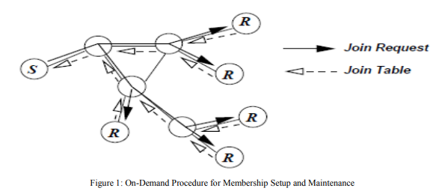

**II. RELATED WORK**

The MANET research has been conducted by some. In [1] Y. Chen et al. presents from theory to experimental evaluation: resource management in Software -Define Mobile Networks, they have done experiments on MATLAB open Flow enable new degrees for the management of wireless and wired resources in dynamic Mobile environment. In [5] A. Khan et al., present AODV is under CBR traffic for MANET nodes operated through Okumura Propagation Model with queue technique as well as DYMO performs well in free space propagation model using queuing technique, also summarize as the node density increases in network throughput performance decreases. Further DRAODV routing protocol is designed and implemented in order to improve the QoS over AODV routing protocol under variable transmission range. In A. Singh,[6] et al., presents a localization based algorithm which will help to provide information about the localized and non-localized nodes in a network. In this approach DREAM protocol and AODV protocol are used to find the localizability of a node in a network. DREAM protocol is a location protocol which helps to find the location of a node in a network whereas AODV is a routing protocol it discover route as and when necessary it does not maintain route from every node to every other. To locate the mobile nodes n/w node identification algorithm is used. With the help of this algorithm localized and non-localized node can be easily detected in respect of radio range. This method helps to improve the performance of a module and minimize the location error and achieves improved performance in the form of UDP packet loss, received packet and transmitted packets, throughput, routing overhead, packet delivery fraction. In [7], Amrit et al. presents simulation of Mobile movement in MANET. This simulation explains all functions as both directions and also conducts testing for MANET applications and protocols. In [8] Hannes et al. presents a tutorial survey on MANET, a testing in directed and wireless multi-hop feasibility of N2N and N2I communications based on wireless local area. In [9] Ian et al. proposes a Software Define MANET: architecture and services, this work describes some of the different operational and service modes that can be provided for MANET technology. This section will explain and describe the evolutionary background of MANET as well as information about the MATLAB to support MANET implementation.

A. MANET Overview:

MANET has two ways communication namely Node to Node (N2N) with Ad-Hoc type and Node to Infrastructure (N2I) with each unit of Road Site Unit (RSU) and mobile network (e.g 4G / LTE). These communication types are explained in figure 1.

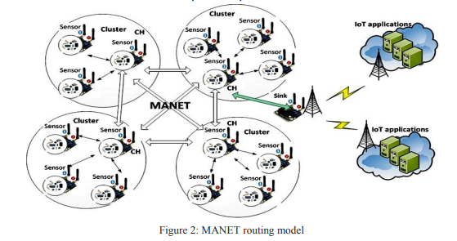

MANET is a high speed data communications technology for a node. This technology is wireless based and has several protocols for data communication namely unicast, multicast, geocast, mobicast and broadcast protocol. Connectivity in MANET uses IEEE 802.11 on 5.9 GHz wave. MANET's traditional services include node and road safety services, traffic efficiency, management services and infotainment services. Traffic efficiency and management services are aimed to improve traffic flow and traffic coordination and to provide local information and maps. In terms of infotainment service, MANET is expected to support information such as multimedia data transfer and global internet access. [6] B. MATLAB for MANET Networking devices have multiple controls and data flow operations in the same device. One of the controls is network management plane. This plane is used to configure each network node separately. The static nature of the current network does not allow full control configuration plane. The main concept of MATLAB is to offer control management for users to manage hardware forwarding of each network element.

The easiest thing MATLAB could support for MANET is by making RSU MATLAB-enabled for example using a controller like in Open Flow switches. In addition, the scope of the controller could be extended to protocol that could act as end users and could be abstracted as elements included in data such as RSU and other infrastructure nodes. Therefore, the protocol could be triggered by the controller for its performance such as the deployment of multi-hop N2N data. [7]

**III. PROPOSED WORK**

This dissertation aims to make significant contributions in addressing the limitations associated with Mobile Ad Hoc Networks (MANETs).

* To overcome above limitations, we need to analyse performance of protocol in MANET in term of throughput, delay and packet drop.
* The N2N ad-hoc communication protocols without RSU coverage are designed and simulated in MATLAB¬ and performance analysis results will be more reliable.

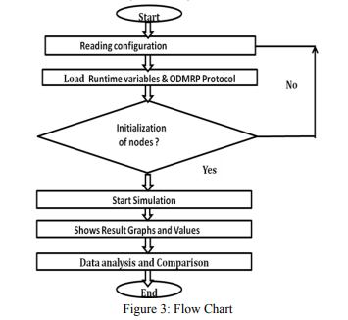

In this study, a simulator that is used for simulation is MATLAB and SIMULINK. This simulator is installed on windows 10 which run on virtual machine. For writing the script we use .m file in MATLAB and also to show the visualization [8].

In this research, two measurement scenarios are conducted to evaluate the performance of the Mobile Ad Hoc Network (MANET) using MATLAB. The first scenario involves measuring the throughput, packet drop, and delay of communication within a single RSU (Roadside Unit) coverage area. The second scenario focuses on measuring the throughput, packet drop, and delay of communication between two different RSUs.The simulation involves the design of a MANET topology with two RSUs and a variable number of nodes (cars) ranging from 5 to 500. The performance of the network is then evaluated in each scenario to understand how the system behaves under different conditions and node densities.By conducting these measurements, the researchers can gain valuable insights into the efficiency and effectiveness of the MANET in various communication scenarios. The results obtained from the simulations will provide crucial data to compare the performance of the network when communication occurs within a single RSU coverage area and when it extends between two different RSUs. The MATLAB simulations enable the researchers to accurately model and analyze the behavior of the MANET, making it possible to study the impact of different parameters on the network's performance. These findings will contribute to a better understanding of the MANET's capabilities and limitations, helping to inform the development of more robust and efficient communication protocols for future Intelligent Transportation Systems and other applications.

**ALGORITHM**

Step-1: Reading Configuration and Runtime Variables

The first step in the simulation process involves reading the configuration file to set up various parameters and runtime variables. These include defining the total number of packets to be generated during the simulation.

Step-2: Topology Builder and Agent Roles

In this step, the topology builder is implemented to create the network's structure. Nodes are defined in the network, each having specific roles such as Physical Layer (PHY), Medium Access Control (MAC) protocol, Agents, and Applications. The PHY layer handles the transmission and reception of signals, the MAC protocol governs access to the shared communication medium, while Agents represent the intelligent entities that perform various tasks in the network. Applications refer to the specific software or algorithms running on the nodes for data processing or communication purposes.

Step-3: Initializing Nodes and Starting Discrete Simulation

Once the topology and node roles are set up, the simulation starts by initializing the nodes with their respective attributes and placing them in their initial positions within the network.

The discrete simulation is initiated, during which the network state is updated at discrete time intervals. Nodes may send and receive packets, change their positions, and update their status based on the events occurring in the network.

Step-4: Updating Topology Matrix and Plotting Graph and Edges

During the simulation, the topology matrix is updated to reflect changes in node connections and communication links. The graph representation of the network is also updated to visualize the nodes and their connections.

Step-5: Moving Nodes

As the simulation progresses, nodes may move within the network based on their mobility models or other factors. The positions of the nodes are updated, and the effects of node mobility on communication and network performance are observed.

The entire simulation process allows researchers to study the behavior of the MANET under various conditions, assess the efficiency of different communication protocols, and analyze the impact of node mobility on network performance. By following these steps, valuable insights can be gained to improve the design and implementation of MANETs and related applications.

**IV. RESULT AND ANALYSIS**

In this simulation study, various scenarios are conducted with a range of nodes (cars) varying from 5 to 500, along with the presence of two Roadside Units (RSUs). The primary performance parameters evaluated in each scenario include delay, throughput, and packet drop.

A. Performance Evaluation for N2N Communication:

Initially, the MANET topology is designed, and subsequent testing is performed to ensure that the N2N connections between nodes (cars) are successfully established. In this context, the term "node" refers to a car participating in the network. The main focus of inter-node communication lies in the ability of each car to communicate effectively with other cars on the road ahead while disregarding communication with cars behind them.

B. Performance Evaluation for N2I Communication with Two RSUs:

The second simulation involves assessing the communication between two cars located within the coverage areas of different RSUs. This scenario examines the N2I (Node-to-Infrastructure) or N2RSU (Node-to-Roadside Unit) communication, where two RSUs are strategically placed to facilitate communication with all the nodes (cars) in the network. The configuration of node-to-roadside communication establishes a high-bandwidth link between cars and the RSUs. The RSUs are positioned at regular intervals, typically every kilometer or less, enabling the maintenance of high data rates, even in heavy traffic conditions.

By evaluating these simulation scenarios, the study aims to gain insights into the performance characteristics of the network under varying node densities and the presence of RSUs. This analysis will provide valuable information about the effectiveness and efficiency of N2N and N2I communication in MANETs, which can lead to enhanced communication protocols and improved Intelligent Transportation Systems (ITS) applications..

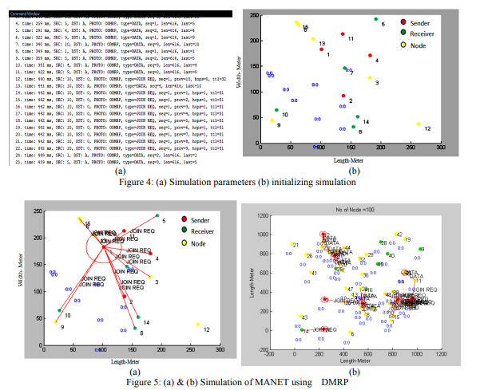

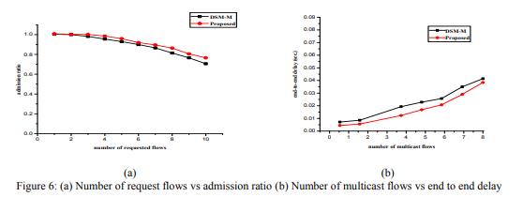

Figure 6 (a) presents the total number of entering nodes with respect to the generate request from node to other node and figure 6 (b) presents the number of multicast flows vs end to end delay. Delay should be minimum during transmission, more delay cause to low throughput. This graph clears proposed method gives reduced delay than previous methods.

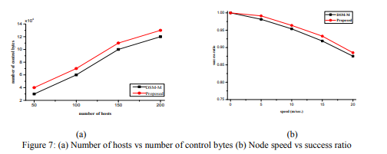

Figure 7(a) presents the total number of hosts vs control bytes, so it should be more for good reliability of system and Figure 7(b) presents the graph between speeds of nodes vs the success ratio. When node is moving at slow speed then success ratio probability is more. So proposed method gives more success ration at high speed, it is also a significant better advancements than previous.

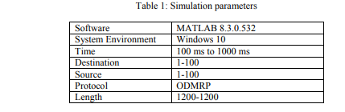

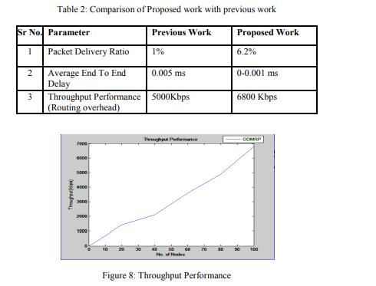

**V. CONCLUSION**

In this experiment, a simulation of MANET using MATLAB has been conducted, and the performance parameters such as end-to-end delay and throughput have been thoroughly evaluated. The focus of the evaluation is to compare the performance of the Dynamic Multicast Routing Protocol (DMRP) with the MAODV and AODV protocols. The comparison is based on essential performance metrics like packet delivery ratio, average end-to-end delay, and routing overhead. The simulations were carried out for different numbers of nodes, up to a maximum of 100 nodes.The results obtained from the simulations clearly indicate that DMRP outperforms both MAODV and AODV protocols, especially at high mobility rates. This suggests that DMRP is more effective and efficient in managing network capacity in MANETs. The significant improvements observed in terms of the evaluated performance parameters indicate the successful enhancement of the network capacity using the multicast routing protocol. By demonstrating better performance at high mobility rates, DMRP showcases its ability to handle dynamic and rapidly changing network conditions effectively. These findings suggest that DMRP holds great promise in enhancing the overall performance and reliability of MANETs, making it a valuable solution for real-world applications, especially in scenarios where high mobility and efficient multicast communication are essential.

**REFERENCES**

1. Y. Chen, C. Hu, E. H. Wu, S. Chuang and G. Chen, "A Delay-Sensitive Multicast Protocol for Network Capacity Enhancement in Multirate MANETs," in IEEE Systems Journal, vol. 12, no. 1, pp. 926-937, March 2018Y.

2. Chen, C. Hu, E. H. Wu, S. Chuang and G. Chen, "A Delay-Sensitive Multicast Protocol for Network Capacity Enhancement in Multirate MANETs," in IEEE Systems Journal, vol. 12, no. 1, pp. 926-937, March 2018

3. E. H. Wu, Y. Chen, C. Lin and G. Chen, "Bandwidth-Satisfied and Coding-Aware Multicast Protocol in MANETs," in IEEE Transactions on Mobile Computing, vol. 17, no. 8, pp. 1778-1790, 1 Aug. 2018.

4. Ramon Fontes, Claudia Campolo, Christian Rothenberg.,”From Theory to Experimental Evaluation: Resource Management in Software-Define Mobile Networks”, Digital Object Identifier 10.1109/ACCESS., January 2017.

5. A. Khan, “QoS Improvement using DRAODV under Variable Transmission Range in MANET”, SMART MOVES JOURNAL IJOSCIENCE, vol. 3, no. 12, Dec. 2017.Retrieved from http://ijoscience.com/ojsscience /index.php/ojsscience/article/view/8 . DOI: <https://doi.org/10.24113/ijoscience.v3i12.8>

6. A. Singh, N. Mishra, and A. Singh, “Localization and Non-Localization Node Identification Using Dream in MANET”, SMART MOVES JOURNAL IJOSCIENCE, vol. 2, no. 2, Apr. 2016. Retrieved from <http://ijoscience.com/ojsscience/index.php/ojsscience/article/view/77DOI:https://doi.org/10.24113/ijoscience.v2i2.77>

7. Ramon R. Fontes, Samira Afzal, Samuel H. B. Brito, Mateus A. S. Santos, Christian Esteve Rothenberg,” Mininet-WiFi: Emulating Software-Defined Wireless Networks.”, IFIP, 2015.

8. Amrit Ekka,” Simulation of Mobile Movement in MANET”, National Institute of Technology Rourkela, June 2013.

9. Hannes Hartenstein, Kenneth P. Laberteaux,” A Tutorial Survey on Mobile Ad Hoc Networks ”, IEEE Communications Magazine, June 2008.

10. Ian Ku, You Lu, Mario Gerla, et.al., ”Towards Software-Defined MANET: Architecture and Service”, Annual Mediterranean Ad Hoc networking workshop (MED-HOC-NET), IEEE, 2014.

11. G. Abdalla, S. Senouci “Current Trends in Mobile Ad Hoc Networks”, Proceedings of UBIROADS workshop, 2007.

12. M. Sivasakthi and S. Suresh, “Research on Mobile ad hoc networks (MANETs): an overview,” Journal of Applied Sciences and Engineering Research, vol. 2, no. 1, pp. 23–27, 2013.

13. Slamet Indriyanto, Muhammad Najib Dwi “Performance Analysis of MANET Simulation on Software Defined Network” IEEE 2017

14. P. Singh, "Similar examination amongst unicast and Multicast Steering Conventions in various information rates utilizing MANET," 2014 Worldwide Meeting on Issues and Difficulties in Insightful Registering Procedures (ICICT), Ghaziabad, 2014, pp. 278-284.

15. H. S. Aghdasi, N. Torabi, A. Rahmanzadeh, M. Aminiazar and M. Abbaspour, "Value of multicast directing conventions for vehicular Specially appointed systems," sixth Worldwide Symposium on Broadcast communications (IST), Tehran, 2012, pp. 459-463.

16. Ben Jemaa, O. Shagdar and T. Ernst, "A system for IP and non-IP multicast administrations for vehicular systems," 2012 Third Worldwide Meeting on The System Without bounds (NOF), Gammarth, 2012, pp. 1-6.

17. R. Yared and J. Demerjian, "Nonconcurrent solid multicast convention in vehicular impromptu systems," 2012 Symposium on Broadband Systems and Quick Web (RELABIRA), Baabda, 2012, pp. 78-82.