**CHANNEL ALLOCATION AND USER SCHEDULING** **IN COGNITIVE RADIO NETWORK BY ENERGY DETECTION SPECTRUM SENSING ALGORITHM WITH** **Co-MP JT**

1 Rahul kumar , 2 Prof. Ankit Tripathi , 3 Dr. Anshuj Jain

1 M.Tech Scholar, Department of Electronics & Communication Engineering, SCOPE College of Engineering, Bhopal, India

2 Assistant Professor, Department of Electronics & Communication Engineering, SCOPE College of Engineering, Bhopal, India

3 Associate Professor & HOD, Department of Electronics & Communication Engineering, SCOPE College of Engineering, Bhopal, India

**ABSTRACT**

The paper introduces a Cognitive Radio (CR) system that incorporates Coordinated Multipoint Joint Transmission (JT) to enhance spectrum utilization efficiency. The primary goal is to allow unlicensed users opportunistic access to unused or underutilized spectrum bands, improving overall network performance.To achieve this, the paper develops an analytical model for calculating the Received Signal-to-Noise Ratio (SNR) at a CR node. This information is crucial for determining the energy detection threshold and the minimum number of required samples needed for energy detection-based spectrum sensing in the CR network with CoMP JT technique.The performance of the energy detection-based spectrum sensing, as per the analytical model, is further evaluated through simulations. The results demonstrate the reliability of this sensing method in the proposed CR system.Additionally, the paper addresses the optimization of channel allocation and user scheduling in the CR network with CoMP JT technique. An optimization problem is formulated to maximize the minimum throughput of the users in the network. By solving this optimization problem, the CRN can efficiently configure its resources, ensuring improved network performance and better user experiences.Overall, the proposed CR system with Coordinated Multipoint Joint Transmission offers a promising approach to enhance spectrum utilization efficiency, making it a valuable contribution to the field of Cognitive Radio Networks. The analytical model and optimization approach presented in the paper provide valuable insights and tools for the practical implementation and management of such networks.

KEYWORDS: Cognitive, Joint Transmission, CRN, Energy, Throughput.

**I. INTRODUCTION**

Cognitive radio (CR) has emerged as a revolutionary technology to enhance spectrum utilization efficiency by providing unlicensed users with opportunistic access to unused or underutilized spectrum bands. This dynamic spectrum access (DSA) approach allows next-generation communication networks to utilize spectrum resources more efficiently without causing interference to primary users.

Unlike conventional radio devices, cognitive radios possess cognitive capability and reconfigurability. Cognitive capability enables them to sense and gather information from their environment, such as transmission frequency, bandwidth, power, and modulation. This allows secondary users (SUs) to identify the best available spectrum. Reconfigurability empowers cognitive radios to rapidly adapt their operational parameters based on the sensed information, thereby optimizing performance.

CR systems can be classified into two main categories: underlay and interweave schemes. In the underlay scheme, cognitive users access the spectrum while ensuring that interference to licensed users (PUs) remains below a specified threshold. In the interweave scheme, cognitive users access the spectrum when PUs are inactive, and spectrum sensing techniques are employed to detect PU inactivity. The interweave scheme aligns well with existing spectrum management policies and legacy wireless systems.

In interweave CR networks (CRNs), accurate spectrum sensing techniques are essential for detecting spectrum activity reliably. However, while CR focuses on better spectrum utilization and increased overall throughput, there is still a need to improve high data rate coverage and enhance user/system throughput. To address these challenges, cooperation among base stations in a network of small cells is considered a viable solution. Coordinated multipoint (CoMP) transmission is a promising approach to increase data rates and optimize network performance. In CoMP operation, multiple base stations coordinate to minimize interference and leverage the advantages of distributed multiple antenna systems.

In the context of CRNs with CoMP transmission, research has been conducted in both underlay and interweave scenarios. Specifically, this research focuses on studying underlay CRNs with CoMP transmission, where interference to PUs is carefully managed to remain below a predefined threshold. This approach offers a compelling solution to the challenges of future cellular networks, providing improved spectrum utilization and enhanced user experiences while ensuring coexistence with primary users.

**II. SYSTEM MODEL DESCRIPTION**

In this scenario, we have a Cognitive Radio Network (CRN) with a primary user (PU) transmitter that continuously operates at a transmit power level denoted as Ppu_tx. The CRN also includes two secondary transmitters, denoted as SU_TX1 and SU_TX2, which can opportunistically perform non-coherent Coordinated Multipoint Joint Transmission (CoMP JT) on the licensed PU band.

The secondary transmitters (SU_TX1 and SU_TX2) are coordinated and will engage in joint transmission only when both of them detect the channel as idle, i.e., when the PU band is not actively used by the primary transmitter.

Figure 1 depicts the system layout, where PU_TX and PU_RX represent the primary transmitter and receiver, respectively. SU_TX1 and SU_TX2 are the two secondary transmitters, and they are located at specific positions relative to the primary transmitter's origin (0,0). The primary receiver (PU_RX) moves around the origin in a circular path with a radius denoted as Rp, which represents the protected radius. The protected radius (Rp) defines the region inside which the primary receiver (PU_RX) must be guaranteed to receive signals successfully, even when the secondary transmitters (SU_TX1 and SU_TX2) are transmitting on the same PU channel.Within this protected radius, the primary receiver (PU_RX) requires a minimum Signal-to-Interference-plus-Noise Ratio (SINR) denoted as 𝛾dec to successfully decode its signal at its desired target rate. The main goal of this setup is to ensure that the primary user's communication is safeguarded within the protected radius, while the secondary transmitters can opportunistically transmit on the PU band when it is not in use, thereby improving spectrum utilization efficiency. The coordination between the secondary transmitters ensures that they avoid causing harmful interference to the primary user, allowing for coexistence and efficient spectrum sharing..

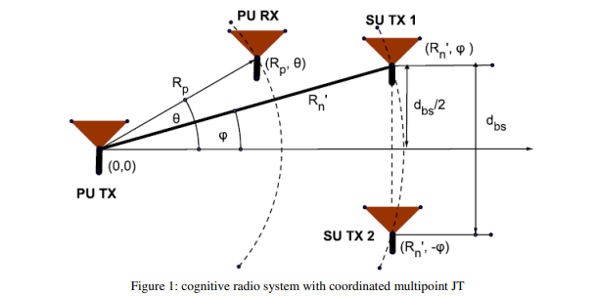

At any instance, the position of the PU RX at the edge of the protected radius is given by the coordinates (Rp, 𝜃). The secondary transmitters are placed at radius Rn with respect to the PU TX, and their coordinates are given by (Rn, 𝜙) and (Rn, −𝜙). We define Rn as the no talk radius for JT. The no talk radius is the distance within which the secondary transmitters must not perform JT using the channels being used by PU to facilitate a successful PU transmission. Thus, any SU situated inside no talk radius must detect an ongoing PU transmission accurately. The distance between the secondary transmitters is denoted as dbs.

**III. METHODOLOGY**

In the considered Cognitive Radio Network (CRN), there are two Base Stations (BSs) labeled as i and j, respectively, and they employ Coordinated Multipoint Joint Transmission (CoMP JT) technique. The set of BSs in the network is represented by B = {i, j}.

The Secondary Users (SUs) are randomly distributed throughout the CRN, and each SU is associated with the nearest BS. The set of SUs associated with a particular BS b ∈ B is denoted as N'_b. The total set of all SUs in the network is given as N = N_i ∪ N_j, and the total number of users is represented as |N| = N.

The set N_ij includes the SUs located in the intersection area covered by both BSs i and j. On the other hand, Ni and Nj represent the sets of SUs associated with BSs i and j, respectively, that are not part of the intersecting area.

For downlink communications in the CRN, only the BSs transmit data to the SUs. The transmission power levels at both BSs i and j are equal and are denoted as Psu_tx.

The time in the CRN is divided into small repetitive time frames, each with a duration of Tframe. Within each frame, three specific time periods are defined:

1. Ts: This is the sensing time period when the SUs perform spectrum sensing to detect if the PU band is idle or busy.

2. Ta: This is the time allocated for the coordination and data exchange between BSs i and j for CoMP JT transmission.

3. Ttx: This is the transmission time period when the BSs transmit data to the associated SUs.

The division of time into these specific periods allows for efficient spectrum sensing, coordination among BSs, and data transmission to the SUs, ensuring smooth and coordinated communication in the CRN.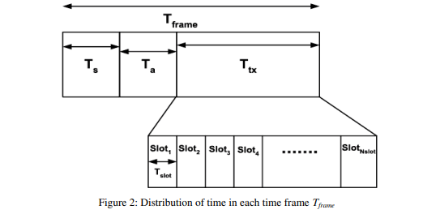

where Ts is the time taken by the BSs to perform spectrum sensing, Ta is the time taken for decision fusion, channel allocation, and scheduling, and Ttx is the time spent for data transmission. The time Ttx is further divided in Nslot slots each with duration Tslot. The free channels are allocated among the different users for the different slots of a time frame.

**IV. SIMULATION AND RESULTS**

In this cognitive radio network (CRN), there are a total of 10 Primary Users (PUs) and 100 Secondary Users (SUs) distributed over an area of 1500×2500m². The CRN consists of two Base Stations (BSs) denoted as Network 1 and Network 2. The distribution of PUs is random, and they are spread out over the given area. The SUs are also randomly distributed within the coverage areas of the two BSs. The number of SUs associated with each BS depends on the positions of the SUs. Some BSs may have more associated SUs, while others may have fewer, depending on their spatial distribution. The distance between the two BSs is 600 meters, and each BS serves a cell with a radius of 400 meters. There is an overlapping region between the cells, and the maximum distance across the center of the cells where they overlap is 200 meters. The configuration of this CRN allows for dynamic spectrum sharing and efficient utilization of available spectrum resources. The SUs opportunistically access the unused spectrum when it is not being utilized by the PUs, ensuring optimal spectrum utilization and improved network performance. The random distribution of PUs and SUs across the area enhances the flexibility and adaptability of the CRN, making it a promising technology for future wireless communication systems.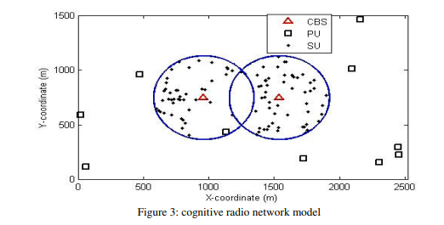

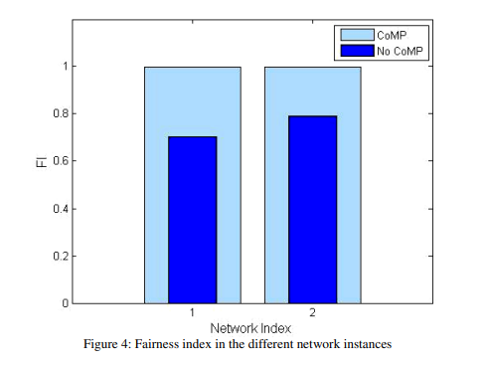

Perform simulation for the other network instances and then calculate the FI for each of the network instances. The FIs of the 2 instances with the proposed and baseline algorithms are depicted. The average FIs for the 2 CRN instances with baseline and proposed algorithms are found to be 0.7377 and 1, respectively. Thus, CoMP JT technique under the proposed algorithm solves the throughput unfairness problem in CRNs.

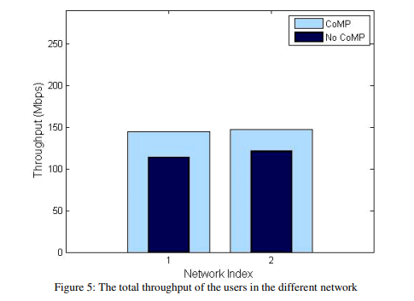

CoMP JT–based CRN with respect to the traditional transmission based CRN. The average increment in the minimum throughput of the users is found to be 102.6876%. We know that there is a trade-off between throughput and fairness in wireless networks. The total throughput of the 2 CRN instances with and without CoMP JT technique is shown in Figure 5. We find that the total throughput in a CoMP JT based CRN is lower compared to that of a CRN without CoMP JT.

**V. CONCLUSION**

In this paper, a Cognitive Radio (CR) system with Coordinated Multipoint Joint Transmission (CoMP JT) technique is proposed. The focus of the research is on determining the design parameters for Energy Detection (ED)-based spectrum sensing in the CoMP JT-based CRN. Analytical formulations are developed to assess the performance of spectrum detection in terms of probability of detection and probability of false alarm, and the results indicate that the spectrum detection is highly effective.

Furthermore, an optimization problem is formulated to maximize the minimum throughput of users in CoMP JT-based CRNs through optimal channel allocation and user scheduling. However, due to the complexity of solving this optimization problem using conventional optimization tools, an alternative algorithm is proposed. The CoMP JT-based CRN under this proposed algorithm shows significant improvements in the fairness index (FI) and max-min throughput compared to a CRN with traditional transmission techniques.

Despite these improvements, it is observed that the total throughput in the CoMP JT-based CRN is lower when compared to a traditional CRN. This might be attributed to the additional overhead and coordination required in the CoMP JT technique, which may impact the overall system throughput.

Overall, the research highlights the potential benefits of CoMP JT-based CRNs, particularly in terms of fairness and individual user throughput. However, further investigation and optimization are necessary to address the issue of overall throughput and to fully exploit the advantages of this advanced transmission technique in Cognitive Radio Networks.

**REFERENCES**

1. W. Lee, Ensemble deep learning based resource allocation for multi-channel underlay cognitive radio system in *IEEE Communications Letters*, vol. 20, no. 19, pp. 1942-1945, Aug. 2022.
2. Nagul, S. (2020). Channel scheduling by spectrum channel white space filling in cognitive radio networks. In 2020 IEEE international conference on electronics, computing and communication technologies (CONECCT) (pp. 1–6) IEEE.
3. Salameh, H. B., Shraideh, S., & Alshamali, A. (2020). Joint channel assignment and adaptive mode selection in MIMO-based cognitive radio networks. Arabian Journal for Science and Engineering, 45(12), 10233–10244.
4. Slimeni, F., Chtourou, Z., Scheers, B., Le Nir, V., & Attia, R. (2019). Cooperative Q-learning based channel selection for cognitive radio networks. Wireless Networks, 25(7), 4161–4171.
5. W. Lee, "Resource Allocation for Multi-Channel Underlay Cognitive Radio Network Based on Deep Neural Network," in IEEE Communications Letters, vol. 22, no. 9, pp. 1942-1945, Sept. 2018.
6. P. Zuo, T. Peng, W. Linghu and W. Wang, "Resource Allocation for Cognitive Satellite Communications Downlink," in IEEE Access, vol. 6, pp. 75192-75205, 2018.
7. Y. Zhang, B. Song, S. Gao, X. Du and M. Guizani, "Monopolistic Models for Resource Allocation: A Probabilistic Reinforcement Learning Approach," in IEEE Access, vol. 6, pp. 49721-49731, 2018.
8. H. Li and X. Zhao, "Power Allocation for Capacity Maximization in Sensing-Based Cognitive DF Relay Networks With Energy Harvesting," in IEEE Access, vol. 6, pp. 48556-48565, 2018.
9. A. E. Omer, M. S. Hassan and M. El-Tarhuni, "Window-based adaptive technique for real-time streaming of scalable video over cognitive radio networks," in IET Communications, vol. 11, no. 17, pp. 2643-2649, 30 11 2017.
10. M. Cui, B. Hu, J. Tang and Y. Wang, "Energy-Efficient Joint Power Allocation in Uplink Massive MIMO Cognitive Radio Networks With Imperfect CSI," in IEEE Access, vol. 5, pp. 27611-27621, 2017.