**“ASSESSMENT OF DIESEL PARTICULATE MATTER LEVEL IN AMBIENT AIR OF JAGANNATHPUR OPENCAST MINE (M/s SECL BILASPUR)”**

**Dr. Ram Narayan Khare*1, Dr. Ketan Chourasia *2, Mr. N Yogesh*3**

*1Principal & Professor Vishwavidyalaya Engineering College, Ambikapur, Chhattisgarh, India.

*2Assistant Professor, Department Of Mining, Vishwavidyalaya Engineering College Ambikapur, Chhattisgarh, India.

*3 Student, Department Of Mining, Vishwavidyalaya Engineering College, Ambikapur,

Chhattisgarh, India.

**ABSTRACT**

This research paper examines the levels of diesel particulate matter (DPM) in the atmosphere of Jagannathpur Opencast Coal Mine. Through extensive monitoring and analysis, spatial and temporal variations in DPM concentrations were identified, with high-traffic areas showing elevated levels. The study also characterizes DPM size distribution and chemical composition, offering insights into potential health and environmental impacts. A predictive model was developed to forecast DPM concentrations under different conditions, enabling the identification of mitigation strategies. The research provides valuable information for promoting sustainable mining practices and reducing the environmental impact of diesel emissions in Jagannathpur Mine and similar operations. In this study, we have focused on areas which are outside the opencast mines so that its health impacts on the workers and people nearby can be seen during the project. For this, have chosen eight different locations in Jagannathpur opencast project around the mines in upwind and downwind direction so that we can assess the dust generated from the mines during different seasons. Distribution of diesel particulate matter are determined by the application of DPM 520, DPM 520i, Kestrel 5500 and EVM is used for the sample collection and characterizing the particulate structures. Several softwares such as SPSS, R, Python are used for the betterment of data analysis and graph plot.

**Keywords:-** Diesel particulate matter(DPM), Air quality, Monitoring, Spatial variation, Air sampling.

**Introduction**

Achieving good air quality is chief fundamental for supporting healthy human lung function, especially when one accounts that an adult male normally inhales 10.8 m3 of air per day (at rest), and toxic air-borne pollutants infiltrate into the body through this primary exposure mechanism (Phalen, 2008). Whilst the air we breathe is comprised largely of gaseous compounds (i.e. 78 % N2, and 21 % O2), small amounts of particulate (i.e. aerosols) that are present in air have an abstruse impact on human respiratory health (Pope & Dockery, 2006).

Two main internal combustion engine types contribute to deteriorating air quality in the atmosphere, namely spark-ignition engines (or petrol engines) and compression ignition (CI) engines (or diesel engines). These two internal combustion engines types differ considerably in particulate matter (PM) emissions, where it is noted that it is much more difﬁcult to control PM with diesel engines by virtue of the heterogeneity of the combustion process. Diesel engines emit a larger mass of PM and number of particles (typically by factors of 10–100) than their petrol engine counterpart (Kittelson, 1998).

The essential driver of DPM emanations is because of the presence of a fuel-rich blend, portrayed by a high identicalness proportion (for example the fuel-air proportion). CI motors work on the standard of inward blend readiness, by which fuel is infused into the burning chamber and along these lines needs to blend in with an oxidant (for example consumption air) before burning can start (Heywood, 1998).

## **PM emissions from mining activities**

In an open cast mines the primary step is to remove the top soil from the area and is stored to a place away from the mining working zone and used for reclamation of the mining after removal of the mineral. when top soil is removed the hard rock present down must need to be loosen by drilling and blasting process which is done by making blast hole patterns. This process generate lots of PM in opencast mine and is considered as first stage of dust generation in OCP. (S. Gautam et al., 2012). An excavator used to remove overburden by loading it into a dumper that haul it to a waste dump site for storage. Bulldozers distribute the material out over the waste dump once the overburden is unloaded. Drilling, which is the second unit operation, leads to generation of a significant amount of PM (M. Onder and E. Yigit, 2009). Loading, unloading and transport of overburden and coal . A loader loads the coal into rail wagons and trucks that takes it to a processing plant where the coal is processed to its final stage and ultimately used for public benefits. The pollution remains very high at the point of loading and unloading (S. Gautam et al., 2016).

Processing of coal- The ore is processed by extracting the final product from the rock, and the emission mechanism includes impact, abrasion, and falling from great heights to break. Apart from these mentioned processes, the fire is also used which tends to increase concentrations of PM pollutants in the atmosphere, which leads to severe air pollution near coal mining areas. It has been observed that out of the total PM generated, the PM10 constitutes one-third to half. As a result, it can be inferred that highly mechanised opencast coal mining produces a large amount of airborne dust, which poses a risk to safety and health. (M.K. Ghose et al., 2000)

## **Why we need to study the DPM in ambient air in SECL**

Diesel particulate matter (DPM) is a serious occupational health concern for mine workers and people living near mining areas (Cantrell et al.,1997). DPM is primarily made up of elemental carbon (EC) and organic carbon (OC), which are found in a fairly steady ratio in mine environments (Abdul-Khalek et al., 2007). In SECL open cast mines production is high due to which a large number of diesel operated machines are required to meet the target production of mines. As such a large number of diesel operated machines are used the chances of presence of high concentration of DPM in the ambient air might exist which can be harmful for workers as well as local people living near mining areas. Knowing the quality of air present is essential and to study the DPM in ambient air near Jagannathpur OCP is needed.

## **Objectives**

1. Assessment of DPM level in ambient mine atmosphere of Jagannathpur opencast project during four seasons.
2. Modeling of DPM generation and dispersion to evaluate DPM exposure of miners at different workplaces.
3. Assessment of health impacts and measures to reduce DPM level in mines.

# Methodology

In this surveying, the 8 locations were marked around the mine in upwind direction, downwind direction and buffer zone. Different instruments like portable DPM sampler, Kestrel 5500 for weather monitoring, GRIMM, EVM for sample dust collection and PM Sensors were set up to record the reading of Diesel particulate matter that were emitted from the mines.

* 1. **Description of the mines.**

The study was conducted for an open cast mine, Jaggannathpur OCM, under the South-Eastern Coalfields Limited (SECL), a subsidiary of Coal India Limited (CIL), situated in the central region of India in the state of Chhattisgarh. The Jaggannathpur sub-block is situated in the northern parts of the Bishrampur coalfield (i.e., north of Mahan River) in Pratappur sub-division of Surguja district, Chhattisgarh state. The latitudes and longitudes of Jaggannathpur Sub Block are given below.

Latitudes: 23 $°$ 21’ 22” & 23 $°$ 23’ 05” N

Longitudes: 83 $°$ 11’ 44” & 83 $°$ 14’ 05” N

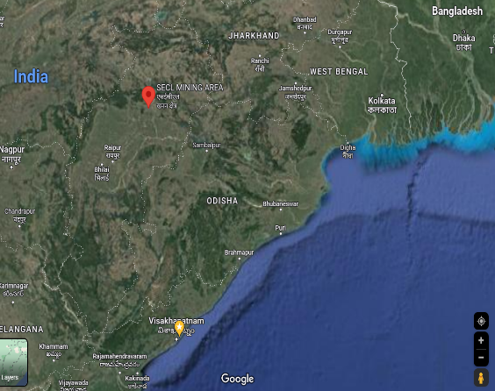

**Study Area**

**Figure 1:** Location of the study area (Source: Google Maps)

Figure

Figure

Figure

levels

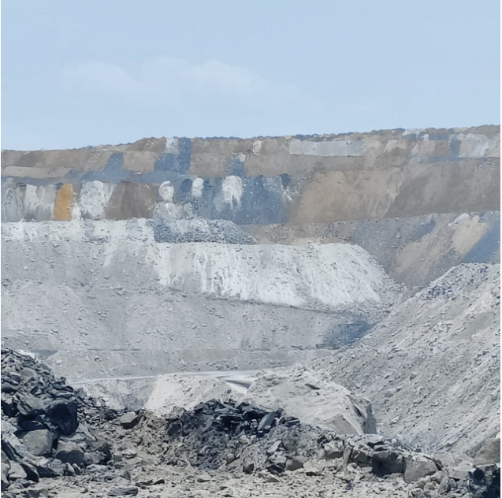

**Figure 2:** Jaggannathpur Open Cast Mine

Figure

Figure

Figure

Figure

levels

## **2.2 Description of the sampling locations**

The study was carried out on 8 different location of Jagannathpur opencast project of M/s SECL.

Table:1 Selected Location for DPM sampling

|  |  |  |  |
| --- | --- | --- | --- |
| Date | Location | Instrument s used | Description |
| 08.06.2023 | Sub-Area Manager Office | Kestrel, DPM, EVM | It was located on the periphery of the mine boundary. Due to rain the reading was low. |
| 08.06.2023 | Time Office | Kestrel, DPM,  PM sensors | HEMMs run from nearby roads. |
| 08.06.2023 | Mine Workshop | Kestrel, DPM, EVM | The Reading was taken under the shed in Mine workshop.Due to rain the reading was low. |
| 09.06.2023 | Mahamaya Sugar Factory, Kerta | GRIMM, DPM | It was located on the opposite side of the highway and many workers regularly visit this location |
| 09.06.2023 | Security Checkpost-1 | kestrel, DPM | It was located on the periphery of the mine boundary. |
| 09.06.2023 | Manager Office | kestrel, DPM | The reading was taken Near the parking shed. Around 50 no. of vehicles were placed there people were coming to the office. |
| 10.06.2023 | CR Camp | kestrel, DPM | ----- |
| 10.06.2023 | Pampapur Village | kestrel, DPM | Buffer zone was located 2 kms from OCP |
| 10.06.2023 | Sub Station | kestrel, DPM, EVM | ---- |

## **Instrumentation**

**2..3.1. AM520i diesel particulate matter (DPM)**

To measure the DPM concentration in the ambient air of mine area, we used a SidePak Personal Aerosol Monitor AM520i DPM sampler with a cyclon of 0.8 μm. The device includes a single- channel, data-logging, light-scattering laser photometer that delivers real-time aerosol mass concentration readings of dusts, fumes, mists, smoke, and fog within a worker breathing zone.

**2.3.2 Grimm Aerosol spectrometer**

We used the No. 02. GRIMM 1.108 Portable Aerosol Spectrometer to measure the PM concentration. It's made to measure particulate matter in the air and the distribution of particle counts in real time. It's a small, portable gadget that can assess powder quality accurately anyplace.

**2.2.3 Portable weather station**

Kestrel 5500 Weather Meter for weather monitoring. The Kestrel 5500 Weather Meter has the same accurate, dependable, and easy-to-use features as the original Kestrel 4500. Measure the temperature, humidity, and wind direction, as well as crosswinds and headwinds/tailwinds.

**2.2.3 EVM**

The 3M™ EVM Series measures both particles and air quality in one compact instrument. This robust, user-friendly model aids in simultaneous worksite area monitoring of Particulate mass concentrations (0.1 -10 m), hazardous gases, volatile organic compounds, carbon dioxide, and other pollutants.

**2.2.4. PM Sensors**

Particulates and aerosols are the most harmful components of poor air quality, and we know that their toxicity is determined by their size and composition. These sensors consist of a line of Optical Particle Counters (OPCs) that give high-quality particle counts and size.

# Result

**3.1 Meteorological parameters**

The weather data was collected during the rainy season between 08 June to 10 June 2023. The ambient temperature ranged from 23.6 to 34.67 o C during the measurement days in rainy seasons with the mean of 27.3 o C . The mean RH for rainy season was 82.42 % (range: 67 – 99.7%).

Table 2.Descriptive of weather parameters

|  |  |  |  |  |  |  |  |  |  |
| --- | --- | --- | --- | --- | --- | --- | --- | --- | --- |
| Locat ion | Monitoring Parameter | | Mean | 95th Percentile | Media n | Min | Max | SD | ANOVA Significance  *p*  Value |
| Jagannathpur OCP | T(oC) | R | 27.830 | 28.300 | 27.800 | 27.40 | 28.80 | 0.237 | *p* < 0.05* |
| RH (%) | R | 82.428 | 85.700 | 81.900 | 80.1 | 91.9 | 1.7095 | *p* < 0.05* |

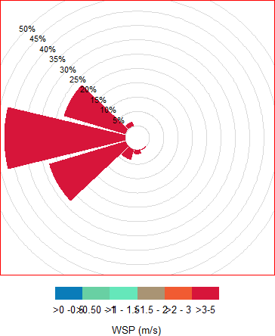

Figure 3. Rainy season’s windrose of Jagannathpur OCP

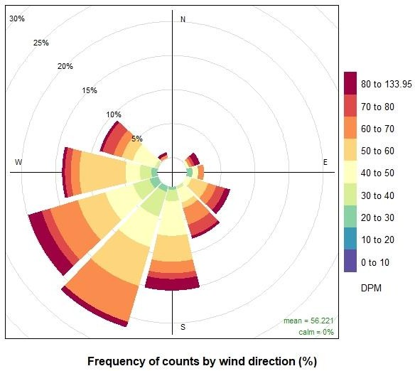

Figure 4. Pollution rows for rainy season at Security Checkpost-1 Jagannathpur OCP

* 1. **DPM concentration at various study locations**

Table 3. Descriptive analysis of DPM of Jagannathpur OCP

|  |  |  |  |  |  |  |  |
| --- | --- | --- | --- | --- | --- | --- | --- |
| Location | Distanc e from mines (km) | Range (µg/m3) | Mean (µg/m3) | Median (µg/m3) | Quartile 1  (µg/m3) | Quartile 3  (µg/m3) | Standard deviation (µg/m3) |
| Mine Workshop | 0.8 | 9-333 | 16.62 | 15 | 13 | 18 | 5.24 |
| Time Office | 0.5 | 4-663 | 11.74 | 10 | 8 | 14 | 12.42 |
| Sub-Area Manager Office | 0.2 | 17-828 | 81.81 | 80 | 53 | 97 | 40.81 |
| Mahamaya Sugar Factory, Kerta | 1.0 | 2-25 | 12.88 | 13 | 11 | 15 | 2.63 |
| Security Checkpost-1 | 0.2 | 1-49 | 19.76 | 19 | 18 | 21 | 2.44 |
| Manager Office | 0.3 | 10-48 | 17.80 | 18 | 16 | 19 | 3.35 |
| CR Camp | 0.1 | 13-184 | 52.48 | 53 | 42 | 66 | 12.61 |
| Pampapur Village | 7 | 2-43 | 9.93 | 9 | 7 | 13 | 4.32 |
| Sub Station | 50 | 4-183 | 19.12 | 15 | 10 | 23 | 13.80 |

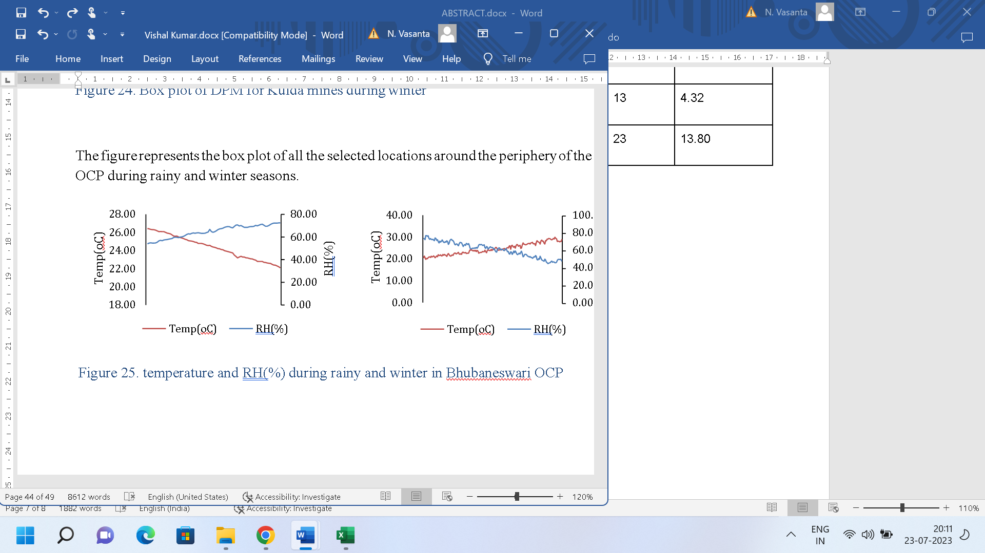

Figure5 . Temperature and RH(%) during rainy season in Jagannathpur OCP

# 4. Conclusion

From this study we can see that the DPM concentration in Rainy season is very less. Thus we can conclude that in as the wind speed increases in rainy season the dispersion of dust cloud increases due to which people nearby and instruments get less affected rainy season as compared to other seasons in which the wind speed is very low. Seasonal variation should be considered in accordance with monitoring of pollutants in mining area.

DPM has ill effect on human respiratory health effects upon inhalation of particles of certain quantity, during winter this effect can be seen due to high concentration.

The physico‐chemical properties of DPM that are relevant from a respiratory health perspective were outlined, where it is noted that the organic carbon content of DPM plays an important role. A mechanism was proposed in this thesis describing potential pathways leading to respiratory illness and disease. This mechanism indicates where mitigation efforts should be directed to protect respiratory health.

**References**

* 1. Pope CA, III, Dockery DW. Health effects of fine particulate air pollution: lines that connect. J. Air Waste Manage. Assoc. 2006; 56: 709-42.
  2. Kittelson DB. Engines and nanoparticles: a review. J. Aerosol Sci. 1998; 29: 575-88.
  3. Heywood JB. Internal combustion engine fundamentals. McGraw-Hill, Inc, New York, 1988.
  4. Sydbom, A., Blomberg, A., Parnia, S., Stenfors, N., Sandström, T., & Dahlen, S. E. (2001). Health effects of diesel exhaust emissions. *European Respiratory Journal*, *17*(4), 733-746.
  5. Nightingale JA, Maggs R et al., 2000, Airway inflammation after controlled exposure to diesel exhaust particulates
  6. Davies B. Diesel particulate control strategies at some Australian underground coal mines. Am. Ind. Hyg. Assoc. J. 2002; 63: 554-8.
  7. Cantrell, B. K., & Watts, W. F. (1997). Diesel exhaust aerosol: Review of occupational exposure. Applied Occupational and Environmental Hygiene.
  8. American Lung Association. 2004. “What is particulate matter?” <http://www.4cleanair.org/Whatisparticulatematter-FINAL.pdf> June 2008.
  9. [Health and Environmental Effects of Particulate Matter (PM) | US EPA](https://www.epa.gov/pm-pollution/health-and-environmental-effects-particulate-matter-pm)
  10. Abdul-Khalek, I. S., Kittelson, D. B., Graskow, B. R., Wei, Q., & Bear, F. (1998). Diesel exhaust particle size: Measurement issues and trends.
  11. [Health Effects of Diesel Particulates](https://dieselnet.com/tech/health_pm.php)
  12. Jesse C. McEnteea,, Yelena Ogneva-Himmelberger, (7 January 2008) ”Diesel particulate matter, lung cancer, and asthma incidences along major traffic corridors in MA, USA: A GIS analysis”
  13. Nightingale JA, Maggs R, Cullinan P, Donnelly LE, Rogers DF, Kinnersley R, Chung KF, Barnes PJ, Ashmore M, Newman-Taylor A., (2000) “ Airway inflammation after controlled exposure to diesel exhaust particulates”
  14. N0.1 DGMS (S&T)/(Tech.) Circular No. 01 Dhanbad, Dated 13-08-2018
  15. [SidePak Personal Aerosol Monitor AM520i](https://tsi.com/products/aerosol-and-dust-monitors/dust-monitors/sidepak-personal-aerosol-monitor-am520i-en/)
  16. [GRIMM Optical Particle Counter 1.108](https://amof.ac.uk/instruments/grimm-optical-particle-counter-1-108/)
  17. [Kestrel 5500 Weather Meter](https://kestrelmeters.com/products/kestrel-5500-weather-meter)
  18. [3M™ EVM 7 Environmental Monitor Kit, with CO, CO2, and PID Sensors 1 kit/cs](https://www.3m.com/3M/en_US/country-monitoring-instr-us/products/~/3M-EVM-7-Environmental-Monitor-Kit-with-CO-CO2-and-PID-Sensors-1-kit-cs/?N=8715292%2B3292720492&rt=rud)
  19. [Particulate Sensors | PM Sensor](https://www.alphasense.com/products/optical-particle-counter/)
  20. Chang, P., Xu, G., Mullins, B., Abishek, S., & Sharifzadeh, M. (2020). Numerical investigation of diesel particulate matter dispersion in an underground development face during key mining activities. *Advanced Powder Technology*, *31*(9), 3882-3896.
  21. [Particulate Matter (PM) Basics | US EPA](https://www.epa.gov/pm-pollution/particulate-matter-pm-basics)
  22. [Diesel Particulate Matter - an overview](https://www.sciencedirect.com/topics/engineering/diesel-particulate-matter)
  23. P.K. Rai and I.S. Panda, (2014) Dust capturing potential and air pollution tolerance index (APTI) of some road side tree vegetation in Aizawl, Mizoram, India: An Indo- Burma hot spot region, Air Qual. Atmos. Health
  24. P.K. Rai, B.M. Chutia, and S.K. Patil, (2014) Monitoring of spatial variations of particulate matter (PM) pollution through bio-magnetic aspects of roadside plant leaves in an Indo-Burma hot spot region. Urban For. Urban Gree
  25. S. Gautam, A.K. Patra, and B.K. Prusty, (2012) Opencast mines A subject to major concern for human health, Int. Res. J. Geo. Min. 2 (2012), pp. 25–31
  26. M. Onder and E. Yigit, (2009) Assessment of respirable dust exposures in an opencast coal mine, Environ. Monit. Assess.
  27. S. Gautam, A.K. Patra, S.P. Sahu & Michael Hitch, (2016) Particulate matter pollution in opencast coal mining areas: a threat to human health and environment, International Journal of Mining, Reclamation and Environment.
  28. A.K. Tripathi and M. Gautam, (2007) Biochemical parameter of plants as indicators of air pollution, J. Environ. Bio.
  29. M.K. Ghose and S.R. Majee, (2000) Assessment of dust generation due to opencast coal mining-an Indian case study, Environ. Monit. Assess.
  30. Mohankumar, S., & Senthilkumar, P. (2017). Particulate matter formation and its control methodologies for diesel engine: A comprehensive review. *Renewable and Sustainable Energy Reviews*, *80*, 1227-1238.