**A view of Molecular Targeted Therapies in Glioblastoma**

Esha Majumdar, Aria Chakraborty

Scottish Church College (Affiliated to the University of Calcutta), Kolkata, West Bengal, India

| **Abstract** :  Glioblastoma is the most common type of brain cancer arising from the stem or progenitor neuroglial cells. When abnormal mutations occur in these cells causing changes in the expression of the genes or proteins regulating the cellular pathways, the cells keep on proliferating without any signal to stop and it gives rise to intrinsic malignant brain tumors. According to epidemiological studies, the median age of diagnosis is nearly 65 years, although it can occur even before 65 years. Males are 1.7 fold times more affected than females. Generally, young age and a healthy lifestyle has therapy independent positive prognosis of the disease. Generally Glioblastoma arises due to mutation of the IDH1 or IDH2 gene, with IDH wild type glioblastomas accounting for nearly 90% of the disease. Radiotherapy followed by temozolomide chemotherapy is the current standard care, although the best supportive care is placebo. IDH wild type glioblastoma may arise due to MGMT promoter methylation or unmethylation or it can arise due to EGFR or changes in PI3K/AKT/mTOR pathway, MET gene, FGFR3-TACC3 fusion, BRAF mutation, NTRK mutation. It can also occur due to pRB pathway alterations, loss of p53 function or TERT promoter mutation. In case of programmed cell death, immunotherapy can be opted as a method of treatment. Here, in this article, we will discuss the different types of mutations which give rise to Glioblastoma and focus on the molecular targeted therapies related to different pathways and mutations. |
| --- |

Keywords : Glioblastoma, IDH wild type, mutations, pathways, temozolomide, bevacizumab, clinical trials, therapies

# **INTRODUCTION**

The most common type of brain cancer, Glioblastomas, arise due to mutations or alterations in the cellular pathways in the neuroglial cells, which account for more than 50% of the nervous system. Glioblastoma is mostly common in adults, however, several cases of pediatric glioblastomas are also observed. The most common type of Glioblastoma is the IDH wild type glioblastoma. The WHO classifies glioblastoma into 2 major types based on mutations in the IDH gene, i.e IDH 1 and IDH 2 gene mutations. The IDH gene encodes the enzyme Isocitrate dehydrogenase, which in normal condition converts isocitrate to

$α$-ketoglutarate. Mutations lead to epigenetic modifications, forming IDH-mut, which lead to increased production of 2-hydroxyglutarate [Fig 1], affecting cell differentiation, leading to formation of tumors. 2-hydroxyglutarate decides the fate of immune cells and leads to tumorigenesis. Thus 2-hydroxyglutarate is an oncometabolite. According to WHO Grade IV, the distinct morphological 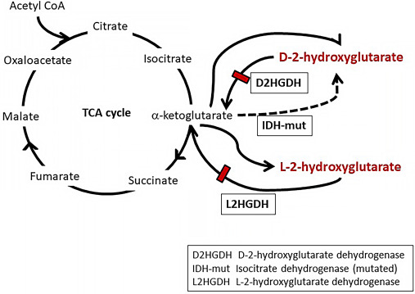

features of brain tumors are

Fig 1 : TCA cycle showing IDH gene mutation & its consequences microvascular proliferation

or According to CNS tumor taxonomy (cIMPACT), the molecular diagnostic detection of glioblastoma can also be done by —-

* Epidermal growth factor receptor (EGFR) gene amplification.
* Combined gain of chromosome 7 & loss of chromosome 10 (+7/-10)
* Telomerase reverse transcriptase (TERT) promoter mutation.

Apart from these, although astrocytes with IDH mutation exhibit typical features of glioblastoma, they are not classified as glioblastoma by WHO because they have a more favorable clinical course. The 2016 WHO classification identifies histological variants of glioblastoma as —

* Giant cell glioblastoma : These are bizarre, multinucleated (>20 nuclei) giant (upto 400 $μm$ diameter) cells and have a very high frequency of TP53 gene mutations.
* Gliosarcoma : These show biphasic growth patterns consisting of both glial and sarcomatous components, i.e., mesenchymal differentiation is seen in glioblastoma.
* Epithelioid glioblastoma : Caused by BRAF V600E mutation and are rarely accompanied by TERT mutation or MGMT methylation. These are large epithelioid cells with abundant cytoplasm and prominent nuclei.

The therapy of giant cell glioblastoma or gliosarcoma does not depend upon classification of tumors into their histological variants. However, epithelioid glioblastoma has better clinical relevance when treated with targeted therapy with mutant BRAF inhibitors. Other molecular subgroups of glioblastoma can be determined by large scale genetic and epigenetic profiling, characterized by DNA methylation patterns associated with characteristic mutational and expression profiles. By DNA methylation profiling, 7 molecular subgroups have been identified where Receptor Tyrosine kinase (RTK) 1 and 2 subgroups and mesenchymal subgroups are the most common.

# **CURRENT STANDARD CARE**

Current standard of care in newly diagnosed glioblastoma individuals is surgery followed by involved field radiotherapy in combination with concomitant and upto 6 maintenance cycles of temozolomide chemotherapy. Except for tumor-treating fields, no other therapies are there as of now to prolong survival. Glioblastomas eventually progress and standards of care are less well defined for patients with recurrence. For localized recurrence of glioblastoma, second surgery or re-radiation might be done but neither of these prolong survival. Another mostly broadly used intervention for localized recurrence is a course of alkylating chemotherapy, mostly the nitrosourea compound and lomustine. However, the best treatment and the best supportive care is placebo, where medicine is prescribed for psychological benefit rather than physiological benefit.

# **MOLECULAR TARGETED THERAPIES**

## **MGMT Promoter methylation**

MGMT gene is located on chromosome 10q26.3 which encodes an enzyme in DNA repair. MGMT removes alkyl groups from O⁶ position of guanine at DNA level, thus antagonizing the lethal effects. However MGMT causes chemoresistance to alkylating chemotherapy agents [Fig 2]. When MGMT becomes defective, O⁶ methylguanine remains as it is causing base mispairing leading to cell cycle arrest and apoptosis. Thus epigenetic modification of MGMT induces CpG methylation, leading to low levels of functional MGMT protein, thus leading to DNA damage but increased response to alkylating chemotherapy [Fig 2]. Thus, MGMT promoter methylation is a potential biomarker of sensitivity to alkylating chemotherapy, including temozolomide (TMZ). Thus, alkylating chemotherapy benefit is limited to patients whose tumors show aberrant CpG methylation of the promoter region of O⁶ methylguanine DNA methyltransferase (MGMT) gene. MGMT methylation is commonly observed in Grade IV gliomas, called Glioblastoma multiforme (GBM). In GBM, monosomy of chromosome 10 is a common event, where methylation of the remaining allele completely blocks MGMT- mediated DNA repair.

In the method of assessment of MGMT methylation, the preliminary phase consists of

genomic DNA extraction, its qualitative/quantitative check and bisulfite conversion. As bisulfite changes cytosine residues in thymine, this treatment allows to distinguish the presence of methylated or unmethylated sequences at MGMT gene promoter, only if the nucleotide is unbound to the DNA adduct.

For patients with MGMT methylation glioblastoma, standard care is given using Stupp protocol in which radiotherapy is followed by concomitant chemotherapy with temozolomide.

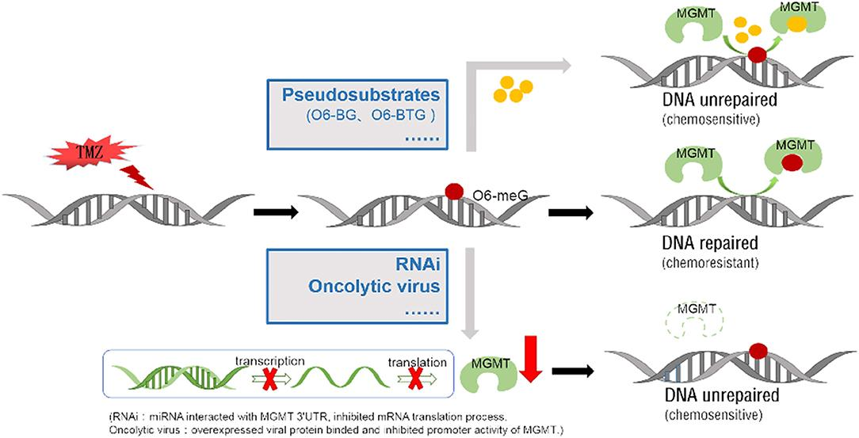

Fig 2 : MGMT promoter methylation mechanism and treatment using temozolomide

## **Glioblastoma Intrinsic Targets**

The majority of clinical trials focusing on intrinsic targets address oncogenic signaling via tyrosine receptor kinases, cell cycle and susceptibility to apoptosis induction.

### Tyrosine Kinase Receptor Pathways

1. **Epidermal Growth Factor Receptor (EGFR)**

EGFR is a protein on cells that makes them grow. Mutation in the gene makes them grow too much and cause cancer. Thus, it is the most important oncogene in IDH wild type glioblastoma. It is overexpressed in 60% tumors and 40% tumors exhibit EGFR gene amplification. In 25% tumors, deletion mutation occurs which results in the formation of EGFRvIII and delta-EGFR. EGFRvIII is the most common mutation of EGFR which results in creation of tumor specific antigen that helps maintain the body’s immune response against cancer cells. This arises due to deletion of EGFR exons 2-7 which generates truncated extracellular domains capable of constitutive EGFR amplification.

The extracellular region of EGFR contains 4 important domains, L1, CR1, L2 and CR2. L1 and L2 are the domains which are rich in leucine and bind the ligand, i.e., cytokines [Fig 3]. However, in EGFR mutation to form EGFRvIII, the L1 and CR1 domains are deleted and ligands can no longer bind. EGFR and EGFRvIII are able to transduce signals via classic RTK pathways including the RAS/RAF/MEK/ERK pathway, the PI3K/AKT/mTOR pathway, JAK/STAT pathway and the PKC pathway. The NS1 gene (neurofibromin) located on chromosome regulates cell growth by the RAS pathway. Mutation causes uncontrolled growth and leads to tumor 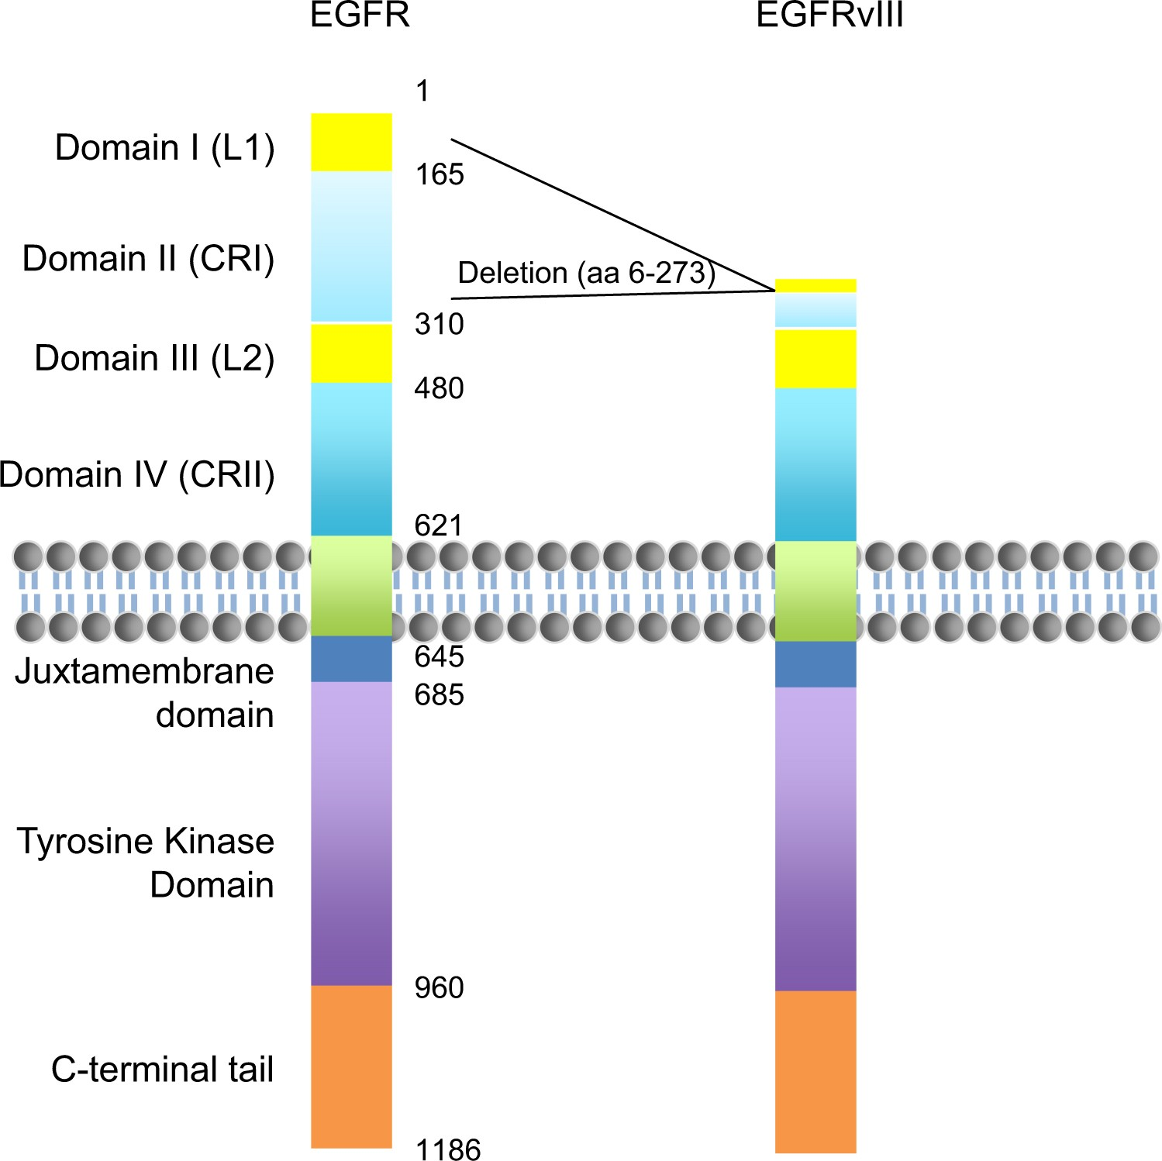

Fig 3 :Domains of EGFR and EGFRvIII formation. The PTEN gene is a tumor suppressor gene which regulates cell division by keeping cells from growing too rapidly. Mutation eliminates TSG function. The JAK/STAT pathway activates STAT which binds to DNA and allows transcription of genes involved in immune cell division and survival activation. Mutations lead to tumor formation. The EGFR also translocates from the cell membrane into mitochondria to induce mitochondrial fission. It binds to CoXII which contributes to the synergistic effects of c-Src and EGFR on oncogenesis.c-Src plays an important role in cell growth. The detailed events of the different pathway regulation using EGFR is given in Fig 4. 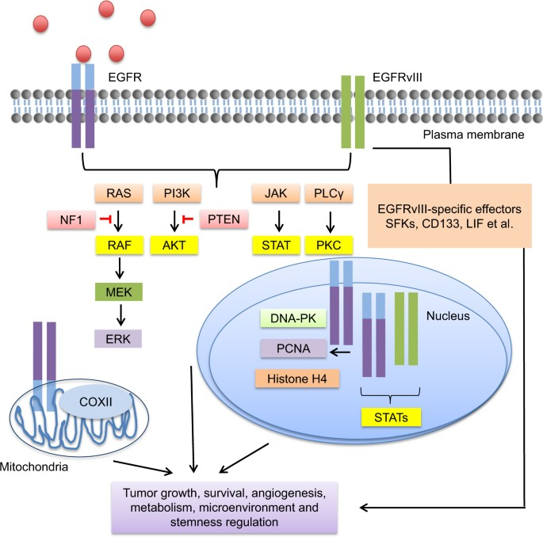

For treatment in individuals with glioblastoma having EGFR gene amplification, EGFR inhibitors are given but they may not be able to suppress pathway activity even if they reach the tumor tissue. Therefore, other approaches include focusing on EGFR and EGFRvIII expression by Fig 4 : Pathways regulated by EGFR & EGFRvIII

providing vaccine rindopepimut that produces survival signal in combination with bevacizumab in EGFRvIII positive recurrent glioblastoma, but failed in phase III in newly diagnosed disease. Resistance to EGFR/EGFRvIII targeted therapies are due to :

* Blood brain barrier penetrance (antibodies and chemicals cannot penetrate)
* PTEN mutation and NF1 mutation
* Tumor heterogeneity (distinct tumor cells can harbor different mutations)

For this reason, Gefitinib and Daconitinib are not so effective. However, Osimertinib shows satisfactory results since it penetrates the blood brain barrier better. It not only inhibits EGFR negative glioblastoma by regulation of the MAPK pathway, but also inhibits transcription factor EGFR-TAZ. Antibody drug conjugate Depatoxizumab mafodotin consisting of EGFR antibody ABT-806 linked to monomethyl auristatin F appeared to be active in combination with TMZ in recurrent EGFR amplified glioblastoma but showed no activity in newly diagnosed individuals. In phase III, ACT IV trial shows loss of EGFRvIII activity thus showing that EGFRvIII is unstable. These also cast doubt on the success of CAR-T cells. However, EGFR gene amplification is maintained throughout.

1. **PI3K/AKT/mTOR Pathway**

The most common mutation pathway in IDH wild type GBM is PI3K/AKT/mTOR pathway. The loss of TSG of phosphate and tensin homolog on chromosome 10 (PTEN) function activates mutations in phosphatidylinositol-4,5-bisphosphate 3-kinase catalytic subunit alpha (PIK3CA), the gene encoding the catalytic subunit p110 alpha & in phosphoinositide-3-kinase regulatory subunit 1 (PIK3R1), encoding the p85 $α$ regulatory subunit. However, it is challenging to translate this pathway alteration into clinical benefit.

In 2005, it was proved that mTOR inhibitor temsirolimus was inactive as a single

drug in recurrent GBM. In a recent phase 1 trial, Temsirolimus in combination with AKT inhibitor perifosine was given which yielded disappointing results but it was observed that patients had higher tolerance to Temsirolimus, which was due to the use of corticosteroids in the experiment. A new PI3K pan-inhibitor Buparlisib, was ineffective when tested, either singly or in combination with carboplatin or Lomustine. Oral PI3K inhibitor bevacizumab in combination with BKM120 was terminated due to low tolerance in patients. mTOR inhibitor Everolimus in newly diagnosed GBM with MGMt promoter methylation was ineffective either singly or in combination with radiotherapy or TMZ. Thus, PI3K pathway as a therapy target is ineffective due to low tolerance and molecular complexity of the pathway. However, some trials are thought to increase tolerance significantly under certain conditions, but that is a topic of research for the future.

1. **MET Gene**

The met gene is commonly known as the scatter factor ,which encodes a hepatocyte growth factor (HGF) and plays a major role in immigration ,invasiveness of the glioma cells as well as the inhibition of hypoxia and angiogenesis [Fig 5]. A proof of the concept of a role of the MET gene and amplification with recurrent Glioblastoma was treated with crizotinib which was a mildly active drug . Another method by blocking a Receptor by single arm antibody on artazumab or cabozantinib ( which was used with a combination of angiogenic drugs) was mildly active on treatment of patients with Glioblastoma. VEGFR2 and AXL also resulted in modest efficiency in recurrent signals and MET fusion genes are also detected in pediatric Glioblastoma. PI3K and MET inhibitors are also considered for the follow up trials as the combination of mutations in C-MET can often lead to drug resistance in Glioblastoma patients thereby influencing the efficiency of PI3K targeted therapies. The antibody charzumab with the combination of antivascular drugs had no significant benefit for the Glioblastoma patients.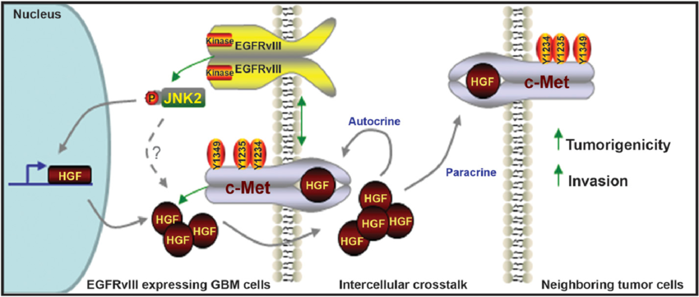

Fig 5 : MET gene pathway in Glioblastoma

1. **Fibroblast growth receptor factor (FGFR)**

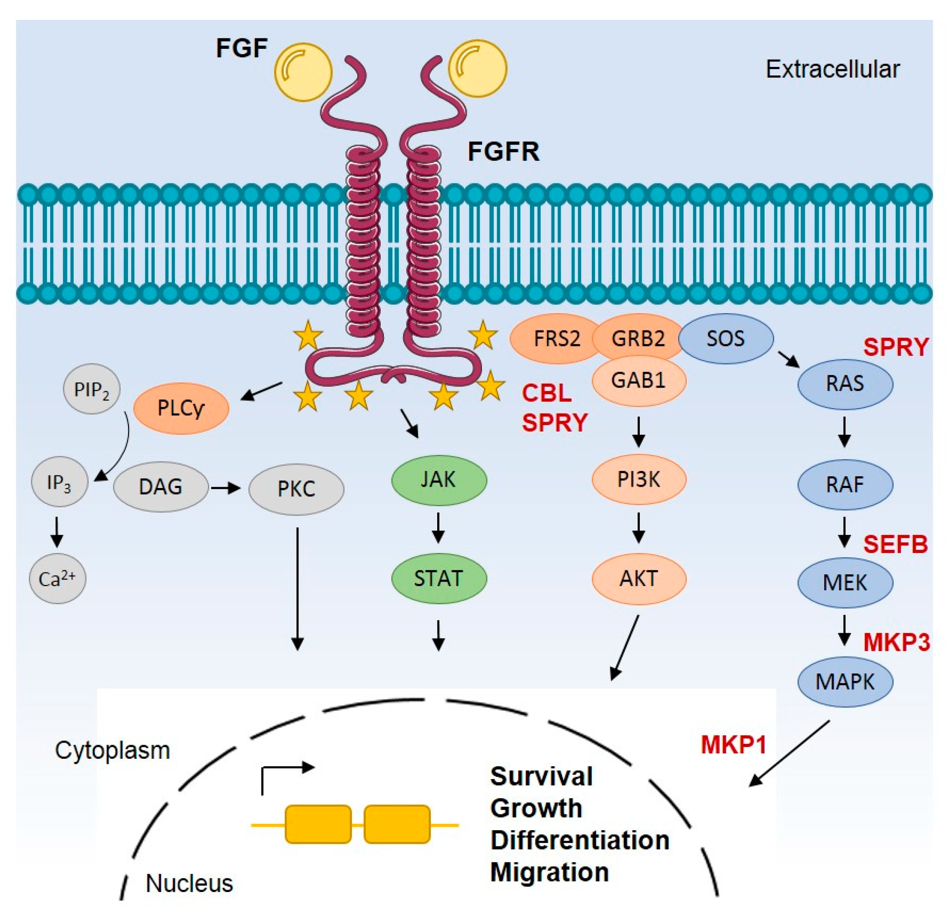

FGFR s play a pivotal role in promotion and differentiation of cancer cells [Fig 6] thereby inactivation of FGFR Tyrosine kinases and achieved a great success in tumor targeted therapies. FGFR is widely expressed in glioblastomas but has limitations in its therapeutic values for only patients w8 FGFR-TACC fusion

Fig 6 : FGFR pathway regulation

(the fusion protein leads to constitutively activated signaling of FGFR3). There was a case where both stable and partial response in FGFR3 -TACC3 positive Glioblastoma patients were treated with oral FGFR Kinase inhibitor called Erdafitinib. Partial response was observed in FGFR3-TACC3 positive Glioblastoma patients in the phase 1 trials. The VEGFR -3 inhibitor also inserts a Kinase domain Receptor inhibitor that reduces angiogenesis or lymphagenosis leading to anticancer therapy.

1. **BRAF Mutation**

This is a member of the Raf family of kinases , it has a signaling pathway that advances proliferation of cells , by activating BRAF mutations the BRAF V600E missense mutations (point mutation at the sites of a thumbnail to adenine on the exon 15 that results in the change of amino acid 600 from valid to glutamine) was observed in having druggable Molecular lesions which are predominantly observed in metastatic melanoma . Previous studies show that glial tumors exhibitingBRAF mutations may respond to BRAF inhibition although moderate efficiency is observed in BRAF V600E mutant Glioblastoma which is a reliable target. These BRAF mutations are rarely found in high grade Glioblastomas.

1. **Neurotrophic Receptor Tyrosine Kinases (NTRK)**

NTRK is being encrypted by three different genes that are respectively ; NTRK1, NTRK2 and NTRK3. The genomic reposition of NTRK gene often results in gene function , which may instigate the function and the activation of the carcinogenic TRK signaling pathway [Fig 7].

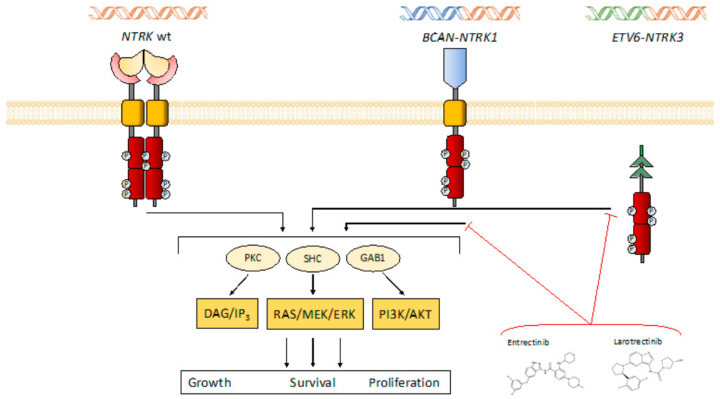

Fig 7 : NTRK pathway

The occurrence of NTRK gene fusion is often expressed in rare proportions in Glioblastoma. When an adult patient had Glioblastoma with IDH-WT along with NTRK2, the reposition was being treated with Larotretinib and Entrectinib which showed an increased temporary response and result. After rebiopsy the disease spread showcased that the tumor cells carrying reposted NTRK2 were deleted whereas the tumor cells with amplification that were amplified by treating them with PDGFRA sustained. The mutated form of PDGFRA gene and protein have been found in a few types of cancer like cancer of gastrointestinal tract, chronic eosinophilic leukemia. Another drug called Larotrectinib was being used in the female patients suffering from Glioblastoma and the results had significant curative effects and this drug is used to treat certain types of solid tumor cells. Entrectinib was also effective in the treatment of infantile Glioblastoma.

### Cell cycle control & Apoptosis regulating pathways

1. **Retinoblastoma pathway (pRB)**

In majority of the cases of IDH-wild type glioblastomas, the process of cell cycle regulation of RBpathway is alternated because of homozygous elimination of CDKN2A/B and magnification of CDK4/6 and also due to swapping of RB1 gene which works as a tumor suppressor gene. This keeps the cells away from rowing and dividing too fast in an uncontrolled manner [Fig 8].

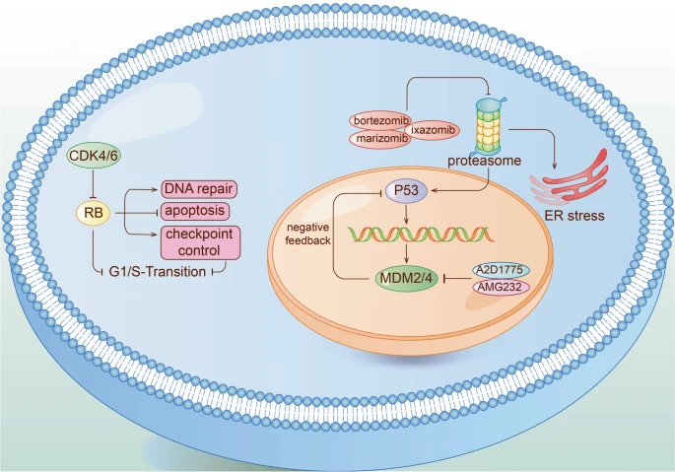

Fig 8 : pRB pathway, p53 pathway and proteasome regulation

The change in the RB1 genes prevents making any functional error, therefore cells are unable to regulate the process of cell division effectively. There are certain cells which divide uncontrollably to form cancer cells and tumors. When provocation obstacles are visible, by applying the RB pathway as a clinical target, for the extensive presence of a particular pathway in the normal cells. The inhibitor CDK4/6 Palbociclib for Glioblastoma failed to give satisfactory results in phase II trials. Ribociclib, which was used as a single agent, also failed to give satisfactory results. SPH3643 which is currently discovered as an inhibitor of CDK4/6 are not being tested in the clinical trials, but expected to have better BBB permeability and may give satisfactory results in comparison to Palbociclib in the clinical trials. Other than this TGO2 which is a multi CDK inhibitor which mainly targets CDK9 other than CDK4/6 presently are being tested in clinical trials for glioblastomas and newly diagnosed cases of glioblastomas.

1. **p53 pathway**

TP53 is a tumor suppressor gene that has been deeply explained in Glioblastoma and one of the most significant gatekeeper genes. The main function of P53 is for blocking cells in go or g1 phase and instigating the phenomenon of apoptosis in contrast to genotoxic pressure, which restores the working of P53. In Spite of drugs for promoting the recording of the mutant gene to wild type confirmations are not triumphant but regular efforts are being put to stop the negative regulatory proteins of P53. AZD 1775, which works as an inhibitor of Wee 1 Kinase, manifested better brain tumor penetration though further clinical trials are needed to prove its best therapeutic effects. MDM2 functions as an E3 ubiquitin lipase to degrade P53. MDM2 also binds to another tumor suppressor gene called ARF. This interaction sequence MDM2 in the nucleolus away from p53 thereby activating p53. AMG-232 an oral selective MDM2 inhibitor that restores P53 tumor suppression by blocking MDM2-P53 pathway [Fig 8]*.*

1. **TERT promoter mutation**

TERTpromoter mutation is one of the most frequently used Molecular markers in IDH - wild type glioblastomas. The two main centers of Tert mutations give rise to new E-26 transcription factors binding sites; thereby increasing the activity of TERT transcription and also the increasing activity of the TERT . Earlier it was thought that the result of MGMT promoter methylation on the process of chemotherapy sensitivity and prognosis are variable in various tumors and along with it has the absence of Telomerase reverse transcripts which promotes mutation. Modern approaches found out that when patients are being treated with MGMT promoter methylation along with the standard doses of chemotherapy, TERT most probably exerts a positive effect on its regulation. TERT promoter mutation is yet to become the main pharmacological target for tumor therapy. Tubulin polymerization inhibitor Eribulin employs TERT suppression activity in glioblastoma which proves the sensibility of the clinical trials. When there is a mutation of the TERT promoter produces a binding site for the GABP transcription factor complex. There is decrease in the production of GAB PILL,(which is an isomer of GABP) , which improves the survival rates when clubbed with chemotherapy in glioblastoma which focuses on the importance for finding its inhibitor. Checking of bases by CRISPR CAS9 with correct TERT mutation and reducing the binding capacity of ETS transcription slows down the tumor growth but is not adapted due to the prospect of gene therapies.

1. **Proteasome**

Proteasome is one of the most important mediators of intracellular degradation of toxic and harmful proteins. It promotes apoptosis by regulation of P53 proteins and ER stress [Fig 8], which controls the phenomena of cell cycle and drug tolerance of tumor cells. Recently Bortezomib, Ixazomib(which is often used in drug treatment of multiple myeloma), Marizomib are some of the clinically approved Proteasome inhibitors. Proteasome is known to collaborate with ubiquitin which polymerizes to form a marker for regulated protein lysis. Ixazomib had a well defined permeability to tumor tissues preclinically , but effective and efficacy trials are needed for further studies. Bortezomib which reversibly binds to chymotrypsin-like structure of 26S Proteasome resulting in prevention of degradation of apostolic functions. These are combined with standard doses of radiotherapy and feature greater survival rates. Another method by using Disfluran not only limits the Proteasome from neighboring blood cells, but also has advantageous blood brain barrier penetration and better drug tumor effects in Glioblastoma and glioblastoma models. Recent findings say that in phase II trials, reported Disfluran had limited capacity in sensitivity chemotherapy.

## **Microenvironmental targets : Angiogenesis**

1. **Vascular Endothelial Growth factor (VEGF)**

Glioblastoma is featured by abnormality on Vascular proliferation, VEGF promotes abnormal proliferation of the tumor blood vessels, and is enlisted as the censoring pathway of tumor existence [Fig 9]. Specutically, the vascular normalization can amplify tumor blood perfusion and helps to accelerate patient survival. There is opposition to the VEGF-A ligand which attaches itself to the Endothelial cells and inhibits the process of angiogenesis. In the phase II clinical uncontrolled trials, Bevacizumab showed significant biological functioning, anti-glioma working, high radiation response rate, high overall survival rate (OS). It also exhibited 6 months PFS ( the length time during and after the treatment and tolerance capacity) in newly diagnosed cases of glioblastomas. In phase III clinical trials Bevacizumab showed significant improvement in PFS. Bevacizumab can develop drug resistance within months. The effectiveness of multikinase inhibitor Ponatinib glioblastoma patients is very restricted in Bevacizumab refractory glioblastoma cases. In recent research, the response to Bevacizumab in few patients correlates with antibody dependent cytotoxicity (ADCC). Bevacizumab when combined with chemotherapy exhibited great efficiency and tolerance. Etoposide also showed a great toxicity which was a topoisomerase inhibitor class of medications. Axitinib, a Tyrosine kinase inhibitor against VEGFR 1, 2 and 3 also serves as a method of chemotherapy.

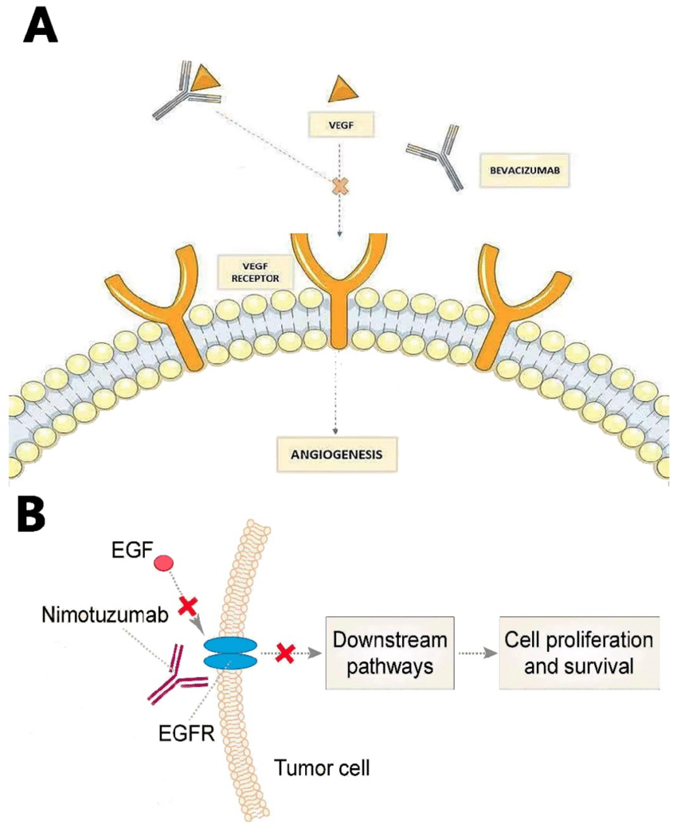

Fig 9 : VEGF pathway in Glioblastoma

1. **Integrins**

They are a family consisting of 24 heterodimer cell surface receptors which take part in signal transduction and are concerned in many cellular procedures. They mediate cellular communication within the extracellular matrix and also regulate adhesion motility, migration, invasion and angiogenesis. Cilengitide is a selective integrin inhibitor which focuses and targets $α$ vβ3 and $α$ vβ5 along with a combination of Cediranib that provides a great tolerance to the Glioblastoma patients in the phase 1 clinical trials. In the phase II Trials, Cilengitide average effectiveness which could be transferred and accumulated in Glioblastoma cells throwing binding with β $α$ vβ3 and αvβ5 targets. Chemotherapy plus Cilengitide with great resistance and effectiveness did not improve invasiveness of recurrent rate of just diagnosed cases of glioblastomas. In phase1 and phase II clinical trials Cilengitide was verified that it was ineffective of correct monotherapy among children with cases of glioblastomas. A phase III trial showed limitations on the effectiveness of Cilengitide. In Spite of not showing remarkable potential as monotherapy, integrins continued to be an important target.

1. **Transforming growth factor (TGF) β**

TGFβ 2 provides instructions for making a protein called Transforming growth factor β. It is a family of proteins that has complex roles in a wide range of controlling pathways, among which the most significant is TGFβ 2 is a tumor suppressor in the tumor Microenvironment about 90% of the Glioblastoma patients. TGFβ ½ inhibits being used in treatment of various types of cancer, they are still complicated to be used in the Glioblastoma targets. TGFβ Receptor 1- kinase inhibitor galunisertib failed in combination with lamostene. Trabederson was effective in few patients but the therapeutic effectiveness was below expectations. Antisense oligonucleotides, ISTH 1047 and ISTH 0047, exhibit anti-tumor properties and are tested in clinical trials. The gene therapy concentrates on hematopoietic stem cells that reveal that TGF Receptor blocks peptides and shows increased effectiveness. TMZ combined with inhibitors are promising due to Glioblastoma MGMT methylation. Then, Snurf gene encodes proteins that are involved in pre real splicing and maps to the smallest deletion region involved in Prader willi syndrome.

## **Immunotherapy**

**Programmed cell death protein (PD-1)**

The evolution of neutralizing antibodies to the checkpoint molecules of the immune system has controlled the field of cancer immunotherapy. Significantly antibodies that are acting as a barrier for the engagement of PD-1 on T cells which is the major ligand out of which PD1 are being expressed on the tumor cells on the host cells that have remarkable interest. In Spite of this, the major developments in the cure of various Solid tumors with immune checkpoint were not successful in the cases of glioblastomas. Leaving the exceptions of the single cases of good results in patients with tumors and high mutational burden, which is caused due to germline mutations causing problems in DNA repair match.There er large haphazard clinical trials of Nivolumab against Bevacizumab in cases if recurrent Glioblastoma and another example is of Nivolumab versus temozolomide along with the standard doses of radiotherapy. MGMT promoter unmethylated recent cases of glioblastomas have failed to give satisfactory results. Pembrolizumab shows significant survival advantages.

# **CONCLUSION**

The failure of various targeted agents for glioblastoma in late clinical development shows that most of the cases of glioblastomas are not near for being a pathway driven disease that would be tactile for a case of targeted therapy. There is a major requirement for better involved clinical trials designs and an early inclusion of control arms in phase II situations that allow reaching meaningful go/on go decisions for further clinical developments. Molecular testing needs to be done faster and rapidly which is enough to allow patients treatment in sufficient time algorithms to rant the molecular lesions found to be in the exact position. The pharmaceutical companies need to be influenced to collaborate in the early stages of drug development. The standard therapy is limited to patients having MGMT promoter hypermethylation and there is no proper standardized therapy for patients with Glioblastoma, therefore more efficient treatment modalities are urgently needed. Some potential attempts for better results can be made such as:

* Developing a more efficient drug delivery system to cross blood brain barriers such as direct intracranial administration.
* Identifying and elaborating more efficient pathways such as PI3K for drug development.
* More timely and precisely molecular diagnosis.

On a concluding note, more laboratorial and clinical efforts are needed for combination of therapy in the treatment of glioblastoma.

# References

* Le Rhun E, Preusser M, Roth P, Reardon DA, van den Bent M, Wen P, Reifenberger G, Weller M. Molecular targeted therapy of glioblastoma. Cancer Treat Rev. 2019 Nov;80:101896. doi: 10.1016/j.ctrv.2019.101896. Epub 2019 Sep 11. PMID: 31541850.
* Yang, K., Wu, Z., Zhang, H. et al. Glioma targeted therapy: insight into future of molecular approaches. Mol Cancer 21, 39 (2022). <https://doi.org/10.1186/s12943-022-01513-z>
* An, Z., Aksoy, O., Zheng, T. et al. Epidermal growth factor receptor and EGFRvIII in glioblastoma: signaling pathways and targeted therapies. Oncogene 37, 1561–1575 (2018). <https://doi.org/10.1038/s41388-017-0045-7>
* Moving to the Mitochondria.Sci. STKE2004,tw286-tw286(2004).DOI:10.1126/stke.2452004tw286
* Louis DN, Perry A, Reifenberger G, von Deimling A, Figarella-Branger D, Cavenee WK,

et al. The 2016 World Health Organization Classification of Tumors of the Central

Nervous System: a summary. Acta Neuropathol 2016;131:803–20.

* MGMT Gene Silencing and Benefit from Temozolomide in Glioblastoma: Monika E. Hegi, Ph.D., Annie-Claire Diserens, M.Sc., Thierry Gorlia, M.Sc., Marie-France Hamou, et al. March 10, 2005 N Engl J Med 2005; 352:997-1003 DOI: 10.1056/NEJMoa043331
* Hegi ME, Diserens A-C, Gorlia T, Hamou M-F, de Tribolet N, Weller M, et al. MGMT

gene silencing and benefit from temozolomide in glioblastoma. N Engl J Med

2005;352:997–1003. doi:10.1056/NEJMoa043331.

* Yang P, Zhang W, Wang Y, Peng X, Chen B, Qiu X, Li G, Li S, Wu C, Yao K, Li W, Yan W, Li J, You Y, Chen CC, Jiang T. IDH mutation and MGMT promoter methylation in glioblastoma: results of a prospective registry. Oncotarget. 2015 Dec 1;6(38):40896-906. doi: 10.18632/oncotarget.5683. PMID: 26503470; PMCID: PMC4747376.
* Yang, K., Wu, Z., Zhang, H. *et al.* Glioma targeted therapy: insight into future of molecular approaches. *Mol Cancer* 21, 39 (2022). <https://doi.org/10.1186/s12943-022-01513-z>
* von Roemeling CA, Wang Y, Qie Y, Yuan H, Zhao H, Liu X, Yang Z, Yang M, Deng W, Bruno KA, et al. Therapeutic modulation of phagocytosis in glioblastoma can activate both innate and adaptive antitumor immunity. Nat Commun. 2020;11(1):1508.
* Wen PY, Weller M, Lee EQ, et al. Glioblastoma in adults: a Society for Neuro-Oncology (SNO) and European Society of Neuro-Oncology (EANO) consensus review on current management and future directions. *Neuro Oncol.* 2020;22(8):1073–1113.
* Delgado-López PD and Corrales-García EM: Survival in glioblastoma: A review on the impact of treatment modalities. Clin Transl Oncol. 18:1062–1071. 2016.
* Taylor JW, Parikh M, Phillips JJ, James CD, Molinaro AM, Butowski NA, et al. Phase-2

trial of palbociclib in adult patients with recurrent RB1-positive glioblastoma. J

Neurooncol 2018;140:477–83. doi:10.1007/s11060-018-2977-3.

* Stupp R, Mason WP, van den Bent MJ, Weller M, Fisher B, Taphoorn MJ, Belanger K, Brandes AA, Marosi C, Bogdahn U, et al. Radiotherapy plus concomitant and adjuvant temozolomide for glioblastoma. N Engl J Med. 2005;352(10):987–96.

<https://www.nejm.org/doi/full/10.1056/NEJMoa043330>

* Batchelor TT, Duda DG, di Tomaso E, Ancukiewicz M, Plotkin SR, Gerstner E, Eichler AF, Drappatz J, Hochberg FH, Benner T, et al. Phase II study of cediranib, an oral pan-vascular endothelial growth factor receptor tyrosine kinase inhibitor, in patients with recurrent glioblastoma. J Clin Oncol. 2010;28(17):2817–23.

<https://ascopubs.org/doi/10.1200/JCO.2009.26.3988>

* Reardon DA, Groves MD, Wen PY, Nabors L, Mikkelsen T, Rosenfeld S, Raizer J, Barriuso J, McLendon RE, Suttle AB, et al. A phase I/II trial of pazopanib in combination with lapatinib in adult patients with relapsed malignant glioma. Clin Cancer Res. 2013;19(4):900–8.

aacrjournals.org/clincancerres/article/19/4/900/78124/A-Phase-I-II-Trial-of-Pazopanib-in-Combination