**Gas Leakage Detection with Buzzer System**

Koushik M, Final Year Student, BCA, BMS College Of Commerce and Management, Bangalore, Karnataka, India

Harshitha P, Final Year Student, BCA, BMS College Of Commerce and Management, Bangalore, Karnataka, India

Kiran Kumar M N, Assistance Professor, BCA, BMS College Of Commerce and Management, Bangalore, Karnataka, India

ABSTRACT

A gas detector is a tool that checks for the presence of gases in a space, frequently as a safety measure. This kind of apparatus can interface with a control system to trigger an automatic process shutdown when it detects a gas leak or other emissions. A gas detector might beep. An alarm to operators in the vicinity of the leak, giving them the chance to flee. This kind of apparatus is crucial since many gases have the potential to be toxic to organic life, including people and animals.Oxygen depletion and poisonous, flammable, and combustible gases can all be found with gas detectors. This kind of equipment is commonly utilized in industry and is available

Key words: Arduino Nano, Active Buzzer, Female header pins, 10K Potentiometer, Perfboard or dotted board.

INTRODUCTION

A project called "Gas leak Detection & monitoring system using Arduino" In the petrochemical industry, wireless communication is used to improve machine and human safety. Despite being the largest process control enterprise in the world today, the petrochemical industry is also extremely vulnerable to catastrophic gas and fire events. A limited space in the petrochemical sector houses an overly large volume of crude oil storage. Therefore, the presence of any external source that might ignite a fire or generate heat would result in a catastrophic event. Even the gas that is produced in oil refineries is dangerous.

Therefore, we have created an integrated system that will promptly monitor gas leakage in any region nearby in order to prevent any risk related to fire and gas leakage in a petrochemical sector.

**METHODS**

1. Arduino Nano - The Arduino Nano is a small, complete, and breadboard-friendly board based on the ATmega328P released in 2008. It offers the same connectivity and specs of the Arduino Uno board in a smaller form factor. The Arduino Nano is equipped with 30 male I/O headers, in a DIP-30-like configuration, which can be programmed using the Arduino Software integrated development environment (IDE), which is common to all Arduino boards and running both online and offline. The board can be powered through a type-B mini-USB cable or from a 9 V battery
2. 16X2 (1602) LCD Display - The term LCD stands for liquid crystal display. It is one kind of electronic display module used in an extensive range of applications like various circuits & devices like mobile phones, 18 calculators, computers, TV sets, etc. These displays are mainly preferred for multisegment light-emitting diodes and seven segments. The main benefits of using this module are inexpensive; simply programmable, animations, and there are no limitations for displaying custom characters, special and even animations, etc. LCD is employed for displaying the message indicating that” gas detected at zone” into the display, which is initially coded in program to display the danger. The message been displayed on the LCD, data and command both are register of LCD and it's shown in fig.5. The register selects is employed to modify the registers. Data register RS=1, whereas for the command register RS=0 is employed.
3. MQ2 gas sensor - MQ2 is one of the commonly used gas sensors in MQ sensor series. It is a Metal Oxide Semiconductor (MOS) type Gas Sensor also known as Chemiresistors as the detection is based upon change of resistance of the sensing material when the Gas comes in contact with the material. Using a simple voltage divider network, concentrations of gas can be detected. The Grove - Gas Sensor (MQ2) module is useful for gas leakage detection (home and industry). It is suitable for detecting H2, LPG, CH4, CO, Alcohol, Smoke or Propane. Due to its high sensitivity and fast response time, measurement can be taken as soon as possible. The sensitivity of the sensor can be adjusted by potentiometer.
4. Buzzer - A buzzer or pager is an audio signalling device, which can be mechanical, mechanical device, or electricity (Piezo for short). It has 2 pins in it. It’s easy construction and low worth makes it usable in varied applications like car/truck reversing indicator, computers, decision bells etc. Once subjected to an alternating field of force they stretch or compress, in accordance with the frequency of the signal thereby producing sound.
5. Potentiometer - The potentiometer is a device that is used to measure the voltage or electric potential. It provides a variable resistance when the shaft of the device is turned. Here, we will measure the amount of resistance as an analog value produced by the potentiometer. We will connect the potentiometer to the Arduino UNO board and will measure the state of the potentiometer. The required code will be uploaded from our computer to the Arduino board. The variable resistance measured by the potentiometer can be easily read as an analog value into the Arduino board.
6. Female header Pins - Pin header connectors comprise several different means of connection. Generally, one side is a series of pins which are soldered to a PCB, and they can either be at a right-angle to the PCB surface (usually called "straight") or parallel to the board's surface (confusingly referred to as "right-angle" pins). Such connectors come in a variety of pitches, and may have any number of individual rows of pins. The most commonly seen pin headers are 0.1" (2.54mm) single or double row connectors. This is a standard breadboard compatible pitch. These come in male and female versions, and are the connectors used to connect Arduino boards and shields together. Users can easily connect jumper wires to breadboards
7. Perfboard - Perfboard is a material for prototyping electronic circuits (also called DOT PCB). It is a thin, rigid sheet with holes pre-drilled at standard intervals across a grid, usually a square grid of 0.1 inches (2.54 mm) spacing. These holes are ringed by round or square copper pads, though bare boards are also available. Inexpensive perfboard may have pads on only one side of the board, while better quality perfboard can have pads on both sides (plate-through holes). Since each pad is electrically isolated, the builder makes all connections with either wire wrap or miniature point to point wiring techniques. Discrete components are soldered to the prototype board such as resistors, capacitors, and integrated circuits. The substrate is typically made of paper laminated with phenolic resin (such as FR-2) or a fiberglass-reinforced epoxy laminate (FR-4)

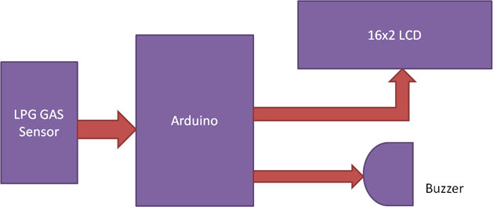

Dig.1 – Process Diagram

**Results**

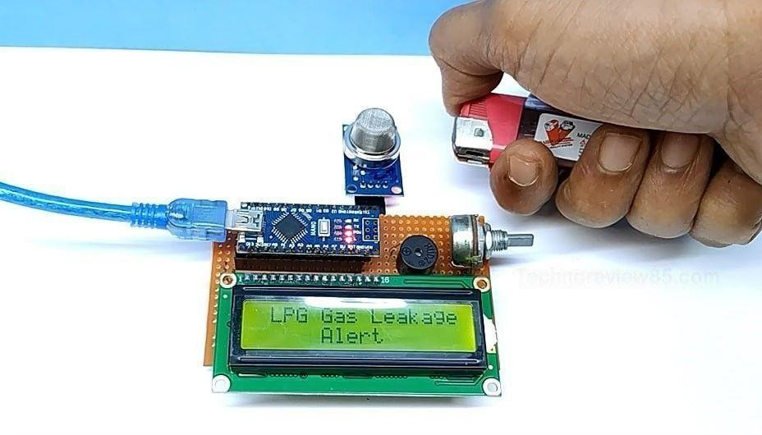

Fig.1-Working

Conclusion

After the completion of this experiment, it is possible to draw the conclusion that LPG leak detection is

amazing in the project management system. Useful for both residential and commercial purposes.

We can use this technique to save lives in dangerous situations. When an alert is present,

the GSM component. Propane, CO2, and other gases are detected by a sensor node. The estimated transmission range and power consumption are obtained. The sensor was constructed using straightforward processes and an Arduino UNO Micro controller.

In this study, a design for a sensor-based automatic gas leakage detector with a control and alarm system has been put forth. This device is affordable, low-power, lightweight, portable, safe, user-friendly, effective, multifunctional, and simple to use.

REFERENCS

1. Yekini N. Asafe Yaba College of Technology, Lagos Nigeria, Gas Leakage Detector and Monitoring System.

# Husman Kareem Embedded real-time system for detecting leakage of the gas used in Iraqi kitchens.

# Punithavathi Duraiswamy FPGA-GSM based gas leakage detection system