**Title Page**

**QUARTERLY EARNINGS ANALYSIS OF SELECTED INDIAN AUTOMOBILE COMPANIES.**

DR.MIJARUL ISLAM

Assistant Professor

Barasat College, wb,India

[Mail-islammijarul2012@gmail.com](mailto:Mail-islammijarul2012@gmail.com)

Phone-7278087957

**QUARTERLY EARNINGS ANALYSIS OF SELECTED INDIAN AUTOMOBILE COMPANIES.**

**Abstract**

The studies on there were any impact on quarterly data of earning of the company which has impacted by performance of the company. As a sample the study consider Maruti Suzuki company which listed in Indian stock exchange and period of the data consider four year from 2017 to 2022 and for the details study of specific tools increased more time frame of the study. On the base of the objective of the study with considering the periodical data we can say that earning of the company has been effected to the performance of the company if other variable remain constant.

The time frame of the study used quarterly data from selected company from the annual financial report. In the general we observed many past studied has been conducted in the selected topic but all the study used annually financial data and the interpretation also draw on the bases on annul time frame. The following study has focused on the important of quarterly data for draw the conclusion. Data presentation also an important variable for the company’s performance analysis so, the study generalised on the how the small time frame given more accurate information then long time frame. So, the study has to consider quarterly financial data and try to focuses importance of its.

**Key words:** Earnings Of The Company, Fundamental Analysis And Technical Analysis.

**Introduction:**

Quarterly earnings have a great role in a financial analysis of a company or a specific industry. In general, we have been waiting for the annual financial report of a company, if we want to analyze a company and consider any policy-making decision, we should observe carefully quarter performance. If we followed the annual performance and then missed some factors in the short term it may affect the policy of the company. Quarter report is also important considerable factor for the policy making of any stake holder of any company. In annual report we find out the actual result and performance of a company which performed during the year. If any company performed better last three month of the year the result show after one year is better. But on the other hand if we see another company in all month of the year performing average compare to above said firm in general scene second one is better company according to the performance. In the practical filed we observed that quarterly performance has affected the sentiment of the stake holder of the company. In the study we try to focus the importance of quarterly report of a firm for the sentiment of any investor in regard of automobile company in India.

**SHORT PROFILE OF MARUTI SUZUKI**

Maruti Suzuki India Limited, formerly known as Maruti Udyog Limited, is an Indian [a New Delhi-based maker of automobiles.](https://en.wikipedia.org/wiki/Automobile_industry)The company is known for producing affordable and reliable cars that cater to the needs of the Indian market. Today, Suzuki India Limited is one of the leading car manufacturers in India with a wide range of models available for customers to choose from. [1] Maruti Suzuki has 44.2 percent market share in Indian passenger car market.[2] The company is known for producing affordable and reliable cars, such as the popular Maruti Suzuki Swift and Alto models. Additionally, Maruti Suzuki has a strong presence in rural areas of India due to its extensive dealership network.

Maruti Udyog Limited was established by the Government of India on January 24, 1981, with Suzuki Motor Corporation as a minor partner, only to become Suzuki's formal JV partner and licence holder in August 2021.[3] In the same year, Maruti's first manufacturing plant was established in Gurugram, Haryana.[4]

Suzuki and Maruti Udyog Ltd. signed a JVA in 1982, allowing Maruti Suzuki to import two assembled Suzuki vehicles. who were struggling to compete with Maruti's imported vehicles. However, in 1983, the Indian government introduced a policy to encourage foreign investment in the automobile industry, which led to Suzuki partnering with the Indian government to establish Maruti Udyog Limited as a joint venture. Maruti started manufacturing vehicles locally to increase domestic components.There were some worries that the Indian market wouldn't support Maruti Suzuki's very high production levels, and the government even considered changing the gas tariff and decreasing the excise fee to increase sales.[5] However, Maruti Suzuki was able to overcome these challenges and went on to become the largest car manufacturer in India. Today, the company continues to prioritize local sourcing and has achieved over 90% localization in its vehicles.

Local production began in December 1983, with the introduction of the SS30/SS40 Suzuki Fronte/Alto-based Maruti 800.[6] When the Maruti Van was debuted in 1984, the Gurgaon plant's installed capacity rose to 40,000 cars and shared the same three-cylinder engine as the 800. In 1985, the 970 cc, 4-wheel drive Gypsy, based on the Suzuki SJ410, was unveiled. The company's 796 cc hatchback Suzuki Alto (SS80), which replaced the original 800 in 1986, was the 100,000th vehicle produced by the company.[7] The business began exporting to western markets in 1987 when a shipment of 500 automobiles was transported to Hungary. The Gurgaon plant's capacity was raised to 100,000 units annually by 1988. The 970 cc, three-box Maruti 1000 was India's first modern sedan when it was released in 1989. Indigenization accounted for 65 percent of all automotive parts by 1991. Suzuki extended its ownership of Maruti to 50% following the liberalisation of the Indian market in 1991, turning the firm into a 50-50 joint venture with the Indian government as the other partner.

Launched in 1993 was the 993 cc Zen hatchback, while the 1,298 cc Esteem sedan followed in 1994. Since production began in 1994, Maruti has manufactured one million vehicles. The second Maruti facility was inaugurated with a 200,000-unit yearly capacity. A 24-hour emergency on-road car service was introduced by Maruti. The redesigned Maruti 800, which marked the first redesign since 1986, was introduced in 1998. Maruti debuted its first diesel vehicle, the 1,527 cc Zen D, as well as a revamped Omni. Wagon R and the 1.6-liter Maruti Baleno three-box car were both introduced in 1999.

Maruti was the first automaker in India to open a contact centre for internal and client services in 2000. Released was the newest Alto model. Maruti True Value, a company that buys and sells secondhand automobiles, was established in 2001. The same year, in October, the Maruti Versa was introduced. Esteem Diesel was first made available in 2002. Maruti Insurance Distributor Services and Maruti Insurance Brokers Limited are two further new subsidiaries that have been established. The Suzuki Motor Company raised their ownership in Maruti to 54.2%.

In 2003, the Zen and the Wagon R underwent upgrades and redesigns while the new Suzuki Grand Vitara XL-7 was unveiled. As Maruti produced its four millionth car, they partnered with the State Bank of India. Maruti Udyog Ltd. was listed on the BSE and NSE following a public offering that saw a tenfold increase in demand. After nearly two decades, the Maruti 800 was surpassed by the Alto in 2004 to become the most popular vehicle sold in India. As the Esteem was being relaunched, a new variation, the Versa 5-seater, was developed. The company's yearly sales of 472,122 units were the highest ever at the end of the fiscal year 2003–2004 for Maruti Udyog. In April 2005, the company's fifty lakh (five millionth) vehicle was rolled out. The Suzuki's 1.3-liter.[8]

**Relevance of the study**

The study focused on the analysis of the financial performance of a company on the basis of historical data which shown financial report which consider quarterly time farmed. The investor considers different kinds of parameter or tools before the investment in any stock, and analysis the every element which effected the performance of the company like EPS,ROE,NI and dividend pay out etc. All the financial data collected from the annual report published by the company, if we see the annual report we can easily understand the basic perception of a company like future opportunity and growth. In the study try to consider the needful feature of quarterly divisible data for the analysis of data of a particular company for conforming the specific and deepest pinpointed analysis of the company.

**Review of the literature**

With the considering of the title of the study conducted some of the pertinent literature which rightly given the route of the methods and systematic flowed and significant direction of the study.

|  |  |
| --- | --- |
| Mohammed Amidu and Joshua Abor(2006)[9] | Examined the factors affecting dividend payout ratios of listed companies in Ghana using Factor analysis. |
| Velnampy. T (2013)[10] | Studied on the corporate governance and firm performance and used samples of 28 manufacturing companies and times periods of 2007 – 2011 state that determinants of business ethic not correlated to the performance measures of the company. |
| Mehrani, Moradi and Eskandar (2011)[11] | This paper examined the relationship between dividend policy and ownership structure in Tehran Stock Exchange from 2000 to 2007. Four regression models were used to analyze the data and determine the impact of ownership structure on dividend policy. The results showed that ownership concentration and institutional ownership have a significant effect on dividend payout ratio, indicating that companies with higher ownership concentration and institutional ownership tend to pay out higher dividends. Further research is needed to explore the underlying reasons for this relationship and to determine whether it holds true in other markets. |
| S. Kulathunga at.all (2016)[12] | This study investigates the association between ownership structure types and dividend policy of listed . The data includes financial information such as revenue, profit, and total assets. This study aims to analyze the financial performance of these companies and identify any significant trends or patterns over the nine-year period. Additionally, the findings of this study may provide valuable insights for investors and policymakers in Sri Lanka's stock market. The regression results indicate that Ownership identity matter in determining the dividends. |
| Ugwuja, Bonaventure Chinedu & Nwala, Maurie, Nneka (2019)[13] | The main objective of this study is to analyze the impact of ownership structure on dividend pay-out of deposit money banks in Nigeria from 2010 to 2017. The sample is made up of six (6) listed banks that paid dividends in all the years used for the study and who were listed on the Nigerian Stock Exchange by the end of 2009 financial year and notdelisted as at the end of 2017 financial year. Secondary data were extracted from the annual reports of the listed banks were used for the study. which involved analyzing existing data from annual reports and financial statements of the selected companies. The study also employed various statistical tools and techniques such as trend analysis, correlation analysis, and regression analysis to analyze the data and draw meaningful conclusions. To test the research hypotheses, this study  Used Panel EGLS (Cross-section weights). The independent variables used are: board ownership, block ownership concentration, block institutional ownership, block family ownership and block foreign ownership. |

**Objective of the study**

The study conducted on the earnings analysis of a company and how it is affected on the performance of the company. Generally we know that the financial information get from annul reports of a company, but the study try to conducted analysis through the quarterly data which published by the company. The following objectives are carried out to the study:

* To explore the relation between earnings of a company and performance of a company.
* To explore the importance of the quarterly publish financial reports of a company.
* To explore the financial health condition of selected company of the study.

**Method of the study**

The study used secondary data collected from company’s annual report which given website of the company. And on the other hand other relevant data collected form national stock exchange home page. Ms- excel used for the calculation of different financial tools for the study. Period of the study is selected three years quarterly financial data from 2019 to 2022. For the specific and clearly represent of data used trading software for focused the trend of any data set and future prediction similarly.

**Data analysis and finding**

TABLE 1 KEY FINANCIAL REPORTS

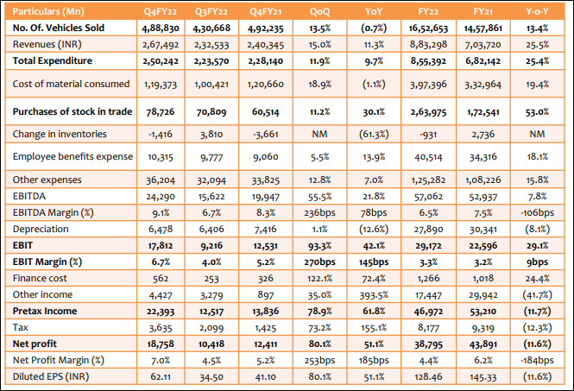

Source: company, authors calculation

In the table-1 represent the key financial report of the company like unite of total sales in every quarter, total expenditure in a year and as well as quarter, details reports about working capital in a year and also quarter report, to focused and given details report on earnings before interest of tax which percentage change in every quarter in a year, percentage change in net profit quarter to quarter and earnings per share etc. If we carefully observe the table-1 and easily quit that the overall performance of the mention company is likely healthy condition which given consider basic key financial indicators. In first quarter 2022 the result show that the unite of quantity sales down in compare to past relevant quarter report but on the other hand next three quarter sales report provide satisfactory result. In the table -1, we have net profit results which provided a reasonable and healthy condition about the company.

Table 2 ratio analysis

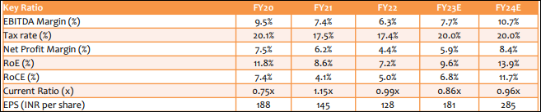

Source: company, author’s calculation

The table-2 given a information which provided the actual muscle of a company. There are many rations we have consider for the analysing the company’s performance or investment decision made by an investor. Percentage of tax would be increased if the earnings increases similarly and data clearly told us about the earning condition of a company, and the same way if we follow the past result of company can able to expect the future growth with considering the other factors. Return on equity and return on capital employed has holed a reasonable position for the selected company, and we expected that the company future position of ROE and ROCE would be better position in next financial year like 2023 and 2024 similarly. Current ratio and earnings per share those are explore a very reasonable position because if we look the current assets and current liability equation through the current ratio the past years result all are more than .75% so, we can say that the company has not hold too much liability.

Table 3 despite strong demand, MSIL’s volumes are impacted by chip shortages adversely

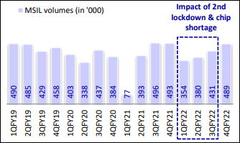

Source: company, author’s calculation

In the table-3 show the demand of the motor vehicles in every quarter from 2019 to 2022 which impacted the volume of sales of the company. In the table-3 indicated that the impact of the second lockdown time and shortage of sales volume.

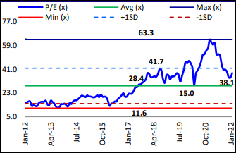Table 4 One-year forward P/E (x) band

Table 5 One-year forward P/B (x) band

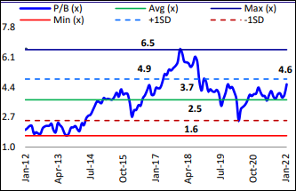

Table-4 showed the one year forward profit earning band, the result of the line chart shows from the year of 2006 to 2019 average value of profit earning run in the market but after that the value is increased and in 2022 again backed in average position. And the standard deviation indicator says that the value of the profit earning ration more volatile for the consider sample of the study.

In the table-5 shows the PB value of the consider company for the study, the line chart explore the reasonable condition because of the average line followed to the PB value and also belong between the upper and lower band of the standard deviation value.

**Conclusion**

The study on there is any impact on quarterly data of earning of the company which has impacted by performance of the company. As a sample the study consider Maruti Suzuki company which listed in Indian stock exchange and period of the data consider four year from 2017 to 2022 and for the details study of specific tools increased more time frame of the study.

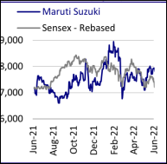

Table 7 stock performance

The table-7, shows that the stock performance of the selected company with compares to the sensex performance of one year quarterly data from 2021 to 2022. We can concluded that the performance of the selected stock run likely similar with index line chart. And the aforesaid studied focused the impact of company’s performance of quarterly earnings.

On the base of the objective of the study with considering the periodical data we can say that earning of the company has been effected to the performance of the company if other variable remain constant.

The time frame of the study used quarterly data from selected company from the annual financial report. In the general we observed many past studied has been conducted in the selected topic but all the study used annually financial data and the interpretation also draw on the bases on annul time frame. The following study has focused on the important of quarterly data for draw the conclusion. Data presentation also an important variable for the company’s performance analysis so, the study generalised on the how the small time frame given more accurate information then long time frame. So, the study has to consider quarterly financial data and try to focuses importance of its.

And third objective is very pertinent because of the sample of the study provide many important information, it may generalised concept or not. Maruti Suzuki Company has selected as a sample of the study, and with assist of fundamental analysis with considering the basic parameter likes; return on equity, return on assets, net profit, dividend payout and capital employed etc. The study can explore that the selected company’s basic financial health condition better and it may said that future result would be satisfactory. And on the another side if we consider the technical analysis with the help of different tools likes; simple moving average, expected moving average, relative strength index, Bollinger brand, MACD and different candlestick patter etc. The study can explore that the selected company’s would be good performance in near future.

**Reference**

1. [Maruti Suzuki Corporate Information](http://marutisuzuki.com/corporate.aspx) [Archived](https://web.archive.org/web/20130126163908/http:/marutisuzuki.com/corporate.aspx) 26 January 2013 at the [Wayback Machine](https://en.wikipedia.org/wiki/Wayback_Machine). Retrieved 2013-02-01
2. Mukherjee, Sharmistha (8 February 2020). ["Maruti Suzuki grabs 53% of passenger vehicle market in January"](https://economictimes.indiatimes.com/industry/auto/cars-uvs/maruti-suzuki-grabs-53-of-passenger-vehicle-market-in-january/articleshow/74019685.cms?from=mdr). [*The Economic Times*](https://en.wikipedia.org/wiki/The_Economic_Times). Retrieved 10 May 2020.
3. ["Maruti Suzuki India Ltd"](https://www.business-standard.com/company/maruti-suzuki-5496/information/company-history#:~:text=Maruti%20Suzuki%20India%20Ltd%20was,car%20for%20middle%20class%20India.). *Business Standard India*. Retrieved 15 May 2021.
4. ["Latest Maruti Company Update"](https://web.archive.org/web/20130515090458/http:/www.marutisuzuki.com/Latest-Maruti-Company-Update.aspx). Marutisuzuki.com. Archived from [the original](http://www.marutisuzuki.com/Latest-Maruti-Company-Update.aspx) on 15 May 2013. Retrieved 15 June 2012
5. B M (30 August 2021). "Message of Maruti-Suzuki". *Economic and Political Weekly*. Mumbai, India: Sameeksha Trust. **XVII** (38): 1524–1525.
6. ["Maruti's domestic sales crosses 1 cr mark"](http://www.indianexpress.com/news/maruti-suzuki-sales-cross-1-cr-mark/909976/). [*The Indian Express*](https://en.wikipedia.org/wiki/The_Indian_Express). Retrieved 9 February 2021
7. ["The Maruti Udyog official Website Timeline Page"](https://web.archive.org/web/20071012122151/http:/www.marutiudyog.com/ab/aboutus.asp?ch=1&ct=1&sc=6). Archived from [the original](http://www.marutiudyog.com/ab/aboutus.asp?ch=1&ct=1&sc=6) on 12 October 2007
8. "Maruti Udyog: Smooth Drive". *Economic and Political Weekly*. Mumbai, India: Sameeksha Trust. **XLI** (8): 672. 25 February 2006.
9. Mohamed et al (2016). “Empirical Analysis of Determinants of Dividend Payment: profitability and Liquidity.” Online: http://www.wbiconpro.com/14%5B1%5D.Hui.pdf
10. <https://www.researchgate.net/publication> 249341798_Corporate_Governance_and_Firm_Performance_A_Study_of_Sri_Lankan_Manufacturing_Companies
11. # Mehrani, Moradi and Eskandar (2011) “Ownership structure and dividend policy: Evidence from Iran”[African journal of business management](https://www.researchgate.net/journal/1993-8233_African_journal_of_business_management), 5(17). <https://www.researchgate.net/publication/266210686>

   
12. S.Kulathunga at.all (2016) “The Impact Of Ownership Structure On Dividend Policy: Evidence From Listed Companies In Sri Lanka”, Qualitative and Quantitative Economic Research (QQE 2016 )At: Singapore Volume: 6th<https://www.researchgate.net/publication/303758159>
13. Ugwuja, Bonaventure Chinedu & Nwala,Maurie,Nneka (2019) “IMPACT OF OWNERSHIP STRUCTURE ON DIVIDEND PAYOUT OF LISTED DEPOSIT MONEY BANKS IN NIGERIA “NSUK Journal of Banking and Finance and Research (JOFBR) ISSN 2408-5200 Volume 5, Number 1 March 2019 . https://www.researchgate.net/publication/342571380