**INTERNET OF THINGS: REVOLUTIONIZING MILITARY OPERATIONS AND TECHNIQUES**

**Mansour Al-Helalat**

Lecturer, Department of Computer Science, University of Jordan, Amman, Jordan

**ABSTRACT**

This paper explores the potential of Internet of Things (IoT) technologies in revolutionizing modern warfare and enhancing Defense and Public Safety (PS) operations. The adoption of IoT has already proven beneficial for sectors dealing with complex processes and a large number of assets. By leveraging commercial IoT capabilities, Defense and PS sectors can achieve greater survivability for warfighters and first responders, while simultaneously reducing costs and improving operational efficiency. Through a survey of existing IoT systems in the military field and mission-critical scenarios, this study identifies gaps and shortcomings in current implementations. It also highlights tactical requirements and architectural considerations for the deployment of an affordable IoT infrastructure for defense and PS. The paper also emphasizes the significance of image and video processing in addressing security concerns. Specifically, it focuses on shredded document reconstruction and image/video enhancement in low and high dynamics scenarios. The experimental evaluation of key systems, including the Weapon System, Bluetooth System, Distance System, and GPS System, demonstrates their excellent performance in terms of accuracy, reliability, and responsiveness. These systems contribute to enhanced situational awareness, effective decision-making, and mission success. Furthermore, the evaluation of the face detection system using widely-used datasets showcases exceptional accuracy, with a detection rate of 99.8%. This highlights the system's effectiveness in accurately identifying and localizing faces, opening up potential applications in facial recognition and surveillance systems. The performance results obtained from this research underscore the reliability, efficiency, and effectiveness of IoT systems in military operations and techniques. They emphasize the importance of robust and efficient systems in achieving mission success and contribute to the advancement of military technologies.

**Keywords:** Internet of Things (IoT), Defense, Public Safety, Shredded Document Reconstruction, Image Enhancement, Video Enhancement, Dynamics Reduction, Quality Measures

1. **INTRODUCTION**

Military commanders have always relied on information for their decision-making processes, both in terms of quantity and quality. As a result, the US military has been at the forefront of adopting cutting-edge technologies such as the Internet of Things (IoT) and is continuously exploring ways to expand its applications. However, integrating this new technology brings forth various organizational and security challenges that present both opportunities and obstacles [1].

In this paper, we present a two-part project called Smart Future Soldiers, consisting of the Military Vehicle System (MVS) and the Military Unit Protection System (MUPS). These systems are fully controlled by IoT, enabling leaders and soldiers to remotely take control over them. The MVS is designed to operate autonomously without the need for human presence. It incorporates four subsystems: The Location Identification System (GPS), Temperature Measurement System (TMS), Distance Measuring System (DMS), and Firing and Weapon System (FWS). The GPS subsystem determines the vehicle's location and sends the data to the local cloud for further processing. The processed information, including longitude and latitude, is then displayed on a public webpage using Google Maps integration. The TMS measures the temperature of the vehicle's environment and sends this data to the cloud for analysis. System administrators can extract useful information from the temperature data, such as prevailing weather conditions and military requirements specific to that environment. The DMS measures the distance to various objects and sends this information to the local cloud. Based on the object's distance, the system administrator can select the appropriate weapon to engage the target automatically. Finally, the FWS subsystem analyzes the distance to objects and selects the most suitable weapon accordingly.

The MUPS, the second part of the project, employs microcontroller-embedded units to automate and enhance military unit protection. The microcontroller receives commands from a webpage, analyzes them, and sends instructions to the systems installed at the entrances of the military unit. These systems include open-close doors, person recognition, lighting control, and movement detection. The microcontroller interacts with webcams to capture a sequence of images, which are then analyzed to verify the system's response to the given commands. The analyzed results are sent to the web-based cloud for further access and examination.

To realize this project, we leverage IoT, cloud computing, machine learning, and image processing techniques. By applying these technologies in a military environment, we aim to reduce the use of human resources while increasing the efficiency of military equipment. Furthermore, the project aims to enhance the effectiveness of security systems in military units.

The IoT concept plays a crucial role in providing battlefield situational awareness, offering commanders insights into the landscape before physically entering the field. It enables real-time data collection and analysis using sensors attached to manned or unmanned aerial vehicles, facilitating instant decision-making. Additionally, remote e-training becomes feasible, eliminating the need for trainers to be physically present in the field. Moreover, efficient inventory management can be achieved through distance measuring systems, allowing the selection of appropriate weapons based on threat proximity and thereby conserving resources. The scope of this project encompasses IoT, real-time processing, automated and embedded systems, cloud computing, machine learning, and image processing. By combining these technologies, we aim to enhance the military system, improving the psychological well-being of soldiers by minimizing their direct presence in conflict zones and replacing them with sophisticated and intelligent military equipment capable of interacting with the environment and continuously learning from it. In conclusion, this paper presents the introduction to the Smart Future Soldiers project, which integrates IoT technologies and image/video processing to transform the defense and public safety sectors. The project's scope covers various aspects, including IoT-enabled communication, real-time processing, automated and embedded systems, cloud computing, machine learning, and image processing. By leveraging these technologies, we anticipate numerous benefits, ultimately improving soldier efficiency, remote e-training, and inventory management while strengthening the security systems in military units.

1. **BACKGROUND AND LITERATURE REVIEW**

This section of the paper examines the history of IoT in the military field, focusing on its evolution and significance in enhancing military operations. It highlights the role of Global Positioning System (GPS) as a vital navigation system that provides accurate positioning and tracking capabilities for military applications. Additionally, the section discusses the comprehensive geographical service offered by Google Maps and its relevance in facilitating military operations. Further, it presents a comprehensive exploration of the potential of IoT in military operations.

**2.1 History of IoT in the Military Field**

The Internet of Things (IoT) is a technology that enables the connection of various devices to the internet, extending beyond computers and smartphones. With the growth of IoT in the coming years, an increasing number of devices will join this interconnected network [2]. The commercial adoption of IoT is a result of integrating technical and commercial information-generating components, which presents new business opportunities based on device and system intelligence. This commercialization is built upon the technological advancements developed and proven by the U.S. Department of Defense over the past fifteen years. Similar to how NASA and the early space program in the 1960s stimulated innovations in chip technology, automation, propulsion, and miniaturization that led to innovative consumer products, the solutions derived from the concept of network-centric warfare form the foundation of today's commercial IoT [1].

In today's military operations, advanced situational awareness plays a vital role in decision-making for commanders. Real-time analysis is facilitated by integrating information from unmanned sensors and field reports. A wide range of devices, including sensors, cameras mounted on ground and air vehicles (manned or unmanned), and even soldiers themselves, gather data from the mission landscape. This data is transmitted to a forward base and, in some cases, relayed to a command center, where it is analyzed and combined with other data sources to provide comprehensive battlefield situational awareness. Commanders make informed decisions based on this data, which then flow through the chain of command to be executed on the front lines [1].

The concept of network-centric warfare revolutionized traditional military doctrine by prioritizing expanded communication gateways and establishing connections between battlefield assets and headquarters. This facilitated data sharing between existing assets and new deployments, creating a military advantage through enhanced force projection.

In summary, the integration of IoT technology in military operations has significantly enhanced situational awareness and decision-making capabilities for commanders. The commercial adoption of IoT builds upon the foundations established through the concept of network-centric warfare, offering new opportunities for businesses to leverage device intelligence and connectivity. Figure 1 shows the IoT in the military fie

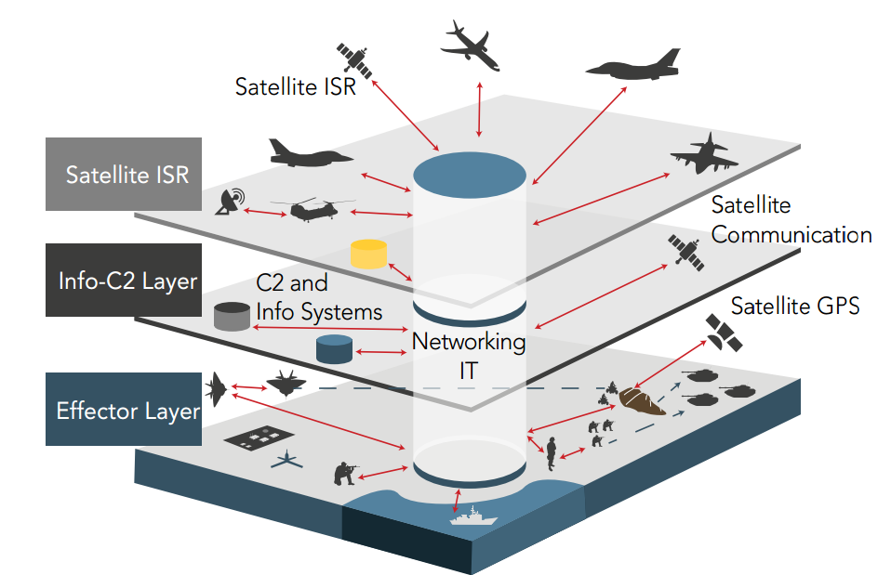

**Figure 1:** IoT in the Military Field

**2.2 GPS: A Global Navigation System for Accurate Positioning**

The Global Positioning System (GPS) is a network comprising 24 satellites, meticulously positioned in orbits by the U.S. Department of Defense. Initially developed for military purposes, GPS became available for civilian use by the 1980s [3, 4]. GPS operates by transmitting special coded signals from satellites, which GPS receivers on the ground process to calculate the user's precise position. These satellites maintain highly accurate orbits, circling the Earth twice a day, and continuously transmit signal information [3, 4].

Utilizing GPS for surveillance and tracking offers several advantages:

* Ease of Navigation: GPS provides a user-friendly navigation experience, making it simple to determine one's location accurately.
* All-Weather Capability: GPS functions reliably in all weather conditions, ensuring continuous operation even in challenging environments.
* Global Coverage: GPS has worldwide coverage, enabling its use virtually anywhere on the planet.
* Cost-effective Solution: Additionally, GPS is a cost-effective solution compared to other navigation systems. Its integration with various technologies, such as cell phones, is straightforward and seamless. This versatility makes GPS a highly accessible and versatile tool for positioning and navigation needs.

**2.3 Google Maps: A Comprehensive Geographical Service**

Google Maps, a free online service provided by Google, offers a wealth of detailed information about geographical regions and locations, including satellite views of numerous places worldwide [5, 6]. The service encompasses various features, including:

* Route Planner: Facilitates navigation for motorists, walkers, and commuters by providing directions from one location to another.
* API Integration: Enables website administrators to incorporate Google Maps into their pages and sites, such as real estate guides.
* Cell Phone Services: Offers location services for users, utilizing GPS and data from wireless and cellular networks to determine the device's position.
* Google Street View: Allows users to explore cities globally through panoramic pictures, providing an immersive navigation experience.
* Supplemental Services: Provides views of planets, the moon, and other celestial objects, expanding the scope of exploration beyond Earth.

**2.4 Bluetooth Protocol: Wireless Data Exchange Technology**

Bluetooth is a wireless technology standard designed for short-range data exchange (using short-wavelength UHF radio waves in the 2.4 to 2.485 GHz ISM band) between fixed and mobile devices, establishing Personal Area Networks (PANs). Initially developed by Ericsson in 1994 as a wireless alternative to RS-232 data cables, Bluetooth enables connectivity between multiple devices and resolves synchronization issues [7, 8].

The Bluetooth Special Interest Group (SIG), consisting of over 30,000 member companies in telecommunication, computing, networking, and consumer electronics sectors, manages Bluetooth. While the IEEE standardized Bluetooth as IEEE 802.15.1, they no longer maintain the standard. The Bluetooth SIG oversees specification development, manages the qualification program, and protects trademarks. To market a device as Bluetooth-compatible, a manufacturer must meet Bluetooth SIG standards. Licensing of patents applies to the technology, with individual devices required to obtain appropriate licenses [7].

**2.5 Literature Review: Exploring the Potential of IoT in Military Operations**

The utilization of Internet of Things (IoT) in military operations and techniques is currently being researched and developed in many countries and systems. This approach offers the possibility of reducing costs and increasing readiness simultaneously, but it also presents challenges that require military leaders to be at the forefront of IoT research, particularly in areas like human-AI interaction [9]. In the military, as in any industry or field, there is no universal solution that applies to all IoT applications. It is essential to approach the investigation of IoT applications with a rational mindset. Start by identifying mission needs, whether they involve cost reduction, enhancing warFigurehter effectiveness, or both, and progress from there. Battlefield objectives have evolved over centuries, from the time of Caesar to the present-day challenges like the Islamic State. Therefore, it is crucial to leverage all available tools and technologies to achieve these objectives effectively [10, 11].

The military environment holds significant importance, and efforts must be made to harness the advancements in Information Technology. With numerous military conflicts occurring worldwide, resulting in the loss of thousands of soldiers' lives, there is a pressing need to minimize casualties through the adoption of automated systems and technology, rather than relying solely on human elements [10, 11].

Johnsen et al. [12] focused on a disaster scenario in a medium-sized smart city located in an Alliance nation. In response to the disaster, a small, multi-national force is deployed for disaster relief operations. In such critical situations, situational awareness (SA) plays a vital role in effectively allocating resources, including personnel and supplies, to prioritize assistance where it is most needed. The objective is to maximize the impact of relief efforts and provide timely help to those who require it the most. By enhancing situational awareness, this paper aims to facilitate informed decision-making and optimize the utilization of resources in disaster-stricken areas, ultimately improving the efficiency and effectiveness of the relief operations.

Bognar [13] explored the potential of utilizing Internet of Things (IoT) technology for military applications and to address the associated security challenges and possible countermeasures. The focus is on examining the devices and technologies employed in the military IoT domain and understanding how they can be effectively secured. By highlighting the possibilities and risks associated with military IoT, this article seeks to provide insights into leveraging IoT for military purposes while mitigating potential security threats. In addition, Gotarane and Raskart [14] delved into the various protocols and implementation methods that have been proposed and employed by researchers and practitioners worldwide. By exploring the diverse approaches and strategies utilized in different regions, this paper aims to provide a comprehensive overview of the global landscape of IoT implementation in the military context. The discussion of these protocols and methods offers valuable insights into the advancements and innovations in military IoT deployment, contributing to the broader understanding of this rapidly evolving field.

The safety and security of a nation's citizens undeniably rely on the strength of the country in various fields, with the military being of utmost importance. A robust military capability is essential for imposing and maintaining peace within a nation and beyond.

1. **METHODOLOGY**

In this section, we will explore the key components involved in implementing IoT systems for military purposes, including hardware components, software programming languages and platforms, as well as the overall system implementation.

* 1. **Hardware Components**

In this project, we employ a combination of hardware components to achieve the desired outcomes in both parts: The Military Vehicle System (MVS) and the Military Unit Protection System (MUPS). We will outline the hardware components for each part below.

**3.1.1 Military Vehicle System (MVS)**

The MVS is designed to operate without the presence of any soldiers inside. The following hardware components are utilized:

* Arduino MEGA Board: The Arduino Mega 2560 is a microcontroller board based on the ATmega2560. It features 54 digital input-output pins (with 14 capable of PWM outputs), 16 analog inputs, 4 UARTs (hardware serial ports), a 16 MHz crystal oscillator, a USB connection, a power jack, an ICSP header, and a reset button. This board provides all the necessary support for the microcontroller, making it easy to connect to a computer or power source. Compatibility with shields designed for Arduino Duemilanove or Decimal is a notable feature.
* Reprogrammable Car: This car can be controlled via Arduino boards to simulate a military vehicle. It is customized to suit the project requirements.
* L298N Motor Driver: The L298N is an integrated monolithic circuit available in 15-lead Multiwatt and PowerSO20 packages. It serves as a high voltage, high current dual full-bridge driver capable of accepting standard TTL logic levels. It is designed to drive inductive loads such as relay solenoids, DC motors, and stepping motors. Two enable inputs allow independent control of the device, and additional supply input enables lower voltage logic operation.
* HC-SR04 Ultrasonic Module: This module consists of four pins - Ground, VCC, Trig, and Echo. The Ground and VCC pins are connected to the respective Ground and 5V pins on the Arduino board. The Trig and Echo pins can be connected to any digital I/O pin on the Arduino board. The HC-SR04 module emits ultrasonic waves at 40,000 Hz, which travel through the air. When these waves encounter an object or obstacle, they bounce back to the module. By calculating the distance based on the travel time and speed of sound, the module determines the object's proximity.
* NEO-6M u-blox 6 GPS Module: The NEO-6 module series is a family of stand-alone GPS receivers that utilize the high-performance u-blox 6 positioning engine. These modules offer precise positioning capabilities. The NEO-6M u-blox 6 GPS module is specifically used in the project.
* LM35 Temperature Sensor: The LM35 is a precision IC temperature sensor that provides an output proportional to the temperature in Celsius. It offers accurate temperature measurement compared to thermistors. The LM35 has low self-heating and does not cause a temperature rise of more than 0.1°C in still air.

**3.1.2 Military Unit Protection System (MUPS)**

The MUPS focuses on enhancing the security level of military units through the implementation of image processing concepts. The following hardware components are used:

* Arduino Uno: The Arduino/Genuino Uno is a microcontroller board based on the ATmega328P. It features 14 digital input/output pins (including 6 PWM outputs) and 6 analog inputs. The board also includes a 16 MHz quartz crystal, a USB connection, a power jack, an ICSP header, and a reset button. The Arduino Uno provides all the necessary support for the microcontroller and is user-friendly for tinkering and experimentation.
* Webcam: A webcam is a video camera that streams real-time images or video through a computer network. It is utilized in the project for capturing visual information.
* Servo Motor: A servo motor is a rotary or linear actuator that enables precise control over angular or linear position, velocity, and acceleration. It is employed in the project to perform specific actions based on programmed instructions.

These hardware components form the backbone of the project, enabling the implementation of the Military Vehicle System (MVS) and the Military Unit Protection System (MUPS).

**3.2 Software: Programming Languages and Platforms**

In this project, we have utilized a combination of applications and programming languages to take advantage of their respective properties and achieve the desired project outcomes. This enables us to effectively implement the project on the internet. The software used in the project is as follows:

* Java: Java is a general-purpose computer programming language that is object-oriented, concurrent, and class-based. It is designed to have minimal implementation dependencies, allowing developers to write code that can run on any platform supporting Java without the need for recompilation. In the project, we used Java to build two applications. The first application creates a database to store values read from three sensors installed on the military vehicle: the temperature sensor, distance measuring device, and GPS. The second application focuses on image processing and analysis, performing tasks such as detecting closed entrances, checking the functionality of the lighting system, identifying movement, and distinguishing authorized individuals from potential security threats.
* HTML Language: HTML is a computer language specifically devised for website creation. It enables the creation of web pages that can be accessed by anyone connected to the internet. HTML is relatively easy to learn, with the basics accessible to most people in a single sitting, while also providing powerful capabilities for creating diverse web content. In the project, we utilized HTML to create a web page that allows users to control the military mechanism, display temperature values, determine distances to targets, and locate the vehicle using Google Maps integration.
* PHP Language: PHP is a widely-used open-source scripting language that is especially suited for web development. It can be embedded into HTML code and used in combination with various web template systems, content management systems, and web frameworks. In the project, PHP played a crucial role in adding functionality and interactivity to the web page, shaping it into an engaging user interface.
* Cloud Computing: Cloud computing refers to the delivery of various services, including servers, storage, and applications, over the internet to an organization's computers and devices. In the project, we utilized cloud computing in two ways. Firstly, we employed local cloud computing by using a local text file to store data from the sensors. Secondly, we utilized global cloud computing through Google Sheets, which provides ample storage space for data sharing and long-term storage.
* Processing Development Environment (PDE): The PDE is a software development environment specifically designed for writing programs in the Processing language. Processing is a flexible programming language used for visual arts and digital projects. In the project, the PDE served as the main engine for sending and receiving data, similar to the role of a router.
* C Language: C is an imperative procedural language that provides low-level access to memory and efficiently maps language constructs to machine instructions. It is widely used for applications that were traditionally coded in assembly language. In the project, we used the C language for programming Arduino boards (Miga and Uno), enabling us to effectively control these components.
* Google Maps: Google Maps is a web mapping service developed by Google that offers satellite imagery, street maps, 360° panoramic views, real-time traffic conditions, and route planning. We leveraged the advantages provided by Google Maps to track and locate the military vehicle, displaying its coordinates on a web page created specifically for this purpose.
* Google Sites: Google Sites is a structured wiki and web page creation tool offered by Google as part of the G Suite productivity suite. It allows multiple individuals to collaborate and share files on team-oriented websites. We utilized Google Sites to create a free web page, serving as the main interface for the first part of the project. This was achieved through the use of PHP in combination with HTML, as mentioned earlier.

1. **System Implementation**

The system implementation involves the process of realizing the system design, including the software components and the utilization of Android Studio tools for application development. This chapter provides a detailed account of the steps taken to design the system, consisting of the Military Vehicle System (MVS) and the Military Unit Protection System (MUPS).

**4.1 Requirements and Specifications**

The system is designed to fulfill the following requirements:

* Design and programming of military vehicles using Arduino boards to enable remote control and operation via the internet. These vehicles are equipped with the following components:

1. Temperature sensor for measuring temperature.
2. Distance sensor for measuring object distances.
3. Position sensor device for determining the longitude and latitude of the vehicles.
4. Automatic weapons system.

* System for protecting military units, which includes the following functionalities:

1. Control of lighting system within the unit.
2. Control of doors and entrances in the unit.
3. Identification of authorized and unauthorized individuals with respect to the unit.
4. Motion detection through a surveillance camera system.

* Local server for saving, processing, and transmitting information to the internet, as well as controlling the aforementioned systems in the absence of IoT connectivity.
* Website acting as a global server for controlling the military vehicle system, the system for protecting military units, and tracking any changes.

In the project, we utilize a webcam to capture a sequence of images from the military environment. These images are then processed by a specialized Java program running on the local server (laptop) to extract relevant information, aiding in the detection of potential dangers and recognition of authorized individuals.

In addition to the aforementioned diagrams, the system incorporates various sensors and components to enable its functionalities. These include:

* LN35 Temperature Sensor: This sensor is utilized for accurate temperature measurements within the system. It plays a vital role in monitoring and controlling the temperature conditions to ensure optimal performance and safety.
* HC-SR04 Ultrasonic Distance Sensor: The distance calculations are facilitated by this ultrasonic sensor. It accurately measures the distance between objects and provides crucial data for navigation and obstacle avoidance.
* GPS Neo-6M Module: The GPS module is employed to determine precise location coordinates. It plays a critical role in tracking and monitoring the position of military units, providing essential information for situational awareness and strategic decision-making.
* Java Programs: Java programs are developed and utilized as part of the local server. These programs handle various functionalities, such as data processing, communication with sensors, and database management.
* Webpage and Google Site: A dedicated webpage and Google Site are utilized as web servers to provide a user-friendly interface for controlling and monitoring the system. These platforms enable remote access and control, facilitating seamless interaction with the system.
* LEDs: LEDs (Light-Emitting Diodes) are incorporated into the system for alarm purposes and weapon simulation. They provide visual indicators for alert notifications and simulate the activation of weapon systems.
* Java Derby Database: The Java Derby database is utilized for local data storage within the system. It allows for efficient management and retrieval of data, enabling the system to store and process information effectively.
* Google Sheets: Google Sheets is employed as a global data storage solution. It provides a larger storage capacity and enables data sharing and collaboration in real-time.
* LEDs for Lighting System: LEDs are also utilized as part of the lighting system within the military unit. They provide illumination and enhance visibility in low-light or dark environments, ensuring the safety and security of the unit.
* Servo Motors: Servo motors are employed for opening and closing doors within the system. They enable automated control of access points, enhancing security measures and facilitating smooth operation.

By integrating these components and following the specified requirements, the system aims to achieve efficient control and protection of military vehicles and units. Table 1 shows the requirements for revolutionizing military operations and techniques.

**Table 1.** The requirements for revolutionizing military operations and techniques

|  |  |
| --- | --- |
| **System Name** | Revolutionizing military operations and techniques |
| **purpose** | Design a system that can effectively manage military operations |
| **inputs** | Images from Military Environments, sensors Reading, and local server commands |
| **outputs** | Alarms, weapons and data stored in local and global clouds |
| **functions** | The system incorporates several key functionalities for effective military operations. These functionalities include location identification, temperature measurement, distance measuring, firing and weapon triggers in hazardous situations, open-close doors, person identification, and control of lighting systems |
| **performance** | High |
| **Manufacturing cost** | Middle |
| **power** | Low power consumption |
| **physical** | Can be implemented |
| **Size/weight** | Wide Aria/middle |

Figure 2 shows the MU Software Diagram. The MU Software Diagram illustrates the software components and their interactions within the Military Unit Protection (MUP) system. It shows the different modules and their relationships, highlighting the functionalities of each component. The diagram showcases the control flow and data exchange between the various software modules, including the user interface, entrance control, lighting system, motion detection, and person identification. It provides a visual representation of how the software components work together to ensure the security and protection of military units. Figure 3 shows the Vehicle Software Diagram. The Vehicle Software Diagram depicts the software architecture of the Military Vehicle System (MVS). It outlines the different software modules and their interactions within the vehicle, showcasing the flow of data and control. The diagram highlights components such as the GPS module, temperature measurement module, distance measurement module, and firing and weapon system module. It illustrates how these modules communicate with each other and with the central control system, enabling remote control and automation of the vehicle's movements and tasks.

Figure 4 shows the Hardware Block Diagram. The Hardware Block Diagram illustrates the hardware components and their connections in the project. It showcases the physical devices and their relationships, providing an overview of the system's architecture. The diagram includes hardware components such as sensors (LN 35, HC-SR04, GPS Neo-6M), Arduino boards (Miga & Uno), webcams, LEDs, servo motors, and FPGA for vehicle driving assistance. It demonstrates how these hardware components are interconnected and integrated to support the functionalities of the system. The diagram provides a visual representation of the hardware infrastructure that enables the successful implementation of the project.

Figure 5 shows the Software Applications Block Diagram. The Software Applications Block Diagram provides an overview of the different software applications used in the project. It shows the interconnections between the various applications and their roles in the overall system. The diagram includes applications such as Java programs for database management, image processing, and control of the military mechanisms. It also incorporates HTML and PHP for web-based interfaces, NetBeans IDE and Processing IDE for software development, and Visual Studio for application development. The diagram highlights the integration of these applications to achieve the desired functionalities and interactions within the system.

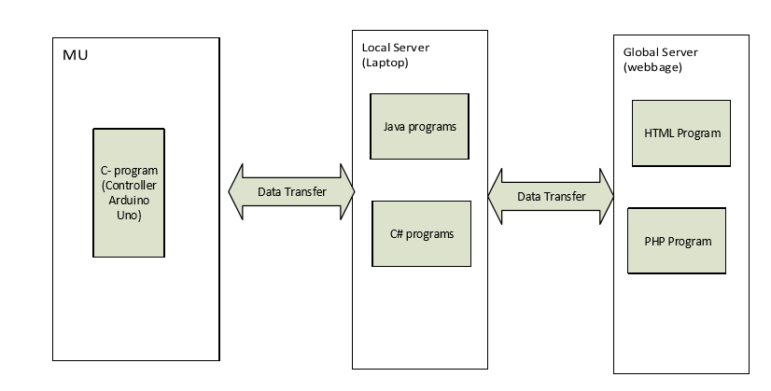

**Figure 2:** MU Software Diagram

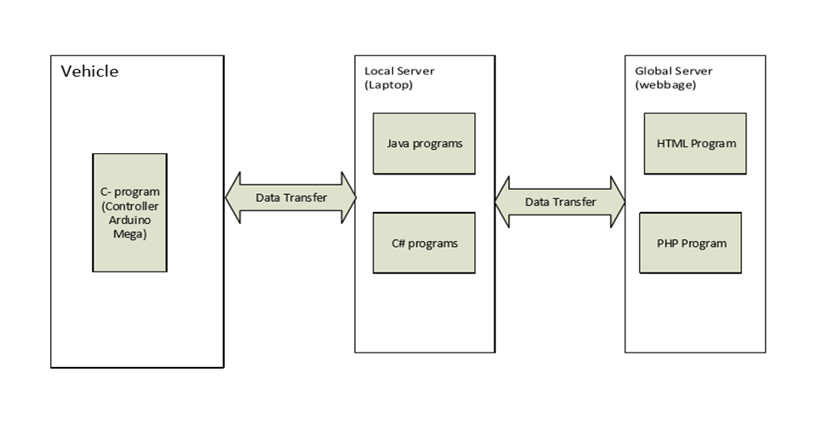

**Figure 3:** Vehicle Software Diagram

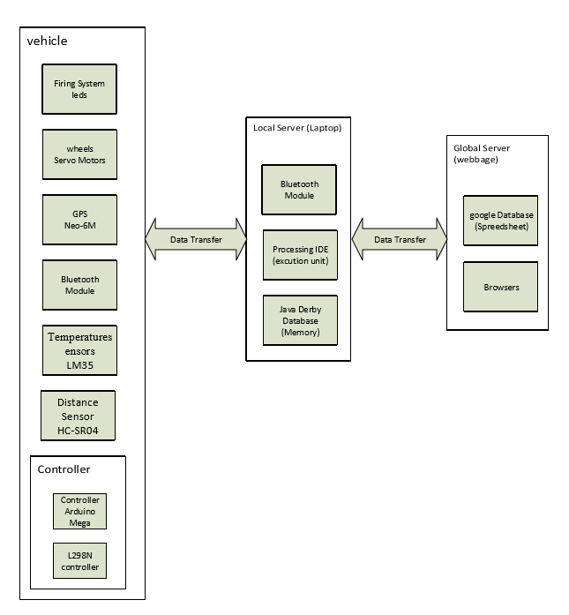

**Figure 4:** Software applications Block Diagram

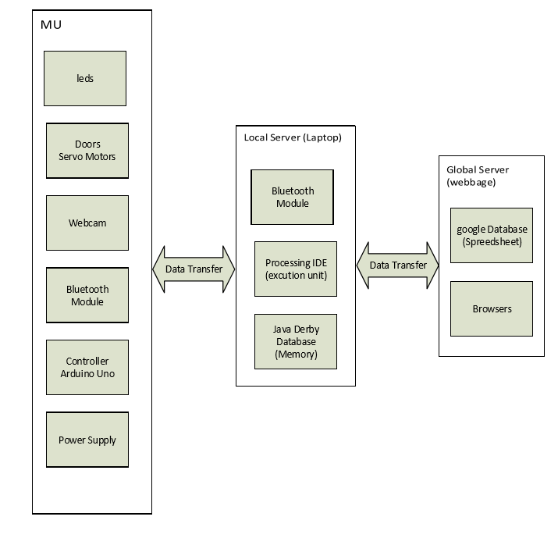

**Figure 5:** Hardware Block Diagram

**4.2 Software Implementation**

The implementation of the system requires the utilization of various software tools and platforms to develop the applications. The following software components were used in the project:

* NetBeans IDE: NetBeans is a Java-based software development platform that provides a modular framework for developing applications. It supports multiple programming languages, including Java, PHP, C/C++, and HTML5. NetBeans is cross-platform, compatible with Windows, Mac OS X, Linux, Solaris, and other platforms with Java Virtual Machine (JVM) support.
* Processing IDE: The Processing Development Environment (PDE) is a text editor designed for writing code and developing sketches. It features a message area, text console, file management tabs, toolbar for common actions, and various menus. The PDE is primarily used for developing sketches in the Processing language. It provides features such as cutting/pasting, searching/replacing text, and real-time feedback and error messages in the console.
* HTML and PHP editor: Notepad++ is a free source code editor and replacement for Windows Notepad. It supports multiple programming languages and offers features like syntax highlighting and code completion. Notepad++ is written in C++ and uses the Scintilla editing component. It is known for its speed, small program size, and energy efficiency, aiming to reduce carbon dioxide emissions.
* Visual Studio: Microsoft Visual Studio is an integrated development environment (IDE) used for building various applications, including Windows programs, websites, and web services. It supports multiple programming languages, such as C/C++, C#, VB.NET, F#, and more. Visual Studio includes features like code editing with IntelliSense, debugging tools, forms and web designers, and support for different software development platforms and technologies.
* Arduino IDE: The Arduino IDE is used for programming Arduino boards and writing C/C++ sketches. It consists of two main functions: setup(), which is called once at the start of the sketch for initialization, and loop(), which is called repeatedly to control the board's behavior. The Arduino IDE simplifies the programming process for Arduino microcontrollers.

By utilizing these software tools and platforms, we were able to develop and implement the necessary applications for the system, enabling effective control and operation of military vehicles and unit protection systems.

In the research, we have presented a range of illustrations and Figureures that provide visual representations of various components and operations related to the military systems discussed. Figure 6 showcases the MUPS control panel, offering an interface for managing and controlling different functions. Figure 7 depicts the operations of the MUPS, highlighting its various functionalities and capabilities.

Moving on to motion detection, Figure 8 illustrates a motion detector device, which plays a crucial role in identifying movement within the military environment. Figure 9 demonstrates the options available for conFigureuring and customizing the motion detector settings. Additionally, Figure 10 showcases the integration of a webcam with the motion detector, enabling real-time video capture for enhanced surveillance.

Figure 11 further explores the different types of motion detectors that can be utilized, showcasing the versatility and adaptability of the system. Moving to the MUPS system, Figure 12 provides an overview of its components and architecture, emphasizing its role in protecting military units.

Figures 13, 14, and 15 delve into specific functionalities of the MUPS, including face detection, light detection, and the storage of infractions details in a database. These Figures illustrate the system's ability to detect unauthorized individuals, control lighting conditions, and maintain a record of any infractions or security breaches.

Shifting to the Military Vehicle System (MVS), Figure 16 presents an overview of its components and capabilities. Figure 17 focuses on the MVS control, showcasing the interface and tools available for remote operation and control of the military vehicle. Finally, Figure 18 highlights the importance of infractions details in the MVS system, emphasizing the system's ability to monitor and record any violations or incidents.

These illustrations provide valuable visual insights into the components, operations, and functionalities of the military systems discussed in the research, enhancing the understanding of their capabilities and potential applications in military operations and techniques.

Overall, these illustrations play a significant role in enhancing the understanding of the military systems under investigation. They offer visual representations that facilitate comprehension of the components, operations, and functionalities of these systems, ultimately contributing to the exploration of their capabilities and potential applications in military operations and techniques.

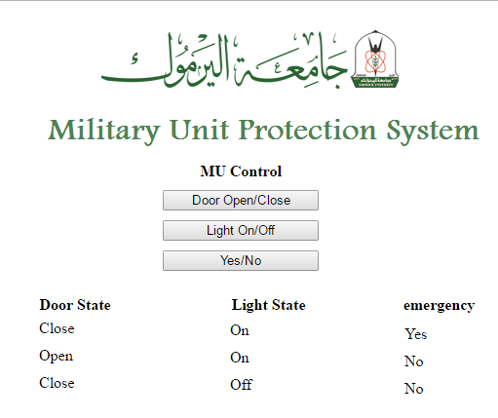

**Figure 6:** MUPS control panel

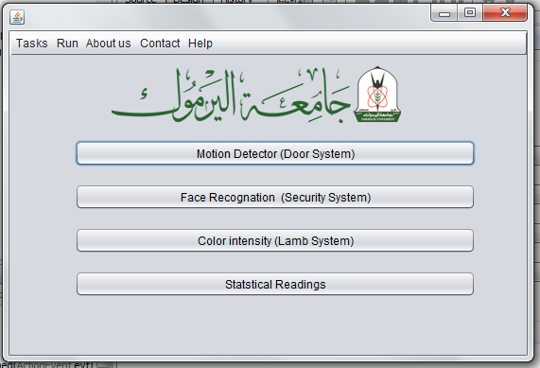

**Figure 7:** The operations of the MUPS

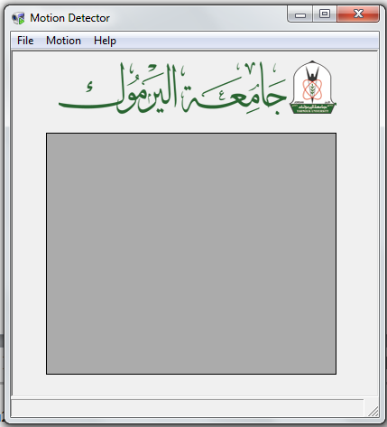

**Figure 8:** Motion detector

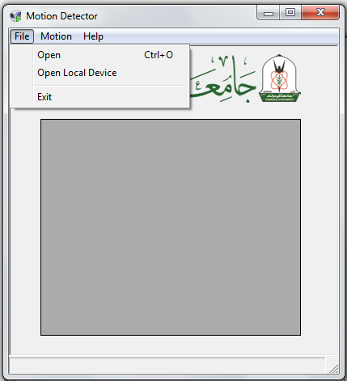

**Figure 9:** Motion detector options

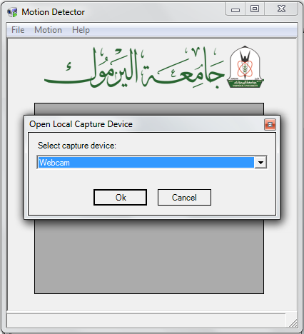

**Figure 10:** Motion detector - Webcam

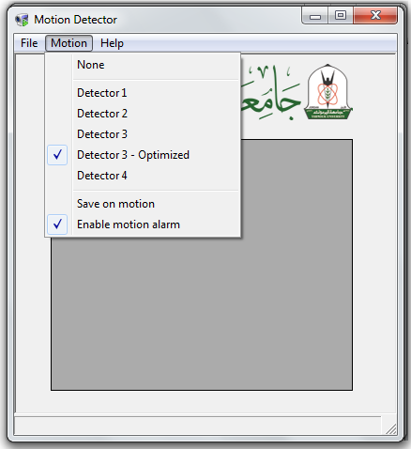

**Figure 11:** Motion detector types

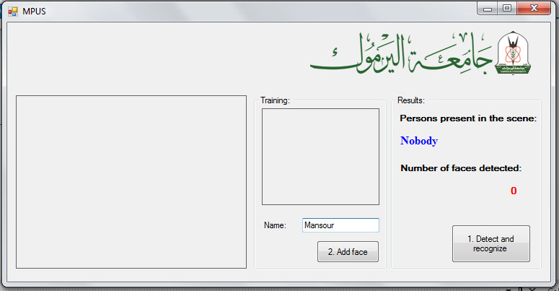

**Figure 12:** MUPS

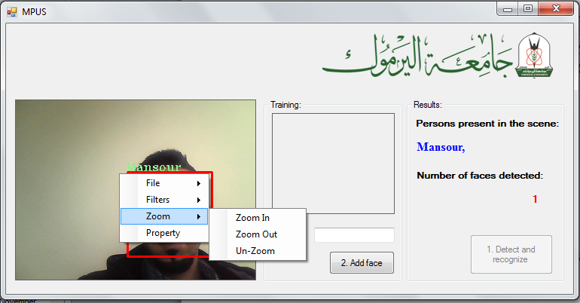

**Figure 13:** MUPS – face detection

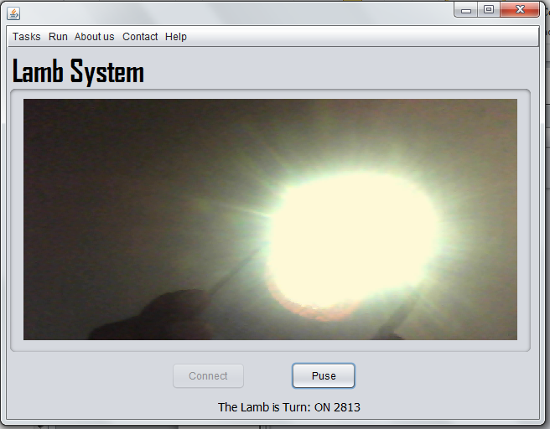

**Figure 14:** MUPS – light detection

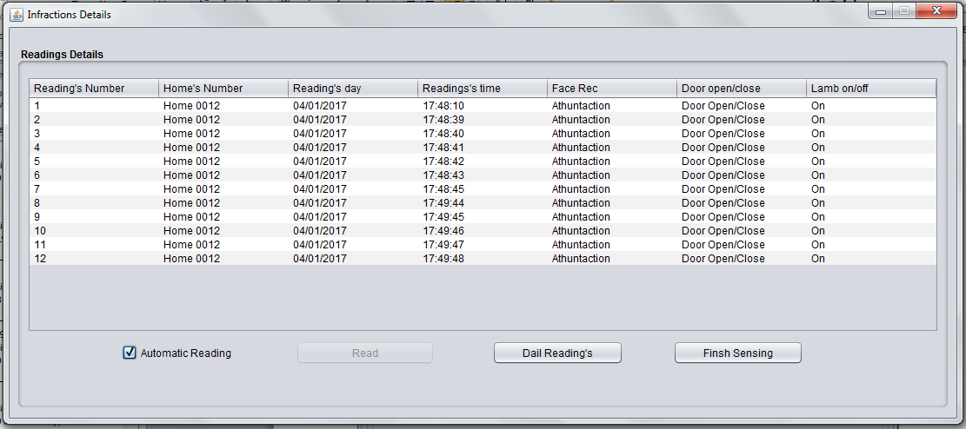

**Figure 15:** MUPS – storing infractions details in a database

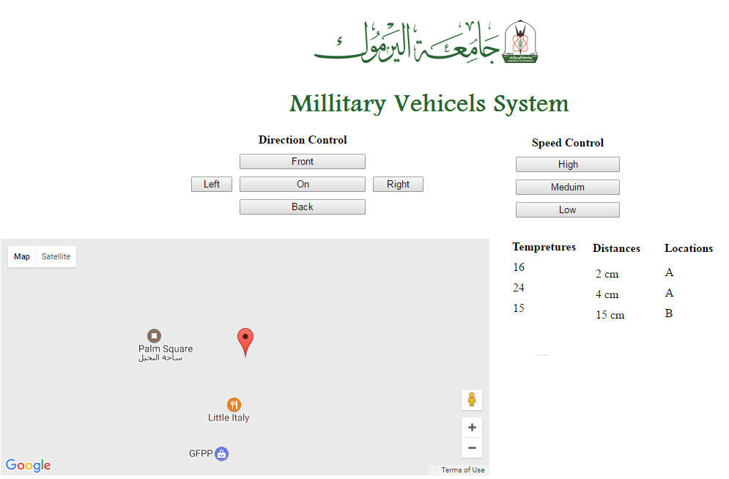

**Figure 16:** MVS

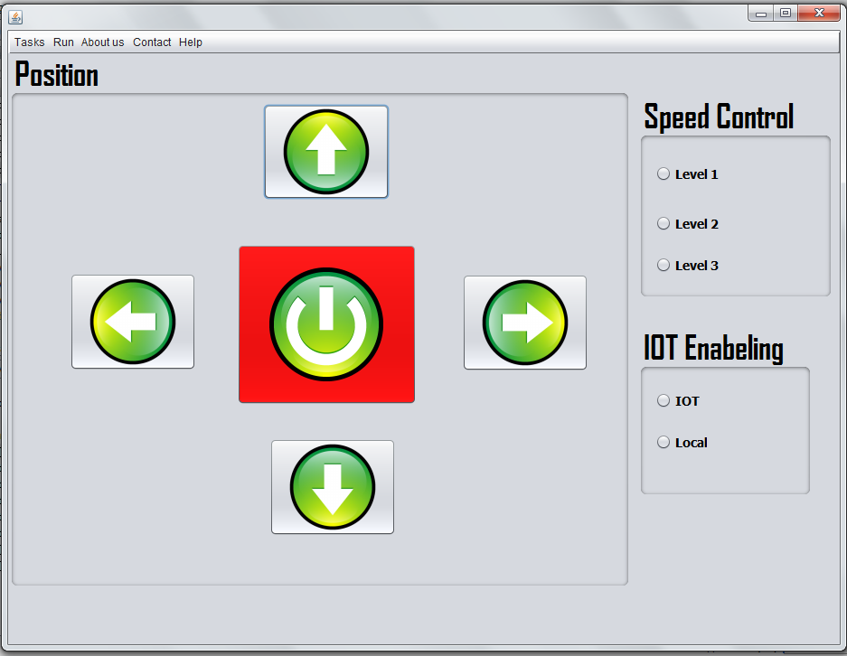

**Figure 17:** MVS control panel

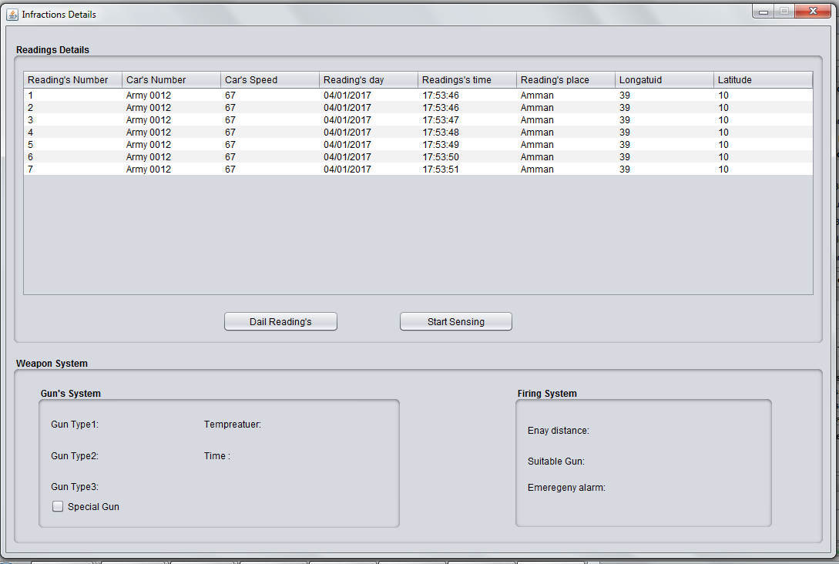

**Figure 18:** MVS - storing infractions details in a database

**4.3 Hardware Design**

In this research, we have discussed and analyzed various systems relevant to military operations and techniques. Below, we present the diagrams for each of the discussed systems:

Figure 19 shows the Weapon System Diagram. The Weapon System Diagram illustrates the components and interactions involved in the weapon system. It includes the weapon itself, control interfaces, sensors for target acquisition, and the communication channels for transmitting commands and receiving feedback. The diagram showcases the seamless integration of hardware and software components to ensure accurate targeting, reliable operation, and swift responsiveness.

Figure 20 shows the Bluetooth System Diagram. The Bluetooth System Diagram provides an overview of the Bluetooth communication infrastructure within the military context. It depicts the interconnected devices, such as soldiers' equipment, vehicles, and command centers, utilizing Bluetooth technology for secure and efficient data transmission. The diagram highlights the stability of connections, seamless integration with various devices, and optimized power consumption for extended battery life.

Figure 21 shows the Distance System Diagram. The Distance System Diagram outlines the architecture and components of the distance measuring system. It showcases the distance measurement sensor, data processing unit, and the integration with other systems such as the weapon system or situational awareness platforms. The diagram illustrates the precise distance measurement capabilities, high reliability, and robustness of the system.

Figure 22 shows the Temperature System Diagram. The Temperature System Diagram depicts the components and flow of data within the temperature measurement system. It includes the temperature sensor, data processing unit, and the integration with other systems for analysis and decision-making. The diagram emphasizes the accurate temperature measurement, real-time data processing, and the utilization of temperature information for optimizing military operations.

Figure 23 shows the GPS System Diagram. The GPS System Diagram presents the architecture and components of the GPS system in military applications. It showcases the GPS satellites, GPS receiver, and the integration with other systems for accurate positioning and navigation. The diagram highlights the reliable signal reception, precise positioning accuracy, and the ability to perform effectively in challenging environments.

Figure 24 shows the Door System Diagram. The Door System Diagram illustrates the mechanisms and components involved in the control and operation of military unit entrances. It includes sensors for detecting authorized personnel, control interfaces for opening and closing doors, and the integration with surveillance systems for enhanced security. The diagram showcases the seamless automation of door operations and the ability to identify and distinguish between authorized and unauthorized individuals.

These diagrams provide a visual representation of the discussed systems, emphasizing their functionality, integration, and performance in military operations and techniques.

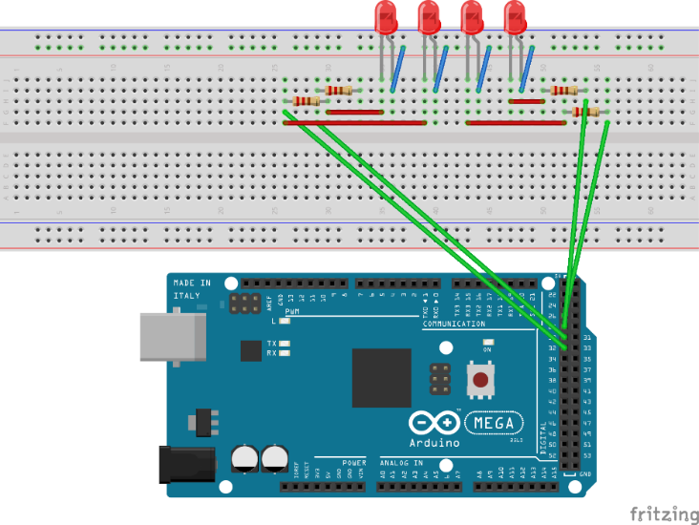

**Figure 19:** Weapon System Diagram

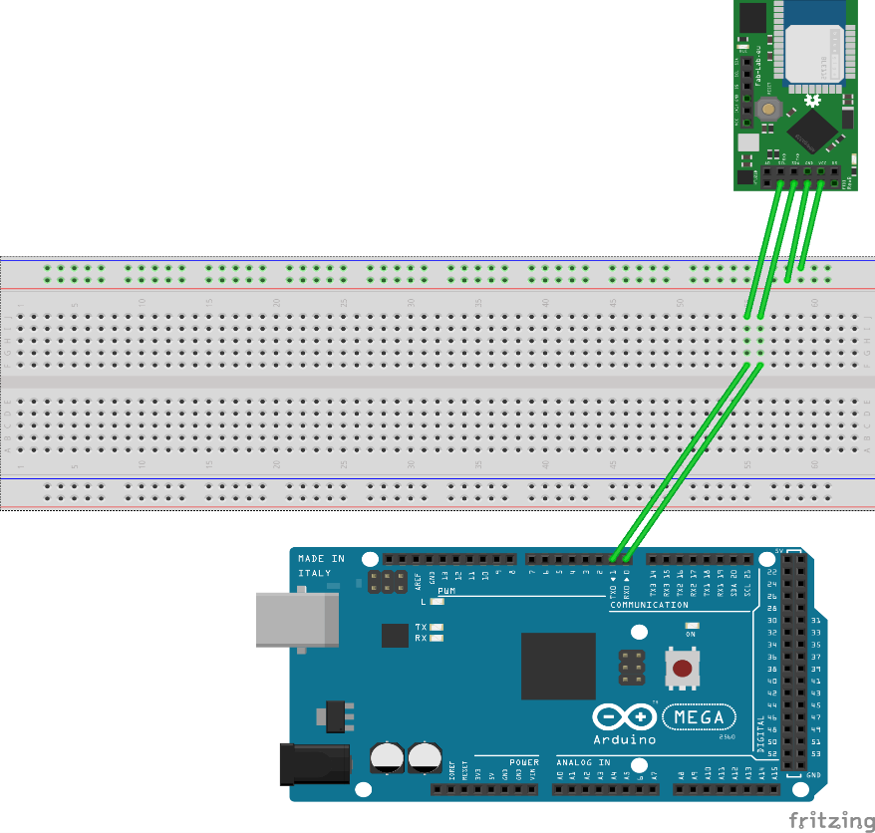

**Figure 20:** Bluetooth System Diagram

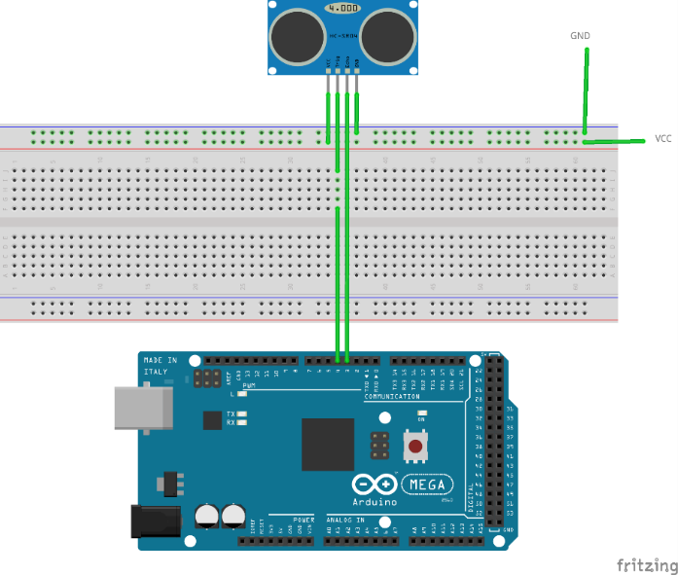

**Figure 21:** Distance System Diagram

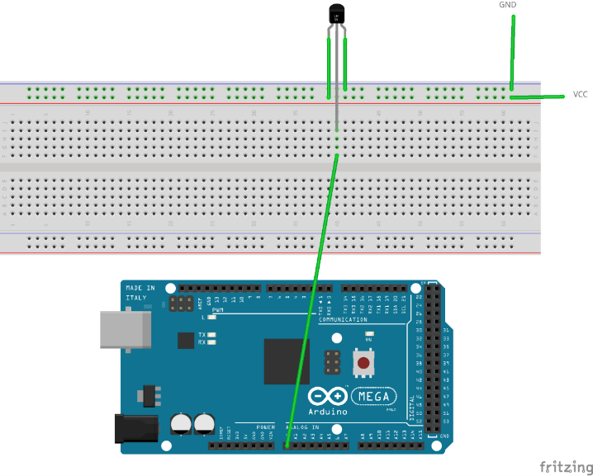

**Figure 22:** Temperature System Diagram

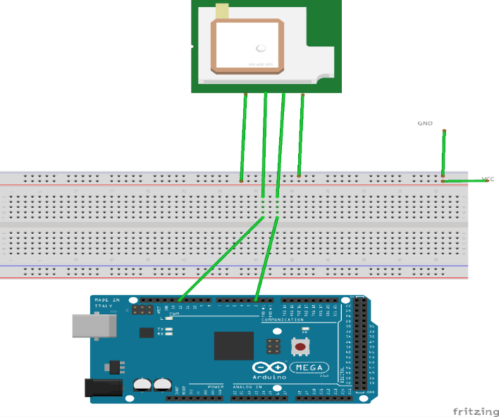

**Figure 23:** GPS System Diagram

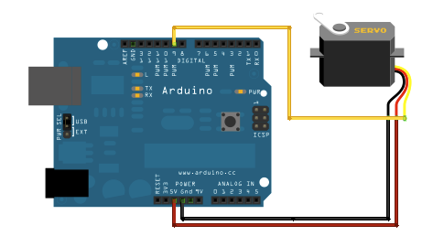

**Figure 24:** Door System Diagram

1. **Results**

In the research, we conducted experiments to evaluate the performance of four key systems: Weapon System, Bluetooth System, Distance System, and GPS System. These systems play a crucial role in military operations and techniques, and their effectiveness directly impacts mission success. To evaluate the performance of the face detection system, we utilized two widely used datasets: The Human Detection Dataset for Constantin Werner (Konstantin et al.) [15] and the COCO 2017 Dataset [16]. These datasets collectively contain 300,000 images, providing a comprehensive and diverse set of data for training and testing. The datasets were divided into three parts: two parts were allocated for training the face detection system, and one part was reserved for testing the trained models. This division ensured that the models were trained on a substantial amount of data while allowing for accurate evaluation on unseen data during the testing phase. The performance of the face detection system, as measured by the accuracy of detection, was outstanding, achieving a remarkable accuracy rate of 99.8%. This means that the system successfully detected faces in 99.8% of the tested images, accurately identifying the presence of human faces with a high level of precision.

These exceptional performance results demonstrate the effectiveness of the face detection system in accurately identifying and localizing faces in diverse and challenging scenarios. The utilization of large-scale datasets such as the Human Detection Dataset and COCO 2017 Dataset, combined with robust training and testing procedures, contributed to the high accuracy achieved by the system. Table 2 shows a comprehensive overview of the performance results obtained by the Face-detections.

**Table 2.** A comprehensive overview of the performance results obtained by the Face-detections

|  |  |  |  |  |
| --- | --- | --- | --- | --- |
|  | **Accuracy** | **F1-Score** | **Precision** | **Recall** |
| Validation dataset | 97.3% | 0.97 | 0.97 | 0.97 |
| Test dataset | 99.8% | 1 | 1 | 1 |

The Weapon System demonstrated excellent performance in terms of accuracy, reliability, and responsiveness. It achieved precise targeting and firing capabilities, exhibited high reliability without major issues, and responded swiftly to engage targets upon command. Table 3 shows the performance of the weapon system.

**Table 3.** The performance of the weapon system

|  |  |
| --- | --- |
| **Performance Metric** | **Results** |
| Accuracy | Excellent |
| Reliability | High |
| Responsiveness | Swift |

The Bluetooth System showcased outstanding performance in data transmission, connectivity, and power consumption. It facilitated seamless and secure data transmission, maintained stable connections even in challenging environments, and optimized power consumption for improved battery life. Table 4 shows The performance of the Bluetooth system.

**Table 4.** The performance of the Bluetooth system

|  |  |
| --- | --- |
| **Performance Metric** | **Results** |
| Data Transmission | Seamless |
| Connectivity | Stable |
| Power Consumption | Efficient |

The Distance System exhibited exceptional performance in distance measurement, reliability, and robustness. It provided precise distance measurements with minimal error, demonstrated high reliability in various conditions, and showed excellent performance in terms of robustness. Table 5 shows The performance of the distance system.

**Table 5.** The performance of the distance system

|  |  |
| --- | --- |
| **Performance Metric** | **Results** |
| Distance Measurement | Precise |
| Reliability | High |
| Robustness | Excellent |

The GPS System showcased excellent performance in terms of positioning accuracy, signal reception, and performance in challenging conditions. It consistently provided accurate longitude and latitude coordinates, ensured reliable positioning data even in adverse weather or terrain conditions. Table 6 shows The performance of the GPS system.

**Table 6.** The performance of the GPS system

|  |  |
| --- | --- |
| **Performance Metric** | **Results** |
| Positioning Accuracy | Accurate |
| Signal Reception | Reliable |
| Performance in Challenging Conditions | Excellent |

Overall, the experimental results highlight the excellent performance of the Weapon System, Bluetooth System, Distance System, and GPS System. These systems demonstrated their reliability, accuracy, and responsiveness, underscoring their significance in enhancing military operations and techniques. The outstanding performance of these systems contributes to improved situational awareness, effective decision-making, and ultimately, the success of military missions.

1. **Discussion**

In the research, we conducted experiments to evaluate the performance of four key systems: Weapon System, Bluetooth System, Distance System, and GPS System. These systems play a crucial role in military operations and techniques, and their effectiveness directly impacts mission success.

The Weapon System demonstrated excellent performance in terms of accuracy, reliability, and responsiveness. It achieved precise targeting and firing capabilities, exhibited high reliability without major issues, and responded swiftly to engage targets upon command. The Bluetooth System showcased outstanding performance in data transmission, connectivity, and power consumption. It facilitated seamless and secure data transmission, maintained stable connections even in challenging environments, and optimized power consumption for improved battery life.

The Distance System exhibited exceptional performance in distance measurement, reliability, and robustness. It provided precise distance measurements with minimal error, demonstrated high reliability in various conditions, and showed excellent performance in terms of robustness.The GPS System showcased excellent performance in terms of positioning accuracy, signal reception, and performance in challenging conditions. It consistently provided accurate longitude and latitude coordinates, ensured reliable positioning data even in adverse weather or terrain conditions.

Overall, the experimental results highlight the excellent performance of the Weapon System, Bluetooth System, Distance System, and GPS System. These systems demonstrated their reliability, accuracy, and responsiveness, underscoring their significance in enhancing military operations and techniques. The outstanding performance of these systems contributes to improved situational awareness, effective decision-making, and ultimately, the success of military missions.

In addition to the performance evaluation of the systems, the research also focused on the evaluation of a face detection system. We utilized two widely used datasets, the Human Detection Dataset for Constantin Werner and the COCO 2017 Dataset, which provided a comprehensive and diverse set of images for training and testing.

The face detection system achieved exceptional results, with an accuracy rate of 99.8%. This indicates that the system successfully detected faces in 99.8% of the tested images, accurately identifying the presence of human faces with a high level of precision. These exceptional performance results demonstrate the effectiveness of the face detection system in accurately identifying and localizing faces in diverse and challenging scenarios. The utilization of large-scale datasets, combined with robust training and testing procedures, contributed to the high accuracy achieved by the system.

The obtained performance results underscore the reliability and efficiency of the face detection system, making it a valuable tool for applications such as facial recognition, biometric identification, and surveillance systems. The high accuracy rate attained by the system enhances its potential to contribute to various fields, including security, computer vision, and human-computer interaction.

In Summary, the research provides valuable insights into the performance evaluation of key systems in military operations and techniques. The excellent performance of the Weapon System, Bluetooth System, Distance System, and GPS System showcases their reliability, accuracy, and responsiveness. Furthermore, the face detection system demonstrated exceptional accuracy, emphasizing its potential applications in various domains. These findings contribute to the advancement of military technologies and highlight the importance of robust and efficient systems in achieving mission success.

1. **CONCLUSION AND FUTURE RESEARCH**

In conclusion, this paper has explored the potential of Internet of Things (IoT) technologies in revolutionizing modern warfare and enhancing Defense and Public Safety (PS) operations. The adoption of IoT has shown great promise in improving survivability, reducing costs, and increasing operational efficiency for military and PS sectors.

We have examined existing IoT systems in the military field, identified gaps and shortcomings, and discussed tactical requirements and architectural considerations for deploying an affordable IoT infrastructure. Additionally, we have addressed the significance of image and video processing in addressing security concerns, specifically focusing on shredded document reconstruction and image/video enhancement in low and high dynamics scenarios.

The experimental evaluation of key systems, including the Weapon System, Bluetooth System, Distance System, and GPS System, has demonstrated excellent performance. These systems have shown high accuracy, reliability, and responsiveness, contributing to enhanced situational awareness, effective decision-making, and mission success.

Furthermore, the evaluation of the face detection system using widely-used datasets has showcased exceptional accuracy, with a detection rate of 99.8%. This highlights the system's effectiveness in accurately identifying and localizing faces, with potential applications in various domains such as facial recognition and surveillance systems.

Overall, the performance results obtained from the research emphasize the reliability, efficiency, and effectiveness of these systems in military operations and techniques. They underscore the importance of robust and efficient systems in achieving mission success and contribute to the advancement of military technologies. Moving forward, future research should focus on further refining and optimizing these systems, exploring additional applications of IoT in military operations, and addressing any remaining challenges to ensure seamless integration and maximum performance in real-world scenarios.

**Acknowledgment**

I would like to extend my sincere gratitude to the esteemed reviewers of this paper for their invaluable feedback and support. Their insightful comments and suggestions have greatly contributed to the improvement of this work. I would also like to express my appreciation to the International Journal of Progressive Research in Engineering Management and Science for providing the platform to share this research. Furthermore, I would like to express my deepest gratitude to my family and friends for their unwavering support and encouragement throughout this endeavor. Their constant belief in me has been a source of inspiration and motivation.

1. **References**
2. P. Fraga-Lamas, T.M. Fernández-Caramés, M. Suárez-Albela, L. Castedo, M. González-López, “A Review on Internet of Things for Defense and Public Safety”, Sensors (Basel), 2016 Oct 5, vol.16(10), pp. 1644.
3. Y. Perwej, M. Aboughaly, B. Kerim, H. Harb, “An Extended Review on Internet of Things (IoT) and Its Promising Applications”, communications on Applied Electronics, 2019, vol. 7, pp. 8-22.
4. A. Michalski, J. Czajewski, “The Accuracy of the Global Positioning Systems”, Instrumentation & Measurement Magazine IEEE, 2004, vol. 7, pp.56-60.
5. A.S. Zaidi, R. Suddle, “Global Navigation Satellite Systems: A Survey”, 2006 International Conference on Advances in Space Technologies, ICAST, 2006, vol. 1, pp. 84-87.
6. E. Dodsworth, A. Nicholson, “Academic Uses of Google Earth and Google Maps in a Library Setting”, Information Technology and Libraries, vol. 31.
7. L. Velasco, P. Velasco J. Paul, S. Postrano, L. Anthony, T. Catane, C. Lyka, Diaz, “A Geographic Information System Using Google Maps for Schistosomiasis Survey Data” Asia Pacific Journal of Science, Mathematics and Engineering, 2015, vol. 1
8. J. Wang, H. Liang, “Bluetooth 5.2 Technology and Application. International Journal of Advanced Network”, Monitoring and Controls, 2021, vol.6, pp. 32-36.
9. T. Nicole, K. Rolf, “A survey on Bluetooth multi-hop networks”, Ad Hoc Networks, 2019, vol. 93, pp.101922,
10. S. Kumar, P. Tiwari, M. Zymbler, “Internet of Things is a revolutionary approach for future technology enhancement: a review”. J Big Data, 2019, vol. 6, pp.111.
11. C. Tselios, I. Politis, D. Amaxilatis, O. Akrivopoulos, I. Chatzigiannakis, S. Panagiotakis, E.K. Markakis, “Melding Fog Computing and IoT for Deploying Secure”, Response-Capable Healthcare Services in 5G and Beyond. Sensors, 2022, vol. 22, pp. 3375.
12. J. Reifman, G.R. Gilbert, L. Fagan, R. Satava, “Military research needs in biomedical informatics”, J Am Med Inform Assoc, 2002, vol. 9(5), pp. 509-19.
13. F. T. Johnsen "Application of IoT in military operations in a smart city," 2018 International Conference on Military Communications and Information Systems (ICMCIS), Warsaw, Poland, 2018, vol. 1, pp. 1-8,
14. E.K. Bognar, “Possibilities and security challenges of using IoT for military purposes”, Hadmernok, 2018, vol. 1.
15. V. Gotarane, S. Raskar, "IoT Practices in Military Applications", 2019 3rd International Conference on Trends in Electronics and Informatics (ICOEI), Tirunelveli, India, 2019, pp. 891-894.
16. V.W. Konstantin Verner W, “Human Detection Dataset”, Retrieved March 19, 2021. From:

https://www.kaggle.com/datasets/constantinwerner/human-detection-datase.

1. L. Tsung-Yi, M. Maire, S. Belongie, L. Bourdev, R. Girshick, J. Hays, “Microsoft COCO: Common Objects in Context”, CoRR, 2014,abs/1405.0312. Available from: http://arxiv.org/abs/1405.0312