Moodie Foodie

Naga Sreeja.P, 3rd Year, BCA, BMS College Of Commerce and Management, Bangalore, Karnataka, India

Poorvika.D, 3rd Year, BCA, BMS College Of Commerce and Management, Bangalore, Karnataka, India Kiran Kumar M.N, Assistance Professor, BCA, BMS College Of Commerce and Management,

Bangalore, Karnataka, India

ABSTRACT

It recommends food, based on your interest. Also, it takes orders from the recommendation list of restaurants using machine learning combining the user feedback, distance and cost for two, hence offering the most optimal choice. The major feature of our project which sets it apart from the traditional application of its kind needs three parameters to order the list of recommended restaurant with the highly recommended restaurant at the top. Based on the user feedback, cost and the restaurant distance from the user. Whenever any user orders from our restaurant, they are asked to rate the restaurant out of 5. The feedback of that restaurant is then dynamically updated using the mathematical average of the current feedback and the new rating. This computation also requires the storage of the number of feedback for a particular restaurant.

Keywords: Food Recommendations, Emotions Analysis, Order Now

INTRODUCTION

At Moodie foodie, we understand that your interest can greatly influence your food cravings. That's why we've created a unique website where we recommend delicious meals tailored to your specific interest. Our dedicated team of highly skilled and experienced chefs is committed to preparing high-quality, mouthwatering dishes that will satisfy your cravings and lift your spirits.

Our team consists of talented and experienced chefs who are passionate about creating culinary masterpieces. They understand the art of combining flavors, textures, and presentation to craft dishes that cater to your specific interest. Whether you're feeling stressed, happy, nostalgic, or adventurous, we have a wide range of options to suit your cravings.

When you visit the Moodie Foodie website, you'll be greeted with an intuitive interface that allows you to select your current interest. We have carefully curated a diverse menu that covers various cuisines and dietary preferences, ensuring there's something for everyone. Our dishes are prepared using fresh, high-quality ingredients, and our chef’s pay attention to every detail to ensure exceptional taste and presentation.

METHODOLOGY

1. Home - After logging in, you'll be greeted by our vibrant and user-friendly homepage. This page serves as your starting point to explore a world of delicious possibilities that cater to your specific interest and cravings.

At the center of the page, you'll find the "Order Now" button, beckoning you to embark on a culinary adventure tailored to your interest. Simply select your current mood from our curated list of emotions - whether you're feeling happy, stressed, adventurous, or something entirely unique - and let our team of skilled chefs work their magic.

1. About us -

The Moodie Foodie project is an innovative concept that combines technology, food, and mood- enhancing experiences. It aims to revolutionize the way people approach their food choices and dining experiences by leveraging the connection between food and emotions.

1. Menu-

Welcome to our culinary sanctuary, where we invite you to embark on a sensory journey that will tantalize your taste buds and uplift your spirit. Our menu is a testament to our passion for creating unforgettable dining experiences. Every dish has been meticulously crafted and thoughtfully curated to ensure a symphony of flavors that will satisfy both your cravings and your mood.

1. Review-

As a food enthusiast and avid traveller, I have had the pleasure of dining at countless restaurants around the world. However, my recent experience at Moodie Foodie surpassed all my expectations and left an indelible mark on my taste buds. I am thrilled to share my review of this culinary gem.

From the moment I stepped into Moodie Foodie, I was enveloped in an inviting ambiance that effortlessly combined elegance and warmth. The soft lighting, tasteful decor, and soothing background music created the perfect atmosphere for an unforgettable dining experience. The staff members were attentive, knowledgeable, and displayed genuine passion for their craft.

1. Our team-

The Moodie Foodie chef team is passionate about creating culinary delights that tantalize the taste buds. With a dedication to quality ingredients, innovative techniques, and a flair for presentation, our chefs aim to provide a memorable dining experience. From carefully crafted dishes to exquisite desserts, our team is committed to delivering exceptional flavors and ensuring that every bite leaves a lasting impression. Join us on a culinary journey that celebrates the art of food at Moodie Foodie.

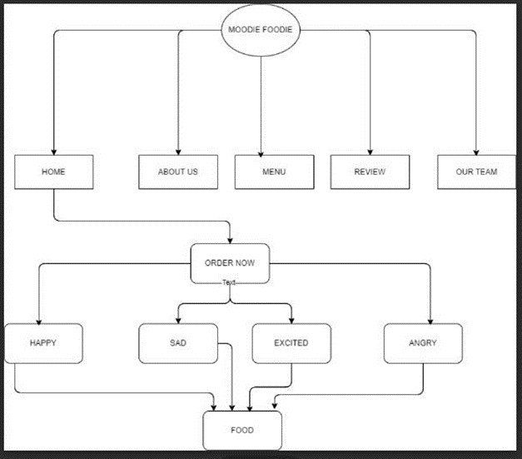

Dig.1

Results-

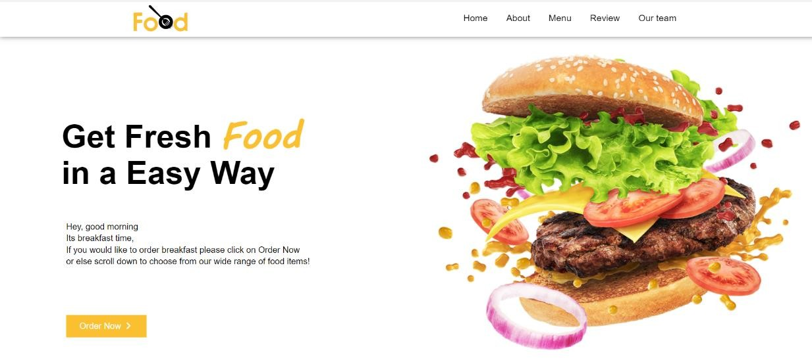

Fig.1-Home page

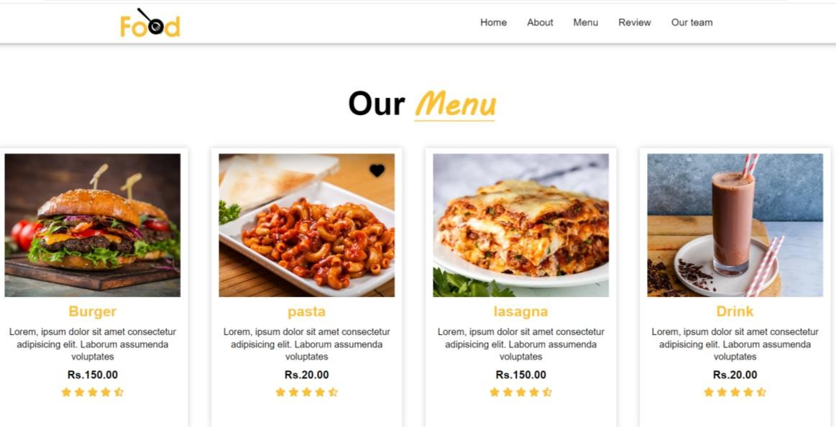

Fig.2 – Menu Page

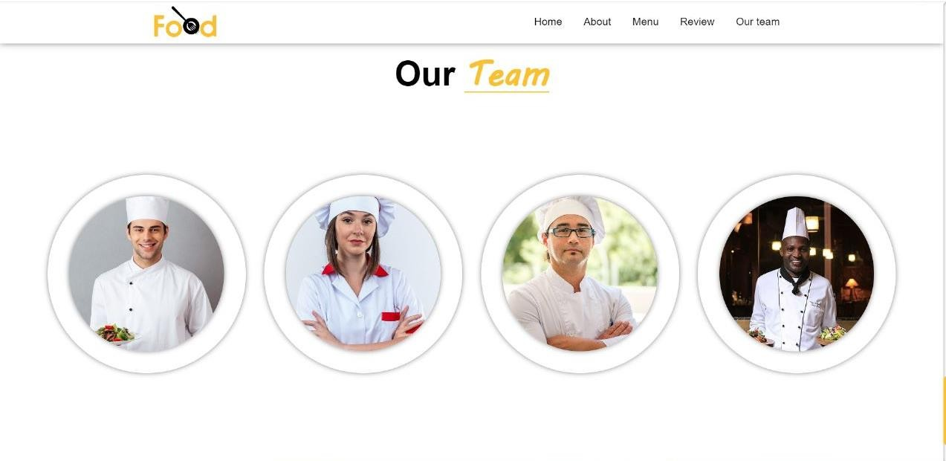

Fig.3 – Our Team

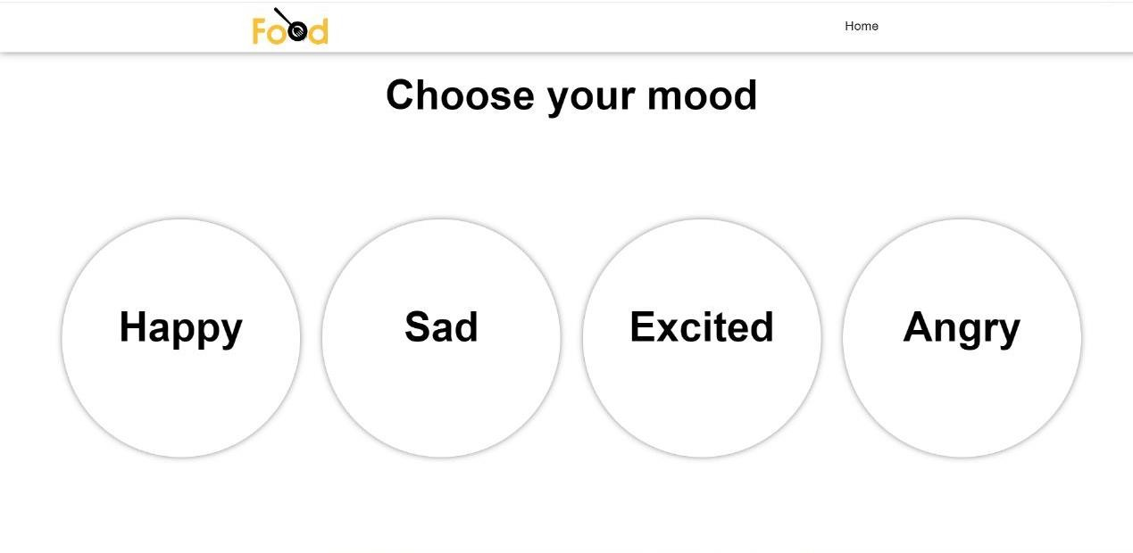

Fig.4 – Mood Analysis

**Conclusion**

Moodie Foodie's integration of mood-based food recommendations and user feedback mechanisms has transformed the way people discover and select restaurants. By offering personalized

recommendations and optimizing the ordering process, the application creates a seamless and satisfying dining experience for users. As technology continues to advance, Moodie Foodie has the potential to further refine its features and revolutionize the way we interact with food and dining establishments.

**References**

1)Lindsey Smith, Eat Feelings : The Food Mood Girls’s Guide to Transferring,2017

2)Natalie Savona, Good Mood Food : Unlock the power of diet to think and feel well,2018

3)T R Padmanabhan, Programming with Python