CROSS THE WALL – The Rolling Ball Game

Likith V, Final Year Student, BCA, BMS College Of Commerce and Management, Bangalore, Karnataka, India

Mayur Shetty C M, Final Year Student, BCA, BMS College Of Commerce and Management, Bangalore, Karnataka, India

Roopashree C S, Assistance Professor, BCA, BMS College Of Commerce and Management, Bangalore, Karnataka, India

ABSTRACT

Cross the wall – The Rolling Ball Game is a 3D game which consists of collectables throughout the game. This game has different levels where the difficulty increases on every level, the player can go to next level only after they clears the previous one. It consists of two different themes bright and dark theme where the player can select the theme they want and enjoy their game in the opted mode. The game has two different types of ball one is of regular ball and the other on is a robo sphere. The game is a 3D game which is simple to play and for fun and entertainment purpose .

Key words: Cross the wall – The Rolling Ball Game,3D ball game, robo sphere game, ball game

INTRODUCTION

It is a ball-based game which consists of two different variants of ball. one is the regular ball and another is a robot ball the ball moves on the inputs provided from the keyboard and rotates on the mouse pointer direction. The robo sphere is animated in such a way that it can be shifted to ball and get back to robot mode using the ctrl key and also the robot has the it can sprint on the shift key. The game consists of two themes Bright and Dark where the user can experience in different modes on his choice. It consists of different levels where the difficulties will be increasing on each level every time the gamer starts the game he has to starts with base level. All the level consist of collectables and the player has to collect the number of collectables in order to unblock the next level. Each level consists of different obstacles where the player may get to restart if he encounters it.

**METHODS**

1)Player input system – It is a package in unity which is use to take the input from the keyboard and perform some pre-deign and user defined actions on the selected object. It has a component called as input action component which has some pre define keys assign to an action to be performed on object it consists of console component like joystick, keyboards touch etc which take the input from the particular console component mentioned.

In this system the pre-defined action will be having pre-defined functions provided by the IDE. The user can also provide it customise actions and his function in the input action component window by creating it with the specific name and input key from the specific console keys.

For these components the script is been assigned from the user to get the input from the console component as a value for the action in the player input system. As the keys is been used the Boolean value will be passed has true and the action will be tigered.

2)Character Controller – I t is a component in the unity which is used to control the first person and third person characters in a game without any rigid body used which is used to control the physics of the character. This receives the action function from the player input system component has the function called the action will be reflected on the characters by this component.

Here we specify a script for this component based on the player input system action function tigered the character will be performing the fixed task in this script we will customise the limitations of the task like how it as to be performed at what extent it has to be performed. Here we use the variables to control such actions performance.

3)Colliders – It is component is every object in the unity which is used to control the actions by the contact of the object with the other object. This component is used to tigered events on the contact of the player with an object. There are different functions in the component which is used to perform different event on the contact of players. This is component which makes game to perform some event without the use of buttons.

4)Button on click function -This is the component in unity which is use to design a user interface which triggers the event or action based on the click of the button this uses user defined scripts to perform some task were the user defines the task has to be done when the function is called then assign the script to the button which has an on click trigger by which when the user clicks on the button the script functions which assign to the button will be executed. This is the component which takes the input has only click

5)Cinemachine – It is a package of unity which is used to customise the camera view. It is used in our project to follow the third person character on a customised way based on the user define script where we have defined some particular angles and movement of the camera with third person character. We have customised the character movement based on the camara facing direction and also the distances of the camara from the third person character.

6)Animation – It is a component in unity which uses the clip for the behaviour of an object. The user has to assign this animation throw animator component object that required a behaviour. The animator components contain controller which has the several motion in to an action the object based on the user inputs. The clips can be modified based on the user wants. It is mainly used for the motions of the characters based on the key inputs by the users.

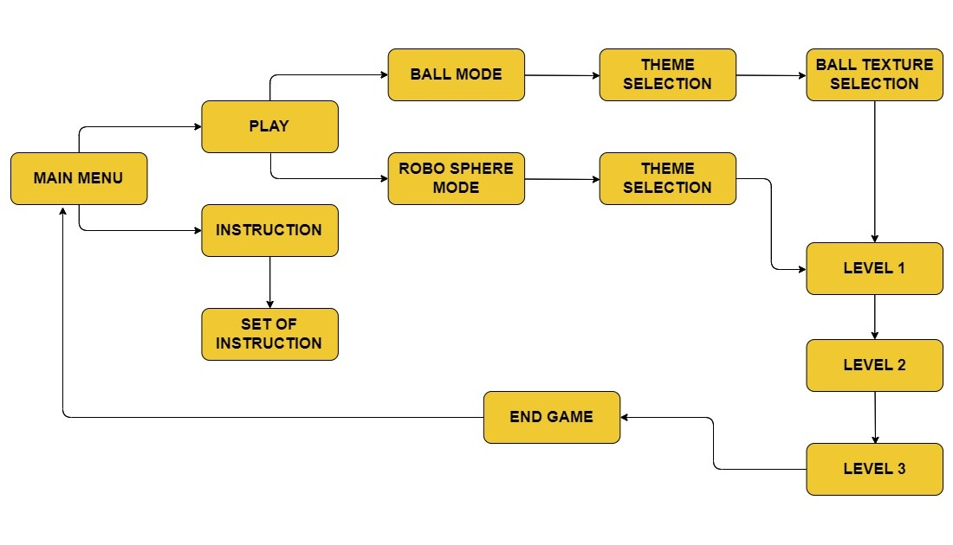

Dig.1 – Process Diagram

Results

UI Design

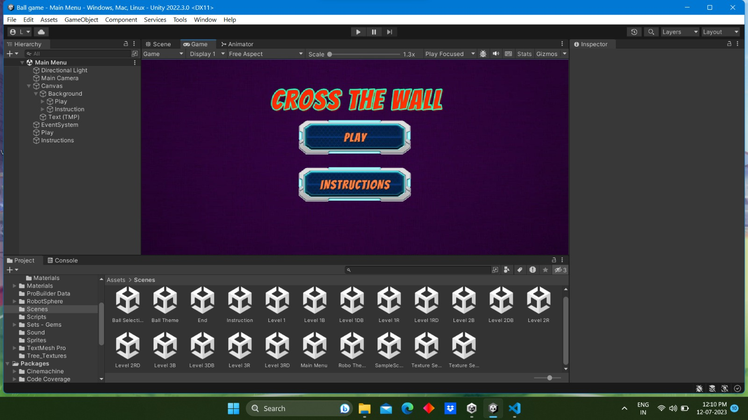

Fig.1 – Main Menu Interface

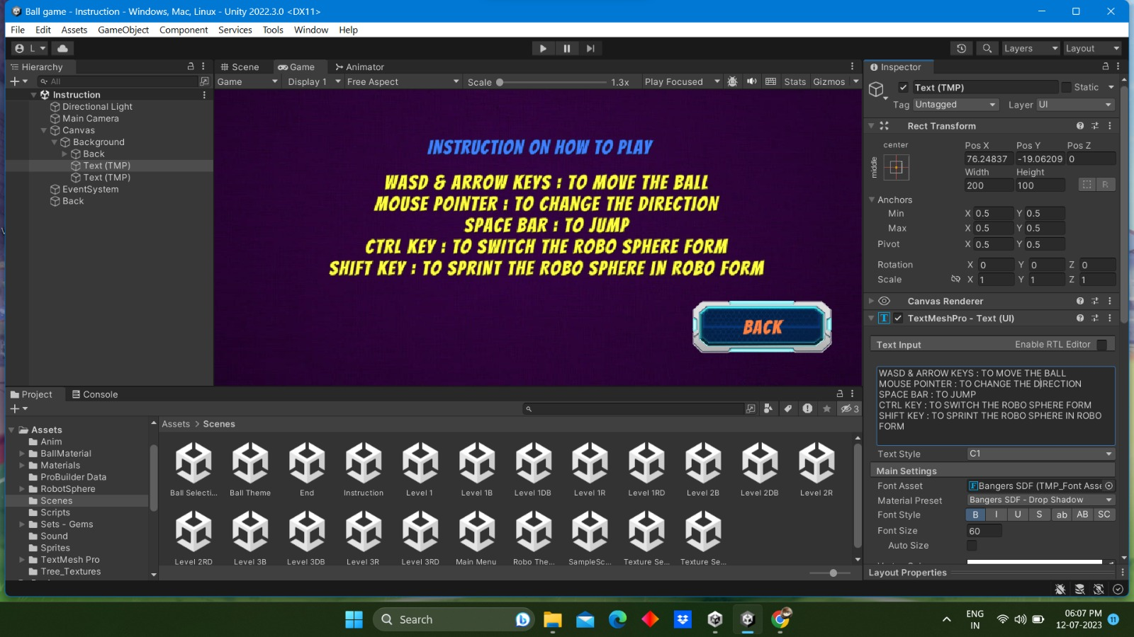

Fig.2 – Instruction Interface

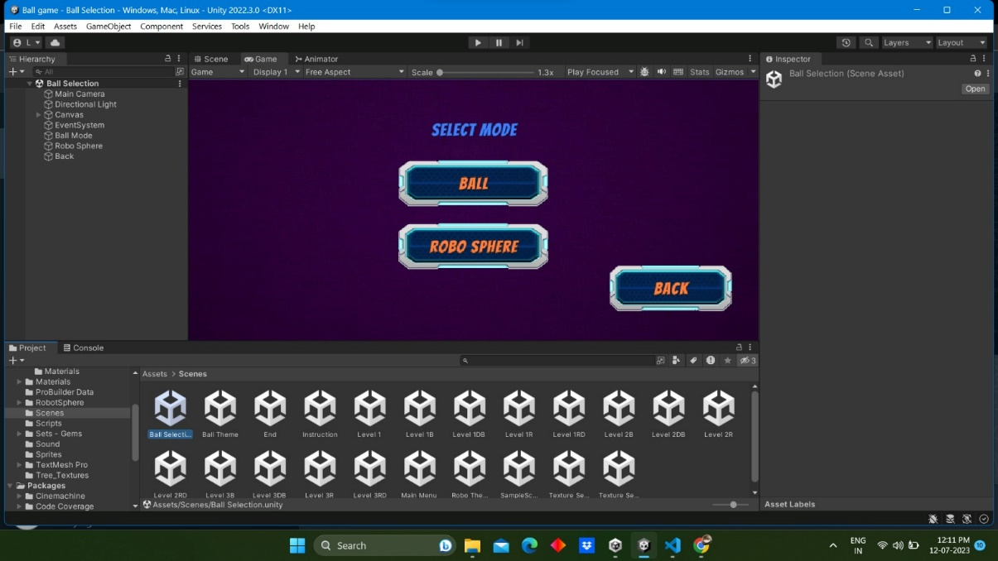

Fig.3 – Ball Selection Interface

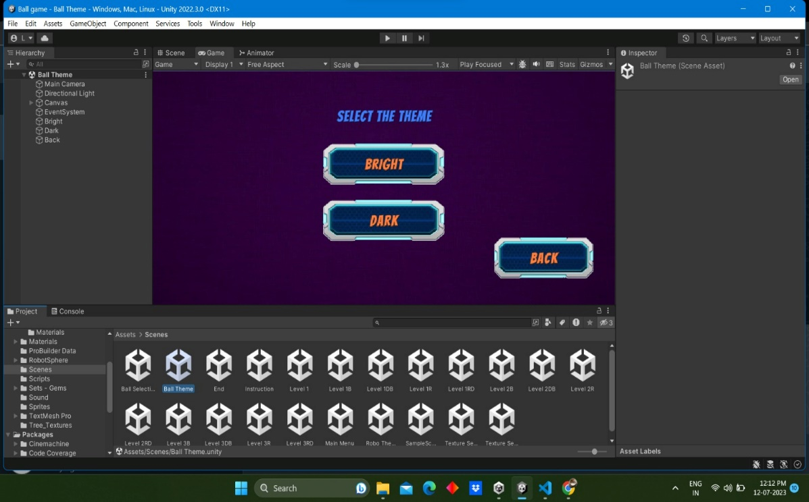

Fig.4 – Them Selection Interface

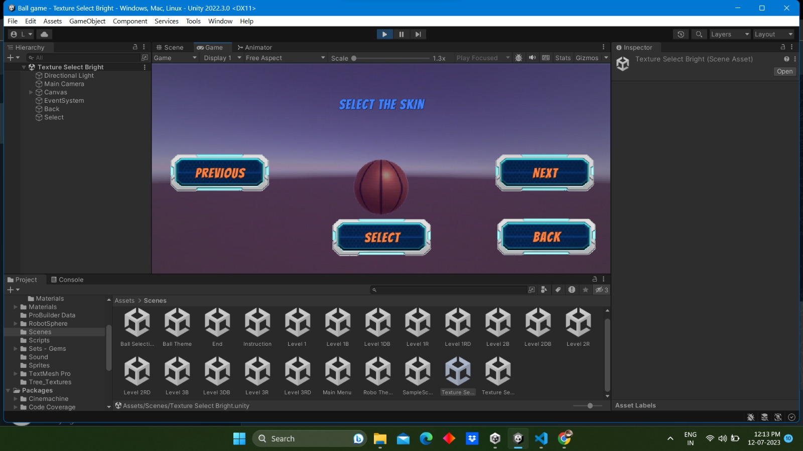

Fig .5– Ball Selection Interface

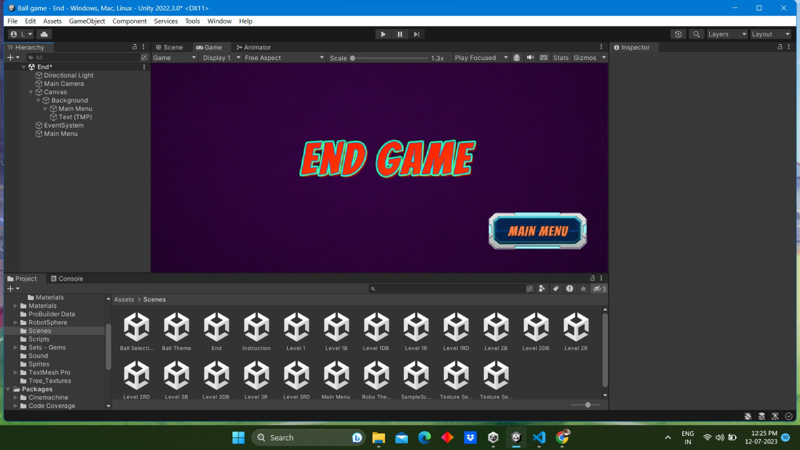

Fig.6 – Final Interface

Level Design

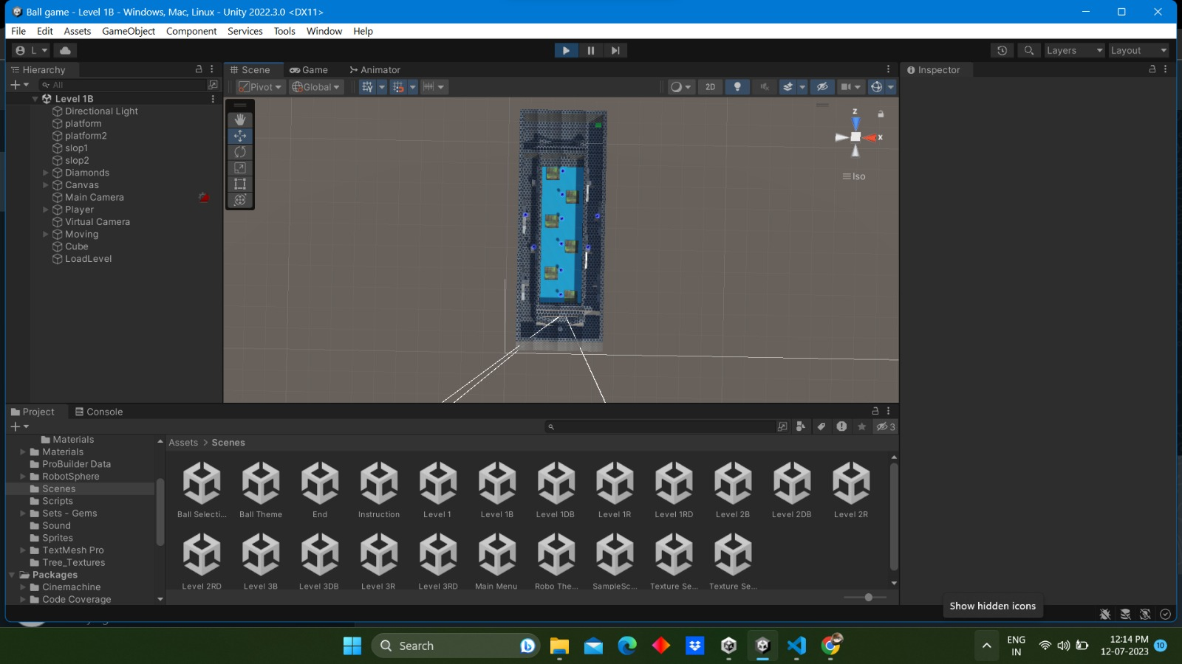

Fig.7 - Bright Mode Level 1

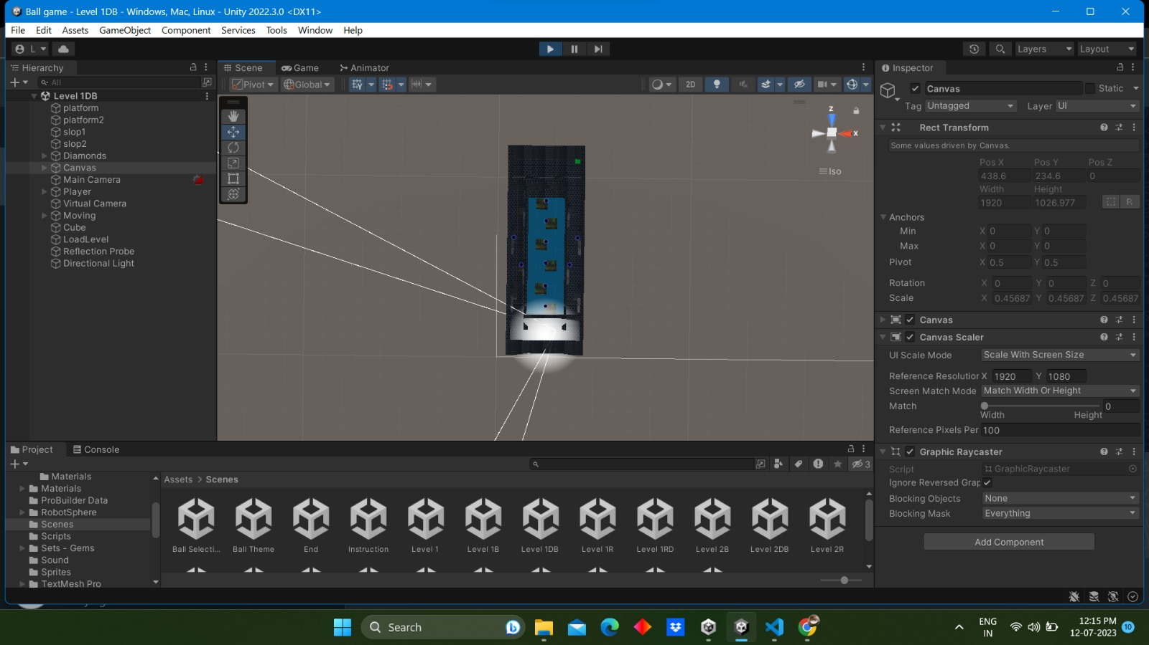

Fig.8 - Dark Mode Level 1

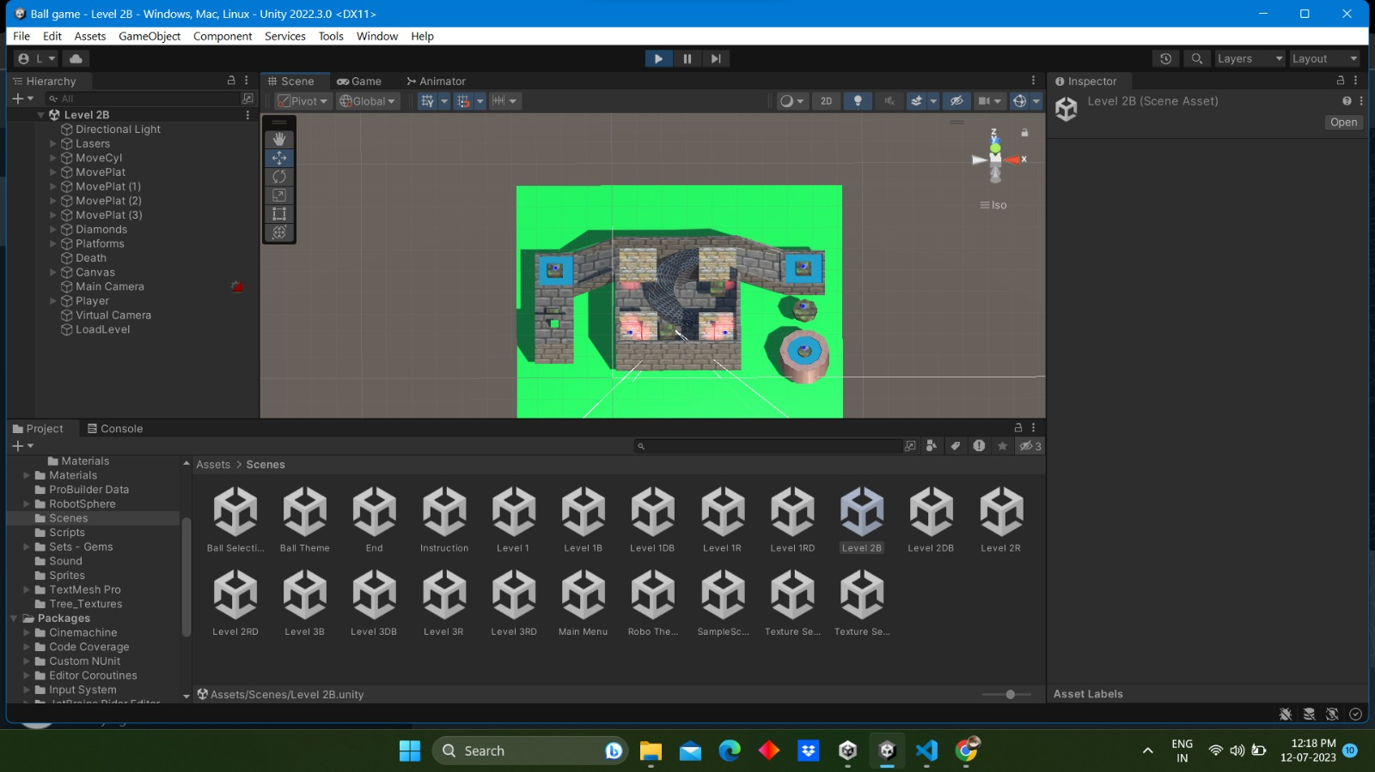

Fig.9 - Bright Mode Level 2

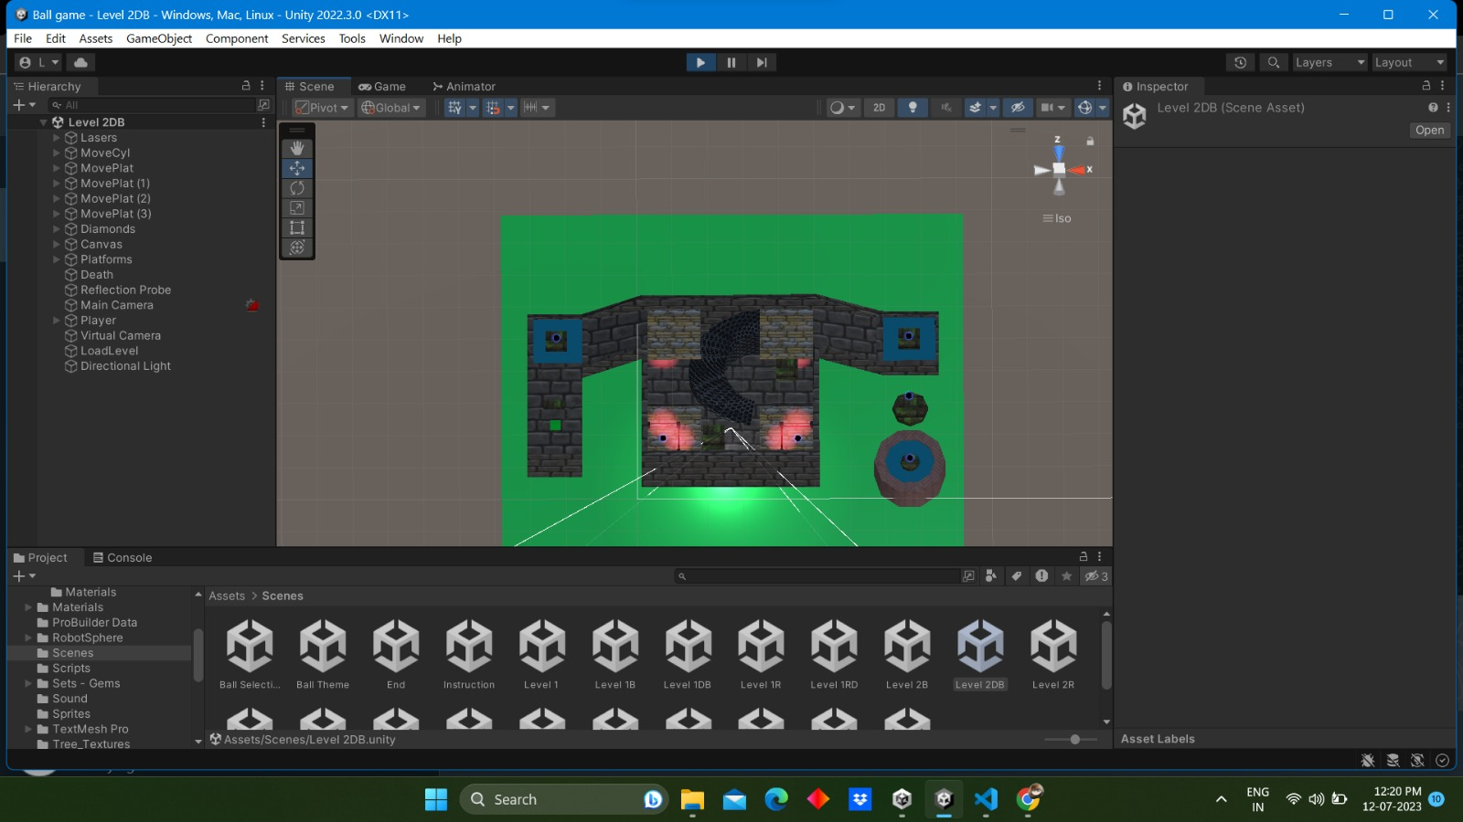

Fig.10 - Dark Mode Level 2

Main objects

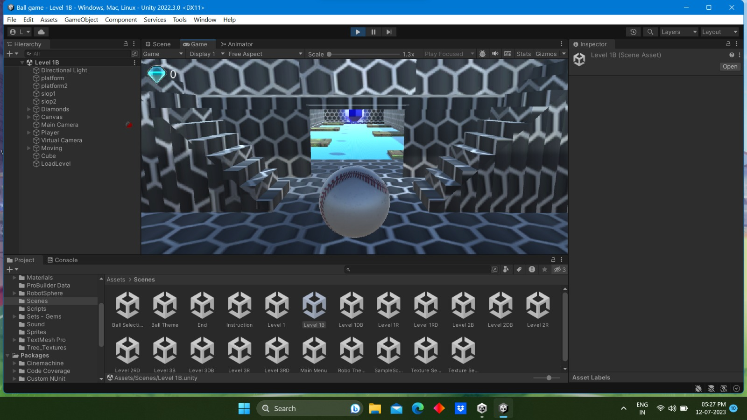

Fig.11 - Ball

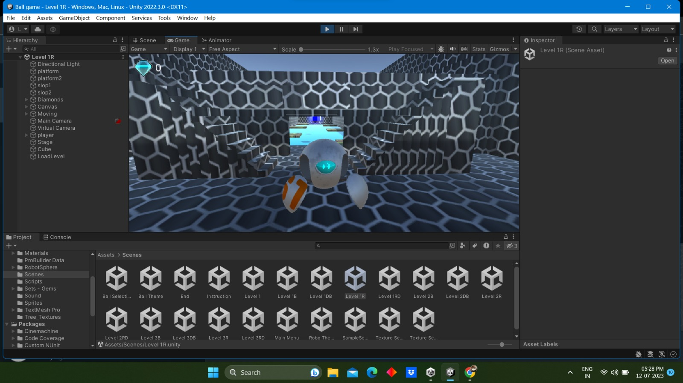

Fig.12 – Robo Sphere

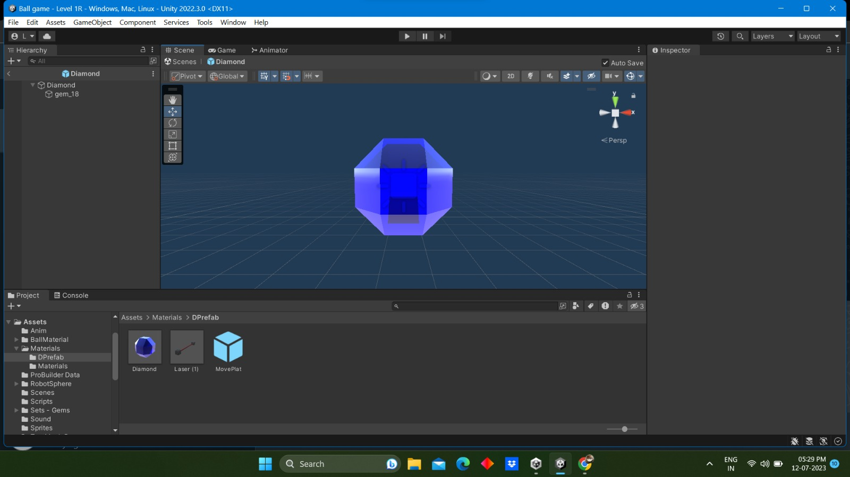

Fig.13 – Collectables

Conclusion

“Cross the wall – The Rolling Ball Game” is an engaging 3D game that offers players an exciting experience filled with collectibles. The game features multiple levels, each progressively more challenging than the last. To advance to the next level, players must successfully clear the previous one. One of the notable aspects of " Cross the wall – The Rolling Ball Game " is its inclusion of two distinct themes: bright and dark also it has two variants of balls to select Players have the freedom to select their preferred theme and balls, allowing them to tailor the game's visual style to their liking. Whether they enjoy vibrant and colourful environments or a more mysterious and atmospheric setting, the game accommodates both preferences.

Overall, " Cross the wall – The Rolling Ball Game " is designed to be a simple and enjoyable 3D game that offers entertainment and fun for players of all ages. Whether someone is looking for a casual gaming experience or a brief escape from reality, this game aims to provide a satisfying and immersive journey.

**REFERENCS**

1)Unity 3D game engine [computer program]. Version 4.3, Unity Technologies: October 15, 2013.

2)Goldstone, Will. Unity 3.x game development essentials. Game development with

C# and JavaScript. Packet Publishing; 2011.

3)Jason Dansie ,Game Development in Unity ,Game Production, Game Mechanics and the Effects of Gaming, Helsinki Metropolia University of Applied Sciences, Bachelor of Engineering, Information Technology, Thesis, 01 August 2013