**TEXT TO SIGN LANGUAGE TRANSLATOR**

**Poralla Harshitha,**

**BCA, BMS College of Commerce and Management, Bangalore**

**Shivani R,**

**BCA, BMS College of Commerce and Management, Bangalore**

**Roopashree C.S**

**Assistant Professor ,BMS College of Commerce and Management, Bangalore**

**ABSTRACT**

Non-verbal communication involves the usage of Sign Language. The sign language is used by people with hearing / speech disabilities to express their thoughts and feelings. But normally, people find it difficult to understand the hand gestures of the specially challenged people as they do not know the meaning of the sign language gestures. to enable the specially challenged people to effectively communicate with the people around them, a system that translates the text to sign language text of English alphabets (A-Z) and 10+ words into gestures.

**1.INTRODUCTION**

Sign Languages vary throughout the world. There are around 300 different sign languages used across various parts of the world. This is because sign languages were developed naturally by people belonging to different ethnic groups. efforts had been taken to standardize the Sign language translator. The proposed system performs text to gesture. The conversion is done using neural network classifiers.. This paper focuses on conversion of Sign Language English to gestures. For this, different neural network classifiers are developed, and their performance in gesture recognition is tested. The most accurate and efficient classifier is chosen and is used to develop an application that converts English text to image.

**2.METHODOLOGY**

An alphabets text to sign language translator would involve mapping each letter of the alphabet to a corresponding sign language gesture. The system would need to recognize the individual letters in the input text and then generate the corresponding sign language gestures to create a visual representation of the text. This process may involve a combination of natural language processing and computer vision techniques to ensure accurate translation.

The ﬁrst module pre-processes the input text in which the text is morpho-syntactically analysed with a language model’s help; In the second module, the pre-processed words are con-verted into sign sequences

**3.MODELING AND ANALYSIS**

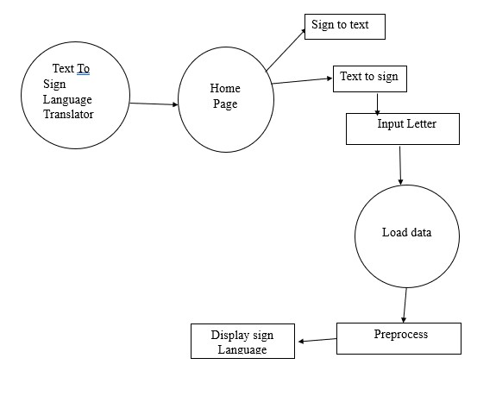

A text-to-sign language translator is a system or tool that converts written text into sign language, allowing communication between individuals who are deaf or hard of hearing and those who use sign language as their primary means of communication.

It can be concluded that text-to-sign language translation systems are being developed and researched to facilitate communication between individuals who use sign language and those who rely on written text. These systems utilize various techniques, including statistical machine translation, neural machine translation, and generative adversarial networks, to improve the accuracy and quality of sign language translation.

**4.RESULT AND DISCUSSION**

**HOME PAGE**: The home page displays title of the project and gives an image about what is it actually about without brief description

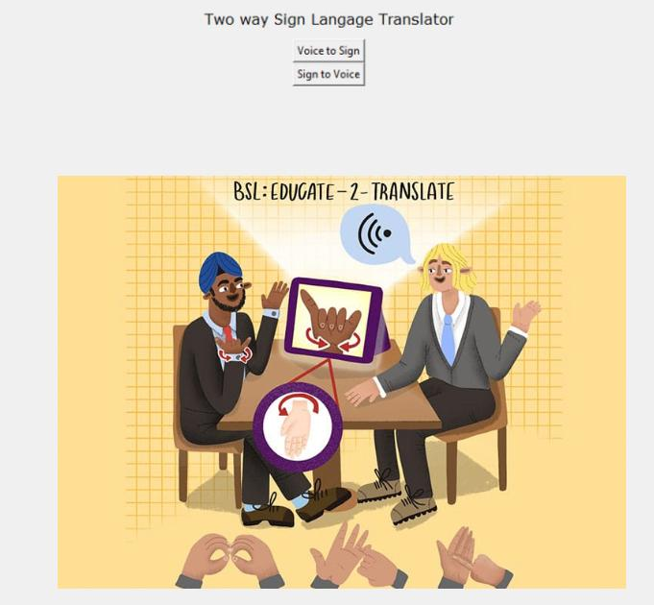

**TEXT TO SIGN**

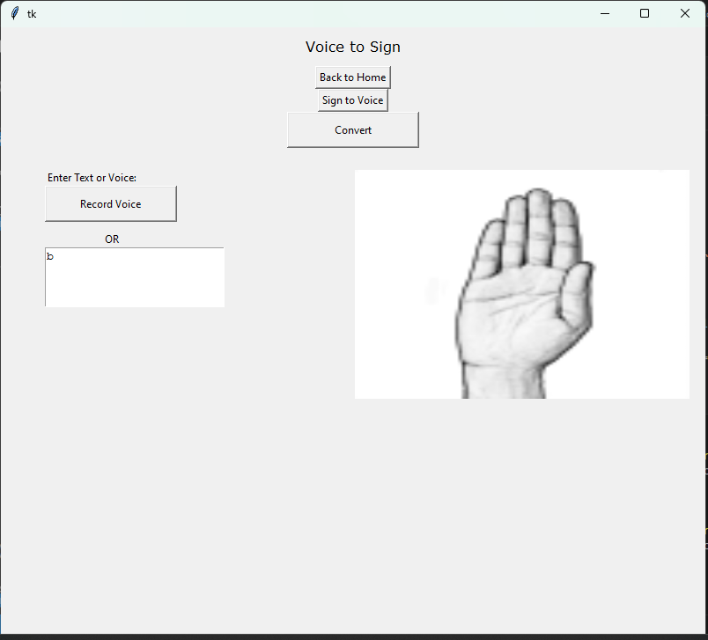

This page has various options to choose from like navigating to home, Sign to Text, convert the selected option etc.. If we add Text of any Alphabet it will convert into Sign Language Gesture

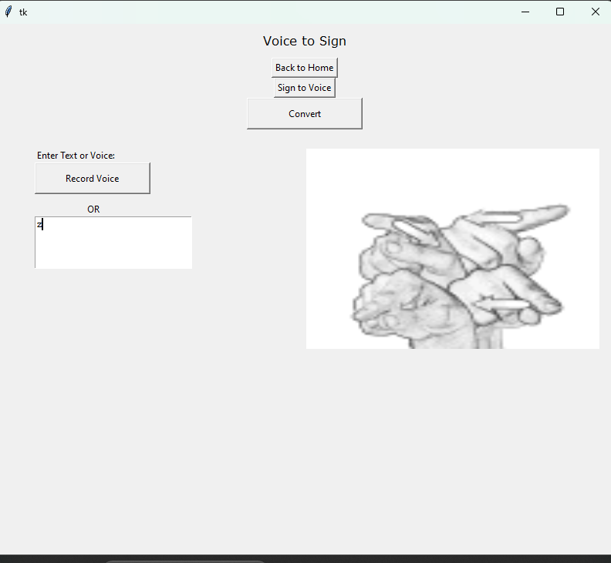

**CONCLUSION**

Mute people are isolated from the most common forms of communication in today’s society such as warning, or any other form of oral communication between people in regular daily activities. Sign language is a primary means of communication.From the results obtained, it is inferred that the CNN classifier is best suited for gesture recognition. A user friendly application that can translate Sign Language has been developed using the most efficient CNN classifier . Thus, a more reliable sign language translator system has been developed.

**FUTURE SCOPE**

The future enhancements will focus on improving the accuracy and scalability of the system. One key area for improvement is the dataset used for training the machine learning models. As the current dataset is relatively small, we plan to expand it and augment it using data synthesis techniques and also to use more advanced machine learning techniques to enhance the reliability and accuracy of system.

**REFERENCE**

[1] Abdel-Fattah, M. (2005). Arabic Sign Language: A perspective. Journal of Deaf Studies and Deaf Education, 10, 212–221.CrossRefGoogle ScholarPubMed

[2] Abercrombie, D. (1967). Elements of General Phonetics. Edinburgh: Edinburgh University Press.Google Scholar

[3] Aboh, E. O., Pfau, R. & Zeshan, U. (2005). When a wh-word is not a wh-word: The case of Indian Sign Language. In Bhattacha