**CLOUD BASED FILE SHARING SYSTEM**

Mohit D Gandhi 1, Sagar K Jain 2, Mrs. Roopashree CS3

Student, Department of BCA BMSCCM1,2

Assistant Professor, Department of BCA BMSCCM3

**ABSTRACT:**

In today's fast-paced and interconnected digital landscape, effective and secure file sharing has become an essential requirement for businesses and individuals alike. Traditional file sharing methods often suffer from limitations such as restricted accessibility, data loss risks, and collaboration challenges. To overcome these obstacles, a cloud-based file sharing system has emerged as a practical and efficient solution. This abstract presents an overview of a cloud-based file sharing system designed to improve collaborative efforts and enhance data accessibility. Leveraging the power of cloud computing, this system provides a centralized platform for users to store, share, and access files securely over the internet. It eliminates the need for physical storage devices and offers several advantages over traditional file sharing methods.

Key features of the proposed system include secure data storage, efficient file synchronization, robust access controls, and real-time collaboration capabilities. With data encryption and authentication mechanisms in place, the system ensures the privacy and integrity of shared files, mitigating the risks associated with unauthorized access or data loss. Additionally, automatic synchronization enables users to access the most up-to-date versions of files across multiple devices, promoting seamless collaboration and productivity.

**Keywords:** File sharing, Data accessibility, Collaborative file sharing, Document collaboration, Remote file access

**INTRODUCTION:**

In the digital age, where data and information are the lifeblood of businesses and individuals, efficient and secure file sharing has become a critical necessity. The traditional methods of sharing files through physical storage devices and email attachments have proven to be inadequate, leading to limitations in accessibility, collaboration, and data security. As a result, organizations and individuals are turning to cloud-based file sharing systems as a reliable and innovative solution.

A cloud-based file sharing system harnesses the power of cloud computing to provide a centralized platform for storing, accessing, and sharing files securely over the internet. With this system, users can break free from the constraints of physical storage devices and gain the ability to access their files from anywhere, at any time, using any internet-connected device. Whether it is sharing documents, images, videos, or any other type of file, the cloud-based approach offers unparalleled convenience and flexibility.

One of the key advantages of a cloud-based file sharing system is enhanced data accessibility. With files stored in the cloud, users can access their data on multiple devices, eliminating the need for manual transfers or carrying physical storage media. This seamless accessibility promotes collaboration, allowing team members to work on shared files simultaneously, regardless of their physical location. Real-time updates and synchronization features ensure that everyone is working on the latest version of a file, enhancing productivity and eliminating version control issues.

Data security is another paramount aspect of a cloud-based file sharing system. These systems employ robust security measures such as data encryption, user authentication, and access controls to safeguard sensitive information from unauthorized access or data breaches. This ensures the privacy and integrity of shared files, instilling confidence in users that their data is protected throughout the sharing process.

**METHODOLOGY:**

Methodology for Cloud-Based File Sharing Systems

1. Define Research Objectives: Clearly define the research objectives of the study, which may include evaluating the security, scalability, performance, user experience, or integration aspects of cloud-based file sharing systems.
2. Literature Review: Conduct a comprehensive literature review to gain an understanding of the existing research and development in cloud-based file sharing systems. Identify relevant scholarly articles, conference papers, technical reports, and industry publications that cover various aspects of cloud-based file sharing.
3. Identify Research Questions: Based on the research objectives and the gaps identified in the literature review, formulate specific research questions that will guide the study. These questions should address the key aspects of cloud-based file sharing systems that are being investigated.
4. Data Collection: Determine the data collection methods required to address the research questions. This may involve collecting data from existing cloud-based file sharing systems, conducting surveys or interviews with users or system administrators, or analyzing system logs and performance metrics.
5. Experimental Setup: If the research involves conducting experiments, define the experimental setup. This includes selecting appropriate cloud-based file sharing platforms or developing a custom system, configuring the necessary infrastructure, and designing specific scenarios or tasks to evaluate the system's performance, scalability, or security.
6. Data Analysis: Analyze the collected data using appropriate statistical or qualitative analysis techniques. This may involve measuring system performance metrics, assessing user feedback or preferences, identifying security vulnerabilities, or comparing different cloud-based file sharing approaches.
7. Evaluation and Validation: Evaluate the findings and validate the results against the research questions. Assess the significance and implications of the results in the context of cloud-based file sharing systems.
8. Draw Conclusions: Summarize the key findings from the study and draw conclusions based on the results obtained. Determine whether the research objectives have been met and address any limitations or challenges encountered during the study.
9. Recommendations: Provide recommendations for future research or system improvements based on the findings. Identify areas that require further investigation or propose potential solutions to address the identified limitations or challenges.
10. Documentation and Reporting: Document the research methodology, data collection process, analysis techniques, and findings in a clear and organized manner. Prepare a detailed report or research paper that communicates the research methodology and outcomes effectively.

**USE CASES:**

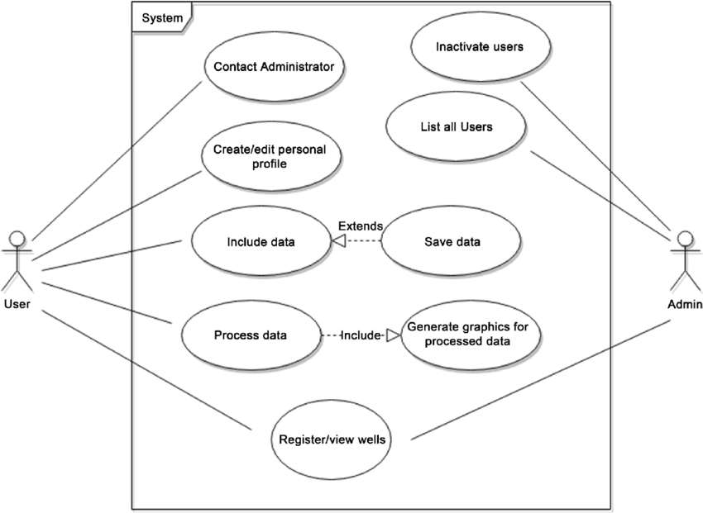

**DFD:**

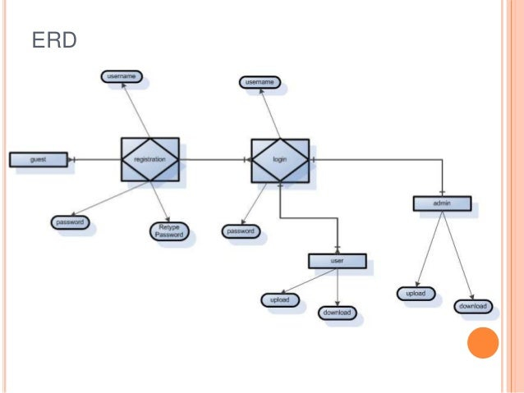

**RESULTS:**

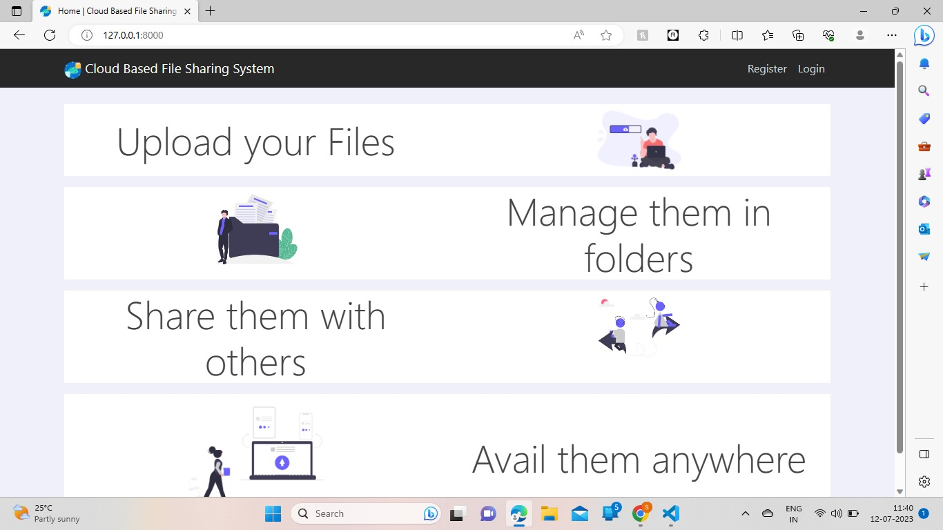

**Fig: 1.1 Home page**

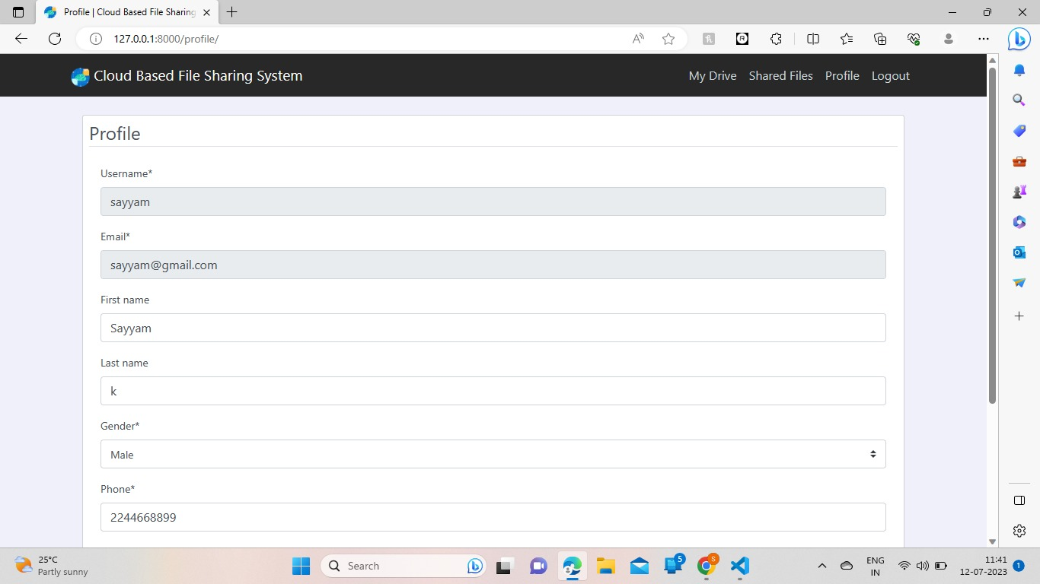

**Fig: 1.2 Registration page**

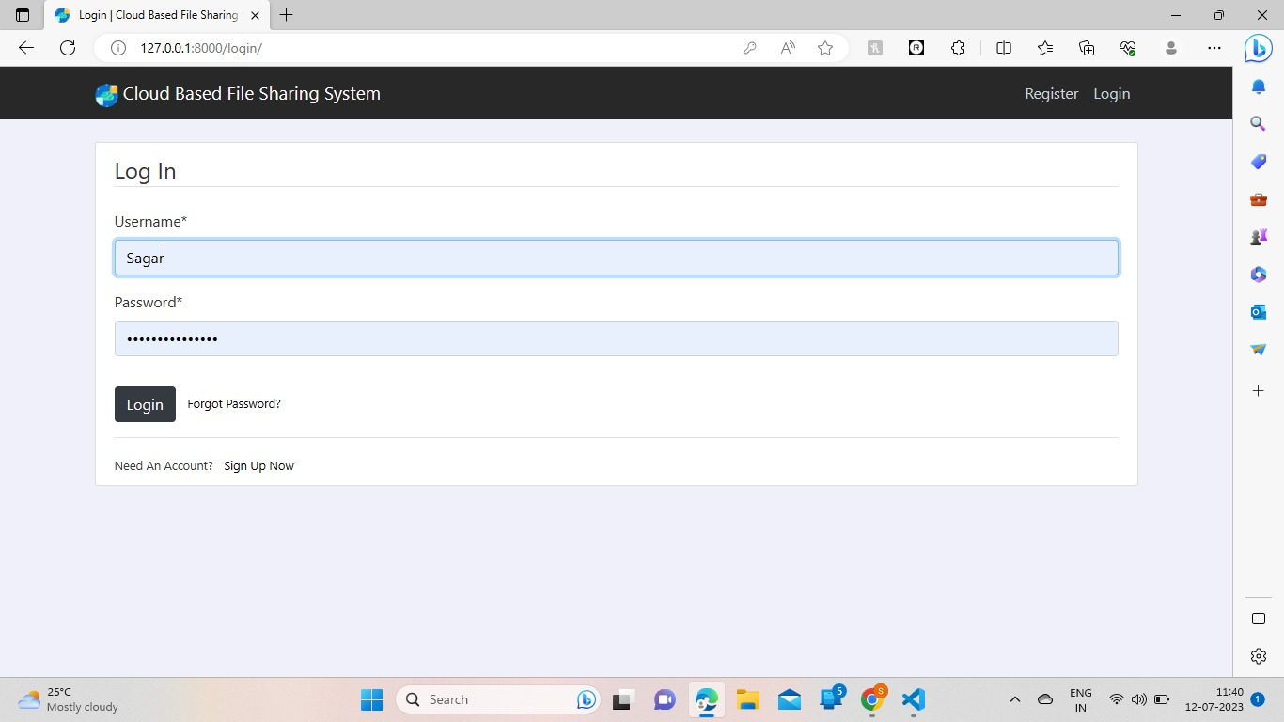

**Fig: 1.3Login page**

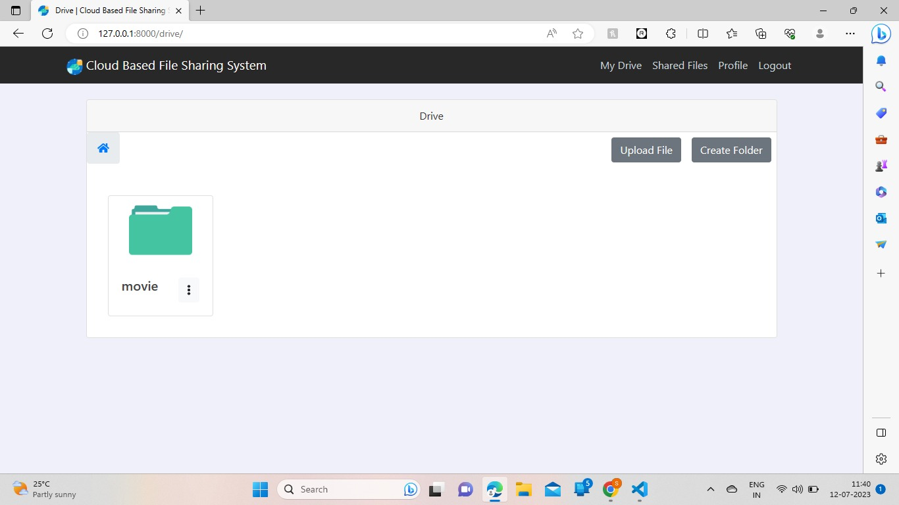

**Fig: 1.4 File sharing and strorage page**

**CONCLUSION:**

In conclusion, a file sharing system is an essential tool that enables efficient and convenient sharing of files among individuals and organizations. It offers numerous benefits, including:

Collaboration and teamwork: A file sharing system promotes collaboration and teamwork by allowing multiple users to access and edit files simultaneously. It facilitates real-time collaboration, enhances productivity, and streamlines workflows.

Accessibility and convenience: With a file sharing system, files can be accessed from anywhere and at any time, as long as there is an internet connection. This accessibility improves flexibility, enabling users to work remotely, share files with clients or partners, and access important documents on the go.

Centralized storage and organization: File sharing systems provide a centralized storage solution, eliminating the need for scattered files across various devices or locations. Files are stored in a structured manner, making it easier to locate and retrieve specific documents quickly. It also helps in maintaining version control and avoiding confusion caused by multiple file copies.

**References:**

[1] Archana K Rajan, Surya Babu, “Privacy and Authenticity for Cloud Data using Attribute Based Encryption and Digital Signature”

2017 Unpublished work.

[2] J. Sánchez-García, J. M. García-Campos, D. G. Reina, S. L. Toral,F. Barrero. “On-siteDriverID: A Secure Authentication Scheme based on Spanish eID Cards for Vehicular Ad Hoc Networks.”

[3] SeDaSC: Secure Data Sharing in Clouds MazharAli, Student Member, IEEE, RevathiDhamotharan, Eraj Khan, Samee U. Khan, Senior Member, IEEE, Athanasios V. Vasilakos, Senior Member, IEEE, Keqin Li, Fellow, IEEE, and Albert Y. Zomaya, Fellow,

IEEE(2017)