**Tribal Community Development Index (TCDI) through Simple Average (SA) Approach of Different Districts of West Bengal of India**

**David Durjoy Lal Soren1\***

**\*** Research Scholar, Department of Geography & RM, Mizoram (Central) University, Aizawl, Mizoram-India

*Email: devid.dls.king@gmail.com

**Abstract:**

The indigenous natives or tribes in India are designated as Scheduled Tribes in the constitution of India. They are the most backward and marginalized community even after passing more than seventy years of independence. There are over 700 tribes with overlapping communities in more than one State in India among which 75 of this community have been identified as**particularly** vulnerable tribal groups (PVTGs) based on the parameters as the determinants of the community based socio-economic development by the Government of India. The present study was conducted to excavate the status of the tribal development with special reference to West Bengal by the application of the tribal community development index (TCDI) through simple average (SA) approach incorporating socio-economic and demographic parameters such as literacy, health status, working force participation, sex ratio and income. From the study, it was explored that the tribal people in West Bengal were unequally concentrated among the districts of West Bengal. Dakshin Dinajpur (7.02), Darjeeling (6.48) and Jalpaiguri (2.88) districts were identified as high tribal concentration area while Howrah (0.03), Kolkata (0.05) and South 24 Pargana (0.11) districts were fall in the low tribal concentration area. TCDI was also highly variable from district to district. The highest and lowest value of TCDI excluding income was found in Kolkata (81.18) and Cooch Behar (33.52) respectively. On the other hand, TCDI including income was highest at the Howrah (50.42) and lowest at the Uttar Dinajpur (37.82). The overall scenario was depicting that the tribal community of the study area was far beyond the total development of the state and the most deprived community. The realistic local priority-based policies are required to elevate the socio-economic status of the tribal people of the state.

**Keywords:** Tribal people; Socio-economic indicators; Simple average analysis; Levels of development; Inclusive growth

**Introduction:**

**The need for equal and rational community development is one of the strongest sought of humanists throughout the globe which motivates the researchers in the fields of social sciences to seek fruitful strategies for balanced social development. The origin of the term “Tribe” was traced back to the ancient Greek city-state and it was defined as**“a group of persons forming a community and claiming descent from a common ancestor” (Oxford English Dictionary, 2019, p. 339). The tribal people are sharing 6.2% of the total population of the world and having about 4000 unique indigenous languages. They are lived in every region of the world but most of them are confined in the Asia and the Pacific region (70%) followed by Africa (16.3%), Latin America and the Caribbean (11.5%), Northern America (1.6%) and Europe and Central Asia (0.1%) respectively (Cultural Survival,2067 Massachusetts Avenue, 1972) (https://www.culturalsurvival.org/issues). The social discrimination and injustice are the worldwide problems and about 260 million people are being humiliated by such problems based on work and descent. One of the significant goals of sustainable development is to eliminate social discrimination and to create equal opportunities for all to promote balanced development in societies all over the world (Mosse, 2018). The causes behind the miseries of the tribal population of the world are the expansion of colonial power, inability of the tribes to adopt economic transitional situation and rapid advancement in the technology, deprivation, and negligence by the privileged society, the cultural orthodoxy of tribal people and lacuna in the developmental policies of the concerned government. They are propelled from their native places to the places of socio-economic inconvenience due to encroachment of the people of the advanced societies (Cardoso, 2001). In the Indian Subcontinent, the tribal population is collectively termed as “Adivasi” means the indigenous native of the land. For the safeguard and socio-economic development of the tribal population of the nation these ethnic groups are scheduled as Scheduled Tribes in the constitution of India, Article 366 (25). The sharing of the Scheduled Tribes was only 8.65% to the total population of India (Primary Census Abstract, Data highlight Census of India, 2001) (https://idsn.org/wp content/uploads/user_folder/pdf/New_files/India/2013/INDIA_CENSUS_ABSTRACT-2011 Data_on_SC-STs.pdf) and about 45.9 % of the members in the tribal communities had the lowest wealth possession in India (National Family Health Survey NFHS 2015-16) (https://archive.indiaspend.com/cover-story/scheduled-tribes-are-indias-poorest-people-18413). On the basis of tribal population concentration total seven regions were identified in the whole country i.e., north zone, north-east zone, central zone, southern zone, eastern zone, western zone and island region. The ‘Dhebar Commission’ (1960-1961) had reported that discrimination and inequality against tribal people was the common scenario in India in the development perspective**.  Despite the indigenous native of the land, they are far beyond the light of the advanced and privileged societies of India. In the different five-year plans of India, 75 communities out of 427 tribal communities were identified as**particularly vulnerable tribal groups (PVTGs) based on the parameters as the determinants of the community based socio-economic development. The PVTGs were characterized by an extremely low level of literacy and engaged in economic activities like hunting and gathering. There were nine structural features could be used to designate the economy of the tribal communities in India included forest-based economy, domestic mode of the productions, use of very simple indigenous technologies, absence of the profit motivating economic transactions, community as a unit of economic cooperation, the gift in the ceremonies, periodical nature of the markets and interdependence in the society (Vidyarthi, 1976). They were inhabited in the diversified geo-ecological conditions along with their distinctive socio-cultural heritages and economic backgrounds throughout the country. The encroachment of the people of the privileged societies in the territories of the tribes had created disturbances and hampered the indigenous nature of the tribal societies (Basu, 2000). Since the initiation of the caste system in the Indian society the tribal people have been excluded from the mainstream of the society and being deprived of the socio-economic opportunities for maintaining the quality of life to the standard of life (Ministry of Labour Employment, New Delhi, 2017) (https://labour.gov.in/sites/default/files/Ch-1%281%29.pdf and Mog and Debbarma 2018). The study area, West Bengal is under the Eastern Tribal zone of the country and sharing 5.65 % of the tribal population to total tribal population of the nation and 5.80% of the total state’s population (Office of the Registrar General & Census Commissioner, 2011) (https://censusindia.gov.in/2011census/SC-ST/pca_state_distt_st.xls). The rate of literacy of the tribal in the state of West Bengal was very low (43.4%) and even it is significantly lesser than the national tribal literacy rate (Office of the Registrar General & Census Commissioner, 2011) (https://censusindia.gov.in/2011census/SC-ST/pca_state_distt_st.xls). The cycle of the poverty is evident from the rate of poverty (43.00%) in last two decades (Ministry of Tribal Affairs, 2016-17) (https://tribal.nic.in/writereaddata/AnnualReport/AnnualReport2016-17.pdf) and about 48.8% of the Tribal population belong to the agricultural labour (Office of the Registrar General & Census Commissioner, 2011) (https://censusindia.gov.in/2011census/SC-ST/pca_state_distt_st.xls). Despite adopting several welfare schemes by the government of India during the five-year plans to elevate and strengthening the socio-economic conditions of the Scheduled Tribes in the post-independence periods but these schemes were failed to fulfil the goals (Frank, 1969). The schemes of the Indian government for the welfare of the tribal communities were not implemented efficiently that resultant to stagnation and very low progress in the socio-economic status of tribal people (Ministry of Tribal AffairS, New Delhi, 2015) (https://tribal.nic.in/repository/ViewDoc.aspx?RepositoryNo=TRI28-08-2017110639&file=Docs/TRI28-08-2017110639.pdf). The contemporary gloomy socio-economic scenario of the tribal communities of India is proving a relevant space for the intensive studies about the status of these communities to excavate the applicable strategies for elevating the quality of the tribal livelihoods and to eliminate the discrimination in the community development. Such studies can also assist the planers and bureaucrats to introduce and implement realistic schemes for enhancing the socio-economic status of the tribal communities of India. The complete development in a nation could not be achieved until the equal development of the backward communities to the mainstream of the society (Thorat and Newman, 2007). The present study was aimed to formulate a tribal community development index (TCDI) in the course of simple average approach of different districts of West Bengal, India by using indices namely index of literacy (Li), index of female literacy (Fli), index of schooling (si), workforce participation index (Pw), male work index (Wmi), female work index (Wfi), index of health (Hi), sex ratio (Rs) and index of average income (Ii). The discrimination in the development of tribal community in the state of West Bengal would be exposed more comprehensively and it might be helpful to the policy makers for searching the fruitful strategies to elevate the socio-economic conditions of tribal people and to minimize the disparity in the community development.

**Study area:**

The study area, West Bengal is one of the states of the eastern region in India and it is the 13th largest of the country has an area of 88752 km2 stretching from the Bay of Bengal in the extreme south and to Darjeeling Himalaya in the extreme north. Geographically the state is extended from 21°25’N to 27°13’N latitudes and 85°50’E to 89°50’E longitudes (Fig. 1). The lofty Himalayan Mountain in the extreme north, active delta plain in the extreme south, low plateau terrain in the western margin and vast lower Ganga plain just from the end of the foothill of Himalaya up to the southern part of the state have imposed the diversity in the topographic characteristics of the state. In the state over 91 million people are residing among which 5.07 % of the population (5296953 persons) is shared by tribal people and most of them are residing in the rural areas (91.66%) of the state (Office of the Registrar General & Census Commissioner, 2011) (https://censusindia.gov.in/2011census/SC-ST/pca_state_distt_st.xls). The major tribes of West Bengal are Asur, Bedia, Bediya, Bhumij, Birhor, Chakma, Bhutia, Sherpa, Toto, Dukpa, Kagatay, Tibetan, Yolmo, Chero, Chik Baraik, Garo, Gond, Gorait, Hajang, Ho, Karmali, Kharwar, Kisan, Kora, Korwa, Lepcha, Lodha, Kheria, Kharia, Lohara, Lohra, Magh, Mahali, Mahli, Mal Pahariya, Mech, Mru, Munda, Nagesia, Oraon, Parhaiya, Rabha, Santal, Sauria Paharia, Savar, Limbu (Subba), and Tamang etc. (State/Union Territory-wise list of Scheduled Tribes in India, 2011) (https://tribal.nic.in/ST/LatestListofScheduledtribes.pdf). Among the tribes of West Bengal, Birhor, Lodha, and Toto are identified as PVTGs by the Government of India. Most of the tribal people of the state are belonging under the line of poverty as defined by the Government of India and considered as the most backward community of the nation.

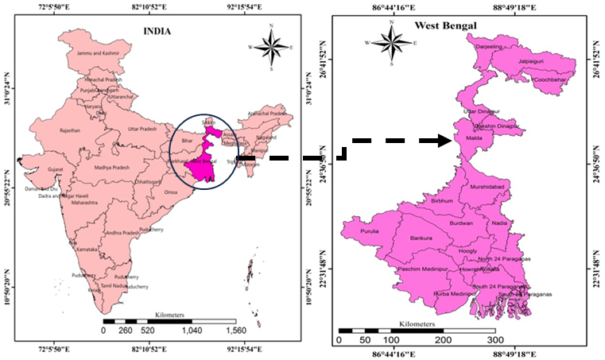

**Fig. 1**: Location of the study area

**Database and methodology:**

The study was performed solely based on the secondary data and both the descriptive and inferential statistical techniques were used to extract the socio-economic status of the tribal community in West Bengal. A flow diagram was used to simplify the methodology adopted for the study (Fig. 2). The district-wise data in West Bengal about the education, workforce, health facility and demographic attributes of the tribal people were downloaded from the website of the Office of the Registrar General & Census Commissioner, Ministry of Home Affairs, Government of India, 2011. The income-related data of the tribal population were collected from the Socio-Economic and Caste Census of India, 2011. The data were analysed through different statistical methods (Eqs. 1-11) with the help of SPSS 17.0, Microsoft office Excel 2007 and mapped using Arc-GIS 10.1. A simple average (SA) approach was used to prepare TCDI.

$a1) LQ=\frac{a1/a2}{b1/b2 }$....................................................................... (Eq.1)

$b1) Li=\frac{P1}{Pt}×100$.................................................................. (Eq. 2)

$b2) Fli=\frac{Flp}{Pf}×100$................................................................ (Eq. 3)

$b3) Si=\frac{Sn}{Pt}×100$.................................................................. (Eq. 4)

$c1) Pw=(\sum{Wmai+Wm-ar }$ ̸ Pt) ×100.......................... ..(Eq. 5)

c2) Wmi = (Wmt ̸ Pm) ×100...................................................... (Eq. 6)

c3) Wfi = (Wft ̸ Pf) ×100......................................................... (Eq. 7)

d1) Hi = (Hcn ̸ Pt) ×100......................................................... (Eq. 8)

e1) Rs= (Nfp1000 ̸ 10) ........................................................... (Eq. 9)

f1) Ii = (∑ I1... 3 / 3) .......................................................... (Eq. 10)

$g) TCDI=\sum_{i=1}^{3}{\frac{bi}{3}}+ \sum_{i=1}^{3}{\frac{ci}{3}}+ \frac{d1+e1+f1}{3}$............................. (Eq. 11)

Where, LQ - Location Quotient, a1 - Total ST population, a2 - Total population, b1 - Area of the district, b2 - Area of the State, Li- Index of literacy, Pl- literate population, Pt- total population, Fli - Index of female literacy, Flp - female literate population, Pf - total female population, Si - Index of school, Sn - number of school {∑ Primary, Middle, High, Higher Secondary, General dergre College, University (Gen.& Tech.)}, Pt- total population, Pw - Workforce participation, Wmai- Main worker, Wmar – Marginal Workar, Pt - Total population, Wmi - Male worker index, Wmt - total male worker, Pm - male population, Wfi - Female worker index, Wft - total female worker, Pf - female population, Hi - Index of health , Hcn - number of health centres {∑ Hospitals, Health Centres etc., Sub-Centres, Family Welfare Centres, Total beds, Number of beds per thousand}, Pt- Total population, Rs– sex ratio (number of female per one hundred male), Nfp1000 Number of female per one thousand male, Ii – Average income rank Index, I1 - <5000, I2-5000 - 10000, I3 - >10000, TCDI – Tribal community development index, bi - b1+b2+b3, ci- c1+c2+c3.

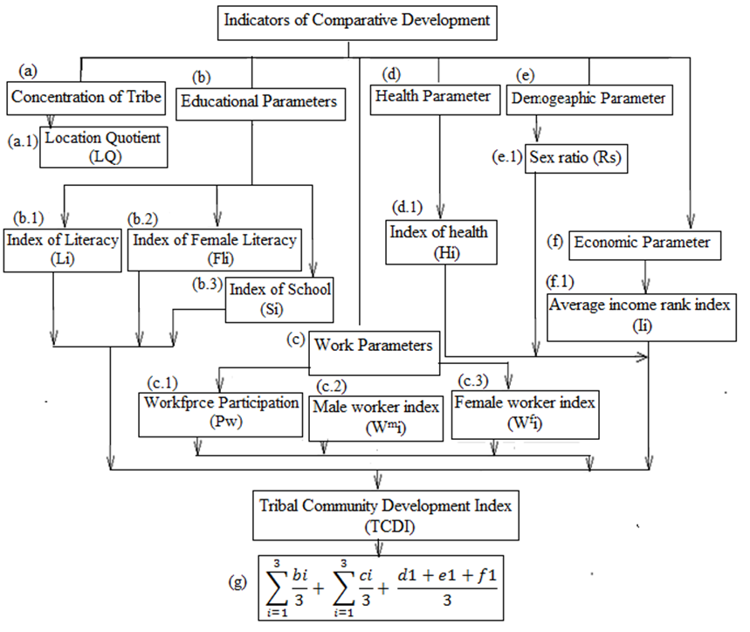

**Fig. 2:** Methodology of the study

**Logic behind the selection of parameters:**

TCDI was applied for assessing the comparative development of the tribal community in West Bengal. Social welfare parameters like the level of education, work participation rate, availability of health facility, sex ratio, and income of the tribal people were incorporated to develop the TCDI. For the measurement of magnitude about the discrimination in community development different indices have been used by researchers in economics, sociology, and geography throughout the globe. For ensuring sustainable development in a region, the comprehensive index was formulated by using income, health, and mean year of schooling of the individuals could be useful to a great extent (Dolan and White 2006). The quality of life could be assessed more precisely by using different socio-economic indicators which were relevant to the concerned society (Jana and Ghosh 2015). Kim and Kim (2012) highlighted that the health status and life expectancy are the significant determinants of social development. The regression analysis of the various social-economic indices about the quality of life in the districts of Tamilnadu in India was effective for comprehending the status of the development (Annapoorani and Sudha, 2013). Sena (2010) emphasized on the poverty, agricultural communities, education and economy to the development of indigenous people of Africa. Sapignoli and Hitchcock (2013) considered rates of poverty, land access, levels of education and literacy, health and nutritional problems and gender inequities to the development of indigenous peoples of Botswana, Namibia and South Africa. Sabiu et al. (2018) focused on the poverty measurement, economic condition, unemployment and government policy which hindered the development of Hausa people of Nigeria. However, the effective and desired outcomes about the tribal community development scenario could be derived from the analysis of the socio-economic indices by selecting appropriate parameters of the concerned (Mallick, 2014). In other words, the magnitude of the development and social wellbeing could be estimated efficiently with the help of the parameters considered for determining the welfare of the communities (Dolan and Tsuchiya, 2011). In addition, there were several theories and models developed for the analysis of the social development like the classical economic theory, the neoclassical economic theory and the human-centred development theories, index of sustainable economic welfare and human development index which emphasized on the different dimensions of human development. Economic welfare stressed on the equality of opportunity and reduction of inequality, elimination of discrimination, policy and social practice. Neoclassical economic theory and the human-centred development theory stated the measurement of development program with poverty reduction strategies considering economic, health and education indicators. Human development index considered life expectancy, education, and per capita income to measuremultidimensional nature and process of human Development. However, the index of sustainable economic welfare and human development index were the most appropriate measurements of the social development in comparison to other measurements argued in the development theories (Biao, 2016). The index of the social wellbeing could be developed for better measurement of the magnitude of the development by considering the parameters such as standard of living, health status, community vitality, level of education, work participation, participation in the democratic process, development of arts and culture and quality of environment parameters (Romanow, 2009). The global Human Development Report (HDR) prepared and published by The United Nations Development Programme (UNDP) since 1990 by focussing the multidimensional nature and processes of human development with consideration of the balanced development from the approach of the sustainable development and aimed to minimize the inequalities in the human development by 2030. There were three basic parameters used in the Human Development Index viz, life expectancy, education, and per capita income (Human Development Report, 2019). The above-mentioned different literatures, theories and indices of social development had used the health, nutrition, life expectancy, education, work force and per capital income parameters. These parameters have been used universally to measure the social development. Index of literacy (Li), index of female literacy (Fli) and index of school (Si) indicated the literacy status and educational achievements. Workforce participation (Pw), male work index (Wmi) and female work index (Wfi) reflected the standard of living. Index of health (Hi) assessed the health facilities, sex ratio (Rs) measured the balance in social life and index of average income (Ii) highlighted the sustainable welfare function.

**Results:**

From the extracted results through the analysis of the selected indices of the study area below mentioned significant facts might be interpreted for the better comprehension of the development scenario of the tribal community in the state of West Bengal.

**District wise Tribal concentration:**

The significant spatial variation about the concentration of tribal population in the state was evident from the calculation of location quotient (LQ) (Table 1 and Fig. 3a). The highest concentration of the tribal population was found at Dakshin Dinajpur (7.02) and the lowest one at Howrah district (0.03). The range of deviation of the district-wise concentration of the tribal population was 99.15% signifying the high inter-district inequality of the same. To visualize the inequality in the district wise concentration of the tribal population in the state five classes viz, very low (0.03-0.35), low (0.35-0.85), moderate (0.85-2.00), high (2.00-2.87) and very high (2.87-7.02) were assumed based on the magnitude of the LQ. The very high concentration of Tribal population was found at Dakshin Dinajpur, Darjeeling and Jalpaiguri districts having LQ value of 7.02, 6.48 and 2.88 respectively. The southern part of the state i.e., Purulia (2.80) and Paschim Mednipur (2.24) districts also had a high concentration of tribes. The moderate concentration was found at Malda (2.00), Uttar Dinajpur (1.64), Birbhum (1.45), Bankura (1.41) and Hooghly (1.25) districts. Low concentration was found at the three districts of the state i.e., Burdwan (0.86), Nadia (0.66) and North 24 Pargana (0.61). Very low concentration was found at Purba Mednipur (0.35), Kolkata (.05), Howrah (.03), South 24 Pargana (0.11), Murshidabad (0.23) and Cooch Behar (0.18) districts.

**Table 1:** Concentration of Tribal Population based on the LQ Value

|  |  |  |  |  |  |  |  |
| --- | --- | --- | --- | --- | --- | --- | --- |
| **Name of the districts** | **Total ST population (a1)** | **Total population (a2)** | **a1/a2** | **Area of district (b1)** | **Area of the state (b2)** | **b1/b2** | **LQ** |
| **Darjeeling** | 397389 | 1846823 | 0.215174 | 3149 | 94875.89 | 0.03 | 6.48 |
| **Jalpaiguri** | 731704 | 38,72,846 | 0.188932 | 6,227.89 | 94875.89 | 0.07 | 2.88 |
| **Cooch Behar** | 18125 | 28,19,086 | 0.006429 | 3,387 | 94875.89 | 0.04 | 0.18 |
| **Uttar Dinajpur** | 162816 | 3007134 | 0.054143 | 3140 | 94875.89 | 0.03 | 1.64 |
| **Dakshin Dinajpur** | 275366 | 1676276 | 0.164272 | 2219 | 94875.89 | 0.02 | 7.02 |
| **Malda** | 313984 | 3988845 | 0.078716 | 3,733 | 94875.89 | 0.04 | 2.00 |
| **Birbhum** | 242484 | 3502387 | 0.069234 | 4,545 | 94875.89 | 0.05 | 1.45 |
| **Murshidabad** | 91035 | 7102430 | 0.012817 | 5324 | 94875.89 | 0.06 | 0.23 |
| **Burdwan** | 489447 | 77,23,663 | 0.06337 | 7,024 | 94875.89 | 0.07 | 0.86 |
| **Nadia** | 140700 | 51,67,600 | 0.027227 | 3,927 | 94875.89 | 0.04 | 0.66 |
| **Purulia** | 540652 | 29,30,115 | 0.184516 | 6,259 | 94875.89 | 0.07 | 2.80 |
| **Bankura** | 368690 | 35,96,674 | 0.102509 | 6,882 | 94875.89 | 0.07 | 1.41 |
| **Hooghly** | 229243 | 55,19,145 | 0.041536 | 3149 | 94875.89 | 0.03 | 1.25 |
| **North 24 Pargana** | 264597 | 1,00,09,781 | 0.026434 | 4,094 | 94875.89 | 0.04 | 0.61 |
| **South 24 Pargana** | 96976 | 81,61,961 | 0.011881 | 9,960 | 94875.89 | 0.10 | 0.11 |
| **Howrah** | 15094 | 48,50,029 | 0.003112 | 9,368 | 94875.89 | 0.10 | 0.03 |
| **Kolkata** | 10684 | 44,96,694 | 0.002376 | 4713 | 94875.89 | 0.05 | 0.05 |
| **Purba Mednipur** | 27952 | 50,95,875 | 0.005485 | 1,467 | 94875.89 | 0.02 | 0.35 |
| **Paschim Mednipur** | 880015 | 59,13,457 | 0.148816 | 6308 | 94875.89 | 0.07 | 2.24 |

**Tribal educational scenario:**

Education is considered one of the strongest determinants of the quality of life as well as the socio-economic development of a society. To evaluate the educational status of the tribal people of the state district-wise literacy index (li) was considered. The overall achievement in the literacy of the tribal population (57.93%) in the state was miserable in comparison to the total literacy rate (77.08%) of the state (Office of the Registrar General & Census Commissioner, 2011) (https://censusindia.gov.in/2011census/SC-ST/pca_state_distt_st.xls). The huge inequality was noticed among the districts in the state about the tribal literacy rate as evident from the highest tribal literacy rate at the Metropolitan Kolkata (74.44%) and the lowest one at Purba Medinipur district (6.47%) (Table 2). The districts occupied as tribal literacy less than 50 % were Dakshin Dinajpur, Burdwan, Purulia, Murshidabad, Birbhum, Malda, Uttar Dinajpur, Cooch Behar, and Purba Medinipur. Merely good condition about the tribal literacy rate was found in the districts had the rate of the tribal literacy more than 50% those were Kolkata, Darjeeling, Howrah, North 24 Paragana, Hooghly, Bankura, Paschim Medinipur, South 24 Paragana, Jalpaiguri and Nadia. Literacy rate of the whole state was categorised into five classes from very low to very high. Very low literacy (5.90-6.74) districts were Cooch Behar, Purba Mednipur, Paschim Mednipur., low rate of literacy (6.74-40.39) districts were Uttar Dinajpur, Malda, Birbhum, moderate group of literacy rate(40.39-47.48) were found in Purulia, Birbhum, Murshidabad, Burdwan, Nadia, high literacy rate (47.48-56.97) districts were Jalpaiguri, Dakshin Dinajpur, Hooghly, North 24 Pargana, South 24 Pargana, Nadia, Bankura and lastly very high literate districts were (56.97-74.76) Darjeeling, North 24 Pargana, Howrah, Kolkata (Fig 3b). The lesser tribal female literacy rate (Fli) in comparison to the total tribal literacy rate almost in all districts of the state was providing the evidence of the very poor social status of the tribal females (Table 2). The highest tribal female literacy rate was at the Metropolitan Kolkata (69.73%) and the lowest one at Cooch Behar (12.30%). Except Kolkata, Purba Medinipur, Darjeeling and Howrah in the other districts of West Bengal less than 50% of the tribal females were literate. Based on female literacy the district was categorised into five groups as very low (29.34-34.19) (Uttar Dinajpur, Malda, Birbhum and Purulia), low (34.19-40.53) (Murshidabad, Burdwan and Bankura), moderate (40.53-49.55) (Jalpaiguri, Dakshin Dinajpur, Nadia, North 24 Pargana, South 24 Pargana, Hooghly and Paschim Mednipur), high (49.55-60.36) (Darjeeling and Howrah) and very high (60.36-70.63) (Cooch Behar, Kolkata and Purba Mednipur) female literacy districts (Fig. 4a). For vivid comprehension of the district-wise scenario of the schooling index five classes of school index had taken into consideration i.e., very low (0.33 -0.78), low (0.78 -1.22), moderate (1.22 -2.33), high (2.33-4.68) and very high (4.68-22.33) respectively (Fig. 4b). Very low school index (0.33-0.78) was found in the districts of Darjeeling, Jalpaiguri, Dakshin Dinajpur, Malda, Purulia and Paschim Mednipur, low group of school index (0.78-1.22) was found in Uttar Dinajpur, Burdwan, Birbhum and Bankura, moderate group of school index (1.22-2.33) was found in Nadia, North 24 Pargana and Hooghly, high level of school index (4.66-22.33) found in Murshidabad and South 24 Pargana and lastly very high (4.66-22.33) school index was found in Cooch Behar, Howrah, Kolkata and Purba Mednipur. The highest school index was found at Kolkata and the lowest one at Jalpaiguri (0.34). Despite the very high school index (14.15) at Purba Medinipur district, the total literacy rate was very low (6.74) although tribal female literacy was (66.60%) (Table 2).

**Table 2:** Statistics of different parameters used to calculate TCDI

|  |  |  |  |  |  |  |  |  |  |  |  |
| --- | --- | --- | --- | --- | --- | --- | --- | --- | --- | --- | --- |
| **Name of the districts** | **(Li)** | **(Fli)** | **(Si)** | **(Pw)** | **(Wmi)** | **(Wfi)** | **(Hi)** | **(Rs)** | **(Ii)** | **TCDI excluding average income** | **TCDI including average income** |
| **Darjeeling** | 66.54 | 60.36 | 0.62 | 39.73 | 48.78 | 30.81 | 0.87 | 101 | 17 | 43.59 | 40.64 |
| **Jalpaiguri** | 51.08 | 43.17 | 0.34 | 41.67 | 49.30 | 34.05 | 0.58 | 100 | 16.67 | 40.02 | 37.43 |
| **Cooch Behar** | 12.22 | 12.30 | 12.10 | 41.29 | 34.27 | 48.83 | 14.12 | 93 | 2.67 | 33.52 | 30.09 |
| **Uttar Dinajpur** | 36.28 | 29.44 | 1.23 | 45.24 | 54.11 | 36.27 | 1.01 | 99 | 7.33 | 37.82 | 34.43 |
| **Dakshin Dinajpur** | 49.73 | 42.38 | 0.53 | 51.41 | 58.61 | 44.17 | 0.53 | 100 | 10.33 | 43.42 | 39.74 |
| **Malda** | 40.01 | 32.41 | 0.79 | 46.26 | 55.49 | 36.97 | 1.05 | 99 | 13.00 | 39.00 | 36.11 |
| **Birbhum** | 40.40 | 32.11 | 1.16 | 50.38 | 57.72 | 43.22 | 1.49 | 102 | 8.33 | 41.06 | 37.42 |
| **Murshidabad** | 44.02 | 37.19 | 4.24 | 47.10 | 55.83 | 38.12 | 4.38 | 97 | 5.00 | 40.98 | 36.99 |
| **Burdwan** | 47.49 | 38.45 | 1.04 | 49.48 | 57.14 | 41.89 | 0.24 | 101 | 15.33 | 42.09 | 39.12 |
| **Nadia** | 50.42 | 43.61 | 2.33 | 43.21 | 58.60 | 27.46 | 0.48 | 97 | 8.00 | 40.39 | 36.79 |
| **Purulia** | 46.24 | 34.20 | 0.66 | 49.96 | 55.74 | 44.13 | 0.59 | 98 | 15.67 | 41.19 | 38.35 |
| **Bankura** | 52.17 | 40.53 | 1.16 | 50.47 | 56.84 | 44.16 | 1.24 | 101 | 13.00 | 43.45 | 40.17 |
| **Hooghly** | 53.56 | 44.58 | 1.68 | 54.73 | 60.64 | 48.96 | 2.43 | 102 | 11.33 | 46.07 | 42.21 |
| **North 24 Paragana** | 56.97 | 49.56 | 1.77 | 41.16 | 56.99 | 24.87 | 2.17 | 97 | 9.33 | 41.31 | 37.76 |
| **South 24 Paragana** | 51.54 | 43.41 | 4.69 | 42.81 | 56.94 | 28.27 | 6.57 | 97 | 6.00 | 41.40 | 37.47 |
| **Howrah** | 62.55 | 56.55 | 19.14 | 43.68 | 58.42 | 28.08 | 40.96 | 94 | 2.67 | 50.42 | 45.12 |
| **Kolkata** | 74.77 | 69.73 | 22.33 | 42.74 | 60.15 | 22.60 | 271.15 | 86 | N.A | 81.18 | N.A |
| **Purba Mednipur** | 6.74 | 66.60 | 14.15 | 48.15 | 58.15 | 37.82 | 15.69 | 97 | 3 | 43.04 | 38.59 |
| **Paschim Mednipur** | 51.56 | 41.72 | 0.66 | 51.57 | 57.98 | 45.15 | 0.75 | 100 | 17.33 | 43.67 | 40.75 |

**(Note* Description of parameters; Li = Index of literacy;** **Index of female literacy = (Fli), Index of School = (Si), Workforce participation = (Pw), Male worker index = (Wmi), Female worker index = (Wfi), Index of health = (Hi), Sex ratio = (Rs), Average income index = (Ii), NA= Data not available)**

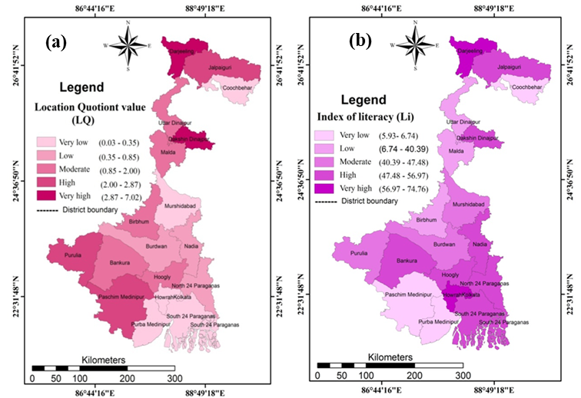

**Fig. 3:** (a) location quotient and (b) index of literacy

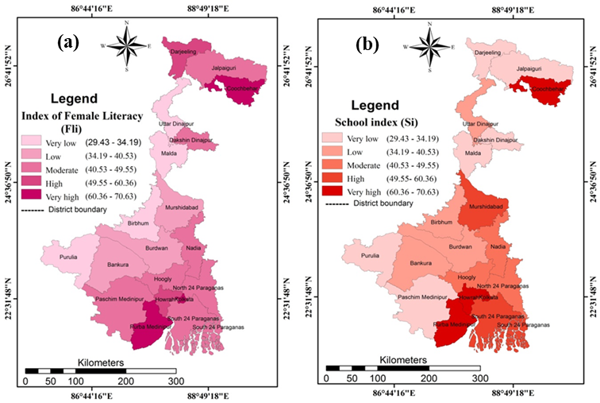

**Fig. 4:** (a) index of female literacy and (b) school index

**Workforce participation (Pw):**

The sharing of the economically active population in a region is also measured by the workforce or labour participation ratio and it also gives an idea about the economic status of the people of the region. Overall participation of the labour force (**Pw**) of the tribal population was not so good in the state and inequality in the district-wise participation rate of the tribal labour force was noticed. The gender-wise rate of the tribal workforce has also revealed the disparity in all districts (Table 2). The highest workforce participation was recorded at Hooghly district (54.73) followed by Paschim Mednipur (51.57), Dakshin Dinajpur (51.41) and Bankura (50.47) respectively. On the other hand, bottom three districts of Tribal work participation were Darjeeling (39.37), North 24 Pargana (41.16) and Cooch Behar (41.29) respectively. For the precise understanding of the workforce participation scenario of tribal people of the state, the districts were categorized in five classes based on the magnitude of the workforce participation ratio i.e. very low work participation (23.53-26.10) was found at Cooch Behar and Purba Mednipur, low work participation (26.10-43.67) at Darjeeling, Jalpaiguri, Nadia, North 24 Pargana, South 24 Pargana, Kolkata and Howrah, moderate level of work participation (43.67-47.09) at Uttar Dinajpur, Malda, Murshidabad, high work participation (47.09-51.56) at Dakshin Dinajpur, Burdwan, Birbhum, Purulia, Bankura and Paschim Mednipur and very high work participation (51.56-54.73) district at Hooghly (Fig. 5a). The gender-based tribal workforce participation ratio was calculated for the comprehension of the gender disparity in the tribal community concerning economic activeness (Table2). Both the highest tribal male **(Wmi)** and female **(Wfi)** workforce participation rate was at Hooghly district and those were 60.64% and 48.96% accordingly. The lowest Wmi (34.27%) and Wfi (22.6) were at Coach Behar and Kolkata respectively. The highest inequality was found between Wmi (60.15%) and Wfi (22.6) in the Metropolitan Kolkata. For better visualization of the district-wise Wmi and Wfi, five classes of these indices were determined based on the magnitudes of the indices (Figs. 5b and 6a).

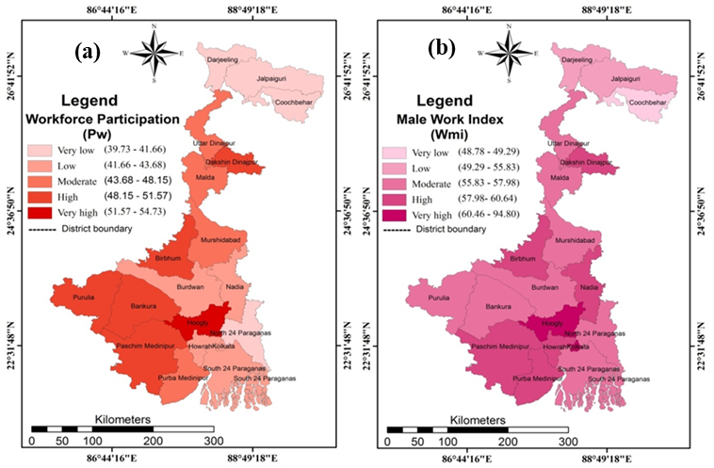

**Fig. 5**: (a) Workforce participation and (b) male worker index

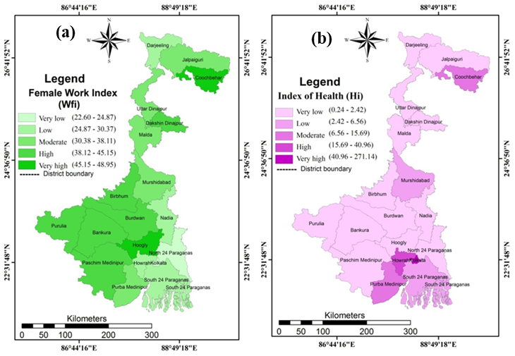

**Fig. 6:** (a) Female work index and (b) index of health

**Health Index (Hi):**

Health index is considered as one of the determinants of the quality of life in the measurement of the Human Development Index (HDI). The health of the individuals in a community is influenced by different geo-environmental factors as well as calorie intake through diet, sanitation condition, and availability of medical facilities in a given region. Except for the geo-environmental condition all other influencing factors of the individual health are dependent on the socio-economic conditions of the concerned community. In the study area, the Health Index (Hi) was measured in terms of the number of hospitals, health centres, sub-health centres, family welfare centres, and the number of doctors per thousand people concerning the total population. The health index in the Metropolitan Kolkata was good enough and it was highest in the state (271.15) and the lowest one was at Burdwan district (0.24). The value of the health index was quite good at Howrah (40.96) and Koch Behar (14.12) but it was in a miserable situation in the rest districts of the state (Table 2). The district-wise health index scenario was visualized by a map showing five categories of health index based on the magnitude (Fig 6b).

**Sex Ratio (Rs):**

The sex ratio is one of the important demographic parameters that gives the picture of the biological and social gender-balanced condition in society as equality in the development in terms of gender. The sex ratio of the tribal population was calculated by number of females per hundred of male tribal population. In India, the total sex ratio was 950 females per thousand male population or 95 females per hundred male (Office of the Registrar General & Census Commissioner, 2011) (https://censusindia.gov.in/2011census/SC-ST/pca_state_distt_st.xls). In India, the tribal sex ratio in India was higher almost in all census years. In the state, it was noticed that tribal sex ration was good and revealed a balanced condition in gender from the biological point of view. The highest sex ratio of the tribal people was 102 and found at Birbhum and Hooghly district while the lower one was at Kolkata (86). Except for Kolkata in other districts, the sex ratio was in almost balanced condition (Table 2). The district-wise tribal sex ratio was visualized through the categorization of the sex ratio into five convenient classes (Fig. 7a).

**Income (Ii):**

One of the strongest determinants of development in a region is the per capita income as it influences other factors of the development processes as well as the quality of life. In India economically the tribal people had been classified into three classes based on the monthly income of the families viz, < Rs-5000, 5000 -1000 and >Rs 1000/ for assessing the economic situation of the tribal people of India. In the study income index of the tribal people was calculated in all districts except Kolkata due to the unavailability of data. The highest average income index was found at Paschim Medinipur (17.33) and the lowest one was at Howrah (2.67). A significant disparity was noticed among the districts in terms of the average income index of the tribal people (Table 3). The state was categorized into five classes based on the average income index of the tribal people for visualizing the income scenario. Very low (<3.00) group of average income were Cooch Behar, Howrah, Purba Medinipur, low (3.00-8.33) group of average income districts were Uttar Dinajpur, Birbhum, Murshidabad, Nadia, South 24 Pargana, moderate (8.33-11.33) average income group districts were Dakshin Dinajpur, Hooghly and North 24 Pargana, high average income (11.33-14.00) group were Malda and Bankura districts and lastly very high (14.00-17.33) group of average income rank districts were Darjeeling,  Jalpaiguri, Burdwan,  Paschim Medinipur,  Purulia (Fig. 7b).

**Table 3**: Income distribution of tribal household of different districts of West Bengal

|  |  |  |  |  |  |  |  |
| --- | --- | --- | --- | --- | --- | --- | --- |
| **Name of the districts** | **<5000 (I1)** | **500-10,000 (I2)** | **>10,000 (I3)** | **Rank of (I1)** | **Rank of (I2)** | **Rank of (I3)** | **(∑ I1... 3 / 3)** |
| Darjeeling | 66414 | 6511 | 6044 | 13 | 19 | 19 | 17 |
| Jalpaiguri | 156510 | 5832 | 3150 | 17 | 18 | 15 | 16.67 |
| Cooch Behar | 3280 | 236 | 367 | 2 | 3 | 3 | 2.67 |
| Uttar Dinajpur | 30015 | 1825 | 526 | 7 | 11 | 4 | 7.33 |
| Dakshin Dinajpur | 62528 | 1814 | 1017 | 12 | 10 | 9 | 10.33 |
| Malda | 59269 | 3617 | 1492 | 11 | 16 | 12 | 13.00 |
| Birbhum | 51982 | 937 | 835 | 10 | 7 | 8 | 8.33 |
| Murshidabad | 18514 | 565 | 707 | 4 | 5 | 6 | 5.00 |
| Burdwan | 91212 | 2659 | 5015 | 15 | 13 | 18 | 15.33 |
| Nadia | 26978 | 1230 | 1049 | 6 | 8 | 10 | 8.00 |
| Purulia | 104736 | 2860 | 3751 | 16 | 15 | 16 | 15.67 |
| Bankura | 74319 | 2677 | 2828 | 13 | 13 | 13 | 13.00 |
| Hooghly | 48795 | 2406 | 2266 | 9 | 12 | 13 | 11.33 |
| North 24 Paragana | 42976 | 1642 | 1407 | 8 | 9 | 11 | 9.33 |
| South 24 Paragana | 19466 | 809 | 726 | 5 | 6 | 7 | 6.00 |
| Howrah | 1396 | 201 | 621 | 1 | 2 | 5 | 2.67 |
| Purba Mednipur | 5749 | 285 | 312 | 3 | 4 | 2 | 3 |
| Paschim Mednipur | 193746 | 4870 | 4813 | 18 | 17 | 17 | 17.33 |
|  |  |  |  |  |  |  |  |

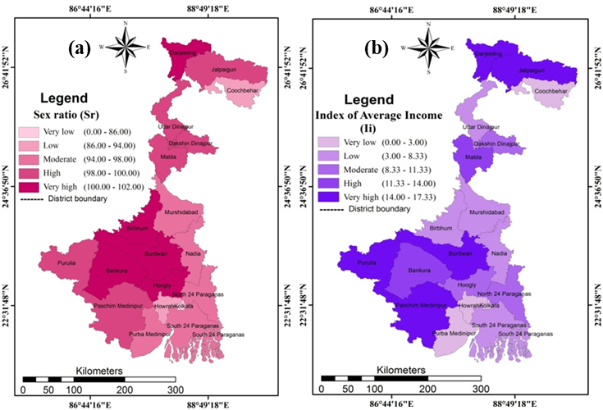

**Fig. 7:** (a) Sex ratio and (b) index of average income

**TCDI through simple average (SA) analysis:**

Tribal Community Development Index (TCDI) through simple average approach of different districts was applied to measure the Tribal community development over 19 districts of West Bengal. The synthesis of nine socio- economic and demographic parameters helps to get a panacea measurement of development and comparative analysis towards the dimension and magnitude of development among different districts. TCDI was calculated in two ways the first one (TCDI-) was included eight socio-economic and demographic parameters out of nine parameters in which the average income index was excluded as this parameter was not available for Kolkata. The second one (TCDI+) was included nine socio-economic and demographic parameters in which Kolkata was excluded (Tables 2 and 4). The results derived from the TCDI (-) had revealed that the Metropolitan Kolkata was ranked 1st position (81.18) and the last rank was achieved by Cooch Behar district (33.52) (Fig. 8). The extracted results of TCDI (+) had excavated that the highest TCDI (+) was at Howrah district (45.12) and the lowest one was at Cooch Bihar district (30.09). The eighteen districts of the state had the magnitude of TCDI (+) less than 50 was highlighted the very poor condition of the tribal community development (Fig. 9). There was a minor change in the TCDI values if we consider income parameter. Malda was shifted from very low to low development category similarly Burdwan and Purulia were shifted from low to Moderate level of development, Hooghly and Purba Mednipur were shifted from moderate to very high level of development category. Positive association was existed between TCDI and Li (0.57), Fli (0.67), Si (0.65), Wmi (0.41) and Hi (0.95) and negative correlation was exhibited between TCDI and Pw (-0.07), Wfi (-0.45), Rs (-0.66) and Ii (-0.37) if we exclude income parameter. On the other hand, if we include income parameter, TCDI was positively associated with the Pw (0.31), Wmi (0.03), Wfi (0.37), Rs (0.78) and Ii (0.48) and negatively linked with Li (-0.20), Fli (-0.24), Si (-0.56), Hi (-0.92).

**Table 4**: Comparative position of the development of different states

|  |  |  |
| --- | --- | --- |
| **Category** | **TCDI excluding average income** | **TCDI including average income** |
| **Very Low** | Uttar Dinajpur, Malda | Uttar Dinajpur |
| **Low** | Jalpaiguri, Birbhum, Murshidabad, Nadia, Purulia, Burdwan, North 24 Pargana, South 24 Pargana | Jalpaiguri, Malda, Birbhum, Murshidabad, Nadia, North 24 Pargana, South 24 Pargana |
| **Moderate** | Darjeeling, Cooch Behar, Dakshin Dinajpur, Bankura, Hooghly, Purba Mednipur | Cooch Behar, Dakshin Dinajpur, Burdwan, Purulia, Bankura, Paschim Mednipur |
| **High** | Howrah, Paschim Mednipur | Darjeeling, Hooghly |
| **Very High** | Kolkata | Howrah, Purba Mednipur |

~~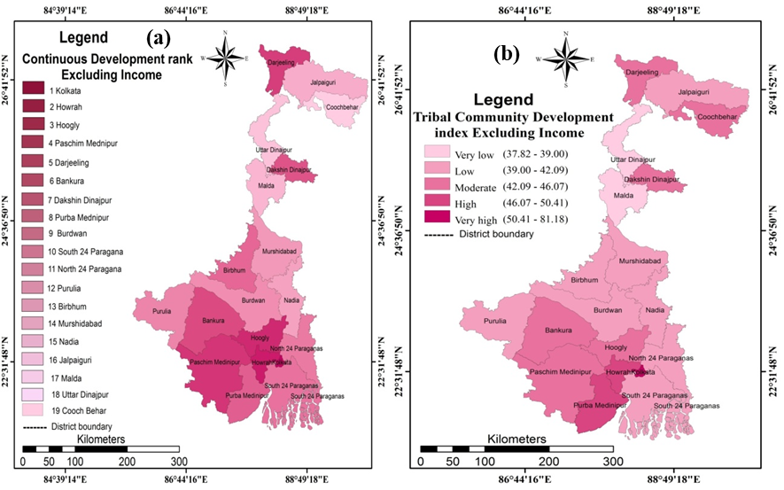~~

**Fig. 8:** TCDI values excluding income (a) Continuous and (b) Categorized

~~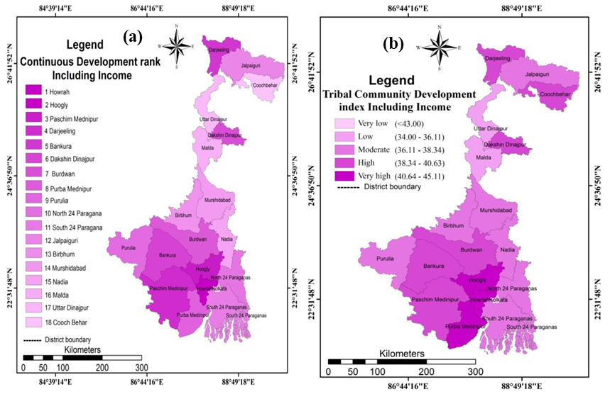~~

**Fig. 9:** TCDI values including income (a) Continuous and (b) Categorized

**Discussion:**

The derived values of the LQ about the district wise concentration of the tribal population to the state had revealed that no district has uniformity (LQ =1) in the concentration of the tribal population to the state. The districts namely Darjeeling, Jalpaiguri, Paschim Medinipur, Dakshin Dinajpur, Malda, Birbhum, Purulia, Bankura, Hooghly and Uttar Dinajpur have higher concentration or more than the unity of the tribal population to the state (LQ > 1). The lesser concentrations or less unity of the tribal population to the state were at the districts namely Cooch Behar, Murshidabad, Burdwan, Nadia, Kolkata, Purba Medinipur, South 24 Pargana, Howrah and North 24 Pargana (LQ < 1). It would be noted in Kolkata metropolitan the concentration of the tribal population was very low (LQ 0.05) signifying the evidence of lesser sharing of urban tribal population in the state. The tribal population was more concentrated in the remote backward rural areas and the areas having inconvenient topographic condition such as rural areas of Dakshin Dinajpur district, Jalpaiguri District, and harsh mountainous tract of Darjeeling district, unfertile plateau terrain of Paschim Medinipur. They were propelled by the people of the advanced communities mainly for economic propulsion since the initiation of the caste system in Indian society. The worst scenario of the tribal literacy rate was at Purba Medinipur district (6.74) signifying the severe backwardness of the tribal people in the state. The notable fact about the tribal female literacy rate was observed at Purba Medinipur district (66.60) that was huge higher literacy rate of the tribal females than the total tribal literacy rate (6.47%). The reason behind the exceptional fact in Purba Medinipur district might be the social conscious of the tribal females was merely good in comparison to the tribal males.Number of the educational institutions reveals the opportunities for attaining education by the people of the concerned area. The school index concerning the total number of government and government-aided education institutions to total population in the respective district as in West Bengal educational institutions open for all irrespective of caste, clan, and religion. Unfortunately, it was found in the study that despite the high school index in some districts the tribal literacy rate was far behind the total literacy rate. In other words, participation of the tribal people in educational attainment was low due to socio-economic backwardness. The districts which had more than 50% of the tribal workforce participation ratio were Hooghly, Paschim Medinipur, Dakshin Dinajpur, Bankura, and Birbhum while in the rest districts of the state had the ration less than 50%. Hooghly and Paschim Mednipur districts were located around Kolkata, the capital city where job opportunities were very high. Though North 24 Paragana is located near the developed area of Kolkata and Hooghly but due to the isolation nature of female Tribal population the workforce participation was less. Dakshin Dinajpur and Burdwan having fertile soil for agriculture which leads to high work force participation in agricultural activity. It was noticed that the tribal female workforce participation ration was always behind the male tribal workforce participation ratio in all districts except Cooch Behar District (48.83). This is due to the active participation in agricultural pursuits. The women labourers are mostly employed in plantation crops, manufacturing of foodstuffs, tobacco products, cotton textiles, cotton weaving in handlooms, silk textile handlooms, bamboo, cane and other allied products. The range deviation of the district-wise health index was extremely high (99.82%). It would be noted that health service centres both the government and private ownership were concentrated mostly in the urban or semi-urban centres of the districts in the state. So, the rural dwellers were being faced with difficulties to reach the health service centre situated in the urban and semi-urban due to remoteness and for want of money. Therefore, the person of the tribal community was deprived of the facilities which were available in the respective districts. The balanced sex ratio of the tribal people all most in all districts in the state was revealed that the tribal people had no gender biases to give birth to the children. The average income index of the tribal people was revealed that the economic condition of the tribal people was not good almost in all districts of the state. The highest average income index was found at Paschim Medinipur (17.33) due to having both high male workforce participation (57.98) and female workforce participation (45.15) which can be reflected in income.

**CONCLUSION:**

The overall development scenario of the district-wise tribal people was extracted from the analysis of the TCDI index incorporated nine socio-economic and demographic parameters that had depicted the unsatisfactory socio-economic situation. A wide disparity was found among the districts in the state in connection to TCDI and as well as of the selected determining parameters of the development. Tribal literacy among the districts ranged from 6.74% at Purba Medinipur to 74.77% in the Metropolitan Kolkata. School index was considered to measure the facilities available for attaining the education in the districts of the state. The district-wise school index was also dissimilar and the most notable factor was that despite the high education index in some districts the tribal literacy rate was very low such as at Purba Medinipur the total literacy rate was 6.74% while school index was 14.15. The index based on the availability of the health centres and the number of doctors per thousand people was revealed the very poor situation of the tribal population due to remoteness from the urban centres had a high concentration of the health service centre and paucity of money to avail the medical services. The workforce participation ratio of the tribal people was not so good in all the districts of the state. The study was revealed that in West Bengal the tribal people were far beyond the development in comparison to the total development of the state. There are necessities for community-based development schemes to elevates the tribal society up to the national standard of the quality of life. The tribal people of the concerned local area are to be incorporated in the tribal development machinery with the administrations for searching appropriate schemes of tribal community development and for the successful implementation of the same. The social awareness of the tribal people is to be enhanced to get benefits of the schemes of the government implemented for tribal development.

**Conflict of interest statement:** The authors declare that there is no conflict of interest.

**REFERENCES:**

Annapoorani, R., & Sudha, S. (2013). An analytical study of inter district variation in quality of life in Tamilnadu. Shanlax International Journal of Economics, 2, 12-23

Biao,I., (2011) Human development index literacy as a new social development theory. International Critical Thought, 1(4), 385-396, DOI: 10.1080/21598282.2011.640136

Biao, I., Mogotsi, K., Maruatona1, T., Raditloaneng, W., Tladi, F., Chawawa, M., Kheru, O. (2014). The contribution of the human development index literacy theory to the debate on literacy and development. World Journal of Education, 3 (4), doi:10.5430/wje.v4n3p1

Beck, P.,& Mishra, B.K. (2010).Socio-economic profile and quality of life of selected oraon Tribal living in and around Sambalpur town, Orissa. Current Research Journal of Social Sciences, Maxwell Scientific Organization,2(6), 340 – 349

Beyond income, beyond averages, beyond today: equalities in human development in the 21st century. Human Development Indices and Indicators, 2019 Statistical Update. By the United Nations Development Programme 1 UN Plaza, New York, NY 10017 USA

Basu, k. (2000). A study of social and political function of economics. Great Caledonian Street. Oxford OX2 6DP. 1-185

Catherine, C. (2009). Tribal development in India with special reference to Manipur: Trajectory and literature.” The NEHU Journal, VII (1), 68 – 88

Cardoso, F.H.( 2001). The policy of globalisation and social information. Lanham, Boulder Newyork. Oxford. 1-144

Dolan,P., Whith, M. (2006). Dynamic well-being: connecting indicators of what people anticipate with indicators of what they experience. Social Indicators Research. 75,303–333

Dolan,P., Tsuchiya,A. (2011). Determining the parameters in a social welfare function using stated preference data: an application to health. Applied Economics, 43:18, 2241-2250, DOI: 10.1080/00036840903166244

Frank, A. G.( 1967). Sociology of underdevelopment and underdevelopment of sociology catalyst Underdevelopment or Revolution. New York: Latin America. Monthly Review Process. (3), 20-73.

Ghoosh, P. (2013). Development programmes and the Tribal: A study on the santals of Birbhum district.” Journal of Applied Geology and Geophysics (IOSR-JAGG), 1 (5), 35-39

Jana, N.C., & Ghosh, P. K. ( 2015). Socio-economic conditions and quality of life in the Tribal areas of Orissa with special reference to Mayurbhanj district. Space and Culture, India. 25 – 41

Kapoor, A. K., & Dhall, M. (2016). Poverty, malnutrition and biological dynamics among Tribes of India” Health Science Journal, 10 (3:5), 1 - 5

Kim J.I. & Kim, G. (2015). Country-level socioeconomic indicators associated with healthy life expectancy: income, urbanization, schooling, and internet users: 2000–2012. Social Indicators Research. 129 (1), 391-402

Mog, U. J., & Debbarma, J. (2018). Socio-economic status of Tribal communities in Tripura. International Conference on Research Developments in Arts, Social Science,& Humanities. 253-265

Mosse,d. (2018).Caste and development: Contemporary perspectives on a structure of discrimination and advantage. World Development. 422– 436

Mullah, M.A.S., Parveen, N., & Ahshanullah, M. (2007). Tribal people and their socio-economic

characterisitcs in Rangamati radar rhana. BRAC University Journal. IV, (1), 47-58

Maharana, R., & Patel, S. P. (2018). The santhal: socio-economic miserable condition and quality of life (An overview of Bantali Rakhasahi village, Mayurbhanj district, Odisha). IJRDO-Journal of Social Science and Humanities Research. 3 (1), 83 - 102

Mishra,P.C., Mishra, B. K., & Tripathy, P.K. (2008). Socio-economic profile and quality of life index of sample households of mining areas in valley coal mines in Orissa. Department of Environmental Sciences, Department of Home Science, Department of Economics, 23(1), 13-20

Mallick, Md. A. (2014). Tribal development and life pattern a case study of Jamalpur block in the district of Burdwan. International Journal of Humanities and Social Science. 3(6), 81-110

Mandal,A.(2018). Village level discrepancy in available facilities, development and related problems: a case study of Ramkishore Gram Panchayet, Kulpi C.D. block, South 24 Parganas, West Bengal, India. International Journal of Research in Social Sciences, 8 (2),330-344

Naik,R. (2017). An Overview of Tribal Development in India: Problems and Prospects. Paripex - Indian Journal of Research. 6 (6). 1322- 124

Narayana, M.R. (2006). Measurement of education achievement in human development: Evidence from India. International Education Journal. 7(1), 85-97

Pal, B., Goswami, A., Biswas, S. (2015). Socio-economic status of some selected Tribes in West Bengal, India. International Journal of Current Research. 7 (04), 14292 - 1429

Patra, H.S., Meher, M.K., Mohan, S.K. (2015). Socio-Economic Profile and quality of life of villages in and around mining area of Keonjhar district, Orissa, India. International Research Journal of Social Sciences. 4(6), 31 - 39

Pal, G.C. (2010 ) Poverty among Tribals in India:Variations and vulnerabilities. Journal of Social Inclusion Studies. 97 -113

Report on A Research Study On Migrant Tribal Women Girls in Ten Cities: A Study of Their Socio-Cultural and Economic Reference to Social Intervention.” (2003). A research study report, Submitted to Planning Commission Government of India, New Delhi.1-57

Report on socio-economic conditions of scheduled Tribes workers in Kbk belt – Orissa. (2011). Government of India Ministry of Labour & Employment Labour Bureau Chandigarh. 2 - 88

Sabiu, I.T., Zainol, F.A. and Abdullahi, M.S. (2018): Hausa people of northern Nigeria and their development, Asian People Journal (APJ), 1 (1), 179-189

Sapignoli, M and Hitchcock, R.K (2013): Indigenous Peoples in Southern Africa, The Commonwealth Journal of International Affairs, 102 (4), https://doi.org/10.1080/00358533.2013.795013

Sena, K (2010): Africa Indigenous Peoples: Development with Culture and Identity: Article 2 and 32 of the United Nations Declaration on the Rights of Indigenous Peoples, Department of economic and social affairs, Division for Social Policy and Development, Secretariat of the Permanent Forum on Indigenous Issues, New York, 12 - 14 January, 2010

Sonowal, C.J.(2008). Indian Tribes and issue of social inclusion and exclusion. Studies of Tribes and Tribals, 6(2), 123-134, DOI: 10.1080/0972639X.2008.11886586

Thorat, S., Newman S. (2007). Caste and Economic Discrimination: Causes, Consequences and Remedies. Economic and Political Weekly. 42 (41), 4121- 4124

Vidyarathy, L.P. (1976). Rise of anthropology in India a social science orientation the rural urban and other dimension. Concept publishing company Delhi

Wani, R.A., & Khairkar, V. P. (2011). Socio-economic and quality of life of Srinagar city. Journal of Arts, Science & Commerce. Health Science Journal. II (2), 123-139