**SOLAR – WIND FED BATTERY CHARGING FOR ELECTRIC**

**VEHICLES USING MATLAB / SIMULINK**

**Harish B N1, Anusha B M2, Deepa K R3, Kiran B P4, Yamini S5**

1Assistant Professor, Department of Electrical and Electronics, PES College of Engineering, Mandya, Karnataka, India

2,3,4,5Student, Department of Electrical and Electronics, PES College of Engineering, Mandya, Karnataka, India

**ABSTRACT**

Electric cars (EVs) are becoming more and more common, hence there is a need to increase the number of charging stations. The rise in oil prices and environmental concerns have stoked interest in the creation of electric automobiles. Electric vehicles typically require batteries that are recharged by an external power source, however solar photovoltaic (PV) modules can charge batteries by receiving solar radiation and converting it to electrical power. Additionally, one of the renewable energy sources with the greatest growth is wind power, which harnesses the kinetic energy of moving air to generate electricity. The electricity for charging the battery packs of electric vehicles is produced in the current work using a charging system based on solar and wind energy. The solar photovoltaic modules and the wind generator make up the renewable charging station. An additional MPPT algorithm is utilised to compensate for the solar panel's maximum power. Perturb & Observe (P&O) approaches are utilised with various MPPT Algorithms. The solar PV panel's DC voltage is decreased using a DC-DC converter. An AC power output from the wind is converted to DC power using a three-phase rectifier. MATLAB/Simulink is used to simulate, design, and validate the proposed system's outcomes.

**Keywords:** Electrical vehicles [EV], Photo voltaic [PV], Solar & wind energy-based charging mechanism [SWCM], Maximum power point tracker [MPPT], Perturb & Observe [P&O]

1. **INTRODUCTION**

Currently, the energy crisis is a significant and unsolvable problem, with high consumption and extraction costs associated with fossil fuels like gasoline and diesel. The burning of these fuels contributes to global warming and pollution due to the emission of greenhouse gases. Furthermore, the escalating demand for gasoline and diesel will eventually deplete these finite resources. Thus, it is prudent to transition to electric vehicles (EVs) instead of traditional internal combustion engine (IC) vehicles. One viable alternative source of renewable energy is solar-wind power technology, which efficiently harnesses energy from the sun and wind. Solar energy is stored in batteries and used to power vehicles. Photovoltaic (PV) models have gained considerable attention due to their lack of moving parts and minimal environmental pollution. The power generated by a PV array depends on parameters such as radiation intensity and temperature. Higher radiation intensity leads to increased power generation at the maximum power point of the PV module. PV cells operate at maximum output power and track the available maximum output power of the PV array, enhancing the efficiency of the PV system. A PV panel consists of interconnected solar cells, and a DC-DC converter based on maximum power point tracking (MPPT) is commonly employed to obtain a steady DC voltage from a DC source, such as a rectifier, battery, or solar cell. The MPPT algorithm determines the popular method used, such as the perturb and observe (P&O) method, incremental conductance method, or ripple correlation technique. The P&O method is widely used in MPPT due to its simplicity and minimal parameter requirements. It perturbs the terminal voltage of the PV array and compares the generated output power with the previous perturbation cycle. Numerous EV charging stations and simulation models have been analyzed, with most of the literature focusing solely on solar PV. Some studies utilize wind energy alone to recharge EVs, while others incorporate hybrid energy sources (wind and others) in charging stations. Ideal simulation models are employed to assess the performance of such systems. In this work, a recharging station based on renewable energy (solar and wind) has been designed, promoting a greener environment. The simulations were conducted using MATLAB/Simulink software. This paper presents a solar-wind hybrid system with an EV charging station to meet the electricity demand of a small shopping complex in an Indian university campus. Economic analysis is performed, considering both EV charging and shopping complex load demand. The system is designed to minimize the levelized cost of electricity (LCOE) and the loss of power supply probability (LPSP) through component sizing and optimization techniques. The results show that the proposed system achieves an LCOE of 0.038 $/kWh and an LPSP of 0.19% with a renewable fraction of 0.87, demonstrating its cost-effectiveness and reliability. It can contribute to reducing reliance on overloaded grids, especially in developing countries [1]. This paper discusses the growing popularity of electric vehicles (EVs) and the need for more EV charging stations. It highlights the potential of wind energy [2] in Newfoundland as a viable source for charging EVs. The paper outlines the system design, dynamics, and presents simulation results to support its findings. This paper presents a renewable-based DC charging system for Electric Vehicles (EVs), integrating power from solar, wind, and battery energy storage. The system utilizes the incremental conductance method with a boost converter for solar power and the hill climb method with a buck converter for wind power to maximize efficiency. A bidirectional converter [3] and a PID controller are incorporated to manage power flow and limit discharge current from the storage system, ensuring uninterrupted power supply for the EV charging load [4]. This paper explores various models of PV systems incorporating different DC-DC converters, such as the buck converter, boost converter, and buck-boost converter, to achieve maximum power point tracking (MPPT)[5]. Four different configurations are presented, including a PV module connected to a buck-boost converter with incremental conductance MPPT and a PID controller, a similar configuration without the PID controller, and two systems using a boost converter with MPPT control and PWM technique [6]. This paper presents a solar and wind energy-based charging mechanism (SWCM) for charging electric vehicle (EV) battery packs. The SWCM [7] utilizes solar photovoltaic (PV) modules and a wind generator to significantly reduce the reliance on fossil fuels and minimize CO2 and CO emissions. The simulation model developed in MATLAB-Simulink analyzes the I-V and PV characteristics [8] of the solar panel under varying irradiance levels and investigates the performance of the wind turbine under different loading conditions.

1. **METHODOLOGY**
   1. **Block Diagram**

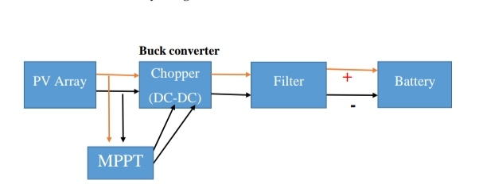

Fig 1: Block Diagram of wind fed battery charger. Fig 2: Block Diagram of solar fed battery charger

Wind fed charger consists of a wind turbine driving a permanent magnet alternator and operates at variable speed. The alternator is connected to a battery bank via a rectifier. The characteristic of the system depends on the wind turbine, the alternator, and the system configuration. A rotor drives a permanent magnet synchronous generator at variable speed, depending on the wind speed. The output of the generator is rectified and fed to a battery bank. Typically, there is a charge controller in the circuit to prevent overcharging of the batteries most common type of battery used in grid energy storage systems are lithium-ion batteries.

Solar panels generate electricity from the sun this direct current (DC) electricity flows through an inverter to generate alternating current (AC) electricity The AC electricity powers your home appliances Extra electricity not used by your appliances charges your batteries When the sun goes down, your appliances are powered by the stored energy in your battery.

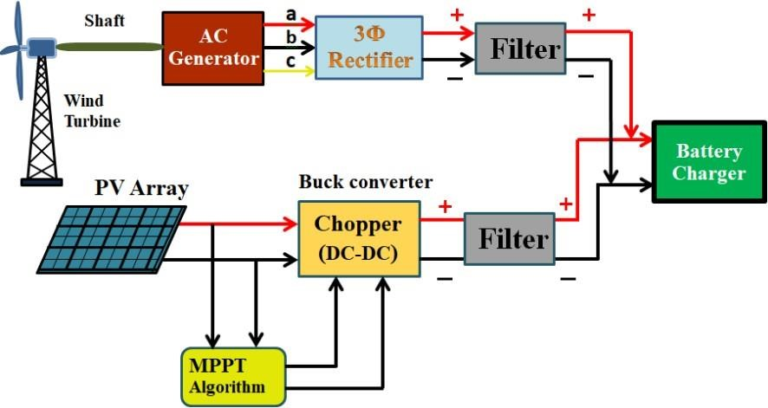

Fig 3: Block diagram of Solar-wind fed battery charger.

The block diagram of Solar-wind fed Battery charger for Electric vehicles is as shown in fig 3. Photo voltaic array is a linked collection of PV modules. Each PV module is made up of multiple interconnected PV cells. The cell converts Solar energy into DC electricity. PV cells operates via the PV effect which describes how certain material can converts sun lights into electricity. They absorb some pf the energy of the sun and cause current flow between to oppositely charged layers. MPPT algorithms are necessary in PV applications because the MPPT of a solar panel varies with the irradiance & Temperature, the use of MPPT algorithm is required in order to obtain the maximum power from PV array. Among all the algorithms P & O are most common as they have the advantage of an easy implementation. There is a maximum power at the output of the wind turbine. If wind and solar power generation system would like to capture the maximum wind energy, wind turbine speed must be adjusted in real time based on changes in wind speed. According to the principle of electric wind generator, we know that when the input mechanical power is greater than the output electrical power.

* 1. **Battery Specifications:**

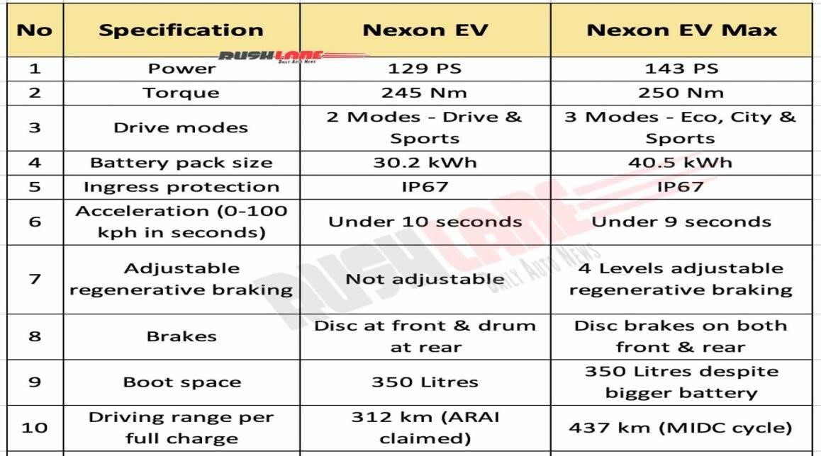

Table 1: Battery Specifications

1. **RESULTS AND DISCUSSION**

The solar fed battery, wind fed battery and solar-wind fed battery models are built using Simulink and following are the results of the same which is shown below.

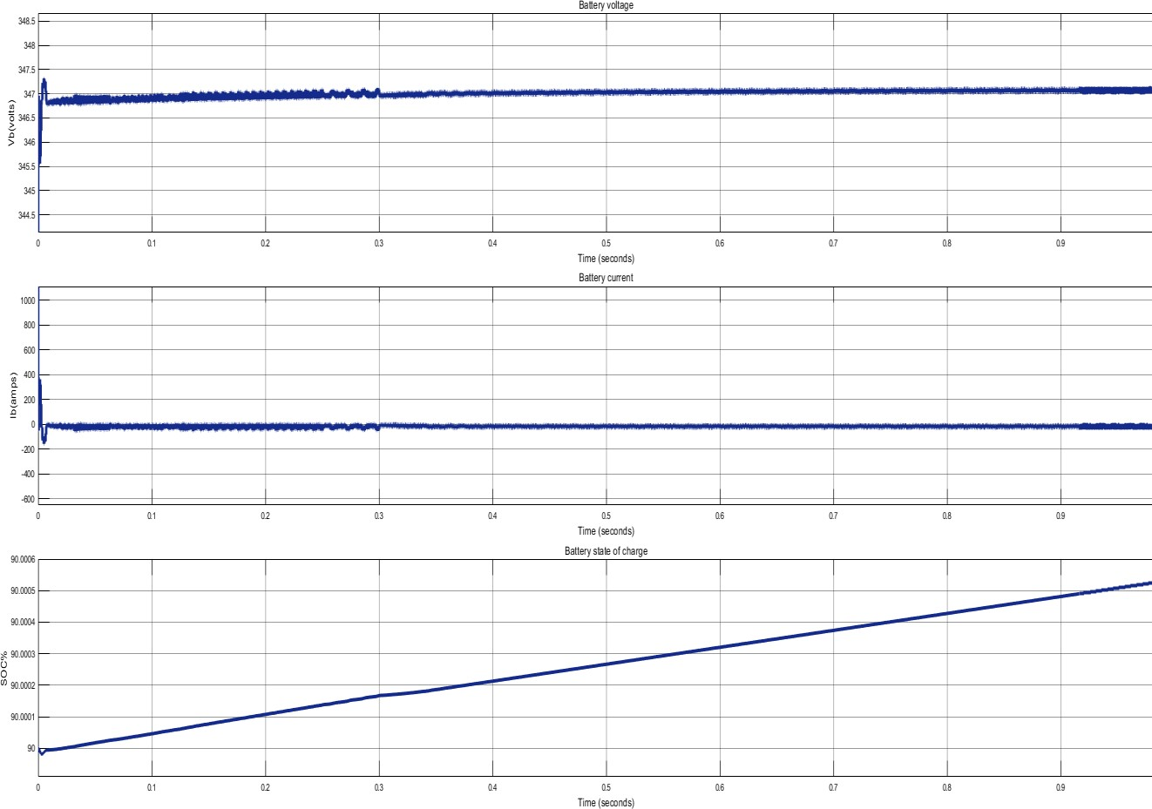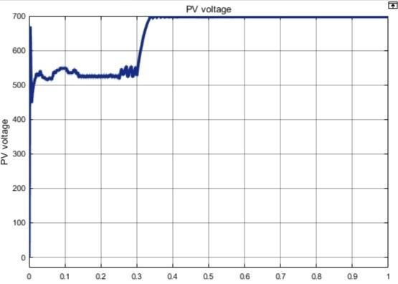

## Fig 4: Solar voltage, current and SOC response Fig 5: Graph of PV Voltage

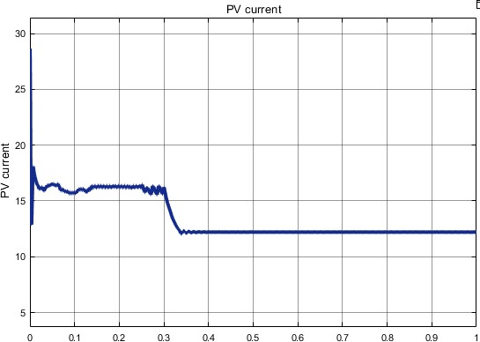 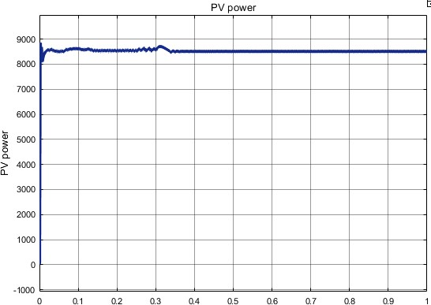

Fig 6: Graph of PV Current Fig 7: Graph of PV Power

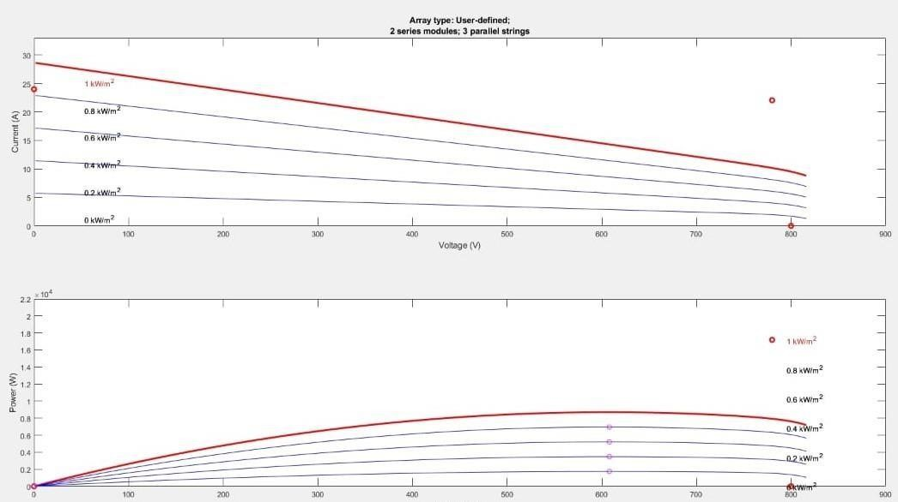

Fig 8: graph of (Power-Voltage) &(Current-Voltage)

The obtained battery voltage is 347V, battery current is 8.65A and the SOC is 90%. The fig 4 represents the graph of solar fed battery. The first graph represents the characteristics of battery voltage in y-axis and time in x-axis with the peak voltage of 347V. The second graph represents the characteristics of battery current in y-axis and time in x=axis with the total current of about 10.19A. The third graph represents the characteristics of state of charge (SOC) in y-axis and time in x-axis.

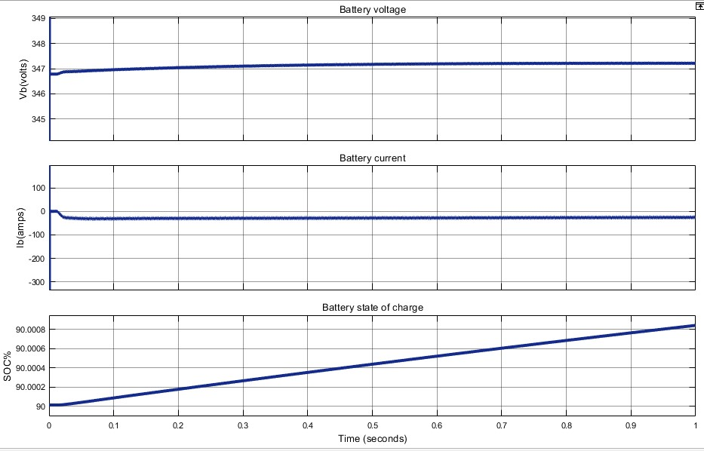

Fig 9: Graph of Wind voltage, current and SOC response

The first graph represents the characteristics of battery voltage in y-axis and total time in x-axis with the peak voltage of 347.5V. The second graph represents the characteristics of battery current in y-axis and total time in x-axis with the total current of about 23.8A The third graph represents the characteristics of state of charge (SOC) in y-axis and total time in x-axis.

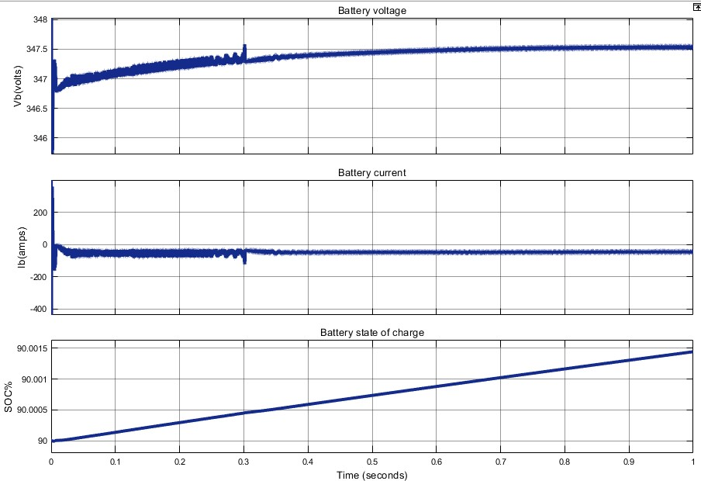

Fig 10: Graph of Hybrid Voltage, Current and SOC Response

The first graph represents the characteristics of battery voltage in y-axis and total time in x-axis with the peak voltage of 347.5V. The second graph represents the characteristics of battery current in y-axis and total time in x-axis with the total current of about 37.1A The third graph represents the characteristics of state of charge (SOC) in y-axis and total time in x-axis.

* 1. **Calculations:**

1.In Solar fed battery the State of charge (SOC) changes from 90 to 90.0006% in 1 second.

Thus, 1Sec=0.0006%

1000sec=6%

X=1%

X=1000/6 sec

=1000/ (6*60) min

=27.78min =28min

Hence battery takes 28 min to charge 1%

2.In Wind fed battery the State of charge (SOC) changes from 90 to 90.0009% in 1 second.

Thus, 1Sec=0.0009%

1000sec=9%

X=1%

X=1000/9 sec

=1000/ (9*60) min

=18.5min =18.5min

Hence battery takes 18.5 min to charge 1%

3.In Solar & Wind fed battery the State of charge (SOC) changes from 90 to 90.0015% in 1 second. Thus, 1Sec=0.0015%

1000sec=15%

X=1%

X=1000/15 sec

=1000/ (15*60) min

=11.11min =11min. Hence battery takes 11 min to charge 1%

* 1. **Comparison Table:**

|  |  |  |  |
| --- | --- | --- | --- |
| **SLNO.** | **SOLAR** | **WIND** | **SOLAR & WIND** |
| 1. | Solar panels are used to convert solar energy into electricity | Wind turbines are used to convert wind energy into electricity | Both solar panels and wind turbine are used to convert solar and wind into electricity |
| 2. | The energy generation depends on factors like irradiance, temperature, and panel efficiency | The energy generation depends on factors like pitch angle turbine size and location | The energy generation depends on both the solar and wind |
| 3. | Obtained battery voltage is 347.1v | Obtained battery voltage is 347.1v | Battery voltage is  347.1v |
| 4. | Less efficient (15-20%) | More efficient (60-70%) | More efficient (70-80%) |
| 5. | Installation cost is more | Installation cost is comparatively less | Installation cost is more |
| 6. | Maintenance cost is less | Maintenance cost is more | Maintenance cost is more |
| 7. | Noiseless operation | Noise operation | Noise operation |
| 8. | The SOC of battery varies from 90% to 90.0006% in 1 sec (28min to charge 1%). thus require more time to charge | The SOC of battery varies from 90% to  90.0009% in 1 sec (18.5min to charge 1%). thus requires.  comparatively less time to charge | The SOC of battery varies from 90% to  90.0015% in 1 sec (11mins to charge 1%). thus require less time to charge |

Table 2: Comparison Table

1. **CONCLUSION**

The Design and Analysis of Solar-Wind fed Battery Charger for Electric Vehicles project aims to design a sustainable charging method for EVs. The combination of solar and wind power was shown to be a reliable and efficient energy source. Energy was stored using a battery bank to lessen the impact of changes in the energy source. The system's performance was examined using simulation software and determined to be satisfactory. The charging time and energy efficiency were also judged to be satisfactory. This project illustrates that renewable energy sources can power EVs, eliminating dependence on fossil fuels. Further development and optimization can lead to widespread use of electric vehicles. The project contributes to a more sustainable future for transportation. The use of renewable energy can be very important in lowering carbon emissions. The ability to combine several renewable energy sources to power different applications is demonstrated by this project.

1. **REFERENCES**
2. Shakti Singh, Prachi Chauhan, Nirbhow Jap Singh, “easibility of Grid-connected Solar wind Hybrid System with Electric Vehicle Charging Station” Journal of modern power systems and clean energy, VOL. 9, NO. 2, MAR 2021.
3. Amirhossein Jahanfar, M. Tariq Iqbal, “Design and dynamic simulation of a wind turbine powered electric vehicle charging system” Presented at 30th IEEE NECEC conference, NOV 2021.
4. P Jyothi, P Saketh, Ch Vignesh, V S Kirthika Devi, “Renewable energy powered DC charging system for electric vehicle” First International Conference on Advances in Physical Sciences and Materials,2020.
5. Osama Elbaksawi, “Design of Photovoltaic System Using Buck-Boost Converter based on
6. MPPT with PID Controller” Universal Journal of Electrical and Electronic Engineering, NOV 2019.
7. C. Chellaswamy, V. Nagaraju, R. Muthammal, “Solar and Wind Energy Based Charging
8. Station for Electric Vehicles” International Journal of Advanced Research in Electrical, Electronics and Instrumentation Engineering, Vol. 7, Issue 1, JAN 2018.
9. Nirmala. M, Malarvizhi. K, Thenmozhi. G, “Solar PV based Electric Vehicle” International
10. Journal of Innovative Technology and Exploring Engineering (IJITEE), ISSN: 2278-3075, Volume-8 Issue-2S2 DEC 2018.
11. Prakhar Sharma, Pankaj Kumar, Himanshu Sharma, Nitai Pal, “Closed loop-controlled boost converter using a pid controller for solar wind power system installation” International Journal of Engineering & Technology, 2018.
12. Bharathi Sankar, R. Seyezhai, “Simulation and Implementation of Solar Powered Electric Vehicle” Circuits and Systems, MAY 2016.