# CHAPTER 1

## INTRODUCTION

This chapter emphasize the significance and characterization of seal and automotive connector.

A connector is a plastic device providing insulation of electrical contacts and assuming a mechanical interface for mating. A terminal is a metallic device creating a link between two electrical points, made up of flexible blades, pressuring the pin and containing male and female contact. The main function of connectors is to maintain electric contact between the terminals. It also provides contact from environmental conditions like mechanical vibrations, dust, humidity, heat, and short circuits. Figure

1.1 shows the male and female contact and figure 1.2 shows connector housing.

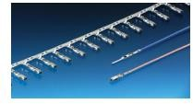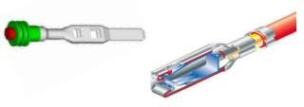

Figure 1.1 Male and Female Contacts

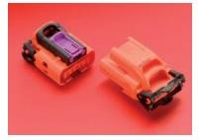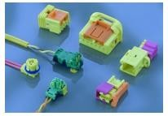

Figure 1.2 Connector Housing

Electrical connectors are used in the electrical system to transmit an electrical signal, allow electrical devices to interact, and transmit power through its contact points. The mating part of the connector’s cable terminal in an electrical circuit is called electrical contact points which are a current-carrying interface that allows electrical connection without constriction for electrical current flow across it. There are different

types of electrical connectors; these can be classified based on their application, size, working environment, mounting location, surface geometry, and other means. Also, the connectors based on their mounting location can be categorized as suitable for cab, chassis, or powertrain (engine, gearbox, and differential).

## ELECTRICAL CONNECTORS IN THE AUTOMOTIVE INDUSTRY

The growing market of electric and hybrid vehicles leads to an increased number of cars with highly complex wiring (electrical) systems. Because of this, there is an increasing need to provide cheap, lightweight, and reliable electrical contacts. **The term electrical contact, at the most basic level, refers to a separable or non-separable connector called a terminal (Figure. 1.3a), allowing for the flow of electrical current between two cables.** The most common types of contacts used in automotive applications are separable multi-way contacts called plug and receptacle connectors. (Figure. 1.3). A plug and receptacle connector (for clarity, this is referred to as a “connector”) consists of several terminals corresponding to the number of cables connected. Terminals are housed in a thermoplastic enclosure called housing, which is sealed with elastomeric seals mounted on the cables, as shown in blue in Figure. 1.3a. Housings and other assembly parts are usually manufactured by injection molding from thermoplastic materials such as PBT, PA6, PA66, etc. **The seals are used for ensuring housing tightness and are injected with liquid silicone rubbers (LSRs), which provide good resistance to chemicals as well as long-term temperature exposure.** Finally, terminals constituting the basic building blocks of the wiring system are manufactured mainly with rolled copper and copper alloys. However, for the cables and busbars - the automotive industry leans toward aluminium due to its low density, moderate electrical properties, and most importantly, its cost-effectiveness. To ensure low electrical resistivity and prevent deterioration of mechanical properties, the terminals are plated with coating materials.

The most commonly used materials for plating are tin, nickel, and two noble metals, gold, and silver. Out of these materials, tin is the most widely used, as it can be applied with various application methods and is cost-effective. However, disadvantages

include its low resistance to wear and degradation in its contact properties over time and temperature. Another popular coating material is silver, which is known for its excellent electrical properties. It is harder than tin, giving it increased resistance to wear and higher operating temperatures (up to 200 ◦C), which allows for its usage in engine sensors. However, silver is prone to tarnishing and electromigration and is significantly more expensive than tin. Another noble material used for coating is gold, especially ‘hard gold’ (hardened with cobalt, making it harder than electroplated silver), which has the lowest friction of all mentioned materials, as well as the highest wear and environmental resistance.

The negative aspect of gold is its high cost; however, gold coatings are applied as very thin layers. Both silver and gold are widely used in connections that are designed to survive numerous mating cycles, such as in charging connectors for electric and plug- in hybrid vehicles. The selection of coating materials is one of the factors influencing the durability of the electrical contact; however, other factors are also important, as described in the following sections.

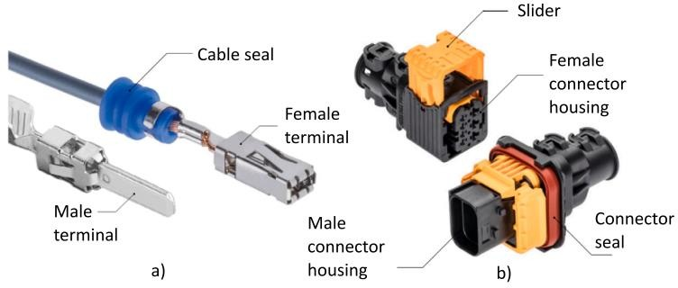

Figure 1.3 Terminal and Housing

## PURPOSE OF SEALS IN AUTOMOTIVE CONNECTORS

**The seal is an elementary component used to prevent external gas or fluid from entering the inside of the component.** The cross-sectional shape of the seal is a very important factor in determining the performance depending on the purpose of use. For example, the O-ring shape is the most efficient and low friction force. It is easy to install due to the high frictional force, and the rectangular cross-sectional shape can

withstand greater pressure than the O-ring shape, but it is difficult to install upwards due to the high frictional force. In some cases, an H or X shape is used to overcome this.

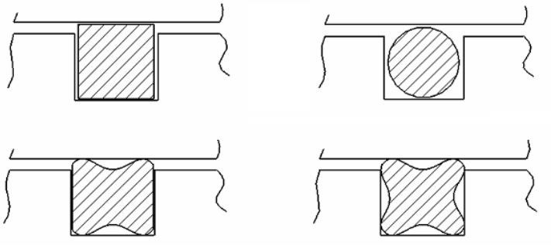

Figure 1.4 Seal cross sections

In the case of connectors used in automobile parts, seals are used to prevent the inflow of external fluids, and although they are manufactured in various material shapes, liquefied silicone rubber **(LSR: liquid silicone rubber).** LSR seals cause large deformation even under small loads.

It is a hyper elastic material, and this material shows different elastic material properties from general filling materials. The Hyperelastic material is the large deformation range in which the load and the deformation show a non-linear relationship. So, there are many difficulties in designing and producing products using elastic materials because these characteristics show a large difference depending on the composition of the material.

### HYPER-ELASTIC MATERIAL PROPERTIES

**Hyperelastic materials** are the special class of materials that respond elastically even when they are subjected to large deformations. They show both a **nonlinear material behaviour as well as large shape changes**.

They are characterized by:

* + 1. Can undergo large elastic deformations in order of 100 to 700% which are fully recoverable, i.e., the initial shape is recovered when the load is removed.
    2. Are nearly incompressible, which means that they can change their shape but overall volume remains almost constant.
    3. Show a highly nonlinear stress-strain relation.
    4. The material softens and then becomes stiffer again when applied to tension whereas, under compression, they have a quite stiff response.

Many polymers show hyperelastic behaviour, such as elastomers, rubbers, and other similar soft flexible materials. Hyperelastic materials are mostly used in applications where high flexibility, in the long run, is required, under the presence of high loads. Some typical examples of their use are elastomeric pads in bridges, rail pads, car door seals, car tires, and fluid seals.

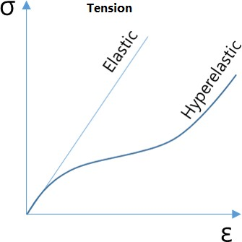

Figure 1.5 Stress vs Strain Graph

### HYPER ELASTICITY THEORY

In finite element analysis, the hyperelasticity theory is used to represent the non- linear response of hyper-elastic materials at large deformations. Hyper elasticity is popular due to its ease of use in finite element models. Usually, stress-strain curve data from experimental tests are used to fit the constants of theoretical models, thus approximating the material response.

The choices of hyperelasticity models are:

* + 1. Neo-Hookean (first-order reduced polynomial)
    2. Mooney-Rivlin (first-order complete polynomial)
    3. Signorini (second-order reduced polynomial)
    4. Neo-Hookean (first-order reduced polynomial)

The Neo-Hookean model is the simplest form of all commonly used hyper- elastic models. The elastic strain energy potential energy is expressed as

(1.1)

Where u is the initial shear modulus. D1 is the material’s incompressible parameter. It can be found that the model is a strain energy function based on the strain tensor invariant I_1. If the material is assumed to be incompressible, J = 1 and the second term becomes zero.

The Neo-Hookean model is derived based on classic statistical thermodynamic results. This is similar to the Arruda-Boyce model we discussed in the last article. When the limiting network stretch parameter in the Arruda-Boyce model becomes infinite, it is equivalent to neo-Hookean. At the same time, this model can be regarded as a special form of the Polynomial model. For polynomial model parameters N = 1 and C01 = 0, the polynomial model is equivalent to neo-Hookean.

The Neo-Hookean model has a constant shear module. Generally, it is only suitable for predicting the mechanical behaviour of rubber with uniaxial tension of 30% to 40% and pure shear of 80% to 90%. While it is not very accurate to predict the large strain deformation. Although this model is not as versatile as other models, especially for large strain or tensile conditions. The neo-Hookean model has the following advantages:

* + - 1. Simple. There are only 2 input parameters. If the material is assumed to be incompressible, then only one parameter is required: the initial shear modulus.

Since only one parameter is needed from the test data, the number of required tests is small.

* + - 1. Compatibles. The material parameter obtained from one type of deformation stress-strain curve can be used to predict other types of deformation. Especially for the small and medium strain conditions.

It is worth mentioning that neo-Hookean is not only applied to science and engineering but also used in the computer graphics in the filming industry because of its simplicity and physical-based solutions. The process of hand movement, the muscle and skin changes calculated using the neo-Hookean model appear extremely natural.

* + 1. Mooney-Rivlin (first-order complete polynomial)

The form of the strain-energy potential for a two-parameter Mooney-Rivlin model is:

(1.2)

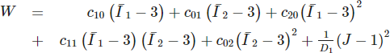(1.3)

Overall, the Mooney-Rivlin model has been widely recognized and applied. Especially in the small and medium strain applications (0 ~ 100% tensile and 30% compression), Mooney-Rivlin can precisely characterize the mechanical behavior of rubber materials. Four types of potentials also provide users with more choices to model various material behaviours. However, Mooney-Rivlin has some limitations:

* Not suitable for the deformation that exceeds 150%.
* Because higher-order Mooney-Rivlin has many parameters, the parameters are relatively difficult to obtain from the manual or literature, which needs curve fitting of experimental data.
* Not suitable for the analysis of compressible hyperelastic materials, such as foam.
* The error could be large when the strain/stress is beyond the range of input experimental data

### NONLINEAR ANALYSIS

Nonlinear analysis is an analysis where a nonlinear relation holds between applied forces and displacements. Nonlinear effects can originate from geometrical nonlinearity’s (i.e., large deformations), material nonlinearity’s (i.e., elasto-plastic material), and contact. These effects result in a stiffness matrix which is not constant during the load application. This is opposed to the linear static analysis, where the stiffness matrix remained constant. As a result, a different solving strategy is required for the nonlinear analysis and therefore a different solver.

### Types of Nonlinearities

* + - 1. **Geometric Nonlinearity**

### Material Nonlinearity

* + - 1. **Contact Nonlinearity**

### Geometric Nonlinearity

The changing geometric configuration due to large deformation of the structure cause nonlinear behaviour. Geometric nonlinearity is not only because of large deformation but also due to large strain & large rotation too. The geometric nonlinearity causes to change in geometry cross section due to large deformation. Geometry buckling is also cause of geometric non linearity, in case of buckling huge compressive load causes the structural member to buckle resulting higher displacement.

### Material Nonlinearity

Material nonlinearity involves the nonlinear behaviour of a material based on a current deformation, deformation history, rate of deformation, temperature, pressure, and so on. Examples of nonlinear material models are large strain (visco) elasto- plasticity and hyperelasticity (rubber and plastic materials).

### Contact Nonlinearity

In contact nonlinearity abrupt change in stiffness may occur when bodies come into or out of contact each other. This type on nonlinearity is used to simulate the gap between two parts. While defining contact between two bodies, you need to decide whether it carries the friction or not. Friction coefficient can be used to decide the amount of resistance between the contact bodies. The selection of friction coefficient affects the contacting surfaces behaviour and hence the friction coefficient is selected based on dry or lubricated friction, contacting material, etc. Sometimes boundary conditions can also be treated as nonlinear analysis like elastic support.

### EXPLICIT ANALYSIS

Explicit FEM is used to calculate the state of a given system at a different time from the current time.

Explicit analysis offers a faster solution in events where there is a dynamic equilibrium or otherwise:

### Sum of all forces = mass x acceleration

(1.4)

The explicit method should be used when the strain rates/velocity is over 10 units/second or 10 m/s respectively. These events can be best example by extreme scenarios such as an automotive crash, ballistic event, or even meteor impacts. In these cases, the material models do not only need to account for the variation of stress with strain but also the strain rate. On this scale, the strain rates play a particularly important contribution.

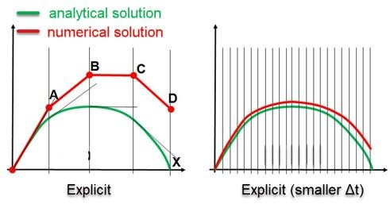

Figure 1.6 Explicit Graph

The computational cost of a single explicit increment is small; all information needed is available and the calculation is straight-forward and fast. However, the time increment cannot be too large, because then method becomes unstable and the error on the solution increases exponentially. This makes sense if we think of it as an extrapolation: extrapolating far beyond the known range tends to give wrong results, especially if errors have a chance to add up. The largest time increment that can be used is calculated automatically by Abaqus and it is referred to as the stable time increment. The stable time increment reduces with smaller element size, lower density, and higher stiffness. The element with the smallest stable time increment determines the time increment for the entire analysis; a single badly shaped element can therefore hugely impact the simulation time. The stable time increment is usually approximately constant throughout the analysis, so that the time required to run an analysis can be estimated once the first increments have completed.

### VALIDATION OF AUTOMOTIVE ELECTRICAL CONNECTORS AND FAILURE ANALYSIS

The use of a connector in a new vehicle is preceded by the validation of components that verify the durability and functionality of the components over the assumed vehicle lifetime. Validation of the automotive electrical connectors is performed based on automotive manufacturer requirements. The main differences can be found both in the detailed descriptions of particular tests and the general sequences.

The sequence of tests as well as their severity (vibration profiles, accelerations, temperatures, humidity, etc.) depend on the location of the connector in the vehicle. The most challenging requirements are defined for connectors located near the engine. Despite differences in the course of the validation process, we can distinguish several common tests along with the most common failures.

These will be discussed in the following sections.

* + 1. Connector/terminal conditioning
    2. Dynamic tests
    3. Pressure vacuum leak

### Connector/terminal conditioning

Before the start of any testing sequence, the connector assembly is conditioned in accordance to the selected standard. These conditioning parameters vary significantly between the requirements of manufacturers. However, a common feature is the repeated mating and unmating of the entire connector assembly, which can be supplemented with storage at elevated temperatures and humidity for a period of time. For the tin-plated terminals which are most widely used, conditioning causes initial wear. This effect is not as significant in terminals plated with noble metals such as silver or gold.

The first few cycles generate large surface irregularities, which partially decrease after subsequent mating and unmating cycles. A limited number of mating and unmating cycles are always performed before the entire validation sequence. Additionally, the automotive terminals are often lubricated. Because of this, we cannot treat the initial surfaces of the terminals as a starting point for performance analysis.

### Dynamic tests

Connector performance under dynamic loading is validated with the use of mechanical shock and vibration sine or random tests. All of these tests are performed on an electromagnetic shaker and are combined in one sequence as they are the most common causes of connector failure.

The usual test sequence, which can last up to 140 h, includes a series of mechanical shocks followed by a sine sweep test and finishes with a random vibration test. The car manufacturers usually specify their own vibration profiles, which is defined as a power spectral density (PSD) in the frequency domain.

### Pressure vacuum leak

Performance of the connector assembly subjected to external pressure is assessed during a simulated forced fluid penetration test. This test is usually performed after humidity-temperature cycling and/or vibration tests, to verify if sealing properties of the wire and connector seals are maintained. Depending on the standard, a submerged connector is subjected to a certain level of internal pressure which is held for a given period of time, after which no air can escape from the connector. The usual defects that might lead to test failure include degradation of the sealing material after thermal aging, compression set of the sealing material creating a gap between seal and cavity, and cut in the seal due to mishandling during insertion.

### SCOPE OF THE WORK

The aim of the present work is focused on the effectiveness of seal like as contact pressure, compression strain and mating maximum force of connector between male and female housing using by Abaqus. And, compare these simulation results with experimental results.

# CHAPTER 2

## LITERATURE SURVEY

In order to gain an insight of into the current studies made in relation to design and analysis of automotive connector. A review of literature was made and the same presented in this section.

**Konrad T. Kloch and Pawel Kozak a (November 2020) studied, The review and perspectives on predicting the performance and durability of electrical contacts in automotive applications.** They reported the numerical modeling in the micro- and macro-scale, including the identification of fretting wear analysis of an electrical connector**.**

**Feihong Yun and Gang Wang (June 2020) conducted Analysis of Sealing and Leakage Performance of the Subsea Collet Connector with Lens‐Type Sealing Structure.** They explained about contact and hydrostatic pressure analysis of connector seal.

**Young-Bae Ko, and Hyung-Pil Park (December 2019) studied on the sealing Characteristic of Automobile Waterproof Connector.** They reported about, the load- deformation relations like tension and compression tests analysis in order to design waterproof connectors for automobiles.

**Amine Beloufa and Mohamed Amirat (March 2018) published Design and study of new power connector with parallel contact points.** They reported about the contact resistance, contact area, temperature, insertion force and mechanical stresses of connector.

**Song and Min-Joe (July 2017) published Optimum design of injection mold heater for uniform curing of LSR seal for waterproof connector.** They designed the capacity of the cartridge heater differently for each position and then linked the heat transfer analysis and optimization module to obtain the optimal cartridge heater capacity.

**S.Schlömer and B.M.Krooss (June 2017) conducted Experimental characterization of the hydrocarbon sealing efficiency of cap rocks.** They explained about, experimental analysis of hydrocarbon leakage rates by pressure-driven volume flow (Darcy flow), and diffusive gas losses for simple, hypothetical scenarios.

**Stanislav I and Pliassounov S (April 2007) published Fundamentals and common problems of seal integrity robustness of standardized brake tubing threaded connectors.** They revealed the requirements, conditions and limitation of connectors capability to achieve their sealed state. And, discussed about improvement of connectors sealing performance with respect to the assembly process.

**David S Goodman and Edgar Burns (February 2017) Published sure-seal Environmental connectors for automotive electronics.** They studied about prevention capacity of oil and hydrocarbon fluid in different temperature conditions.

**L. Lam and C. Maul (September 2004) published Temperature, humidity and pressure measurement on automotive connectors.** They studied about environmental conditions of connectors such like as evaluate the mechanical stability of the connector housing and terminals. Then, coMPare this simulation results with experimental results.

**Chang and ChunLeeaKuo (January 2004) investigated Design and analysis of gasket sealing of cylinder head under engine operation conditions.** They revealed both the distribution of the contact pressure on the gasket, and the stresses of the cylinder head at different loading conditions, such as cold assembly, hot assembly, cold start, and hot firing, are explored by numerical calculation based on the finite element method (FEM).

# CHAPTER 3

## METHODOLOGY

### 3.1 FLOWCHART

The methodology followed present work for the project to characterize the simulation and experimental validation of connector seal effectiveness is shown in Figure 3.1

Process study & Literature review

Simplification of CAD model

Meshing and Boundary conditions setup

Analyze the simulation results

Experimental validation

Comparison of experimental result with simulation results

Results and conclusion

Tool: UTM machine

Tool: Abaqus 2022HF1

Tool: NX CAD V11.0

Figure 3.1 Flow Chart

* 1. **PRE-PROCESSING**

# CHAPTER 4

## SIMULATION PROCESS

The entire process including the pre-processing and numerical analysis of results is done in Abaqus software version 2022 Hf1. It contains different modules like part, property, assembly, step, interaction, load, mesh, optimization, job, and visualization module.

### CAD Model

The connector and seal CAD model has been developed using NX CAD software shown in the figure 4.1. Modeling in NX is done using a solid modeling section as per the standard rules followed in the organization.

Header

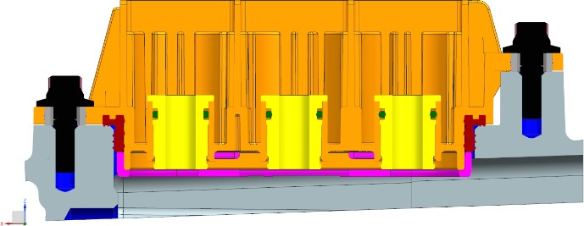

**Section A-A**

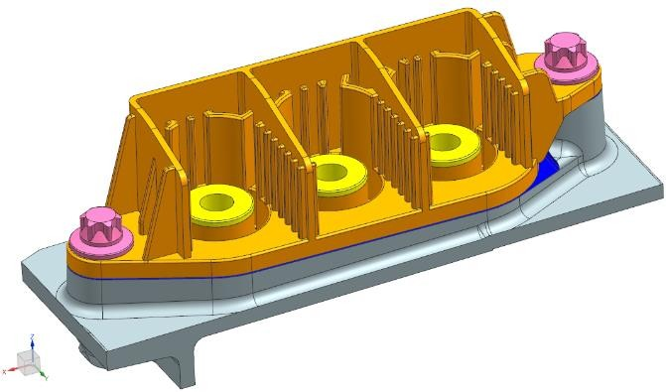

**A**

**A**

Interfacial seal

**Top view without header (Perfectly Symmetry)**

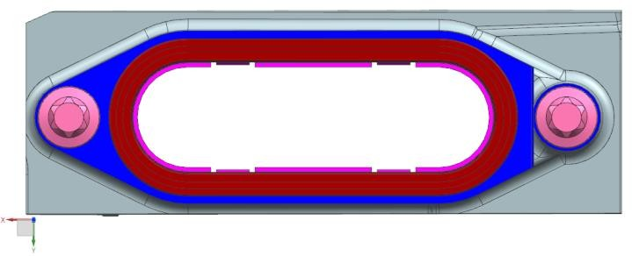

Figure 4.1 CAD Model

### Simplification of CAD Model

The CAD model is initially simplified using NX CAD software to reduce the computational run time and also the mesh count. The simplification means removing or eliminating the unwanted details from the CAD model like holes, chamfers, fillets, rounds, logos, text, etc. Numberings and naming in the part are also removed before the part is imported to the Analysis software.

The connector is cut along the section (figure 4.2b) shown below and only half the symmetry part is considered for analysis.

Header **A**

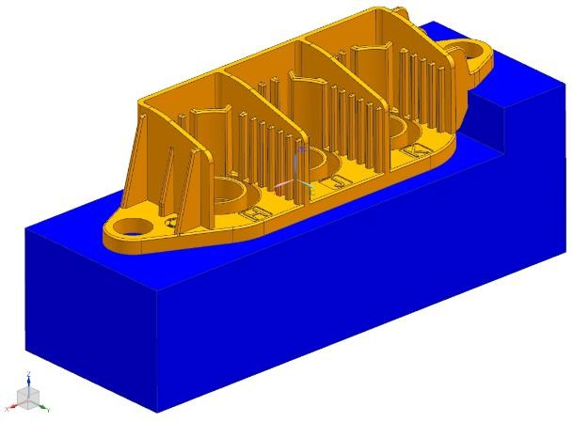

Half Symmetry

**A**

* + - 1. Test block (Maximum/ Minimum) tolerance model
      2. Seal retainer

Figure 4.2 Simplified CAD Model

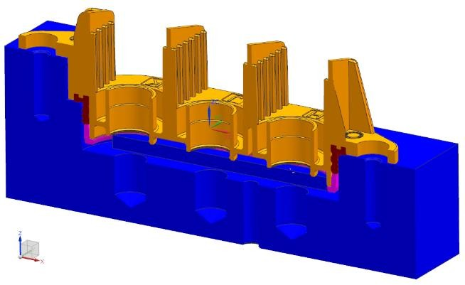

**Section A-A**

seal

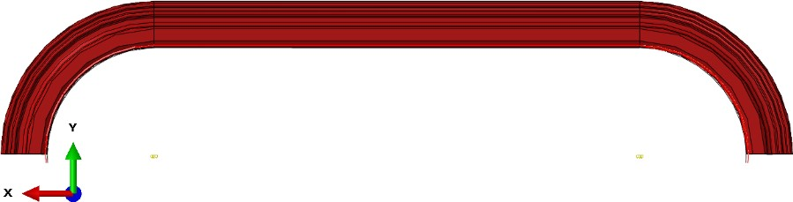

Interfacial seal

Figure 4.3 Half Symmetry view of seal

4.1.2.1 Geometry comparisons

Two different types of test blocks have been developed for analysis. One is the maximum tolerance test block another one is the minimum tolerance test block shown in figure 3.4

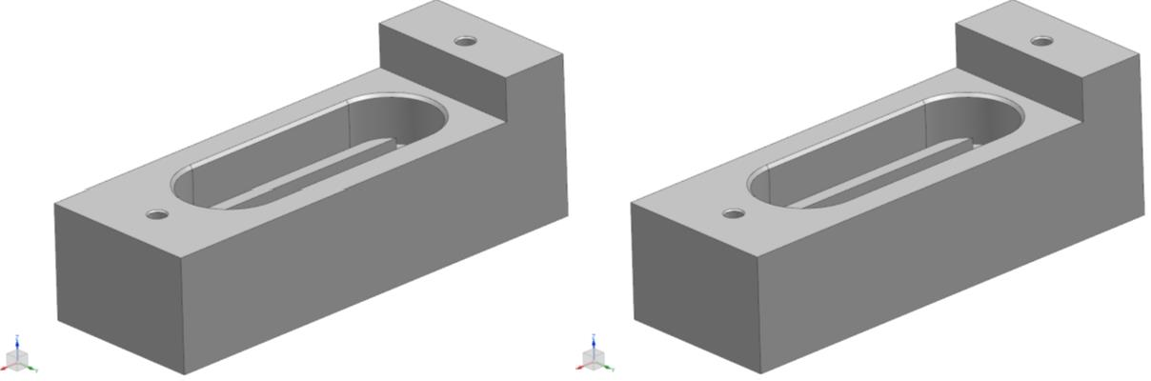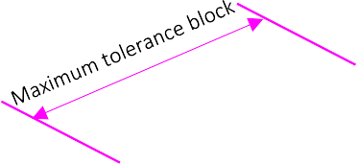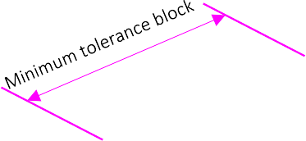

Figure 4.4 Maximum and Minimum tolerance

### Introduction and Import the Model to Abaqus

Abaqus CAE is a software suite for finite element analysis and computer-aided engineering, originally released in 1978. It is a product of Dassault systems. It is a software application used for both the modeling and analysis of mechanical components and assemblies (pre-processing) and visualizing the finite element analysis result. A subset of Abaqus/CAE including only the post-processing module can be launched independently in the Abaqus/Viewer product.

The simplified CAD model parts are converted into the Parasolid format after giving suitable names and, this Parasolid file is imported to Abaqus CAE for carrying out the further simulation.

### Material Properties

The materials should be assigned after the models are imported. The material used for the seal part is silicon rubber named Duro 40 LSR and, the remaining parts are considered a rigid so no need of material selection from material library in Abaqus. The table 4.1 shows the material properties of parts used.

Table 4.1 Material Properties

|  |  |
| --- | --- |
| **Properties** | **Value** |
| Density | 1.1x10-9 tonn/mm3 |
| Hardness | 40 shore |
| Tensile strength | 6.5 N/mm2 |
| Elongation at break | 500% |
| Tear strength | 27.15 N/mm |
| Poisson ratio | 0.375 |
| Reference temperature | 23oC |

### Assembly

Once the material is defined the parts needs to be assembled to the initial position of the analysis. So, the test block is move back 5.8mm negative Z-direction for analysis. Figure 4.6 shows the initial position of assembly along with side view parts**.**

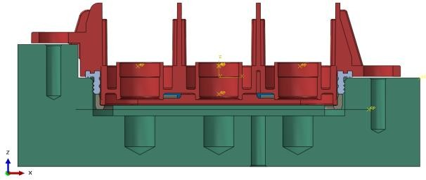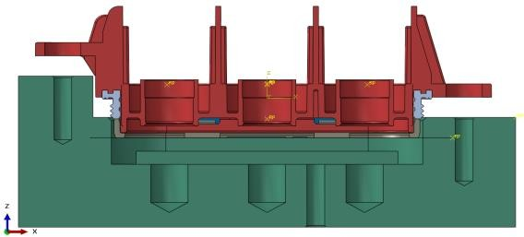

5.8 mm

Figure 4.6 Assembled view

### Defining the Steps

The step sequence provides a convenient way to capture changes in the loading and boundary conditions of the model, changes in the way parts of the model interact with each other, the removal or addition of parts, and any other changes that may occur in the model during the course of the analysis. In addition, steps allows us to change the analysis procedure, the data output, and various controls. The figure 4.7 shows the step manager dialogue box for explicit analysis.

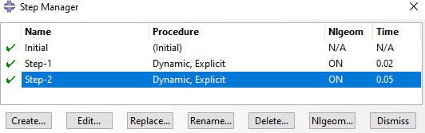

Figure 4.7 Step Manager

The first step (Step-1) is Dynamic Explicit step in which the seal mount on header by three different two-dimensional rigid plane and time period is 0.02s. The second step (Step-2) is also Dynamic Explicit in which displacement or insertion of test block into header part and time period of this step is 0.05s.

### Contact Interaction

In this module the surface-to-surface contacts are assigned between the three different pair of parts such like as seal and test block, seal and header, seal and 2D rigid planes. The contact interaction property of part is assigned as “penalty method” with friction coefficient 0.1 for tangential behaviour and “Hard contact” method is used for normal behaviour. Figure 3.8 shows the surface-to-surface interaction between different parts.

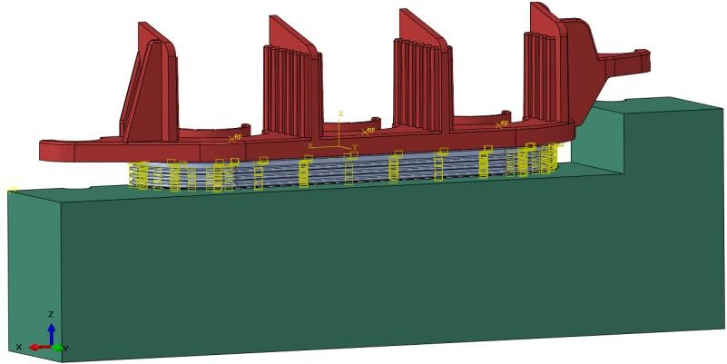

Figure 4.8 Contact Interaction

### Boundary Condition

As discussed earlier totally two steps are used for this analysis, Step-1 for seal mounding on header and Step-2 for insertion of test block into header part. So, boundary conditions for both steps are displayed below.

* + - 1. For seal mounting on header (Step-1)

Totally, three boundary conditions are used for step-1 analysis. First, boundary condition is which the highlighted surfaces are fixed in all directions (Rigid surface 1 &2). Second boundary condition is which the highlighted surfaces fixed in Y-symmetry (Figure 4.9). And, third boundary condition is Rigid 1, 2 & 3 is moved 0.4 mm in +XY and -XY direction for seal mounting on header (Figure 4.10).

Header rigid fixed in all direction [All DOF = 0] [Rigid surface 1]

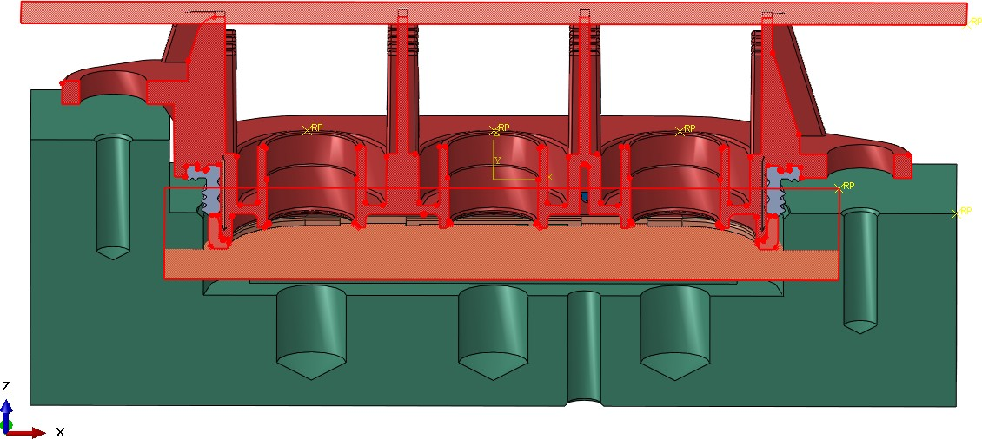

Seal, Header, Seal retainer midplane surfaces symmetry in Y axis [U2=UR1=UR3=0]

Seal retainer rigid fixed in all directions [All DOF = 0] [Rigid surface 2]

Figure 4.9 Fixed and symmetry Boundary condition

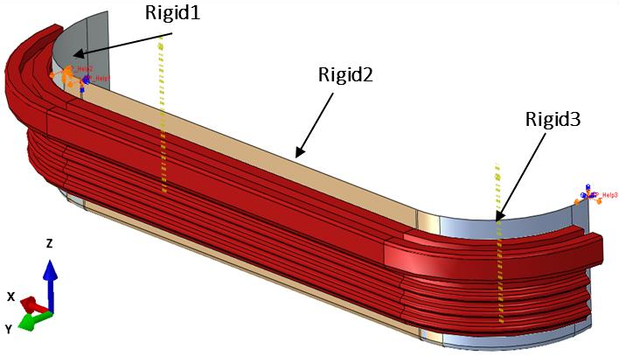

Figure 4.10 Seal Rigid boundary condition

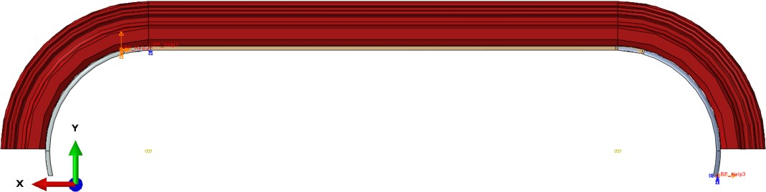

Rigid2 moved 0.4 mm in +Y direction (to seal mounting on header)

Rigid3 moved 0.4 mm in +X & +Y

direction (to seal mounting on header)

Rigid1 moved in 0.4 mm -X & +Y direction (to seal mounting on header)

Figure 4.11

Table 4.2 Boundary condition of Seal rigid

|  |  |  |  |
| --- | --- | --- | --- |
| **Parts** | **Time (s)** | **Amplitude** | **Velocity (mm/s)** |
| Rigid Plane 1 | 0.02 | 1 | 20 |
| Rigid Plane 2 | 0.02 | 1 | 20 |
| Rigid Plane 3 | 0.02 | 1 | 20 |

* + - 1. For insertion of test block

Here also totally three boundary conditions are used for Step-2 analysis. First and second boundary conditions follow as from step-1 analysis and third boundary condition is which the highlighted part is move in 5.8 mm positive Z-direction for insertion of test block to the header (figure 4.12).

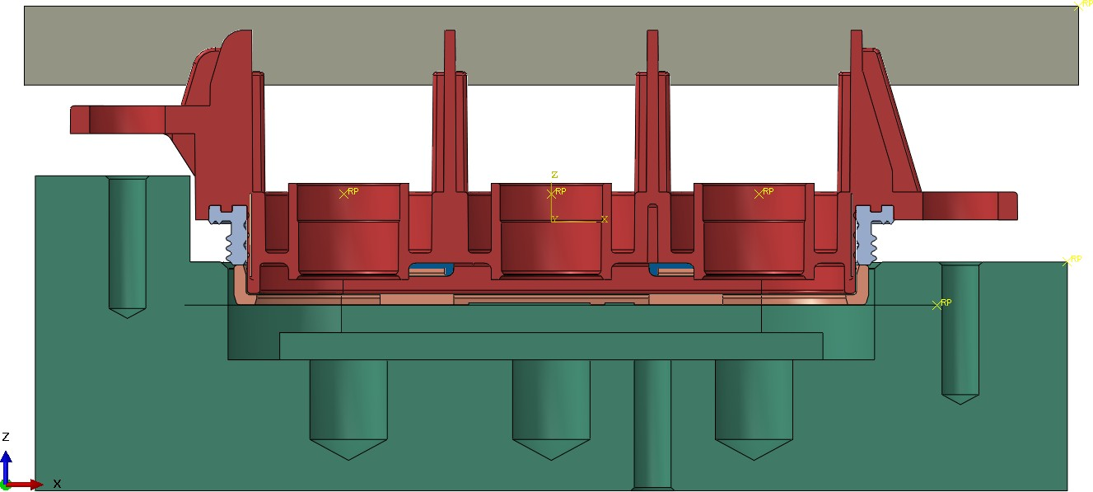

Moving the test block 5.8mm in +ive Z-direction

Figure 4.12 Moving test block boundary condition

Table 4.3 Boundary condition of test block

|  |  |  |  |
| --- | --- | --- | --- |
| **Parts** | **Time (s)** | **Amplitude** | **Velocity (mm/s)** |
| Maximum tolerance test block | 0.05 | 1 | 116 |
| Minimum tolerance test block | 0.05 | 1 | 116 |

### Meshing

Meshing is also one of the crucial parts in analysis since the accuracy depends on meshing also. The type of element used is second order hexahedral and tetrahedral element C3D10 i.e., continuum 3D 10 node elements. Variable mesh sizing is used for whole assembly. The region which is taking active part in analysis is meshed fine and other parts are meshed coarse. This helps to maintain the number of elements due to which the computational time is also saved. After meshing it is also important to check quality of mesh done. Various parameters can be checked like shape factor, edge length, aspect ratio etc., some of which are mentioned in the table 4.4 and Figures 4.13 shows the meshed assembly.

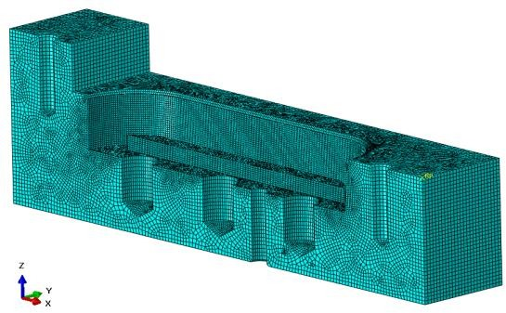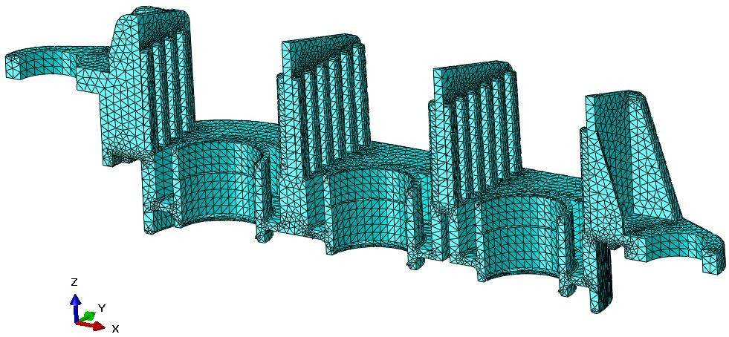

Block

Header

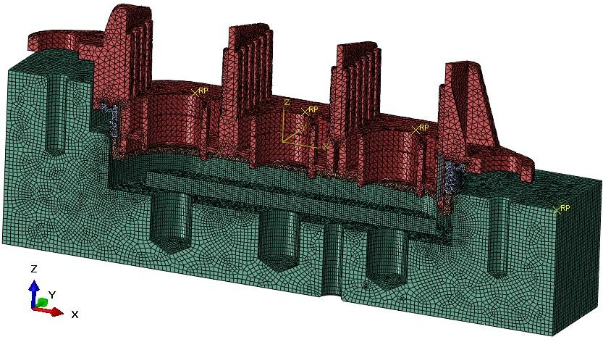Assembled view

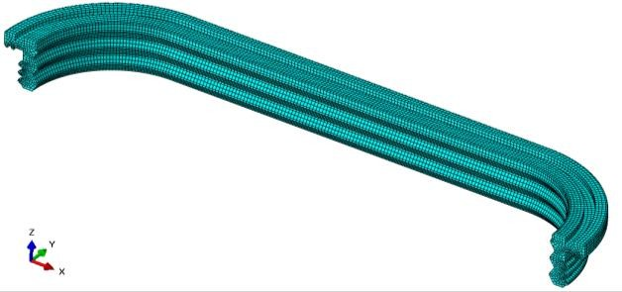

Seal

Figure 4.13 Meshing

Table 4.4 Meshing Properties

|  |  |  |  |  |  |
| --- | --- | --- | --- | --- | --- |
| **Parts** | **Mesh Type** | **No. of elements** | **No. of nodes** | **Avg element size (mm)** | **Avg aspect ratio** |
| Test block | hexahedral | 38658 | 38660 | 0.5 | 1.26 |
| Header | tetrahedral | 137234 | 226148 | 0.7 | 2.05 |
| Seal | hexahedral | 64470 | 75116 | 0.25 | 2.54 |
| Assembled parts | Hexahedral & tetrahedral | 315588 | 451072 | 0.55 | 2.7 |

The aspect ratio is the ratio between the longest and shortest edge of an element. The shape factor criterion is available only for triangular and tetrahedral elements. The shape factor ranges from 0 to 1, with 1 indicating the optimal element shape and 0 indicating a degenerate element. In our case average shape factor is closer to 1 which is ok. Also, the analysis errors shown in the above table is 0 (0%) which means that there are not any mesh errors in the model.

# CHAPTER 5 SIMULATION RESULT ANALYSIS

## RESULTS

The contact pressure, compression strain and maximum insertion forces are obtained successfully after the analysis is completed. And, exported the graph in excel sheet format after plotting insertion force vs applied displacement results during mating. Finally, compare these simulation result with experimental results.

### FEA ANALYSIS RESULTS FOR MAXIMUM TOLERANCE TEST BLOCK

* + 1. **Contact pressure analysis**

The figures 5.1-5.4 shows contact area and contact pressure of seal, header and test block.

The seal analysis results are scaled two different pressures values such like as

0.4 MPa and 0.5 MPa for find out suitable contact pressure of seal during insertion of maximum tolerance test block.

Scaled to 0.4MPa Scaled to 0.5MPa

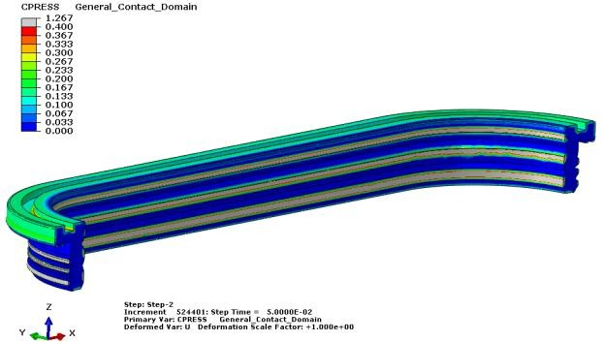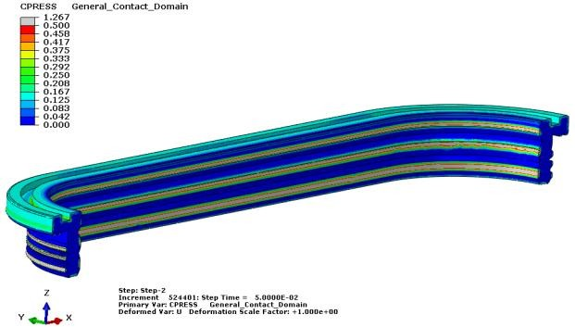

Figure 5.1 (a) Figure 5.2 (b)

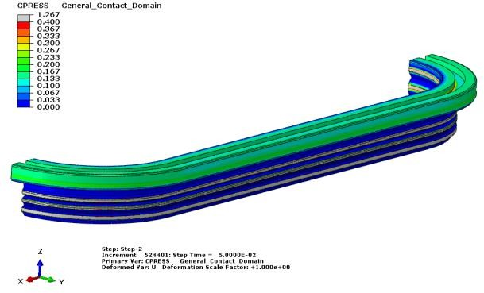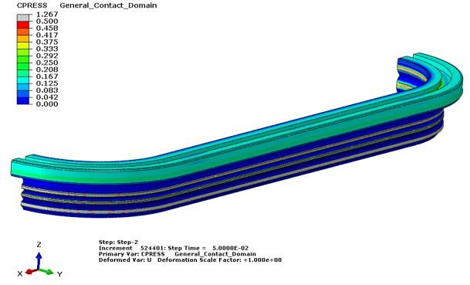

Figure 5.3 (c) Figure 5.4 (d)

The grey region of seal indicates the contact pressure of seal crossed the scaled limit (0.4 MPa & 0.5 MPa).

The grey region of seal is uniformly distributed in three lips in figures 5.1(a) & 5.3(c) comparing than figures 5.2(b) & 5.4(d). So, we can finalize the contact pressure of maximum tolerance test block is 0.4 MPa.

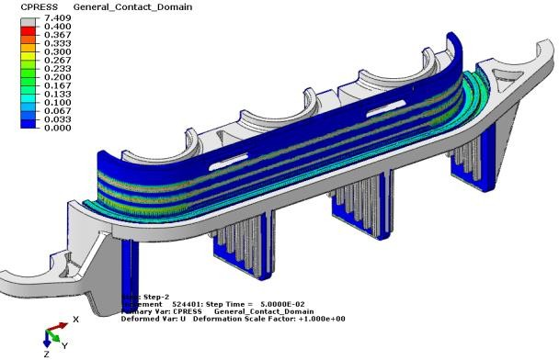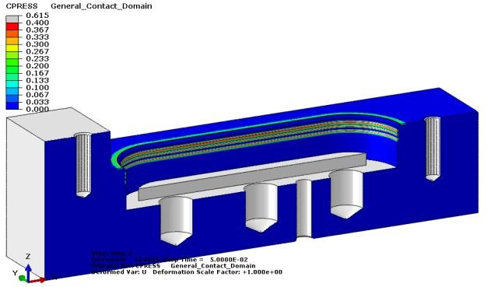

Figure 5.5 Header Figure 5.6 Test block From figure 5.5 & 5.6 we can analyze the contact region of header & test block

during insertion.

### Compression strain analysis (von Mises strain)

von Mises stress is a value used to determine if a given material will yield or fracture. It is mostly used for ductile materials, such as metals. The von Mises yield criterion states that if the von Mises stress of a material under load is equal or greater than the yield limit of the same material under simple tension then the material will yield.

The seal analysis results are scaled two different strain such like as 10% and 15% for find out suitable strain of seal during insertion of maximum tolerance test block.

Scaled to 10% Scaled to 15%

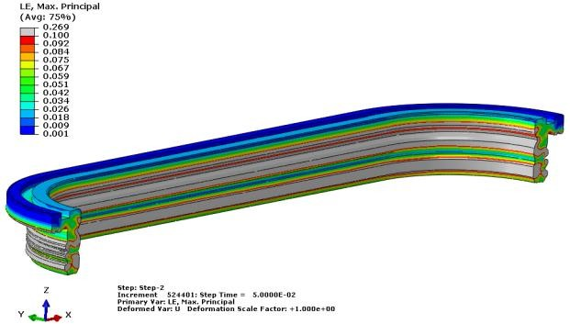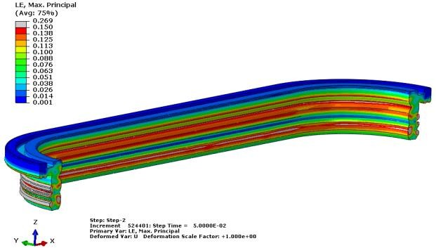

Figure 7

Figure 8

Figure 5.7 (a) Figure 5.8 (b)

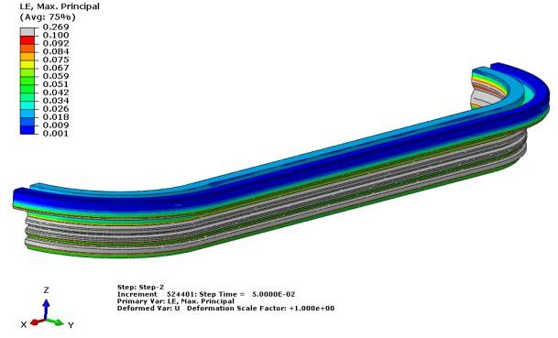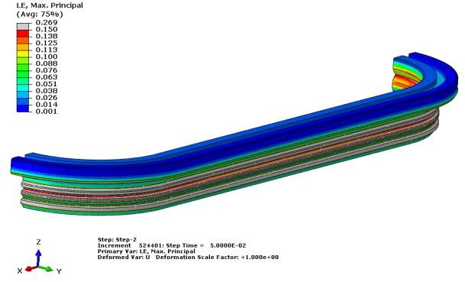

Figure 5.9 (c) Figure 5.10 (d)

The grey region of seal indicates the compression strain of seal crossed the scaled limit (10% & 15%).

The grey region of seal is uniformly distributed in three lips in figures 5.7(a) & 5.9(c) comparing than figures 5.8(b) & 5.10(d). So, we can finalize the compression strain of maximum tolerance test block is 10%.

### Insertion force analysis for Maximum tolerance test block

From this analysis result we can find out maximum insertion force of maximum tolerance test block during mating.

In this graph, X-axis is input applied displacement of maximum tolerance test block in ‘mm’.

Y-axis is output reaction force/ insertion force of full model seal in ‘Newton’ during insertion.

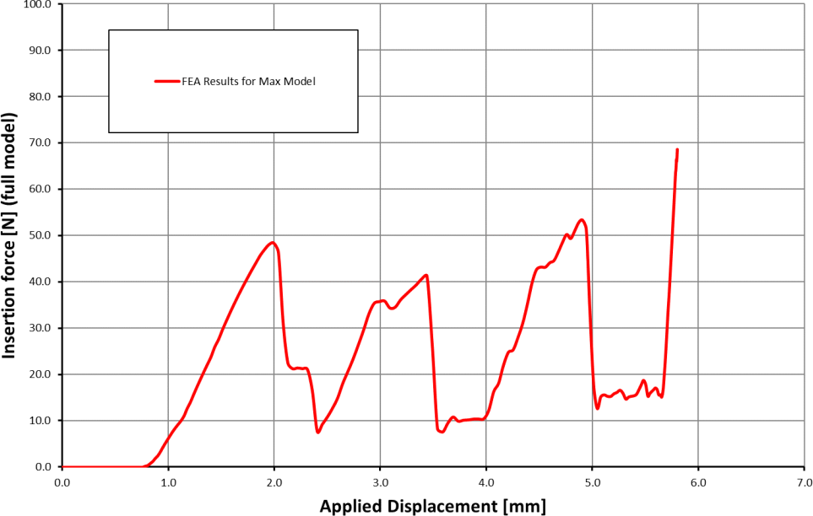

#1

Figure 5.11 Force and Displacement curve

Table 5.1 Insertion result for maximum tolerance block

|  |  |  |  |
| --- | --- | --- | --- |
| **No** | **Simulation** | **Position** | **Insertion Force [N]** |
| #1 | Maximum Test block with Friction coefficient 0.1 | Max. Force | ~52 (Fmax) |

From the graph (figure 5.11), When the maximum tolerance test block crosses the lip of interfacial seal that time seal reaction force will reach maximum peak points.

Here, totally three peak points of force (49N, 41N & 52N) are there during insertion. So, maximum insertion force of maximum tolerance test block is 52N.

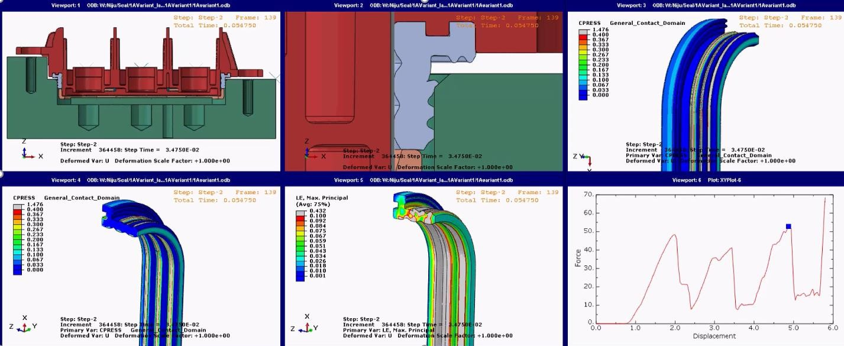

Figure 5.12

### FEA ANALYSIS RESULTS FOR MINIMUM TOLERANCE TEST BLOCK

* + 1. **Contact pressure analysis**

The figures 5.13-5.16 show contact area and contact pressure of seal, header and test block.

The seal analysis results are scaled two different pressures values such like as

0.4 MPa and 0.5 MPa for find out suitable contact pressure of seal during insertion of maximum tolerance test block.

Scaled to 0.4MPa Scaled to 0.5MPa

Figure 5.13(a) Figure 5.14(b)

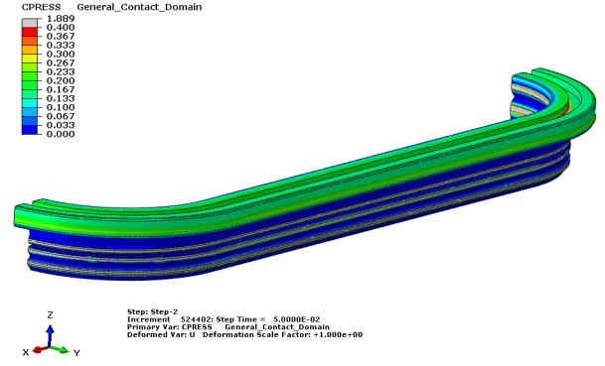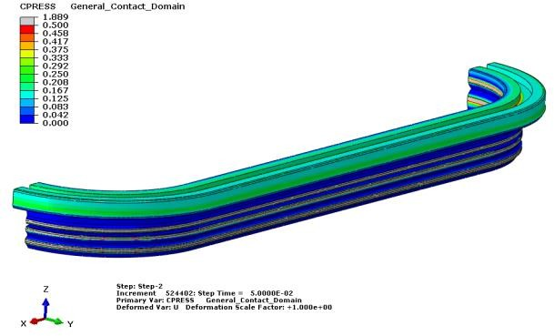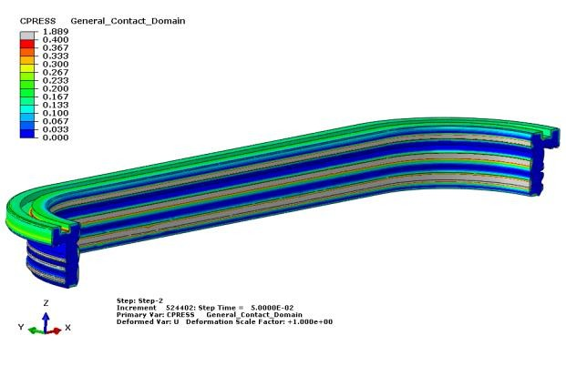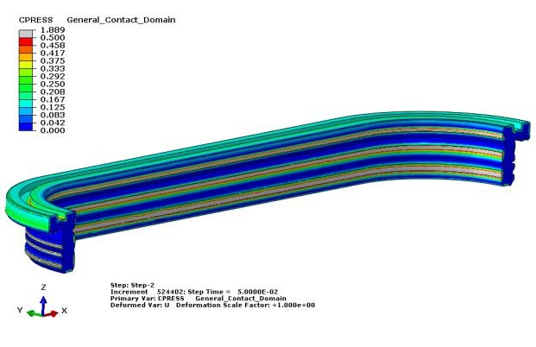

Figure 5.15(c) Figure 5.16(d)

The grey region of seal indicates the contact pressure of seal crossed the scaled limit (0.4 MPa & 0.5 MPa).

The grey region of seal is uniformly distributed in three lips in figures 5.13(a) & 5.15(c) comparing than figures 5.14(b) & 5.16(d). So, we can finalize the contact pressure of maximum tolerance test block is 0.5 MPa.

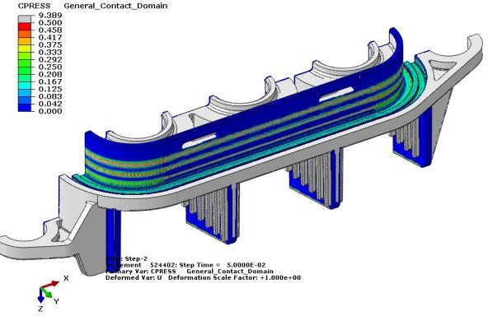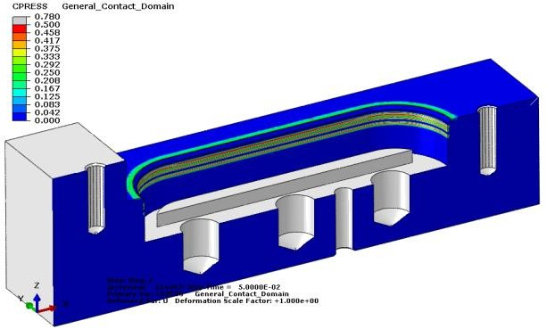

Figure 5.17 Header Figure 5.18 Test block From figure 5.17 & 5.18 we can analyze the contact region of header & test

block during insertion.

### Compression strain analysis (von Mises strain)

The seal analysis results are scaled two different strain such like as 10% and 15% for find out suitable strain of seal during insertion of minimum tolerance test block.

Scaled to 10% Scaled to 15%

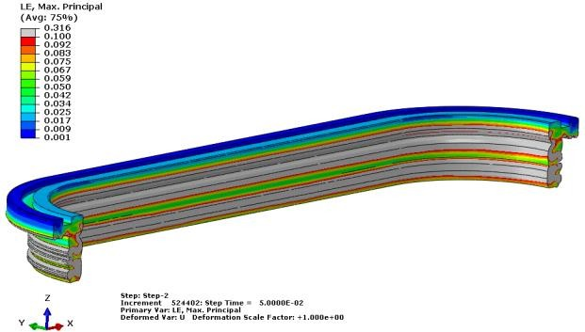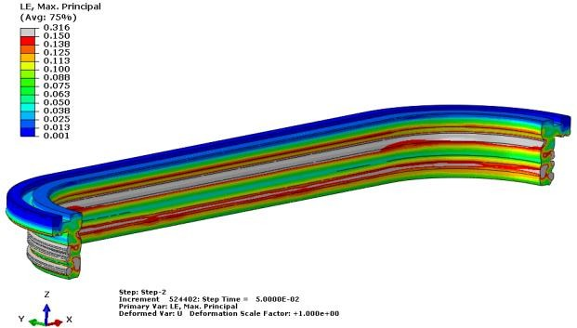

Figure 5.19(a) Figure 5.20(b)

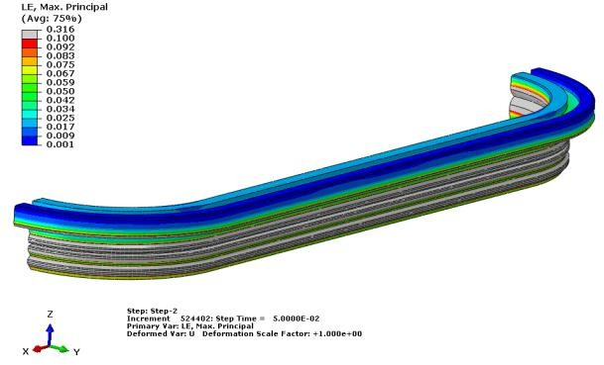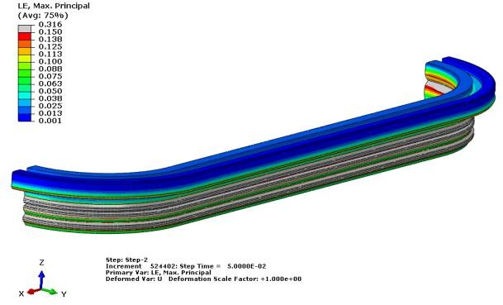

Figure 5.21(c) Figure 5.22(d)

The grey region of seal indicates the compression strain of seal crossed the scaled limit (10% & 15%).

The grey region of seal is uniformly distributed in three lips in figures 5.19(a) & 5.21(c) comparing than figures 5.20(b) & 5.22(d). So, we can finalize the compression strain of minimum tolerance test block is 10%.

### Insertion force analysis for Minimum tolerance test block

From this analysis result we can find out maximum insertion force of minimum tolerance test block during mating.

In this graph, X-axis is input applied displacement of minimum tolerance test block in ‘mm’.

Y-axis is output reaction force/ insertion force of full model seal in ‘Newton’ during insertion.

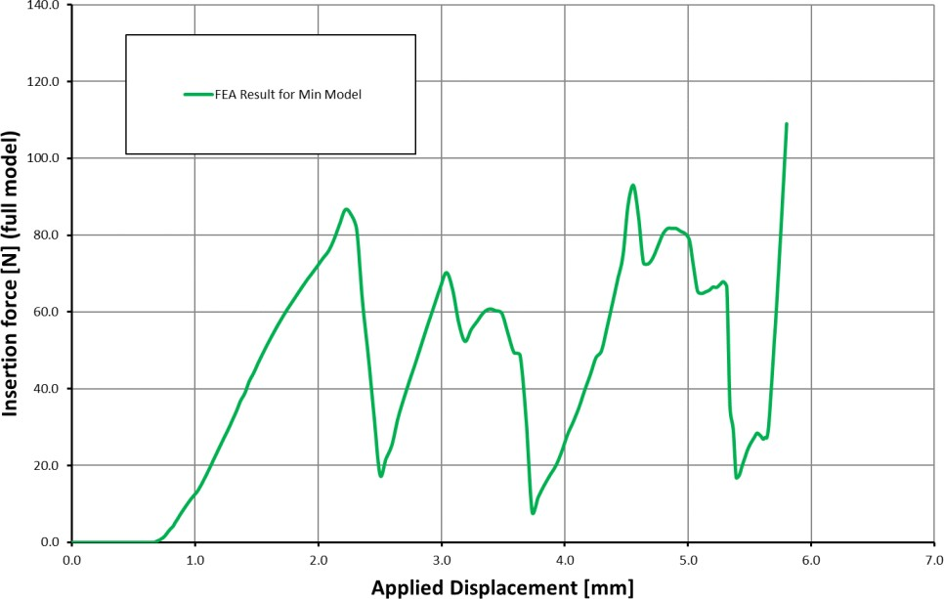

#3

Figure 5.23 Force and displacement curve

Table 5.2 Insertion result for minimum tolerance block

|  |  |  |  |
| --- | --- | --- | --- |
| **No** | **Simulation** | **Position** | **Insertion Force [N]** |
| #3 | Minimum Test block with Friction coefficient 0.1 | Max. Force | ~94 (Fmax) |

From the graph (figure 5.23), When the minimum tolerance test block crosses the lip of interfacial seal that time seal reaction force will reach maximum peak points.

Here, totally three peak points of force (94N, 70N & 83N) are there during insertion. So, maximum insertion force of minimum tolerance test block is 94N.

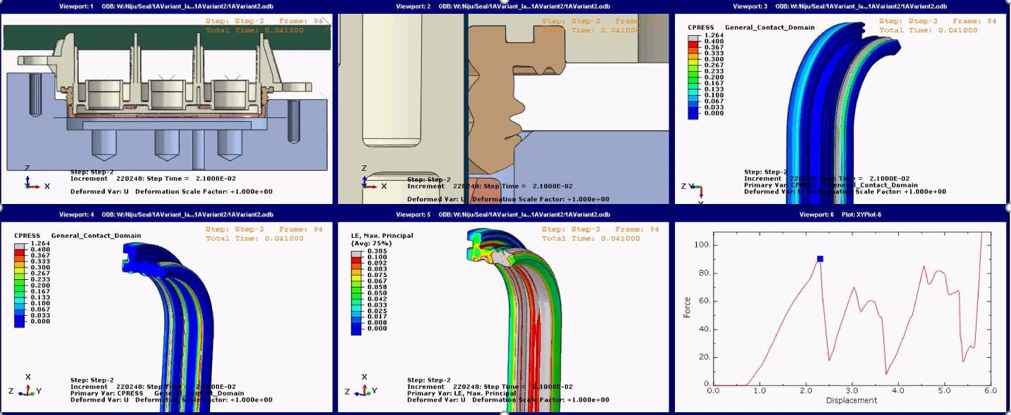

Figure 5.24

# CHAPTER 6

## EXPERIMENTAL RESULTS

The entire experimental process of simulation results is done using by Universal Testing Machine (UTM).

### INTRODUCTION OF UTM MACHINE

UTM machine is also known as UTM tester, materials testing machine or material testing frame and that’s why manufacturers gave a common name `Universal testing machine’ and this machine used to test the tensile strength and compressive strength of materials. And other mechanical properties like tension, exerting tensile, and compression or transverse stresses. Also gives different tests like peel test, flexural test, tension test, bend test, friction test, spring test, etc. UTM machines have different roles stripped of capabilities or marketed for specific industries & sectors which play unique roles in the development of infrastructure, roads, and highways. UTM is one of the best multi-purpose equipment for R&D labs or the QC department.

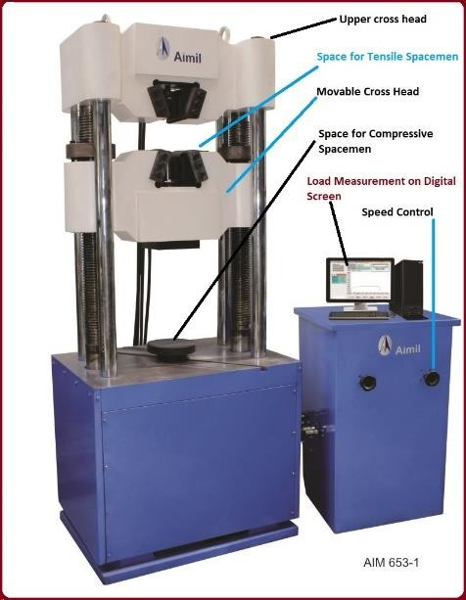

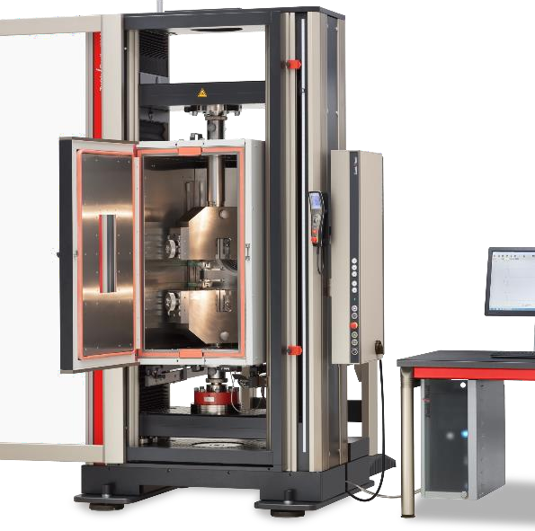

Figure 6.1 UTM machine

* 1. **BLOCK DIAGRAM OF UTM MACHINE**

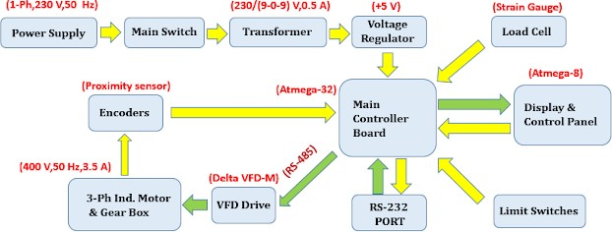

Figure 6.2 Block diagram

### EXPERIMENTAL RESULTS OF MAXIMUM TOLERANCE TEST BLOCK

The female part of the connector is placed in the upper crosshead of UTM and the male part of the connector is placed in the lower crosshead of UTM (Figure 6.3). And move the lower head of the UTM machine 5.8 mm in the upward direction with a velocity of 120 mm/s. Then, noted the final mating parameters for analysis.

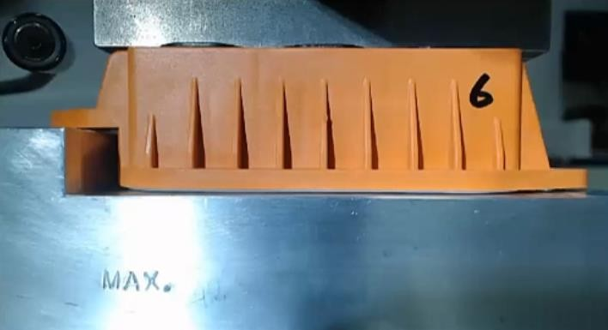

Figure 6.3 Capture image of Maximum block

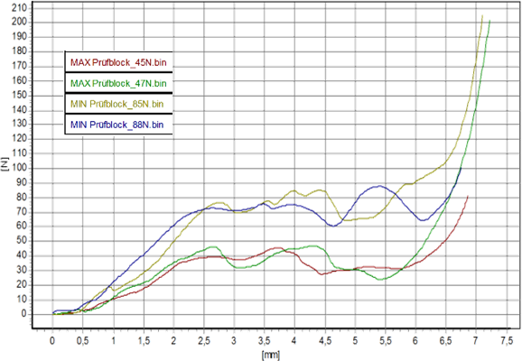

Figure 6.4

Then, convert raw UTM output data into understandable excel format (Figure 6.5).

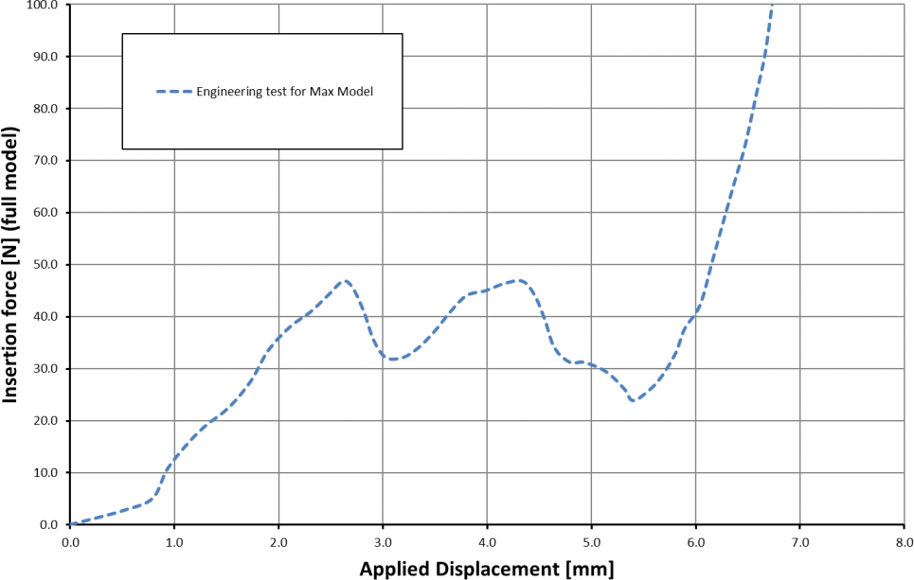

#2

Figure 6.5 Force and displacement graph

From this graph (figure 6.5) maximum insertion force of maximum tolerance model test block is 47 N.

### EXPERIMENTAL RESULTS OF MINIMUM TOLERANCE TEST BLOCK

Similar as, the female part of the connector is placed in the upper crosshead of UTM and the male part of the connector is placed in the lower crosshead of UTM (Figure 6.6). And move the lower head of the UTM machine 5.8 mm in the upward direction with a velocity of 120 mm/s. Then, noted the final mating parameters for analysis.

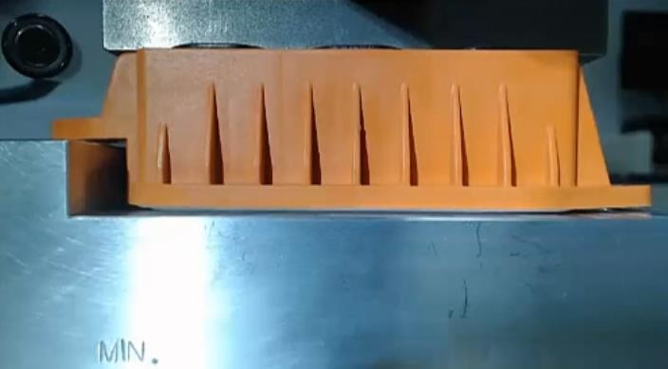

Figure 6.6 Capture image of minimum block



Figure 6.7

Then, convert raw UTM output data into understandable excel format. (Figure 6.8)

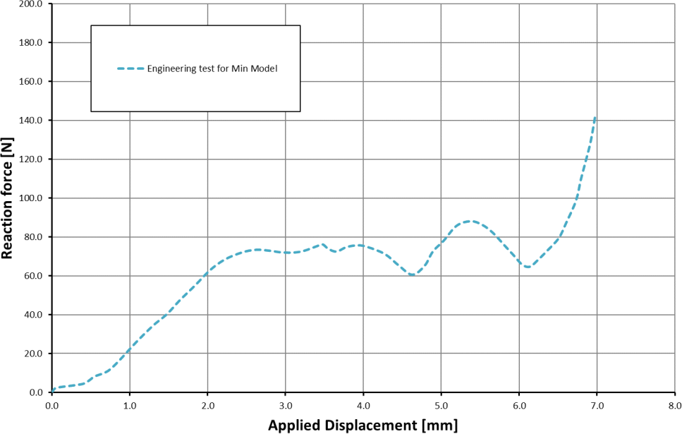

#4

Figure 6.8 Force and displacement graph

From this graph maximum insertion force of minimum tolerance model test block is 88 N.

# CHAPTER 7

## SIMULATION RESULTS COMPARISON WITH EXPERIMENTAL TEST DATA

### FOR MAXIMUM TOLERANCE TEST BLOCK

Both simulation and experimental graphs are reached the maximum insertion forces in third peak point/ third lip of seal.

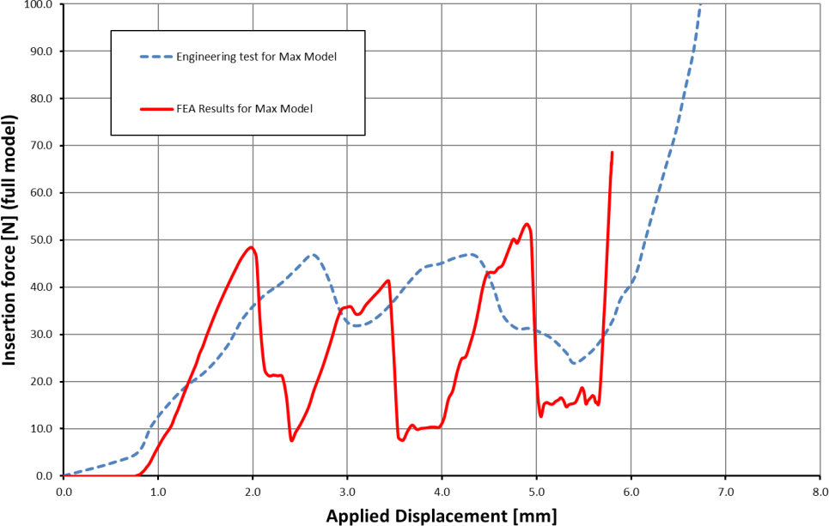

#1

#2

Figure 7.1

Table 7.1 FEA result compare with experimental test for maximum tolerance block

|  |  |  |  |
| --- | --- | --- | --- |
| **N°** | **Simulation** | **Position** | **Insertion Force [N]** |
| #1 | Maximum Test block with Friction coefficient 0.1 | Max. Force | ~52(Fmax) |
| #2 | Engineering test for Max Model | Max. Force | 47 |

Calculate the percentage of error for high accuracy results.

**Percentage of error (%) =** |𝑺𝒊𝒎𝒖𝒍𝒂𝒕𝒊𝒐𝒏 𝑽𝒂𝒍𝒖𝒆−𝑬𝒙𝒑𝒆𝒓𝒊𝒎𝒆𝒏𝒕𝒂𝒍 𝑽𝒂𝒍𝒖𝒆| × 𝟏𝟎𝟎 **(7.1)**

𝑬𝒙𝒑𝒆𝒓𝒊𝒎𝒆𝒏𝒕𝒂𝒍 𝑽𝒂𝒍𝒖𝒆

**=** |𝟓𝟐−𝟒𝟕| × 𝟏𝟎𝟎

𝟒𝟕

## Percentage of error (%) = 10.6 %

### FOR MINIMUM TOLERANCE TEST BLOCK

Both simulation and experimental graphs are reached the maximum insertion forces in first and third peak points in graph.

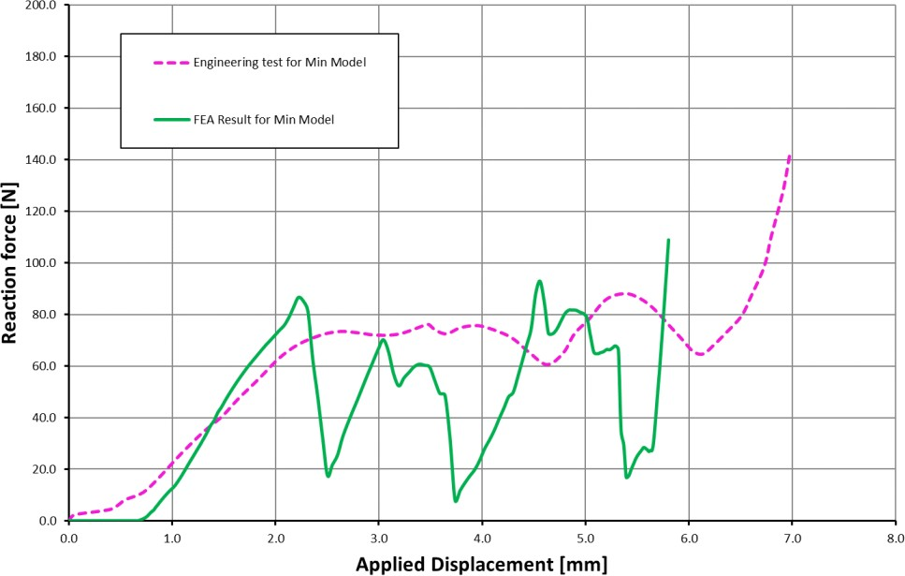

#3 #4

Figure 7.2

Table 7.2 FEA result compare with experimental test for minimum tolerance block

|  |  |  |  |
| --- | --- | --- | --- |
| **No** | **Simulation** | **Position** | **Insertion Force [N]** |
| #3 | Minimum Test block with Friction coefficient 0.1 | Max. Force | ~94(Fmax) |
| #4 | Engineering test for Max Model | Max. Force | 88 |

Calculate the percentage of error for high accuracy results.

**Percentage of error (%) =** |𝑺𝒊𝒎𝒖𝒍𝒂𝒕𝒊𝒐𝒏 𝑽𝒂𝒍𝒖𝒆−𝑬𝒙𝒑𝒆𝒓𝒊𝒎𝒆𝒏𝒕𝒂𝒍 𝑽𝒂𝒍𝒖𝒆| × 𝟏𝟎𝟎 **(7.2)**

𝑬𝒙𝒑𝒆𝒓𝒊𝒎𝒆𝒏𝒕𝒂𝒍 𝑽𝒂𝒍𝒖𝒆

**=** |𝟗𝟒−𝟖𝟖| × 𝟏𝟎𝟎

𝟖𝟖

## Percentage of error (%) = 6.8 %

* 1. **RESULTS SUMMARY**

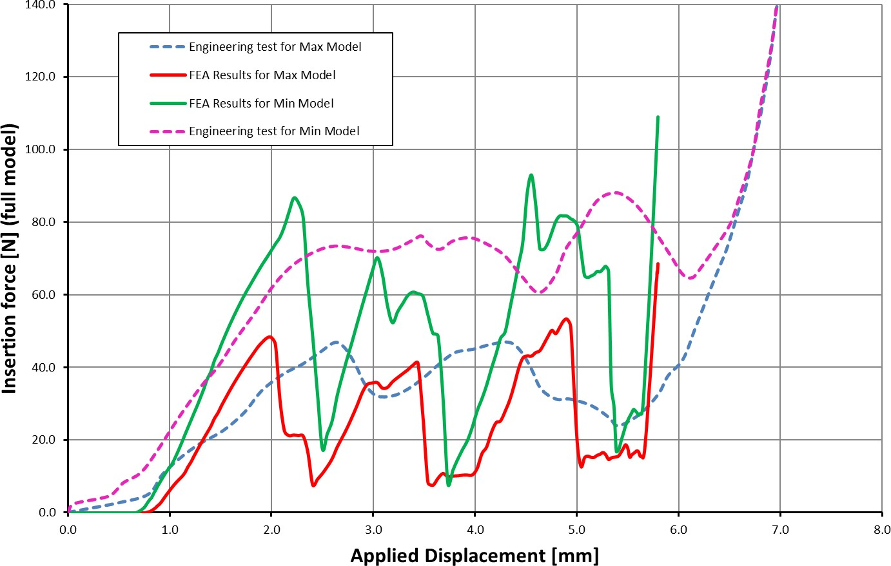

#3

#4

#1

#2

Figure 7.3

Table 7.3 Summary of Result

|  |  |  |  |  |  |
| --- | --- | --- | --- | --- | --- |
| **Design model** | **Max Insertion Force [N]** | | **Percentage of Error (%)** | **Contact Pressure [MPa]** | **Percentage of Compression strain (%)** |
| Simulation Result | Experimental Result |
| Maximum tolerance test block | 52 | 47 | 10.6 | 0.4 | 10 |
| Minimum tolerance test block | 94 | 88 | 6.8 | 0.5 | 15 |

# CHAPTER 8

## CONCLUSION

In this study, the deformation behavior of seal like compression strain, contact pressure and mating/insertion force of two different tolerance test blocks obtained from numerical explicit analysis to design waterproof connectors for automobiles. And, these effectiveness parameter of simulation results successfully compared with experimental test.

From the result summary, the simulation result of mating forces is approximate

1.1 times higher than the experimental tests. And, the mating/insertion force of connector is inversely proportional to the tolerance of test block.

The contact pressure of minimum tolerance test block is 0.1 MPa higher than the maximum tolerance of test block. And, the contact pressure of interfacial seal is inversely proportional to the tolerance of test block.

The compression strain of minimum tolerance test block is 5% higher than the maximum tolerance test block. And, the compression strain of interfacial seal is inversely proportional to the tolerance of test block.

Hence, the study of sealing effectiveness for an automotive connector is done by numerical and experimental tests.

# REFERENCES

1. Abaqus6.10 Documentation. (n.d.). Retrieved from [www.sharcnet.ca:](http://www.sharcnet.ca/) [https://ww](http://www.sharcnet.ca/Software/Abaqus610/Documentation/docs/v6.10/books/u)w.sharc[net.ca/Software/Abaqus610/Documentation/docs/v6.10/books/u](http://www.sharcnet.ca/Software/Abaqus610/Documentation/docs/v6.10/books/u) sb/default.htm?startat=pt03ch06s03at16.html
2. Chang and ChunLeeaKuo (January 2004) investigated Design and analysis of gasket sealing of cylinder head under engine operation conditions.
3. Chang-ChunLeeaKuo-NingChiangaWen-KingChenbRong-ShiehChenb (2004) “Design and analysis of gasket sealing of cylinder head under engine operation conditions”
4. Feihong Yun, Gang Wang, Zheping Yan, Peng Jia, Xiujun Xu, (2020) “Analysis of Sealing and Leakage Performance of the Subsea Collet Connector with Lens‐ Type Sealing Structure” Journal of Marine science and Engineering, Vol 8, pp 444
5. Hyperelastic rubber plug retention (2015), Abaqus process guide.
6. Konrad T. Kloch a,b , Pawel Kozak a , Andrzej Mlyniec b, (2020) “A review and perspectives on predicting the performance and durability of electrical contacts in automotive applications” Engineering Failure Analysis.
7. L. Lam and C. Maul (September 2004) published Temperature, humidity and pressure measurement on automotive connectors.
8. S.Schlömer B.M.Krooss (2017) “Experimental characterization of the hydrocarbon sealing efficiency of cap rocks”
9. Stanislav I and Pliassounov S (April 2007) published Fundamentals and common problems of seal integrity robustness of standardized brake tubing threaded connectors.
10. Young-Bae Ko, Hyung-Pil Park, Jeong-Won Lee (2019) “A Study on the sealing Characteristic of Automobile Waterproof Connector” Journal of the Korea ACADemia-Industrial cooperation Society · April 2014, Vol. 15, No. 4 pp. 1859- 1864, 2014