**ON ROAD VEHICLE BREAKDOWN ASSISTANT MANAGEMENT**

M. Vasuki1, M.Prathiba

1 Associate professor, Department of Master Computer Application, Sri Manakula Vinayagar Engineering College, Pondicherry-605 107, India.

vasukimca@smvec.ac.in

2 Student, Department of Master Computer Application, Sri Manakula Vinayagar Engineering College, Pondicherry-605 107, India

prathibamuralidharan27@gmail.com

**ABSTRACT**

The road vehicle breakdown assistant management system comprises three modules: User, Admin, and Mechanic. The admin module is responsible for verifying mechanic details and approving licensed drivers for the application. To enable location sharing, the system utilizes the Google tracking system. This feature allows users to share their real-time location during breakdown incidents, enabling efficient dispatch of nearby mechanics. The system's abstract demonstrates its capability to streamline the verification process, ensuring that only licensed drivers gain access to the application. Furthermore, by leveraging Google tracking, the system enhances the overall responsiveness and effectiveness of the breakdown assistance, facilitating timely support for users in need.

**KEY WORDS**: user, admin, mechanic, licenced driver, google tracking system.

**1.INTRODUCTION**

The on-road vehicle breakdown assistant management system is designed to provide seamless assistance during breakdown incidents and consists of three modules: User, Admin, and Mechanic. The User module enables drivers to report their breakdown incidents and share their real-time location using the Google tracking system. This ensures accurate and swift dispatch of nearby mechanics to the driver's location. The Admin module plays a crucial role in verifying mechanic details and approving licensed drivers to ensure the credibility and reliability of the application. By utilizing PHP, the system securely handles the verification process and grants access only to authorized individuals. HTML and CSS are used to create an intuitive and visually appealing user interface, while AngularJS enhances the application's interactivity and responsiveness across different devices. This project aims to provide an efficient breakdown assistant management system that streamlines the verification process, facilitates timely assistance, and offers a seamless user experience to users facing vehicle breakdowns.

**2.EXISTING SYSTEM**

The existing system faces challenges where users have limited access to mechanics in their database, resulting in difficulties when their vehicles break down in remote or distant locations where their known mechanic shops may not be present. Users are unaware of whether their vehicles have encountered any mechanical issues in these areas. In such situations, users may rely on personal contacts at the location to seek help, but this is contingent upon the willingness and availability of those contacts. Finding a suitable mechanic for the required service becomes a daunting task at remote locations. As a result, users often resort to alternative transportation options when faced with a breakdown and subsequently need to arrange for a mechanic to reach the location where their vehicle is stranded. These challenges emphasize the need for an improved on-road vehicle breakdown assistant management system that can efficiently address these limitations and provide timely assistance to users, regardless of their location.

**3.PROPOSED SYSTEM**

The On Road Vehicle Breakdown Assistance (ORVBA) system empowers users by providing them with the capability to search for a comprehensive list of mechanics located at any desired location or nearby areas. This feature proves invaluable in addressing unexpected situations that arise due to mechanical issues in their vehicles. The system ensures that only licensed mechanics are listed, guaranteeing the expertise and professionalism of the available service providers. Users can have confidence in the reliability and quality of the mechanics enlisted in the system. Moreover, the ORVBA system goes beyond simply providing a list of mechanics; it also facilitates direct communication between users and available mechanics. This streamlined communication enables mechanics to promptly reach the user's location and efficiently repair the mechanical issues in their vehicles, ensuring a quick resolution and minimizing any inconvenience caused by breakdown incidents.

**4.FLOW CHART**

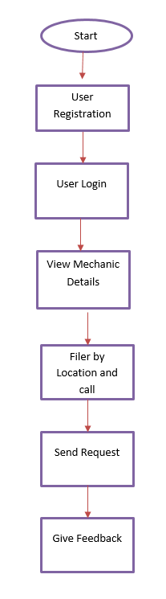

**Fig 1.1 Flow chart**

Description: The above Diagram shows that the Flow chart diagram.

**5.ORVBA ARCHITUCTURE**

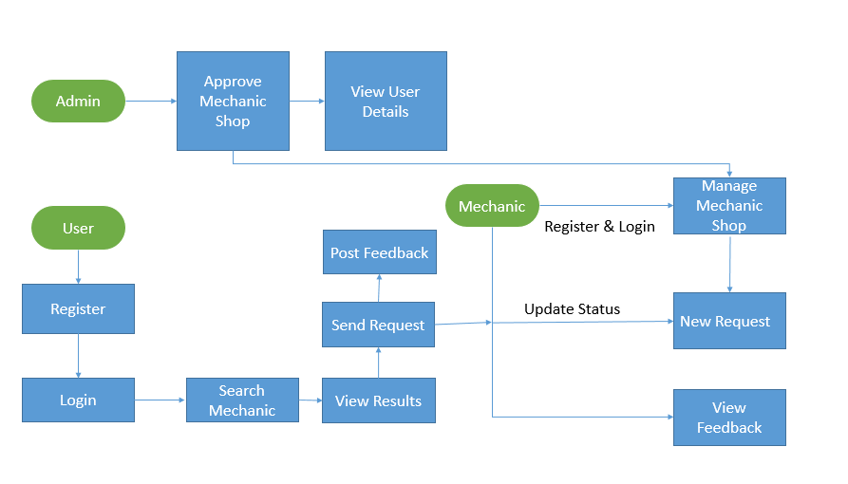

**Fig 1.2 Architecture Diagram**

Description: The above Diagram shows the Architecture Diagram of ORVBA System.

**6.ORVBA MODULES**

The system after careful analysis has been identified to be presented with the following modules User, Administrator and Mechanic.

ADMIN MODULE: The Administrator module of the application plays a crucial role in ensuring the quality and reliability of the breakdown assistance service. Administrators are responsible for reviewing and approving the registration requests of mechanics after verifying their licensing details. By carefully assessing the qualifications and credentials of each mechanic, administrators ensure that only licensed and competent professionals are listed in the application. This approval process guarantees that users can rely on the mechanics enlisted in the system, promoting trust and confidence in the provided services.

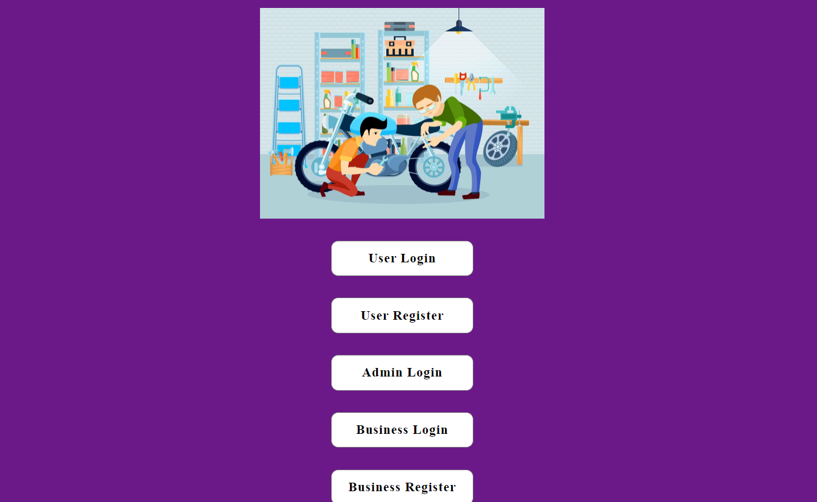

**Fig 1.3 Home page**

Description: The above screenshot shows the home page.

**7.USER MODULE**

The User module of the application provides various functionalities for users to access the on-road vehicle breakdown assistance. Users can register by providing their basic details, enabling them to login and utilize the services when needed. Upon logging in, they can view the approved list of mechanics available through the application. Users can search for mechanics based on their location and contact them directly. To facilitate efficient assistance, users can share their location manually using Google Maps and provide details of the problem they are facing. They can track the status of their requests and view whether they have been accepted or are still pending. Once the service is provided, users are encouraged to post their feedback about the adopted service, allowing for continuous improvement of the assistance provided through the application.

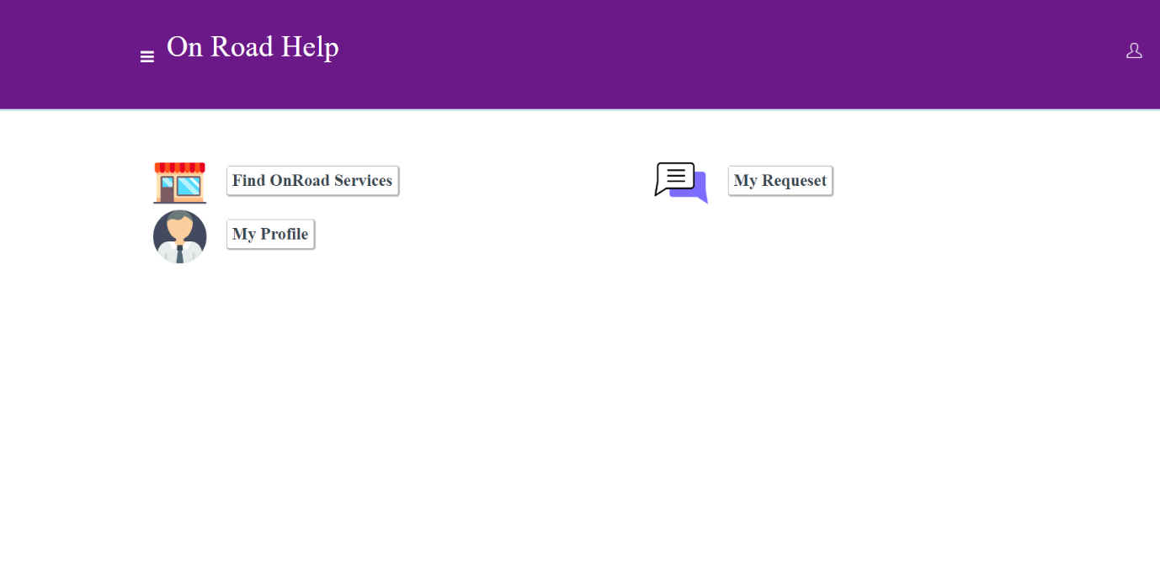

**Fig 1.3 Home page**

Description: The above screenshot shows the user module.

**8.BUSINESS MODULE:**

In the Business module, mechanics are required to register their details with the administrator to receive approval for using the on-road vehicle breakdown assistance service. Once approved, mechanics can login to their accounts and post their relevant information, including their name, location, and the services they offer. It is essential for mechanics to view and consider the feedback provided by users/customers to maintain and improve the quality of their services. When a new request is received from a user, mechanics can utilize Google Maps for directions to reach the user's location. This module ensures efficient communication and service delivery between mechanics and users, enhancing the overall experience of both parties involved.

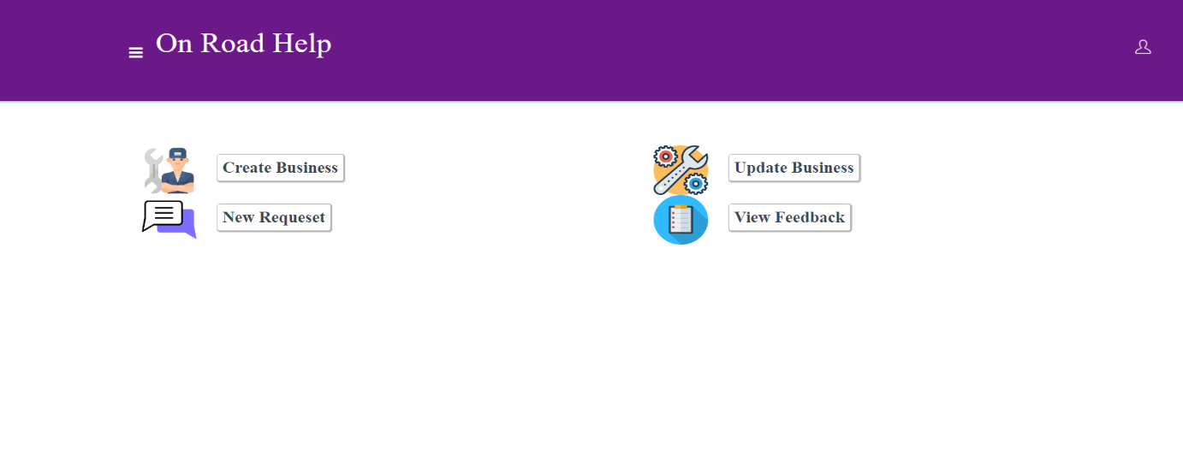

**Fig 1.4 Business page**

Description: The above screenshot shows mechanic module.

**9.ADMIN MODULE:**

The Administrator module of the application plays a crucial role in ensuring the quality and reliability of the breakdown assistance service. Administrators are responsible for reviewing and approving the registration requests of mechanics after verifying their licensing details. By carefully assessing the qualifications and credentials of each mechanic, administrators ensure that only licensed and competent professionals are listed in the application. This approval process guarantees that users can rely on the mechanics enlisted in the system, promoting trust and confidence in the provided services.

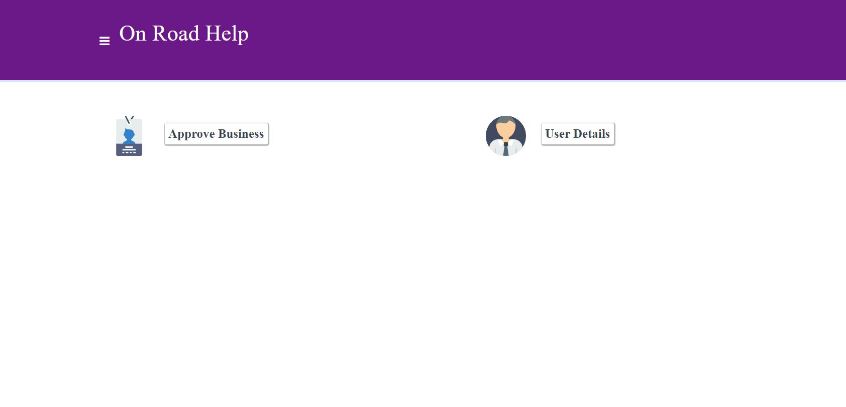

**Fig 1.5 Admin page**

Description: The above screenshot shows the admin module.

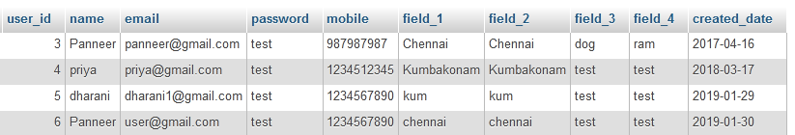

**Fig 1.6 Database**

Description: The above screenshot shows the user database.

**10.IMPLEMENTATION**

The implementation of the On Road Vehicle Breakdown Assistant Management system utilized HTML, CSS, and Bootstrap for the frontend development, ensuring a responsive and visually appealing user interface. AngularJS was leveraged for the backend, enabling dynamic functionality and seamless interaction between different modules. PHP was used to handle the server-side processing and database connectivity, with MySQL as the chosen database management system. The XAMPP tool was utilized to create a local development environment, providing the necessary infrastructure for testing and deployment. This combination of frontend and backend technologies, along with the XAMPP tool, facilitated the successful implementation of the system, providing users with a reliable and user-friendly platform for on-road vehicle breakdown assistance management.

**11.FUTURE ENHANCEMENT**

One future enhancement for on-road vehicle breakdown assistant management could be the integration of Internet of Things (IoT) technologies, allowing the system to connect and communicate with vehicles and roadside infrastructure in real-time. This integration would enable the system to receive live diagnostic data from vehicles, monitor critical parameters, and proactively identify potential breakdown issues. Additionally, it could facilitate seamless communication with roadside assistance infrastructure, such as traffic management systems or nearby repair shops, to expedite assistance and optimize the overall breakdown management process.

**12.CONCLUSION**

In conclusion, In this paper we probe into position Grounded Services, which utilizes the knowledge of the geo-specific position of a position- apprehensive mobile device and facilitates services grounded on that information. We also bandied about LBS Components and LBS Architecture. position Grounded Services uses technologies like GPS, cellular network, Wi- Fi to give colorful services. Android provides colorful services to apply position grounded operations. Our paper discusses APIs like position API, Google Charts, Direction API and Places API which helps in making position- apprehensive operations under android platform. moment android is the most habituated mobile operation system in the request. Hence developing LBS operations on android platform can help maximum population to get the benefits of this technology. Hence Location Based Services can help the druggies in a variety of aspects and has a lesser compass of development in colorful mobile operating system technologies like Android.

**REFERENCE**

* Adler M. J. (2009). Harvard Business Review. Health Care Requires Big Changes to Complement New IT, 87, 20.
* Appolinário, F. (2004). Dicionário de MetodologiaCientífica: um Guiapara a Produção do ConhecimentoCientífico.
* Arnhold, l.; Schmidt, S. &Bohnenberger, M.C. (2008). Seleção e Implantação de ERP emumaCooperativaMédica no RS: Um Estudo de Caso. In: EncontroAnual da ANPAD. 32, Rio de Janeiro, 2008. Anais... Rio de Janeiro: ANPAD.
* Bahensky, J. A.; Jaana, M. & Ward, M. M. (2008). Health Care Information Technology in Rural America: Electronic Medical Record Adoption Status in Meeting the National Agenda. The Journal of Rural Health.
* Balfour III, D.C. (2009). et al. Health Information Technology — Results From a Roundtable Discussion. JMCP Supplement to Journal of Managed Care Pharmacy. (January/February).
* The Interaction Design Foundation. (2020). Prototyping: Learn Eight Common Methods and (Anon., 2020)Best Practices. [online] Available at: https://www.interactiondesign.org/literature/article/prototyping-learn-eight-common-methods-and-best-practices [Accessed 20 Jan. 2020].
* The Interaction Design Foundation. (2020). Prototyping: Learn Eight Common Methods and Best Practices. [online] Available at: https://www.interaction-design.org/literature/article/prototypinglearn-eight-common-methods-and-best-practices [Accessed 20 Jan. 2020.
* Monica, 2018. A Car Breakdown Service Station Locator System. INTERNATIONAL JOURNAL OF ADVANCE SCIENTIFIC RESEARCH, 3(4), pp. 13-16
* Florian, e., 2017. Google Patent. [Online] Available at: https://patents.google.com/patent/US20190171758A1/en [Accessed 17 January 2020].
* Reichardt, e., 2002. Car Talk 2000. [Online] Available at: https://ieeexplore.ieee.org/abstract/document/1188007 [Accessed 17 December 2019 ].