**BIDIRECTIONAL SMART ENERGY MANAGEMENT CHARGING FROM GRID TO VEHICLE AND VEHICLE TO LOAD**

**Harish B N1, Monisha S2, Deepashree B C3, Vaibhavi Naidu S4, Yashwanth Kumar R5**

1Assistant Professor, Department of Electrical and Electronics, PES College of Engineering, Mandya, Karnataka, India

2,3,4,5Student, Department of Electrical and Electronics, PES College of Engineering, Mandya, Karnataka, India

**ABSTRACT**

This research has created and presented the bidirectional power transfer technique known as Vehicle-to-Home (V2H) and Grid-to-Vehicle (G2V). With this system, electricity can move both ways between a car and a house or the grid. Bidirectional power transfer has been made possible by a successful implementation in hardware after the system's efficiency and dependability were proven through simulations. Depending on the circumstances and requirements, this permits energy to be transported from the vehicle to the home or from the grid to the vehicle. By offering a reliable way to transfer power between cars, houses, and the grid, this technology promotes effective energy management and utilization. Voltage sensors and an Arduino microcontroller are used in the hardware implementation to monitor and manage battery charging. When the grid is not available, an inverting programme creates AC power, and when it is, a voltage regulator charges the battery. On an LCD panel, current data is shown, including the battery level. In the simulation, vehicle-to-home systems are capable of intelligent energy management thanks to the integration of battery current monitoring and State of Charge tracking. This integration helps to build a more efficient and sustainable energy ecology.

**Keywords:** Vehicle-to-home(V2H), Grid-to-vehicle(G2V), Battery level, Bidirectional power transfer, Arduino.

1. **INTRODUCTION**

The widespread use of electric vehicles (EVs) in recent years has been fueled by the accelerating pace of technological innovation and the growing demand for environmentally friendly transportation options. Because of this, the integration of EVs into the current power grid infrastructure has gained a lot of attention. Our energy systems now have new opportunities and perspectives for improving their efficiency, dependability, and sustainability because to the convergence of EVs, smart grids, and smart houses. Power generators, consumers, and other grid players can exchange information and electricity in both directions thanks to smart grids, which are characterised by the integration of cutting-edge communication and control technologies. This two-way communication enables a more dynamic and adaptable control of the supply and demand for electricity, opening the path for a cleaner and more reliable energy future. Homeowners are adopting automation and connectivity to optimize their energy use patterns, which has given rise to the concept of smart homes. Residents may remotely monitor and manage their energy use with smart home technologies, which optimize energy flows and lower total demand. These systems are growing more complex and are able to incorporate different energy-consuming devices, such as EV chargers. A rare chance to change how we see and use energy is presented by the convergence of EVs, smart grids, and smart houses. With their huge batteries, EVs can function as mobile energy storage units, absorbing electricity, and re-injecting it into the grid. This vehicle-to-grid (V2G) capability has the potential to enable techniques for cost-effective energy management in addition to supporting grid stability. The growing desire for environmentally friendly transportation options and the quickening rate of technological progress have both contributed to the widespread adoption of electric cars (EVs) in recent years. Due to this, the incorporation of EVs into the infrastructure of the current power grid has drawn a lot of interest. Smart homes, smart grids, and EV integration have opened up new opportunities and perspectives for enhancing the dependability, sustainability, and efficiency of our energy systems. Thanks to smart grids, which are characterised by the incorporation of cutting-edge communication and control technology, power producers, consumers, and other grid participants may exchange information and electricity in both directions. This article discusses the advantages and difficulties of smart energy management strategies for bidirectional charging systems and suggests an intelligent energy management strategy [1]. This study examines intelligent charge management techniques for V2G (vehicle-to-grid) applications for electric vehicles, examining topics like charging scheduling, power flow control, and load balancing tactics.[2].[3] In a smart grid setting, the study suggests an ideal method for charging and discharging electric vehicles while considering user preferences, vehicle mobility, and the cost of electricity. The goal of this research is to schedule electric vehicle charging in smart grids as efficiently as possible while taking user needs, grid limitations, and renewable energy integration into mind. The system described in this study uses a hierarchical control architecture to coordinate power flow depending on load demand, energy price, and grid stability [4]. It is designed for grid-to-vehicle and vehicle-to-load integration. In order to balance load and reduce costs, this study considers the combined optimization of residential energy management [5] and electric vehicle charging in smart networks. The integration of electric vehicle-to-load (V2L) technology for grid-to-vehicle (G2V) [6] applications is examined in this study, along with possible advantages such load balancing, peak shaving, and grid support. The system described in this study uses a hierarchical control architecture to coordinate power flow depending on load demand, energy price, and grid stability [7]. It is designed for grid-to-vehicle and vehicle-to-load integration. In order to balance load and reduce costs, this study considers the combined optimization of residential energy management and electric vehicle charging in smart networks. The integration of electric vehicle-to-load (V2L) technology for grid-to-vehicle (G2V) applications is examined in this study, along with possible advantages such load balancing, peak shaving, and grid support [8]. The study addresses load demand, energy price, and grid stability while concentrating on the best power flow management for electric vehicle bidirectional charging stations [9]. An overview of vehicle-to-grid (V2G) technologies, configurations, applications, and their effects on power systems is given in this review. The study discusses the functionality, optimization techniques, and grid integration of sophisticated battery management systems (BMS)[10] for electric vehicles in smart grids. This study examines energy management programmed for EVs in smart grids, including themes like demand response, renewable energy integration, and charging schedules [11]. The study addresses load demand [12], energy price, and grid stability while concentrating on the best power flow management for electric vehicle bidirectional charging stations. An overview of vehicle-to-grid (V2G) technologies, configurations, applications, and their effects on power systems is given in this review [13]. The study discusses the functionality, optimization techniques, and grid integration of sophisticated battery management systems (BMS) for electric vehicles in smart grids. This study examines energy management programmed for EVs in smart grids, including themes like demand response [14], renewable energy integration, and charging schedules.

1. **METHODOLOGY**
   1. **Block Diagram**

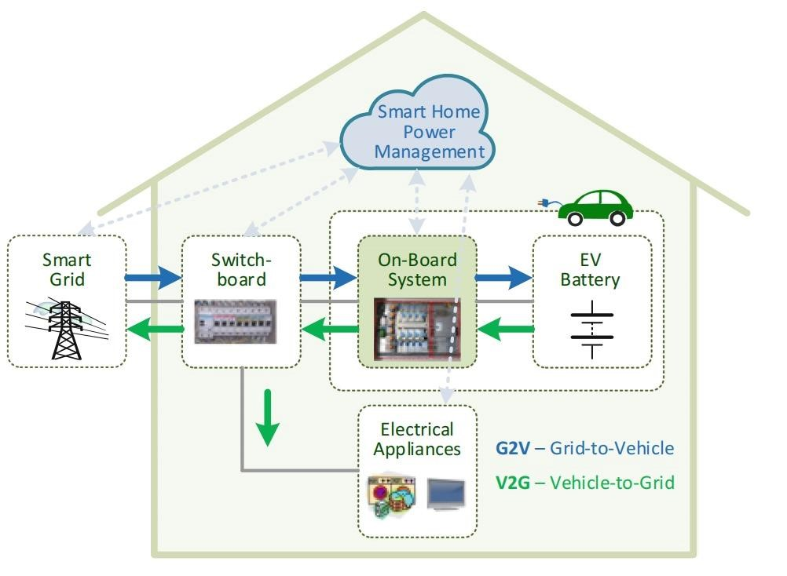

Fig 1: General system diagram for G2V and V2G

Bidirectional EV chargers are being implemented with internal converters capable of converting DC electricity stored in the EV's battery back into AC electricity. This allows for versatile usage of the converted energy, such as powering various household appliances or sending it back to the grid.

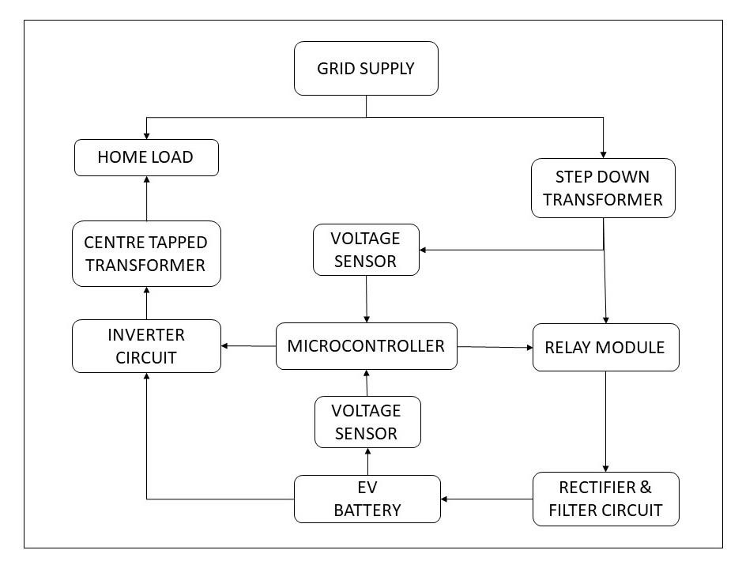

Fig 2:Block Diagram for Hardware Model

Arduino microcontroller is the brain of the system which is programmed using Arduino IDE. Our system consists of 2 voltage sensor which reads voltage coming from grid - step down transformer for charging the battery and also to measure the battery voltage. When there is no grid power, microcontroller turns on inverting program where 2 MOSFETS are triggered alternatively producing a square wave at the input of Centre tapped step up transformer which produces 220-250 v ac at the output, this process is continued till battery gets below 10.5v or the grid power established again. When there is grid power, a voltage regulator will charge the battery until 12.7 is achieved later the transformer is turned off via relay. All the operations are displayed on the lcd including battery percentage.

* 1. **Model And Analysis:**

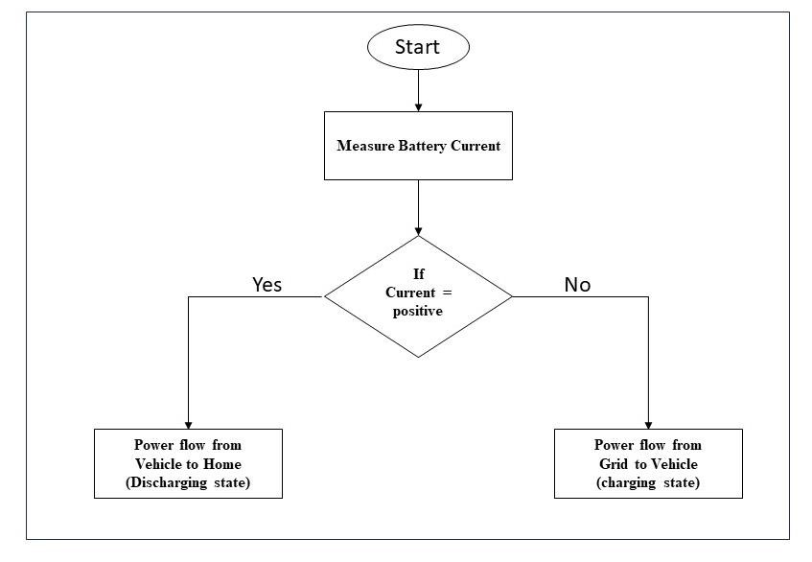

Fig 3: Flowchart for Simulink model

There are two methods to determine the charging and discharging of a battery. In the first method, if the battery current is positive, it indicates that power is being transferred from the vehicle to the home. Conversely, if the current is negative, it means that power is flowing from the grid to the vehicle. The second method involves monitoring the State of Charge (SoC) of the battery. If the SoC is increasing, it signifies that power is being supplied from the grid to the vehicle. On the other hand, if the SoC is decreasing, it indicates that power is being transferred from the vehicle to the home. By employing these two methods, it becomes possible to track the direction of power flow and the status of the battery, enabling effective management of energy transfer between the vehicle and the grid.

1. **RESULTS AND DISCUSSION**
   1. **Hardware results:**

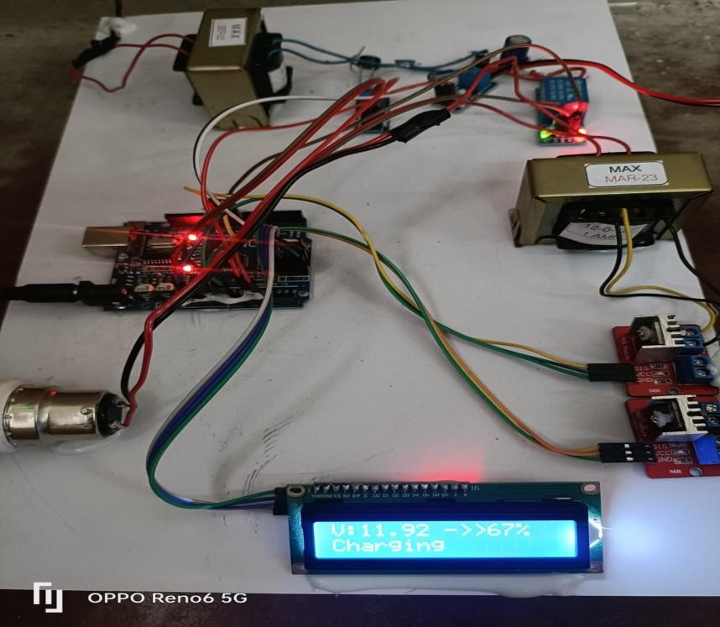 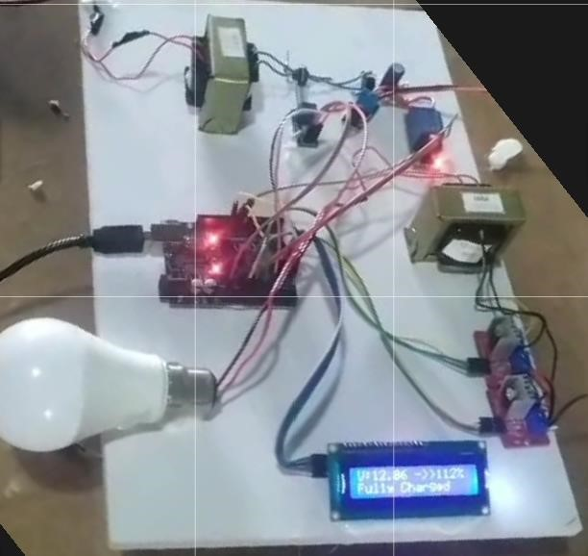

Fig 4: Hardware module in charging state Fig 5: Hardware Module in fully charged state.

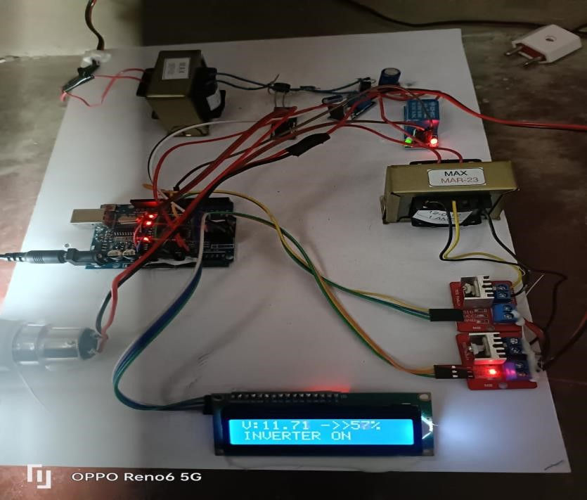

Fig 6: Hardware module in discharging state

Bidirectional charging systems offer opportunities for vehicle owners to participate in demand response programs, allowing them to sell surplus energy back to the grid, leading to potential cost savings and revenue generation.

The implementation of smart energy management bidirectional charging has demonstrated the potential to enhance grid stability, increase renewable energy integration, and provide additional benefits to EV owners and the wider energy ecosystem. Continued research and development in this area will likely lead to further advancements and widespread adoption of this technology.

* When there is a grid supply: The voltage sensor senses the voltage and gives a input to the microcontroller to turn the charging circuit automatically to charge the battery.
* When the battery is fully charged: System disables the charging of battery when the battery voltage is 12.7 (100%) and above, it automatically turns off the rectifier circuit by triggering the Relay module.
* When the battery is completely discharged: System disables the discharging of battery when the battery voltage is 10.5 (0%) and below.
* When there is no grid supply: The voltage sensor senses that there is no voltage and gives a input to the microcontroller to turn the inverter circuit automatically.

* 1. **Simulation Results:**

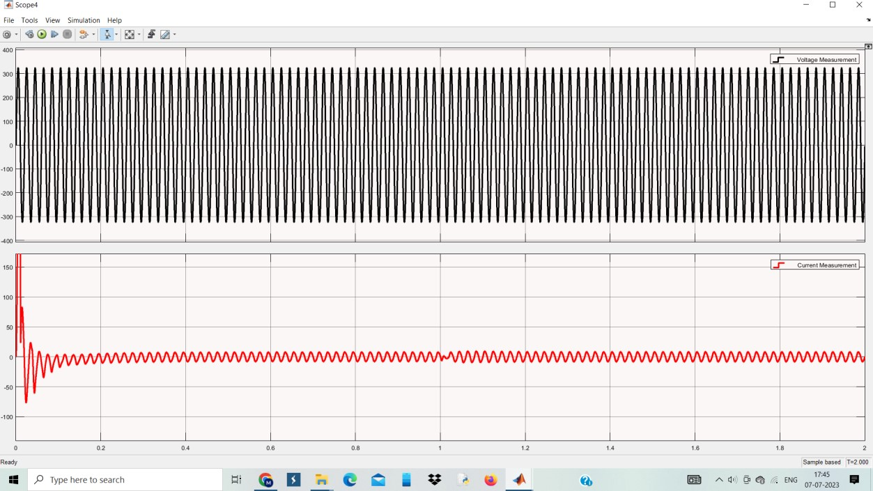

Fig 7: supply voltage and current (VG and IG) Fig 8:Input Voltage and Current showing In or Out of phase

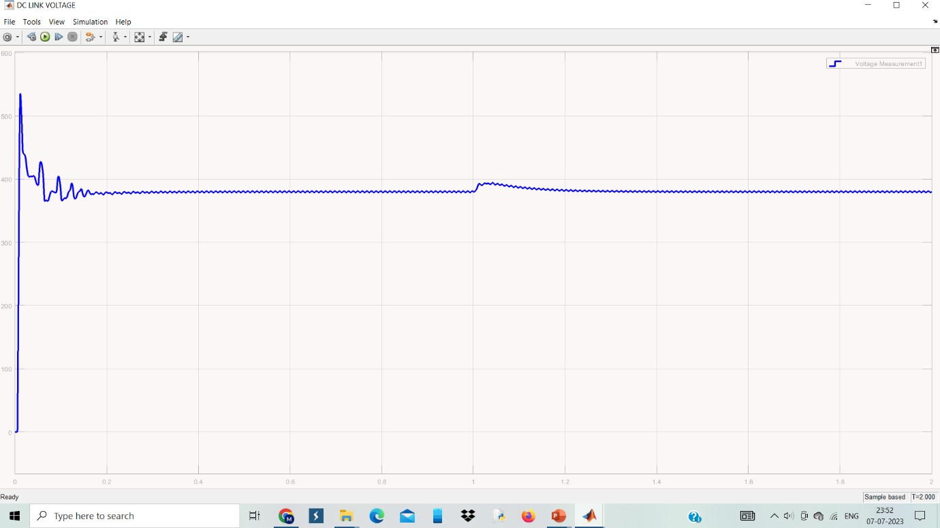

### Fig 9: DC Link voltage (VDC) Fig 10: Battery current (IBAT)

Fig 11:Battery Voltage (VBAT)Fig 12: SOC of Battery

The simulation results indicate that the voltage and current across the grid vary as the step reference value ranges from +10 to -10, as depicted in Figure 7. During battery charging, the current and voltage are in phase, while during battery discharging, they are out of phase, as illustrated in Figure 8. Figure 9 demonstrates the DC link voltages over time, showing that the voltage remains nearly equal during both charging and discharging phases. Furthermore, Figures 10,11, and 12 represent the battery current, battery voltage, and state of charge (SoC) of the battery, respectively. During battery charging, the current is positive, whereas during discharging, it becomes negative, as shown in Figure 10. As depicted in Figure 12, the SoC increases during charging conditions and decreases during discharging conditions.

1. **CONCLUSION**

The grid-to-vehicle (G2V) and vehicle-to-home (V2H) bidirectional power transfer schemes have been created. With this system, electricity can move both ways between a car and a house or the grid. Simulated tests have been used to confirm the system's functionality, confirming its efficacy and dependability. Additionally, the plan has been put into practice in hardware, allowing for the creation of a bidirectional power flow. According to the needs and circumstances, energy can move from the vehicle to the home as well as from the grid to the vehicle. Overall, this technology makes it easier to control and use energy effectively.

1. **REFERENCES**
2. Mukesh Singh, Praveen Kumar, Indrani Kar.’ Analysis of Vehicle to Grid Concept in Indian

Scenario, 14th International Power Electronics and Motion Control Conference, EPE-PEMC T6 149-156.,2010

1. Anu G Kumar, Anmol. M., Akhil V.S.’A strategy to Enhance Electric Vehicle Penetration Level in India’ SMART GRID Technologies, Procedia Technology 21 Pg.552 – 559, 2015
2. J. G. Pinto, Vítor Monteiro, Henrique Gonçalves, Bruno Exposto, Delf m Pedrosa, Carlos

Couto, João L. Afonso, “Bidirectional Battery Charger with Grid-to-Vehicle, Vehicle-to-Grid and Vehicle-to-Home Technologies”, IECON 2013 - 39th Annual Conference of the IEEE, Nov. 2013

1. Visal Raveendran; Manjula G Nair ‘Vehicle-to-grid transactions and shunt active filtering capability of Smart Parks equipped with modified IcosФ controller, Electrical, Electronics and

Computer Science (SCEECS), IEEE Students’ Conference Pages: 1 – 7,2014

1. C. Liu, K. T. Chau, W. Diyun and S. Diyun,” Opportunities and challenges of vehicle-to home, vehicle-to-vehicle, vehicle-to-grid technologies” Proc. IEEE, vol. 101, no. 11, pp. 24092427, 2013
2. Vítor Monteiro, Bruno Exposto, João C. Ferreira, João Luiz Afonso, “Improved Vehicle to-Home (iV2H) Operation Mode: Experimental Analysis of the Electric Vehicle as Off-Line

UPS”, IEEE Transactions on Smart Grid, Volume: PP, Issue: 99, pp 1 – 10,2016

1. W. Kempton and J. Tomic, “Vehicle-to-grid power fundamentals” Journal of Power Sources, vol. 144, pp. 268-279. Year 2005.
2. A.K Verma, B. Singh, D.T Shahani, “Grid to Vehicle and Vehicle to Grid Energy Transfer using Single-Phase.

Bidirectional AC DC Converter and Bidirectional DC – DC converter”, 14th International Power Electronics and Motion Control Conference, EPE-PEMC 2010.

1. Bhim Singh, Brij N. Singh, Ambrish Chandra, Kamal Al-Haddad, Ashish Pandey and

Dwarka P. Kothari, “A review of single-phase improved power quality ac–dc converters,” IEEE Trans. Industrial Electronics, vol.50, no. 5, pp. 962-981, Oct. 2003.

1. W.C., & Tse, C. K. (1996). “Development of a fuzzy logic controller for DC/DC converters: Design, computer simulation and experimental evaluation”. IEEE Transactions on Power Electronics. vol.21, no. 2, pp. 269-277, Oct.

2003

1. Mohan, Ned, Tore M Undeland, and William P Robbins. Power Electronics. New York:

Wiley, 1995. Print.