**Different Types Of Strategies For Power Factor Improvement.**

Yuga Dhawale

Guide: Prof. Mr. Mukul Pande

Co-Guide: Prof. Mr. Sandeep Thakre

**TULSIRAMJI GAIKWAD-PATIL COLLEGE OF ENGINNERING AND TECHNOLOGY, NAGPUR**

**Department of M.Tech (ECE)**

**Session 2019-20**

**M.Tech (ECE)-IInd Year**

**Email : dhawaleyuga@yahoo.in**

**Abstract:** The power factor is a calculation of how you use energy effectively. There are different forms of power at work to give us electrical energy. Here's what each one does. Power quality is essential for efficient equipment operation, and power factor contributes to this. Improving the PF can maximize current-carrying capacity, improve voltage to equipment, reduce power losses, and lower electric bills. Hence the power factor improvement is very essential in household purpose as well as electrical industries. Power factor can be improved with different strategies which are used after analysing the problem and select the suitable of them.

***Keywords:*** Power *Factor, Improvement Strategies, Power Factor Correction, Capacitor Bank.*

1. **Introduction**

Correction of the power factor can be highly advantageous. The advantages include everything from lower demand charges on power system to improved load carrying capacities in existing circuits and lower total power system losses. Working Power – the "actual" or "real" power used to conduct heating, lighting, motion, etc. work in all electrical appliances. This is what we convey as kW or kilowatts. Electric heating and lighting are common forms of resistive loads. Power factor is the ratio of active to apparent power.

Active Power (P) = the power necessary in Watt or Kilo-Watt (kW) for useful work, such as turning a lathe, providing light or pumping water.

Apparent Power (S) = the vector sum of active and reactive power expressed in Volt Amperes or KiloVolt Amperes (kVA).

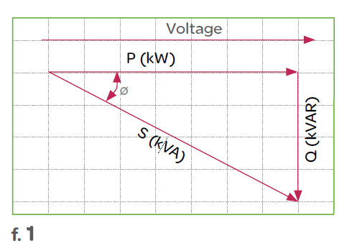

Figure 1: The Power Triangle

1. **Measurement Of Power Factor**

Power factor can be measured with the help of ZCD. The ZCD is nothing but the zero cross detector.

**2.1. Zero Crossing Detector**: A significant application of the op-amp comparator circuit is the zero crossing detector circuit. It may also be called the converter sine to square wave. We can use either of the inverting or non-inverting comparators as a zero-crossing detector. The only change to be made is the reference voltage, which must be zero (Vref = 0V) for the input voltage to be compared.

Reactive Power (Q) = a measure of the energy stored reflected to the source that does not perform any useful work, expressed in var or Kilovar (kVAR)

The phase shift between the voltage and the current of the circuit is known as the power factor. It is represented by the cosine of the angle φ. The power factor represents the fraction of total energy use for doing useful work, and the remaining energy is stored in the form of magnetic energy in the inductor and capacitor of the circuit. The value of power factor lies between -1 to +1. The most economical value of power factor lies between 0.9 to 0.95. If the value of power factor lies below 0.8 (approx), then it draws more current from the load. The large current increases the losses and requires a large conductor, thus increases the cost of the system. The loss can be reduced by correcting the power factor of the system.

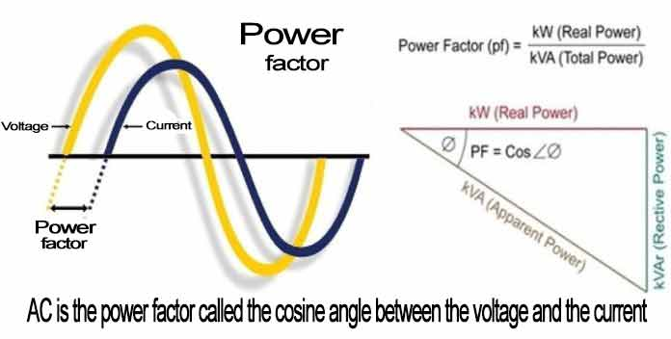

**Figure 1: Power Triangle**

Figure 1 show the power triangle of power factor where power factor is the ratio of active power to the apparent power which is nothing but COSӨ.

1. **Design Methodology**

Our proposed scheme consists of Simulation based study of power factor correction using Proteus8 design software.

**Proteus 8 Professional**: The **Proteus Design Suite** is a proprietary software tool suite used primarily for [electronic design automation](https://en.wikipedia.org/wiki/Electronic_design_automation). The software is used mainly by electronic [design engineers](https://en.wikipedia.org/wiki/Design_engineer) and technicians to create [schematics](https://en.wikipedia.org/wiki/Schematic) and electronic prints for manufacturing [printed circuit boards](https://en.wikipedia.org/wiki/Printed_circuit_board).

It was developed in [Yorkshire](https://en.wikipedia.org/wiki/Yorkshire), England by Labcenter Electronics Ltd and is available in English, French, Spanish and Chinese languages.

The design consists of:

* Voltage and current sensor circuit(ZCD)

1. **Voltage and Current Sense Circuit (ZCD)**

Figure 2 shows the voltage and current sensor circuit. It is a zero cross detector circuit by using LM2903 IC, which compares the input voltage to the zero reference. We get square waveform at the output of the comparator in synchronize with the input waveform. We use current transformer to sense the current and is converted to the voltage by using resistor in parallel with the CT. The output of current and voltage waveform are then fed to the EX-OR gate 4070 to get the phase difference between current and voltage. The ZCD shown in figure 2 is consist of voltage source and current source available in the design suit. Just to make sure that the circuit is giving the phase shift, the phase shifted current source is used i.e. by changing some parameters inside the current source the phase shift is generated.

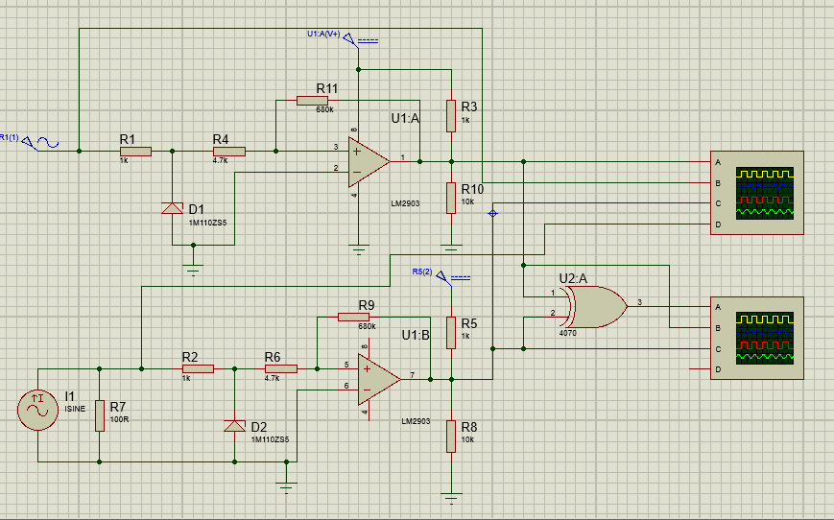

**Figure 2: Voltage and Current Sense Circuit (ZCD)**

The waveforms for the above ZCD is shown in the following figure.

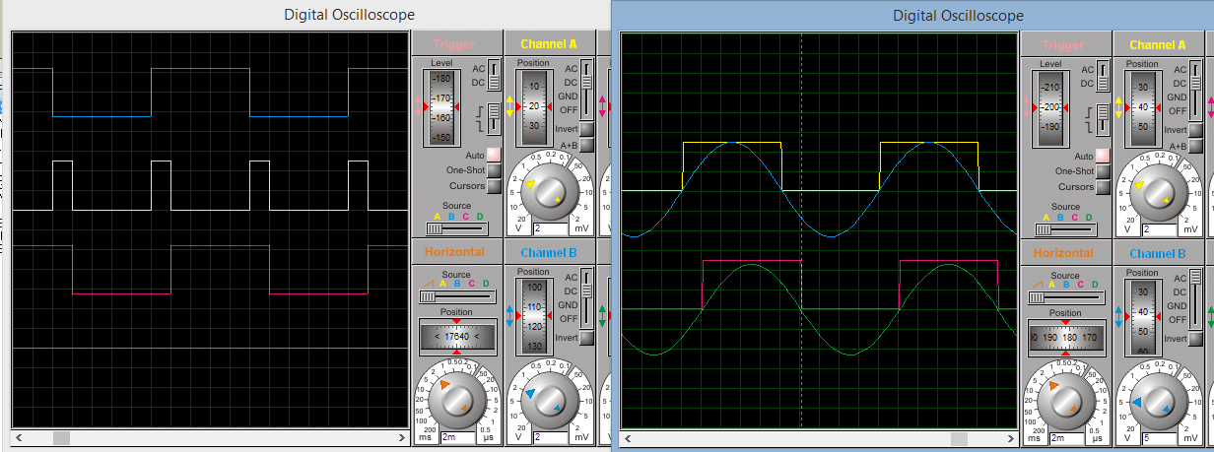

**Figure 3: Voltage and Current**

**Waveforms and phase shift between**

**Voltage and current**

1. **Practical circuit:**

In practical circuit we are using the 3 phase voltage source consists of R Y B and Neutral terminal. Here in this circuit we are using only single phase supply means R phase and Neutral provides 230V ac. Which is then fed to voltage or potential step down transformer to get the voltage square wave in synchronized with input supply. To do this we are using a zero cross detector using LM2903 IC. The current transformer is used to sense the current waveform by using inductor in series with the phase for generating the phase shift. The figure shows as follows.

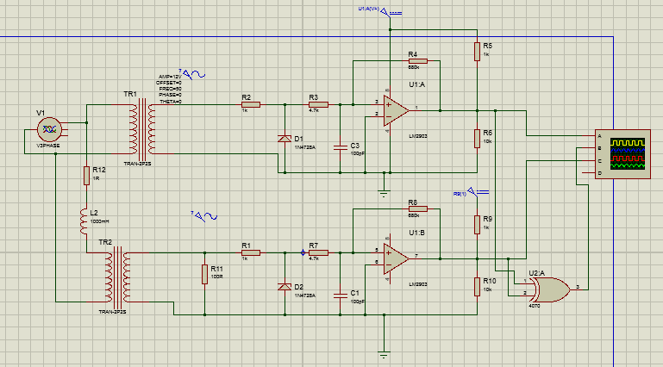

**Figure 4: Single phase Voltage and**

**Current Sense Circuit (ZCD)**

And the waveform are shown in following figure.

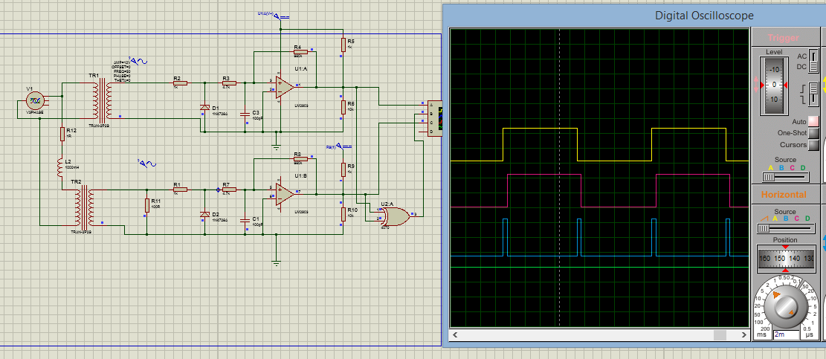

**Figure 5: Voltage and Current**

**Waveforms and phase shift between**

**Voltage and current**

1. **Calculation of the Phase Angle**

Phase shift is a small difference between two waves; in math and electronics, it is a delay between two waves that have the same period or frequency. Typically, phase shift is expressed in terms of angle, which can be measured in degrees or radians, and the angle can be positive or negative. For example, a +90 degree phase shift is one quarter of a full cycle; in this case, the second wave leads the first by 90 degrees. You can calculate phase shift using the frequency of the waves and the time delay between them.

Calculation between phase angle *φ*° in degrees (deg), the time delay *Δt* and the  
frequency *f* is:   
**Phase angle (deg) *φ***° **= *360****°****. f . Δt***

In our case the waveform is shown the phase difference or time delay is 5 ms. Hence the phase angle is calculated as:

**Phase angle (deg) *φ***°**= *360°x50x0.0005***

***= 9°***

***Power factor (PF)= cos φ***°

***= cos(9***°***)***

***= 0.98***

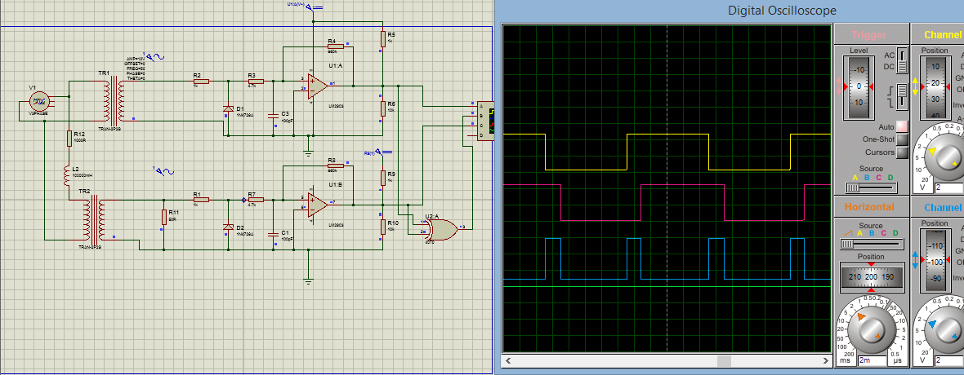

**Figure 6: Voltage and Current**

**Waveforms and phase shift between**

**Voltage and current**

Here in above figure the time delay is generated between voltage and current waveform is 2ms. It is due to the change in load.

**Phase angle (deg) *φ*°= *360°x50x0.002***

***= 36°***

***Power factor (PF)= cos φ***°

***= cos(36***°***)***

***= 0.80***

The power factor correction capacitor should be connected in parallel to each phase load.

The power factor calculation does not distinguish between leading and lagging power factors.

The power factor correction calculation assumes inductive load.

* 1. **Single phase circuit calculation:**

Power factor calculation:

*PF* = |cos *φ|* = 1000 × *P*(kW) / (*V*(V) × *I*(A))

Apparent power calculation:

*|S*(kVA)| = *V*(V) × *I*(A) / 1000

Reactive power calculation:

*Q*(kVAR) = √(*|S*(kVA)|2 - *P*(kW)2)

Power factor correction capacitor's capacitance calculation:

*S*corrected (kVA) = *P*(kW) / *PF*corrected

*Q*corrected (kVAR) = √(*S*corrected (kVA)2 - *P*(kW)2)

*Q*c (kVAR) = *Q*(kVAR) - *Q*corrected (kVAR)

*C*(F) = 1000 × *Q*c (kVAR) / (2π*f*(Hz)×*V*(V)2)

* 1. **Three phase circuit calculation**

For three phase with balanced loads:

**Calculation with line to line voltage**

Power factor calculation:

*PF* = |cos *φ|* = 1000 × *P*(kW) / (*√*3 × *V*L-L(V) × *I*(A))

Apparent power calculation:

*|S*(kVA)| = *√*3 × *V*L-L(V) × *I*(A) / 1000

Reactive power calculation:

*Q*(kVAR) = √(*|S*(kVA)|2 - *P*(kW)2)

Power factor correction capacitor's capacitance calculation:

*Q*c (kVAR) = *Q*(kVAR) - *Q*corrected (kVAR)

*C*(F) = 1000 × *Q*c (kVAR) / (2π*f*(Hz)×*V*L-L(V)2)

**Calculation with line to neutral voltage**

Power factor calculation:

*PF* = |cos *φ|* = 1000 × *P*(kW) / (3 × *V*L-N(V) × *I*(A))

Apparent power calculation:

*|S*(kVA)| = 3 × *V*L-N(V) × *I*(A) / 1000

Reactive power calculation:

*Q*(kVAR) = √(*|S*(kVA)|2 - *P*(kW)2)

Power factor correction capacitor's capacitance calculation:

*Q*c (kVAR) = *Q*(kVAR) - *Q*corrected (kVAR)

*C*(F) = 1000 × *Q*c (kVAR) / (3×2π*f*(Hz)×*V*L-N(V)2)

1. **Power Factor Calculation**

In **power factor calculation**, we measure the source voltage and current drawn using a voltmeter and ammeter respectively. A wattmeter is used to get the active power.

Now, we know P = VIcosφ watt

https://www.electrical4u.com/electrical/power-system-equations/transmission-equation/electrical-power-factor-4.gif

Hence, we can get the electrical power factor.

Now we can calculate the reactive power Q = VIsinφ VAR

This reactive power can now be supplied from the capacitor installed in parallel with the load in local. The reactive power of a capacitor can be calculated using the following formula:

https://www.electrical4u.com/electrical/power-system-equations/transmission-equation/electrical-power-factor-5.gif

In **power factor improvement**, the reactive power requirement by the load does not change. It is just supplied by other devices, thus reducing the burden on the source to provide the required reactive power.

Let us we consider one example of 3phase load of 10kw has power factor is of 0.8, to make it 0.99 the KVAR (capacitor) calculation is as follows: (this is the simplest method to calculate the KVAR)

KVAR = P ( tanɵ1 – tanɵ2)

Now from above example we have,

cosɵ1=0.8, and cosɵ2=0.99

therefore ɵ1= cos­¹(0.8) = 36.86º

ɵ2= cos­¹(0.99) = 8.10º

now, KVAR = 10( tan(36.86) – tan(8.10) )

= 10 (0.70 – 0.14)

= 10 (0.60)

KVAR = 6

Hence we have to add 6 KVAR capacitor in the load to compensate the power factor to 0.99.

The lookup table for fix load 10KW for different power factor is as follows:

|  |  |  |  |
| --- | --- | --- | --- |
| **Power (Kw)** | **Power Factor(Pf)** | **Desired Pf** | **Kvar** |
| 10 | 0.5 | 0.99 | 15.89 |
| 10 | 0.55 | 0.99 | 13.75 |
| 10 | 0.6 | 0.99 | 11.91 |
| 10 | 0.65 | 0.99 | 10.26 |
| 10 | 0.7 | 0.99 | 8.77 |
| 10 | 0.75 | 0.99 | 7.39 |
| 10 | 0.8 | 0.99 | 6.07 |
| 10 | 0.85 | 0.99 | 4.77 |
| 10 | 0.9 | 0.99 | 3.41 |
| 10 | 0.95 | 0.99 | 1.86 |

**Figure 7: Lookup table for**

**Calculation of KVAR**

1. **Result & Conclusion**

Engineers use different techniques to improve power quality for such electrical installations. Power factor improvement for linear loads can be brought about by reactive power compensation to compensate for the leading or lagging VARs. However, nonlinear loads generating harmonics require power factor correction techniques like tuned or active harmonic filters to mitigate these harmonics and improve power quality. Such power factor correction techniques rely on the use of power electronics, controlled using analog or digital controllers.

Digital power factor correction control design using Proteus8® lets you make use of multirate simulation to design and tune digital control algorithms, enabling you to tailor the input current waveforms, thus keeping losses low while improving the power quality to a desired value. This approach also enables you to test and verify controllers in the presence of varying loads and input voltages before deploying the control algorithms on hardware.

1. **References**
2. **“Design and Simulation of Automatic Power Factor Correction For Industry Application” Ararso Taye** *1 M.Tech, Electrical Engineering Department, Parul University, India** **[*Taye*, Vol.5 (Iss.2): February, 2018*]
3. **“Simulation of Power Factor Correction For the Single Phase And Three Phase Load By Capacitors”** Dhruvang R Gayakwad Asst. Professor, G.I.D.C. Degree Engg. College, Navsari PRINT): 2393-8374, (ONLINE):2394-0697, VOLUME-5, ISSUE-5, 2018
4. **“Simulation Analysis Of Automatic Power Factor Correction Technique Using Capacitor Bank” Anant Kumar Tiwari1,Ms. Durga Sharma2,Mr. Vijay Kumar Sharma3** 1Research Scholar,Dept of ECE, Dr. C.V. Raman Institute of Science and Technology, Bilaspur, MP, India,

E-mail: anantkumar.tiwari217@gmail.com.

2Asst Prof,Dept of ECE, Dr. C.V. Raman Institute of Science and Technology, Bilaspur, MP, India. 3Asst Prof,Dept of ECE, Dr. C.V. Raman Institute of Science and Technology, Bilaspur, MP, India. **International Journal of Scientific Engineering and Technology Research**

**Volume.03, IssueNo.04, April-2014, Pages: 0574-0576**

1. **“Automatic Power Factor Correction Based On Alienation Technique” by R. Abd Allah** International Journal of Engineering and Advanced Technology (IJEAT) ISSN: 2249 – 8958, Volume-3, Issue-4, April 2014
2. **“Simulation & Hardware Implementation of APFC Meter to Boost Up Power Factor Maintain by Industry.”** By Bhargav Jayswal1, Vivek Khushwaha2, Prof. Pushpa Bhatiya3*1.2 B. E Electrical Engineering, Vadodara Institute of Engineering, Vadodara, Gujarat, India* 3*: Assistant Professor in Electrical Engineering Department, Vadodara Institute of Engineering, Vadodara, Gujarat, India* Volume: 05 Issue: 03 | Mar-2018
3. **“Automated Power Factor Correction and Energy Monitoring System”** by Yasin Kabir,Yusuf Mohammad Mohsin, and Mohammad Monirujjaman Khan Department of Electrical and Computer Engineering, North South University Bashundhara R/A, Dhaka-1229, Bangladesh, Year 2017 [yasin.kabir@northsouth.edu](mailto:yasin.kabir@northsouth.edu) [yusuf.mohsin@northsouth.edu](mailto:yusuf.mohsin@northsouth.edu) [monirujjaman.khan@northsouth.edu](mailto:monirujjaman.khan@northsouth.edu)
4. “**Improvement of the Power Factor Correction in Machine Tools”**By Reimund Neugebauer, Artem Kolesnikov, Markus Richter, Joerg PaetzoldFraunhofer Institute for Machine Tools and Forming Technology, Chemnitz, Germany, Year 2010. e-mail: [reimund.neugebauer@iwu.fraunhofer.de](mailto:reimund.neugebauer@iwu.fraunhofer.de)
5. “**Power Factor Correction Controlled by DSP and its Matlab Simulation”** B**y** Xin-ge Lv1, Hui-bin Qin1, and Pei-liang Wang, Year 2012 College of Electronic Information, HangZhou DianZi University, HangZhou, 310018 2School of Information Engineering, Huzhou Teachers College, Huzhou, 313000
6. **“The DSP Based Controller For Power Factor Correction (PFC) In A Rectifier Circuit”** by Minghua Fu Texas Instruments 12030 TI Blvd, Dallas, TX 75243 Qing Chen Lucent Technologies 1125 E. Collins Blvd, Richardson, TX 75081, Year 2001.
7. “**Automatic Three Phase Selector with Power Factor Improvement”**

Volume: 04 Issue: 04 Apr-2017 By Ajith Kumar V1, Deepak P R2, Fayis Muhammed T V3,Vishnu R41234Student, Dept. of Electrical and Electronics Engineering, Mar Athanasius College of Engineering, Kerala, India

1. “**Improvement of the Power Factor Correction in Machine Tools”**By Reimund Neugebauer, Artem Kolesnikov, Markus