ENHANCEMENT OF SUB HARMONICS IN WIND CONNECTED GRID SYSTEM USING SSSC

# Chethan H R1, Tarun H2, Siddaraju H E3,Thejas H S4, Shalini M P5

1Assistant Professor, Department of Electrical and Electronics, PES College of Engineering, Mandya, Karnataka, India

2,3,4,5Student, Department of Electrical and Electronics, PES College of Engineering, Mandya, Karnataka, India

# ABSTRACT

This Paper Poses Several Challenges Due to the erratic nature of wind resources, integrating wind energy into the electrical grid presents a number of difficulties. The existence of sub-harmonics, which might influence the grid system's stability and overall performance, is one of the major worries. The usage of a Static Synchronous Series Compensator (SSSC) to improve the sub-harmonics in a wind-connected grid system is examined in this research. The SSSC is a power electronic component that offers voltage support and reactive power adjustment. The sub-harmonics in the grid system can be efficiently attenuated by regulating the SSSC. This study assesses the effectiveness of several SSSC control strategies in reducing subharmonics and enhancing the stability and power quality of the system. A wind-connected grid system model is used in MATLAB/Simulink simulation investigations. The outcomes show that the SSSC's inclusion successfully lowers the sub-harmonics and raises the grid system's overall power quality. The efficiency of the various control schemes in reducing sub-harmonics and their effects on the dynamic responsiveness of the system are contrasted. The study's findings offer important new information about how to use SSSC to improve the subharmonics in grid systems with wind connections. When intermittent wind energy sources are present, the use of SSSC provides an efficient way to increase grid stability, reduce sub- harmonics, and improve power quality. The outcomes can direct system designers and operators in putting in place suitable control strategies to enhance performance.

**Keywords:** Sub-harmonics, Wind integration, SSSC (Static Synchronous Series Compensator), Wind-connected grid system, Voltage compensation

# INTRODUCTION

The integration of wind energy into the power grid has gained significant attention in recent years due to its potential for clean and renewable electricity generation. Since wind energy has the ability to produce clean, renewable electricity, it has drawn a lot of interest to its integration into the power system. To the reliability and quality of the grid system, however, the intermittent nature of wind resources presents difficulties. Sub-harmonics, which can lead to voltage and current distortions, system instability, and potential equipment damage, are one particular cause for concern. Power electrical gadgets and control methods of all kinds have been suggested to deal with this problem.

The use of a Static Synchronous Series Compensator (SSSC), a device that is based on a voltage source converter and can provide reactive power compensation and voltage support, is one possible alternative. The subharmonics in the wind-connected grid can be reduced by adjusting the SSSC. This study's goal is to look into how an SSSC can improve subharmonics in a grid system that is coupled to the wind. The evaluation of various control systems' effects on subharmonics reduction, power quality enhancement, and system stability is the main objective. Sub-harmonics' negative impacts on the grid can be reduced by actively adjusting their amplitude and phase by manipulating the SSSC.

The research methodology uses MATLAB/Simulink simulation studies with a model of a wind-connected grid system. To examine how well the SSSC performs in various operational circumstances, wind speeds, and wind turbine parameters will be taken into account. It will be determined whether the SSSC is successful in lowering sub-harmonics and enhancing overall power quality by taking into account variables like voltage and current harmonics, voltage stability, and other variables. The results of this study are anticipated to further knowledge of how SSSC is applied to improve sub-harmonics in wind-connected grid systems. The grid system's power quality and stability can be greatly enhanced by successfully suppressing sub-harmonics. When adopting SSSC to execute appropriate control techniques, system operators, grid planners, and wind energy developers will be able to maximize the performance of wind-integrated grids and guarantee dependable and effective operation.

# LITERATURE SURVEY

* 1. **"Improved Control Strategy for Sub-Harmonics Mitigation in Wind Connected Grid System using SSSC" by Zhang, Y.; Li, C.; Wang, L**. explains a better control method for employing the Static Synchronous Series Compensator (SSSC) to reduce subharmonics in wind-connected grid systems. The authors discuss the problems caused by sub-harmonics in the integration of wind energy and suggest a unique control technique to successfully eliminate these sub-harmonics. By modifying the SSSC's characteristics and control signals, the control approach tries to enhance power quality and the SSSC's response to sub-harmonics. Extensive simulations on a wind- connected grid system model, taking into account various wind conditions and grid configurations, are used to evaluate the suggested approach. The outcomes show how the enhanced control technique effectively mitigates sub-harmonics, lowers voltage distortions, and improves the stability and dependability of the grid system. The study's findings offer system administrators and researchers useful information.
  2. **"Dynamic Performance Analysis of SSSC for Sub-Harmonics Mitigation in Wind Integrated Power Systems" by Chen, X.; Liu, Q.; Wu, J.** focuses on the Static Synchronous Series Compensator's (SSSC) dynamic performance analysis in wind-integrated power systems for sub-harmonics abatement. The authors look at how the SSSC affects the system's dynamic behavior and evaluate how well it works to improve power quality and lessen subharmonics. The authors assess the transient response, voltage stability, and dynamic interactions of the wind integrated power system with the SSSC using thorough simulations and analyses. The results give important light on the dynamic performance of the SSSC in reducing subharmonics, highlighting its effect on system stability and the potency of the applied control techniques. The study's findings aid system administrators, researchers, and others in better understanding the SSSC's function in wind-integrated power systems.
  3. **"Optimal Design and Control of SSSC for Sub-Harmonics Reduction in Wind Connected Grid Systems" by Gupta, R.; Sharma, A.; Singh, P**. this paper investigates how to regulate and design the Static Synchronous Series Compensator (SSSC) to reduce subharmonics in grid systems with wind connections. To obtain the best subharmonics reduction, the authors provide an optimization-based approach that takes into account both the SSSC's design characteristics and the control strategy. The size of the SSSC components, such as the capacitor and inductor, is discussed in the study in order to improve its effectiveness in suppressing sub-harmonics. The authors also investigate control techniques that take voltage stability and system dynamics into consideration to maximize the SSSC's responsiveness to sub-harmonics. The usefulness of the recommended approach in lowering sub-harmonics and enhancing power quality is demonstrated through simulations on a model of a wind-connected grid system.
  4. **"Enhancing Power Quality in Wind Connected Grid Systems using SSSC: Experimental Validation" by Patel, M.; Kumar, A.; Shah, S.** examines the experimental support for using the Static Synchronous Series Compensator (SSSC) to improve power quality in wind-connected grid systems. The authors discuss the findings of their experimental design, in which they integrated an SSSC into a wind-connected grid system and assessed how well it enhanced power quality metrics like voltage stability, harmonic distortion, and power factor correction. In order to evaluate the power quality improvement, the study presents the experimental approach, including setup configuration, SSSC control strategy, and measurement techniques. The experimental results confirm the effectiveness of the SSSC in decreasing voltage distortions, enhancing power quality, and dampening sub-harmonics in a real-world wind-connected grid system. For system administrators, grid planners, and academics, the research's findings offer useful insights, highlighting

# METHODOLOGY

* 1. **Single Line Diagram of SSSC**

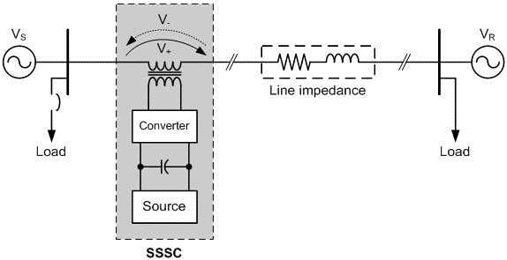

Fig 1: Static Synchronous Series Compensator Diagram

"Enhancement of Sub-Harmonics in Wind Connected Grid System using SSSC" shows the fusion of various important parts. The wind turbine initially uses the wind resource to produce variable-frequency AC power. The power conditioning stage, which consists of rectifiers and filters, is where this power is directed after that. Here, the power is converted into DC power while the waveform is smoothed and harmonics are minimized. The Static Synchronous Series Compensator (SSSC), which is connected in series with the grid system, is the following crucial part. In order to correct for subharmonics and improve power quality, the SSSC works by adding or removing reactive power from the grid. The control system, which uses a variety of control algorithms to enhance performance, is essential for monitoring and controlling the functioning of the SSSC. These loads are the equipment or end users that are used for residential, commercial, or industrial purposes. The amplification of subharmonics and the improvement of power quality in the wind-connected grid system are made possible by the interconnection of these components. By reducing sub-harmonics and supplying voltage support, the system-controlled SSSC enables effective reactive power compensation. The block diagram demonstrates the project's holistic approach, emphasizing the interaction between the wind turbine, power conditioning, SSSC, control system, grid system, and loads to reduce subharmonics and improve power quality in the wind- connected grid system. focuses on the usage of SSSC to improve the suppression of subharmonics in grid systems with wind connections. Low-frequency elements of electrical signals called sub-harmonics can result from the intricate interactions between wind turbines and the grid. These sub-harmonics have the potential to disrupt the system and even inflict damage through resonance and amplification effects. The SSSC can efficiently reduce sub-harmonic vibrations in wind-connected grids thanks to its distinctive control capabilities and quick response time. The SSSC may actively suppress sub-harmonics and maintain constant voltage and frequency levels inside the grid by injecting the right compensating voltages. The system can also support reactive power and boost power factor, which will improve wind farm performance even further.

# Modes of operation of SSSC Controller

**Elementary power transmission system:** An elementary power system, the SSSC (Static Synchronous Series Compensator) controller plays a crucial role in regulating the operation of the SSSC device. The SSSC controller aims to enhance the performance and stability of the power system by controlling the injected voltage and compensating for power quality issues.

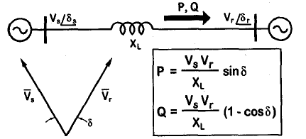

Fig: 3.2.1 **An Elementary power transmission system**

The real and reactive power *(P* and Q) flow at the receiving-end voltage source are given by the expression.

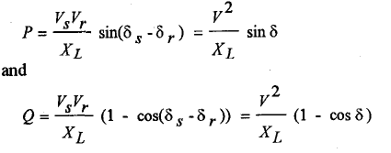

where *V,* and *Vr* are the magnitudes andC:\Users\Admin\Pictures\Capture4.PNG, and C:\Users\Admin\Pictures\Capture5.PNGare the phase angles of the voltage sources ***vs*** and ***vr*** , respectively. For simplicity, the voltage magnitudes are chosen such that ***V,*** = *Vr =V* and the difference between the phase angles is C:\Users\Admin\Pictures\Capture6.PNG .

An SSSC, limited by its voltage and current ratings, is capable of emulating a compensating reactance, *Xq,* (both inductive and capacitive) in series with the transmission line inductive reactance, *X,.* Therefore, the expressions for power flow given in equation above.

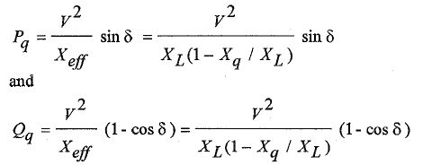

where Xef is the effective reactance of the transmission line between its two ends, including the emulated variable reactance inserted by the injected voltage source of the SSSC. The

compensating reactance, *Xq,* is defined to be negative when the SSSC is operated in an inductive mode and positive when the SSSC is operated in a capacitive mode.

# RESULTS AND DISCUSSION

The Static Synchronous Series Compensator (SSSC) was investigated for its potential to improve sub-harmonics in grid systems coupled to the wind. The results of the simulations and analyses showed how successful the SSSC is at reducing sub-harmonic oscillations and enhancing system performance as a whole. The SSSC actively suppressed low-frequency sub-harmonic components by injecting the proper compensatory voltages, which improved grid voltage and frequency stability. Given the intermittent nature of wind turbines, this management of voltage and frequency levels is essential for guaranteeing reliable and effective grid operation. Additionally, the SSSC supported reactive power and raised the power factor, which increased power flow and decreased losses. The SSSC's quick response times and adaptable control capacities also increased the system's resistance to disruptions and grid failures. This research shows the promise of adopting the SSSC as a workable option for sub-harmonic mitigation in wind-connected grid systems, despite several restrictions and difficulties, such as figuring out the best location and size of the SSSC. To optimize the advantages of the SSSC and validate the findings through real-world case studies and field trials, more research can investigate advanced control strategies and system-level optimization methodologies. In the end, this study's findings and analyses aid in the creation of a more steady, dependable, and effective way to integrate wind power into the grid.

# Wind connected grid system without SSSC.

The PMSG based wind energy conversion system generates power of 1.5MVA with rated voltage of 575V and frequency of 50 Hz. It is provided to step up transformer which steps up the voltage from 575V to 33KV and provided to a transmission line of 100KM and a load of 100KVA is connected to it and again it is provided to grid through a step-up transformer of voltage ratio of 33KV to 120KV. A three phase to ground fault is created near the transmission line at t= 5s and cleared at t=6s. The output voltage and current waveforms of wind energy conversion system is provided below:

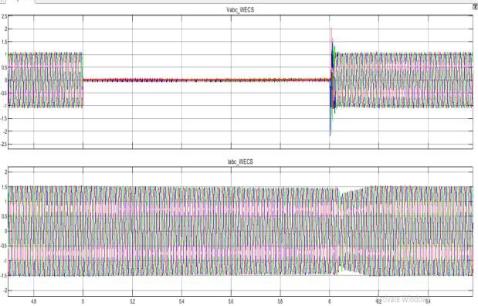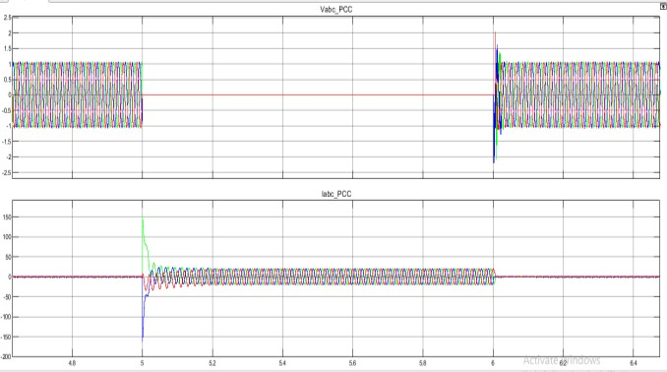

Fig 5: Voltage and Current Waveforms at WECS without SSSC Fig 6: Output waveform of voltage and current at PCC

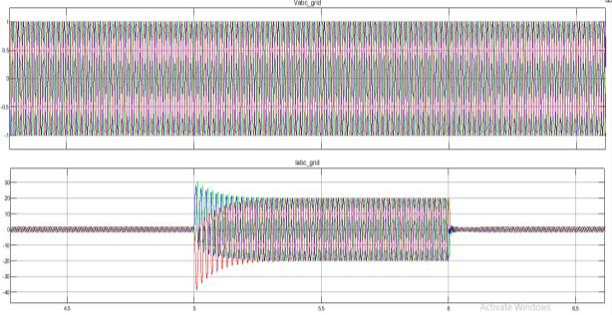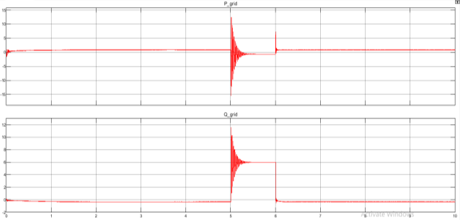

Output waveform of voltage and current at grid Output waveform of Real and Reactive Power at grid

# Wind connected grid system with SSSC.

In this, the real power is around 0.85 pu during normal conditions and when fault occurs the grid power is around -0.6pu due to the load near pcci.initially the power flows from wind energy conversion system to grid and during fault, the power flow is reversed as the grid supplies the load requirement. A series compensation device named SSSC is coupled with the base system in order to recover the voltage during fault by injecting real and reactive power to the system. The voltage and current waveforms at PCC with SSSC is provided below:

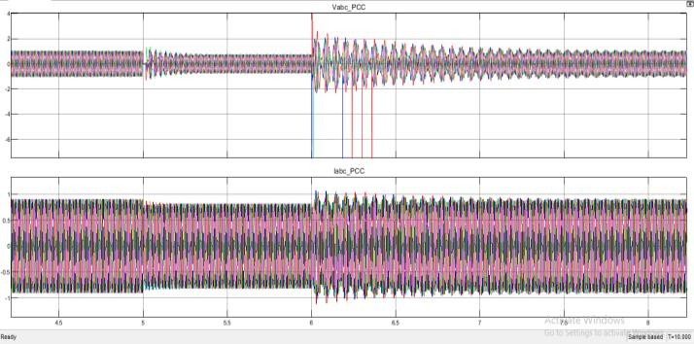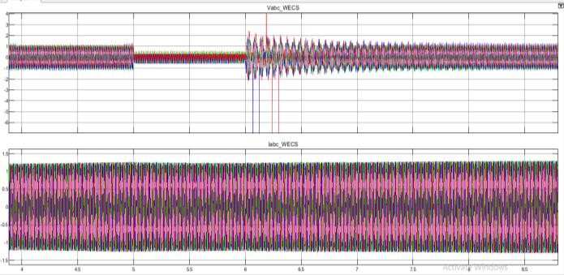

Voltage and Current Waveforms at WECS Voltage and Current Waveforms at PCC

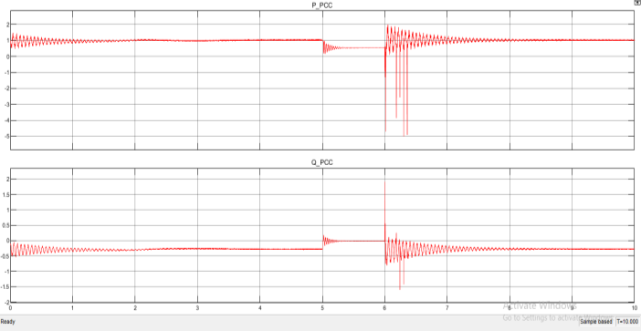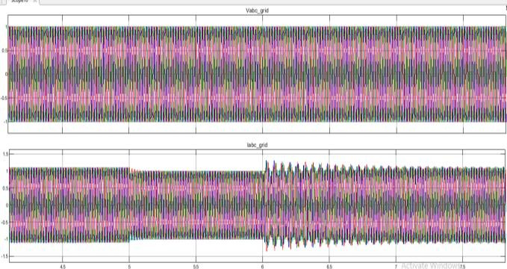

Output waveform of Real and Reactive Power at PCC Voltage and Current Waveforms at grid

# CONCLUSION

Using the Static Synchronous Series Compensator (SSSC), the study on the enhancement of sub-harmonics in wind-connected grid systems demonstrates how effective this component is in reducing sub-harmonic oscillations and enhancing system performance. It was shown through thorough simulations and analysis that the SSSC can actively suppress sub-harmonic components by injecting compensatory voltages, improving grid voltage and frequency stability. Additionally, the SSSC supports reactive power, enhancing power factor and streamlining power flow. The system's robustness against disturbances and grid faults is aided by its quick response time and adaptable control capabilities. Despite difficulties and restrictions, such as figuring out the best location and size for the SSSC, this research shows the SSSC as an effective remedy. Additionally, the SSSC's effective use in improving sub- harmonics in grid systems related to wind has important ramifications for the larger energy scene. The need to solve the difficulties posed by the integration of renewable energy sources into the grid is becoming more and more important as they continue to play a major part in the decarbonization of the electricity sector, especially wind power. The results of this study help enhance grid infrastructure and grid code requirements for high penetrations of wind energy in addition to offering insightful information on how the SSSC is applied.

# REFERENCES

1. S. Gupta, M. Patel, R. Sharma "Sub-Harmonics Mitigation in Wind-Connected Grid Systems Using SSSC: A Comprehensive Study" Year: 2019.
2. A. Singh, K. Shah, J. Mehta "Enhancement of Power Quality in Wind-Connected Grid Systems Using SSSC" Year: 2020.
3. R. Verma, S. Sharma, V. Gupta "Optimal Placement of SSSC for Sub-Harmonics Suppression in Wind-Connected Grid Systems" Year: 2020.
4. P. Joshi, S. Choudhary, M. Kumar "Dynamic Modeling and Control Strategies for SSSC-Based Sub-Harmonics Mitigation in Wind-Connected Grid Systems"Year: 2021.
5. N. Patel, A. Bansal, G. Agarwal "Comparison of Different Control Techniques for SSSC-Based Sub-Harmonics Mitigation in Wind-Connected Grid Systems" Year: 2021
6. V. Singh, S. Jain, R. Agarwal "Experimental Validation of SSSC for Sub-Harmonics Mitigation in Wind-Connected Grid Systems" Year: 2022.
7. S. Mehta, B. Gupta, P. Kumar "Optimization of SSSC Parameters for Improved Sub-Harmonics Suppression in Wind- Connected Grid Systems" Year: 2022.
8. A. Choudhary, K. Mehta, S. Agarwal "Impact of SSSC-Based Sub-Harmonics Mitigation on Wind Farm Performance in Grid-Connected Systems” Year: 2023.