**Lightweight design of automotive composite wheel rim for a two wheeler application**

*1Mohammed Mohiuddin, Technician/ Diploma Membership, Mechanical Engineering, Indian Institute of Industry Interaction Education and Research, India*

*2Murugu Nachippan, Assistant Professor, Indian Institute of Industry Interaction Education and Research, India*

*3Tamilarasan, Project Coordinator, Indian Institute of Industry Interaction Education and Research, India*

**Abstract**

A vehicle's rim is one of the most critical components to its overall function. It is the component that provides support for the solid rubber compound that is known as the tyre. Rims can vary in terms of their shape, size, and the number of spokes that they include. Historically, aluminium alloy and magnesium alloy have been utilised throughout the manufacturing process of rims. The following study discusses the transition from more conventional metals like aluminium into a more contemporary S-glass fiber epoxy composite material.

**Keywords:** Vehicle, Rims, Aluminium, Composite material

**1. Introduction**

The automobile industry is currently focusing on making their products lighter in order to meet the latest trend in product development. A composite material is one that is created by combining two or more materials, each of which has its own unique set of characteristics. In terms of applications, composite materials will be able to be utilised in an increasing number of different components as a result of upcoming advancements in both technology and production methods. When it comes to two-wheelers, the part that rotates is the wheel rim. This part's lightweight effect is equivalent to around 1.5 times that of the parts that do not rotate. Therefore, a decrease in the weight of the wheel rim will have a substantial impact on the reduction of the overall weight of the vehicle, as well as an improvement in fuel economy and a decrease in emissions. As a result of the fact that the planet as a whole is undergoing an acceleration of global warming, we have started to become concerned about the environment, and the strategy that we are employing these days is to cut back on consumption and pollution. The transportation industry as a whole is responsible for around one-sixth of the world's total emissions of carbon dioxide (CO2); nevertheless, the automotive industry has also been forced to innovate in this manner in order to cut down on emissions and improve fuel efficiency. This is accomplished by enhancing previously developed technologies while simultaneously creating new ones. In the realm of materials engineering, the creation of composite materials is one of these emerging new technologies that is seeing growth. Steel wheels and aluminium alloy wheels are widely utilised, despite the fact that it appears to be difficult to reduce their respective weights due to the relatively established structural shapes and mature extraction and fabrication processes [1]. However, long fibre reinforced thermoplastics (mostly made of glass or carbon fibre) have captured the attention of a significant number of automobile manufacturers due to their low cost, high manufacture efficiency, reusable and recyclable nature [2]. Using Finite Element Analysis (FEA), the primary objective of this research is to determine the optimal mass for an aluminium alloy vehicle wheel. The mass of the optimised wheel rim can be reduced by up to fifty percent in comparison to the solid disc type Al alloy wheel that is currently in use, which generates stress that is lower than the Al alloy yield stress [3]. The S-N curve of the component reveals an endurance limit of 90 MPa, which is significantly less than the material's yield stress and is hence suitable for application. The FE research demonstrated that there was 0.2% damage to the wheel after 1020 fatigue cycles [4]. The paper also examines composite wheel rim finite element analysis, which is used to quantify stress and deformation under radial fatigue load conditions [5]. This analysis was conducted to determine how the rim would deform under the load. Wheels made of carbon fibre composite are being examined because of the potential benefits they offer for lowering the bulk of unsprung weight, rotational inertia, and overall vehicle weight. The findings are discussed in relation to aluminium alloy [6]. Static, modal, harmonic, and fatigue analyses are also performed on alloy wheels made of aluminium, magnesium alloy, and structural steel in this work [7]. The wheel of a four-wheeler vehicle is modelled in CATIA software, and then the model is exported to IGES format before being integrated into Ansys software for analysis. The project creates alloy wheels out of lightweight alloy materials like as magnesium, CRPF, and aluminium alloys. Structural analysis is performed by applying different loads to the alloy wheels utilising solid works premium 2014 [8]. The satisfaction of the wheel rim with the disc wheel class is the primary focus of the evaluation of tyres to fit the disc wheel class that is included in the study. The wheel rim is modelled with the catiav5r18 programme, which cuts down on the amount of time required for the manufacture of advanced 3D models as well as the amount of risk associated in both style and production [9]. SOLIDEDGE, a company that specialises in the design of wheel rims, and ANSYS, a company that investigates 3-D wheel rim IGES files, are both examples of companies that use finite element analysis as a significant technique for the analysis of wheel rims. The results of the investigation are compared to those obtained with steel material, which has lower values for both deformation and shear stress. Because steel alloy is more durable than aluminium, magnesium, and forged steel, wheel rims made of steel alloy are the more practical option [10]. In conclusion, the findings of this study demonstrate how important it is to optimise the mass of the wheel rim as well as the material selection in order to achieve the highest possible levels of performance and safety in automotive applications. The purpose of this study is to increase the overall performance of wheel rims as well as their durability by employing sophisticated fatigue strain life techniques and making use of a combination of materials [11]. The core objective of our project is a) To replace the conventional aluminium alloy rim with much more lightweight and hybrid composite material. b) To increase the impact strength of the rim such that it will be able to withstand sudden application of loads. c) To reduce the deformation of wheel rim to avoid tyre dislodge from rim. d) To Increase the life of the wheel rim since it is corrosion resistant.

**2. Properties of Materials**

|  |  |  |  |
| --- | --- | --- | --- |
| **S.No** | **Properties** | **Aluminum alloy (Al356)** | **S-Glass Fibre/epoxy composites** |
| 1 | Density | 2.7 Kg/m3 | 2.49 Kg/m3 |
| 2 | Tensile Ultimate Strength | 2.3x108 Pa | 1.84x108 Pa |
| 3 | Young’s Modulus | 7.1x1010 Pa | 9x1010 Pa |
| 4 | Poisson’s Ratio | 0.33 | 0.23 |

**3. Finite element analysis**

**3.1 Modelling**

The current specifications of the wheel rim are being considered. The first step involves transforming the given data into a geometry model using the CREO software. Subsequently, the generated model is imported into the ANSYS software for further analysis.

**3.2 Meshing**

Three meshing types are given to find out the accurate and converging result for deformation, equivalent stress and strain.

**3.3 Loading**

* Calculation of load applied on wheel.

**3.4 Loads applied on the wheel**

In this experiment, the air pressure in the front wheel tyre was measured to be 28 psi. This value was subsequently converted to pascal, resulting in a value of 193053 Pa. The radial load is now being applied, and its calculation involves determining the kerb weight, which is equal to 135 kg.

The seating capacity of the entity in question is two. The estimated weight of each individual is approximately 80 kilogrammes. The total weight can be calculated by adding 153 kilogrammes to twice the weight of each person, resulting in a sum of 295 kilogrammes. The allocation of weights among the two wheels

295/2 = 147.5Kg

In order to obtain a total mass of 200 kilogrammes.

The maximum vertical load (F) can be calculated by multiplying 200 by the acceleration due to gravity (9.81 m/s2), resulting in a value of 1962 N.

The formula for calculating the radial load (Fr) is expressed as Fr = K*F, where K represents a constant value of 2.2, as confirmed by the Society of Automotive Engineers (SAE). By substituting the given force value of 1962 N into the equation, the resulting radial load is calculated as Fr = 2.2*1962 = 4316.4 N.

Consequently, the resultant load is determined to be 4316.4 Newtons.

When the load is applied to the wheel, it is divided into two parts in order to distribute the load evenly. As a result, the load on each side of the wheel is determined to be 2158.2 N.

**4. Results and Discussion**

**4.1 Analysis of aluminium (Al356) wheel rim**

Deformation in Aluminium are more when compared to the s-glass fibre/epoxy composites. Deflection should be very less, so that tyre will not dislodge from wheel rim. Based on this consideration, s-glass fibre/epoxy composites slightly lower when compared to Aluminium alloy.

Both cases, maximum von misses stress generated are much lower compared to the ultimate tensile stress. Hence design is safe for all these two materials.

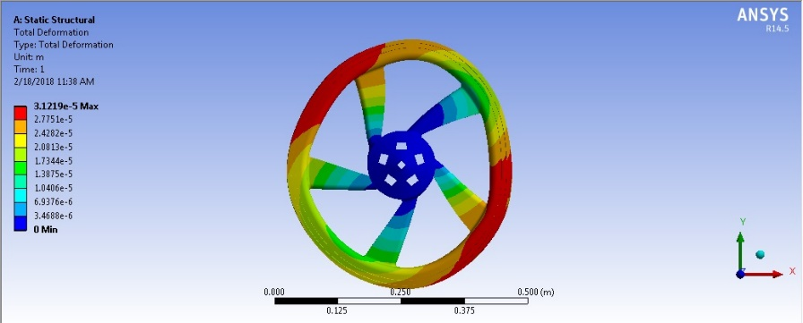 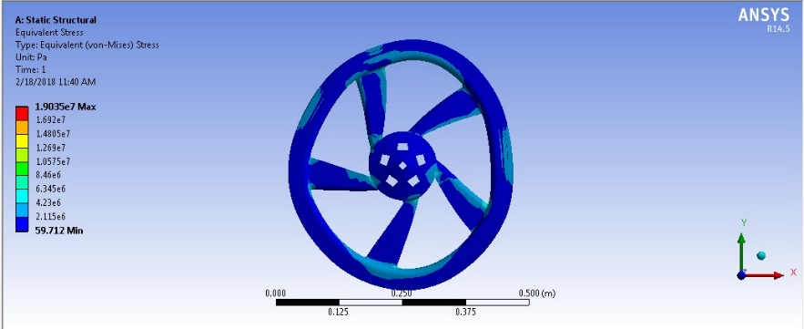

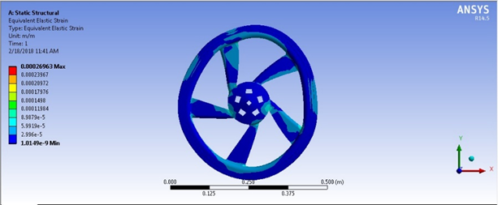

**4.2 Analysis of S-glass fiber/epoxy composites wheel rim**

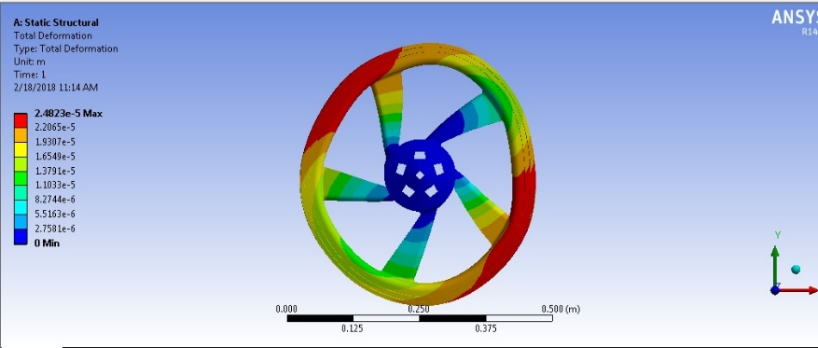 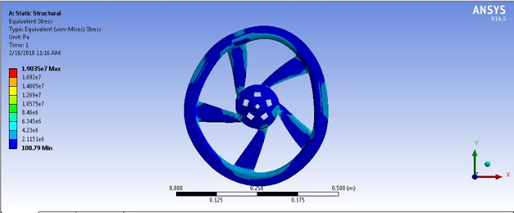

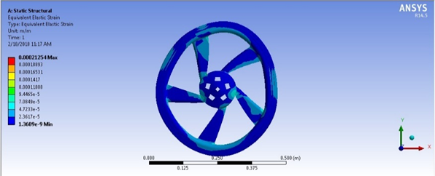

**6. Meshing effect**

|  |  |  |  |  |
| --- | --- | --- | --- | --- |
| **S.No** | **Description** | **Coarse** | **Medium** | **Fine** |
| For aluminum alloy (Al 356) | | | | |
| 1 | Nodes | 19754 | 22339 | 39117 |
| 2 | Elements | 9947 | 11315 | 20310 |
| 3 | Maximum Deformation | 0.031219 mm | 0.03167 mm | 0.033272 mm |
| 4 | Maximum Stress | 19.035 Mpa | 19.235 Mpa | 16.964 Mpa |
| 5 | Maximum strain | 0.00026963 | 0.00027268 | 0.0002567 |
| For S-Glass Fiber/epoxy composites | | | | |
| 1 | Nodes | 19754 | 22339 | 39117 |
| 2 | Elements | 9947 | 11315 | 20310 |
| 3 | Maximum Deformation | 0.024823 | 0.025199 | 0.02652 |
| 4 | Maximum Stress | 19.01 Mpa | 19.15 Mpa | 16.58 Mpa |
| 5 | Maximum strain | 0.00021254 | 0.00021554 | 0.00019843 |

**6.1 Effect of Meshing on Deformation**

**6.2 Effect of Meshing on Maximum Stress**

**6.3 Effect of Meshing on Maximum Strain**

**7. Conclusions**

The wheel rim's CAD model is created using CATIA software, and subsequently imported into ANSYS for further processing and analysis. The magnitude of the load exerted on each side of the wheel rims is 2158.2 N. The material employed for analysis consists aluminium and glass fibre composites. The impact of meshing is evaluated on the material's deformation, stress, and strain. The numerical findings indicate that the S-Glass Fiber/epoxy composites material demonstrates a stress level that is lower than the ultimate strength of the material. Therefore, based on the observations made, it can be concluded that the design under consideration is deemed to be safe and represents the most optimal choice for the wheel rim material.

**Reference**

[1] Rahul K. Jape, “CAD Modeling and FEA Analysis of Wheel Rim for Weight Reduction,” *Int. J. Eng. Sci. Comput.*, vol. 6, no. 6, pp. 7404–7411, 2016, doi: 10.4010/2016.1756.

[2] C. D. Rohan, “Design and Analysis of a Composite Wheel Rim,” *J. Mater. Sci. Mech. Eng.*, vol. 2, no. 6, pp. 50–56, 2015, [Online]. Available: http://www.krishisanskriti.org/jmsme.html.

[3] B. O. F. Technology and A. Khan, “Design and analysis of wheel rim using composite materials and carbon fibres AND Design and analysis of the effect through different aspect ratio on performance of VAWT,” 2021.

[4] R.Vijayan, T. T. Geetha, V. J. Saai, and M.A.S.MuthuKumara Swamy M.Saravanan, “Design and Finite Element Analysis of tractor wheel rim,” vol. 115, no. 7, pp. 257–261, 2017.

[5] M. A. Ahmed, “Design and Simulation of Composite Wheel,” no. 5, pp. 6686–6688, 2017.

[6] R. Ansari, S. Rajesh, P. Rama, and M. Raju, “Finite Element Analysis on Alloy Wheel Using Different Materials,” vol. 12, no. 10, pp. 41–51, 2021, [Online]. Available: www.jespublication.com.

[7] S. Undru, “Design and Analysis of Aluminum Alloy Wheel,” *Int. J. Eng. Res. Appl.*, vol. 07, no. 03, pp. 57–65, 2017, doi: 10.9790/9622-0703055765.

[8] S. V Dongare and S. G. Thorat, “Experimental and Numerical Analysis of Testing Wheel Rim,” vol. 16, no. 4, pp. 21–30, 2019, doi: 10.9790/1684-1604042130.

[9] Y. P. S. Parihar and A. Chakraborty, “Dynamic Design and Analysis of Car Wheel Rim Using FEA Method,” *Int. J. Res. Appl. Sci. Eng. Technol.*, vol. 10, no. 5, pp. 723–734, 2022, doi: 10.22214/ijraset.2022.42319.

[10] E. Scharifi, A. Danilenko, U. Weidig, and K. Steinhoff, “Influence of plastic deformation gradients at room temperature on precipitation kinetics and mechanical properties of high- strength aluminum alloys,” *J. Eng. Res. Appl.*, vol. 9, no. 1, pp. 24–29, 2019, doi: 10.9790/9622.

[11] K. V. Rao and T. Dharmaraju, “Analysis of Wheel Rim Using Finite Element Method,” *Int. J. Eng. Res. Technol.*, vol. 3, no. 1, pp. 1259–1263, 2014.