**Finite Element Modelling of Eco-Friendly Brake Pads**

*1Shankar, Graduateship / Associate Membership, Mechanical Engineering, Indian Institute of Industry Interaction Education and Research, India*

*2Murugu Nachippan, Assistant Professor, Indian Institute of Industry Interaction Education and Research, India*

*3Tamilarasan, Project Coordinator, Indian Institute of Industry Interaction Education and Research, India*

**Abstract**

Brake pads are a component of disc/drum brakes used in a variety of automotive and non-automotive applications. Typically, brake pads consist of steel backing panels and friction material. Recent changes to the manufacture process of these pads have increased their sustainability by incorporating renewable crops. This has been demonstrated by the use of natural fibres such as banana rind, palm fronds, and sugar cane. It is possible to replace aramid fibre with a more cost-effective and environmentally friendly alternative without sacrificing efficacy. Copper, lead, tin, antimony trisulphide, and whisker materials were eliminated from the formulation of brake friction materials in order to make them environmentally sustainable. This has been done to mitigate any potential negative environmental effects. As indicated by the weighted average dependent degree in extension evaluation, the eco-pad exhibited superior quality on the whole. The brake liner is a component that facilitates a mobile object's deceleration or cessation of motion. The safe operation of a vehicle's braking system requires the dependable absorption of kinetic energy from moving elements. The dissipation of heat is caused by the brakes' absorption of energy. The vehicle's velocity is reduced by the release of heat into the encircling atmosphere. Due to the interference between the brake drum and brake lining, the life expectancy of the brake lining is likely to be reduced. Modelling brake shoes requires the use of the SOLIDWORKS 2020 software and precise measurements taken from the brake shoe of the Hero Passion Pro motorcycle. To evaluate the effectiveness of three distinct categories of braking materials, namely static structural, steady-state thermal, and wear testing, the ANSYS19.2 software employs a FEA approach in order to achieve optimal results. This study evaluates distinct eco-friendly braking materials: composite banana peel, included in the experiments are total deformation, equivalent von Mises stress, equivalent elastic strain, total heat flux.

Keywords: Brake pad, Eco friendly, Banana peel particles, Structural, Thermal

**1. Introduction**

Modern automobiles employ drum brakes and brake pads. Early motor vehicles used single-shoe brakes, but road sliding limited the force applied. Friction modifiers, powered metal, binders, fillers, and curing agents make brake pads. Graphite, cashew nut shells, lead, zinc, brass, aluminium, and other powdered metals boost heat fade resistance. Binders bond friction material together, while fillers, like rubber chips to minimise braking noise, are added in small amounts. A high-temperature glue bonds the brake pad material to a stamped steel base plate, and a slit on the pad face indicates the permissible pad wear and allows brake dust and gas to escape. On the piston side of the pad, metal plates or anti-squeal shims reduce brake squeal, and springs and clips reduce rattle and brake noise. Shims and plates can be reused for changing pads. Shims should be greased before installation. The utilisation of banana peels has been explored as a potential method for producing a brake-pad that is environmentally sustainable. This approach has been found to result in a brake-pad with enhanced compressive strength, hardness, and specific gravity [1]. The brake lining of a commercial vehicle was subjected to design and analysis through the utilisation of SolidWorks and ANSYS software [2]. The natural fibres as fillers in the production of brake pads from Agro Waste has been found to enhance wear resistance and improve the performance of friction. The effectiveness of the friction is contingent upon the friction layer generated on the friction surface. This approach is considered eco-friendly due to the use of sustainable materials [3]. Friction materials for brakes that are environmentally friendly are cost-effective and exhibit consistent friction performance that is comparable to traditional materials [4]. This study aims to analyse stir die cast Al-SiC composite brake drums through the use of the coefficient of friction (m) and scanning electron microscope. The objective is to investigate the impact of braking on the sliding surface of the brake drum [5]. The study revealed that brake pads with low steel content exhibited a greater emission factor compared to brake pads without steel content. Additionally, emissions were detected subsequent to brake applications even when the brakes were not in use. No significant association was observed among the chemical composition, size distribution, and particle morphology [6]. Brakes have been advanced in recent years, but previously brake pads were made of asbestos fiber, which was harmful and entrapped in the brake housing. Analysis has been done to find a better material for manufacturing brake pads [7]. The aim of this study is to enhance the braking efficiency of the brake pads while ensuring minimal environmental impact through the utilisation of sustainable materials. This study examines three distinct natural materials, namely banana peel particles, palm kernel fibre and shell, and sugar cane bagasse. Conducting a comparative analysis of these three materials in relation to pre-existing materials. SolidWorks 2012 is utilised for the purpose of modelling brake pads, while structural analysis is conducted through Ansys workbench. The objective is to conduct a comparative analysis between the outcomes of utilising conventional asbestos brake pads and those of natural fiber-based brake pads.

**2. Problem description**

Asbestos was formerly utilised in the production of brake components, and was extensively accessible and cost-effective. Mesothelioma is a malignant neoplasm that is associated with exposure to airborne asbestos fibres. These fibres adhere to the mesothelium and persist in the lining of the lungs indefinitely. The body's defence mechanism involves the formation of scar tissue over irritants, which may remain asymptomatic for several decades until the development of cancerous tumours. Mesothelioma currently lacks a cure.

**3. Materials and Methods**

**3.1 Brake linings**

The composition typically consists of a durable yet pliable substance possessing a substantial dynamic friction coefficient, affixed to a sturdy metallic support structure through the application of adhesives capable of withstanding elevated temperatures. The coefficient of friction for typical brake pads typically falls within the range of 0.35 to 0.42. However, certain brake pads designed for racing applications exhibit a higher coefficient of friction, ranging from 0.55 to 0.62, and are known for their superior performance under high-temperature conditions. These pads exhibit a high rate of wear and also contribute to accelerated wear of the discs, rendering them a cost-effective option. The careful consideration of materials for Eco-friendly Brake Pads is crucial, as they must possess desirable attributes such as robustness, rigidity, and mechanical efficacy. The selected materials for the final product comprise of particles derived from banana peels, fibres obtained from palm kernels, and bagasse originating from sugar cane shells. The act of comparing with alternative materials is a favoured approach for achieving enhanced quality.

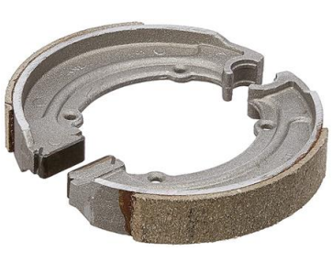 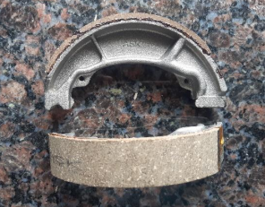 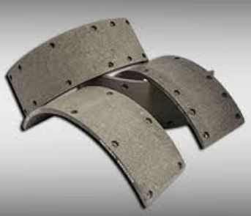

Fig.1. Pictorial image of brake lining

**3.2 Brake pad calculations**

Kerb weight = 118 kg

Let us assume each person weight = 75 kgs

2P = 2 x 75 = 150 kgs

Gross weight of the vehicle (m) = 118 kg + 150 kg = 270 kgs

Initial velocity of the vehicle (u) = 60 km/hr = 16.62 m/sec

Final velocity of the vehicle (v)= 0 km/hr

Let us assume the Braking distance (s) = 15m

The energy of motion as well as the work done when something is stopped. A moving vehicle has something called kinetic energy, the value of which is determined by the vehicle's mass in addition to its speed. This energy is supplied by the engine, which allows the vehicle to accelerate from a stop to a given speed. However, in order for this energy to be used effectively when the vehicle is slowed down or brought to a stop, some of it must be lost. Therefore, the purpose of the brake is to convert the kinetic energy that the vehicle possesses at any given time into thermal energy by means of friction. This can take place at any time. It is possible to express kinetic energy, often known as the energy of motion, using the equation.

Uk = mv2 /2

Uk = kinetic energy of the vehicle (J) m = mass of the vehicle (kg)

v= speed of the vehicle (m/s) Uk = mv2 /2

= 270 x (16.62)2 / 2

= 37.29 kj

F = 37.29/15 = 2.486 kN

**3.3 Brake Stopping Distance and Efficiency**

Producing a force that acts in opposition to the motion of the wheels of the vehicle is what is meant by the term "braking." This action either slows down the vehicle or brings it to a complete stop. The force that is given to the wheels of a vehicle in order to slow it down or bring it to a complete stop is referred to as the braking force. A vehicle's braking efficiency can be defined as the braking force produced in relation to the vehicle's overall weight; more specifically, this ratio is expressed as a percentage.

Braking efficiency = avg. braking force × 100 Weight of vehicle

When the amount of force used to the brakes is proportional to the total weight of the vehicle being stopped, we say that the braking efficiency is 100%. In most cases, the braking efficiency is less than 100% because there is insufficient adhesion between the car and the road, the vehicle is travelling downhill, or the braking system is inefficient. A comparison may be made between the break efficiency and the coefficient of friction, which is defined as the ratio of the frictional force to the normal load that exists between the rubbing surfaces.

**3.4 Determination of Brake Stopping Distance**

A rough estimate of the performance of a vehicle’s brakes can be made by applying one of the equations of motion assuming the brakes are 100%

V2 =U2+2gs

U = initial braking speed (m/s) V = final speed (m/s)

g = deceleration due to gravity (9.81 m/s2 ) s = stopping distance (m)

if the final speed of the vehicle is zero, then V = 0 m/sec 0 = U + 2gs

And s = U2 /2g

= (16.62)2 / 2(9.81)

Braking distance s = 14.07 m

Braking torque T = F X Radius of wheel drum

= 2486 X 0.06

= 147 Nm

**4. Modelling of Brake Pads**

The SolidWorks designing software was utilised in the design process of the brake pads for the Hero Passion Pro. The brake pads were meticulously crafted to meet the necessary fitment and dimensional requirements, with both a frontal and isometric perspective taken into account during the design process. The reference model utilised in this study was sourced from the brake pads of the Hero Passion Pro, and the data was subsequently gathered from said reference model. The brake pads were meticulously crafted based on the fitment and prescribed dimensions, incorporating both a frontal and isometric perspective.

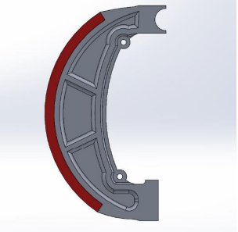 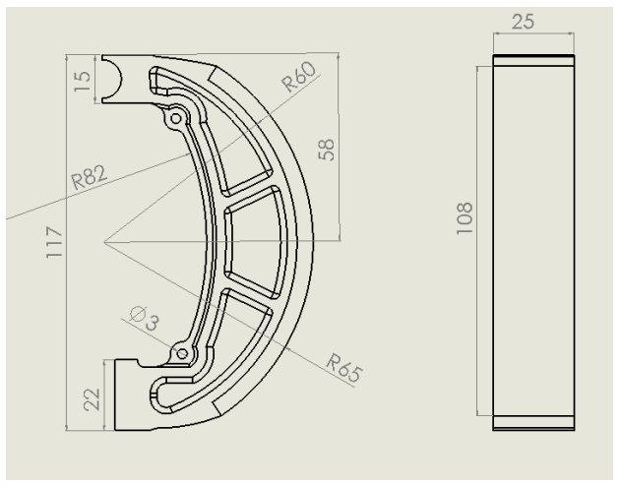

Fig. 2 a) Modelling of brake pad b) Geometrical design of brake pad

**5. Finite Element Analysis of Brake Pad**

* After the completion of design the data file saved in step(.stp) format
* This is imported in ANSYS Workbench geometry
* For static structural, the Engineering data is given from the literature
* Next, meshing is done by inserting automatic method which gives a coarse
* tetrahedron mesh
* In the part of load application fixed support is given at two ends of brake shoe and
* Pressure is applied on brake pad
* Total deformation, equivalent stress and elastic strain values are evaluated.

**5.1 Input Parameters**

|  |  |
| --- | --- |
|  | **Banana Peel** |
| Density(MPa) | 2801 |
| Young’s modulus (pa) | 1730 |
| Thermal Conductivity (W/mk) | 0.70 |

**5.2 Stress Strain deformation analysis of banana peel particle**

The Fig.3. a) shows the maximum stress at the corners of the brake shoe after the application of calculated load normal to the brake lining. The maximum stress produced by the application of load is observed 37.26 Pa

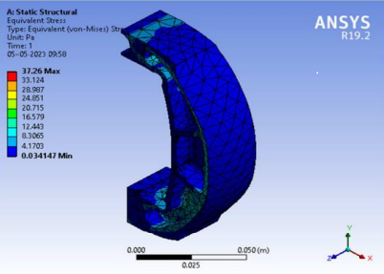 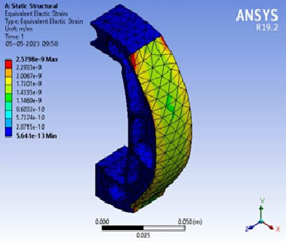

Fig.3. a) Stress and b) Strain of banana peel particles brake pad

The Fig.3. b) shows the equivalent strain the red color concentrated area represent the maximum strain produced on the brake lining. The maximum strain was on corners of brake lining the value is 2.57x10-9

We observed that there was maximum deformation at the edges of the brake lining. The maximum deformation is 2.54x10-11 m

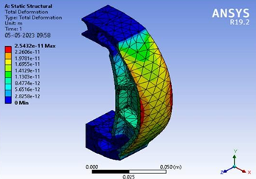

Fig.3. c) Deformation of banana peel particles brake pad

**5.3 Static structural result of Banana peel brake pad**

|  |  |  |
| --- | --- | --- |
|  | Maximum | Minimum |
| Equivalent Stress (Pa) | 37.26 | 0.03 |
| Equivalent Elastic Strain | 2.5e-9 | 5.6e-13 |
| Total Deformation (m) | 2.54e-11 | 0 |

**5.4 Steady State Thermal Analysis**

For thermal analysis, the design geometry and engineering data is same as for the static analysis. Meshing is done by using the automatic method which gives a coarse tetrahedron mesh. Temperature is applied on brake pad for entire body selection i.e., 120oC

Total heat flux and directional heat flux is evaluated in results. The total heat flux and directional heat flux are the shown in Fig.4.a) and Fig.4.b). We can observe that the temperature raise during the application of brake is transmitted through the edges of the brake pad to the surroundings. The total heat flux can be seen 2.9453e-6W/m2 as maximum value for the banana peel composite brake.

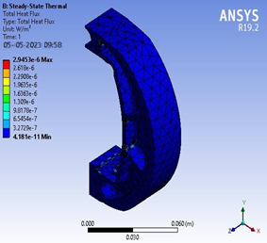 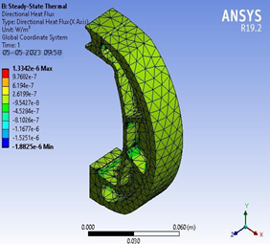

Fig.4. a) Heat flux and b) Directional heat flux of banana peel particles brake pad

|  |  |  |  |  |
| --- | --- | --- | --- | --- |
|  | Total Heat Flux (w/m2) | | Directional Heat Flux (w/m2) | |
|  | Maximum | Minimum | Maximum | Minimum |
| Banana Peel Particles | 2.83e-6 | 4.18e-11 | 1.33e-6 | -2.00e-6 |

**6. Conclusions**

The assessment of deformations and stresses induced by a specified force, it has been determined that the banana peel brake pads under consideration is capable of withstanding the applied force. However, it should be noted that the stresses obtained from such evaluations may not always be sufficient for real-world scenarios. Structural design modifications may be implemented to enhance performance in material design. In order to assess the behaviour of brakes under varying temperatures, thermal analysis is carried to find the heat flux of the banana peel particles brake pad. The fact that density and high strength-to-weight ratio, which make them desirable materials for achieving fuel efficiency and reducing emissions in vehicles. The safety of a design is typically evaluated based on its strength and rigidity.

**Reference**

1.U.D. Idris a , V.S. Aigbodion b, I.J. Abubakar c , C.I. Nwoye d, Eco-friendly asbestos free brake-pad: Using banana peels by a King Saud University, Journal of King Saud University – Engineering Sciences (2013)

2.RINKU B. PRADHAN, Mr. S.SIVASARAVANAN, Design And Analysis Of Brake Lining Of Commercial Car, by a International Research Journal of Engineering and Technology Volume 05, Issue 08,Aug 2018

3.Bushra Rashid, Alzafaranya, Zulkiflle Leman, Mohammad Jawaid, and Mohamad R Ishak, Eco-Friendly Composites for Brake Pads From Agro Waste, A Review In: Saleem Hashmi (editor-in-chief), Reference Module in Materials Science and Materials Engineering. Oxford: Elsevier; 2017. pp. 1-21.

4.Rongping Yun, Yafei Lu, P. Filip, Performance and evaluation of eco-friendly brake friction materials by Article in Tribology International · November 2010

5.Rehman , S. Das , G. Dixit, Analysis of stir die cast Al–SiC composite brake drums based on coefficient of friction by Materials Today: Proceedings 16 (2019) 1067– 1074 batch no ICAMMAS17

6.S.Sri karthikeyan, E.Balakrishnan. S.Meganathan ,M.Balachander, A.Ponshanmugakumar, Elemental Analysis Of Brake Pad Using Natural Fibres by Journal of Materials Research and Technology.2020;(xx):12926- 12935.

7.Jongsung Park a , Byungsoo Joo a , Hyungjo Seo a , Wansu Song a , Jung Ju Lee b, Wan Kyu Lee c , Ho Jang, Analysis of wear induced particle emissions from brake pads, by Wear 466–467 (2021) 20353 2013