**Analog-to-digital converter-based industrial fault indicator system that detects overvoltage and temperature**

*1Musthak Ali. P, Graduateship / Associate Membership, Electrical and Electronics Engineering, Indian Institute of Industry Interaction Education and Research, India*

*2Murugu Nachippan, Assistant Professor, Indian Institute of Industry Interaction Education and Research, India*

*3Tamilarasan, Project Coordinator, Indian Institute of Industry Interaction Education and Research, India*

**Abstract**

In order to quantify the electrical properties of voltage, current, and resistance, it is necessary to construct analog circuits. The aforementioned analog circuits are capable of measuring three distinct parameters and subsequently generating corresponding outputs. The analog circuit outputs are intended to be linked to an ADC, which in turn is connected to a microcontroller for the purpose of acquiring the desired parameter. The program defines a predetermined set point for the temperature of the DC motor. When the temperature reading falls below this set point or exceeds it, the motor is activated. Likewise, the voltage can be determined by observing the green and red LED. Subsequently, the aforementioned readings have the capability to be exhibited on the liquid crystal display (LCD) screen.

Keywords: Voltage, Temperature, Analog to Digital converter, Microcontroller

**Introduction**

A software-based or hardware-based solution is referred to as a fault monitoring system. This type of solution is designed to monitor and detect faults or irregularities in a piece of equipment or an entire system. It is widely employed in a variety of industries, including manufacturing, power generation, telecommunications, transportation, and many others, to maintain the reliable functioning of important assets and prevent potential failures or accidents. In addition, it is utilized in a number of other applications. The continuous monitoring of critical parameters, such as temperature, pressure, voltage, flow rate, or performance metrics of equipment or processes, is the primary objective of a defect monitoring system. It does this by first collecting data in real time from sensors, equipment, or other sources, and then analysing that data to look for any deviations from the usual operating circumstances. An industrial fault indicator system that is based on an analog-to-digital converter (ADC) and can detect overvoltage and temperature is a monitoring solution that is designed to identify and alert operators or maintenance personnel about potential faults that are related to overvoltage or excessive temperature conditions in industrial settings. ADCs are put to use in this system so that analog voltage and temperature signals can be converted into digital data for the sake of analysis and finding errors. Data collecting, data processing, alarm and alert production, visualization and reporting, diagnostic tools, integration and compatibility, and user interfaces are often included in fault monitoring systems. Sensors, meters, PLCs, SCADA systems, and several other data streams are among the sources from which data is gathered for analysis. When a problem is discovered, alarms and notifications are produced automatically. Increased system uptime, improved operational efficiency, reduced maintenance costs, enhanced safety, and proactive problem detection, which helps prevent catastrophic failures and downtime are some of the benefits of a fault monitoring system. Other benefits include improved operational efficiency, reduced maintenance costs, and enhanced safety. Accidents happen quite frequently in the workplace these days. In industries such as petroleum, chemicals, oil, and gas, there is a significant risk of fire dangers. These fires have the ability to wreak massive amounts of harm, along with the loss of property and, most importantly, lives. It is of the utmost importance to have a system in place that can maintain the area's safety and send an alert to the appropriate stakeholders within the specified amount of time in the event that such an incident takes place. Accidents of this kind have been known to take place in our nation as well. monitoring system for faults that checks and controls the frequency, phase, and voltage. The reliability of power supply networks is becoming increasingly important as a result of the ongoing expansion of these networks. The complexity of the entire network is comprised of a number of different components, each of which is prone to phase failure and has the potential to disrupt the flow of energy to end consumers. Low voltage, high voltage, and low frequency are all forms of energy that are used in the vast majority of the world's operational industries. The regulation of characteristics such as current, voltage, load, and temperature has become increasingly vital to the induction motor's overall well-being. Induction motors are susceptible to damage when faults occur in the aforementioned parameters. The monitoring systems used in IMs include a variety of mechanical and electrical equipment, including as timers, contactors, and current/voltage relays, to name a few. These fundamental procedures involve some mechanical and dynamic components of the apparatus, any of which may give rise to a problem over the course of operation, so diminishing the system's longevity and effectiveness. Our project's goals are to investigate the industry's parameters and to offer automated prevention on a limited scale. In order to take preventative measures, components such as fans, LEDs, and buzzers are interfaced with the main controller. In the event that there is a risk of a fire breaking out or a gas leak, the LEDs and the buzzer will sound an alarm. In the event that there is a gas leak, a fan is employed not only to provide cooling action but also to act as an exhaust. [1] The purpose of this work is to present an Internet of Things (IoT) based industrial fault detection and diagnostic system that uses Arduino, temperature monitoring, a phase fault detector, a voltage controller, and frequency monitoring in order to safeguard companies from accidents and monitor problems. Thermal power plants (TPPs) have implemented modern techniques for failure detection and diagnosis (FDD) in order to reduce the amount of downtime required for maintenance and the associated expenses. This article provides an overview of the most important FDD methodologies, including as model-based, data-driven, and statistically-based approaches, as well as their applications in improving the efficacy and reliability of TPPs. It highlights the original and innovative elements of these techniques and emphasizes their significance in the development of sustainable energy and the feasibility of thermal power generation over the long term. [3] This project makes use of GSM to communicate real-time information to the operator or owner of the plant, thereby enabling the operator or owner to control the plant from a considerable distance. The microcontroller that is employed aids in connecting a large number of input/output devices at the same time, and the amount of time it takes for an SMS to be delivered is determined by the coverage area or range of the mobile network. [4] The purpose of this work is to describe an innovative system that protects industrial and home loads against overvoltage and under voltage in AC mains supply. It is made up of a mechanism for tripping that keeps an eye on the supply voltage and trips when it reaches one of the pre-set limits. The efficiency of the system is evaluated with the help of a lamp load. [5] It is essential to safeguard an induction motor (IM) from any potential issues that may arise, and the traditional approaches entail the utilization of mechanical components. The majority of the mechanical components are removed thanks to protection systems based on computers and PICs, however these methods do not visualize the electrical parameters that are being measured. This research presents a novel form of protection that is based on a programmable logic controller (PLC) and has the potential to reduce overall costs, improve accuracy, and create an environment that is both safe and visible. [6] Two sensors, an LPG Gas sensor and a Temperature sensor, are included in an Android-based industrial fault monitoring system. If any of these sensors detects that the threshold has been exceeded, a warning signal is transmitted to an Android mobile device through Bluetooth technology, and a buzzer is activated. This project has applications in both private residences and commercial hotels. [7] Using a circuit and a microcontroller, the primary objective of this article is to identify faults in a three-phase induction motor, provide an indication of those faults, and then safeguard the motor from those faults. In the event that a fault develops, it will turn off the power and disable the motor until it returns to normal.[8] Using an advanced microprocessor called an AVR ATMEGA16 and a variable potentiometer that is connected across the circuitry, the purpose of this article is to identify problems with single-phase induction motors.[9] Estimating the implications of a defect requires taking into account a number of significant elements, including the fault current, location, system earthing, source impedance, and duration of the fault. When compared to series faults, which are disruptions in one or more phases, shunt faults are considered to be more severe. [10] The measurement of voltage, current, and resistance is the basic function of analog circuits. This is also their major purpose. In the following step, the outputs of these circuits are connected to ADCs as well as microcontrollers. In order to provide a visual representation of the specified values of set points, green and red light-emitting diodes (LEDs) are used. These LEDs serve the purpose of indicating voltage.

**Materials and Methods**

Micro controller

The microcontroller under consideration possesses a range of features, including 8K Bytes of In-System Reprogrammable Flash Memory, with an endurance of 1,000 Write/Erase Cycles. The device is capable of fully static operation, with a frequency range of 0 Hz to 24 MHz Additionally, the microcontroller contains 256 x 8-bit Internal RAM and 32 Programmable I/O Lines. It also includes three 16-bit Timer/Counters, eight Interrupt Sources, and a Programmable Serial Channel. Furthermore, the device offers low-power Idle and Power-down Modes.

ADC

The AT89C52 is a CMOS 8-bit microcomputer that offers both excellent performance and low power consumption. It was designed by Texas Instruments. Flash programmable and erasable read-only memory (PEROM) in the capacity of 8 kilobytes is included in its construction. The use of on-chip Flash makes it possible to rewrite the contents of program memory either within the system itself or with the assistance of a traditional non-volatile memory programmer. By combining a flexible 8-bit central processing unit (CPU) with Flash memory on a single chip, the powerful microcomputer known as the Atmel AT89C52 is able to provide a solution that is both adaptable and affordable for a wide variety of embedded control applications.

VCC - Supply voltage.

GND - Ground.

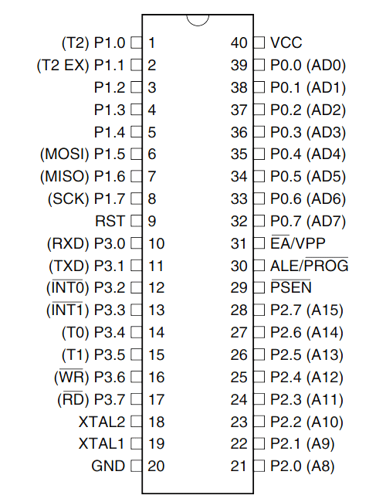

Fig.2. PIN diagram of AT89C52

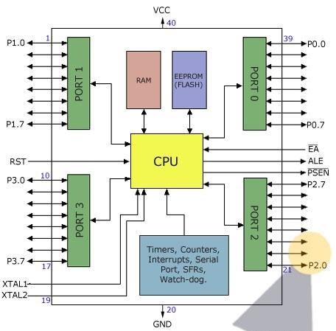

Fig.3. Port diagram of AT89C52

LM 35(temp sensor)

The device is calibrated directly in degrees Celsius (Centigrade). The given parameter exhibits a linear relationship with a scale factor of 10.0 millivolts per degree Celsius. The device is capable of providing a level of accuracy of 0.5°C, with a guarantee of such accuracy at a temperature of +25°C. The product has been evaluated and certified to operate within a comprehensive temperature range of -55°C to +150°C. This product is appropriate for implementation in remote settings. The low cost is attributed to the utilization of wafer technology. The trimming process is performed at a certain level. The device is functional within a voltage range of 4 to 30 volts. The device exhibits a current drain of less than 60 μA, low self-heating of 0.08°C in still air, typical nonlinearity of only ±1⁄4°C, and a low impedance output of 0.1 for 1 mA load.

LCD

The Liquid Crystal Display (LCD) is a type of display used in digital watches and portable computers. It utilizes two sheets of polarizing material with a liquid crystal solution between them. An electric current passed through the liquid causes the crystals to align so that light cannot pass through them. The LCD monitor is able to display images by controlling where and what wavelength (colour) of light is allowed to pass. Other advances have allowed LCDs to greatly reduce liquid crystal cell response times, making complicated equipment easier to operate. The most common LCD is the 16-character x 4-line display with no backlight, which requires only 11 connections and runs off a 5V DC supply and only needs about 1mA of current.

LEDs

A light-emitting diode, often known as an LED, is a type of semiconductor diode that, when electrically biased in the forward direction of the pn-junction, as is done in a typical LED circuit, generates incoherent light with a restricted spectrum. This effect is a variation on the phenomenon known as electroluminescence. When we send a message in the form of bits such as 1, the data is transferred to the receiver side. Correspondingly, the data is transmitted to the receiver side and the LED lights signifying the data is being received simultaneously. The LED turns off when we send 8 as a data.

Software:

• Functionality of all above components

• Embedded C programming

**Circuit Diagram**

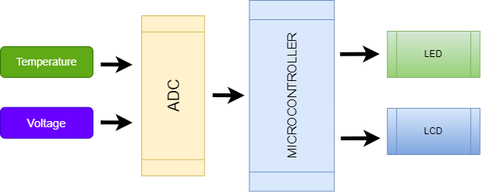

Fig.1.Block diagram of fault monitoring system

**Operation**

The construction of a fault indicator system with over voltage and over temperature can be accomplished with the use of analog-to-digital (ADC) converters. The block diagram demonstrates how to create analog circuits to measure voltage, current, and resistance, and it also demonstrates how the circuits are prepared to output measurements. In order to obtain the needed parameter, the outputs of the analog circuit are connected to the ADC, which in turn is connected to the microcontroller. The program starts in the off condition for the dc motor until the set point is exceeded, at which point it will switch to the on condition. The set point is predefined in the program. Readings are shown on the LCD display, which correspond to the voltage that is indicated by the green and red LEDS. Microcontroller, analog-to-digital converter (ADC), LM35 temperature sensor, liquid crystal display (LCD), direct current (DC) motor, and LEDS are the components utilized in this project's hardware. The software consists of embedded C programming and functioning of the components. A low-power 8-bit microprocessor with high-performance CMOS and 8Kbytes of Flash Programmable and Erasable Read Only Memory (PEROM) is provided by the AT89C52. A non-volatile memory programmer is required for reprogramming the program memory because it is stored in an on-chip Flash. The Atmel AT89C52 is a powerful microcomputer that offers a solution to embedded control applications that is both extremely versatile and very cost-effective. It accomplishes this by combining an 8-bit CPU with Flash on a single monolithic chip. Sensor Interface, Process Control, Data Acquisition, and Battery Operated Systems are some of the applications that it is used for. The components manufactured by Microchip Technology are 12-bit Analog to Digital (A/D) Converters that include hold circuitry and on-board samples. It is possible to provide two pseudo input pairs, four single ended inputs, or eight single ended inputs based on the settings that are programmed into it. The devices are able to communicate with one another with the assistance of a straightforward serial interface that is compatible with the SPI protocol. The power supply unit maintains a consistent dc voltage of 5 volts and supplies that to the peripherals. Regulator LM7805 is a digital integrated circuit that is used for regulating the output and delivers a constant 5V DC supply as output. It does this by providing the output with a constant voltage.

**Conclusions**

The project's development has demonstrated the significant effort required for the establishment of a system. The "Industrial Fault Detection" project utilized a microcontroller, resulting in a reduction of hardware requirements. The initiation of this project has facilitated the cultivation of essential skills such as teamwork, patience, and time management that are imperative for contemporary technical professionals. Therefore, it can be inferred that the project's intended goals and objectives have been successfully attained. This project has instilled within us a sense of self-assurance that any obstacle can be overcome through unwavering perseverance, diligent effort, and a positive outlook. We believe that our product has a positive impact on society and we are eager to showcase it to the global community. Through the completion of this project, we have gained a deeper comprehension of the multifaceted aspects involved in the development of an embedded system project, which is currently a highly sought-after technology.

**Reference**

[1] A. Viju, P. Shukla, A. Pawar, and P. Sawant, “Iot Based Industrial Monitoring and Fault Detection System,” no. June, pp. 3149–3151, 2020.

[2] N. Islam, M. A. Rahman, K. Muhammad, A. Ashrafi, and T. Ahmed, “Development of an IOT Based Industrial Fault Detection and Diagnosis System,” vol. IX, no. I, pp. 18–22.

[3] S. Khalid, J. Song, I. Raouf, and H. S. Kim, “Advances in Fault Detection and Diagnosis for Thermal Power Plants: A Review of Intelligent Techniques,” *Mathematics*, vol. 11, no. 8, 2023, doi: 10.3390/math11081767.

[4] P. Keerthija, N. Hema, P. Vaishnavi, and M. Shyam Sunder, “Gsm Based Industrial Fault Detection System,” *Int. Res. J. Mod. Eng. Technol. Sci. www.irjmets.com @International Res. J. Mod. Eng.*, vol. 807, no. 11, pp. 2582–5208, 2021, [Online]. Available: www.irjmets.com.

[5] P. Rama Mohan, A. P. Neeli Mallikarjuna, and K. Niteesh Kumar, “A Novel Over Voltage and Under Voltage Protecting Systemfor Industrial and Domestic Applications,” *Int. J. Innov. Sci. Res. Technol.*, vol. 5, no. 10, pp. 885–889, 2020, [Online]. Available: www.ijisrt.com.

[6] D. Kumar, A. Basit, A. Saleem, and E. G. Abbas, “PLC based monitoring protection of 3-phase induction motors against various abnormal conditions,” *2019 2nd Int. Conf. Comput. Math. Eng. Technol. iCoMET 2019*, no. April, 2019, doi: 10.1109/ICOMET.2019.8673497.

[7] A. Mathematics, “Android based industrial,” vol. 116, no. 15, pp. 423–428, 2017.

[8] B. E. Student, “Fault Detection , Indication & Protection of Induction Motor by Several Modified Techniques,” vol. 3, no. 09, pp. 207–209, 2017.

[9] Ms. Thorat Snehal Anuprao and Assistant Prof. Dusing Priyanka, “Fault Detection and Protection of Single Phase Induction Motor Using Microcontroller AVR ATmega16,” *Int. J. Eng. Res. Technol.*, vol. 4, no. 4, pp. 177–179, 2015, [Online]. Available: www.ijert.org.

[10] M. Ohrstrom, “Fast fault detection for power distribution systems,” *Proquest Diss. Theses*, p. P118, 2003.