**HEALTH SURVEILLANCE SYSTEM USING IOT AND EMBEDDED**

**H C Manohara1, Preethi Y2, Reethu M K3, Suraj Kumar S4, Syed Nizamuddin5**

1Assistant Professor, Department of Electrical and Electronics, PES College of Engineering, Mandya, Karnataka, India

2,3,4,5Student, Department of Electrical and Electronics, PES College of Engineering, Mandya, Karnataka, India

**ABSTRACT**

The integration of Internet of Things (IoT) and embedded systems has paved the way for innovative health monitoring systems that enable continuous and remote tracking of individuals' health conditions. This research paper explores the design and implementation of an IoT and embedded-based health monitoring system. The system leverages wearable sensors and embedded devices to collect real-time health parameters, which are then transmitted to a central server for analysis and storage. The paper presents the system architecture, methodology, and hardware components employed. The proposed system holds significant promise for revolutionizing healthcare by providing timely interventions, early anomaly detection, and improved patient management. Through this research, we aim to shed light on the potential benefits and challenges of IoT and embedded-based health monitoring systems and inspire further advancements in this domain.

**Keywords**: IoT, embedded systems, health monitoring, wearable sensors, remote patient management.

1. **INTRODUCTION**

The pursuit of happiness and prosperity is intrinsically linked to an individual's health. Without good health, achieving true happiness becomes elusive. As science and technology continue to advance, so do the challenges posed by health-related diseases. The rising prevalence of such diseases underscores the need for effective measures to control and manage them. In this research, we, as electrical engineers, contribute to the endeavor of combating health-related diseases by designing an IoT-based health monitoring system. The aim of this research is to develop a comprehensive health monitoring system that can monitor vital aspects of a person's health, including heart activity, heart rate, and body temperature. By integrating sensors such as heart rate sensors and temperature sensors, we can continuously monitor these critical parameters. The designed health monitoring system proves particularly beneficial for individuals residing in remote areas, far from urban centers and healthcare facilities. These individuals often face challenges in accessing timely medical care, jeopardizing their health and well-being. By incorporating SMS alert and Wi-Fi alert modules into the system, we enhance its capabilities to provide immediate assistance. In emergency situations, where time is of the essence, the system can alert healthcare professionals and concerned individuals. This prompt notification allows for quick intervention and potentially life-saving measures. Furthermore, by connecting the IoT-based health monitoring system to the patient's body, doctors can remotely diagnose and assess the patient's condition through online platforms and SMS communication. This enables doctors to provide timely prescriptions and recommend hospitalization if necessary, minimizing the risk of losing a patient's life due to delayed medical attention. The significance of the IoT-based health monitoring system lies in its potential to bridge the gap in healthcare access, particularly for individuals in remote or underserved areas. By providing real-time monitoring and remote diagnosis, the system facilitates timely intervention, reduces the barriers to healthcare, and improves health outcomes. It empowers individuals to take charge of their health and allows healthcare professionals to extend their reach beyond physical limitations.

1. **LITERATURE SURVEY:**

**1. Wang, H., & Wang, M. (2018). IoT-based personalized healthcare system using big data analytics. IEEE Access, 6, 52479-52488.**

- This paper proposes an IoT-based personalized healthcare system that utilizes big data analytics for health monitoring, data collection, and analysis.

**2. Ochoa, S. F., & Vargas-Cuentas, N. I. (2019). Design of a remote health monitoring system based on IoT. In Proceedings of the International Conference on Innovative Computing and Communications (pp. 24-31). Springer, Singapore.**

- This study presents the design and implementation of a remote health monitoring system using IoT technologies for real-time monitoring and management of patients' health conditions.

**3. Banerjee, A., & Bhattacharya, S. (2019). An IoT-based wearable sensor system for real-time health monitoring in personal healthcare. In Internet of Things (pp. 137-152). Springer, Cham.**

- This paper discusses an IoT-based wearable sensor system for real-time health monitoring in personal healthcare, focusing on the development of wearable devices, data collection, and analysis.

**4. Fernández-Caramés, T. M., & Fraga-Lamas, P. (2018). Towards the internet of smart trains: A review on industrial IoT-connected railways. IEEE Internet of Things Journal, 5(2), 954-967.**

- Although not specific to health monitoring, this review article provides insights into the industrial Internet of Things (IoT) applications, which can be relevant to health monitoring system design and implementation.

**5. Lin, F., & Lan, T. (2019). An IoT-based physiological parameter monitoring system for healthcare applications. Journal of Medical Systems, 43(7), 193.**

- This paper presents an IoT-based physiological parameter monitoring system for healthcare applications, including the design of wearable devices, data transmission, and data analysis techniques.

1. **METHODOLOGY:**
   1. **Block Diagram**

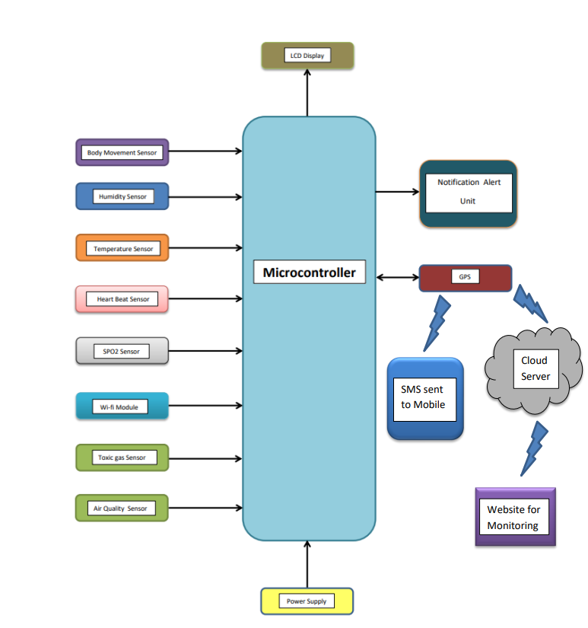

Fig 1: Block Diagram of Health Monitoring System

The health monitoring system based on IoT was developed using the Arduino microcontroller as the central processing unit. The Arduino collects real-time health data using a max30100 sensor, which measures the heart rate in beats per minute (BPM). Additionally, a digital temperature sensor connected to the Arduino measures the patient's body temperature, while another temperature sensor measures the room temperature. When the patient's heart rate exceeds a specified threshold, the buzzer produces audible beeps. Moreover, the system measures the spo2 values and activates the buzzer and sends an alert to the caretaker if the threshold is exceeded. An emergency button is provided to instantly alert the caretaker, and all the data can be accessed remotely on smartphones using IoT technology. This system offers healthcare professionals a comprehensive understanding of a patient's heart functioning in different health conditions. Abnormal heartbeats can be detected by simply listening to the beeps. The standard ESP8266 IoT module connects the machine to the internet, enabling the transmission of health data to an IoT server for storage and monitoring. Additionally, the system can display real-time data on a 16x2 LCD display, providing on-site healthcare professionals with immediate access to the patient's health information.

* 1. **Hardware Components Used**

**1. Microcontroller:** The microcontroller, such as Arduino, serves as the brain of the system, controlling and coordinating the various components. It processes data, executes algorithms, and manages communication between different modules.

**2. LCD (16x2):** The LCD (Liquid Crystal Display) provides a visual interface to display important information such as health data, alerts, and notifications. It enables healthcare professionals or users to monitor and interpret the system's output in a user-friendly manner.

**3. Heartbeat Sensor:** The heartbeat sensor measures the heart rate in beats per minute (BPM) by detecting the pulsations of blood vessels. It captures the electrical signals generated by the heartbeat and provides real-time heart rate data, crucial for monitoring a patient's cardiovascular health.

**4. Spo2 Sensor:** The Spo2 sensor (Oxygen Saturation Sensor) measures the oxygen saturation levels in the blood. It helps determine how well the oxygen is being carried to different parts of the body, providing insights into a patient's respiratory health and oxygenation.

**5. Body Movement Sensor:** The body movement sensor detects any significant movements or vibrations of the patient's body. It helps track physical activity levels, monitor sleep patterns, and detect abnormal movements, providing valuable information about the patient's overall well-being.

**6. Temperature Sensor:** The temperature sensor measures the patient's body temperature as well as the ambient room temperature. It enables the monitoring of fever or any temperature variations, which can be crucial in assessing the patient's health condition.

**7. Emergency Button:** The emergency button is a dedicated switch that can be pressed in case of any critical situation or when immediate attention is required. It triggers an instant alert or notification to the caretaker or healthcare provider, ensuring swift action can be taken.

**8. Notification Alert Unit:** The notification alert unit is responsible for sending alerts or notifications to the caretaker or healthcare provider. It can utilize various communication methods such as SMS, email, or app notifications to ensure timely communication and response.

**9. Buzzer**: The buzzer produces audible alerts or beeps when certain conditions are met, such as abnormal heart rate, critical temperature levels, or emergency button activation. It helps draw attention to critical situations and facilitates immediate response.

**10. Power Supply:** The power supply provides the necessary electrical power to operate the entire system. It ensures a stable and reliable power source for the microcontroller and all the connected components to function properly and continuously monitor the patient's health.

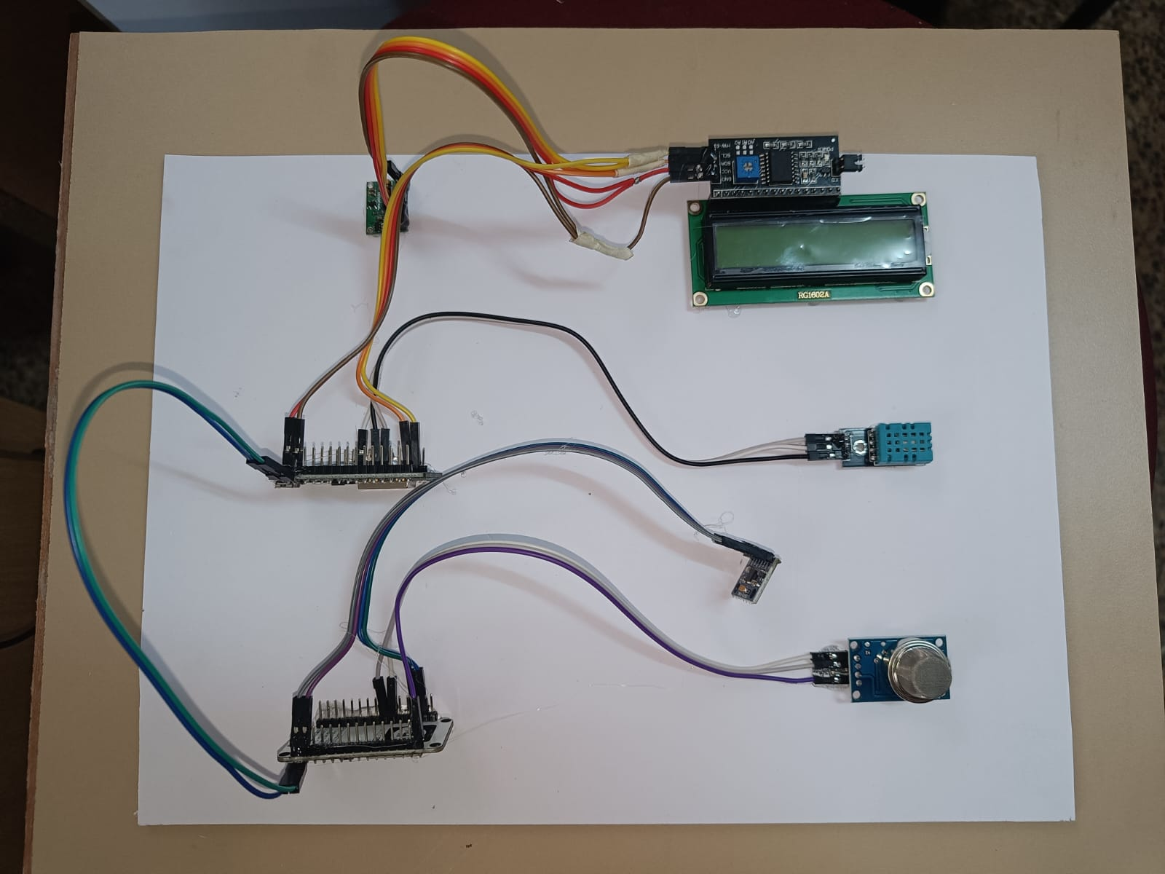

Fig 2: Hardware Setup of Health Surveillance System

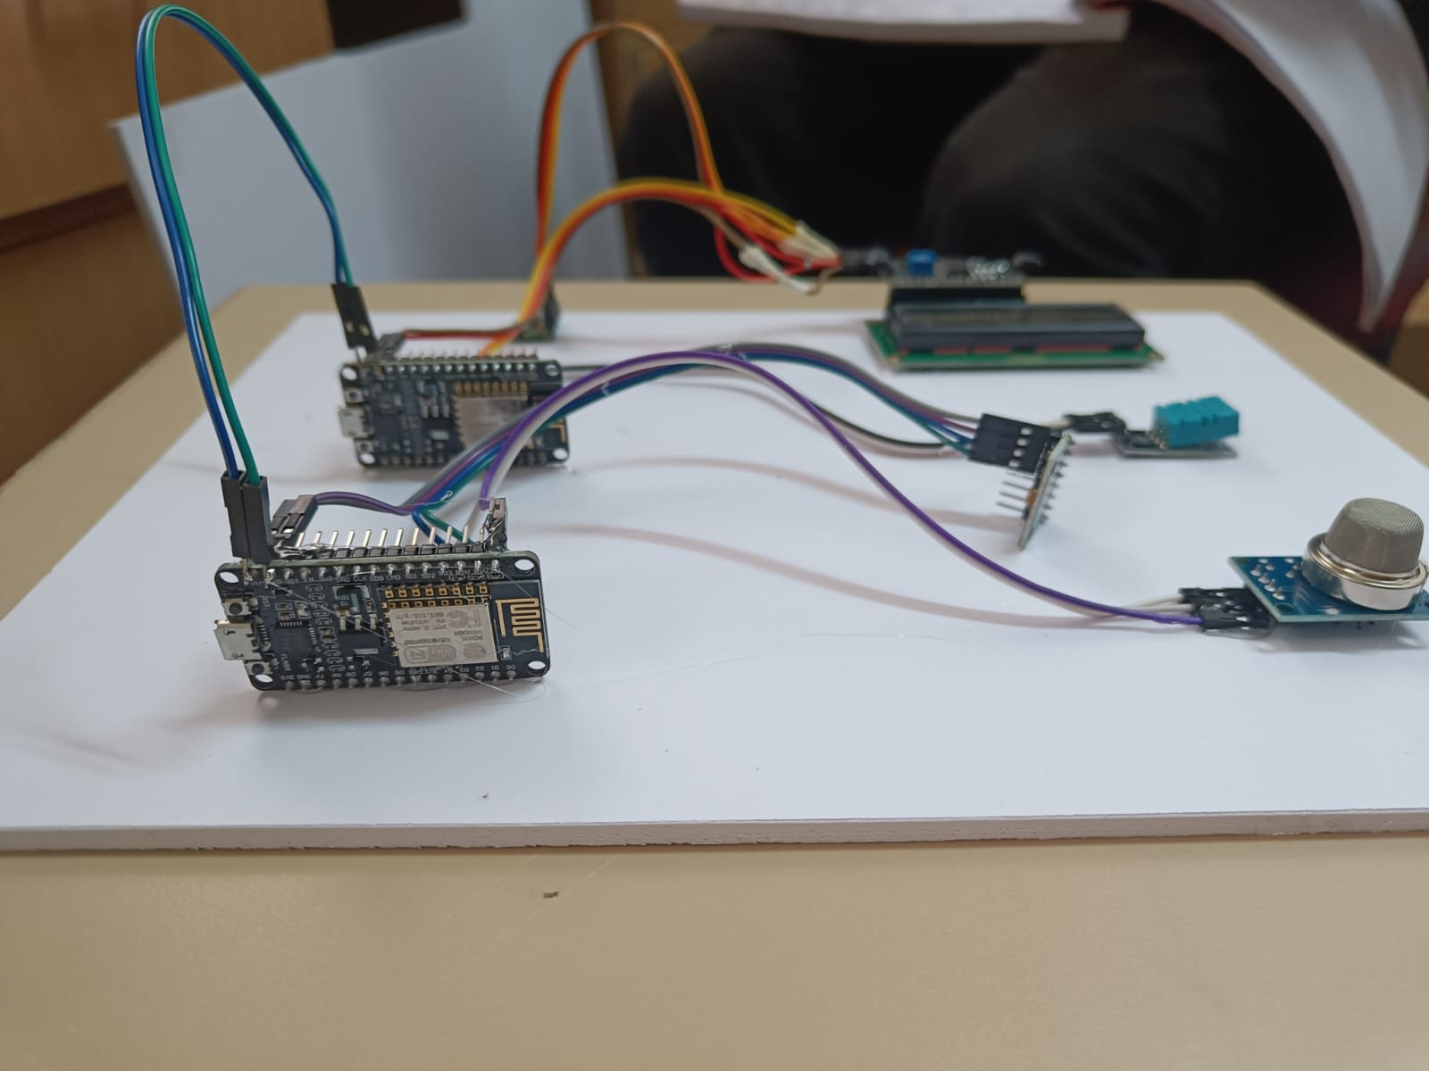

Fig 3: Working Model of Health Surveillance System.

An IoT-based health monitoring system leverages the power of interconnected devices to monitor and manage the health of individuals remotely. It involves the integration of various hardware and software components to collect, transmit, analyze, and store health-related data. Here's a general overview of how such a system works:

1. Sensing Devices: The system starts with the deployment of sensing devices or sensors that gather relevant health data from the individual. These sensors can be wearable devices like smartwatches, fitness bands, or specialized medical sensors for measuring vital signs, such as heart rate, blood pressure, body temperature, blood glucose levels, etc.

2. Data Collection: The sensing devices collect the health data and transmit it to a central hub or gateway device. This data can be transmitted through wireless communication technologies such as Bluetooth, Wi-Fi, or cellular networks.

3. Data Transmission: The gateway device acts as a bridge between the sensing devices and the cloud or server where the data is processed and stored. It securely transmits the collected data to the cloud using encryption and authentication mechanisms to ensure data privacy and security.

4. Cloud Infrastructure: The health data received by the cloud server is processed and stored in a secure and scalable infrastructure. The cloud server can perform various tasks like data aggregation, analysis, and storage. It can also run algorithms and machine learning models to derive meaningful insights from the collected data.

5. Data Analysis and Insights: The collected health data is analyzed in real-time or periodically to identify patterns, trends, anomalies, or potential health risks. Advanced analytics techniques can be applied to provide actionable insights to healthcare professionals, caregivers, or the individuals themselves. These insights can help in early detection of diseases, monitoring chronic conditions, or assessing overall health and well-being.

6. Notifications and Alerts: Based on the analysis, the system can generate notifications or alerts for healthcare providers, caregivers, or individuals themselves. These alerts can be sent via mobile applications, SMS, email, or other communication channels to inform about critical health events or deviations from normal health parameters.

7. Remote Monitoring and Intervention: The IoT health monitoring system enables remote monitoring of individuals' health conditions. Healthcare providers can access the collected data and insights through secure web portals or mobile applications, allowing them to remotely monitor patients' health, provide timely interventions, and make informed decisions regarding treatment plans or adjustments.

8. Data Privacy and Security: Ensuring data privacy and security is crucial in an IoT health monitoring system. Robust security measures, such as encryption, authentication, and access controls, are implemented at various levels to protect sensitive health data from unauthorized access or breaches.

1. **RESULTS AND DISCUSSION**

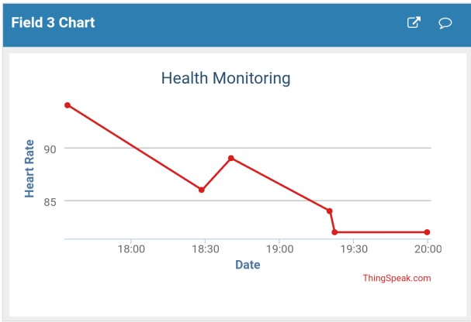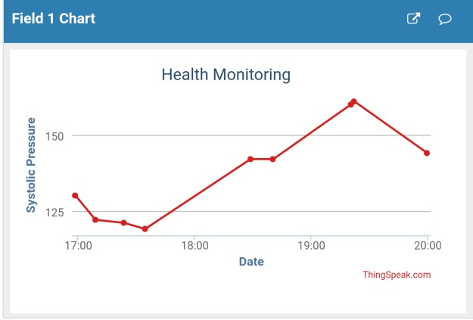

**Fig 4: Heart Rate of Patient Fig 5: Systolic Pressure of Patient**

1. **CONCLUSION**

The IoT and embedded-based health monitoring system holds great potential in improving healthcare outcomes, reducing healthcare costs, and enhancing the overall quality of life. By leveraging connectivity and advanced analytics, healthcare professionals can gain valuable insights into patients' health conditions and make informed decisions. The system's ability to transmit data in real-time and enable remote diagnosis opens up new possibilities for telemedicine, allowing doctors to provide prompt and accurate assessments regardless of geographical constraints. However, the implementation of IoT and embedded-based health monitoring systems also presents challenges. Ensuring data security and privacy is of paramount importance to protect sensitive health information from unauthorized access. Interoperability and standardization need to be addressed to ensure seamless integration of different devices and platforms. Moreover, the scalability and reliability of the system should be thoroughly evaluated to accommodate a large number of users and maintain uninterrupted functionality. In conclusion, the IoT and embedded-based health monitoring system represents a significant advancement in healthcare technology. Its potential to provide continuous, remote, and personalized monitoring has the capacity to transform healthcare delivery, improve patient outcomes, and enhance the overall well-being of individuals. As research and development in this field continue, it is imperative to address the challenges and refine the system's capabilities to unlock its full potential in creating a healthier and more connected world.

1. **REFERENCES**
2. Rahaman A, Islam M, Islam M, Sadi M, Nooruddin S. Developing IoT based smart health monitoring systems: a review. Rev Intell Artif. 2019; 33:435–40. https://doi.org/10.18280/ria.330605.
3. Riazul Islam SM, Kwak Daehan, Humayun Kabir M, Hossain M, Kwak Kyung-Sup. The Internet of Things for health care: a comprehensive survey. IEEE Access. 2015; 3:678–708. https://doi. org/10.1109/ACCESS.2015.2437951.
4. Lin T, Rivano H, Le Mouel F. A survey of smart parking solutions. IEEE Trans Intel Transp Syst. 2017; 18:3229–53. https:// doi.org/10.1109/TITS.2017.2685143.
5. Al-Ali AR, Zualkernan IA, Rashid M, Gupta R, Alikarar M. A smart home energy management system using IoT and big data analytics approach. IEEE Trans Consum Electron. 2017. https:// doi.org/10.1109/TCE.2017.015014.
6. 5. Zanella A, Bui N, Castellani A, Vangelista L, Zorzi M. Internet of Things for smart cities. IEEE Internet Things J. 2014; 1:22–32. <https://doi.org/10.1109/JIOT.2014.2306328>.
7. Mois G, Folea S, Sanislav T. Analysis of three IoT-based wireless sensors for environmental monitoring. IEEE Trans Instrum Meas. 2017; 66:2056–64. <https://doi.org/10.1109/TIM.2017.2677619>.
8. Chen B, Wan J, Shu L, Li P, Mukherjee M, Yin B. Smart factory of Industry 4.0: key technologies, application case, and challenges. IEEE Access. 2018; 6:6505–19. https://doi.org/10.1109/ ACCESS.2017.2783682.
9. Ayaz M, Ammad-Uddin M, Sharif Z, Mansour A, Aggoune E-HM. Internet-of-Things (IoT)-based smart agriculture: toward making the fields talk. IEEE Access. 2019; 7:129551–83. https:// doi.org/10.1109/ACCESS.2019.2932609.