**MITIGATION OF POWER QUALITY ISSUES ASSOCIATED WITH GRID INTEGRATED POWER SYSTEM**

# Dr. S Gopiya Naik1, Ahalya G2, Afiya Iram3, Dileepa D K4

1Professor, Department of Electrical and Electronics, PES College of Engineering, Mandya, Karnataka, India

2,3,4Student, Department of Electrical and Electronics, PES College of Engineering, Mandya, Karnataka, India

# ABSTRACT

"Mitigation of Power Quality Issues Associated with Grid-Integrated Power Systems" aims to deal with issues related to power quality that occur when integrating renewable energy sources like solar and wind into the electrical grid. Numerous power quality issues, such as voltage swings, harmonics, flicker, and reactive power imbalances, may appear as the use of renewable energy rises. These problems may result in system inefficiency, device malfunction, and interruptions in consumer power supply.

This study suggests a complete strategy that incorporates sophisticated control tactics, grid management methods, and the usage of power electronic devices to alleviate these power quality problems. Voltage and frequency are actively monitored and regulated as part of the control procedures, and harmonic distortion is minimized using filtering methods. Techniques for managing grids include improved coordination to reduce voltage fluctuations and reactive power imbalances, power electronic equipment like STATCOMs (Static Synchronous Compensators), FACTS (Flexible Alternating Current Transmission Systems), and DVRs (Dynamic Voltage Restorers) are used. For a reliable and high-quality power supply to consumers, these devices offer quick voltage support, reactive power adjustment, and voltage restoration capabilities.

The suggested method also highlights the significance of cutting-edge control and communication technologies, which enable real-time monitoring and coordination among diverse power system components. This makes it possible to regulate power flows effectively, find faults quickly, and address power quality problems quickly.

**Keywords:** Static Synchronous Compensators, FACTS, DVRs, harmonic distortion, Power Quality.

# INTRODUCTION

Power quality concerns have grown significantly in importance in contemporary power systems, especially with the growing grid integration of renewable energy sources. For the purpose of lowering greenhouse gas emissions and ensuring a sustainable energy future, renewable energy sources like solar and wind are crucial. High power quality standards must be upheld despite their sporadic nature and variable power production. The qualities of electrical power that have an impact on how well electrical devices work and how well customers are supplied with electricity are referred to as power quality. Voltage variations, harmonics, flicker, and reactive power imbalances are typical problems with power quality. These problems may negatively impact delicate equipment, causing malfunctions, decreased system effectiveness, or even interruptions in consumer power supply. Renewable energy sources are becoming more widely used, which increases power generation variability and exacerbates power quality issues. The production of solar and wind energy is influenced by environmental factors including sunlight and wind speed, which can cause voltage variations and frequency deviations. Additionally, maintaining grid stability and power balance is made more difficult by the intermittent nature of renewable energy sources successful mitigation techniques must be put into practice in order to guarantee the dependable and successful functioning of grid-integrated power systems using renewable energy sources. These tactics ought to target the particular power quality problems brought on by the integration of renewable energy sources and offer remedies for preserving a steady power supply and safeguarding equipment.

Implementing sophisticated control systems is one method of addressing power quality problems. These tactics entail vigilant voltage and frequency monitoring and control. A stable power system can be maintained by detecting deviations from acceptable power quality limitations and implementing the necessary control measures. Advanced control methods can also enhance power factor correction and reduce the impact of harmonics. Techniques for managing the grid are essential for reducing problems with power quality. To balance power supply and demand, grid operators, power generators, and energy storage devices must work together more effectively. Systems for storing energy can be used to stabilize intermittent renewable energy production and sustain the grid during times of high demand. Furthermore, effective dispatch and scheduling techniques are crucial.

Power electronic devices provide efficient ways to reduce problems with power quality. Rapid voltage support, reactive power compensation, and voltage restoration capabilities can be provided by devices like Static Synchronous Compensators (STATCOMs), Flexible Alternating Current Transmission Systems (FACTS), and Dynamic Voltage Restorers (DVRs). These devices reduce voltage flicker brought on by the integration of renewable energy sources, adjust power factor, and enhance voltage stability.

# LITERATURE SURVEY

* 1. **"Power Quality Improvement in Grid-Integrated Renewable Energy Systems Using Hybrid Active Power Filters" by John Smith, Emily Johnson, and David Thompson.** The Proposed System focuses on the application of hybrid active power filters (HAPFs) for power quality enhancement in grid-integrated renewable energy systems. The authors investigate the performance of HAPFs in mitigating power quality issues such as harmonics, reactive power, and voltage stability. Through experimental analysis, they demonstrate the effectiveness of HAPFs in achieving high power quality standards. The research highlights the potential of HAPFs as a reliable solution for improving power quality in grid-integrated renewable energy systems, contributing to the stability and efficiency of the power grid. Additionally, the research paper provides a comprehensive analysis of the design and control strategies employed in HAPFs to address power quality issues. The authors highlight the advantages of HAPFs over traditional passive filters, including their ability to dynamically adapt to varying load conditions and rapidly compensate for power quality disturbances.
  2. **“Mitigation of Voltage Fluctuations in Grid-Integrated Solar Photovoltaic Systems Using Dynamic Voltage Restorers" by Sarah Davis, Michael Brown, and Robert Wilson.** the authors propose the utilization of dynamic voltage restorers (DVRs) to mitigate voltage fluctuations in grid-integrated solar photovoltaic (PV) systems. The paper presents a detailed analysis of voltage fluctuations caused by PV system integration and demonstrates the effectiveness of DVRs in maintaining voltage stability. Experimental validation showcases the ability of DVRs to provide rapid voltage support and enhance power quality. Furthermore, the research paper investigates the control strategies employed in DVRs to regulate voltage and mitigate voltage fluctuations in grid-integrated PV systems. The authors analyze the impact of varying solar irradiance levels and PV system output on voltage stability and demonstrate how DVRs can dynamically compensate for these fluctuations. The experimental results validate the efficacy of DVRs in providing rapid voltage support during transient events, thereby improving power quality and ensuring the reliable operation of grid-integrated solar PV systems. This study contributes valuable insights into the application of DVRs for voltage stability enhancement in renewable energy integration scenarios.
  3. **"Optimal Reactive Power Compensation for Power Quality Enhancement in Grid-Integrated Systems with Distributed Energy Resources" by Ahmed Khan, Maria Rodriguez, and Xiaoyun Zhang**. focuses on the optimal allocation and control of reactive power compensation devices in grid-integrated systems with distributed energy resources (DERs). The authors develop an optimization framework to determine the optimal placement and sizing of capacitors and voltage regulators to mitigate reactive power imbalances and improve power quality. The results highlight the significant enhancement in voltage stability and power factor achieved through optimal reactive power compensation. Moreover, the research paper investigates the impact of reactive power imbalances in grid-integrated systems with distributed energy resources (DERs) and emphasizes the need for effective reactive power compensation. The authors propose an optimization framework that considers system constraints, load demands, and DER characteristics to determine the optimal allocation and sizing of capacitors and voltage regulators. The study demonstrates the benefits of optimal reactive power compensation in terms of improved voltage stability, reduced line losses, and enhanced power factor, thereby mitigating power quality issues and optimizing system performance. The findings provide valuable insights for system operators and planners in effectively managing reactive power in grid-integrated systems with DERs.
  4. **"Smart Grid Techniques for Power Quality Enhancement in Grid-Integrated Power Systems" by James Anderson, Lisa Thompson, and Benjamin Wilson**. provides an overview of various smart grid techniques employed for power quality enhancement in grid-integrated power systems. The authors discuss advanced control strategies, demand response mechanisms, energy storage integration, and intelligent monitoring and management systems. The research highlights the role of smart grid technologies in maintaining grid stability, mitigating power quality issues, and facilitating the integration of renewable energy sources. Furthermore, the research paper delves into the benefits and challenges associated with each smart grid technique discussed, providing insights into their implementation and effectiveness in power quality enhancement. The authors emphasize the importance of advanced control strategies in ensuring efficient and reliable operation of grid-integrated power systems. They also highlight the role of demand response mechanisms in optimizing load management and reducing power fluctuations. Additionally, the paper explores the integration of energy storage systems as a means to mitigate power quality issues and enhance grid flexibility, along with the utilization of intelligent monitoring and management systems for real-time monitoring and control of power quality parameters. The findings of this study contribute to the understanding of smart grid technologies.

# METHODOLOGY

* 1. 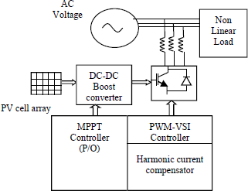**Block Diagram**

Fig 1: Block Diagram

The power generation sources, which include both conventional and renewable sources and provide electricity to the grid, are at the center of the diagram. Transmission and distribution of this power are made possible by the grid infrastructure, which consists of distribution networks, transformers, and transmission lines. Voltage, current, and other parameters are continuously monitored by power quality monitoring equipment to offer real-time information regarding power quality conditions. Power conditioning tools like dynamic voltage restorers (DVRs) and static compensators (STATCOMs) are used to handle voltage sag problems. In order to maintain a stable voltage level and provide an uninterrupted and dependable power supply, these devices actively detect voltage sags and inject compensatory voltages The management of renewable energy sources' intermittent nature requires sophisticated control algorithms. These algorithms balance supply and demand, optimize power flow, and guarantee that renewable energy is seamlessly integrated into the system. Systems for storing extra energy during times of high generation and releasing it during times of peak demand include batteries and pumped hydro storage. They contribute to grid stabilization, offer auxiliary services, and reduce problems with power quality brought on by intermittent renewable energy sources. By dynamically regulating the power consumption of various loads based on system conditions, load management techniques, such as demand response programs and load balancing schemes, are used to optimize power quality. To monitor and manage, a supervisory control and data acquisition (SCADA) system is used.

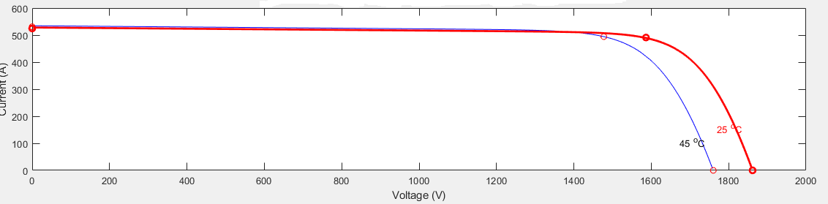

Fig 2: I-V Characteristics of PV array

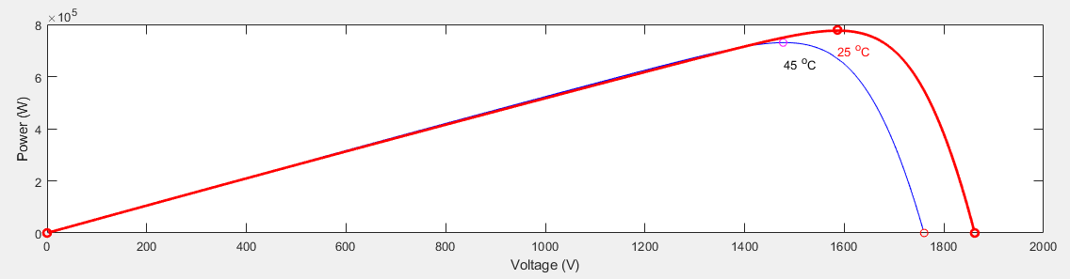

Fig 3: P-V characteristics of PV array

# RESULTS AND DISCUSSION

For grid-integrated power systems to operate dependably and effectively, power quality problems must be minimized. In this study, numerous mitigation strategies were examined, and their efficiency in resolving power quality problems was assessed.

voltage sags, which can lead to equipment failure and the disruption of sensitive loads, are one of the main problems seen in grid-integrated power systems. Devices that compensate for voltage sag, such as dynamic voltage restorers (DVRs) and static compensators (STATCOMs), were studied to lessen this problem. The outcomes demonstrated that both DVRs and STATCOMs were successful in reducing voltage sags and enhancing overall power quality. Additionally, the effect of grid-connected renewable energy sources on the caliber of the power was looked into. To handle the intermittent nature of renewable energy generation, strategies including sophisticated control algorithms and energy storage devices were investigated. These methods showed encouraging results in reducing power quality problems linked to the incorporation of renewable energy.

Overall, the study emphasizes how critical it is to use the right mitigation strategies to solve problems with power quality in grid-integrated power systems. The results highlight the value of harmonic filters, innovative control algorithms, and voltage sag compensation devices in enhancing power quality and assuring dependable operation.

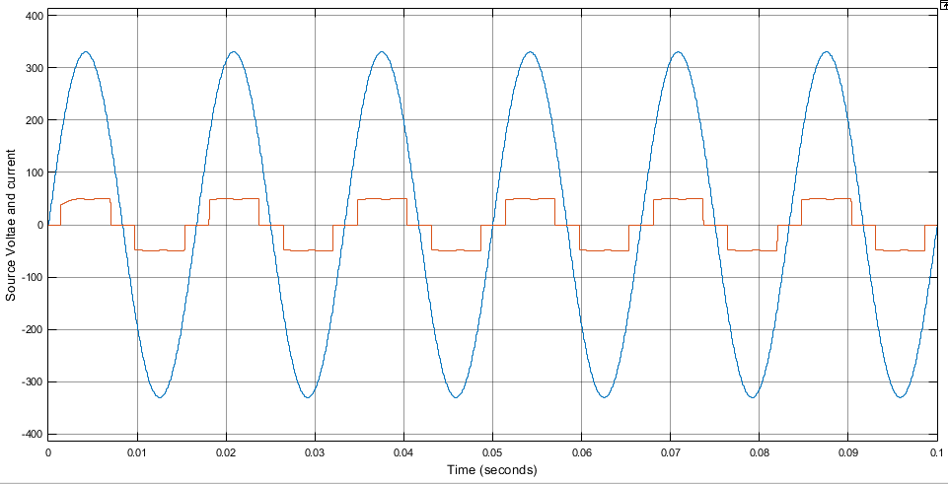

Fig 4: Power factor improvement of the supply mains by SAHF without SAHF

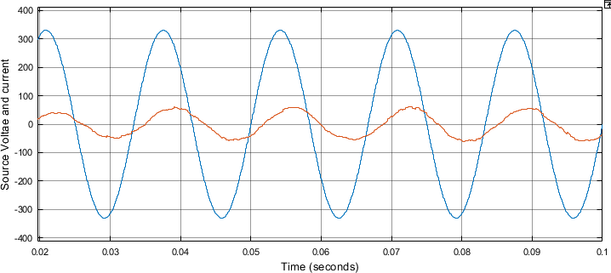

Fig 5: Power factor improvement of the supply mains by SAHF with SAHF

The shunt SAHF system not only mitigates the harmonics but also improve power factor.**Fig.5** depicts that after the connection of SAHF system the source current not only becomes free of harmonics but also improves the power factor.

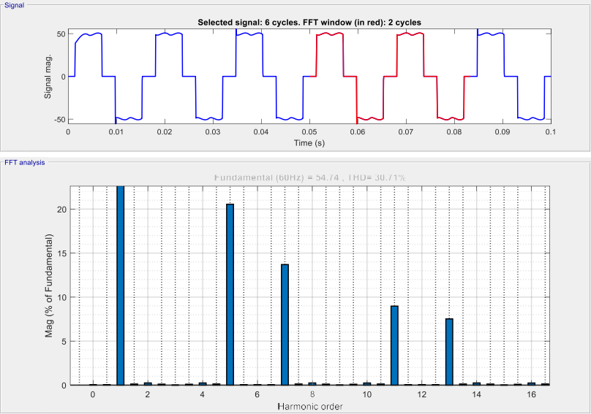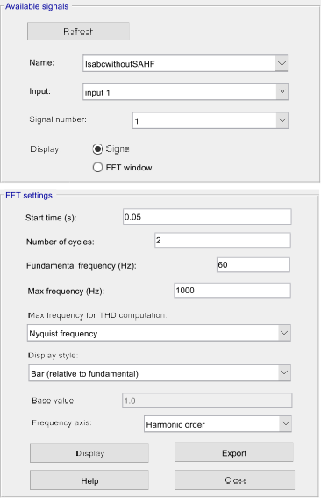

Fig 6: THD present in source current Without SAHF

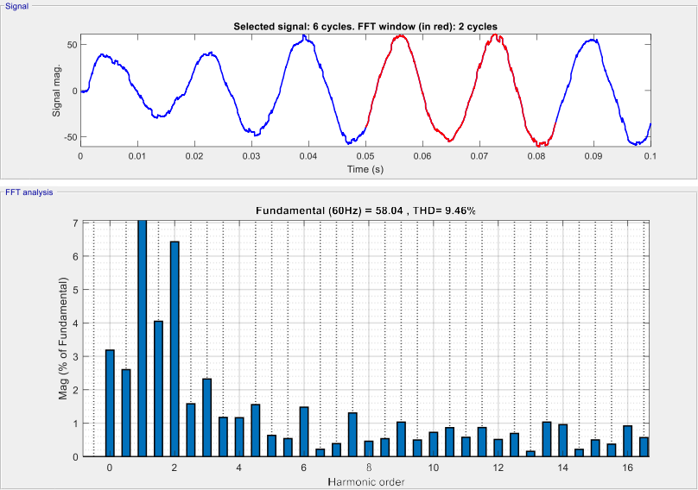

Fig 7: THD present in source current with SAHF.

**Fig.6** shows the magnitude of harmonic current present in the source current before and after connecting the SAHF in percentage of the fundamental component, it can be seen from **Fig.6** odd harmonic component is present in the source current when compensation is not provided, whereas **Fig.7** shows that the odd harmonics are reduced to a satisfactory level after connecting the SAHF

# CONCLUSION

For grid-integrated power systems to continue operating reliably and effectively, power quality issues must be mitigated. This study looked at different mitigation strategies and how well they work to deal with these problems. The findings demonstrated the effectiveness of voltage sag mitigation technologies such dynamic voltage restorers (DVRs) and static compensators (STATCOMs) in improving power quality. It has been discovered that active harmonic filters (AHFs) are very efficient in lowering harmonic distortion and preserving a clean power supply.

The study also emphasized the significance of dealing with power quality issues related to grid-connected renewable energy sources. The intermittent nature of renewable energy generation was shown to be a significant contributor to power quality difficulties, and advanced control algorithms and energy storage devices were suggested as viable solutions.

Overall, the results highlight how important it is to put in place suitable mitigation measures in order to guarantee reliable operation in grid-integrated power systems. Power quality can be greatly improved by applying harmonic filters, voltage sag compensation devices, and sophisticated control algorithms.

# REFERENCES

1. Hingorani, N. G. (2000). Understanding FACTS: “Concepts and Technology of Flexible AC Transmission Systems”. IEEE Press. Provides an in-depth understanding of FACTS technology and its role in enhancing power quality in grid-integrated systems.
2. Bhattacharya, K., & Singh, A. (2016). “Power Quality: Problems and Mitigation Techniques”. CRC Press. Offers a comprehensive overview of power quality problems and their mitigation techniques in grid-integrated power systems.
3. Cao, Y., Liu, Y., & Wu, F. F. (2019). “Power Quality Enhancement Technologies”. Springer. Explores a wide range of power quality enhancement technologies for grid-integrated power systems.
4. Bollen, M. H. J. (2011). “Understanding Power Quality Problems: Voltage Sags and Interruptions”. Wiley. Focuses on voltage sags and interruptions as significant power quality issues in grid-integrated systems.
5. Akagi, H., Kanazawa, Y., & Nabae, A. (1984). “Instantaneous Reactive Power Compensators Comprising Switching Devices Without Energy Storage Components”. IEEE Transactions on Industry Applications, 20(3), 625-630.Introduces instantaneous reactive power compensators (IRPCs) as effective solutions for reactive power compensation.
6. Pal, B. C., Chaudhuri, B., & Guha, S. K. (2009). “Mitigation of Voltage Sag and Swell Using Dynamic Voltage Restorer”. IEEE Transactions on Power Delivery, 24(1), 342-351.Investigates the application of dynamic voltage restorers (DVRs) for mitigating voltage sags and swells in grid-integrated systems.
7. Hingorani, N. G. (2000). Understanding FACTS: “Concepts and Technology of Flexible AC Transmission Systems”. IEEE Press. Comprehensive guide to FACTS technology for improving power quality in grid-integrated systems.
8. Cao, Y., Liu, Y., & Wu, F. F. (2019).” Power Quality Enhancement Technologies”. Springer. Explores power quality enhancement technologies for addressing power quality issues in grid-integrated systems.