**IMPLEMENTATION OF HIGH FREQUENCY RFID BASED REAL-TIME BUS TRACKING SYSTEM**

**Ashwini C N1, Manjunath R2, Sangeetha A C3, Sanjeev S4**

1Assistant Professor, Department of Electrical and Electronics of Electrical and Electronics, PES College of Engineering, Mandya, Karnataka, India

2,3,4Student, Department of Electrical and Electronics, PES College of Engineering, Mandya, Karnataka, India

**ABSTRACT**

Public transportation, particularly buses, plays a crucial role in the daily commute of a large population. To enhance the user experience and provide real-time information on bus status, an IoT-based real-time bus tracking system is proposed. This paper presents the design and implementation of a bus tracking mobile application using high-frequency RFID (HF-RFID) technology. The system utilizes HF-RFID tags installed on buses and RFID receivers placed at bus stops. The RFID tags continuously transmit bus-related data, including location and running status, to the RFID receivers. This real-time information is collected and processed using NodeMCU devices, which are equipped with Wi-Fi capabilities to establish a connection with the internet. The collected RFID data is then uploaded to the cloud, where it is stored and made accessible to users through a mobile application. The mobile app provides a user-friendly interface that allows passengers to precisely locate buses and obtain accurate arrival time information at their desired bus stops. By leveraging IoT technology and HF-RFID, the proposed system enables real-time bus tracking and improves the overall efficiency of public transportation. Passengers can conveniently access up-to-date bus information, eliminating uncertainties and reducing waiting times at bus stops. The system enhances the user experience, increases passenger satisfaction, and promotes efficient utilization of public transport resources. Overall, this IoT-based real-time bus tracking system using HF-RFID offers a reliable and user-friendly solution to improve the efficiency and effectiveness of public transportation services.

**Keywords:** IoT, Real-time, Bus tracking, HF-RFID, FAR, NodeMCU

1. **INTRODUCTION**

The implementation of a high-frequency RFID-based real-time bus tracking system is a significant advancement in the field of transportation technology. Public transportation, particularly buses, plays a crucial role in the daily commute of a large population. However, the lack of accurate and timely information regarding bus schedules and locations often leads to inconvenience and frustration for passengers. To address this issue, this paper presents a novel approach using high-frequency RFID technology to develop a real-time bus tracking system. The system aims to provide instant bus status updates to users through an automated and user-friendly interface. By utilizing high-frequency RFID tags installed on buses and RFID receivers strategically placed at bus stops, the system collects real-time data about bus movements and locations. This data is processed and transmitted to a central controller, such as a NodeMCU, which acts as the brain of the system. The collected bus tracking information is then uploaded to a cloud-based platform, where it can be accessed by users through a mobile application. This application provides a convenient way for passengers to access real-time bus location information, estimated arrival times, and other relevant details. The implementation of this RFID-based real-time bus tracking system offers numerous benefits. Passengers can make informed decisions about their travel plans, reducing waiting times and improving overall commuting experiences. Transportation authorities can monitor bus operations more effectively, optimize route planning, and enhance the efficiency of public transportation services. Overall, this implementation of a high-frequency RFID-based real-time bus tracking system has the potential to revolutionize the public transportation industry, providing passengers with reliable and up-to-date information while improving the efficiency of bus operations. The following sections will delve into the technical details and components involved in the system, highlighting its capabilities and potential impact on the transportation sector.

1. **LITERATURE SURVEY**
2. **"Design and Development of IoT based Real-Time Bus Tracking System" by Muhammad Muzammil, Muhammad Adnan Khan, Shahbaz Ahmad, Muhammad Haris Aziz, and Nabeel Akhtar.**

This study proposes an IoT-based real-time bus tracking system using HF-RFID technology. It focuses on the design and development of the system architecture and components required for accurate bus tracking and real-time data updates.

1. **"Smart Bus Tracking System Using RFID and IoT" by P. Deepika and R. Padmapriya.**

The authors present a smart bus tracking system that utilizes RFID and IoT technologies. The system incorporates HF-RFID tags on buses and RFID readers at bus stops to track and monitor bus movements in real-time.

1. **"Real-Time Bus Tracking System using RFID and IoT" by M. Srinivasan, M. Ramani, S. Senthil, and K. Kalaiarasan**.

This paper proposes a real-time bus tracking system based on RFID and IoT. HF-RFID tags are used to identify buses, and the data is transmitted through IoT protocols to provide accurate bus tracking and real-time updates to users.

1. **"Design and Implementation of IoT-based Bus Tracking System Using RFID Technology" by V. Shanthi and K. Saranya.**

The authors present the design and implementation of an IoT-based bus tracking system using RFID technology. HF-RFID tags are deployed on buses, and RFID readers at bus stops collect the data to provide real-time bus tracking and arrival information to users.

1. **"IoT based Real-Time Bus Tracking System using RFID Technology" by B. Suresh and A. Joseph.**

This study proposes an IoT-based real-time bus tracking system using HF-RFID technology. The authors focus on the integration of RFID technology with IoT to enable accurate bus tracking, real-time data updates, and improved user experience.

* 1. **Objectives**

1. To track the locations of buses travelling along various routes at different times and providing data in “real-time” to a central control room.
2. To provide the location of the bus to the user.
3. To give approximate distance and time of the bus to the user through an application.
4. Give a list of bus numbers for particular source and destination.
5. **METHODOLOGY**
   1. **Block Diagram**

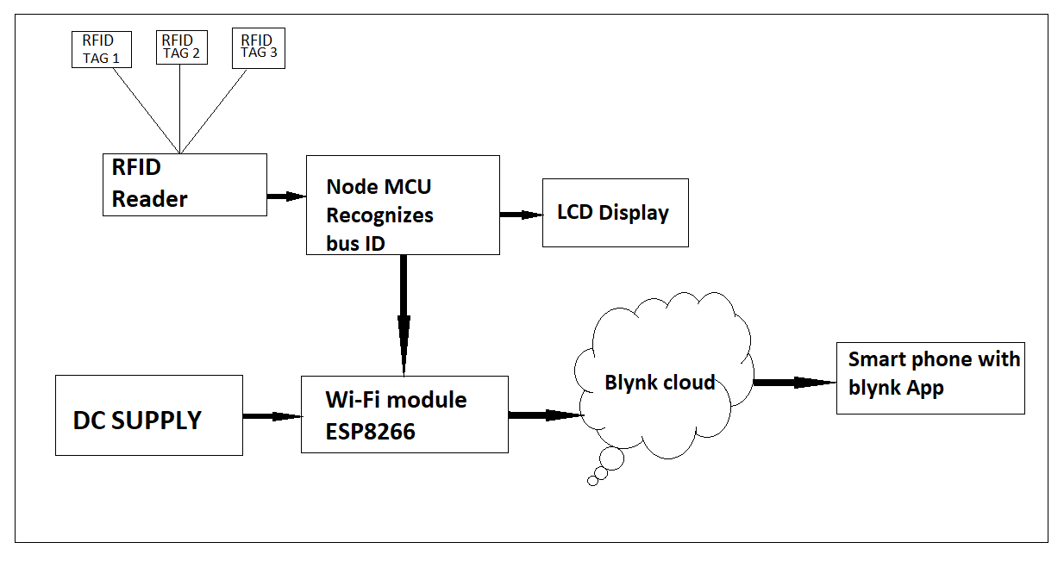

Fig 1: Block Diagram of Bus Tracking System

The presented work utilizes NodeMCU instead of Arduino, offering faster communication due to its integrated Wi-Fi module. Blynk cloud service is used for IoT connectivity, providing advanced real-time updates for bus tracking, which is more efficient than the Things peak web server. Three modifications were made compared to existing work to enhance real-time monitoring and improve detection in an IoT environment.

The proposed framework consists of two modules: the detecting module and the IoT application. The detecting module includes a HF-RFID unit to detect the bus when it arrives at a bus station. The IoT application serves as the user interface and provides location updates to passengers. The framework is divided into three sections: the bus unit, the central processing unit, and the IoT application. The bus unit contains RFID tags inside the bus and an RFID receiver placed outside the bus. The RFID tags are placed at different locations within the bus, and the RFID receiver detects the bus's arrival and departure at bus stops. The central processing unit consists of NodeMCU, which processes data received from various modules. The IoT application is developed using the Blynk platform, offering a user-friendly interface and easy access to the system. When the bus arrives at a particular bus stop, the RFID receiver detects the unique code on the RFID tag. The NodeMCU then sends the bus code information, along with the bus stop ID and time, to the Blynk cloud. People waiting at other bus stops can use the Blynk application to check the bus status. The Android application displays the current bus stop and the next bus stop that the bus will reach. The proposed system provides flexibility and scalability by incorporating a database containing bus information to ensure accurate arrival times.

* 1. **Components used:**

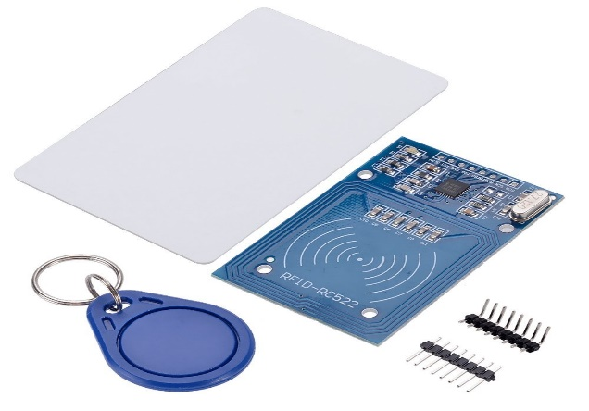 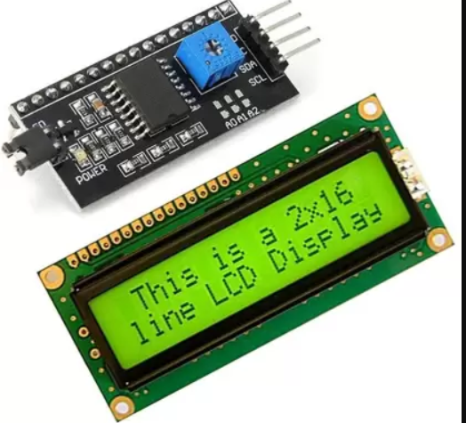

Fig 2: RFID Reader With Tag Fig 3: 16x2 LCD Display

Fig 4: Wi-Fi Module

1. **RESULTS AND DISCUSSION**

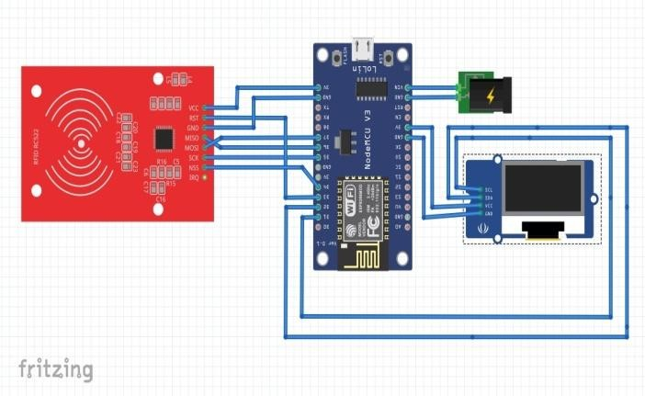

Fig 5: Prototype of Bus Tracking System

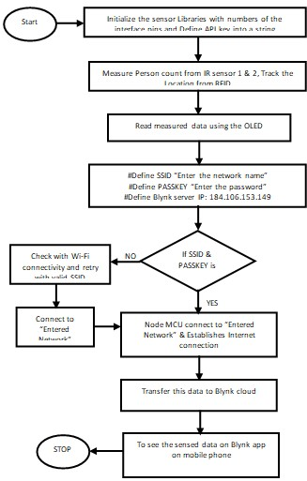

Fig 6: Flowchart of Proposed System

The proposed work's working flow is depicted in Figure 6. The system aims to operate autonomously, minimizing the need for human intervention and reducing the potential for errors. The main components of the system include the Bus module, processing unit, and user interface (UI). The UI is designed using the Blynk platform, an IoT application that facilitates user interaction. Initially, the system remains inactive until the target (bus) is detected. Once the target is identified, a signal is sent to the processing unit, which receives outputs from the RFID unit containing unique RFID tags placed at the front and back of the buses, as well as responses from the RFID transmitter. Each bus is assigned a unique 12-bit ID, which is transmitted to the processing unit along with the bus's location information tracked by Blynk. Additionally, a timestamp is included to indicate the arrival and running time of the bus at the bus station. The system also provides information about the next bus stop that will be reached. This feature enables users to have a clear understanding of the bus's current and upcoming locations, providing flexibility in choosing alternative buses for timely access. To ensure accuracy and facilitate the optimal arrival of buses, the bus's location, along with its ID or route number, is continuously updated and communicated to authorized individuals or websites through notification services offered by the IoT cloud. The application interface is designed to cater to users of all age groups, providing the best possible user experience.

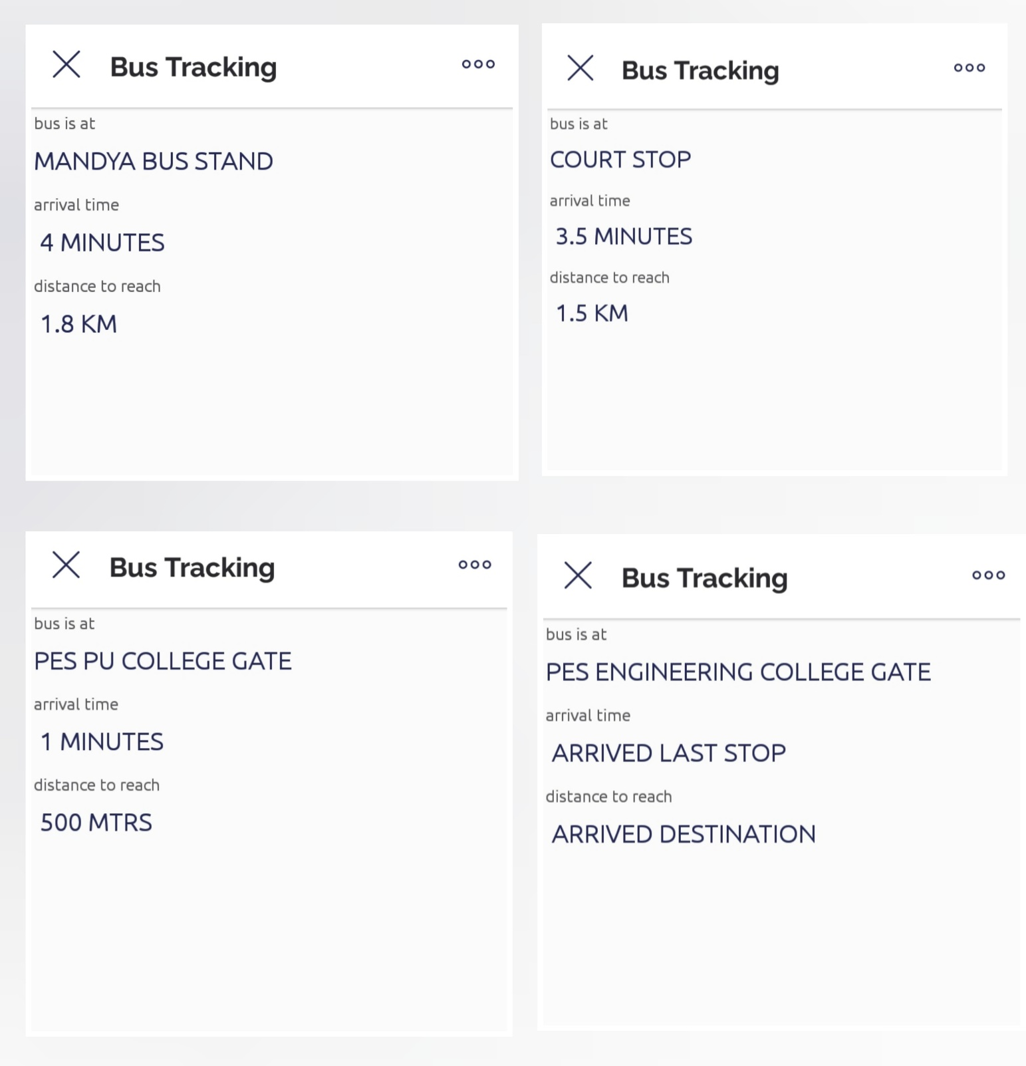

Fig 7: Bus Tracking on Blink App

1. **CONCLUSION**

In conclusion, the implementation of a high-frequency RFID-based real-time bus tracking system offers numerous benefits for efficient and reliable public transportation. By using NodeMCU and Blynk cloud service, the system provides faster communication, advanced real-time updates, and a user-friendly interface. The integration of HF-RFID technology enables accurate detection of buses at bus stops, allowing for precise tracking of their movement and locations. Passengers can conveniently access the bus's location, estimated distance, and arrival time through the mobile application. The proposed system enhances the overall efficiency of public transportation by providing real-time information and reducing waiting times. It improves the probability of detection and monitoring in an IoT environment, making it a valuable solution for smart cities and transportation systems. With the successful implementation of this real-time bus tracking system, it is evident that RFID technology, combined with IoT connectivity, can significantly enhance the management and accessibility of public transportation services. Future enhancements and optimizations can be explored to further improve the system's performance and expand its capabilities in meeting the evolving needs of urban transportation.

1. **REFERENCES**
2. Deebika Shree, J. Anusuya and S. Malathy, "Continuous Bus Tracking and Location Updation System," 2019 fifth International Conference on Advanced Computing and Communication Systems (ICACCS), Coimbatore, India, 2019, pp. 242-245.
3. P. A. Kamble and R. A. Vatti, "Bus following and checking to utilize RFID," 2017 Fourth International Conference on Image Information Processing (ICIIP), Shimla, 2017, pp. 1-6.
4. T. Lindgren, B. Kvarnström and J. Ekman, "Monte Carlo reenactment of a radio recurrence recognizable proof framework with moving transponders utilizing the fractional component equal circuit technique," in IET Microwaves, Antennas and Propagation, vol. 4, no. 12, pp. 2069-2076, December 2010.
5. A. Habadi and Y. S. Abu Abdullah, "Keen Safety School Buses System Using RFID and Carbon Dioxide Detection," 2018 first International Conference on Computer Applications and Information Security (ICCAIS), Riyadh, 2018, pp. 1-7.
6. Sarah Aimi Saad, Amirah 'Aisha Badrul Hisham, Mohamad Hafiz Izran Ishak, Mohd Husaini Mohd Fauzi, Muhammad Ariff Baharudin, Nurul Hawaii Idris "Continuous on-Campus Public Transportation Monitoring System " IEEE fourteenth International Colloquium on Signal Processing and its Applications (CSPA 2018), 9 - 10 March 2018.
7. Darshan Ingle, Dr A. B. Bagwan " Real-Time Analysis and Simulation of Efficient Bus Monitoring System" second international meeting on Electronics, Communication and Aerospace Technology (ICEC 2018)
8. Manini Kumbhar, Meghana Surface, Pratibha Mastud, Avdhut Salunke " Real-Time Web-Based Bus Tracking System" IRJET-International Research Journal of Engineering and Technology, Volume: 03| Issue: 02 | Feb-2016
9. Nusrath Jahan, Kamal Hossein and Muhammad Kamrul, Hossain Patwary "Execution of a Vehicle Tracking System utilizing Smartphone and SMS administration" 2017 fourth International Conference on Advances in Electrical Engineering (ICAEE) 28-30 September.
10. Jerrin George James, Sreekumar Nair "Effective, Real-time Tracking of Public Transport, Using LoRa WAN and RF Transceivers" Proc. of the 2017 IEEE Region 10 Conference (TENCON), Malaysia, November 5-8, 2017, 11. Leeza Singla, Dr Parteek Bhatia "GPS Based Bus Tracking System" IEEE International Conference on Computer, Communication and Control (IC4-2015).