PROBLEMS AND CHALLENGES FACED BY THE FRESHERS DURING GETTING THEIR FIRST JOB:

A LITERATURE REVIEW

Madhumanjuri Ghosh

Student, Pune Institute of Management Studies (PIMS)

ABSTRACT

In today’s world getting a job is the most valuable & prestigious thing for a student. Cause a job is the only thing that gives them a dream full-filled life. So after completing their degree either it is Graduation or Engineering, or maybe MBA they want to have a high package salary job. But the reality is quite harsh because no one doesn’t want to accept a newly fresh Graduate candidate. The employer always has a huge amount of dough about freshers and their abilities. According to them, freshers have only degrees but do not have communication skills, practical knowledge, or technical knowledge as per the organization’s needs, and demands. So in reality, it is very risky for any organization. Somehow if they get a job then it will be a low salary package and below their expectations. The present paper aims to study the kinds of problems and challenges faced by freshers during their first job. This study is quantitative in nature, where the responses of 50 students and working employees in various organization sectors have been taken from that we can understand the strength and weaknesses of the freshers in which particular area they need to improve

Keywords: Engineering and MBA Graduates, soft skills recruitment, Selection &recruitment problem, organization’s need & demands.

**INTRODUCTION:-**

The main motive of this theoretical paper is to discourse some difficulties with the necessary employability abilities for freshers graduates. And give some guidance about how they should improve their skills to become more “Employable”

In this paper, we can see how our higher education system makes students only degree-based puppets instead of skills-oriented job seekers, which makes them incompetent in getting their first job.

Every organization is now directly competing due to globalization in all areas of its survival. Therefore, to meet the market’s needs and wants, they require a high-level qualified full applicant who can easily handle all those issues and challenges as a big component of the organization.

Due to the enormous evaluation of technology, the nature of work, businesses, and employment have changed.

Employers all over the world demand highly technology-based skilled full candidates. But they face disappointment again and again.

According to them, there is a huge gap between academic knowledge and skills that accurately company desires according to the current market’s needs and demands.

communication skills, the latest technology, and decision-making power in every aspect.

So it is very challenging for employers to hire a fresher as per the current scenario.

Companies are putting more effort into improving their interview methods and tactics in response to shifting market conditions in order to accomplish recruitment goals and uphold the fairness and efficiency of the interviewing process.

The technological advancement in job responsibilities and the demand for skill-based (as opposed to degree-based) candidates are the driving forces behind this transformation in the recruitment process. But a recent study said that around 80% of freshers cannot clear their basic interview for getting their first job because they have very poor communication and technical skills. So freshers have to face lots of challenges and difficulties.

**Literature Review**

The problems and challenges facing today's fresh Graduates are quite different from their previous generation. According to them the first few years after Graduation is very challenging and stressful. Altho they are ready to accept this kind of stressful situation. They might think that getting a Graduate degree is a golden milestone in their life. But as newly freshers candidates don't know about the outside competitive world and how to utilize their skills and competency. So failure creates a huge negative impact on their minds. **Steve Conn (2010).**

Not only freshers are facing problems and challenges but recruiters also face problems and challenges in hiring freshers candidates. As per the HR recruiters, fresher's candidates do not have that many skills and competencies required for the job. Like mindblowing communication, critical thinking ability, problem-solving ability, leadership skills adaptability power, etc. When there is recruitment for a startup company recruiters always want an experienced candidate because they want to grow faster than others. And for this reason, they can only rely on experienced people because they have all the skills and competency that the company needs. So automatically freshers are getting rejected **(Gethe R.K.et.al, 2019).**

A newly fresh Graduate Candidate should be very careful and skillful in every required aspect for getting their entry-level job. These skills not only help them to get their first job but also help to sustain their job and also help them to overcome all kinds of work field pressure and challenges. This study also states that the relationship between the universities and the various working sectors needs to be very healthy. So this kind of working sector conveys their messages, needs, and demands from the fresh Graduate students to the Universities. So that universities can build the students. And they may not be faced with any challenges in getting their first job. **(Thi Tuyet June Tran2008)**

we can see a positive side of hiring a new fresh Graduate candidate. Some organization sectors prefer freshers Graduate candidates. According to them, freshers are full of creative and enthusiastic. They are fully loaded with the latest technological skills in comparison to old staff. They are like raw materials, organization can mold them according to their needs or requirements. Which can help the organization reach its destination. But sometimes it is seen that altho freshers are intelligent in every aspect of their job but they do not get the recognization they deserve. It creates a lot of mental pressure and stress. As they are new to the organization, do not know the work environment policies so some times they quit the job**. (Catherine Lissette Caballero 2010)**

The exact depth of the market demand for new fresh Graduate candidates in comparison to the whole job market and what skills and competencies satisfied Malaysian employers. According to this study, Malaysian employers want to chaque the background of the university. That means the student is from a foreign university or the local university. For this particular reason, the whole new fresh Graduate students category is divided into two parts. Employers things that a Foreign University fresh Graduate is much better than a local University student in every aspect like skills, knowledge, communication, etc. So for this reason the local Graduate candidate loses their opportunity altho they are also very capable of the job. So this kind of biasness sometimes creates huge mental backwardness and unsatisfied feelings among the local but talented Graduate candidates**. ( Seibu Mary Jacob, Lee Miin Huui and Su Sueh Ing 2006)**

That every high-degree holder Graduate student either an Engineer or MBA wants a high salary after getting their Degree. But the irony is either they are not getting their first job as they are expected or getting their first job but with a low package salary. According to the employers, the reason behind this is they want skills and knowledge rather than conventional Degrees. Altho MBA and Engineering a high degree in comparison to others but an MBA student or an Engineer needs additional skills and bits of knowledge because of the Globalization Era. The Employers say that business schools and engineering colleges try to train their students according to the company's needs and demands. But some students are so stubborn that they don't want to improve themself. Cause they think that they pay lots of money in their colleges to get their so-called degree so it's the college's responsibility to get them placed in a reputed organization. So they don't give that much effort to build themself or enhance their skills, knowledge, and communication. So employers have to reject this kind of High-Degree holder but ineffective candidates. That means if a fresh Graduate candidate wants to build a magnificent career then he/she must improve skills, knowledge, and communication if not in today's era it doesn't matter if you are MBA or an Engineer. **(Rajashree K. Gethe1, Mahesh S. Hulage2*)**

there is some kind of problems and challenges freshers faces in their first job. 1st problem is -- Lack of job preparation-- this kind of situation makes Employers soo unbearable. They complain that sometimes freshers candidates are not fully prepared for their interviews. They don’t know about the organization or job description, as well as their communication skills are very low. Also, they have very poor knowledge about their Domen. So in this kind of situation, the employers deny recruiting freshers and go for the experienced ones to save their money, time, as well as the organization’s reputation. 2nd Resignation within six months ----today’s generations are too fast. They want money as soon as possible. So after getting the job and gathering some experience they switched to a new organization for getting more money and exposure. On the other hand, sometimes freshers can’t handle the pressure. So they quit their job. 3rd Poor marketing skills ----- as a fresher they don’t know how to deal with clients and customers. And they face huge difficulties. 4th --- Lack of presentations skills ----As Freshers have difficulties with communicating in front of everyone so it is very obvious that they lack presentation skills which are not acceptable by the company But in that case, Freshers are victims of today’s education systems. Because it’s all about theoretical knowledge rather than practical company’s need-oriented knowledge**. (INDIA TODAY)**

The author says that shyness and fairness to express their point of view in front of everyone is one of the topmost problems of freshers. As they newly joined employ so they don’t know how to deal with seniors and how to express their thoughts, their skills, and knowledge confidently. which creates low self-estimates among themselves. And this is not a good sign for their bright career and opportunities. As they can’t express themselves so they can’t ask questions of their higher authorities. That creates a huge gap between expressing and learning things. That’s not good for freshers at all. So the author of this article suggests to every fresher that be bold and confident and ask whatever they want to ask in front of their seniors. Because there is no space for hesitation in learning. (**FPS JOBS)**

The current awful situation of B-schools in India. Most of the schools are under expectation and have very low-quality teaching styles. Most of the teachers are not fully trained, they don’t know how to train a management student. And the reason behind this is the teacher’s background. There are many teachers who failed in their corporate careers, so they switched to teaching careers only for the low amount of salary, so that they can survive. Naturally when colleges appointed this kind of teacher creates a very big blander in the student’s career. Also, some colleges are not following Government protocol so Govt. needs to shut down these kinds of colleges. As a result, students from these colleges were affected very badly. Because neither they are accepted by any other colleges or the corporate world. For avoiding this kind of situation B-School has to improve its infrastructure, and teaching style, and follow all the Govt. protocols, rules, and responsibilities. And the most important thing is that the teaching style should be corporate needs and demand-oriented not the old theoretical pattern. B-School should remember that they are the creator of future Leaders so they have to be very careful and honest in their path. **(The Hindu businessline)**

Information Technology (IT) Companies in hiring freshers Graduate candidates. Although the IT sector is the only sector in India that recruit huge numbers of freshers every year. But the present scenarios are a little bit different from the previous scenario. Now the IT recruiters are quite concerned when it comes to hair a fresh candidate. Because as we all know that IT deals with clients who give them projects. And these clients don’t want that their projects will handle by a new freshly joined employee. According to them, freshers don’t have that much knowledge, skills, or mental ability to handle a big responsibility. So they always do complaining when it comes to freshers. IT recruiters also agree with this reason, they say that today’s freshers do not have enough skills, and knowledge that corporate seeks. Also, they are still in their college life carefree mood so don’t want to understand the work’s responsibility and corporate rules and regulations. So these 9-5 job schedule is a big burden for them. They don’t want to compromise their freedom. As a result, work-life balance is very difficult for them and sometimes they quit their job within 6 months. Which is not acceptable for any organization. So there is a direct message from the IT recruiters to the freshers that be professional during their college life because this is the time when they can enhance themselves with skills, knowledge, and technology. So they can snatch their rights and build a very bright yet powerful career**. (Gunjan Malhotra)**

The problems, challenges, and difficulties faced by commerce students. And what is the major plus point of this stream? Basically, we know that after 10th students go for their specialized stream either science, arts, or maybe commerce. Previously commerce students’ opportunity was limited. They just did their B.Com either in Accountancy or Management. As the opportunities are very low so they can’t get their job. But now times are completely changed. Students are doing specialization in Bachelor in Accountancy and Finance (BAF), Bachelor in Banking and Insurance (BBI), and Bachelor in Financial Markets (BFM). They know very well what is business. How threads are done What is the current situation of Indian Economics? What is the demand of Govt and private sectors? The good thing is both Govt. and corporate can understand the potential of commerce students. Because of globalization both in Govt. and private sectors commerce students’ demands are huge. They know that commerce can be a good Bank manager, Insurance officer, Consultant, CA, or a highly efficient corporate executive. In both filed they do their best and earn a high package salary.

**( Latasha Mohapatra and Bharat Kumar Maher(2018)**

The thinking and expectation of employers during hiring Graduate candidates. According to the study, this thinking pattern Varies according to the company’s size and the number of employees working there. The small company where employees are less than 100 prefer smart, good communication skills, presentable, and confident candidates rather than those with good educational qualifications. Because the company knows that as they are new in the market so needs that kind of employee who can easily spread its company name among the market. So they prefer smart and intellectual candidates. The second fact is the company has more than 100 employees but less than 1000 employees prefer team-working skills. This type of company is in its growth phase, they are growing day by day. So their employee should be cool-minded, team workers, who work as a team in every aspect of the company’s needs and welfare. And the big companies are the big and powerful catfish in the mud. Their expectation is high. First of all, they don’t want to hire a fresh Graduate candidate because for them it is very time-consuming and costly. They don’t have that much time to train a fresh candidate. So always prefers an experienced candidate who is fully loaded with good communication skills, technology, industry rules, and regulations, and is flexible. Who knows how to deal with the public and customers, and how to manage the work-life balance. So freshers candidates must be prepared themselves mentally and emotionally according to the company’s position in the market. **(Authors: Will Archer and Jess Davison with editorial support from Richard Brown and Keith Herrmann)**

The difficulties faced by freshers during their first job. 1st they can’t express their thoughts about a particular topic in front of their boss or higher authorities. 2nd the freshers don’t know how to do their job professionally, and as a result, sometimes they fail to complete their tasks within the deadline. Naturally, they are getting scolded by their boss which creates dissatisfaction in their job. 3rd Freshers do have not very good communication skills, and technical skills and don’t know how to use the latest software and technology. As a result, they miss being a part of every goods project which is not pleasant for their career. 4th can’t adjust to long working hours and are unable to work-life balance. 5th freshers don’t know to build strong make contacts with their seniors, boss, and clients so sometimes they feel left alone and creating a huge mental pressure. Which is not good for their mental peace. **(Shatavisha** **Chakravorty)**

Some advice to the freshers who just joined the company. Here are some dos & don’t rule for the freshers during their first week in the organization. 1st as a fresher it is very difficult to cope with their co-workers and fellow team members. So they can’t catch up with the speed of the work, also they lack knowledge. so they have to gather lots of information about their work and feel himself a fully loaded machine and become frustrated. But the author says that don’t take stress and frustrated. Just stay cum and after the working hours just go through with all the work as homework. As a result, you can understand all the processes and can cooperate with your team members. 2nd some times it has been observed that freshers don’t get any kind of work in their first week and there are different reasons behind it. Maybe sometimes seniors are too much busy, they have lots of work. So they can’t give attention to the freshers. The Author says that don’t be disheartened just observe them and their work and try to learn some things. 3rd always be humble and respectful to your seniors, and co-workers. 4th try to work-life balance, complete all your task before the deadline. 5th follow the dress code. 6th try to make connections. 7th don’t be overconfident and last but not least 8th follow the company’s rules and regulations and culture. Always be on time.

**(Nicole Fallon)**

Higher education like MBA, PGDM, Ph.D., and other degrees are very important for both corporate and Govt. sectors. These kinds of high degree holder candidates are very appreciated by both sectors so their demand is too high. So automatically every student wants to pursue this kind of high degree. But the problem is money because this kind of degree is very costly. Students who are wealthy can easily afford this kind of degree. But those who do not mainly depend on Banks. In this scenario, Banks Loan comes under the picture. According to the Govt. of India and Reserve Bank of India’s rules, these kinds of students are eligible for Education Loans. Altho education loans are also very costly nowadays. Students have to pay a high rate of interest, also providing all the documents related to their parents, previous education details, types of universities, etc. But as it is a need of the students so they take the loan. Recently some studies say that average MBA students take around 8-10 lakes education loans for their studies. And if it is in a foreign university then the amount of the loan varies from 20-25 lakhs. But the challenges come under the picture during student’s placement time. Every student wants to high package salary so they can repay their loan as soon as possible. Because this loan amount is a huge burden for them. As we all know salary package is depends on studen's own capabilities. So, for freshers who are not getting a high-package job, these bank loans are quite stressful for them. **(Rajashree Gethe and Mahesh Hulage)**

**Research Methodology**

**Area of Research:** HR

**Sources for the Data:**

**Primary Data:** Primary data will be collected through face-to-face interviews with the candidate, telephonic interviews, or sharing Google link survey form for getting the responses from the prospective respondents.

**Secondary Data:** Collected through various research papers published related toproblems and challenges faced by the freshers while getting their first job in National and Internal Levels Journals.

**Sampling Technique:** Probability Random sampling technique will be used

**Sample Size:** For this research, we received 65 responses

**Data Analysis:**

Data will be analyzed in terms of percentage analysis and will be presented in bar charts, Pie charts, and, histograms.

**DATA ANALYSIS AND INTERPRETATION**

No Respondents = 65

**Specify your age**

**Table No: 1 Specify your age**

|  |  |  |
| --- | --- | --- |
| **Age** | **No of Respondents** | **Percentage** |
| 10-20 | 4 | 6.2% |
| 21-30 | 48 | 78.8% |
| 31-40 | 10 | 15.4% |
| 41-50 | 3 | 3.6% |

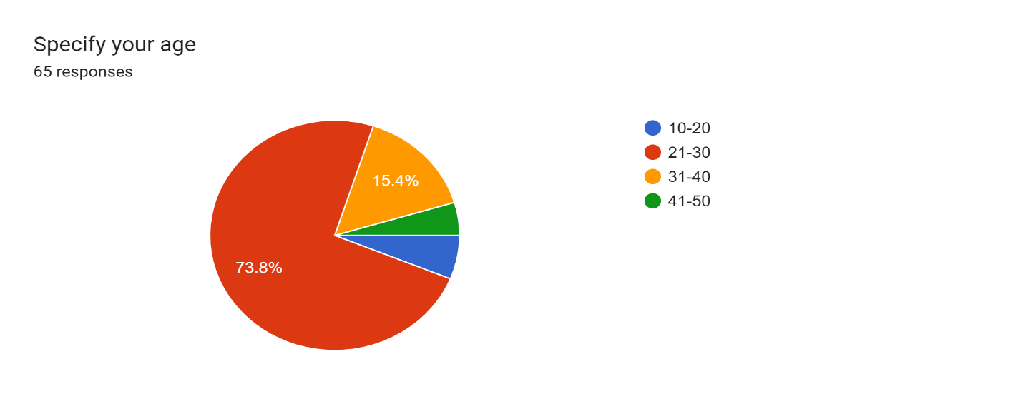

**Chart 1: Specify your age**

**Interpretation:**

According to the Graph above 78.8% of respondents are within the 21-30 age group.15.4% of respondents are within the 31-40 age group. 6.2% of respondents are within the 10-20 age group. 3.6% 0f respondents are within the 41-50 age group.

**Specify your Gender**

**Table No: 2 Specify your Gender**

|  |  |  |
| --- | --- | --- |
| **Gender** | **No of Respondents** | **Percentage** |
| Male | 46 | 70.8% |
| Female | 19 | 29.2% |

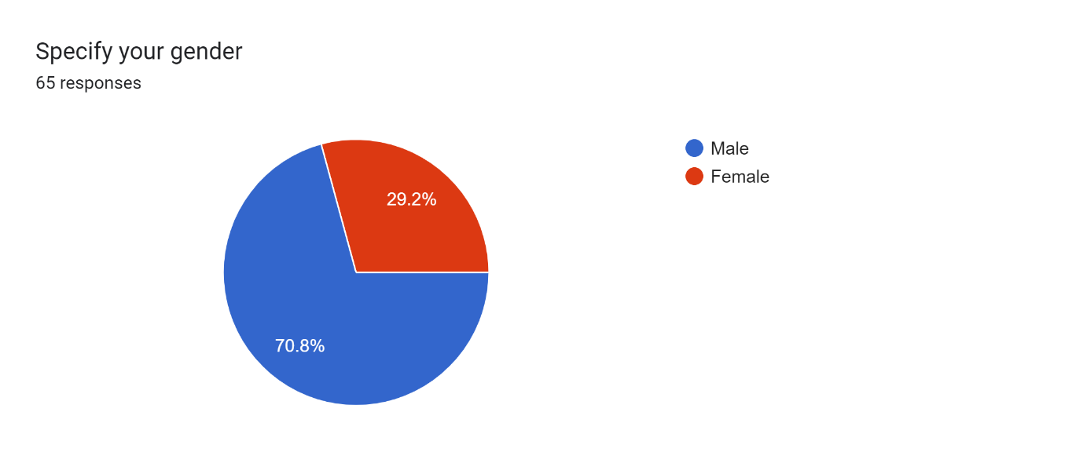

**Chart 2: Specify your Gender**

**Interpretation:**

According to this Graph, 70.8% of respondents are male and 29.2 of % of respondents are female. It represents that there are more male respondents than female respondents.

**Specify your qualification**

**Table No: 3 Specify your qualification**

|  |  |  |
| --- | --- | --- |
| **Qualification** | **No of Respondents** | **Percentage** |
| BA/B.Sc /B.Com | 28 | 43.1% |
| Engineering (B.E / B.Tech.) | 10 | 15.4% |
| MA/M.Sc/M.Com | 4 | 6.4% |
| MCA | 1 | 1.5% |
| MBA/PGDM | 22 | 33.8% |

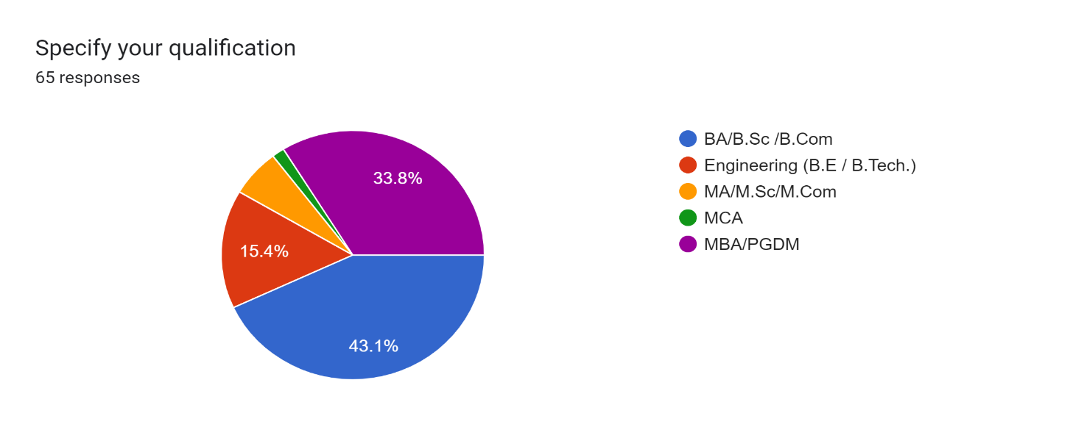

**Chart 3: Specify your Qualification**

**Interpretation:**

According to the Graph above 43.1% of respondents are from BA/B.Sc/B.Com background. 33.8% of respondents are from MBA/PGDM.15.4% of respondents are Engineers. 6.4% of respondents are from MA/M.Sc/M.Com backgrounds, and only 1.5% of respondents are from MCA backgrounds.

**Do you know how to prepare the resume for getting a job?**

**Table No: 4 Do you know how to prepare the resume for getting a job**

|  |  |  |
| --- | --- | --- |
| **Do you know how to prepare the resume** | **No of Respondents** | **Percentage** |
| Yes | 45 | 69.2% |
| No | 8 | 12.3% |
| Maybe | 12 | 18.5% |

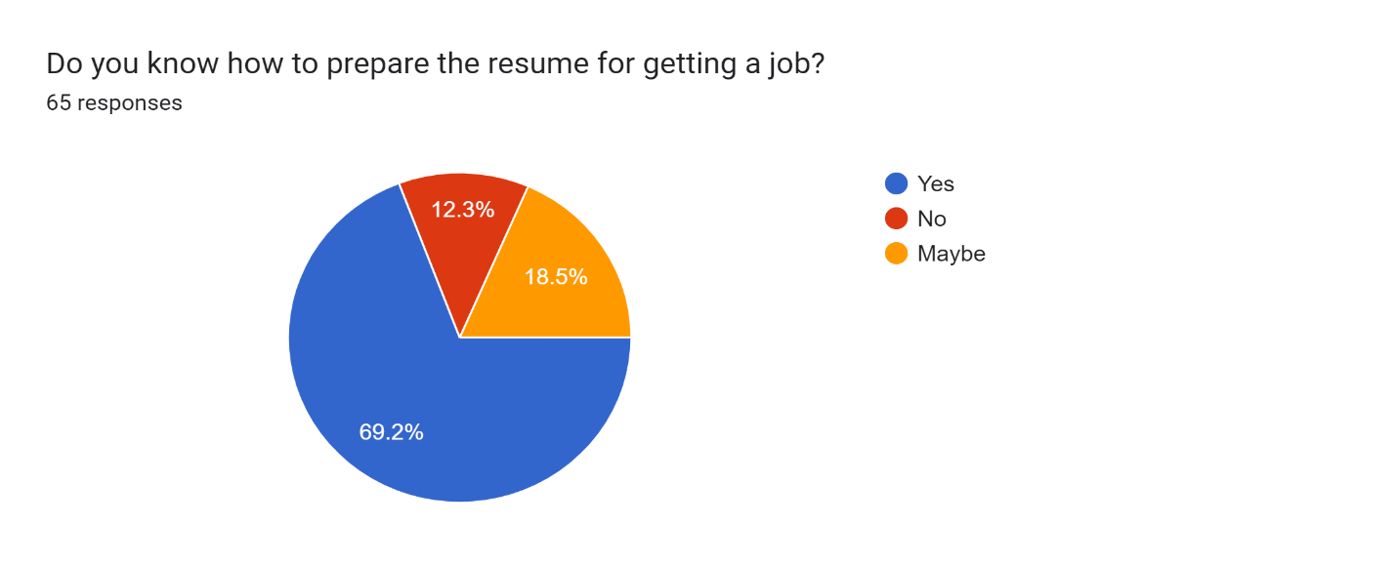

**Chart 4: Do you know how to prepare the resume for getting a job**

**Interpretation:**

According to this Graph, 69.2% of respondents know how to prepare a resume for getting a job. 12.3% of respondents don’t know how to prepare a resume. And 18.5% of respondents are not sure how to prepare a resume for getting a job.

**What type of skills do you think are important for getting a job?**

**Table No: 5 What type of skills do you think are important for getting a job**

Communication skills Command over core technical skills Practical Exposure (like projects, internships) Presentation skills

|  |  |  |
| --- | --- | --- |
| **Skills** | **No of Respondents** | **Percentage** |
| Communication skills | 54 | 83.1% |
| Command over core technical skills | 32 | 49.2% |
| Practical Exposure (like projects, internships) | 43 | 66.2% |
| Presentation skills | 33 | 50.8% |

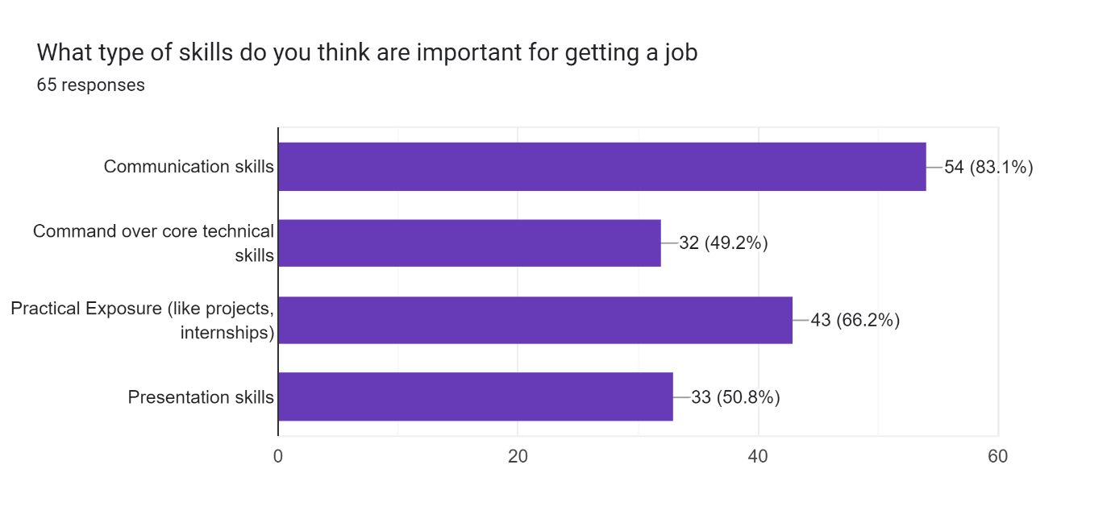

**Chart 5: What type of skills do you think are important for getting a job**

**Interpretation:**

According to this Graph among 65 respondents around 54 (83.1%) of respondents think communication skills are important. Around 32 (49.2%) of respondents think command over core technical skills is important. 43 (66.2%) of respondents think practical exposure (like projects, internship) skills are important. 33 (50.8%) of respondents think presentation skills are important.

**Kindly rate this skills required as per importance (1- Least important, 2- Slightly important, 3- important, 4- fairly important, 5- Very Important**

Table No: 6. A. Technical Skills

|  |  |  |
| --- | --- | --- |
| **Criteria** | **No of Respondents** | **Percentage** |
| Least important | 3 | 4.61% |
| Slightly important, | 10 | 15.38% |
| Important, | 9 | 13.84% |
| Fairly important, | 23 | 35.38% |
| Very Important | 20 | 30.76% |

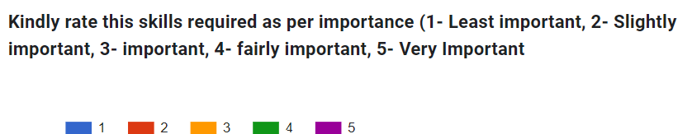

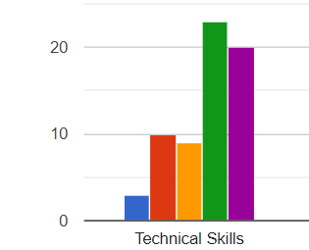

**Chart No: 6. A. Technical Skills**

**Interpretation:**

According to the Graph above 35.38% of respondents think that technical Skills are Fairly Important. 30.76% of respondents think that technical skills are Very Important. 15.38% of respondents think that technical skills are Slightly Important.13.84% of respondents think that technical skills are Important. 4.61% of respondents think that technical skills are the Least Important.

**Table No: 6. B. Oral/Written Communication Skills**

|  |  |  |
| --- | --- | --- |
| **Criteria** | **No of Respondents** | **Percentage** |
| Least important | 3 | 4.61% |
| Slightly important, | 6 | 9.23% |
| Important, | 14 | 21.53% |
| Fairly important, | 16 | 24.61% |
| Very Important | 26 | 40% |



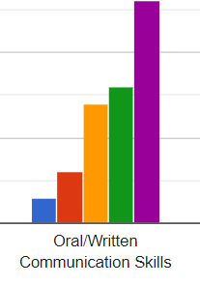

**Chart No: 6. B. Oral/Written Communication Skills**

**Interpretation:**

According to the Graph above 40% of respondents think that Oral/Written Communication Skills are Very Important. 24.61% of respondents think that Oral/Written Communication skills are Fairly Important. 21.53% of respondents think that Oral/Written Communication skills are Important.9.23% of respondents think that Oral/Written Communication skills are Slightly Important. 4.61% of respondents think that skills Oral/Written Communication skills are the Least Important

**Table No: 6. C Problem Solving &Analytical Thinking Skills**

|  |  |  |
| --- | --- | --- |
| **Criteria** | **No of Respondents** | **Percentage** |
| Least important | 2 | 3.07% |
| Slightly important, | 5 | 7.69% |
| Important, | 17 | 26.15% |
| Fairly important, | 21 | 32.30% |
| Very Important | 20 | 30.76% |



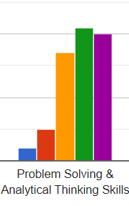

**Chart No: 6. C Problem Solving &Analytical Thinking Skills**

**Interpretation:**

According to the Graph above 32.30% of respondents think that Problem Solving &Analytical ThinkingSkills are the Least Important. 30.76% of respondents think that Problem Solving &Analytical Thinkingskills are Fairly Important. 26.15% of respondents think that Problem Solving &Analytical Thinking skills are Important. 7.69% of respondents think that Problem Solving &Analytical Thinking skills are Slightly Important. 3.07% of respondents think that Problem Solving &Analytical Thinking skills are the Least Important**.**

**Table No: 6. D Logical Reasoning Ability**

|  |  |  |
| --- | --- | --- |
| **Criteria** | **No of Respondents** | **Percentage** |
| Least important | 2 | 3.07% |
| Slightly important, | 12 | 18.46% |
| Important, | 15 | 23.07% |
| Fairly important, | 17 | 26.15% |
| Very Important | 19 | 29.23% |



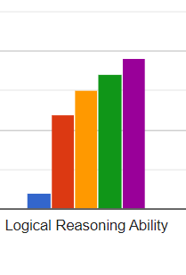

**Chart No: 6. D Logical Reasoning Ability**

**Interpretation:**

According to the Graph above 29.23% of respondents think that logical reasoning ability is Very Important. 26.15% of respondents think that logical reasoning ability is Fairly Important. 23.07% of respondents think that these skills are Important. 18.46% of respondents think that these skills are Slightly Important. 3.07% of respondents think that logical reasoning ability is the Least Important.

**Table No: 6. E MS Office/Personal Skills**

|  |  |  |
| --- | --- | --- |
| **Criteria** | **No of Respondents** | **Percentage** |
| Least important | 2 | 3.07% |
| Slightly important, | 10 | 15.38% |
| Important, | 15 | 23.07% |
| Fairly important, | 18 | 27.69% |
| Very Important | 20 | 30.76% |



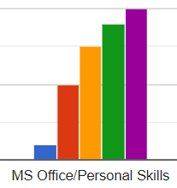

**Chart No: 6. E MS Office/Personal Skills**

**Interpretation:**

According to the Graph above 30.76% of respondents think that MS Office/Personal skill is Very Important. 27.69% of respondents think that MS Office/Personal skill is Fairly Important. 23.07% of respondents think that these skills are Important. 15.38% of respondents think that these skills are Slightly Important. 3.07% of respondents think that MS Office/Personal Skill is the Least Important.

**Do you think additional skills (i.e. skills which are not the part of your core degree/education) are important**

**Table No: 7. Do you think additional skills (i.e. skills which are not the part of your core degree/education) are important**

|  |  |  |
| --- | --- | --- |
| **Do you think additional skills are important** | **No of Respondents** | **Percentage** |
| Yes | 40 | 61.5% |
| No | 4 | 6.2% |
| Maybe | 21 | 32.3% |

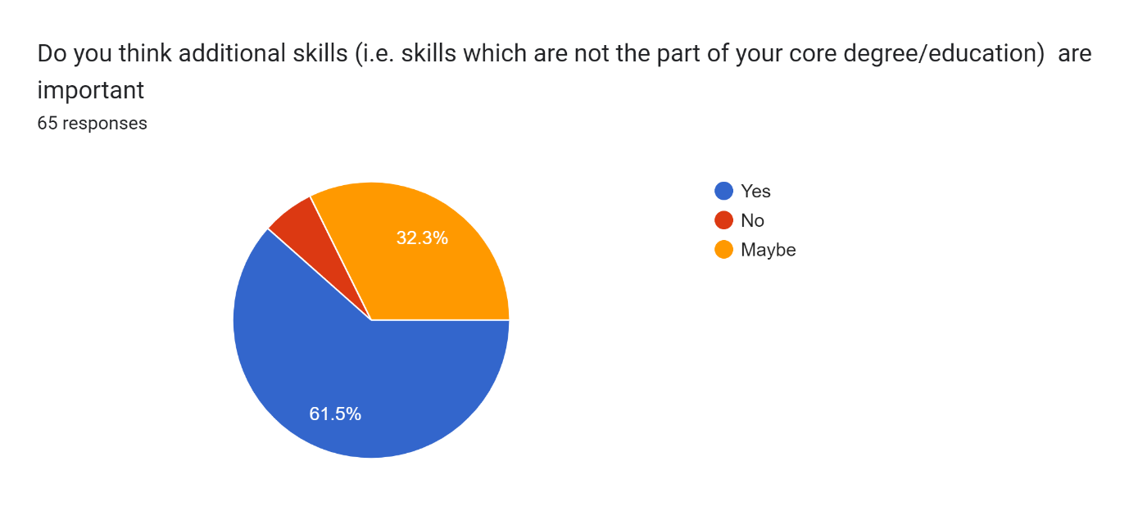

**Chart No: 7. Do you think additional skills (i.e. skills which are not the part of your core degree/education) are important**

**Interpretation:**

According to this Graph, 61.5% of respondents think that additional skills are important. 6.2% of respondents think that additional skills are not important. 32. 3% of respondents were not sure about that.

**Do you think that today's freshers are lacking in skills? kindly rate the skills which they are lacking**

**Table No: 8. A**. **Adaptability to situation and openness to learning**

|  |  |  |
| --- | --- | --- |
| **Criteria** | **No of Respondents** | **Percentage** |
| Strongly Disagree | 8 | 12.30% |
| Disagree | 7 | 10.76% |
| Neutral | 27 | 41.53% |
| Agree | 18 | 27.69% |
| Strongly Agree | 5 | 7.69% |



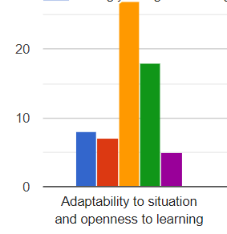

**Chart No: 8. A**. **Adaptability to situation and openness to learning**

**Interpretation:**

According to the Graph above 7.69% of respondents strongly Agree with Adaptability to situations and openness to learning. 27.69% of respondents Agree. 41.53% of respondents are Neutral. 10.76% of respondents disagree and 12.30% of respondents Strongly Disagree withAdaptability to situation and openness to learning.

**Table No: 8. B**. **Integrity and cultural fitment**

|  |  |  |
| --- | --- | --- |
| **Criteria** | **No of Respondents** | **Percentage** |
| Strongly Disagree | 6 | 9.23% |
| Disagree | 10 | 15.38% |
| Neutral | 26 | 40% |
| Agree | 20 | 30.76% |
| Strongly Agree | 3 | 4.61% |
|  |  |  |



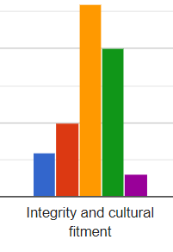

**Chart No: 8. B**. **Integrity and cultural fitment**

**Interpretation:**

According to the Graph above 30.76% of respondents agree with Integrity and Cultural Fiment. 15.38% of respondents disagree with Integrity and Cultural Fiment. 40% of them were neutral, while 9.23% of respondents strongly disagree and 4.61% of respondents strongly agree with Integrity and cultural fitment.

**Table No: 8.C**. **Team orientations**

|  |  |  |
| --- | --- | --- |
| **Criteria** | **No of Respondents** | **Percentage** |
| Strongly Disagree | 9 | 13.84% |
| Disagree | 5 | 7.69% |
| Neutral | 22 | 33.84% |
| Agree | 20 | 30.76% |
| Strongly Agree | 9 | 13.84% |



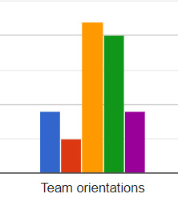

**Chart No: 8. C**. **Team orientations**

**Interpretation:**

According to the Graph above 30.76% of respondents are agree with Team Orientation. 33.84% of respondents are neutral toward Team Orientation. 13.84 % of respondents are strongly agree with Team Orientation. While 13.84% of respondents strongly disagree with Team Orientation. 7.69% of respondents disagree with Team Management.

**Table No: 8. D. Attentional to detail**

|  |  |  |
| --- | --- | --- |
| **Criteria** | **No of Respondents** | **Percentage** |
| Strongly Disagree | 7 | 10.76% |
| Disagree | 9 | 13.84% |
| Neutral | 20 | 30.76% |
| Agree | 20 | 30.76% |
| Strongly Agree | 9 | 13.84% |



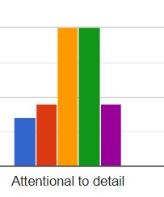

**Chart No: 8. D. Attentional to detail**

**Interpretation:**

According to the Graph above 30.76% of respondents are agree with Attentional to Detail.30.76% of respondents are neutral. 13.84% of respondents are strongly agree. Also, 13.84% of respondents are disagree with Attentional to Detail. And 10.76% of respondents are strongly disagree with Attentional to Detail.

**Table No: 8.E. Result orientation and ability to plan**

|  |  |  |
| --- | --- | --- |
| **Criteria** | **No of Respondents** | **Percentage** |
| Strongly Disagree | 5 | 7.69% |
| Disagree | 10 | 15.38% |
| Neutral | 19 | 29.23% |
| Agree | 21 | 32.30% |
| Strongly Agree | 10 | 15.38% |



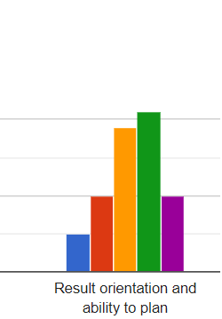

**Chart No: 8. E. Result orientation and ability to plan**

**Interpretation:**

According to this Graph 32.30% of respondents are agree with Result orientation and ability to plan. 29.23% of respondents are neutral. 15.38% of respondents are strongly agree with Result orientation and ability to plan.15.38% of respondents are strongly disagree with Result orientation and ability to plan. And 7.69% of respondents are disagree with Result orientation and ability to plan.

**Do you think that skill level is getting differ in freshers from metro city & non-metro city**

**Table No: 9. Do you think that skill level is getting differ in freshers from metro city & non-metro city**

|  |  |  |
| --- | --- | --- |
| **9 Do you think that skill level is getting differ in freshers from metro city & non-metro city** | **No of Respondents** | **Percentage** |
| Yes | 34 | 52.3% |
| No | 13 | 20% |
| Maybe | 18 | 27.7% |

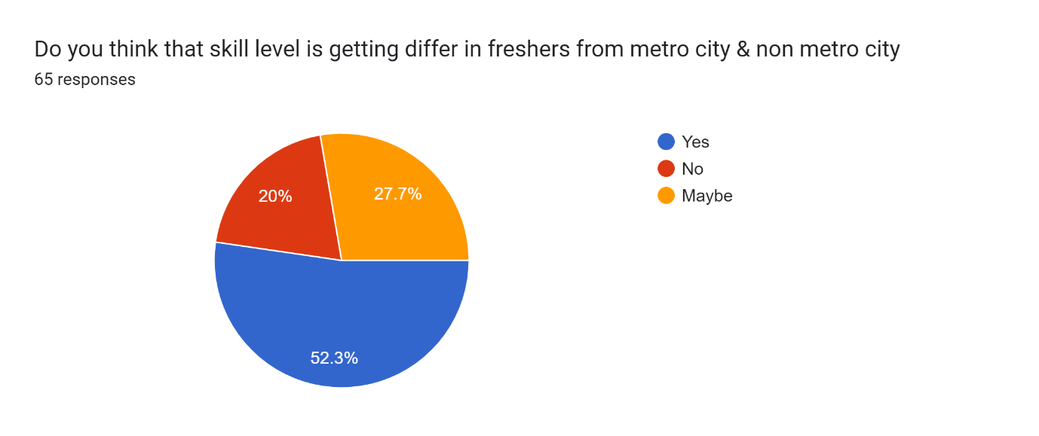

**Interpretation:**

According to this Graph, 52.3% of respondents think that skill level is getting different in freshers from metro city & non-metro city. 20% of respondents do not think so. And 27.7% of respondents are not sure about it.

**kindly rate the attitudinal issues of freshers**

**Table No: 10. A.** **Struggle with team dynamics**

|  |  |  |
| --- | --- | --- |
| **Criteria** | **No of Respondents** | **Percentage** |
| Strongly Disagree | 5 | 7.69% |
| Disagree | 10 | 15.38% |
| Neutral | 21 | 32.30% |
| Agree | 20 | 30.76% |
| Strongly Agree | 9 | 13.84% |



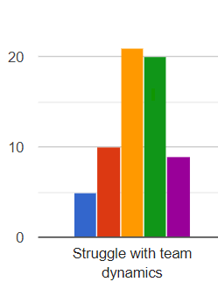

**Chart No: 10. A.** **Struggle with team dynamics**

**Interpretation:**

According to this Graph, above 32.30% of respondents are neutral. 30.76% of respondents agree with Struggle with team dynamics. 15.38% disagree with it. 13.84% of respondents strongly agree and 7.69% of respondents strongly disagree with Struggle with team dynamics.

**Table No: 10. B.** **Unable to meet work deadlines**

|  |  |  |
| --- | --- | --- |
| **Criteria** | **No of Respondents** | **Percentage** |
| Strongly Disagree | 8 | 7.69% |
| Disagree | 11 | 15.38% |
| Neutral | 22 | 33.84% |
| Agree | 21 | 32.30% |
| Strongly Agree | 3 | 13.84% |



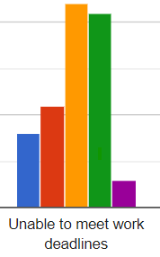

**Chart No: 10. B.** **Unable to meet work deadlines**

**Interpretation:**

According to the Graph above 32.30% of respondents are agree with Unable to meet work Deadlines. Where 33.84% of respondents are neutral. 15.38% of respondents are disagree while 13.84% of respondents are strongly agree with unable to meet work deadlines. And 7.69% of respondents strongly disagree with it.

**Table No: 10. C**. **Inflated option about own Capabilities**

|  |  |  |
| --- | --- | --- |
| **Criteria** | **No of Respondents** | **Percentage** |
| Strongly Disagree | 6 | 9.23% |
| Disagree | 13 | 20% |
| Neutral | 22 | 33.84% |
| Agree | 14 | 21.15% |
| Strongly Agree | 10 | 15.38% |



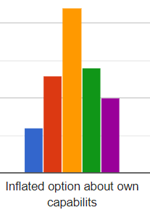

**Chart No: 10. C**. **Inflated option about own Capabilities**

**Interpretation:**

According to the Graph above 33.84% of respondents are neutral with the Inflated optionabout own Capabilities. Where 21.15% of respondents agree. 20% of respondents disagree while 15.38% of respondents are strongly agree with the Inflated option about ownCapabilities. And 7.69% of respondents strongly disagree with it.

**Table No: 10.D** **Unrealistic Expectations of Salary and Workplace**

|  |  |  |
| --- | --- | --- |
| **Criteria** | **No of Respondents** | **Percentage** |
| Strongly Disagree | 6 | 9.23% |
| Disagree | 13 | 20% |
| Neutral | 20 | 30.76% |
| Agree | 13 | 20% |
| Strongly Agree | 13 | 20% |



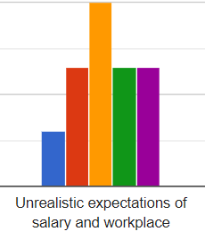

**Chart No: 10.D** **Unrealistic Expectations of Salary and Workplace**

**Interpretation:**

According to this Graph, about 30.76% of respondents are neutral with Unrealistic Expectations of Salary and Workplace. While 20% of respondents agree and 20% of them are agree and 20% of them are strongly agree. And 9.23% of respondents strongly disagree

**Table No: 10.E** **Lack of clear career goals**

|  |  |  |
| --- | --- | --- |
| **Criteria** | **No of Respondents** | **Percentage** |
| Strongly Disagree | 7 | 10.76% |
| Disagree | 7 | 10.76% |
| Neutral | 19 | 29.23% |
| Agree | 19 | 29.23% |
| Strongly Agree | 13 | 20% |



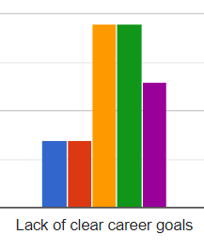

**Chart No: 10. E** **Lack of clear career goals**

**Interpretation:**

According to this Graph, 29.23% of respondents are neutral as well as agree respectively with Lack of clear career goals.20% of respondents strongly agree with Lack of Clear career goals. 10.76% disagree with it while 10.76% of respondents strongly disagree with it.

**Findings of the study**

According to this study, 73.8% of respondents are within the 21-30 age group.15.4% of respondents are within the 31-40 age group. 6.2% of respondents are within the 10-20 age group. 3.6% 0f respondents are within the 41-50 age group. 70.8% of respondents were male and 29.2% of respondents were female. 43.1% of respondents were from BA/B.Sc/B.Com backgrounds. 33.8% of respondents were from MBA/PGDM.15.4% of respondents were Engineers. 6.4% of respondents were from MA/M.Sc/M.Com backgrounds, and only 1.5% of respondents were from MCA backgrounds. 69.2% of respondents know how to prepare a resume for getting a job. 12.3% of respondents don’t know how to prepare a resume. And 18.5% of respondents are not sure how to prepare a resume for getting a job. 54 (83.1%) of respondents think communication skills are important. Around 32 (49.2%) of respondents think command over core technical skills is important. 43 (66.2%) of respondents think practical exposure (like projects, internship) skills are important. 33 (50.8%) of respondents think presentation skills are important. 35.38% of respondents think that technical Skills are Fairly Important. 30.76% of respondents think that technical skills are Very Important. 15.38% of respondents think that technical skills are Slightly Important.13.84% of respondents think that technical skills are Important. 4.61% of respondents think that technical skills are the Least Important. above 40% of respondents think that Oral/Written Communication Skills are Very Important. 24.61% of respondents think that Oral/Written Communication skills are Fairly Important. 21.53% of respondents think that Oral/Written Communication skills are Important.9.23% of respondents think that Oral/Written Communication skills are Slightly Important. 4.61% of respondents think that skills Oral/Written Communication skills are the Least Important. 32.30% of respondents think that Problem Solving &Analytical ThinkingSkills are Very Important. 30.76% of respondents think that Problem Solving &Analytical Thinkingskills are Fairly Important. 26.15% of respondents think that Problem Solving &Analytical Thinking skills are Important. 7.69% of respondents think that Problem Solving &Analytical Thinking skills are Slightly Important. 3.07% of respondents think that Problem Solving &Analytical Thinking skills are the Least Important**.** 29.23% of respondents think that logical reasoning ability is Very Important. 26.15% of respondents think that logical reasoning ability is Fairly Important. 23.07% of respondents think that these skills are Important. 18.46% of respondents think that these skills are Slightly Important. 3.07% of respondents think that logical reasoning ability is the Least Important. 30.76% of respondents think that MS Office/Personal skill is Very Important. 27.69% of respondents think that MS Office/Personal skill is Fairly Important. 23.07% of respondents think that these skills are Important. 15.38% of respondents think that these skills are Slightly Important. 3.07% of respondents think that MS Office/Personal Skill is the Least Important. 61.5% of respondents think that additional skills are important. 6.2% of respondents think that additional skills are not important. 32. 3% of respondents were not sure about that. 52.3% of respondents think that skill level is getting different in freshers from metro city & non-metro city. 20% of respondents do not think so. And 27.7% of respondents are not sure about it.

**Suggestions and Recommendations**

* As per this study 78.8% of respondents are belongs to the 20-30 years of age group. So these are the raw resources of the company with full potential. The company needs to utilize these resources in a very effective way.
* 70.8% of respondents are male. Here we can see that the participation of female candidates is very low. So the Organization should be more focused on female empowerment. So that the employment ratio between male & female should be balanced.
* Here we can see 43.1% of respondents were from BA/B.Sc/B.Com backgrounds. 33.8% of respondents were from MBA/PGDM. That means we need to increase the business-oriented study culture more. So that the students get more motivated and achieve their success Globally.
* It is relaxing that 69.2% of respondents know how to prepare a resume. But what about others? In the current scenario, every candidate needs to know how to prepare a resume, because it is the first step by which an organization will judge that either you should get entry or not. So as per my study, I would that candidate must know how to prepare the resume
* 66.2% of respondents think practical exposure (like projects, internship) skills are important. As we all know that Indian education system is theoretical and old fashion.

They don’t give attention to practical learning. But in the Globalization era, the education system should be practically oriented like the live project, internships, etc. And for that, colleges and universities must be weak up from their winter sleep and provide students with practical-oriented learning.

* 50.8% of respondents think presentation skills are important and it is very true. This is the only skill by which one person can convey their messages effectively to others. So if candidates want to step into the corporate world then they need to master this presentation skill, otherwise, they can’t be able to survive anymore
* 32.30% of respondents think that Problem Solving & Analytical ThinkingSkills are very important. Actually, these skills represent how a person can take a valuable decision in a difficult situation. This power represents their strong mindset. So the organization always looking for those candidates who have these kinds of abilities.
* 30.76% of respondents think that MS Office/Personal skills are very important. As we all know that this is the technological era. Everything depends on technology and new tools. As maximum respondents are freshers so it is very easy for them to learn new technology and tools. By which they can upgrade their skills and easily get their dream job.
* Around 52% of respondents are believes that skill levels vary from region to region. That means metro city candidates are more knowledgeable and skills full than the ruler area’s candidates. And it is partly right because in maximum cases all the facility is only centralized in the urban area. I think our Government is responsible for it. The government needs to create more opportunities for the ruler also. So the candidates from the ruler should also get benefitted.

Altho this should not be an excuse for the candidates for the ruler areas because if you want to achieve something then you should achieve it no matter what.

**Conclusion:**

This study is completely based on Fashers and their problems and challenges while getting their first job. So they need to focus on their personal improvement in every aspect. And prepare themselves corporate-ready mentally and physically. So they can face any kind of situation regarding their career

**References**

Taylor University Pillars at Taylor University Master of Arts in Higher Education (MAHE) Theses Graduate Theses 2010 Student Transition: Common Challenges Facing Recent Graduates Steve Conn

Graduate Employability The views of employers Authors: Will Archer and Jess Davison with editorial support from Richard Brown and Keith Herrmann © The Council for Industry and Higher Education, 2008

Hiring Freshers Challenges and Problems Faced By HR Recruriters. Prof.Rajashree K. Gethe and Dr.Bhavyadeep Bhatia. Journal Of Management Research and Analysis (JMRA)

Enhancing graduate employability and the need for universityenterprise collaboration. Thi Tuyet (June) Tran(2008). Institute for Employment Research, German Federal Employment Agency, Ghana.

Work readiness in graduate recruitment and selection: A review of current assessment methods. Catherine Lissette Caballero (2010), Deakin University, and Arlene Walker, Deakin University cathy.caballero@deakin.edu.au; [arlene.walker@deakin.edu.au](mailto:arlene.walker@deakin.edu.au)

EMPLOYER SATISFACTION WITH GRADUATE SKILLS -A CASE STUDY FROM MALAYSIAN BUSINESS ENTERPRISES. Seibu Mary Jacob, Lee Miin Huui and Su Sueh Ing (2006). <https://www.researchgate.net/publication/255580516>

Current Employability Scenario of Indian Graduates (Engineering, MBA & Other Streams): A Review. Rajashree K. Gethe1, Mahesh S. Hulage2, ISSN: 2278-3369 International Journal of Advances in Management and Economics

4 problems freshers face in their first job and how to overcome them. INDIA TODAY. New Delhi, UPDATED: Apr 7, 2017 13:33 IST

The Problems Freshers Faces in Their First Job, FPS JOBS, FPS JOB.COM 2020-01-17 7:58:02

Lower-rung b-school churning out unemployable graduates:Assocham, The Hindu businessline, January 20, 2018 - Updated 11:07 am IST | Ahmedabad, April 27

Challenges in Employing Fresh Graduates in Information Technology Companies, Gunjan Malhotra, International Journal of Business and Economic Vol. 4, No. 2, 2019, pp. 18-34s http://ijbe.ielas.org ISSN: 2545-4137

EMPLOYMENT OPPORTUNITIES IN INDIA AND CHALLENGES WITH SPECIAL REFERENCE TO THE STUDENTS OF COMMERCE STREAM, Latasha Mohapatra and Bharat Kumar Maher(2018), Jamshedpur Research Review (UGC Approved International Research Journal) (ISSN: 2320-2750) Year V Vol. IV Issue XXIII

5 Problems Freshers Face In Their First Job & Overcoming Them, Shatavisha Chakravorty, CarrearIndia Published: Friday, July 20, 2018, 9:00 [IST]

Nicole Fallon, Nicole Fallon, BUSUNESS NEWS DAILLY Updated Aug 06, 2022

An Empirical Analysis of Student’s Experience Towards Educational Loan Service Offered by Banks, Rajashree Gethe and Mahesh Hulage