**Artificial Intelligence-The Transformational Tool in the Accounting System**

1Prof. Suraj Kumar Swain 2Prof. Purnima Sarkar

1Adjunct Professor, Amity Global Business School, Bhubaneswar

2Asst.Professor, Amity Global Business School, Bhubaneswar

**Abstract:**

With the rapid development of economy, science and technology, the era of artificial intelligence has come, which has exerted a great influence on all aspects of life. Whether the situation of accountants facing elimination is widely concerned. This article will be focusing on the application of artificial intelligence in the system of accounting and its impact on accounting information quality and decision making, so it won’t cause a mass unemployment. Artificial Intelligence (AI) is the terminology of technology that means make machine smart. It is a system that is designed by a human to work intelligently. It is mainly developed to increase the capability of learning and problem-solving. AI plays a vital role in the accounting system to efficiently manage accounting tasks in the organization.

**Key Words:** **Artificial Intelligence, Digitalisation, Big Data, Robotics**

**Introduction**

In this era of technological revolution, Digitalisation makes the use of technology more productive. In the last few decades, the evolution of Artificial Intelligence (AI), Big Data, and Cloud has become the central part of the era. It provides a platform where businesses can be fully digitalised; make use of robotics and use of Artificial intelligence in accounting. This new trend has reduced the need for employment in specific areas, and the possibility of changing industrial structures has been greatly addressed (Frey and Osborne, 2017). This enabled to change the style of accounting from paperwork into computerised format. We can say that, due to AI it is possible to process huge amount of data easier and quicker; which is beyond the human capacity. Application of AI in accounting lessens the workload of accountants made in accounting works like review of journal entries, maintaining ledger accounts, making legality of financial accounts in a particular way. Fraud and error detection and reporting becomes very easy by application of AI.

AI includes functions like Robotic Process Automation (RPA) and Deep Learning (DL), and this makes possible computer processing potential to be considerably superior. A process that required a substantial quantity of time in earlier period can be completed immediately now. These novel technologies have already been adopted in numerous fields. The novel technologies have been accepted everywhere like in corporate houses in private sectors as well as in public sector, in the field of accounting, finance, business support, marketing and HR. It has also been adopted by national institutions such as education, finance, fin-tech, medical care, environment, security, the military, and so on.

Nevertheless, as Information and Communication Technologies (ICT) have advanced, technologies such as AI, Cloud, and Big Data are extensively and aggressively used in accounting procedure. These new technologies not only enable bulky data to be processed almost instantaneously, but they also assist to attain improved transparency.

**AI Accounting Market Leaders**

There are some companies that are working and developing the application models of Artificial intelligence

1.xerox Ltd

2.Intuit Inc.

3.Sage Group

4.SAP SE

5.Epicor Software Corporation

The above popular companies provide the platform in developing A.I softwares for implementation

**Literature Review**

***Conceptual Review***

John McCarthy coined the name “Artificial Intelligence”. (Yadav, Gupta, Sahu, and Shrimal, 2017). Artificial intelligence (AI) is the academic field of study that deals with the technical know-how on creating computers and computer software that are capable of intelligent behaviour or the study of programming computers to do things better and more accurately than humans (Elaine, 2000).

Artificial intelligence can be divided into four different aspects which include intelligence, business, research, and programming dimensions (Carol and O’Leary, 2013). Artificial intelligence Expert system software can be developed for any kind of problem that involves a selection from a group of choices especially if the decision is based on logical steps. Hence any area where a person or group of persons has special expertise needed by others is a potential area for creating an expert system (Taghizadeh, Mohammad, Dariush, and Jafar, 2013).

***Major Technologies of Artificial Intelligence Expert Systems***

An Expert system shell is a software programming system that enables the creation of expert or knowledge-based systems. This system is easily implemented. Expert systems are the most widely used artificial intelligence technology. This artificial intelligence program was adopted in the 1980s, and it was programmed to achieve a level of expertise that is capable of replacing human dominance in a particular field of decision making. They are developed often with expert system shells. Hence, this implies any area in which a person/group has special capabilities needed by others. This is a potential area for an expert system.

***Neural Networks***

This is an aspect of artificial intelligence that deals with electronic models of human brain neural structures (Taghizadeh, Mohammad, Dariush, and Jafar, 2013). Neural network installs the ability to learn into a computer program and the imitation of the human brain through structural simulation by any machine is rendered possible due to neural network (Shukla and Jaiswal, 2013). This was in line with the findings of other artificial intelligence researchers that neural network is one of the chief aspects of artificial intelligence and it is of great interest because it mainly enables any machine to execute the functions of the human brain (Greenman, 2017: Taghizadeh, Mohammad, Dariush, and Jafar, 2013:Kuma, and Thakur, 2012).

***Robots***

This aspect of artificial intelligence technology deals with the science and technology that is behind designing, manufacturing, and application of robots (Graetz and Michaels, 2015). The Robot Institute of America in 1979 defined a robot as a programmable, reprogrammable, multifunctional manipulator that is designed to move parts, materials, tools, or specialized devices through several programmed and reprogrammable motions to carry out a variety of tasks. Robots are built and equipped with the ability to sense their environment in a way that is similar to human sensing their surroundings. Robots can sense their environment, power itself and move around utilizing sensors: pressure sensors (hands), light sensors (eyes), sonar and hearing sensors (ears), chemical sensors (nose), and task sensors (tongue) hence appearing smart.

***Fuzzy Logic***

Fuzzy logic is an aspect of artificial intelligence that deals with a process of reasoning that resembles that of humans. Fuzzy logic imitates the approach of decision making in humans. It usually involves partial truth which ranges between completely false and completely true (Taghizadeh, Mohammad, Dariush, and Jafar, 2013). Fuzzy logic is based on the fuzzy set theory which is a generalization of the classical set theory, which states that “an element either is or is not a member of the set” (Taghizadeh, Mohammad, Dariush, and Jafar, 2013). In artificial intelligence, fuzzy logic is very useful for practical and commercial purposes. It can control machines even though its reasoning may not be accurate, it gives acceptable.

**Objective of the Study**

This research study has been undertaken with the objective :

To study the impact of the application of artificial intelligence in accounting system and

To measure the pros and cons of implementing artificial intelligence in accounting process

**Research Methodology**

It is a Descriptive Research study which is expressive in approach based on the surveys of different literatures and the study on the recent trends prevailing in the industry.

The secondary data sources have been explored for the purpose of the study. The data has been collected from various sources like research articles, publications, accounting websites, and essay from Newspapers, Magazines and Journals from the various websites which deals directly or indirectly with Artificial intelligence. Descriptive research was chosen for developing a better understanding in depth.

**Data Analysis & Interpretation**

As per the recent data, the application of the AI system is enhancing day by day. Artificial intelligence in the accounting market was valued at USD 0.87 billion in the previous year and is expected to register a CAGR of 32.58%, reaching USD 11.0 billion by the next five years.

**Findings of the Study**

* The majority of the top four accounting and law firms have already implemented robotic process automation and AI-driven NLP to automate auditing procedures that would otherwise take the companies several weeks to complete. ​​

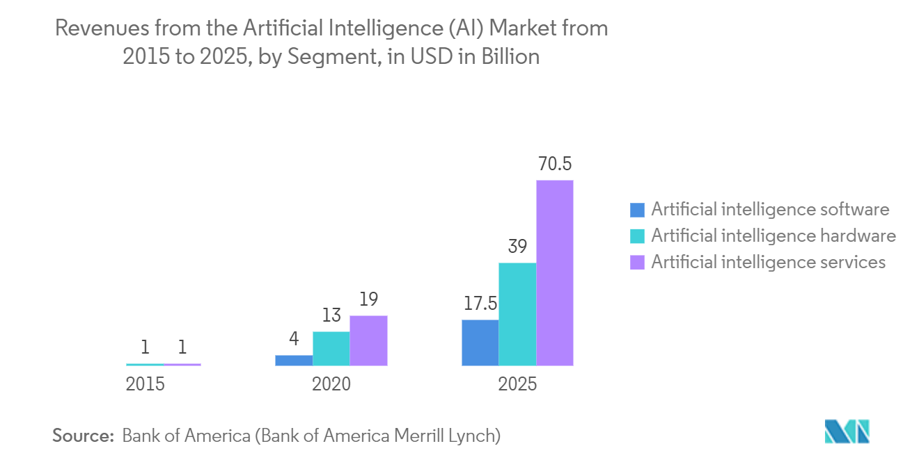

**The Impact of Artificial Intelligence on the Accounting Industry**

In the age of artificial intelligence, traditional accounting personnel will leave a few more complicated tasks to the accounting software to complete, this will greatly improve the working efficiency, reduce the working error, improve the competitiveness of the enterprises, the accounting industry, and this will also be conducive to promote the transformation of the accounting industry.

***Avoid the possibility of financial fraud***

In those traditional accounting positions, incompatible positions are not actually separated, especially in small and medium-sized enterprises, financial personnel will have access in both cash flow and the bookkeeping, so there will be disorder accounts in financial accounting, and of course financial fraud, self-serving criminals are given the opportunity to benefit themselves. The management level has the authority over the internal control, which will cause harm to the relevant interests parties like shareholders and this situation is not conducive to the long-term development of the enterprise. However, in the environment of artificial intelligence, a large amount of accounting and other work will be handed over to the computer to complete; accounting personnel only need to review it

***Improve the quality of accounting information***

In the traditional accounting position, from the making of accounting vouchers, the registration of accounting books, to the formation of statements, the accounting personnel will have to check all these procedures. When an enterprise uses accounting software to do accounting, on the one hand, all financial procedures can be completed in time, which improves the efficiency of the work. Financial personnel only need to do the audit in the accounting system. On the other hand, by using the accounting software, accounting personnel only need to input data, then leave the process to the computer to complete, although there could also be errors when the accounting personnel try to input the financial data, but when you have a wrong data entry, the accounting software system will automatically report the error, which will greatly reduces the working error, improve the quality of accounting information.

***Promote the reform of traditional accounting and auditing***

In the traditional accounting profession, the job duties of accounting personals are divided according to the business process, but under the circumstances of artificial intelligence, This will also optimize the setting of accounting posts, optimize the structure layout, and change the traditional financial and practical working modes.. The history of computerized accounting in our country begins as early as the 1980s, so far, it has been commercialized, used by all kinds of accounting entities, forcing those originally simple accounting records and accounting work replaced by artificial intelligence, accordingly, most positions of accounting personnel are no longer needed.

**Impact of Artificial Intelligence on the Accounting Industry**

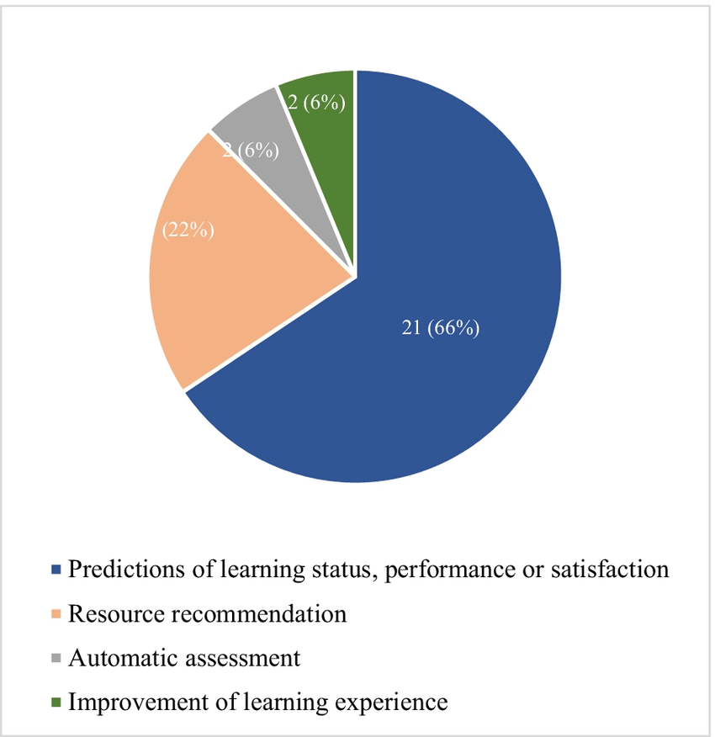

**The Impact of Artificial Intelligence on Accounting system**

New technology is shaping Industry 4.0 in every vertical with intelligent responses to changing expectations of customers, suppliers, vendors, and partners. Almost all accounting tasks, including payroll, tax, banking, and audits, have become automated with AI, disrupting the accounting industry, and bringing about a big change in how business is done.

* AI provides a broad range of opportunities and minimizes the traditional time-consuming responsibilities of the finance team to look at more venues for business growth.
* AI helps in forecasting accurate financial statements. With machine learning (ML), finance professionals can predict future trends based on historical data/ records.

Robotic Process Automation (RPA) can complete repetitive tasks in the enterprise's business processes with amazing efficiency, including document or data analysis. With RPA in place, the finance team can break free of getting bogged down by non-value-added tasks. Instead, they can focus more on taking up strategic and advisory responsibilities.

**Payables/ Receivables Processing**

Invoice processing is considered one of the more time-consuming and labor-intensive parts of the enterprise. AI-based invoice management systems help by increasing the volume, performing zero-error processing, and improving vendor relationships.

**Supplier Onboarding**

The AI-based approach helps expand customers' reach, increase revenue, and evaluate the suppliers with minimal human intervention.

**Procurement Processes**

Purchasing and procurement processes mean a lot of paperwork - sometimes in different systems that are seemingly unconnected! With AI-driven workflows, finance teams can process unstructured data while automatically mitigating governance/compliance/risks.

**Auditability**

Data analytics establishes the scope of the audit, and risk assessment as RPA and analytics facilitate tracking of routine transactions. Cognitive computing, predictive analytics, and AI enable tracking more complex transactions that go with estimates and judgments.

**Monthly and Quarterly Cash Flows**

AI-based tools empower enterprises to reconcile financial activities quickly, understand historical cash flows, and predict future cash requirements. AI applications also ensure that all financial processes are secure by collecting data from many sources and integrating the data.

**Expenses Management**

When manually done, managing expenses-related processes is not only filled with complex paperwork - but also prone to fraud and data breaches. Expenses management automation ensures almost zero errors and alerts the team to a breach if it occurs.

**Chatbot Support**

AI-driven chatbots help solve user queries quickly and efficiently, including queries on account balance, financial statements, account status, etc. Tracking outstanding invoices and automating the follow-up collection processes with AI ensures that accounts are kept balanced and closed promptly. Moreover, AI chatbots answer customers' routine questions and can provide level-1 support. Adopting AI and automation tools into an enterprise can come with a few challenges, but none that can’t be overcome.

**Limitation of the Study**

The study relies on published data and information. No primary data is being collected. Secondary data may be lacking in accuracy. The Scope of the study is limited only on the application of information technology in the field of Accounting.

**Conclusion**

The emergence of artificial intelligence is the result of advancement of technology and research & development. Artificial intelligence has reduced the dependency on human power for accounting work. The use of AI technology will play a vital role for firms worldwide, if they want to remain competitive in business in the coming years. The effectiveness, speediness, and accurateness of Artificial Intelligence are difficult to be compared. Accountants are bound to welcome the AI technology and integrate it into maximizing professional output. Though there are challenges in adopting AI, but it should be viewed as a greater opportunity rather than a challenge due to its enormous benefits. AI requires the accounting personnel to have a positive view on artificial intelligence, to continuously improve their comprehensive ability, make their efforts to improve their comprehensive ability, to make changes from traditional accounting personnel to a management type, high-end accounting personnel. Accountants should actively adapt to the development of this society, constantly innovate, change themselves, constantly update their knowledge, and become an irreplaceable high-quality accountant.

**References:**

1. Carol, E., and O’Leary, D. (2013). Introduction to artificial intelligence and export system. Retrieved from :http://www.mbsfile03.uscredu/dialtalmeasures
2. Elaine, R. (2000). Overview of AI and its application area. Retrieved from http://members.90n.at/frankstein/frankeinsteinnovelhtm
3. Frey, C.; Osborne, M. The future of employment: Howsusceptible are jobs to computerization? Technol. Forecast Soc. Chang. **2017**, 114, 254–280.
4. Graetz, G., and Michaels, G. (2015). Estimating the impact of robots on productivity and employment. *Center for Economics and performance*.
5. Greenman, C. (2017). Exploring the impact of artificial intelligence on the accounting profession*. Journal of Research in Business, Economics and Management* (JRBEM), 1451-1454.
6. Shukla, S., and Jaiswal, V. (2013). Applicability of artificial intelligence in different fields of life. *International Journal of Scientifc Engineering and Research* (IJSER).
7. Taghizadeh, A., Mohammad, R., Dariush, S., and Jafar, M. (2013). Artificial intelligence, its abilities and challenges. *International Journal of Business and Behavioral Sciences*.
8. Yadav, A., Gupta, V., Sahu, H., and Shrimal, S. (2017). Artificial intelligence – new era. *International Journal of New Technolog*y, 3(3), 30-33.