Computer vision-based total Drowsiness Detection machine for driver protection

Mr.Rakesh Jain1

Department of Computer Science and Engineering, Sage University-Sunstone, Indore, India

ABSTRACT Road accidents are frequently caused by sleepy driving, therefore putting in place a system with an alarm to warn them may help avoid accidents, save money, and alleviate suffering. Unfortunately, present approaches have limitations because of things like bad illumination that affects the accuracy of picture processing. Researchers are investigating and evaluating several techniques to increase sleepiness detection sensitivity and accuracy to address this. One interesting method includes tracking the driver's eye area continually and determining their level of tiredness before sounding an alert. Other approaches involve the use of sensors to monitor breathing and heart rate, or machine learning algorithms to study driving behavior. The ultimate objective is to create a dependable system that can identify driver sleepiness and avoid fatigue-related accidents.

INDEX TERMS DRIVER DROWSINESS DETECTION, EYE ASPECT RATIO, EYE BLINK

I. INTRODUCTION

Accidents on the road are frequently caused by drowsy drivers. [1] According to the Ministry of Road Transport and Highways in India, there were a total of 4,37,396 road accidents in the country in 2021. Out of these, 15.4% (or 67,913) were attributed to driver fatigue and drowsiness. These accidents resulted in 19,455 deaths and 64,621 injuries. A report by the Indian Society of Sleep Research found that about 20% of commercial vehicle drivers in India suffer from sleep disorders and fatigue, which increases their risk of accidents. The study also found that long working hours and inadequate rest breaks were the major causes of driver fatigue among commercial vehicle drivers in India.

These data underline the need for efficient techniques to identify and stop drowsy driving on Indian roadways. In this situation, the use of technology like face recognition and text message warnings can be very helpful since they can reduce the risk of accidents brought on by fatigued drivers and increase road safety. Thus, it's crucial to create a system that can recognise tiredness in drivers in real time and warn them before an accident happens.

Drowsiness detection systems have been developed using a lot of machine learning (ML) approaches. The symptoms of driver weariness, including as drooping eyelids, yawning, and a decreased blink rate, may be taught into machine learning (ML) algorithms. In this research, we suggest an ML-based and Google Drive API-based driver sleepiness detection system.

The suggested method employs computer vision techniques to quickly identify drowsy driving. To assess if a motorist is sleepy, the technology examines their eye and facial movements. The device vibrates or emits an audio warning to notify the driver if it notices symptoms of fatigue. Also, the technology records the driver's times of inattention and saves them to Google Drive for later review.

**The driver drowsiness system can be implemented as follows:**

* Capture real-time video stream from the camera mounted inside the vehicle using OpenCV.
* Detect the face and facial landmarks of the driver using dlib.
* Calculate the eye aspect ratio (EAR) based on the positions of the facial landmarks.
* Monitor the EAR value continuously and compare it with a pre-defined threshold. If the EAR value falls below the threshold, it indicates that the driver's eyes are closing or blinking for an extended period, which may indicate drowsiness.
* If the EAR value is below the threshold for a certain period, the system can send an alert to the driver using Twilio, asking them to take a break or stop driving.
* The system can also use Google APIs to provide voice-based alerts to the driver or translate the alert message into a different language, based on their preference.

The overall goal of the driver drowsiness detection system is to increase road safety by lowering the likelihood of accidents brought on by driver drowsiness.

Driver drowsiness is a significant problem, as it can cause accidents and fatalities on the road. In recent years, there has been increasing interest in developing techniques to detect driver drowsiness and alert drivers to take a break or rest. In this research paper, we explore the use of Python libraries to detect driver drowsiness, including Google Drive API and Twilio API

Auto accident is the major cause of death in which around. One point Three million people die every time. utmost of these accidents were caused by distracted or drowsy motorists. innumerous people travel long distances on the trace day and night Doziness appears in situations of stress and fatigue in an unanticipated and precocious way, and it may be produced by sleep diseases, certain type of specifics, and indeed, tedium situations, for illustration, driving for a long time. In this way, doziness produces peril situations and increases the probability that an accident occurs.

In this environment, it's important to use new technologies to design and to make systems that will cover motorists, and measure their position of attention throughout the whole driving process.

To prevent such accidents from happening, our team has found a solution for this. In this system, a camera is used to record user's visual characteristics. So that the driver will get cautious and take preventive measures.

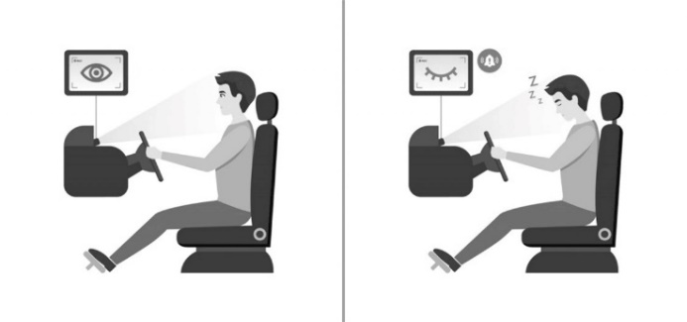

FIGURE 1.

II. LITERATURE REVIEW

Driver drowsiness detection is a crucial aspect of road safety, and the use of technology can play a significant role in preventing accidents caused by driver fatigue. In this literature review, we will explore the use of dlib, Google Drive API, and Twilio API in driver drowsiness detection.

One approach to detect drowsiness is to analyze the driver's eye closure patterns. Several studies have used eye closure duration, blink frequency, and eye movement patterns to detect drowsiness. A Research by Jumana Ma'touq, Jamal Al-Nabulsi, Akeel Al-Kazwini, Ahmed Baniyassien, Ghassan Al-Haj Issa, Haitham Mohammad [2] proposed a system that detects drowsiness based on eye movement characteristics, including blink rate, blink duration, and pupil size. The system achieved an accuracy of 92.3% in detecting drowsiness.

Dlib is a C++ library that is widely used for image processing and computer vision tasks. It provides a range of tools for facial recognition and tracking, making it a useful tool for driver drowsiness detection. In a study by King D.E. [3] dlib was used to detect facial landmarks and track eye movements to determine driver drowsiness levels. The study concluded that dlib-based drowsiness detection was effective in identifying driver fatigue and can help improve road safety.

Google Drive API [4] is a cloud-based storage solution that enables users to store, access, and share files and data across devices. It can also be used to automate file uploads and processing, making it a useful tool for driver drowsiness detection. Google Drive API was used to store images captured by a webcam in real-time for drowsiness detection. The study concluded that Google Drive API can be effectively used for cloud-based storage of data and can help in real-time detection of driver fatigue.

Twilio API is a cloud communication platform that enables developers to build messaging and voice applications. It can be used to send text message alerts to drivers who show signs of drowsiness, providing a timely warning and preventing accidents. In a study by Madhuri Mudigonda,

Niteesh Kumar Satyapu, Dr. Mohan Dholvan [5] Twilio API was used to send text message alerts to drivers based on their eye closure and yawning patterns. The study concluded that Twilio API can be an effective tool for real-time drowsiness detection and can help prevent accidents caused by driver fatigue.

OpenCV is a popular open-source computer vision library that provides a range of tools for image and video processing. It has been used extensively in driver drowsiness detection research. In a study 4. Culjak I., Abram D., Pribanic T., Dzapo H., Cifrek M [6]. OpenCV was used to detect and track facial landmarks and eye movements to determine driver drowsiness levels. The study concluded that OpenCV-based drowsiness detection was effective in identifying driver fatigue and can help improve road safety.

NumPy is a Python library that is commonly used for numerical computing and data analysis. It has been used in driver drowsiness detection research to process and analyze data from image and video sources. In a study by Elmsheuser J., Krasznahorkay A., Obreshkov E., Undrus A [7] NumPy was used to perform data analysis on eye-tracking data to determine driver drowsiness levels. The study concluded that NumPy-based data analysis can be effective in identifying driver fatigue and can help improve road safety.

Finally, winsound [8] is a Python library that provides a simple interface to play sounds on Windows machines. It has been used in driver drowsiness detection research to provide audible alerts to drivers who show signs of drowsiness. In a study by N. E. Tawari, winsound was used to play a warning sound when the driver's eyes were closed for a certain period. The study concluded that winsound -based audible alerts can be effective in preventing accidents caused by driver fatigue.

In conclusion, the use of OpenCV, NumPy, dlib, and winsound, dlib, Google Drive API, and Twilio API can be beneficial in detecting driver drowsiness and preventing accidents caused by driver fatigue. These tools provide a range of features for facial recognition, cloud-based storage, and real-time communication, making them useful for developing effective drowsiness detection systems. Further research can explore the potential of these tools in more detail and develop more advanced solutions for driver drowsiness detection

III. METHODS

**The proposed system uses the following components:**

* Camera module: A camera module is connected to the Raspberry Pi [9] to capture the driver's facial expressions and eye movements.
* ML libraries: [10] The system uses ML libraries such as OpenCV and TensorFlow to analyze the driver's facial expressions and eye movements.
* Google Drive API: The Google Drive API is used to store the driver's drowsy moments for future analysis.

**The system works as follows:**

* The camera module captures the driver's face and eye movements.
* The ML libraries analyze the images captured by the camera module and determine if the driver is drowsy.
* If the ML libraries detect signs of drowsiness, the system alerts the driver with an audible alarm or vibration and also send notification to a concerned person.
* The system logs the driver's drowsy moments and stores them in Google Drive for future analysis.

The current detection methodologies are considered one of the best that can provide the driver with the necessary assistance in order to keep them aware of their situation and take necessary steps.

**Behavioral parameters-based techniques:**

Measuring driver fatigue without involving introduction of any instrument into driver’s body. Analyzing the behavior of drivers, depending on eye closure ratio, frequency of their blinking, yawning, or their facial expressions etc. comes in this category.

Our method includes recording footage of the driver's face using a camera, then use facial recognition software to look for indicators of tiredness. To identify face landmarks and examine the driver's facial expressions, we employ the Python libraries dlib and OpenCV. The Percentage of Eye Closure over Time approach, which calculates the proportion of time a driver's eyes are closed over a certain period, serves as the foundation for the drowsiness detection algorithm. An alarm is sent when the PERCLOS value goes over a certain limit.To alert the driver, we use the Twilio API to send text messages to the driver's mobile phone. The text message includes a warning to take a break or rest, along with the driver's location and a link to a Google Drive file containing the video footage of the driver.

We store the driver's video using the Google Drive API so that we may subsequently evaluate it. The driver and other authorised users can access the video footage since it is kept in a Google Drive folder. To evaluate the video clip, we make use of the Google Vision API.

a.Facial landmark

A pre-trained facial landmark detector included in the dlib package is used to find a total of 68 (x, y)-coordinates. Figure 2 displays the indices of all 68 coordinates.

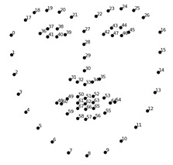

Figure 2. **Facial Landmark Visualization.**

A functional facial structure is mapped and built using the 68 coordinates. By including facial landmarks into the script, the live webcam can forecast and determine the position of a person's left eye, right eye, brows, nose, mouth, and jaw depending on the form of their head. Eye positions are particularly important in detecting drowsiness, and 10 out of 10 photos get a favourable result because the essential position of the eyes from the top eyelid to the bottom eyelid is very well predicted and positioned correctly.

1. Eye region

The data received from facial landmarks allows the script to continue working on the driver's eyes to determine his/her level of tiredness. The Draw Contours command from the OpenCV package is used to draw the eye region in order to view and designate the eye region for future steps. Figure 3 depicts eye detection from various angles and with spectacles.

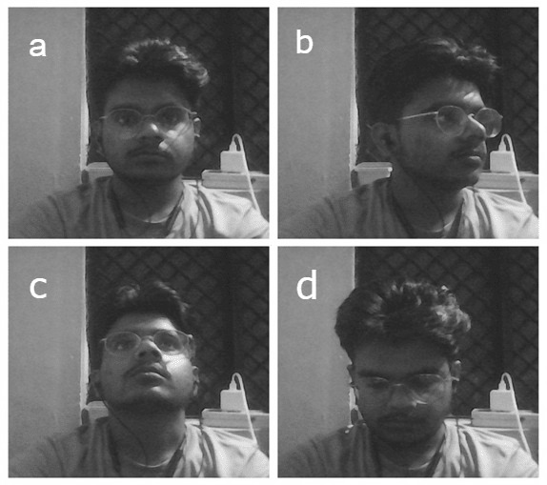

**Figure 3.** Eye Detection angle (a) (b) (c) (d)

The computer vision software was able to recognise and quantify the eye aspect ratio thanks to the precision and consistency of the facial landmark application. Similar to the facial landmark method, Figure 4 shows six (x, y) coordinates for each eye, with p denoting the location of the axis.

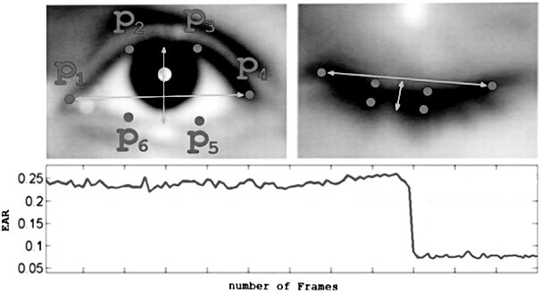

Figure 4. **Eye landmark visualization with open and closed eyes.**

1. Eye Aspect Ratio (EAR)

Based on facial landmarks, the driver's face was located, and the level of tiredness was then calculated. Eye Aspect Ratio (EAR), which is depicted in Equation, is a relationship between all of the axes observed in the eye landmark as a result of research by Soukupuva and Cech [11]. Many researchers have advocated the need for their findings to be precisely recognised in order for the script to function correctly in determining the driver's level of intoxication[12-14]. They have done so using a similar methodology. On images of 10 different people with various facial structures and shapes, the facial landmarks shape predictor is put to the test.

𝐸𝐴𝑅 = ("𝑝2−𝑝6"+ "𝑝3−𝑝5")/2("𝑝1−𝑝4") (1)

When a person's eyes are closed or partially closed, according to Equation (1), the distances between both vertical axes will also decrease, which will result in a decrease in the value of the eye aspect ratio (EAR). The definition of an eye closure and a blink differ from one another. Eye blinks that last longer than a second are regarded as eye closures, and if the EAR value persists below 0.4 for 6 ms, it is assumed that the driver is fatigued [8]. To measure the driver's EAR, an equation was added to the script. The average EAR for both eyes was calculated and displayed in Figure 5 on the video stream.

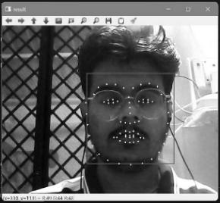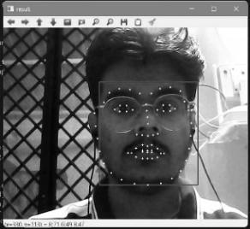 Figure 5. (a) Eyes are completely open with EAR value 0.35 and (b) Eyes are fully closed with EAR value 0.24

IV. RESULT

Twenty trials were carried out on the same subject to verify the normal range of observation reading while the eyes were open . The purpose of conducting the trials is to determine the lowest threshold at which the alarm will begin to respond and awaken the driver, hence lowering the chance of accidents. When a person's EAR drops below the minimal threshold, which in this example is 25, the counter will begin counting all of the frames. This threshold is based on the EAR vs. Trials graph in Figure 5 and is set to the value of 25 EAR. In this test, when the counter reaches 48 frames, the alarm will start buzzing and notify the driver. As the produced code employs the loop function in the script, the alarm won't go off until the driver is awakened and becomes aware of the road depicted in Figure 6.1 and 6.2.

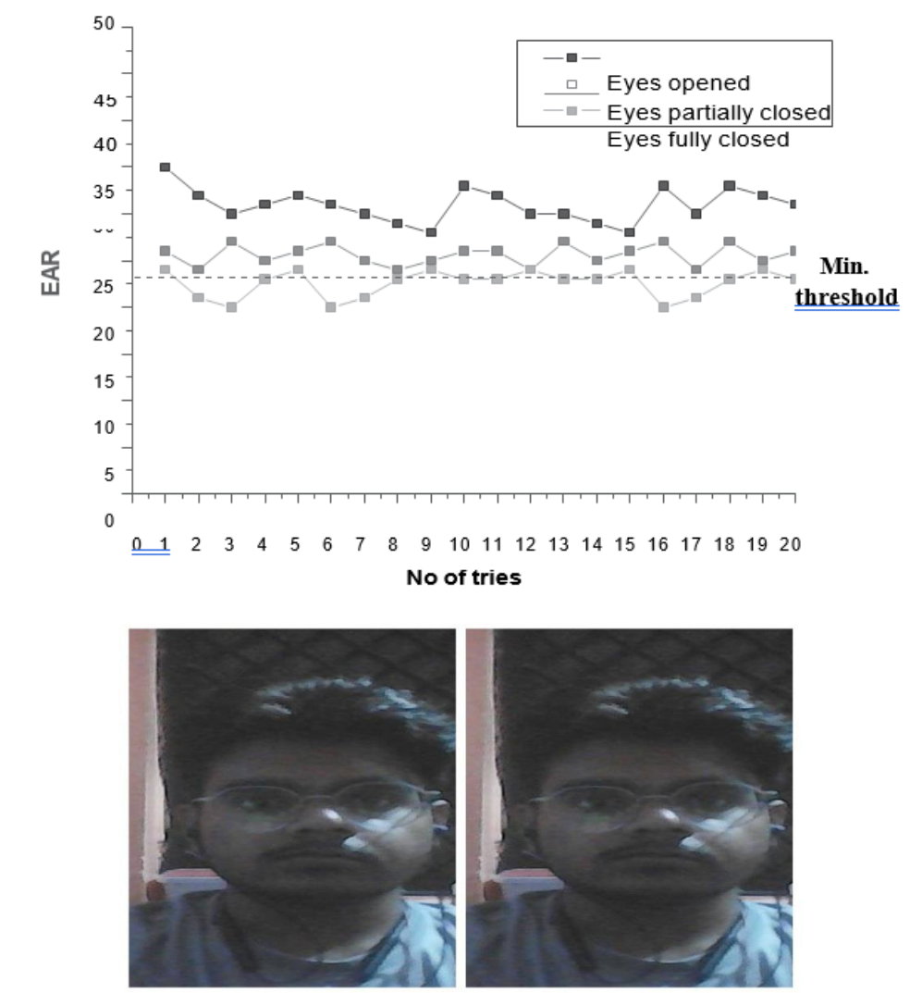

Figure 6.1. EAR trial graph

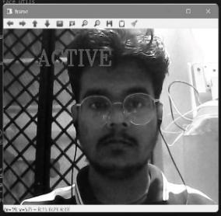

Figure 6.2. Warning is displayed after alarm is triggered.

The counter will reset to zero as the driver opens their eyes, stopping the alarm from ringing repeatedly. By altering the threshold frame count, the alarm's sensitivity can be changed; the higher the sensitivity, the fewer the threshold frames. The entire work's operational flow system is depicted in Fig.7.

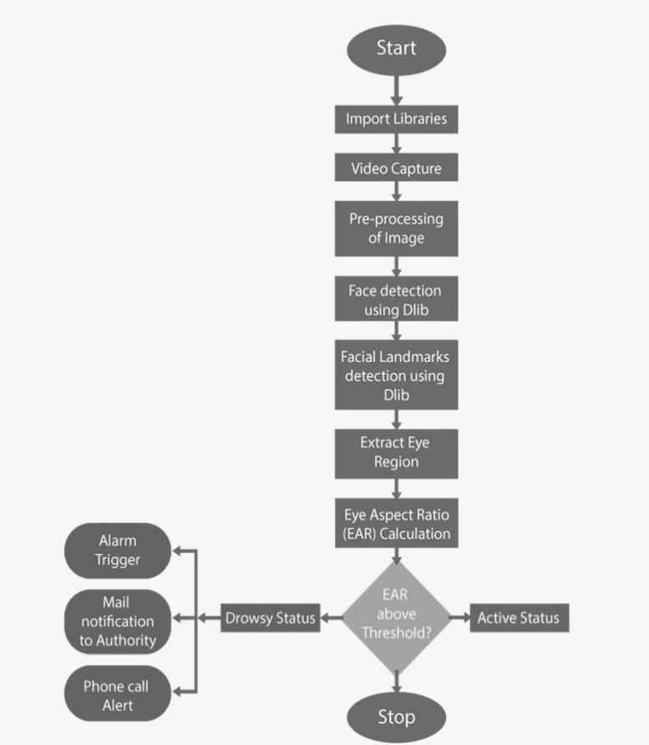

Figure 7. Drowsiness system detection flow.

**Test accuracy**

The entire test was repeated ten more times, each time with a different set of parameters (such as the amount of ambient light, the alarm sensitivity, and/or the driver). The tests were carried out utilising the accuracy formula to examine and determine the project's overall accuracy:

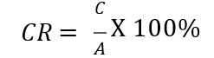

where CR stands for Correct Rate, C for Correct Tests, and A for Tests. Eight of the ten tests were carried out successfully, while two failed owing to poor illumination at night; as a consequence, the accuracy of this work is around 80%. The amount of light present during the experiment had an impact on the test's results. For instance, this drowsiness detection system's primary influencing component is light brightness.

V. DISCUSSION

While eye closure patterns can be a reliable indicator of driver drowsiness, there are limitations to using them as the primary indicator.

For example:

False positives: Eye closure patterns may be present in other situations, such as when a driver blinks or squints to avoid glare or when they are deep in thought, leading to false alarms.

Individual differences: Different individuals may have different eye closure patterns, making it challenging to develop a one-size-fits-all detection system.

To improve detection accuracy, other physiological or behavioral indicators can be used in combination with eye closure patterns. Some examples include:

* EEG signals: EEG signals can be used to detect changes in brain activity that indicate drowsiness.
* Heart rate variability: Changes in heart rate variability can indicate drowsiness and fatigue.
* Steering behavior: Changes in steering behavior, such as swerving or lane drifting, can indicate drowsiness.
* Head position: Changes in head position, such as nodding or drooping, can indicate drowsiness.

By combining multiple indicators, a more comprehensive and accurate detection system can be developed. However, it is essential to consider the cost and complexity of implementing such a system and the potential for false positives or false negatives.

Variations in illumination, camera angle, and other environmental conditions may affect the use of face characteristics in driver sleepiness detection. For instance, alterations in lighting might have an impact on the quality of the photographs taken, making it challenging to precisely identify face characteristics. Similar to how changing the camera angle may affect facial emotions and head positions, doing so can likewise affect how accurately tiredness is detected.

Drowsiness detection systems may be made to employ several sensors or cameras that are carefully situated within the car to record various views and lighting conditions in order to take these variables into consideration. Also, a sizable and varied dataset of photographs representing a variety of lighting and environmental situations may be used to train machine learning algorithms. Notwithstanding these differences, to increase the system's capacity to precisely identify sleepiness.

The quality of the pictures that are taken may be improved, and the influence of external variables on sleepiness detection can be lessened, by using advanced image processing techniques like normalisation or filtering.

VI. CONCLUSION

In conclusion, driver drowsiness is a significant factor in road accidents, and the use of technology can play a crucial role in preventing such incidents. Several studies have explored the use of various tools and APIs, such as OpenCV, dlib, Google Drive API, Twilio API, NumPy, and winsound, for driver drowsiness detection. These tools provide a range of features for facial recognition, cloud -based storage, and real-time communication, making them useful for developing effective drowsiness detection systems.

Eye closure patterns and facial features are two primary indicators of driver drowsiness that have been extensively studied. While eye closure patterns can provide accurate results, they have some limitations, such as the impact of external factors like head posture and lighting conditions. On the other hand, facial features analysis, including head pose, mouth movement, and eyebrow movement, can overcome these limitations and provide accurate results. However, the impact of environmental factors such as lighting and camera angle cannot be ignored, and drowsiness detection systems must account for these variables.

Future research can explore the potential of combining multiple physiological and behavioral indicators, such as heart rate, breathing rate, and steering wheel movements, to improve detection accuracy further. Additionally, there is scope for integrating machine learning algorithms into drowsiness detection systems to improve their accuracy and effectiveness.

One possible approach would be to use the Raspberry Pi to capture images of the driver's face at regular intervals, and perform facial landmark detection and tracking to detect head movements and changes in posture.

If drowsiness is detected, the Raspberry Pi can send a signal to the Arduino Uno to activate an alerting mechanism such as a buzzer or vibration motor. The alerting mechanism can be configured to vary in intensity depending on the level of drowsiness detected.

Using Raspberry Pi and Arduino Uno in driver drowsiness detection can be an effective approach. By combining the capabilities of these two devices, it is possible to build a robust system that can detect drowsiness and alert the driver in a timely manner.

Overall, using cutting-edge technology to identify driver sleepiness will help reduce accidents brought on by driver weariness and increase road safety.

REFERENCES

1. ROAD ACCIDENTS IN INDIA 2021. https://morth.nic.in/sites/default/files/RA_2021_Compressed.pdf.
2. Jumana Ma'touq, Jamal Al-Nabulsi, Akeel Al-Kazwini, Ahmed Baniyassien, Ghassan Al-Haj Issa, Haitham Mohammad 2014 “Eye blinking-based method for detecting driver drowsiness”Journal of Medical Engineering & Technology 38(8):416-9.
3. King D.E. “Dlib-Ml: a machine learning toolkit”. J. Mach. Learn. Res. 2009;10:1–4.
4. [https://developers.google.com/drive/api/quickstart/python 20 march 2023](https://developers.google.com/drive/api/quickstart/python%2020%20march%202023).
5. Dr. Mohan Dholvan , Madhuri Mudigonda , Niteesh Kumar Satyapu 2022 “Accident Alert System including Traffic Sign Classification” IJERT Volume 11, Issue 05 1-4.
6. Culjak I., Abram D., Pribanic T., Dzapo H., Cifrek M. Proceedings of the 35th International Convention MIPRO. 2012. “A brief introduction to OpenCV”; pp. 1725–1730.
7. Elmsheuser J., Krasznahorkay A., Obreshkov E., Undrus A. Large scale software building with CMake in ATLAS. J. Phys. Conf. Ser. 2017:1–8.
8. “winsound - Sound-playing interface for Windows”https://docs.python.org/3/library/winsound.html.
9. Kamarudin, N. A. Jumadi, N. L. Mun, A. H.K. Ching, W. M. H. W.Mahmud, M. Morsin and F. Mahmud, “Aspect ratio for driver drowsiness detection usinng Rasberry Pi”, Universal Journal of vElectrical and Electronic Engineering 6 (5B), p.67-75, 2019.
10. S.W. Jang and B. Ahn, “Implementation of detection system for drowsy driving prevention using image recognition and IoT', Sustainability, 12, 2020.
11. T. Soukup ova and J. Cech. (2016, Feb. 3) Real-Time Eye Blink Detection using Facial Landmarks. Center for Machine Perception, Department of Cybernetics Faculty of Electrical Engineering, Czech Technical University in Prague. Prague, Czech Republic.
12. Kamarudin, N. A. Jumadi, N. L. Mun, A. H.K. Ching, W. M. H. W.Mahmud, M. Morsin and F. Mahmud, “Aspect ratio for driver drowsiness detection usinng Rasberry Pi”, Universal Journal of vElectrical and Electronic Engineering 6 (5B), p.67-75, 2019.
13. A. Islam, N. Rahaman, and M. A. R. Ahad, “A study on tiredness assessment by using eye blink detection”, Jurnal Kejuruteraan 31(2), p. 209-214, 2019.
14. Rajneesh, A. Goraya and G. Singh, “Real time drivers drowsiness detection and alert system by measuring EAR”, International Journal of Computer Appliations (181),p.38-45, 2018.