**A SELF-DRIVING CAR IMPLEMENTING MACHINE LEARNING WITH IMAGE PROCESSING**

**Srinath M S1, Cheluvaraju2, Chethan3, Darshan H N4, Monika B5**

1Assistant Professor, Department of Electrical and Electronics, PES College of Engineering, Mandya, Karnataka, India

2,3,4,5Student, Department of Electrical and Electronics, PES College of Engineering, Mandya, Karnataka, India

**ABSTRACT**

The self-driving car is an emerging technology in the automotive industry that can navigate and move through traffic and obstacles without or with minimal human intervention. It has gained traction in foreign markets as both private and public vehicles, including taxis, and various companies such as Waymo, Uber, Nissan, and Nvidia are actively involved in developing these autonomous vehicles. The introduction of self-driving cars has significantly improved safety, security, and efficiency in automotive transportation while reducing human errors during driving. This project focuses on creating a prototype of a monocular vision autonomous car using the Raspberry Pi as the processing chip. The car's objective is to safely and intelligently reach a given destination by responding to real-time traffic conditions and obstacles. It incorporates several existing algorithms, including lane detection, obstacle detection, and traffic light recognition, to provide the necessary control for the car's movements. This innovation holds tremendous potential as it reduces the cognitive load and mental strain required while driving, ultimately minimizing the likelihood of accidents caused by careless or disobedient driving behaviors. By leveraging advanced technologies and algorithms, the autonomous car aims to eradicate human errors and enhance overall road safety. This advancement in the field of self-driving cars promises to revolutionize the way we commute and travel, offering a safer and more efficient transportation experience for individuals and communities.

**Keywords:** Lane detection, Road markings, IoT-based, Computer vision, Real-time detection

1. **INTRODUCTION**

Self-driving vehicles, also known as autonomous cars or driverless cars, have become a reality and are a widely discussed technology in the modern era. These vehicles operate without human intervention and rely on sensors to perceive their surroundings, including the road, obstacles, pedestrians, and other objects. The advantages of self-driving cars include reduced fuel waste, increased safety, improved mobility, enhanced customer satisfaction, and more. They can contribute to fewer traffic accidents, lower accident rates, reduced fatalities, and lower insurance costs due to their safety benefits. Additionally, self-driving cars have the potential to improve traffic flow by providing efficient and routine transportation from one point to another. They can benefit various groups, such as children, the elderly, people with disabilities, and those who cannot operate non-autonomous vehicles. By converting existing vehicles like taxis, trains, and buses into fully automated vehicles, transportation can become more convenient, reducing stress related to driving and navigation issues. This transformation can also decrease the need for parking space, lower fuel consumption, and enhance overall convenience. The development of self-driving vehicles has led to the categorization of vehicles into different levels of automation, ranging from manually operated vehicles (SAE Level 0) to fully autonomous vehicles (SAE Level 5). Semi-automated vehicles were introduced as an intermediate step towards complete automation. These vehicles partially automate certain aspects while still allowing the driver to maintain control. However, since self-driving cars rely on preprogrammed code and secondary data processing for scenarios like traffic lights and pedestrian interactions, they may travel at slower speeds to ensure accurate processing of these additional factors. Certain challenges exist, such as difficulty in identifying certain objects like debris or interpreting signals from humans, such as police officers signaling the vehicle to stop. Additionally, detecting potholes can be challenging, making it difficult to avoid them. However, self-driving vehicles offer the potential for higher speed limits and smoother drives due to their advanced perception capabilities and ability to see a greater distance compared to human drivers. This can improve highway capacity and reduce traffic congestion by minimizing safety gaps between vehicles. Currently, drivers maintain considerable distances (40 to 50 meters or 130 to 160 feet) on highways, leading to increased congestion in some areas, particularly urban environments. By leveraging data and predicting driving behaviors, self-driving vehicles can help reduce traffic congestion and potentially eliminate the need for traffic police and road signs. Surveys indicate that manual-driven vehicles are only used around 4-5% of the time, while being parked and unused for the remaining 95-96% of the time. In contrast, autonomous vehicles can be utilized continuously, even after completing a trip from one source to a destination. This utilization pattern could decrease the demand for parking space.

1. **LITERATURE SURVEY**
2. **R. Shashidhar *et.al.*, proposed a system for Computer Vision and the IoT-Based Intelligent Road Lane Detection.** The proposed system uses a combination of computer vision techniques, such as edge detection, Hough transform, and Kalman filter, to detect and track lanes on the road. The system uses a camera mounted on the front of the vehicle to capture images of the road ahead. The images are processed in real-time to detect the edges of the lanes and estimate their position and orientation. The system uses a Kalman filter to track the detected lanes over time and predict their future position. The Kalman filter also helps to reduce the noise in the lane detection output and improve the accuracy of the system. The authors of the paper conducted experiments to evaluate the performance of the system. The experiments showed that the system was able to accurately detect and track lanes in various driving conditions, including curved roads and low-light environments. The system also demonstrated a fast-processing time, making it suitable for real-time applications.
3. **U. Suddamalla *et.al.*, proposed a system for Real-time Lane detection based on deep learning.** The proposed system uses a combination of sensors, cameras, and IoT devices to monitor the road and detect any potential hazards. The sensors are placed along the road to collect data on the road conditions, such as the presence of potholes or waterlogging. The cameras are used to monitor the vehicles on the road and detect any lane violations or other dangerous driving behavior. The IoT devices are used to transmit the data to a central server for analysis. The system uses computer vision algorithms to process the images captured by the cameras and detect lane violations. The system can identify any potential hazards on the road, such as a vehicle driving in the wrong lane, and alert the driver to take corrective action. The system can also alert the authorities in case of an accident or other emergency. The authors of the paper conducted experiments to evaluate the performance of the system. The experiments showed that the system was able to accurately detect lane violations and other dangerous driving behavior. The system also successfully detected potholes and waterlogging on the road.
4. **D. Kavitha *et.al.*, proposed a system for Designing an IoT based autonomous vehicle meant for detecting speed bumps and lanes on roads.** The system uses a camera mounted on a vehicle to capture images of the road ahead. These images are then processed by a convolutional neural network (CNN) to identify the boundaries of the lanes on the road. The CNN is trained using a dataset of images labeled with lane boundaries, and the system is designed to adapt to different road conditions and lighting conditions. The authors of the paper conducted experiments to evaluate the performance of the system. The experiments showed that the system was able to accurately detect lane boundaries on the road, even in challenging conditions such as low lighting or different road surfaces. The system was also shown to be robust to changes in camera position and orientation. The paper presents an innovative approach to lane detection using machine learning algorithms and a low-cost, accessible hardware platform. The proposed system has the potential to improve road safety by providing real-time information to drivers about their position on the road and any potential hazards.
5. **S. Swetha *et.al.*, proposed a SSLA system-based traffic sign and lane detection for autonomous cars.** The system is based on the Internet of Things (IoT) technology and uses a Raspberry Pi as the main processing unit. The authors designed and implemented a lane detection algorithm using OpenCV, a popular computer vision library. The algorithm analyzes the video feed from a camera mounted on the vehicle and detects the lanes on the road. If the vehicle deviates from the detected lane, the system sends an alert to the driver. The authors also propose an additional safety feature, which is the integration of a proximity sensor to detect any obstacles in the vehicle's path. The system can also detect the speed of the vehicle and provide warnings to the driver if the speed limit is exceeded. The proposed system is an interesting approach to prevent accidents on roads, and it has the potential to reduce the number of accidents caused by lane departures.
6. **METHODOLOGY**

**3.1 Block Diagram**

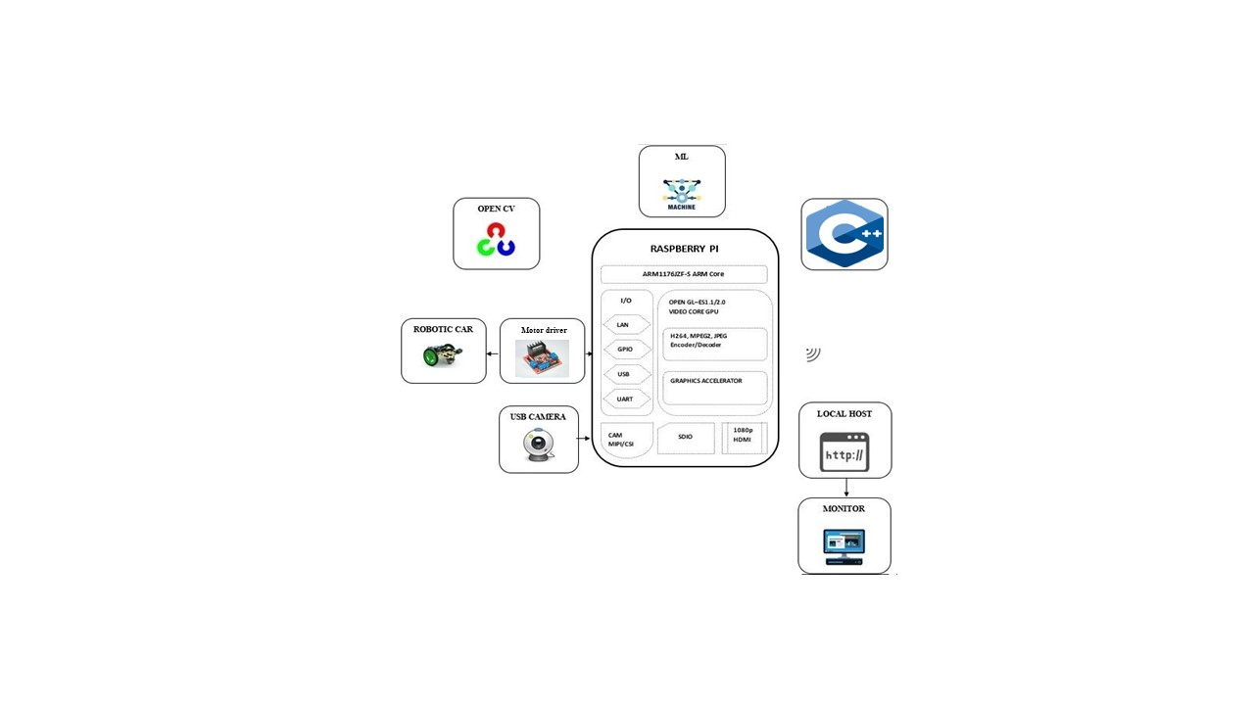

Fig 1: Block Diagram

With the aid of image processing and machine learning, we suggest a solution for the automatic driving car that does not include human mistake. Our solution makes use of the front-facing camera to record real-time footage of the road for analysis utilizing image processing and machine learning. Based on a number of sensors positioned throughout the vehicle, autonomous automobiles build and update a map of their surroundings. Traffic lights, road signs, other vehicles, lane markers, and pedestrians are all detected by video cameras. I R sensors are utilized to identify any impediments in front of the vehicle and to prevent collisions. Then, sophisticated software analyses all of this sensory data, draws a path, and issues commands to the actuators in the automobile that manage acceleration, braking, and steering. Predictive modelling, object identification, hard-coded rules, and obstacle avoidance algorithms aid the software in adhering to traffic regulations and avoiding obstructions.

* 1. **Model and Analysis**

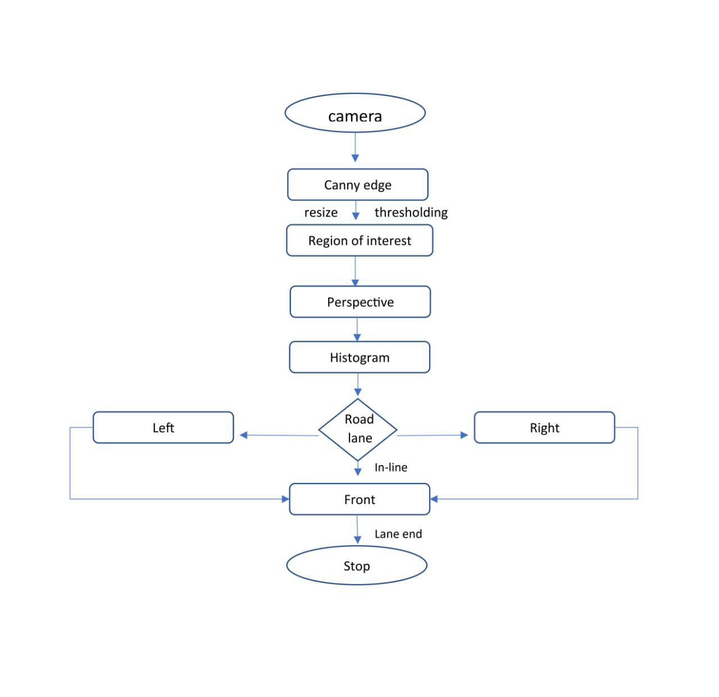

Fig 2: Flowchart

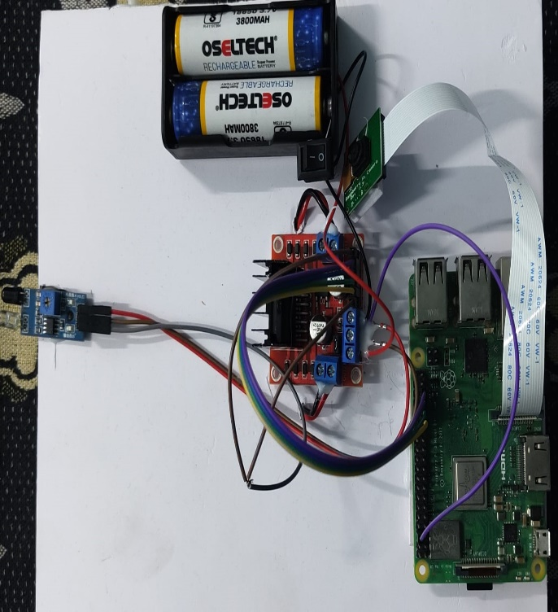

1. (b)

Fig 3(a, b): Hardware setup

1. **RESULTS AND DISCUSSION**

The initial step in working with our images is to convert them to grayscale, which involves combining the red, green, and blue pixel value channels into a single channel with a pixel value range of 0 to 255. Even after this conversion, the yellow lane lines can still be visible. If the image is in black and white, we can consider converting it to the Hue Value Saturation (HSV) color space. Additionally, we can apply a mask to the original RGB image to isolate the pixels we are interested in. The lane detection pipeline focuses on analyzing the area in front of the driver. To achieve this, we create a region of interest (ROI) mask, where everything outside the ROI is set to black or zero, allowing us to concentrate on the relevant information. Subsequently, we utilize the Hough transform to obtain two primary lines representing the detected lanes. To achieve a clean and smooth overlay, we can average our line image with the original, unmodified road image.

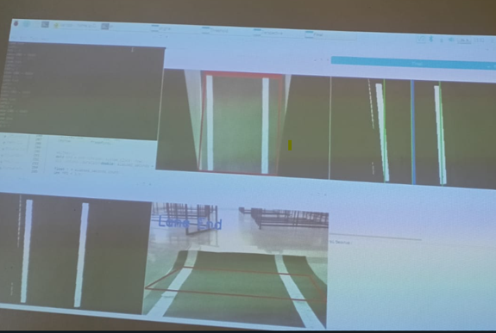

Fig 5: Detecting Road Lanes Fig 6: Movement Of Road Lane Detecting Model

1. **CONCLUSION**

This paper presents a method for developing a successful self-driving car model using Image Processing and Machine Learning techniques. The model performed as expected, demonstrating its effectiveness. The proposed system addresses the limitations of non-autonomous vehicles by reducing the amount of human effort required to operate the vehicle. In the future, a mobile app could be developed as an extension of this project. This app would allow users to communicate with the vehicle when faced with multiple paths to a common destination. Additionally, the app could provide recommendations for nearby places to visit. Autonomous cars have the potential to revolutionize the automation industry, surpassing traditional methods. They can be utilized for tasks such as patrolling and collecting photographs of suspects. By eliminating the need for human drivers, these vehicles can significantly reduce accidents caused by reckless driving of commercial vehicles, thereby improving logistics operations. Moreover, the autonomous nature of these cars can contribute to better regulation and control in the public transportation sector, minimizing errors. Overall, the implementation of such autonomous car models can offer realistic and advantageous solutions for enhanced efficiency and regulation in the movement of goods and people.

1. **REFERENCES**
2. R. Shashidhar, B. N. Aruna Kumari, A. S. Manjunath, Neelu Jyoti Ahuja, Vinh Truong Hoang, Kiet Tran-Trung, and Assaye Belay, ‘‘Computer Vision and the IoT-Based Intelligent Road Lane Detection System,” Research Article (Open Access) Volume 2022, Article ID 4755113 https://doi.org/10.1155/2022/4755113.
3. S.-W. Baek, M.-J. Kim, U. Suddamalla, A. Wong, B.-H. Lee, and J.-H. Kim, ‘‘Real-time Lane detection based on deep learning,’’ J. Electr. Eng. Technol., vol. 17, no. 1, pp. 655–664, Jan. 2022, DOI:10.1007/s42835-021-00902-6.
4. D. Kavitha and S. Ravikumar, ‘‘Designing an IoT based autonomous vehicle meant for detecting speed bumps and lanes on roads,’’ J. Ambient Intell. Hum. Comput., vol. 12, no. 7, pp. 7417–7426, Jul. 2021, DOI:10.1007/s12652-020-02419-8.
5. S. Swetha and P. Sivakumar, ‘‘SSLA based traffic sign and lane detection for autonomous cars,’’ in Proc. Int. Conf. Artif. Intell. Smart Syst. (ICAIS), Mar. 2021, pp. 766–771, DOI: 10.1109/ICAIS50930.2021.9396046.
6. N. Kanagaraj, D. Hicks, A. Goyal, S. Tiwari, and G. Singh, ‘‘Deep learning using computer vision in self-driving cars for lane and traffic sign detection,’’ Int. J. Syst. Assurance Eng. Manage., vol. 12, no. 6, pp. 1011–1025, Dec. 2021, DOI: 10.1007/s13198-021-01127-6.
7. D. K. Dewangan and S. P. Sahu, ‘‘Lane detection for intelligent vehicle system using image processing techniques,’’ in Data Science. Singapore: Springer, 2021, pp. 329–348, DOI: 10.1007/978-981-16-1681-5-21.
8. Yang, W. Zhang, X. Lei, Q. Shen, D. Xiao, P. Huang, Y. Lane Position Detection Based on Long Short-Term Memory (LSTM). Sensors 2020, 20, 3115. <https://doi.org/10.3390/s20113115>.
9. Jiayuan Gong, Haiying Zhou, Dong Bi, Jianping Lan, Leipeng Qie, “An Overview of Recent Progress of Lane Detection for Autonomous Driving,” 6th International Conference on Dependable Systems and Their Applications (DSA), January 2020, DOI:10.1109/DSA.2019.00052