**DESIGN AND FABRICATION OF ELECTRIC/PETROL GO-KART**

**PROJECT REPORT**

**(2022-2023)**

***Submitted in the partial fulfillment for the award of***

**DIPLOMA IN MECHANICAL ENGINEERING**

**Submitted by**

**NAME: REGISTER NO:**

RUTHRACHALAM.PM 21208858

SANJAY PRIYAN.K 21208860

SANJAY.S 21208861

SANJIV.H 21208862

SANTHOSH.M 21208863

SARAN.K 21208864

**Under the guidance of**

**Mr.K.MEGANATHAN.,M.E., MISTE.,**

**HoD / Mechanical Engineering**



**DEPARTMENT OF MECHANICAL ENGINEERING**

**SRI DURGADEVI POLYTECHNIC COLLEGE**

**R.S.M. NAGAR, KAVARAIPETTAI-601 206**

**THIRUVALLUR DISTRICT**

**SRI DURGADEVI POLYTECHNIC COLLEGE**

**R.S.M. NAGAR, KAVARAIPETTAI-601 206**

**THIRUVALLUR DISTRICT**

**DEPARTMENT OF MECHANICAL ENGINEERING**

**BONAFIDE CERTIFICATE**

*This is to certify that this project work entitled “Design and Fabrication of Electric/Petrol Go-Kart” Submitted by………………………………………………………………….*

*Register No: …................................... In partial fulfillment for the award of DIPLOMA IN MECHANICAL ENGINEERING.*

*This is the Bonafide record of work carried out by him under our supervision during the year 2022-2023 submitted for the Board Examination held on...........................................*

**PROJECT GUIDE**  **HEAD OF THE DEPARTMENT**

**INTERNAL EXAMINER EXTERNAL EXAMINER**

**ACKNOWLEDGEMENT**

**ACKNOWLEDGEMENT**

We sincerely own our heartfelt andsincere thanks and

respect to our honourable **Chairman Thiru.R.S.MUNIRATHINAM**

and **Vice Chairman Thiru. R.M.KISHORE.**

We also thank our principal **Dr.K.LAKSHMANAN., M.E.,**

**Ph.D.,AIE. MISTE** for giving us the necessary support during this project.

We also thank our **HOD Mr.K.MEGANATHAN., M.E., MISTE,**

Who inspired us to do the project in successful manner.

We also thank our guide **Mr.K.MEGANATHAN., M.E., MISTE,**

For providing valuable guidance.

We also thank all our department staff who have rendered their

direct andindirect help.

The moral support of our friends and family cannot be forgotten,

as the project would not have been impossible without their

support.

We also thank each and everyone who have been directly or

Indirectly responsible for the successful completion of our project.

Of our project.

**CONTENTS**

|  |  |  |
| --- | --- | --- |
| **S.No** | **Contents** | **PAGE NUMBER** |
| **1.**  **2.**  **3.**  **4.**  **5.**  **6.**  **7.**  **8.** | **Abstract**  **Introduction**  **Literature Review**  **Block diagram**  **Construction details**  **Working Principle**  **Advantages & Disadvantages**  **Application** | (i)  1  3  7  8  15  22  23 |

1.1

**ABSTRACT**

**ABSTRACT**

Go-kart is a racing vehicle that has very low ground clearance and can be worked on only flat racing circuits. This paper concentrates on explaining the Engineering behind designing of a safe, rigid, and torsional free frame, well mounted power train along with braking and steering system.

Go-karts are Small-size and small-weight vehicles that were developed for racing. These are made with materials that are strong and durable. It consists of many Parts which include a chassis, engine, steering and braking system, and electronic controls. The chassis is the main part that is responsible for the Stability of the vehicle. Chassis is made with material having greater endurance and rigidity. It was developed in the 1950s in the USA and now getting popular.

These are now used in amusement parks as a recreational activity. Many researchers have done work on go-karts and improve their Design. This project was intended to design and fabricate a reliable and durable go-kart. Its primary objective is to build a go-kart using local resources and applying different techniques to limit the cost of vehicles.

A reliable design was chosen which can be implemented and can be completed in our period. Parts whose manufacturing easy and cost-effective were Manufactured in a local workshop while other parts which cannot be manufactured locally and were costly, were purchased.

**Introduction**

**Introduction**

The go-kart is a vehicle that is small, quick, light, and simple to drive. Since the go-kart is designed for flat-track racing, it has poor ground clearance relative to most cars, but it does not have suspension. Engine, steering, tires, and bumpers are the elements of a go-kart. A go kart engine is either a two-stroke or a four-stroke engine.

The word "Eco-kart" refers to a car that uses electric motors instead of an engine. Go-karting is a form of open-wheel motorsport that involves lightweight, open-wheeled vehicles with four wheels. To feel the excitement, the chassis is independent of the suspension. Because of its ease, low cost, and safer way of racing, go-karting is a perfect outlet for those involved in racing. It is possible to have an indoor or outdoor track.

The go-kart tracks are much smoother than the F1 tracks. Go-karting experience will better introduce the driver to the actual racing environment, allowing them to participate as professional motor racers in various competitions. This project is intended to design and fabricate a low-weight go-kart. To reduce the weight of this vehicle, the main effort in this project is to select material. Hence, by choosing an appropriate material for its fabrication, one can reduce the overall weight of this vehicle.

The design process of the vehicle is based on various engineering aspects depending upon

1. Safety and Ergonomics
2. Market Availability
3. Cost of the Components
4. Safe Engineering Practices

The general definition of any kart, a vehicle without suspension and differential. It is a vehicle specially designed for a flat track race. An enormous range of engine karts were on track since the mid of the 20th century. The current automotive scenario encourages eco-friendly vehicles to attenuate the damage done by the emissions. An efficient alternative for the engine is that the motor which as compared can give an equivalent output power.

This can be implemented within the karting field. Motor replaces the engine and hence the kart gets dramatically changed in both design and performance. The vehicle, hence, runs only on electricity and is designed to satisfy the mandatory requirements for karting. The design of the frame indicates that it is an open kart with a straight chassis. The frame acts as a suspension in karts. It must also be rigid to not break under extreme load conditions. Hence, flexibility should be compromised with stiffness. The first objective is to design a stable and safest vehicle for the driver.

**Literature Review**

**Literature Review**

There is growing demand for fossil fuels like diesel and petrol to power the automotive and cater to other human needs. Fossil fuels are being depleted because of their excessive use and limited stocks. Further the use of fossil fuels is polluting the environment. In metro cities like Delhi and Beijing, the level of pollution from vehicles during peak hours is dangerous. Because of this people are fragile to wear masks for filtering the polluted air for respiration. Further, there are frequent traffic jams on the road and due to this there is a waste of fuel and time. All these factors are responsible for various problems in humans such as headache, stress, reduced performance etc.

To minimize all these problems and to keep our earth free from pollution and human health and fitness, there is an urgent need to explore alternatives in place of fossil fuel powered vehicles. Efforts are being put to develop vehicles powered by solar energy, hydrogen, biodiesel, and batteries. Battery powered vehicle are not so popular in India because they need frequent charging, small distance travelled in single charging, small range of speed in comparison to conventional automotive short battery life etc.

To overcome the above-mentioned problems an attempt has been made to design and fabricate environmentally friendly, battery powered, single passenger Hybrid kart. Hybrid Technology is defined as a technology that uses two or more distinct power sources to move the vehicle. The term most commonly refers to hybrid electric vehicles (HEVs), which combine an internal combustion engine and one or more electric motors.

A Hybrid-Electric Vehicle (HEV) combines the power of a gas engine with an electric motor. These dual engine systems can be configured for different purposes such as increasing the car's power, improving fuel economy, mileage, efficiency etc. A HEV may include a battery, an electric motor, a generator, an internal combustion engine and a power split device.

All these components make the vehicle able to run on both gas and electric power. Any vehicle that combines two or more sources of power that can directly or indirectly provide propulsion power can be called a hybrid. In fact, Hybrid vehicles are all around us. For example, a moped (a motorized pedal bike) is a most common type of hybrid because it combines the power of a gasoline engine with the pedal power of its rider.

Electric motors use no energy during idle or during turn off and use less energy than IC engines at low speeds. IC engines do better at high speeds and can deliver more power for a given motor weight.

That means during rush hour to stop and to go, the electric motor works great and, as an added benefit, does not produce any exhaust thus reducing smog levels. At higher speeds, the IC-engines kicks in and gives that power feeling that many car owners look for when driving on the highway. Another benefit is to charge the batteries while it is running. Much of the fuel efficiency comes from improvements in aero dynamics behaviors of vehicles, weight reduction and the biggest change: a smaller, less powerful gas engine.

In fact, any vehicle will get better mileage just by reducing the engine size. Even a slight increase in fuel economy makes a major difference in emissions over the life of the vehicle. Also, in large cities where pollution is at its worst, they make an even larger difference since they produce little emissions during low-speed city driving and the inevitable traffic jams. Because hybrids use regenerative braking, brake pads may even last longer than those in normal vehicles. A hybrid vehicle cuts emissions by 25% to 35%over even the most fuel-efficient gas-powered models.

**Description of Components**

1. Frame
2. BLDC Motor 48v
3. IC Engine (Petrol)
4. Lead acid battery 12v 26ah (4-nos)
5. Hydraulic disc brake.

Block diagram

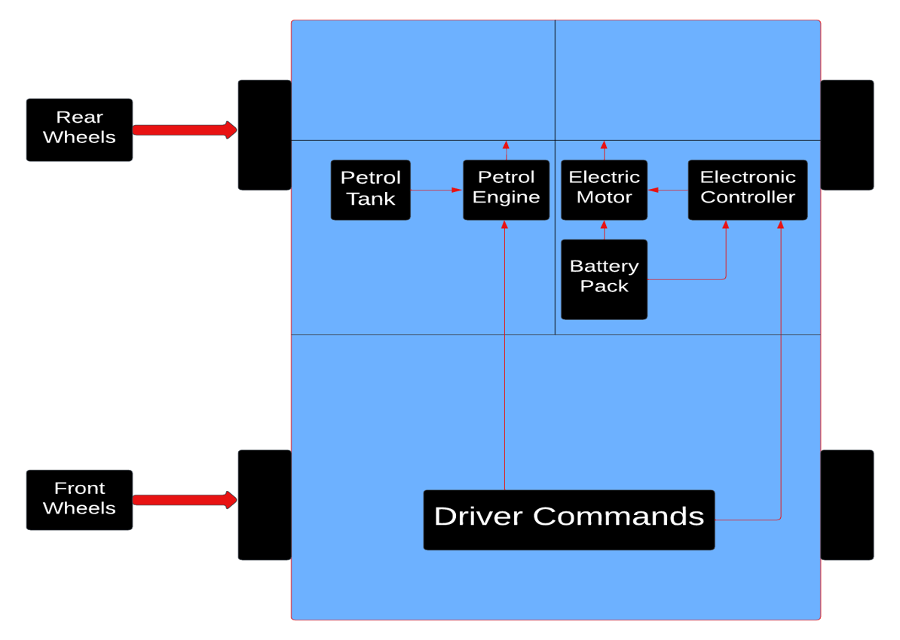

**Construction & Working Principle**

**Construction & Working Principle**

**1. Transmission Type:**

**1.1 Torque converter:**

Go-kart torque converters are variable transmissions, which means that they do not have a fixed gear ratio. Torque converters typically start with a gear ratio that is about 2:1 and will move closer to a 1:1 ratio, the faster the crankshaft spins.

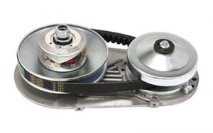

**1.2 Hero Honda Transmission**

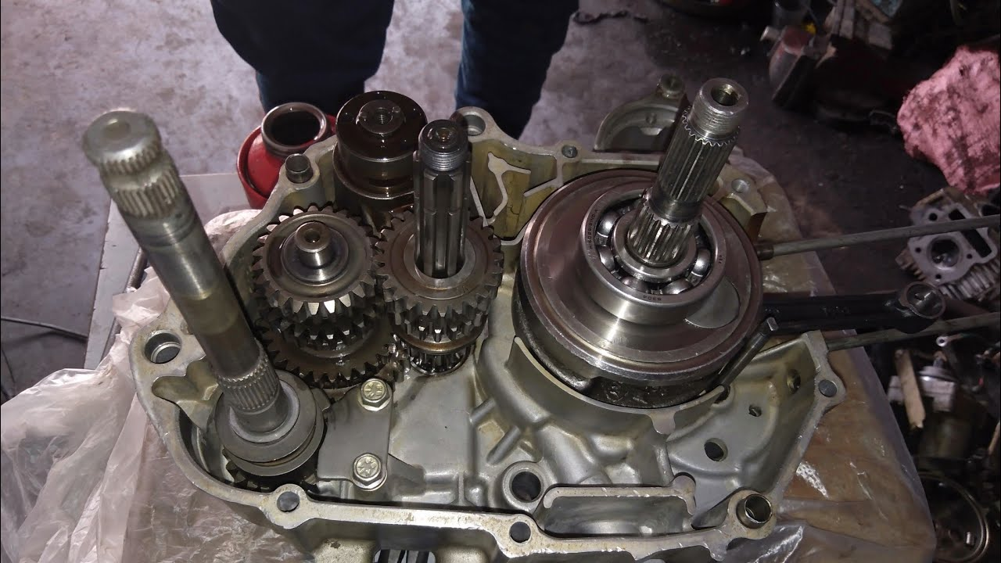

Gearbox arrangement

* We decided to go with manual transmission. Most of the Go-Kart engines come with a Torque converter.
* 4 Speed manual gearbox.
* Constant mesh gearbox.

**2. Braking system**

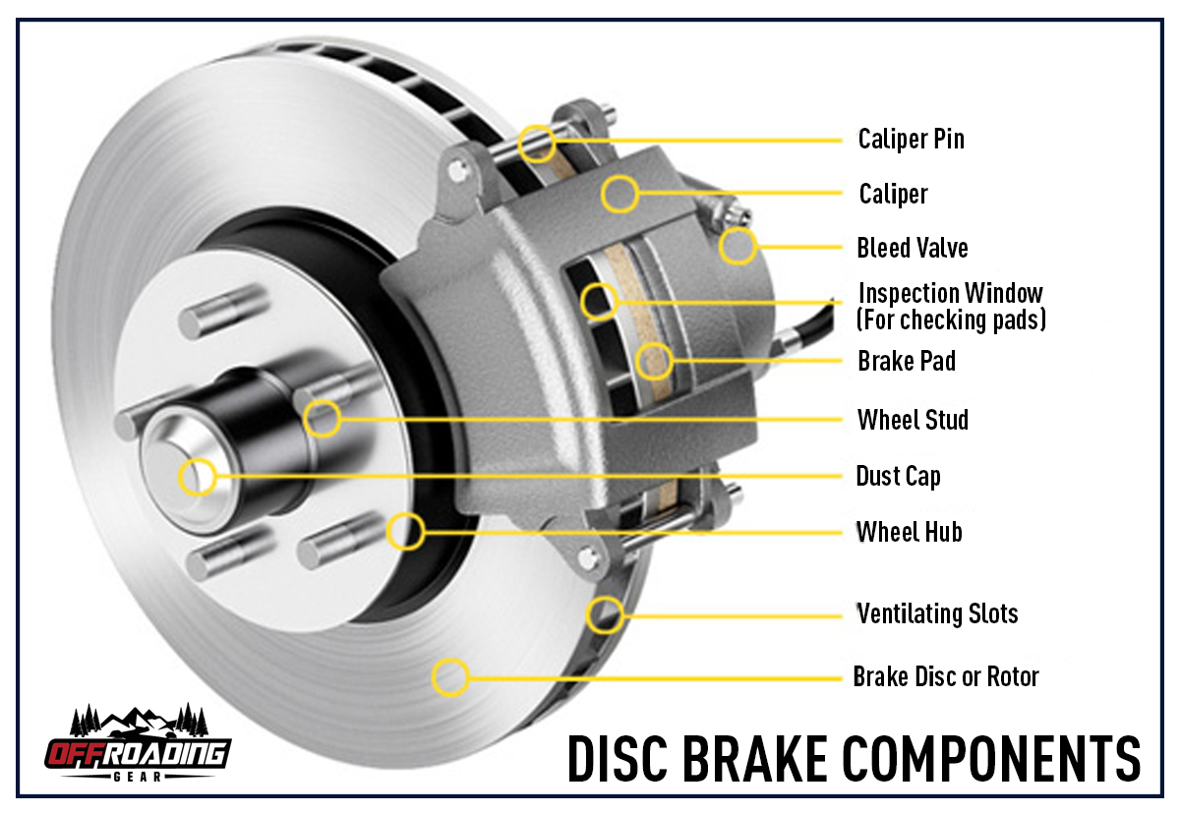

* We used hydraulic disc brakes for more braking power and to stop quickly.
* The brake rotor (disc) which rotates with the wheel, is clamped by brake pads (friction material) fitted to the caliper from both sides with pressure from the piston pressure mechanism and decelerates the disc rotation, thereby slowing down and stopping the vehicle.

**The main components of a disc brake are**:

* The brake pads
* The caliper, which contains a piston
* The rotor, which is mounted to the hub

**Advantages of Disc Brakes**

* Disc brakes offer greater stopping power, which can be helpful on long descents.
* Disc brakes do not heat the rim, which has been known to cause tire blowouts on long descents when rim brakes are used.
* Disc brakes allow for more precise braking, making wheel lockup less likely.
* Disc brakes work better than rim brakes in wet weather.
* Changing rotor sizes allows you to adjust how much braking power you want.

**Disadvantages of Disc Brakes**

* A disc brake is much more prone to noise so timely service is required.
* The rotors wrap easier than the drum brake system.
* Disc brakes are not self-energizing thus need higher clamping forces, which requires a power booster.
* Expensive as compared to a drum brake.
* Too many components are used in this brake, so it increases weight.

**3. Steering System**

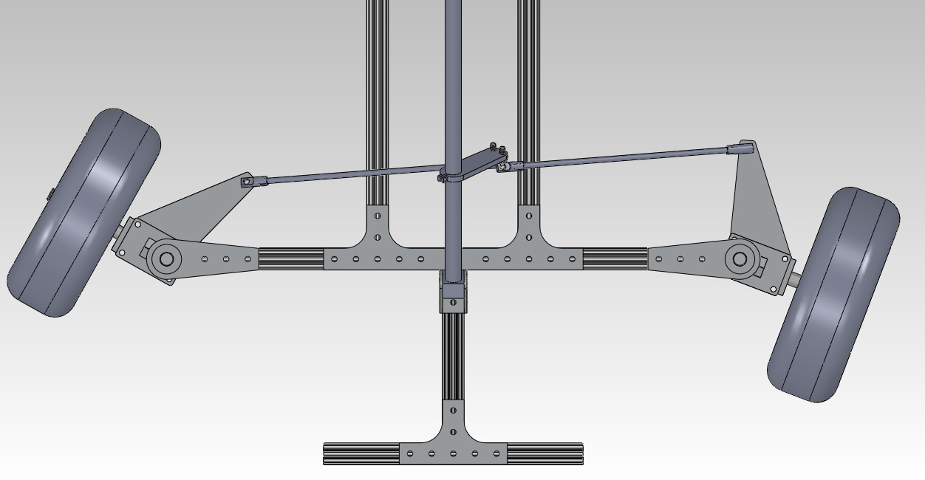

A steering system is one of the most important parts of an automobile used to give directional stability to the vehicle. This is typically achieved by a series of linkages, rods, pivots, and gears. The Ackerman Steering Mechanism is used in all vehicles. The significance of Ackermann geometry is to avoid the need for tires to slip sideways when following the path around a curve.

Our steering geometry has 78.8% Ackerman and gives a 45-degree Ackerman angle. We can decrease the turning radius of the kart by reducing distance between the two hinge points of the tie rod on the tripod, tripod is the triangular geometry on which both the tie-rods are hinged Tie-rods are then attached to stub axle and the stub axle is mounted with the front wheel by means of bearing. The third end of the tripod is attached to the steering column and at the other end of the steering column the steering wheel is attached by means of hub.

**4. Electrical components**

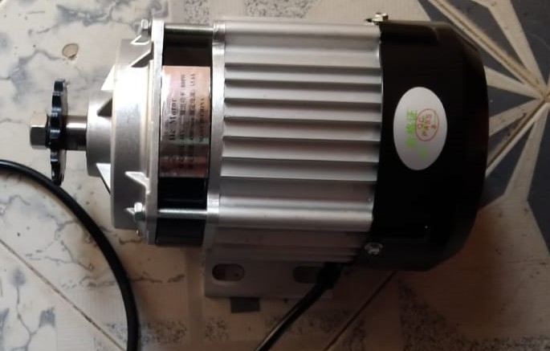

**Brushless DC motor**

**Brushless DC motor**

* 48 v
* 800 w
* 450 rpm
* 15.6 A

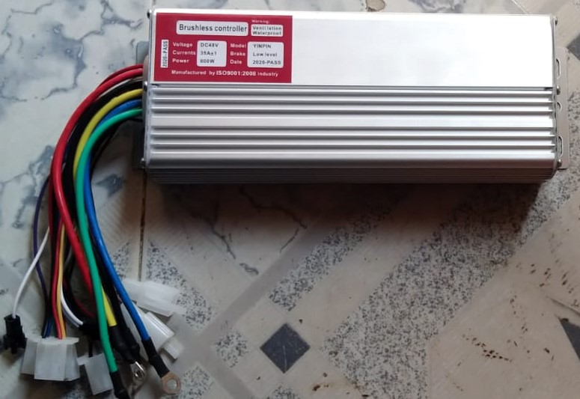

**DC motor Controller**

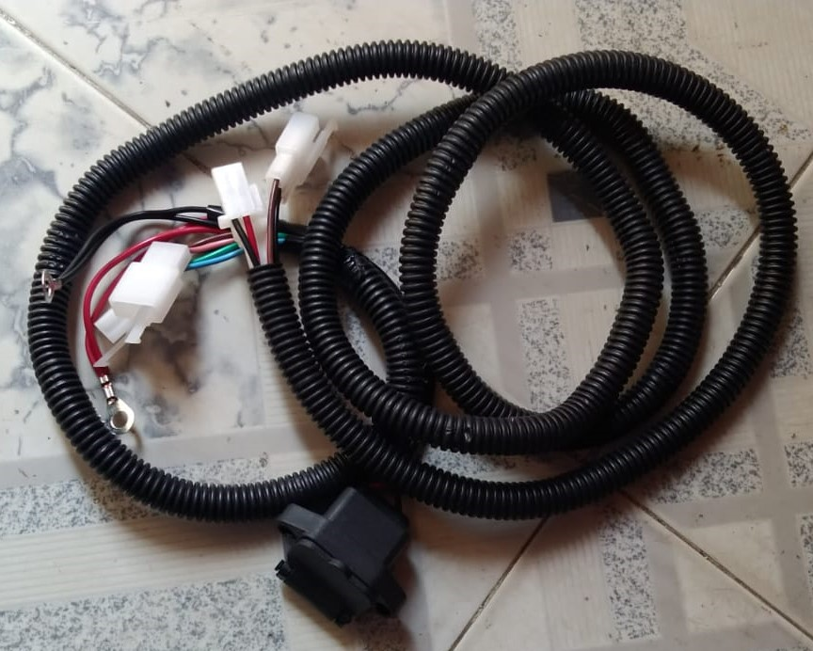

**Wiring Kit**

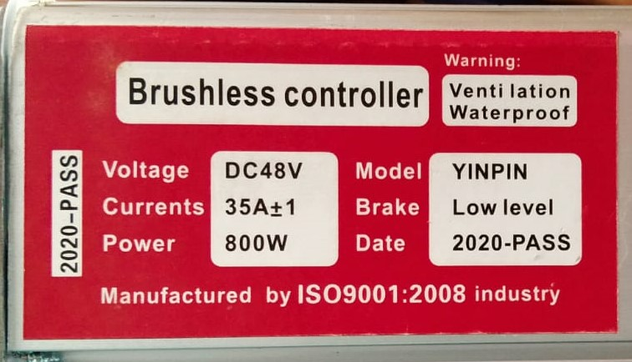

**Specifications**

**BLDC motor:**

A brushless motor (BLDC) consists of two main parts, a stator, and a rotor. For this illustration, the rotor is a permanent magnet with two poles, while the stator consists of coils arranged as shown in the picture below.

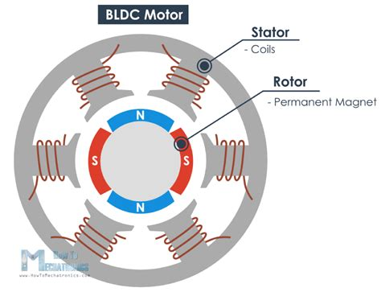

**BLDC Block Diagram**

We all know that if we apply current through a coil it will generate a magnetic field and the magnetic field lines or the poles depends on the current direction.

So, if we apply the appropriate current, the coil will generate a magnetic field that will attract the rotors permanent magnet. Now if we activate each coil one after another the rotor will keep rotating because of the force interaction between permanent and the electromagnet.

To increase the efficiency of the motor we can wind two opposite coils as a single coil in way that will generate opposite poles to the rotors poles, thus we will get double attraction force. With this configuration we can generate the six poles on the stator with just three coils or phase. We can further increase efficiency by energizing two coils at the same time. In that way one coil will attract and the other coil will repel the rotor.

## **Electronic Speed Controller**

An ESC or an Electronic Speed Controller controls the brushless motor movement or speed by activating the appropriate MOSFETs **(Metal Oxide Semiconductor Field Effect Transistor)** to create the rotating magnetic field so that the motor rotates. The higher the frequency or the quicker the ESC goes through the 6 intervals, the higher the speed of the motor will be.

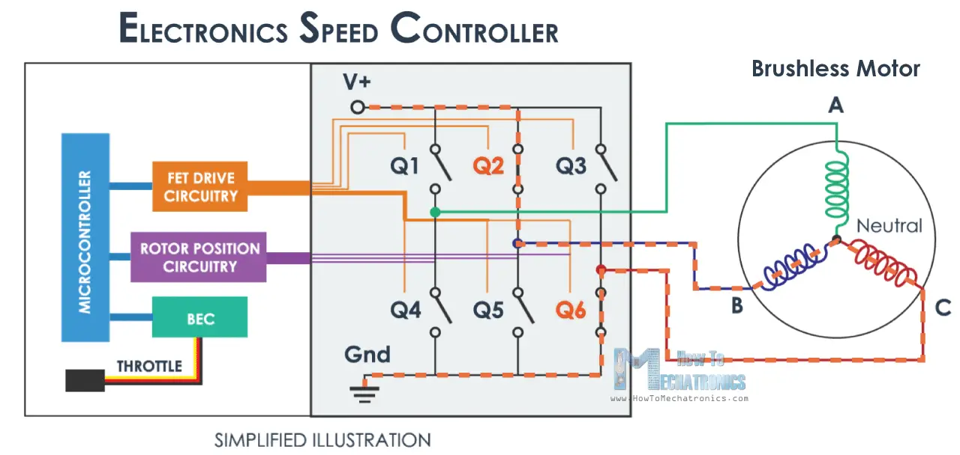

However, here comes an important question, and that is how we know when to activate which phase. The answer is we need to know the rotor position, and there are two common methods used to determine it. The first common method is by using Hall-effect sensors embedded in the stator, arranged equally 120 or 60 degrees from each other.

As the rotors permanent magnets rotate the Hall-effect sensors sense the magnetic field and generate a logic “high” for one magnetic pole or logic “low” for the opposite pole. According to this information the ESC knows when to activate the next commutation sequence or interval.

The second common method used for determining the rotor position is through sensing the back electromotive force or back EMF. The back EMF occurs because of the exact opposite process of generating a magnetic field or when a moving or changing magnetic field passes through a coil it induces a current in the coil. So, when the moving magnetic field of the rotor passes through the free coil, or the one that is not active, it will induce a current flow in coil and as result a voltage drop will occur in that coil. The ESC captures these voltage drops as they occur and based on them it predicts or calculates when the next interval should take place.

So that is the basic working principle of brushless DC motors and ESCs and it is the same even if we increase the number of poles of the both the rotor and the stator. We will still have a three-phase motor, only the number of intervals will increase to complete a full cycle.

**5. Engine specifications**

* There are many engines especially for Go-Karts available in the market like
* Tillotson 212cc
* Predator 6.5 HP
* Lifan LF 168F-2BDQ
* BILT HARD 301cc
* Briggs and Stratton 550 Series
* AlphaWorks 7 HP
* BILT HARD 212cc
* Xtremepower US 7HP
* Briggs and Stratton CR950
* Titan TX200
* The engine we used in our project is an old Hero Honda engine. Why we chose Hero Honda instead of other engines is that it gives better mileage, and it is a four-stroke engine, and its spares are available everywhere, we also decided to go with manual transmission. Most of the Go-Kart engines comes with a Torque converter.

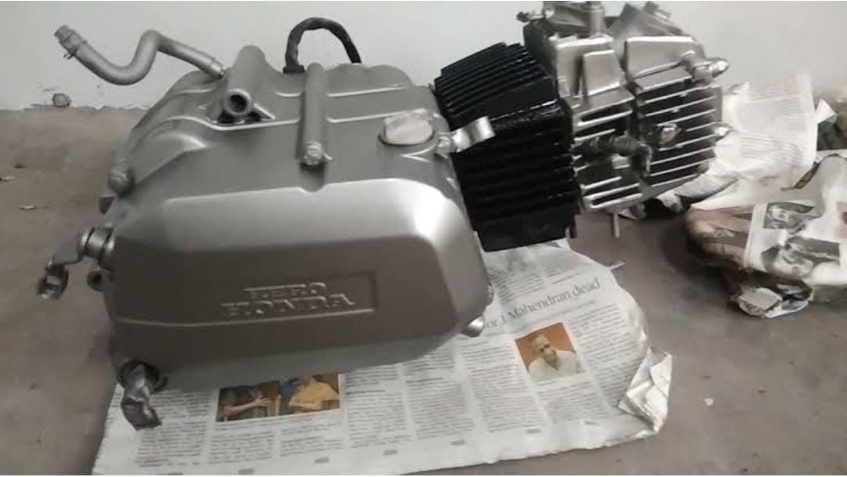

**Engine**

**Specification of Engine**

|  |  |
| --- | --- |
| **ENGINE**, **POWER** **&** **TORQUE** | |
| Displacement | 109.7 cc |
| Maximum Power | 7 BHP @ 7500 rpm |
| Maximum Torque | 8.3 Nm @ 5500 rpm |
| Engine Description | 109.7cc, 4-sroke |
| Cooling | Air Cooling |
| Bore | 53.5 mm |
| Stroke | 48.8 mm |
| Number of Cylinders | 1 |
| **TRANSMISSION** | |
| Gearbox | 4 Speed Manual |
| Clutch | Wet multiplate clutch |
| **BATTERY** | |
| Lead acid | 48v |
| Battery Type | Maintenance Free |

**Working of Petrol Engine**

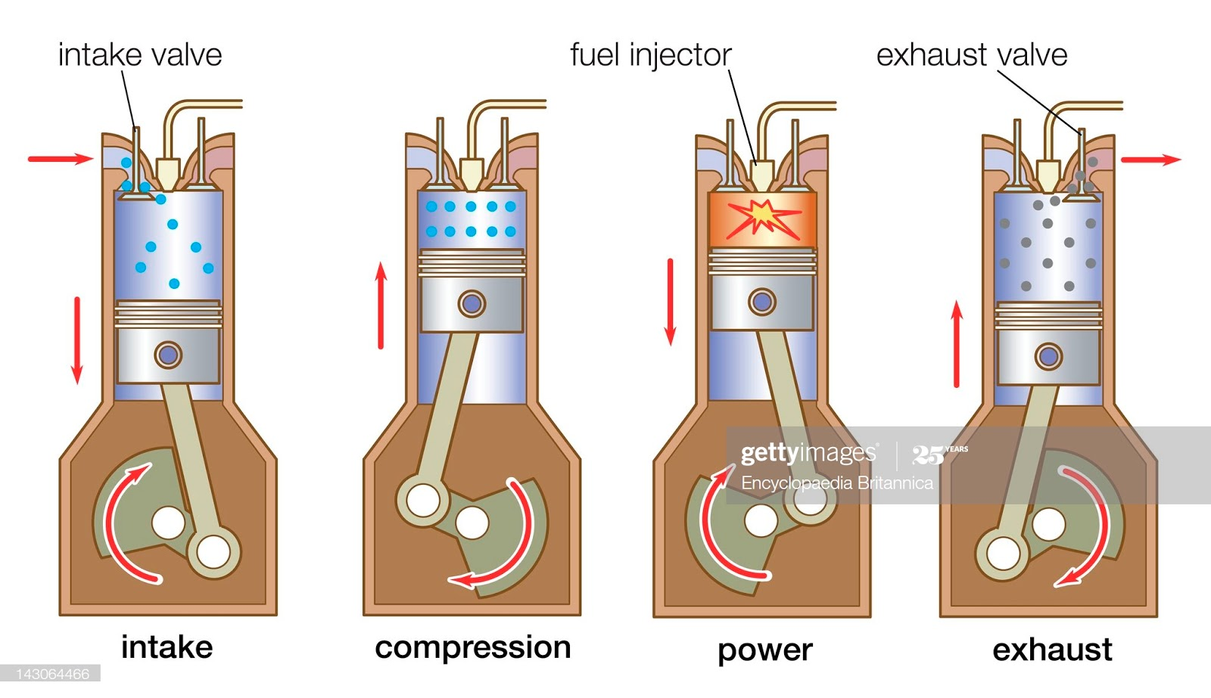

FOUR STROKE PETROL ENGINE  refers to its use in petrol engines, gas engines, light, oil engine and heavy oil engines in which the mixture of air fuel are drawn in the engine cylinder. Since ignition in these engines is due to a spark, therefore they are also called spark ignition engines. In four stroke cycle engine, cycle is completed in two revolutions of crank shaft or four strokes of the piston. Each stroke consists of 1800 of crankshaft rotation. Therefore, the cycle consists of 7200 of crankshaft rotation.

**Cycle consists of following four strokes**

1) Suction Stroke

2) Compression Stroke

3) Expansion or Power Stroke

4) Exhaust Stroke

**SUCTION STROKE:** In this Stroke the inlet valve opens and proportionate fuel-air mixture is sucked in the engine cylinder. Thus the piston moves from top dead centre (T.D.C.) to bottom dead centre (B.D.C.). The exhaust valve remains closed throughout the stroke.

**COMPRESSION STROKE:** In this stroke both the inlet and exhaust valves remain closed during the stroke. The piston moves towards (T.D.C.) and compresses then closed fuel-air mixture drawn. Just before the end of this stroke the operating. Plug initiates a spark which ignites the mixture and combustion takes place at constant pressure.

**POWER STROKE OR EXPANSION STROKE**: In this stroke both the valves remain closed during the start of this stroke but when the piston just reaches the B.D.C .the exhaust valve opens. When the mixture is ignited by the spark plug the hot gases are produced

which drive or throw the piston from T.D.C. to B.D.C. and thus the work is obtained in this stroke.

**EXHAUST STROKE:** This is the last stroke of the cycle. Here the gases from which the work has been collected become useless after the completion of the expansion stroke and are made to escape through exhaust valve to the atmosphere. This removal of gas is accomplished during this stroke. The piston moves from B.D.C. to T.D.C. and the exhaust gases are driven out of the engine cylinder; this is also called scavenging

**The four stroke petrol engine has the following advantages**:-

1. The 4-stroke petrol engines work at high speed and low torque.
2. The 4-stroke petrol engines work at a comparatively lower compression ratio.
3. It does not require a high-pressure fuel injection system and fuel injectors.
4. The engines are light in weight.
5. The working of 4 stroke petrol engine is less noisy.
6. Because of the spark plug, cold starting is easier in 4-stroke petrol engines.
7. The initial cost of 4 stroke petrol engine is less.
8. It has a lower maintenance cost.
9. The engine creates fewer vibrations.

**Four stroke petrol engine has the following disadvantages:-**

1. It requires an external device like a carburettor for the mixing of air and fuel.
2. The fuel used by the four stroke petrol engine is highly volatile.
3. The spark ignition system is required to ignite the compressed mixture.
4. The cost of fuel used in four stroke petrol engine is comparatively high.
5. It creates less torque than diesel engines.
6. The 4 stroke petrol engine has lower thermal efficiency.
7. It is not suitable for heavy load application due to the less torque generation.
8. This engine consumes more fuel for a unit amount of power generation, thus it has lower specific fuel consumption.

**The four stroke petrol engine has applications in the following vehicles**:-

1. Auto-rickshaw
2. Scooter
3. Motorcycle
4. ATVs
5. Petrol Cars
6. Generators
7. Light-duty transport vehicles
8. **6. Battery Description**

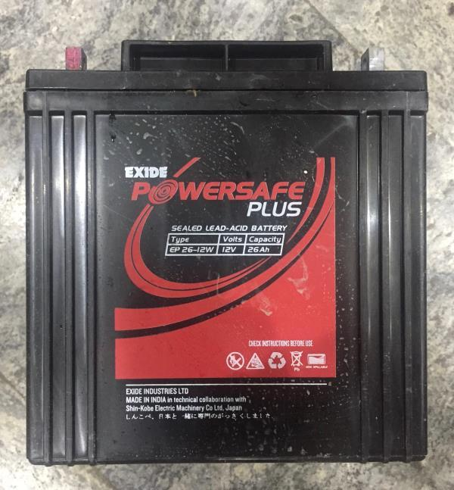

The lead–acid battery is a type of rechargeable battery. Compared to modern rechargeable batteries, lead–acid batteries have relatively low energy density. Despite this, their ability to supply high surge currents means that the cells have a relatively large power-to-weight ratio. These features, along with their low cost, make them attractive for use in motor vehicles to provide the high current required by starter motors. Lead-acid batteries suffer from short cycle lifespan as they are inexpensive compared to newer technologies, lead–acid batteries are widely used even when surge current is not important and other designs could provide higher energy densities.

### **Charging**

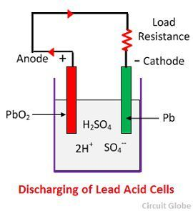

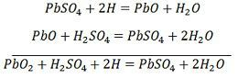

The hydrogen ions move to the anode and reaching the anodes receive one electron from the anode and become hydrogen atom. The hydrogen atom comes in contacts with a PbO2, so it attacks and forms lead sulphate (PbSO4), whitish in colour and water according to the chemical equation.

The each sulphate ion (SO4—) moves towards the cathode and reaching there gives up two electrons becomes radical SO4, attack the metallic lead cathode and form lead sulphate whitish in colour according to the chemical equation

### **Charging**

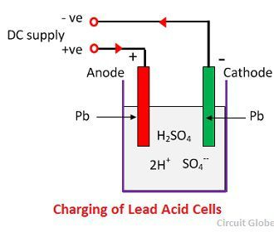

The anode and cathode are connected to the positive and the negative terminal of the DC supply mains. The molecules of the sulfuric acid break up into ions of 2H+ and SO4—. The hydrogen ions being positively charged moved towards the cathodes and receive two electrons from there and form a hydrogen atom. The hydrogen atom reacts with lead sulphate cathode forming lead and sulfuric acid according to the chemical equation.

SO4—ion moves to the anode, gives up its two additional electrons becomes radical SO4, react with the lead sulphate anode and form leads peroxide and lead sulphuric acid according to the chemical equation.



## **Construction**

* Positive terminal
* Negative terminal
* Negative Plates
* Positive plate
* Separators
* Container
* Filler Cap
* Electrolyte

**Advantages of Hybrid Go-kart:**

* In the case of emergency, if the vehicle breaks down in the middle of the race, the driver can activate the dc motor and move the vehicle to a safe place.
* Electric motors reduces pollution level.
* This Go-kart can be used both in indoor as well as outdoor racing.
* Simple steering Mechanism.
* Easy to reach and service each part of the Kart.

**Disadvantages:**

* High maintenance cost.
* Air pollution due to usage of petrol engine.
* Less ground clearance.
* Charging of battery can be a problem sometimes.
* It cannot be used in indoor without proper ventilation, Emission from engine can suffocate humans

**Applications in future:**

* Hybrid can be used in bikes and cars.
* Heavy duty commercial vehicles.
* Light duty commercial vehicles.
* Auto rickshaws.

|  |  |  |  |
| --- | --- | --- | --- |
| **S.NO** | **NAME OF THE ITEM** | **QUANTITY USED** | **COST(Rs)** |
| 1. | ENGINE (SPLENDER 100CC) | 1 | 3000 |
| 2. | BATTERY (LEAD ACID) | 4 (RENT) | 200 |
| 3. | DISC BRAKE CALIPER | 1 | 600 |
| 4. | ELECTRIC MOTOR KIT | 1 | 4000 |
| 5. | WELDING CHARGES | - | 1500 |
| 6. | FRAME WORK (CHASSIS) | 10 meters | 1000 |
| 7. | SEAT | 1 | 1000 |
| 8. | WHEELS | 4 | 1000 |
| **Total cost (Rs)** | 12,300 |

**Cost Estimation**

**Conclusion**

* With the help of this project, we gained a lot of practical knowledge and learned how to design, plan, and execute it.
* During the building process we learned about machines and about automobiles and engines.
* Our project's main motive is to reduce pollution by using electric motor and making it hybrid with low cost.

**BIBLIOGRAPHY**

**Reference books:**

1. Automotive Engineering, Kirpal Singh, Standard Publishers

2. Automobile Mechanics, A.K. Babu & S.C. Sharma, T.R. Banga, Khanna Book Publishing

3. Automotive Electricals and Electronics, A.K. Babu, Khanna Publishing House

4. A Textbook of Automobile Engineering, R.K. Rajput, Laxmi Publications

5. Hybrid Electric Vehicles (Principles and Applications with Practical Perspectives), Chris Mi, M. Abul Masrur

6. The Race for a New Game-Changing Electric Car Battery" by Venkat Viswanathan and Chen.

**YouTube Reference:**

https://www.youtube.com/watch?v=9OhZK_wyPqY

**PROJECT PHOTOGRAPHY**

