**ENHANCEMENT OF PROCESS PARAMETERS FOR MILLING USING TAGUCHI METHOD**

**Dayakar Renukuntlaa**

*a Asst. Professor, Dept. of Mechanical Engineering, KU College of Engineering and Tecnology KU Campus, Warangal, Telangana.*

–––––––––––––––––––––––––––––––––––––––––––––––––––––––––––––––––––––––––––––––––––––––––––––––

# Abstract

Present work investigates the effect of turning parameters such as rotational speed, feed rate and depth of cut on surface roughness of high carbon steel. Taguchi’s method was used for designing the experiments and optimization of turning parameters. Experiments were conducted as per L9orthogonal arraywith three factors having three levels for each factor. The analysis of variance technique is employed to study the significance and contribution of each factor on surface roughness. Results revealed that feed rate has a significant effect on surface roughness and it is the most dominating factor affecting the surface roughness with contribution of 99.58 %. The optimal parameter combination for minimum surface roughness is found to be A1B1C2 i.e., rotational speed of 315 rpm, feed rate of 15 mm/min and depth of cut of 0.8 mm.

**Keywords:** Milling Machine, Anova and Feed rate.

# ––––––––––––––––––––––––––––––––––––––––––––––––––––––––––––––––––––––––––––––––––––––––––––––––––

**Introduction:**

In the conventional varying one factor at a time technique lot of experimental data can be obtained. This way of experimentation not only consumes lot of time but also poses a challenge to the investigator for deriving appropriate conclusion from the huge experimental data. Design of Experiments (DOE) is at our rescue for planning systematic experimentation and arriving at a meaningful conclusion without being inundated in huge set of experimental data. “DOE” is an experimental strategy in which, effects of multiple factors are studied simultaneously by running tests at various levels of factors [1]. In today environment industry want to manufacture low cost, high quality product in short time. The principle of micro-machining is similar to those of conventional cutting operations. The surface of the work- piece is mechanically removed using micro-tools [2]. In micro-machining operations, the rotational speed of spindle should be very high to maintain acceptable productivity since the small tool diameter decrease the chip removal rate. Micro-end milling is emerging as an important micro-machining process and it is widely used in most of the manufacturing industries due to its capability of producing complex geometric surfaces with reasonable accuracy and surface finish [3]. In micro end milling material removal rate is one of the important aspects, which require attention both from industry personnel as well as in Research and development. In modern industry one of the trends is to manufacture low cost product in short time. MRR which indicates

processing time of the work piece and it is an important factor that greatly influences production rate and cost [4]. MRR greatly vary with the change of cutting process parameters. That is why the proper selection of process parameter is essential for maximum MRR in micro-end milling process. Literature review reveals that the researchers have carried out most of the work on micro- machining processes developments, monitoring and control but very limited work has been reported on optimization of process parameters [5]. In this work, the length of tool, radius and fluids are considered as constant and also tool deflection and tool wear is considered as negligible. This paper focuses the Taguchi technique for the optimization in micro-end milling operation to achieve maximum metal removal rate (MRR) considering the spindle speed, feed rate and depth of cut as the cutting parameters. Material removal rate which indicates processing time of the work piece is important factor that greatly influences production rate and cost. It is necessary to study the material removal rate in micro-end milling process [6]. Because of these, MRR is taken as output response. An orthogonal array, signal-to-noise (S/N) ratio and Pareto analysis of variance (ANOVA) are employed to analyze the effect of these milling parameters. Using Taguchi method for design of experiment (DOE), other significant effects such as the interaction among milling parameters are also investigated.

# Experimental Details: Material Used:

* AISI 304 plates
* Mild steel Plate

# Process Parameters:

* Spindle Speed
* Feed rate
* Depth of cut

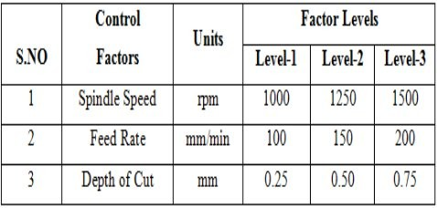

Table 1: Milling parameters and their levels **Optimization of Process Parameters for Surface Roughness:**

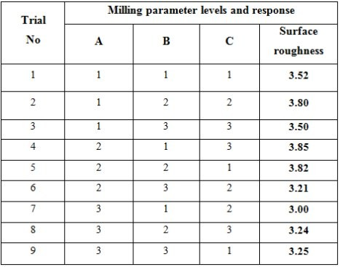

Table 2: Parameter Levels and Response of Surface Roughness

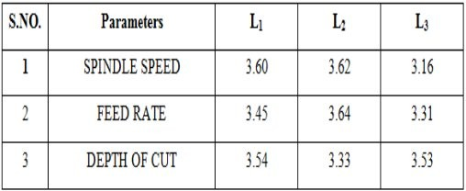

Table 3: Influence of each Process Parameter on Surface Roughness

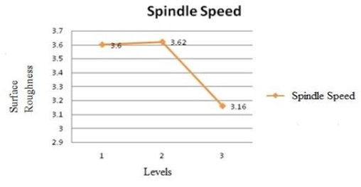

Figure 1: Influence of spindle speed on surface roughness

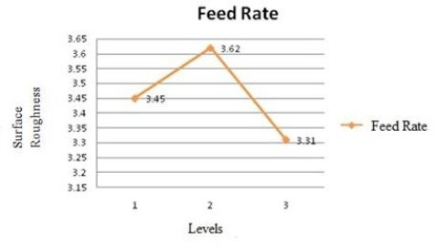

Figure 2: Influence of Feed rate on surface roughness

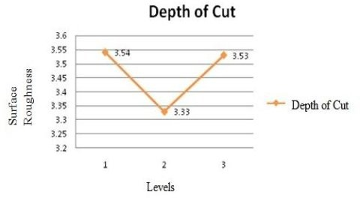

Figure 3: Influence of depth of cut on surface roughness

# ANOVA:

Hence, spindle speed and Depth of cut are significant parameter which must be maintained at the levels specified i.e. Depth of cut at level-2 and Spindle speed at level-3 other parameter can be maintained at any one of the level values specified based on cost consideration

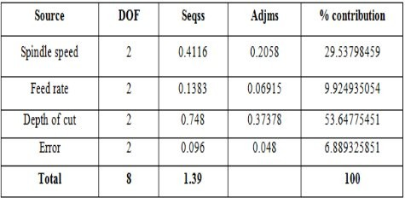

Table 4: Analysis of Variance (ANOVA) for Surface Roughness

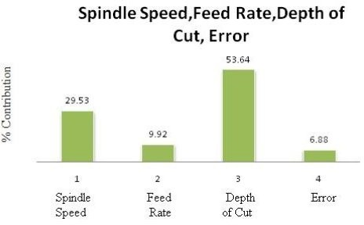

Figure 4: Percentage Contribution of each factor on Surface Roughness

# Optimization of Process Parameters for Material Removal Rate:

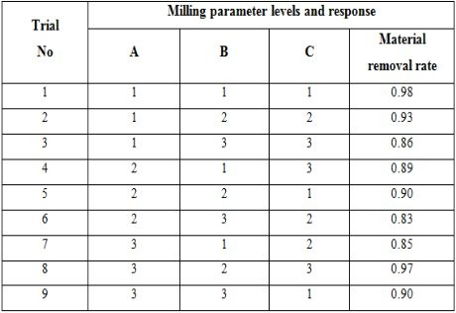

Table 5: Parameter Levels and Response of Material Removal Rate

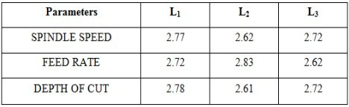

Table 6: Influence of each Process Parameter on Material Removal Rate

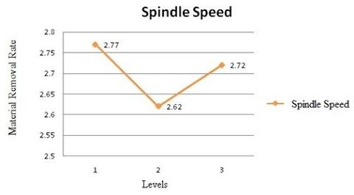Figure 5: Influence of Spindle speed on Material Removal Rate

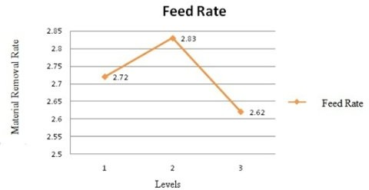

Figure 6: Influence of Spindle speed on Material Removal Rate

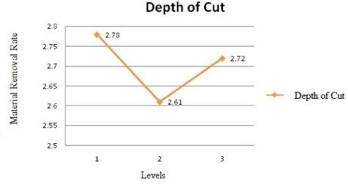

Figure 7: Influence of depth of cut on Material Removal Rate

# Analysis of Variance (ANOVA) for Material Removal Rate:

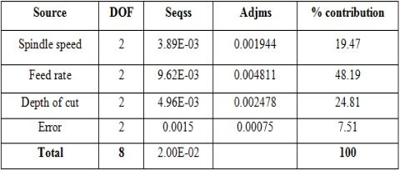

Table 7: Analysis of anova for material removal rate

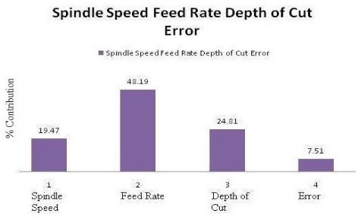

Figure 8: Percentage Contribution of each factor on Material removal rate

# Conclusions:

As per L9 orthogonal array, we have 3 3=27 combinations. Instead of 27 experiments, nine numbers of trials were conducted. The optimum value for surface roughness and material removal rate is not available in the nine numbers of experiments. The optimum values of surface roughness, combinations of parameters and their levels are also predicted by Taguchi method.

By the experiment results it was found that the surface roughness quality characteristic is smaller the better but the experimental value is 3.00mm i.e., at parameters S3, F1, D2 and for material removal rate quality characteristic is bigger the better but experimental value is i.e., 0.98 at S1, F1, D1.

After applying Taguchi techniques the predicted values are 2.82mm and material removal rate is 5.97mm. The values obtaining after applying Taguchi technique is more effective than the experimental values.

By ANOVA techniques, influence of each milling parameter is studied and the prediction of the surface roughness and material removal rate is done.

# REFERENCES:

1. M.S. Phadke, “Quality Engineering Robust Design”, Prenticehall, Engle Woodclitts, Nj (1989).
2. Milon D. Selvam, Dr.A.K.Shaik Dawood,Dr. G. Karuppusami, “Optimization Of Machining Parameters For Face Milling Operation In A Vertical CNC Milling Machine Using Genetic Algorithm”, An International Journal (ESTIJ), ISSN: 2250-3498, Vol-2, August (2012).
3. Anil Choubey, Vedansh Chaturvedi, Jyoti Vimal, “The Implementation Of Taguchi Methodology For Optimization Of End Milling Process Parameter Of Mild Steel”, International Journal of Engineering Science and Technology, ISSN : 0975-5462, Vol-2, (2007)
4. Nafis Ahmad, Tomohisa Tanaka and Yoshio Saito, “Optimization Of Cutting Parameters For End Milling Operation By Soap Based Genetic Algorithm”, ICME05-AM-08, August (2006).
5. 5. R. JaliliSaffar, M.R. Razfar, A.H. Salimi and M.M. Khani, “Optimization of Machining Parameters to Minimize Tool Deflection in the End Milling Operation Using Genetic Algorithm”, World Appl. Sci. J., 6 (1): 64-69, 2009.
6. Vellela, S. S., & Balamanigandan, R. (2022, December). Design of Hybrid Authentication Protocol for High Secure Applications in Cloud Environments. In 2022 International Conference on Automation, Computing and Renewable Systems (ICACRS) (pp. 408-414). IEEE.
7. Vellela, S. S., Basha Sk, K., & Yakubreddy, K. (2023). Cloud-hosted concept-hierarchy flex-based infringement checking system. International Advanced Research Journal in Science, Engineering and Technology, 10(3).
8. Vullam, N., Vellela, S. S., Reddy, V., Rao, M. V., SK, K. B., & Roja, D. (2023, May). Multi-Agent Personalized Recommendation System in E-Commerce based on User. In 2023 2nd International Conference on Applied Artificial Intelligence and Computing (ICAAIC) (pp. 1194-1199). IEEE.
9. Vellela, S.S., Balamanigandan, R. Optimized clustering routing framework to maintain the optimal energy status in the wsn mobile cloud environment. Multimed Tools Appl (2023). [https://doi.org/10.1007/s11042-023- 15926-5](https://doi.org/10.1007/s11042-023-%2015926-5)
10. Sk, K. B., & Vellela, S. S. (2019). Diamond Search by Using Block Matching Algorithm. DIAMOND SEARCH BY USING BLOCK MATCHING ALGORITHM", International Journal of Emerging Technologies and Innovative Research (www. jetir. org), ISSN, 2349-5162.
11. Vellela, S. S., Balamanigandan, R., & Praveen, S. P. (2022). Strategic Survey on Security and Privacy Methods of Cloud Computing Environment. Journal of Next Generation Technology (ISSN: 2583-021X), 2(1).
12. Vellela, S. S., & Krishna, A. M. (2020). On Board Artificial Intelligence With Service Aggregation for Edge Computing in Industrial Applications. Journal of Critical Reviews, 7(07), 2020.
13. Madhuri, A., Jyothi, V. E., Praveen, S. P., Sindhura, S., Srinivas, V. S., & Kumar, D. L. S. (2022). A New Multi-Level Semi-Supervised Learning Approach for Network Intrusion Detection System Based on the ‘GOA’. Journal of Interconnection Networks, 2143047.
14. Madhuri, A., Praveen, S. P., Kumar, D. L. S., Sindhura, S., &Vellela, S. S. (2021). Challenges and issues of data analytics in emerging scenarios for big data, cloud and image mining. Annals of the Romanian Society for Cell Biology, 412-423.
15. Praveen, S. P., Sarala, P., Kumar, T. K. M., Manuri, S. G., Srinivas, V. S., &Swapna, D. (2022, November). An Adaptive Load Balancing Technique for Multi SDN Controllers.In 2022 International Conference on Augmented Intelligence and Sustainable Systems (ICAISS) (pp. 1403-1409).IEEE.
16. Sk, K. B., Roja, D., Priya, S. S., Dalavi, L., Vellela, S. S., & Reddy, V. (2023, March). Coronary Heart Disease Prediction and Classification using Hybrid Machine Learning Algorithms. In 2023 International Conference on Innovative Data Communication Technologies and Application (ICIDCA) (pp. 1-7). IEEE.
17. Sk, K. B., Vellela, S. S., Yakubreddy, K., & Rao, M. V. (2023). Novel and Secure Protocol for Trusted Wireless Ad-hoc Network Creation. Khader Basha Sk, Venkateswara Reddy B, Sai Srinivas Vellela, Kancharakunt Yakub Reddy, M Venkateswara Rao, Novel and Secure Protocol for Trusted Wireless Ad-hoc Network Creation, 10(3).
18. Venkateswara Reddy, B., Vellela, S. S., Sk, K. B., Roja, D., Yakubreddy, K., & Rao, M. V. Conceptual Hierarchies for Efficient Query Results Navigation. International Journal of All Research Education and Scientific Methods (IJARESM), ISSN, 2455-6211.
19. Yakubreddy, K., Vellela, S. S., Sk, K. B., Reddy, V., & Roja, D. (2023). Grape CS-ML Database-Informed Methods for Contemporary Vineyard Management. International Research Journal of Modernization in Engineering Technology and Science, 5(03).
20. Karthik, J. V., & Reddy, B. V. (2014). Authentication of secret information in image stenography. International Journal of Computer Science and Network Security (IJCSNS), 14(6), 58
21. Vellela, S. S., & Sk, K. B. (2023). Cryonics on the Way to Raising the Dead Using Nanotechnology.
22. Vellela, S. S., Roja, D., Reddy, V., Sk, K. B., & Rao, M. V. (2023). A New Computer-Based Brain Fingerprinting Technology.
23. Vellela, S.S., Balamanigandan, R. Optimized clustering routing framework to maintain the optimal energy status in the wsn mobile cloud environment. Multimed Tools Appl (2023). [https://doi.org/10.1007/s11042-023- 15926-5](https://doi.org/10.1007/s11042-023-%2015926-5)
24. Vellela, S. S., Reddy, B. V., Chaitanya, K. K., & Rao, M. V. (2023, January). An Integrated Approach to Improve E-Healthcare System using Dynamic Cloud Computing Platform. In 2023 5th International Conference on Smart Systems and Inventive Technology (ICSSIT) (pp. 776-782). IEEE.
25. VenkateswaraRao, M., Vellela, S., Reddy, V., Vullam, N., Sk, K. B., & Roja, D. (2023, March). Credit Investigation and Comprehensive Risk Management System based Big Data Analytics in Commercial Banking. In 2023 9th International Conference on Advanced Computing and Communication Systems (ICACCS) (Vol. 1, pp. 2387-2391). IEEE.