**SRI DURGADEVI POLYTECHNIC COLLEGE**

**DEPARTMENT OF ELECTRICAL AND ELECTRONICS**

**ENGINEERING**

**PROJECT PROPOSAL FOR THE YEAR 2022-2023**

**TITLE OF PROJECT:**

**SOLAR AND WIND PV MICRO GRID SYSYTEM**

**PROJECT MEMBERS:**

**REGISTER NUMBER NAME OF THE STUDENT**

21306428 BELLAMKONDA MUKESH KUMAR

21306424 ASHWIN R

21306433 DEVASENNATHIPATHY K

21306455 LOKESWARAN B

21306441 GOKUL RAMAN K

21306452 LAKNESH V

**GUIDED BY:**

**Mrs.S.JAMUNA B.E.,**

**LECTURER/EEE.,**

**APPROXIMATE COST: Rs.**10,000/-

**PROJECT ABSTRACT**

**INTRODUCTION:**

**T**HERE are many remote locations in the world, which do not have access to electricity. There are also

many places, which are connected to the grid, however, they do not receive electricity for up to 10- 12 h

in the day and as a result of it, economic activities of inhabitants suffer. Many of such places are rich in renewable energy (RE) sources, such as wind, solar, and bio-mass. An autonomous generation system

utilizing locally available RE sources can greatly reduce the dependency on the grid power, which is

predominantly fossil power. Wind and solar energy sources are more favorite than bio-mass-based system as latter is susceptible to supply chain issue. However, wind and solar energies suffer from high level of

power variability, low capacity utilization factor combined with unpredictable nature. As a result of these factors, firm power cannot be guaranteed for the autonomous system. While the battery energy storage

(BES) can be helpful of lowering power fluctuation and increasing predictability, utilization factor can be increased by operating each energy source at optimum operating point.

**EXISTING SYSTEM:**

A hybrid energy system consisting of two or more type of energy sources has ability to reduce the BES

requirement and increases reliability. Wind and solar energies are natural allies for hybridization. Both have been known to be complementary to each other in daily as well as yearly pattern of the behavior.

Acknowledging advantages of this combination, many authors have presented autonomous wind solar

hybrid systems .The most favorite machine for small wind power application is permanent magnet

synchronous generator . It is possible to achieve gearless configuration with PMSG, however, it requires 100 % rated converter in addition to costlier machine . Some authors have also used a wind solar hybrid

system with a squirrel cage induction generator (SCIG) . Although SCIG has commercial edge regarding

machine cost, however, the scheme does not have speed regulation required to achieve MPPT. Moreover, if the speed regulation is done, it requires full power rated converter.

**PROPOSED SYSTEM:**

This paper presents a microgrid fed from wind and solar based RE generating sources (REGS). DFIG is used for wind power conversion while crystalline solar PV panels are used to convert solar energy. The control of overall scheme helps to provide quality power to its consumers for all conditions,

e.g.,

no-load, nonlinear load, and unbalanced loads. The controls of both generating sources are equipped with MPPT The DFIG in a proposed system has also two voltage source converters (VSC). In addition to LSC, DFIG also has another VSC connected to rotor circuit termed rotor-side converter (RSC). The function of RSC is to achieve wind MPPT(W-MPPT). The solar PV system is connected to the dc bus through solar converter, which boosts the solar PV array voltage. With this configuration, the solar power can be evacuated in a cost effective way. This converter too is equipped with solar MPPT(S-MPPT) control strategy to extract maximum solar energy. In case of unavailabity of wind energy source and lower state of charge of the battery, the battery bank can be charged through the grid power or a diesel generator through the same RSC.A single line diagram of the proposed RE generation system (REGS) fed

microgrid is shown in Fig. 1. the wind energy source can be isolated using a three-pole breaker from the

network in case of insufficient wind

speed.

**CIRCUIT DIAGRAM :-**

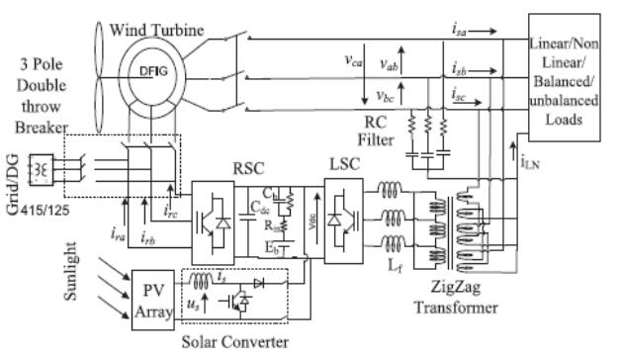

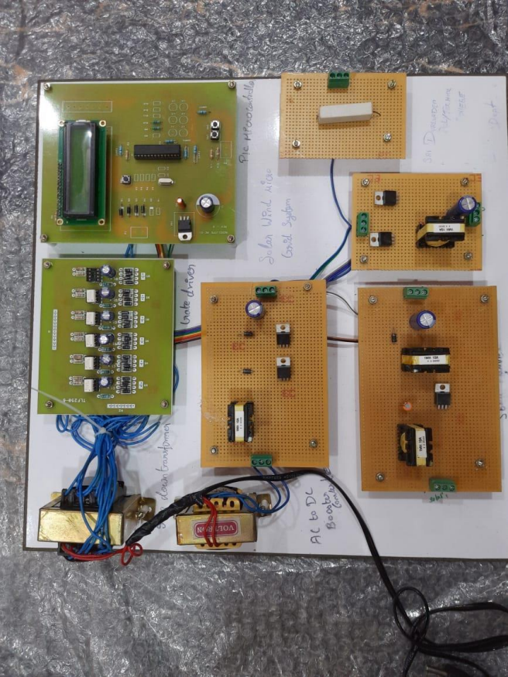

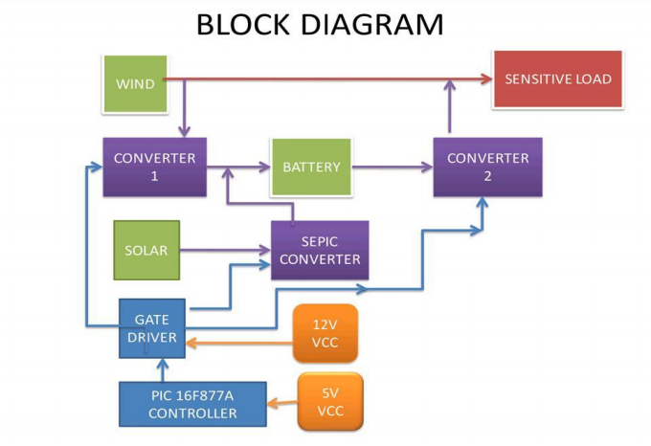

The dc side of both RSC and LSC along with HV side of solar converter is connected at the battery bank. RSC helps the wind energy system to run at the optimum rotation speed as required by W-MPPT

algorithm. The LSC controls the network voltage and frequency.

**ADVANTAGES:**

• REGS comprises wind and solar energy blocks, which are designed to extract the maximum power from the RE sources and at the sametime, it provides quality power to the consumers. The system has been designed for complete automated operation. This work also presents the sizing of

the major components.

**APPLICATIONS:**

• Wind based energy sources.