**WIRELESS CHARGING OF ELECTRIC VEHICLES BY ZVS-IPT TOPOLOGY**

**Sukanya H N1, Mohammed Najath2, Meghana N3, Nayana N P4, Rakesh D H5**

1Assistant Professor, Department of Electrical and Electronics, PES College of Engineering, Mandya, Karnataka, India.

2,3,4,5Student, Department of Electrical and Electronics, PES College of Engineering, Mandya, Karnataka, India.

**ABSTRACT**

Wireless charging technology for electric vehicles (EVs) has gained significant attention as a promising solution to overcome the limitations of conventional plug-in charging methods. The fundamental principle involves transferring electrical energy from a charging pad on the ground to a receiver pad installed on the EV through ZVS IPT topology. The abstract highlights the key advantages of wireless charging, including the elimination of cables and connectors, improved user experience, and reduced wear and tear on charging interfaces. It also addresses the challenges associated with wireless charging, such as lower efficiency compared to wired charging, standardization, and cost considerations. Moreover, the abstract discusses the current state of wireless charging technology, including its deployment in commercial and public settings, as well as ongoing research and development efforts to enhance charging efficiency, alignment tolerance, and interoperability. Overall, wireless charging holds great potential to revolutionize the charging experience for electric vehicles, providing a convenient and seamless charging solution. However, further advancements and standardization are necessary to address the existing challenges and accelerate the widespread adoption of this technology in the transportation sector.

**Keywords**: Electric Vehicle Wireless Power Transfer, Plug –In Charging, Static and Dynamic Charging systems, ZVS Topology.

1. **INTRODUCTION**

The harmful effects of incremental per capita fuel consumption result in temperature rise and global warming. So a partial but effective solution is selected as a gradual reduction in the carbon footprint of each individual by adopting green energy-based electric transportation systems. However, electric vehicles (EVs) yet facing challenges in economy, driving range, fuel efficiency, battery, and its charger technology. The user of battery chargers embraces onboard, off-board or plug-in, and contactless chargers based on its cost, efficiency, convenience, and safety. Nowadays, contactless inductive power transfer (IPT) based chargers expanding its market because of its safety, convenience, performance, reduced battery size and adaptability. The performance of the IPT system predominantly depends on network construction of DC-DC converter exercising loosely coupled transformer Since the high leakage inductance prevents power transfer to a large extent. Therefore, a leading power factor impedance network is essential to resolve the high circuit impedance issues. With the depletion of fossil fuels and an increase in global warming, the awareness of society towards the use of renewable resources has increased. Transportation is one of the essential parts of society, but the use of conventional methods leads to increased pollution. To overcome the aforementioned problem, electric vehicle (EV) becomes one of the economical and environmentally friendly solution [2]. Normally, battery-bank based EV is dominating due to rapid decay in the price of the battery (from 2007 to 2016 the cost of Li-ion battery is reduced by 8%). Primarily, plugin EV battery chargers are accepted at the price of human safety, convenience, leakage current, contact losses, isolation, and flexibility. To overcome these drawbacks, inductive power transfer (IPT) becomes one of the rapidly growing and eyecatching technology. The Society of Automotive Engineers (SAE) set an international standard SAE J2954, which treated 85 kHz ± 5% acts as a nominal frequency for a light-duty passenger vehicle. It is to say, the battery capacity of an EV requires to cover a certain distance would significantly reduce if the EV is charged. On taking the example of the electric bus the size of its battery is reduced by a factor of five. Therefore, based on the urban driving style, the IPT converters are placed in the garage, parking (commercial or official), bus stoppage etc. Even though it is costly to install the IPT on the different locations, the economic analysis in shows that dynamic charging can be beneficial for the battery life. The IPT is fundamentally based on the magnetic resonant coupling. This system consists of a primary coil mounted outside the vehicle and a secondary coil is fixed on the vehicle chassis. These coils are responsible for the power transfer through an alternating electromagnetic field. The full bridge DC (FBDC), DC converter configuration is used for power transfer in IPT, but the conventional FBDC suffers from loss of soft-switching during the light-load condition. Most electric vehicles use lithium-ion batteries (Li-Ions or LIBs). Lithium-ion batteries have higher energy density, longer life span and higher power density than most other practical batteries. Complicating factors include safety, durability, thermal breakdown and cost. Li-ion batteries should be used within safe temperature and voltage ranges in order to operate safely and efficiently. Increasing the battery's lifespan decreases effective costs. The prices of lithium-ion batteries are constantly decreasing, contributing to a reduction in price for electric vehicles. coil mounted outside the vehicle and a secondary coil is fixed on the vehicle chassis. These coils are responsible for the power transfer through an alternating electromagnetic field. The full bridge DC (FBDC), DC converter configuration is used for power transfer in IPT, but the conventional FBDC suffers from loss of soft-switching during the light-load condition. Most electric vehicles use lithium-ion batteries (Li-Ions or LIBs). Lithium-ion batteries have higher energy density, longer life span and higher power density than most other practical batteries. Complicating factors include safety, durability, thermal breakdown, and cost. Li-ion batteries should be used within safe temperature and voltage ranges in order to operate safely and efficiently. Increasing the battery's lifespan decreases effective costs. The prices of lithium-ion batteries are constantly decreasing, contributing to a reduction in price for electric vehicles.

**Literature Review**

**1.Lalit Patnaik, Phuoc Sang Huynh; Deepa Vincent; Sheldon S. Williamson-Wireless Opportunity Charging as an Enabling Technology for EV Battery Size Reduction and Range Extension:**

Analysis of an Urban Drive Cycle Scenario. Irrespective of the specific WPT technology used, it is possible to quantify the effect of opportunity charging on EVs using energy calculations. This paper presents an analysis of the potential reduction in battery size and extension in EV range enabled by opportunity charging, using urban driving cycle data and various charging power levels.

**2.Eiman ElGhanam; Hazem Sharf; Yazan Odeh; Mohamed S. Hassan; Ahmed H. Osman-** **On the Coordination of Charging Demand of Electric Vehicles in a Network of Dynamic Wireless Charging Systems.**

To ensure optimal utilization of this charging infrastructure, coordination of EV charging demand is essential to achieve grid load balancing and prevent grid overload. In contrast to offline, day-ahead charging scheduling, this work proposes an online, mobility-aware, spatial EV allocation algorithm within a DWC coordination strategy. This strategy allocates EVs requesting charge to the most optimal DWC lanes within an EV charging network (ECN) in an Internet of EVs (IoEVs).

**3. Chunhua Liu; Chaoqiang Jiang; Chun Qiu-Overview of coil designs for wireless charging of electric vehicle.**

This paper presents an overview of coil designs for wireless principles, and distinct features. The basic topologies including the circular rectangular pad (CRP), circular pad (CP), homogeneous pad (HP), double-D pad (DDP), double-D quadrature pad (DDQP), and bipolar pad (BP), are introduced and discussed.

**4.Abhishek Shakya; Mayank Kumar-Implementation of Inductive Wireless Power Transmission system for Battery Charging applications.**

Wireless power transfer technology known as inductive power transfer (IPT) is a sort of technology which is known as wireless power transfer technology. The goal of this work is to construct an electric vehicle wireless power transfer charger based on IPT. A series– series (SS) compensated IPT system has been developed for this purpose. To begin, the SS compensated IPT system’s designing formulas are derived. Based on the derived formulas of design, values are calculated for deriving a 2 KW wireless power charger and the same is implemented using Simulink/MATLAB.

**5.Palwasha W. Shaikh; Hussein T. Mouftah-Intelligent Charging Infrastructure Design for Connected and Autonomous Electric Vehicles in Smart Cities.**

For an environmentally sustainable future, electric vehicle (EV) adoption rates have been growing exponentially around the world. There is a pressing need for constructing smart charging infrastructures that can successfully integrate the large influx of connected and autonomous EVs (CAEVs) into the smart grids. To fulfill the aspirations for massive deployments of autonomous mobility on demand (AMoD) services, the proposed fast and secure framework will also need to address the long charging times and long waiting times of static charging and will need to consider dynamic wireless charging as a viable solution for the CAEVs on the move.

**6.Rui Li; Feng Wen; Qiang Li; Li Liuao; Tao Wu-Research on Harmonic Influence of Electric Vehicle Wireless Charging System on Power Grid.**

The charging behavior of a large number of electric vehicles will induce harmonic pollution to the power grid caused by wireless charging. In this paper, we establish a model of WPT charging system for EVs and study the impact of the system on the power grid under the condition of resonant, capacitive and inductive. Fast Fourier Transform (FFT) is performed on the voltage waveforms of the grid side to analyze the harmonic pollution on the grid side when the system works at different power levels.

1. **METHODOLOGY**

**2.1 Objectives**

1. To develop a system with zero voltage switching inductive power transfer topology (ZVS-IPT) in order to reduce the switching losses of MOSFET.
2. To obtain an efficiency of about 92% is with ZVS for a full dynamic/static power transfer.

**2.2 Block Diagram**

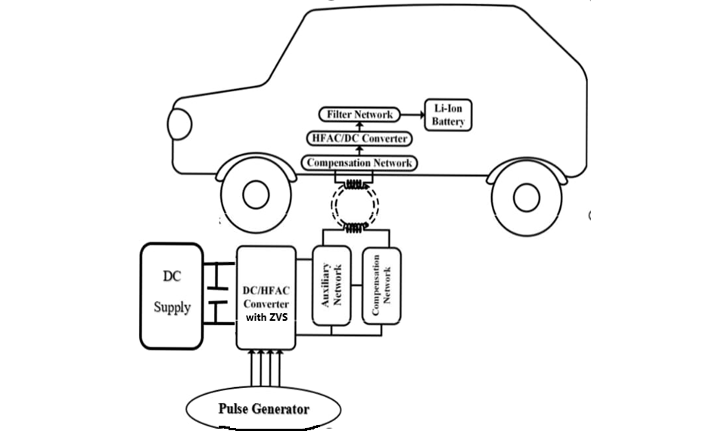

Fig 1: Block Diagram of Wireless Charging Of Electric Vehicle Using ZVS

In this project, Zero Voltage Switching Inductive Power Transfer (ZVS-IPT) topology and its switching pattern is proposed. ZVS is achieved by optimizing the classical series compensation and additionally, an auxiliary network is employed to achieve wide range performance independent of loading conditions. If the input voltage is subjected to a wide range of voltage variation the output current can easily controlled from the input side voltage. The block diagram consists of DC supply connected to DC/HFAC Converter (Inverter)with ZVS which converts DC to high frequency AC.pulse generator is used to give pulses to switches used in inverter and then High frequency AC is fed to auxiliary network and compensation network which helps for effective functioning of transmission, and it helps in steady state accuracy of the system and high frequency AC is transmitted from primary coil to secondary coil. Then the high frequency AC obtained at secondary is given to compensation network and converted to DC using Diode rectifier and fed to the filter network to prevent loss due to leakage inductance between transmitter coils. The filtered DC is supplied to lithium-ion battery.

The Components that are used in the system are listed below:

**1. AC/DC Converter:** AC/DC converter (rectifier) is a device that converts an oscillating two-directional alternating current (AC) into a single-directional direct current (DC). A diode behaves as a one-way valve that allows current to flow in a single direction. This process is known as rectification. This is also called as Power factor correction converter which supervises the reactive power flowing from the source to the transmitter coil to ensure grid stability.

**2. DC/AC Converter:** A High frequency full bridge inverter is used to deliver a high excitation current to the transmitter coil. DC/AC converters (Inverters) are also called AC Drives, or VFD (variable frequency drive). They are electronic devices that can turn DC (Direct Current) to AC (Alternating Current). An inverter converts the DC electricity from sources such as batteries or fuel cells to AC electricity. The electricity can be at any required voltage; in particular it can operate AC equipment designed for mains operation or rectified to produce DC at any desired voltage.

**3. Compensation network:** There are four types of compensation networks namely a) series-series, b) parallel-series, c) parallel-parallel, d) series-parallel. We are selecting series-series compensation because of its increased steady state accuracy of the system.

**4. Filter network:** The filter network is needed to prevent loss due to leakage inductance between transmitter coils 5. Auxiliary network: Auxiliary network mean all networks for control, regulation, protection, communication, and information necessary for the effective functioning of the transmission and distribution networks.

**6. Pulse generator:** Pulse generators are items of electronic test equipment that are used to generate pulses normally rectangular pulses. Pulse generators are used primarily for working with digital circuits; related function generators are used primarily for analog circuits.

1. **MODELING AND ANALYSIS**

**3.1 Proposed Network Configuration for EV Battery Charger:**

The proposed DC – DC converter configuration is shown in fig 2, and it is designed using enlisted devices:

• DC power supply consisting of input DC source VDC parallel with split capacitors Ca1, Ca2.

• H-Bridge inverter consisting Active switches S1, S2, S3, S4, parallel parasitic capacitance CS1, CS2, CS3, CS4, and anti-parallel body diode D1, D2, D3, D4 respectively.

• Auxiliary network made by transformer TA, and inductor LA.

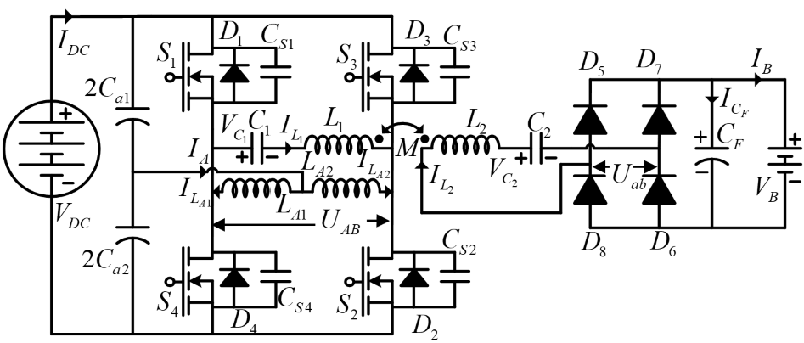

Fig 2: Proposed DC-DC Configuration Network

• IPT network which includes transmitting coil inductance L1 and its compensating capacitance C1 with receiving coil inductance L2 and its compensation capacitance C2.

• Rectifier circuit made by diodes D5, D6, D7, D8 and filter capacitance CF. The following assumptions are considered to understand the operating principle of the proposed converter better:

• All passive and active devices, i.e., capacitors, transformer, DC source, switches, diode are considered ideal.

• Ca = Ca1 = Ca2, CF are large enough to such that voltage at input terminals of H-bridge inverter and at the output of rectifier is constant

• Electrical series resistance of inductor and capacitors are neglected. Inter-winding capacitance of inductor is neglected.

The steady state operation of the proposed topology is divided into eight intervals (I to VIII) as shown in Fig.3



**4.2 ZVS TOPOLOGY**

Fig 3: Operating Modes of Proposed Battery Charger Topology (a) Interval I, (b) Interval II, (c) Interval III, (d) Interval IV, (e) Interval V, (f) Interval VI, (g) Interval VII, (h) Interval VIII.

1. **RESULTS AND DISCUSSION**

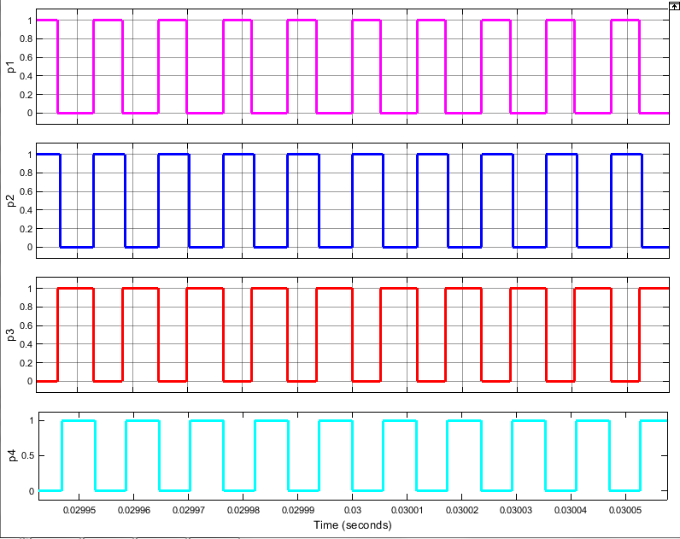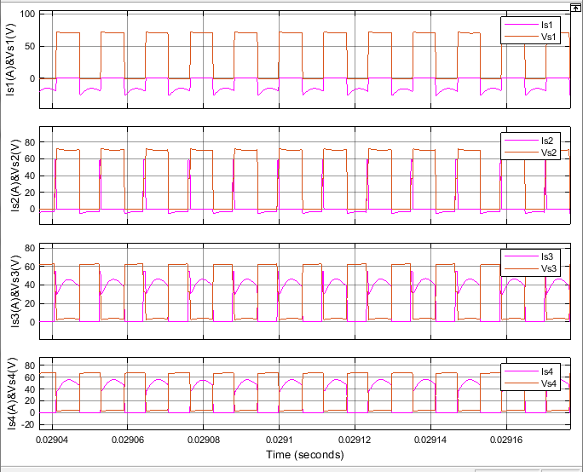

Fig 4: Waveforms of Pulse Generator Fig 5: Switching Waveforms Of Current And Voltages.

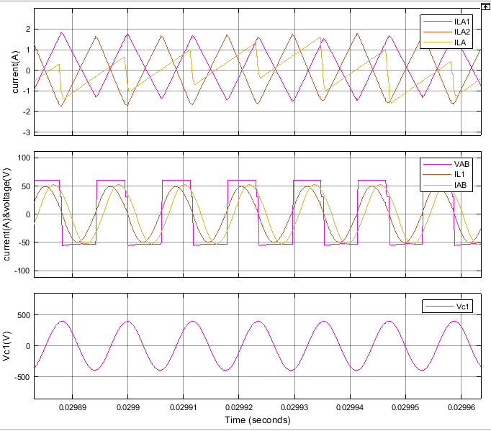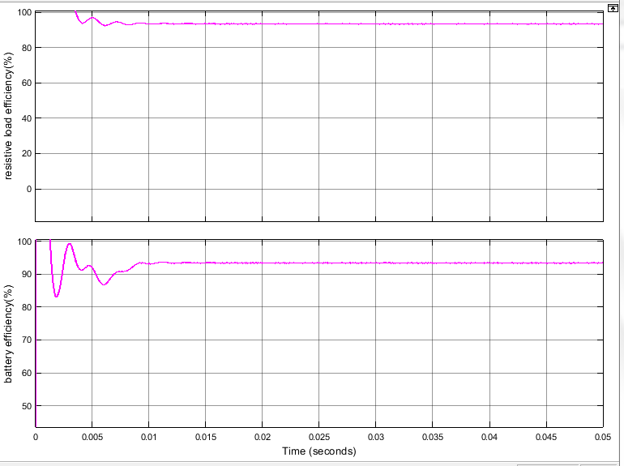

Fig 6: Auxiliary Network Waveforms Fig 7: Efficiency Waveforms of Battery And Resistive Load

In simple terms, zero-voltage switching can be described as the power to the device is turned off or on only when the output voltage is zero volts. This technique functions on pulse width modulation based (PWM) operations like most other contemporary switching voltage regulators. But the ZVS operation comes into play due to an additional separate phase to the PWM timing. With zero-voltage switching, the voltage regulator can engage in “soft switching,” which help avoid switching losses that are normally seen during conventional PWN operations. When you turn to soft switching, the voltage drops to zero instead of just minimum before the metal-oxide-semiconductor field-effect transistors (MOSFET) are turned off or on, which helps eliminate any overlap between current and voltage. This helps minimize losses. Another advantage with soft switching is that these waveforms minimize electromagnetic interference (EMI). Using this technique, zero-voltage switching can effectively reduce losses and this technique can be applied to create the most power-conversion designs. This technique is, however, most beneficial to those operating using high-voltage inputs. Using ZVS, you can see significant improvements in efficiency using high voltage compared to their equivalents that use PWN-controlled techniques. The Fig 7 shows the efficiency of 92% of resistive load and battery is achieved by ZVS IPT topology in MATLAB/Simulink.

1. **CONCLUSION**

Electric car wireless charging has the potential to revolutionize the automobile industry's approach to road transportation. By the end of the next decade, wireless charging technology is anticipated to grow dramatically along with the development of electric car technology. The primary goal of this study is to provide a summary of the numerous wireless charging methodologies, of which inductive wireless transmission has emerged as the most effective methodology. The application of static and dynamic wireless charging as well as the significance of the battery in electric vehicles are also reviewed in this study. Here, wireless charging methods have an impact on battery size, lowering the overall cost of the electric car. As the battery capacity of electric vehicle batteries decreases, they will charge more quickly compared to how long it used to take to charge them to their rated value. However, ease of use and requiring the least amount of driver involvement are crucial aspects that consistently outperform the competition. When these attributes are combined with excellent power transfer efficiency, wireless charging of electric vehicles is a successful strategy.

1. **REFERENCES**
2. Poriferae, A.; Narimani, M.; Emadi, A. A Review of Multilevel Inverter Topologies in Electric Vehicles: Current Status and Future Trends. IEEE Open J. Power Electron. 2021, 2, 155–170.
3. Sources of Greenhouse Gas Emissions. 2020. Available online: https://www.epa.gov/ghgemissions/sourcesgreenhouse-gasemissions (accessed on 18 December 2022).
4. Xu, S.; Guo, Y.; Su, W. A proof-of-concept demonstration for the transportation electrification education. In Proceedings of the 2014 IEEE Conference and Expo Transportation Electrification Asia-Pacific (ITEC Asia-Pacific), Beijing, China, 31 August–3 September 2014; pp. 1–5.
5. Meintz, A.; Zhang, J.; Vijaya Gopal, R.; Kreutzer, C. Ahmed, S.; Bloom, I.; Burnham, A.; Carlson, R.B.; Dias, F.; Tanim, T.; et al. Enabling fast charging-vehicle considerations. J. Power Sour. 2017, 367, 216–227.
6. Ronanki, D.; Kelkar, A.; Williamson, S.S. Extreme Fast Charging Technology—Prospects to Enhance Sustainable Electric Transportation. Energies 2019, 12, 3721.

1. Chakraborty, S.; Vu, H.-N.; Hasan, M.M.; Tran, D.-D.; El Baghdadi, M.; Hegazy, O. DC-DC Converter Topologies for Electric Vehicles, Plug-in Hybrid Electric Vehicles and Fast Charging Stations: State of the Art and Future Trends. Energies 2019, 12, 1569.
2. Ahmad, A.; Alam, M.S.; Chabaan, R. A Comprehensive Review of Wireless Charging Technologies for Electric Vehicles. IEEE Trans. Transp. Electrify. 2018, 4, 38–63.
3. Bradley, T.H.; Frank, A.A. Design, demonstrations, and sustainability impact assessments for plug-in hybrid electric vehicles. Renew. Sustain. Energy Rev. 2009, 13, 115–128.3.
4. Emadi, A.; Lee, Y.J.; Rajashekara, K. Power Electronics and Motor Drives in Electric, Hybrid Electric, and Plug-In Hybrid Electric Vehicles. IEEE Trans. Ind. Electron. 2008, 55, 2237–2245.
5. Ehsani, M.; Gao, Y.; Miller, J.M. Hybrid Electric Vehicles: Architecture and Motor Drives. Proc. IEEE 2007, 95, 719–728.