**LOCATION DETECTION FOR WIRELESS CHARGING OF ELECTRIC VEHICLE WITH REALTIME TRACKING SYSTEM**

**Gaana H1, Rohini S2, Syed Awayz3, Sameer4, Rajendra Prasad C M5**

1Assistant Professor, Department of Electrical and Electronics, PES College of Engineering, Mandya, Karnataka, India

2,3,4,5Student, Department of Electrical and Electronics, PES College of Engineering, Mandya, Karnataka, India

**ABSTRACT**

The rapid proliferation of electric vehicles (EVs) has necessitated the development of efficient and convenient charging solutions. Wireless charging, with its potential for seamless and automated charging, has emerged as a promising technology. However, one of the critical challenges in wireless charging systems is the precise positioning of the electric vehicle over the charging pad to ensure optimal power transfer efficiency. This abstract presents a position detection system integrated with an online monitoring system for wireless charging of electric vehicles. The proposed solution aims to enhance the user experience by providing real-time feedback on the vehicle's position during the charging process.

**Keywords:** Electric Vehicles, Wireless Power Transfer, Position detection**,** Online monitoring system, Power transfer efficiency, IOT.

1. **INTRODUCTION**

With the rapid advancement and widespread adoption of electric vehicles (EVs), the need for efficient and convenient charging solutions has become increasingly critical. Wireless charging technology has emerged as a promising alternative to traditional plug-in charging, offering the potential for seamless and automated charging experiences. However, one of the significant challenges in wireless charging systems is the precise positioning of the electric vehicle over the charging pad to ensure optimal power transfer efficiency. Position detection with an online monitoring system represents a compelling solution to address this challenge. By integrating various sensors and advanced algorithms, this system aims to accurately determine the position of the vehicle relative to the charging pad in real-time. Additionally, it provides continuous feedback and guidance to the driver, simplifying the positioning process and enhancing the overall charging experience. The position detection system employs a combination of optical sensors, proximity sensors, and magnetic field sensors to capture essential data such as distance, orientation, and alignment. These sensors, strategically placed around the charging pad and integrated into the vehicle or charging infrastructure, work together to provide precise measurements of the vehicle's position. To process the sensor data and estimate the vehicle's position accurately, advanced algorithms are employed. Computer vision techniques, including image processing and object recognition, enable the system to analyze visual cues and determine the alignment between the vehicle and the charging pad. Machine learning algorithms can be utilized to train the system to recognize specific patterns and optimize the accuracy of position detection over time. In addition to position detection, an online monitoring system is incorporated into the charging infrastructure. This system provides real-time feedback to the user, offering visual indicators and guidance prompts through a user-friendly interface. The monitoring system continuously updates the driver about the vehicle's alignment with the charging pad, ensuring proper positioning and reducing the likelihood of misalignment or inefficient charging. The benefits of the position detection system with online monitoring are multifaceted. Firstly, it enhances charging efficiency by ensuring precise alignment between the vehicle and the charging pad, minimizing energy losses and optimizing power transfer. This, in turn, reduces charging times and improves the overall charging experience for EV owners. Secondly, the system significantly improves user convenience. By eliminating the need for precise manual positioning, it simplifies the charging process and reduces the potential for human errors. The real-time feedback and guidance provided by the online monitoring system empower drivers to effortlessly position their vehicles correctly, promoting a seamless and user-friendly charging experience.

1. **METHODOLOGY**
   1. **OBJECTIVES**
2. To simplify and enhance the battery charging process for electric vehicles, the use of cables is eliminated, making it more convenient and user-friendly.
3. WPT technology reduces the need for human effort in locating specific charging stations, as different vehicle models have different charging ports.
4. Battery Monitoring Systems (BMS) employ conventional or optimization techniques to ensure the battery is protected and prevent any operations that exceed safety limits.
5. Charging systems for electric vehicles can be conducted through either wired or wireless methods. Wired chargers require heavy cables and bulky mechanical plugs, while wireless chargers utilize an inverter circuit to generate a high-frequency current that creates a magnetic field.
6. The inverter circuit supplies a high-frequency current to the transmitter (Tx) coil, enabling the creation of a high-frequency magnetic field for wireless charging.
7. The proposed system incorporates IoT technology, enabling remote monitoring and control of the charging process.
8. The extended use of electric vehicles is accompanied by battery-related challenges, such as slow charging speed, limited range, and heavy battery weight.
   1. **LITERATURE SURVEY**
9. **Title: Wireless Charging Station for Electric Vehicles. Authors: Darshana wagh, International Research Journal of Engineering and Technology (IRJET) e-ISSN: 2395-0056 Volume: 08 Issue: 01 | Jan 2021**

**Abstract:** This paper presented review on wireless charging system for electric vehicle. Wireless charging is most efficient method for electric vehicle. Wireless charging provides numerous benefits as compared to wired charging. As it has wide range for travelling. It reduces the time spent on recharging the vehicle and even allows the EV’s to be charged during its movement. Initially it has high cost but eventually the maintenance cost gets low.

1. **Title: Efficient Wireless Charging for Electric Vehicle Authors: Yash Baviskar.**

**Abstract:** Student, Department of Electrical Engineering SVKM’s Institute of Technology, Dhule Maharashtra, India. In this project we designed a wireless power transmission charging circuit for electric vehicles to increase the battery life of the vehicle and also to sort out the issue of battery overheating due to plugged in charging. In plugged in charging heat losses are more and it directly affects the life of the battery so that Battery thermal management is the main issue for electric vehicles.

1. **Title: Analysis on Wireless Charging Technology of Electric Vehicle Authors: Deng Fang1 , Zhang Yuanqing, Journal of Physics: Conference Series 1827 (2021)**

**Abstract:** In this paper the charging technology of electric vehicles has been continuously improved and perfected, and its charging method has developed from traditional wired charging to wireless charging which is being perfected at present. Compared with the traditional charging method, the traditional charging method is complex, which needs to be combined with socket and charging line at the same time to complete charging, while wireless charging is to achieve wireless power transmission through the specific working principle of electric vehicles, and it is convenient and quick to operate.

1. **Title: Wireless Charging of Electrical Vehicle on Road Authors: Mr. Suraj Hussainsaheb Mulla (2021), International Journal of Advanced Research in Science, Communication and Technology (IJARSCT)**

**Abstract:** This paper has dealt with Wireless Charging Systems for Electric Vehicle Batteries. An Inductive Power Transfer (IPT) system for an E-bike battery charging has been designed and assembled. The target is to build a prototype of toy car charging. After the magnetic design of the IPT coils, the electric model of the coupling structure has been gained and acquired from an electronic simulation tool, in order to complete the design of the whole system.

1. **Title: Wireless Charging of Electric Vehicles Authors: Asst Prof.Swapna Manurkar, International Research Journal of Engineering and Technology (IRJET) (2022)**

**Abstract:** This paper has outlined a comprehensive overview of wireless charging technology for EVs. This paper has outlined a comprehensive overview of wireless charging technology for EVs.WPT technology offers the possibilities for better energy performance, lower environmental impacts, lower life cycle cost, and more convenience and operational safety benefits. With the advancement of EV technology, charging infrastructure and grid integration facilities, EV popularity is expected to increase significantly in the next decade. In this context, wireless charging has aroused wide attention since it is spark-free, independent of environment and applicable to unmanned operation.

* 1. **BLOCK DIAGRAM**

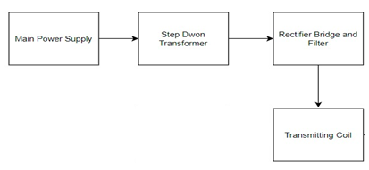

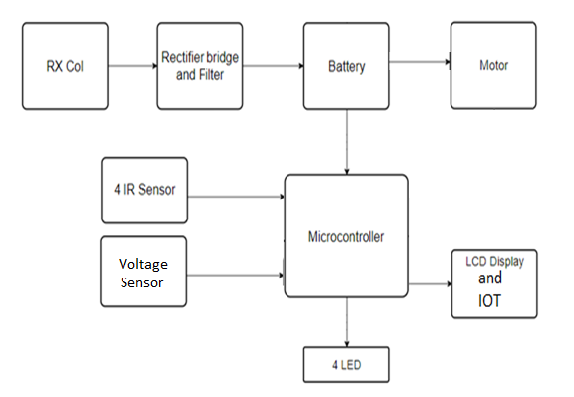

Fig 1: Block Diagram of Proposed System

The system consists of a transmitter and receiver part, utilizing specific components. The transmitting unit includes a step-down transformer, rectifier bridge, filter, high-frequency section, and transmitting coil. The receiver unit comprises a receiving coil, rectifier bridge, filter, battery, and voltage sensor.

Initially, the 220V AC supply is converted to 12V DC using a step-down transformer, rectifier bridge, and filter. This DC power is then fed into a push-pull oscillator transistor, which generates a high-frequency AC current across the transmitting coil, creating a magnetic field.

On the receiver side, the magnetic field generated by the transmitter is transferred to the receiving coil. According to Faraday's law of induction, the receiver coil produces an electromotive force (EMF) voltage. This voltage is converted into pure DC using a rectifier bridge and filter, and then stored in the battery. The voltage sensor monitors the battery's charging status.

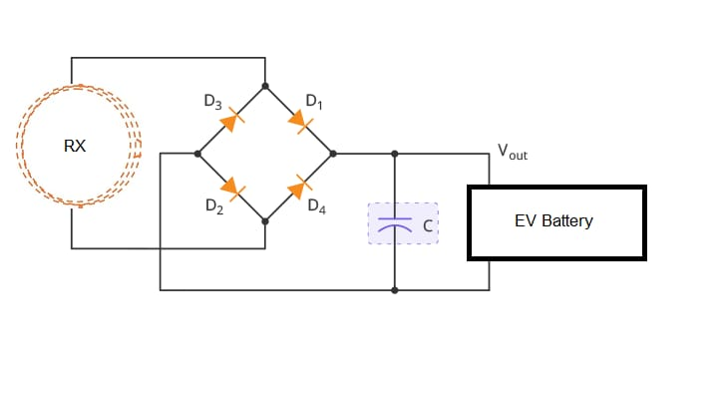

In summary, the system utilizes a transmission and receiver part with specific components. The transmitter generates a magnetic field using a high-frequency AC current, while the receiver converts the magnetic field into usable DC power. The power is rectified, filtered, and stored in the battery.

1. **RESULTS AND DISCUSSION**

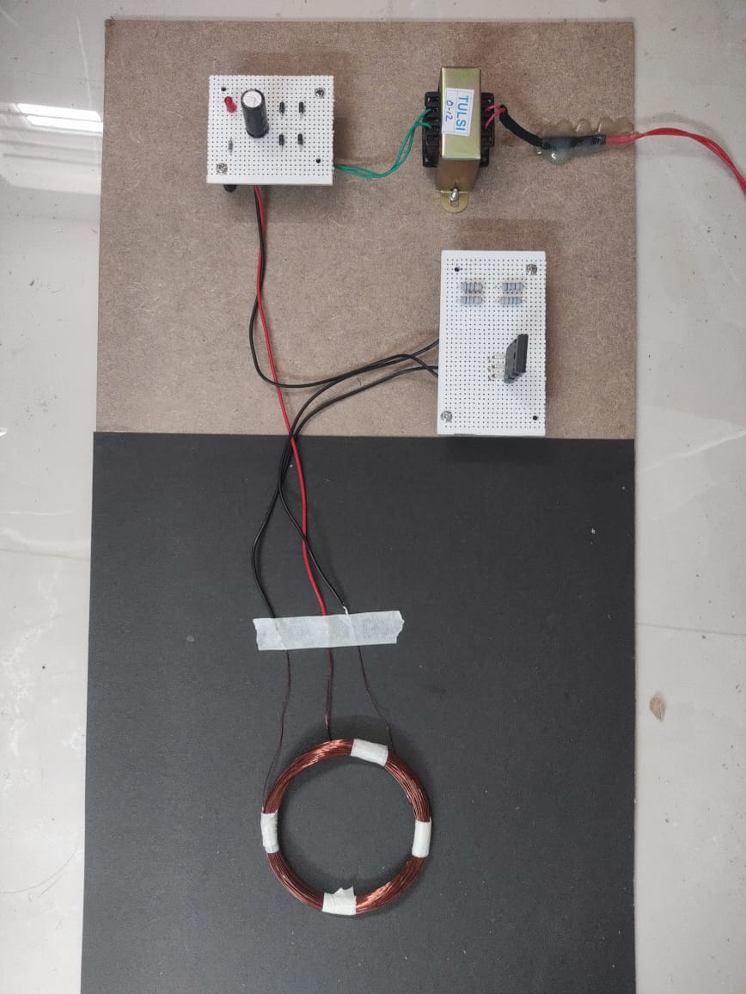

Fig 2.1: Hardware Model of Transmission Part

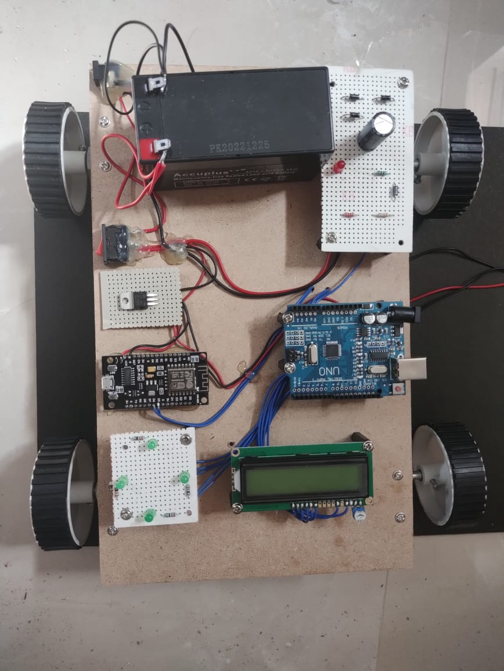

Fig 2.2: Hardware Model of Receiver Part

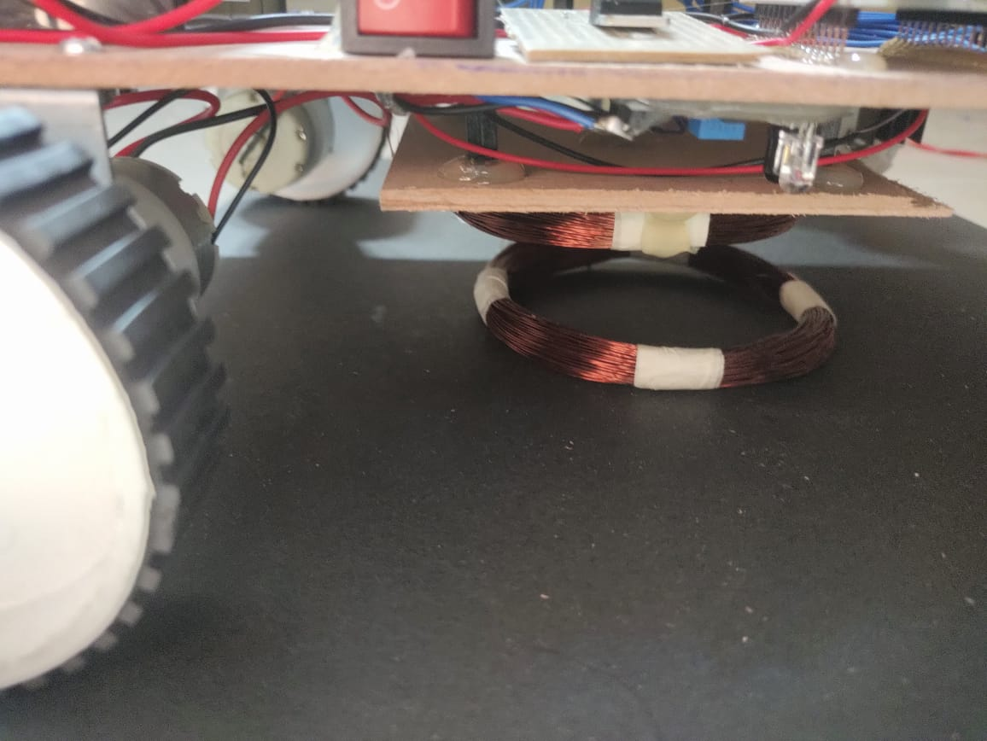

Fig 2.3: Hardware Model of Wireless Power Transfer

* 1. **Possible Outcome**
* Wireless charging of Electrical vehicle
* LCD display for user information
* Empty Slot information on IOT

1. **CONCLUSION**

The study introduces a technique for detecting the aligned position between the transmitter and receiver coil in wireless charging systems for electric vehicles. To achieve this, a retroreflective photoelectric sensor is employed. Experimental results demonstrate that the proposed method increases system efficiency. Additionally, the study successfully implements online monitoring of battery status and notifications for fully charged batteries through an IoT platform. The simplicity, accuracy, and ease of implementation make the proposed system highly practical. Future research directions include analyzing and designing the system to further improve overall efficiency. Comparison results between the proposed system and a system without the presented technique indicate that high system efficiency is consistently achieved when the proposed system is utilized. In contrast, misalignment between coupled coils significantly reduces system efficiency. The study showcases the Blynk application, which monitors battery status in real-time, and illustrates the notification of a fully charged battery via the Line application. Wireless power transfer (WPT) technology helps alleviate the challenge of locating specific charging stations, as different models may require different charging ports. By reducing human effort, WPT streamlines the charging process. The Battery Management System (BMS) plays a vital role in protecting the battery and preventing any operations that could exceed its safety limits.

1. **REFERENCES**
2. Harsha Jain et.al. “Weapon and militant detection using artificial Intelligence and deep learning for security applications” ICESC 2020.
3. Arif Warsi et.al “Automatic handgun and knife detection algorithms” IEEE Conference 2021.
4. Neelam Dwivedi et.al. “Weapon and militant classification using deep Convolutional neural networks” IEEE Conference CICT 2020.
5. Gyanendra Kumar Verma et.al. “Handheld Gun detection using Faster R-CNN Deep Learning” IEEE Conference 2022.
6. Abhiraj Biswas et.al. “Classification of Objects in Video Records using Neural Network Framework,” International conference on Smart Systems and Inventive Technology, 2021
7. Pallavi Raj et.al. “Simulation and Performance Analysis of Feature Extraction and Matching Algorithms for Image Processing Applications” IEEE International Conference on Intelligent Sustainable Systems, 2020.
8. Mohana et.al. “Simulation of Object Detection Algorithms for Video Surveillance Applications”, International Conference on I-SMAC (IoT in Social, Mobile, Analytics and Cloud), 2022.
9. Glowacz et.al. “Visual Detection of Knives in Security Applications using Active Appearance Model”, Multimedia Tools Applications, 2020.
10. Mohana et.al. “Performance Evaluation of Background Modeling Methods for Object Detection and Tracking” International Conference on Inventive Systems and Control, 2020
11. Rojith vajihalla et.al. ” Inventive system and control for performance evaluation of background modeling method of object detection and tracking” International 2020