## FABRICATION OF PNEUMATIC GLASS CUTTING MACHINE

**PROJECT REPORT**

**(2022-2023)**

**Submitted in the partial fulfillment for the award of DIPLOMA IN MECHANICAL ENGINEERING**

#### Submitted by

**NAME OF THE STUDENT: REGISTER NO:**

|  |  |
| --- | --- |
| DEEPAK K | 21208809 |
| DHANUSH M | 21208810 |
| DINESH KUMAR S | 21208811 |
| DOMNIC P | 21208812 |
| G KALYAAN CHAKRAVARTY | 21208813 |

**Under the guidance of JAGADEESH.V, B.E, M.E, M.B.A, MISTE.,**

**Lecturer / Mechanical Engineering**



#### DEPARTMENT OF MECHANICAL ENGINEERING

**SRI DURGADEVI POLYTECHNIC COLLEGE**

**R.S.M. NAGAR, KAVARAIPETTAI-601 206 THIRUVALLUR DISTRICT**

**SRI DURGADEVI POLYTECHNIC COLLEGE**

**R.S.M. NAGAR, KAVARAIPETTAI-601 206 THIRUVALLUR DISTRICT**

#### DEPARTMENT OF MECHANICAL ENGINEERING

**BONAFIDE CERTIFICATE**

***This is to certify that this project work entitled “*FABRICATION OF PNEUMATIC GLASS**

**CUTTING MACHINE*” submitted by* G KALYAAN CHAKRAVARTY *Register No.* 21208813**

***in partial fulfillment for the award of DIPLOMA IN MECHANICAL ENGINEERING.***

***This is the bonafide record of work carried out by him under our supervision during the year 2022-2023 submitted for the Board Examination held on ........................***

**PROJECT GUIDE HEAD OF THE DEPARTMENT**

**INTERNAL EXAMINER EXTERNAL EXAMINER**

**ACKNOWLEDGEMENT**

We sincerely owe our heartful and sincere thanks and respect to our Honorable **Chairman Thiru.R.S.Munirathinam** and **Vice Chairman Thiru.R.M.Kishore.**

We also thank our Principal **Dr.K.Lakshmanan., M.E., Ph.D., AIE. MISTE** for giving us the necessary support during this project.

We also thank our **HOD Mr.K.MEGANATHAN., M.E., MISTE,**

who inspired us to do the project in successful manner.

We also thank our guide **Mr. JAGADEESH.V, B.E., M.E., M.B.A**.**, MISTE.,** for providing valuable guidance.

We also thank all our Department Staff who have rendered their direct and indirect help.

The moral support of our friends and family cannot be forgotten, as the project would not have been impossible without their support.

We also thank each and everyone who have been directly or indirectly responsible for the successful completion of our Project.

# CONTENTS

**CONTENTS**

|  |  |  |
| --- | --- | --- |
| **CHAPTER NUMBER** | **DESCRIPTION** | **PAGE NUMBER** |
|  | ABSTRACT |  |
| 1 | INTRODUCTION | 1 |
| 2 | LITERATURE SURVEY | 4 |
| 3 | MANUFACTURING PROCESS | 6 |
| 4 | CONSTRUCTION | 10 |
| 5 | WORKING PRINCIPLE | 14 |
| 6 | PNEUMATIC SYSTEM | 17 |
| 7 | DESCRIPTION OF COMPONENTS | 23 |
| 8 | DESIGN CALCULATIONS | 32 |
| 9 | MERITS AND DEMERITS | 36 |
| 10 | APPLICATIONS | 39 |
| 11 | COST ESTIMATION | 41 |
| 12 | CONCLUSION | 43 |
| 13 | BIBLIOGRAPHY | 45 |
| 14 | PHOTOGRAPHY | 48 |

# ABSTRACT

## ABSTRACT

Cutter is a common tool used in various cutting shape for a variety purposes. In this project, a glass cutter is provided which can form, using a wheel, a uniform crack in glass even when a projection or an earlier-formed scribe line is present on the glass. When the wheel is moved on the glass, a fracture layer is formed causing a rib mark to be formed below the fracture layer and a crack to be formed below the rib mark. To cut the glass, the crack is required to be formed uniformly.

A glass cutter may use a diamond to create the split or more commonly a small cutting wheel is used made of hardened steel or tungsten carbide 4-6 mm in diameter, with its cutting edge ground to a V-shaped profile. Some glass cutters hold a small amount of cutting oil, which both lubricates the wheel and prevents the split in the glass from closing. When properly lubricated a steel wheel can give a long period of satisfactory service. The improvement of cutter which is design and fabricate of a pneumatic cutter.

This cutter also safe to use when press the ON button the high pressure air comes and leads the cutter to cut on the mirror surfaces. Hence, cutter can help people to cut the mirror easily and also can use it in a long term. Simplicity of design and control-Machines are easily designed using standard cylinders and other components and operate via simple on-off control.

# INTRODUCTION

## INTRODUCTION

Pneumatic systems are used extensively in industry and factories are commonly plumbed with compressed air or compressed inert gases. This is because a centrally located and electrically powered compressor that powers cylinders and other pneumatic devices through solenoid valves can often provide motive power in a cheaper, safer, more flexible and more reliable way than a large number of electric motors and actuators.

Pneumatic systems in fixed installations, such as factories, use compressed air because a sustainable supply can be made by compressing atmospheric air. The air usually has moisture removed and a small quantity of oil is added at the compressor to prevent corrosion and lubricate mechanical components. Factory-plumbed pneumatic-power users need not worry about poisonous leakage, as the gas is usually just air. Smaller or stand-alone systems can use other compressed gases that present an Asphyxiation hazard, such as Nitrogen-often referred to as OFN (oxygen-free Nitrogen) when supplied in cylinders.

Any compressed gas other than air is asphyxiation hazard-including nitrogen, which makes up 78% of air. Compressed Oxygen (approx. 21% of air) would not asphyxiate, but is not used in pneumatically-powered devices because it is a fire hazard, more expensive and offers no performance advantage over air. Carbon dioxide is an asphyxiate and can be a freezinghazard if vented improperly.

Both pneumatics and hydraulics are applications of Fluid Power. Pneumatics uses an easily compressible gas such as air or a suitable pure gas-while Hydraulics uses relatively incompressible liquid media such as oil. Most industrial pneumatic applications use pressures of about 80 to 100 pounds per square inch (550 to 690 kPa).Hydraulics applications commonly use from 1,000 to5,000 psi (6.9 to 34 MPa), but specialized applications may exceed 10,000 psi (69 MPa).

# LITERATURE SURVEY

## LITERATURE SURVEY

Literature Review is implemented to carry out to acquire knowledge and skills needed to complete this project. Several studies had been done to create a precision cut. Surveys had been done to achieve accurate cutting of glass

This paper involves measure and control of Double acting pneumatic cylinder the using 5/3 DCV. 5/3 valve are most often used as directional control valves for double-acting pneumatic actuators. Hand Lever Valves are used to operate Pneumatic Cylinders. In the absence of electrical supply, manually operated valves such as Hand Lever Valves are used. The functioning is the same; however, the solenoid coil is replaced by a hand lever, which controls the movement of the spool inside the valve, thereby allowing the air to pass.

The handle is used to control the flow of air in 3 positions. The FCV is used to control the rate of air flow during cutting stroke by manually adjusting the FCV using screw mechanism. The pneumatic cylinder is actuated by the piston due to the pressure of air. At the end of the piston rod a cutting knife is fixed .when the cylinder is actuated the piston rod moves front. Due to this action the blade in the piston rod cuts the glass. When the piston retracts the glass is free to remove. Below this set up there are two pneumatic cylinders.

# MANUFACTURING PROCESS

## MANUFACTURING PROCESS

Manufacturing processes are the steps through which the raw materials are transformed into a final product. Manufacturing process begins with thecreation of the materials from which the design is made. These materials are then modified through manufacturing processes to become therequired part. Manufacturing process can include treating machining or reshaping the material. The manufacturing process also includes tests and checks for quality assurance during or after manufacturing and planning the production process prior to manufacture.

### WELDING

Welding is a fabrication process that joins materials, usually metals or thermoplastics, by using high heat to melt the parts together and allowing them to cool, causing fusion. Welding is distinct from lower temperature metal-joining techniques such asbrazing and soldering, which do not melt the base metal.

In Arc welding process, heat can be generated through an electric arc struck among an electrode as well as the work piece. The electric arc is glowing electrical discharge among two electrodes using ionized gas.

Any type of arc welding technique depends on an electric circuit that mainlyincludes different parts like power supply, work piece, welding electrode & electric cables to connect the electrode as well as work piece toward the power supply.

### SAWING

Sawing is a process where in a narrow slit is cut into the work piece by a toolconsisting of a series of narrowly spaced teeth, called a saw blade. Sawing is used to separate work parts into two or more pieces, or to cut off an unwanted section of a part. These processes are often called cut-off operations and since many manufacturing projects require cut-off operations at some point in the production sequence, sawing is an important manufacturing process.

Basically, sawing is a simple process: As the blade moves past the work, each tooth takes a cut. Depending on the thickness or diameter of the work, the number of teeth cutting at one time varies from two to ten or more. Saws may be of the continuous cutting (band or rotary) or reciprocating type.

### FASTENING

Fastening is a [hardware](https://en.m.wikipedia.org/wiki/Household_hardware) device that mechanically joins or affixes two or more objects together. In general, fasteners are used to create non- permanent joints; that is, joints that can be removed or dismantled without damaging the joining components.

Welding is an example of creating permanent joints. Steel fasteners are usually made of [stainless steel](https://en.m.wikipedia.org/wiki/Stainless_steel), [carbon steel](https://en.m.wikipedia.org/wiki/Carbon_steel), or [alloy steel](https://en.m.wikipedia.org/wiki/Alloy_steel). Mechanical fastener that is usually used with a nut for connecting two or more parts.

A bolted joint can be readily disassembled and reassembled; for this reason bolts or screw [fasteners](https://www.britannica.com/technology/fasteners) are used to a greater extent than any other type of mechanical fastener and have played an important part in the development of mass- produced articles and steel structures.

Nut is a type of fastener with a threaded hole. Nuts are almost alwaysused in conjunction with a mating bolt to fasten multiple parts together. The two partners are kept together by a combination of their threads' friction, a slight stretching of the bolt, and compression of theparts to be held together.

# CONSTRUCTION

## CONSTRUCTION

### The Components used in the project are:

1. Double acting pneumatic cylinder
2. 5/3 DCV
3. Base
4. FCV
5. CV
6. Cutting tool
7. Glass fixture

Initially, starting with air compressor, its function is to compress air from a low inlet pressure (usually atmospheric pressure) to high pressure level. This is accomplished by reducing the volume of the air. Air compressors are generally positive displacement units .The air compressor used here is typically small, and two stage compressor.

The compressed air is goes to the cylinder through flow control valve & FCV. The flow control valve is used to control the flow and FCV is used to control pressure of compressed air. The compressed air is transmitted from air compressor to flow control valve, FCV and pneumatic cylinder through connecting pipes. The flow control valve and pneumatic cylinder are connected through connecting pipes.

The piston rod of the pneumatic cylinder is connected tothe nut & bold mechanism which connects cutting tool & piston. The piston rod is connected to piston rod to transmit the motion to cut the glass by cutting tool which connected to piston rod. The double acting cylinder are clamped to the top of the base by using fasteners & clap according to the size of cylinder & drilling operation is done to screw fasteners & clamp on base. The 8 mm hose is used to connect the pneumatic cylinder, DCV, FCV & air compressor. An 8mm wooden board is used to clamp the glass to the base. Cutting & drilling are done to wooden piece according to the requirements.

**PICTURE OF WOODEN CLAMP**

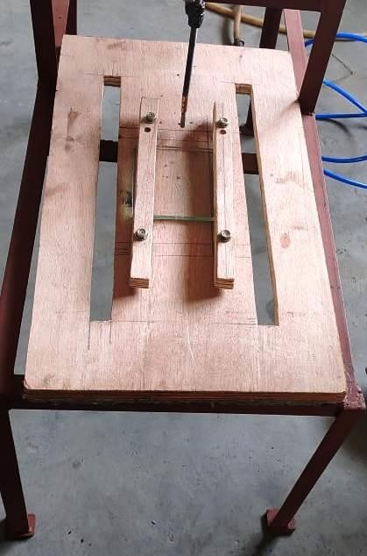

Fasteners

Glass Piece

Wooden Piece

# WORKING PRINCIPLE

## WORKING PRINCIPLE

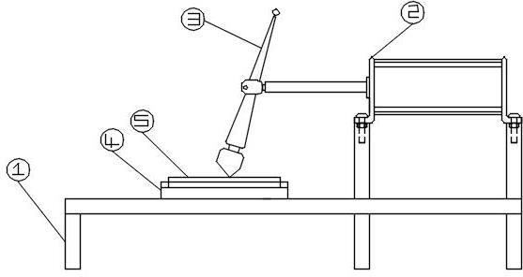

|  |  |
| --- | --- |
| **S.NO** | **NAME OF THE COMPONENTS** |
| **1.** | **BASE** |
| **2.** | **DOUBLE ACTING CYLINDER** |
| **3.** | **CUTTING TOOL** |
| **4.** | **GLASS FIXTURE** |
| **5.** | **GLASS** |

### The arrangement of components in the Pneumatic system

Initially compressor supplies the air at certain pressure to the DCV valve. This DCV valve is used to control the direction of flow of air to the pneumatic cylinder. The pneumatic cylinder is actuated by the piston due to the pressure of air. At the end of the piston rod a cutting knife is fixed. When the cylinder is actuated the piston rod moves front. Due to this action the blade in the piston rod cuts the glass. When the piston retracts the glass is free to remove. Below this set up wooden fixture is used to fix the glass to the base. The DCV is fixed parallel to cylinder on the base. The hose is used to connect & flow of air in pneumatic system.

### CIRCUIT DIAGRAM

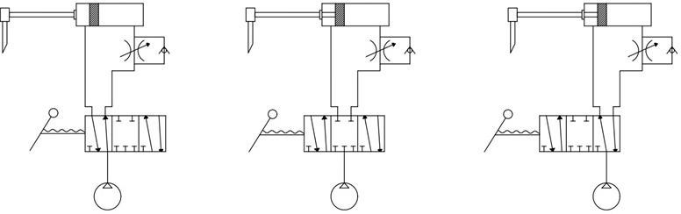

CUTTING STROCK NUTRAL STROCK NON-CUTTING STROCK

**BLOCK DIAGRAM**

PNEUMATIC POWER

PNEUMATIC CYLINDER

RAM

GLASS CUTTER

GLASS PIECE

# PNEUMATIC SYSTEM

## PNEUMATIC SYSTEM

A pneumatic system is a connection of various components such as (compressors, intercoolers, controllers, and actuators), that converts the pressure energy of compressed air into mechanical work. Pneumatic systems are used where human strength and accuracy are not enough. Nowadays Pneumatic systems are widely used in various industries to automate several processes.

It not only lifts heavy loads and increases the accuracy but it also decreases the time period to perform certain activities. Some of the most common examples of pneumatic systems are air brakes, pneumatic arms, pneumatic cable jetting, and pneumatic shock absorbers.

### Pneumatic System Component

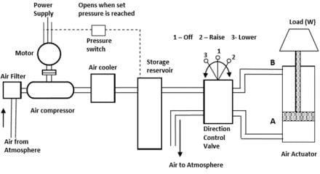

**Motor:**

A suitable motor is used to run the compressor in a pneumatic system. The capacity of the motor depends on the size of the compressor and the power required running the compressor. The motor is directly connected to the power supply.

### Air cooler:

Air temperature increases when the air is compressed in the compressor. This hot air is not suitable for further operation. Hence it is important to cool down the hot air coming out of the air compressor. The cooling of air is done by an air cooler. The main objective of an air cooler is to reduce the temperature and moisture content in the air coming out from the air compressor.

#### There are two types of commonly used air coolers.

* Air-cooled air cooler.
* Water-cooled air cooler.

In an **air-cooled air cooler**, the hot air is enclosed in pipes and cool air is forced on it with the help of a fan this cool air carries away heat from the hot air without decreasing the pressure.

While in the case of a **water-cooled air cooler** the heat is exchanged by indirect contact between the hot air from the compressor and cold water.

Much lower temperature can be obtained by a water-cooled air cooler than the air-cooled air-cooler. As cold water is available in large quantities, water- cooled air coolers are cost-effective and quick.

### Storage reservoir:

A storage reservoir is an air pressure vessel used to store compressed air under high pressure. This storage device ensures a smooth supply of pressurized air and eliminates fluctuations caused due to loading and unloading of air demand. Storage reservoirs play an important role in pneumatic systems as they ensure quick response to user demand. Storage reservoirs can store both dry and wet air depending on demand.

A storage reservoir must be strong, must have high tensile strength, and must be durable. Hence the commonly used materials for storage reservoirs are Mild steel, Aluminum, Carbon steel, and Stainless steel. Storage reservoirs have several parts. Each part is first cut down into its required dimension. These parts are then assembled by welding and bending.

### Directional control valve:

Directional control valves are the most important device used in a pneumatic system. The directional control valves or DVCs are used to control the direction and the amount of air entering the actuators.

The valves transfer the pressure energy of air to the actuators as per the command given by the operator. The generally used valve in a pneumatic system is a solenoid valve, also sometimes known as a spool valve.

These valves are operated by the action of a solenoid coil coupled with

an electromagnet.

### Pneumatic system Working:

The air comes into the compressor through an air filter due to the vacuum generated by the blades of the compressor. The air is filtered out in the air filter and then goes into the compressor. The compressed air then enters the air cooler where the temperature of the air is reduced to improve the efficiency of the system.

This compressed cold air is then stored in the storage reservoir to make the air readily available. The air then enters the FRL unit where it is filtered again, pressure is regulated and some oil is added to lubricate the air. From the FRL unit, the air goes into the direction control valve where the air is sent according to the user’s action.

#### Advantages of Pneumatic System:

* The air used is infinitely available.
* The working medium is inflammable.
* It is independent of the outside temperature.
* The system is safe and tidy.

#### Disadvantages of Pneumatic system:

* The system is noisy.
* There are often leaks in the system.
* Low power-to-weight ratio.
* Suitable only for low-pressure applications.

# DESCRIPTION OF COMPONENTS

## DESCRIPTION OF COMPONENTS

### PNEUMATIC CYLINDER

Pneumatic actuators are mechanical devices that use compressed airacting on a piston inside a cylinder to move a load along a linear path.Unlike their hydraulic alternatives, the operating fluid in a pneumatic actuator is simply air, so leakage doesn’t drip and contaminatesurrounding areas.

There are many styles of pneumatic actuators including diaphragm cylinders, rodless cylinders, telescoping cylinders and through-rod cylinders.

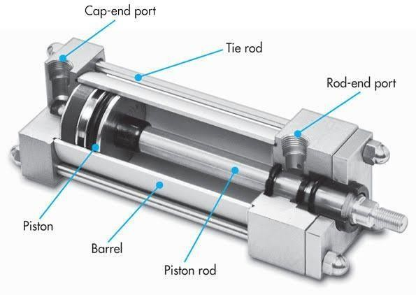

The most popular style of pneumatic actuator consists of a piston androd moving inside a closed cylinder. This actuator style can be sub- divided into two types based on the operating principle: single actingand double acting.

Single-acting cylinders use one air port to allow compressed air to enter the cylinder to move the piston to the desired position, as well as an internal spring to return the piston to the “home” position whenthe air pressure is removed.

Double-acting cylinders have an air port at each end and move the piston forward and back by alternating the port that receives the highpressure air.

### Double-acting cylinders

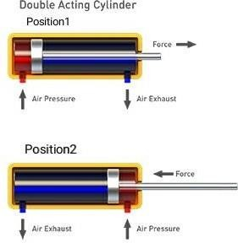

A double-acting pneumatic cylinder is one where the thrust, or output force, is developed in both extending and retracting directions.Double-acting cylinders have a port at each end and move the pistonforward and back by alternating the port that receives the high- pressure air, necessary when a load must be moved in both directionssuch as opening and closing a gate.

Air pressure is applied alternately to the opposite ends of the piston. Application of air pressure produces a thrust in the positive (push) stroke, and thrust in the negative (pull) stroke. Double-acting cylinders are typically used in all applications where the thrusts and stroke lengths required are in excess of those available from single-acting cylinders. Small double-acting cylinders are also used for applications where positive end-of-stroke positions are required for both strokes.

### AIR COMPRESSOR

An air compressor is a device converts power into potential energy stored in pressurized air. By one of several methods, an air compressor forces more and more air into a storage tank, increasing the pressure. When tankpressure reaches its engineered upper limit, the air compressor shuts off. The compressed air then is held in the tank until called into use. The energycontained in the compressed air can be used for a variety of applications, utilizing the kinetic energy of the air as it is released and the tank depressurizes, When tank pressure reaches its lower limit, the air compressor turns on again and re-pressurizes the tank .An air compressor must be differentiated from a pump because it works for any gas/air, while pumps work on liquid.

#### PRODUCTION OF COMPRESSED AIR

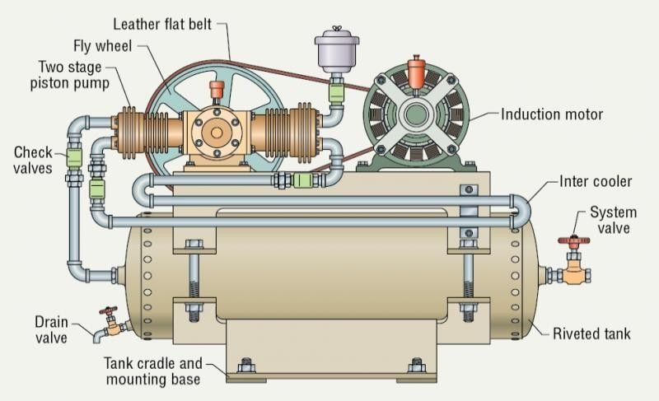

Pneumatic systems operate on a supply of compressed air, which must be made available. In sufficient quantity and at a pressure to suit the capacity of the system. When pneumatic system is being adopted for the first time, it will indeed the necessary to deal with the question of compressed air supply.

At intake conditions namely at atmosphere pressure and normal ambient temperature .Clean condition of the suction air is one of the factors, which decides the life of a compressor. Warm and moist suction airwill result increased precipitation of condense from the compressed air.

### CONNECTING PIPES (POLYURETHANE TUBE)

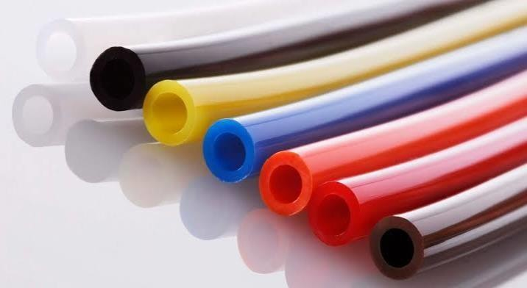

The basic function of connecting pipes is to convey pressurized air to actuators, valves, tools and other devices. But there are countless types and sizes of tubing and hose on the market, so engineers should consider a number of important factors to select the right one for a given task.

Start with construction. Tubing for air applications may be extruded of a single material or reinforced internally, typically with textile fibers, for higher strength. Pneumatic hose generally consists of an inner tube, one or more layers of reinforcing braided or spiral-wound fiber, and an outer protective cover. In broad terms, hose is more rugged than tubing but costsmore. The connecting pipes are made of Polyvinyl Chloride (PVC), Polyurethane, nylon, polyethylene, etc.

### Glass cutter

A glass cutter is a tool used to make a shallow score in one surface of a piece of [glass](https://en.wikipedia.org/wiki/Glass) (normally a flat one) that is to be broken in two pieces, for example to fit a window. The scoring makes a split in the surface of the glass which encourages the glass to break along the score. This is not to be confused with the tools used to make [cut glass](https://en.wikipedia.org/wiki/Cut_glass) objects. A glass cutter may use a [diamond](https://en.wikipedia.org/wiki/Diamond) to create the split, but more commonly a small cutting wheel made of [hardened steel](https://en.wikipedia.org/wiki/Hardened_steel) or [tungsten carbide](https://en.wikipedia.org/wiki/Tungsten_carbide) 4–6 mm in diameter with a V-shaped profile called a "hone angle" is used. The greater the hone angles of the wheel, the sharper the angle of the V and the thicker the piece of glass it is designed to cut.

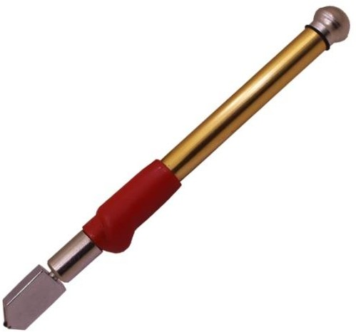

The hone angle on most hand-held glass cutters is 120° to 140°, though wheels are made as near-flat as 154° or even 160° [180° would be flat like a roller] for cutting glass as thick as 0.5 inches (13 mm). Their main drawback is that wheels with sharper hone angles will become dull more quickly than their more obtuse counterparts.

### FCV (Flow Control Valve)

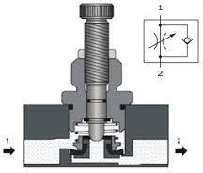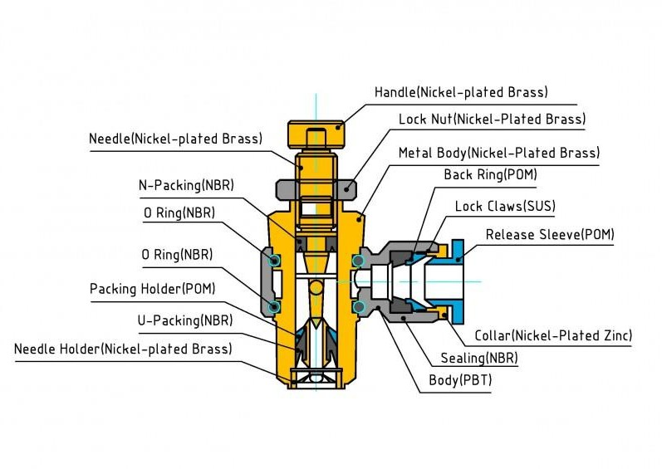Flow control valves are used in pneumatic systems to regulate the flow rate of compressed air. By controlling the flow rate, the speed of the pneumatic cylinder can also be regulated directly. In addition, a good throttling valve contributes to reducing wear due to a lower kinetic load. Moreover, the control valves also support a steadier and thus reliable movement. The latter has to do with the fact that if the speed is unthrottled, the velocity can fluctuate. This in turn can lead to a stick/slip effect and thus to a faltering motion.

Flow control valves are also referred to more generally as flow regulators or flow controllers. They are available in different versions. This blog focuses on the banjo shaped flow control valve with in-built check valve. This valve is by far the most commonly used. And not without reason. On the one hand, this flow regulator is popular because of its functionality and on the other hand because of its easy assembly. This type of flow control valve is mounted directly on the cylinder, allowing the actuator speed to be set on site. In addition, the angled flow regulator with check valve is very easy to operate from the side.

### Glass fixture

Glass fixture is wooden block of 450*150mm. which has been drilled & cutted according to the applications. Then the glass piece is fixed to wooden block using fasteners.



Fasteners

Glass Piece

Wooden Block

# DESIGN CALCULATIONS

## DESIGN CALCULATIONS

### Design of frame

Frame no. 1 design 800 x 350 x 400

Frame no. 2 design 350 x 350 x 200 Square angle mild steel channels

b = 25 mm, d= 25 mm,

t= 3 mm.

Max load: 45kg

### 5/3 DCV

Type : 5/3

Port size : Inlet port- 8mm diameter, Outlet port- 8mm diameter

Medium : Compressed air, filtered & lubricated

Working pressure : 0-10 bar Working temperature : 5 - 60*C Flow : 1200 LPM

Material : Aluminum, Nitrate, Brass, Polymer

Length : 15 mm

Width : 5 mm

Weight : 50g

### Double acting cylinder

Working pressure : 8 bar

Test pressure : 10 bar

Maximum working speed : 80mm per 1 second Temperature : 15 – 40*C

Piston diameter : 50mm diameter

Piston thickness : 5mm

Rod length : 150 mm

Rod diameter : 10 mm

Stroke : 170 mm

Chrome plating : Nickel chrome

Mounting type : threaded type

Painting : Phosphate & finish painting

### Cutting tool

Length : 150 mm

Diameter : 20 mm

Material of tool body : (SS) Stainless steel Cutting roller holder material : (MS) Mild steel Cutting tip type : Roller type

Cutting tip material : Diamond tip

### Glass fixture

Fixture material : wooden fixture

Length : 450 mm

Breath : 150 mm

Thickness : 15 mm

No. of fasteners : 4 Nos

### FCV

Fluid type : Air, Vacuum Operating pressure : 10 bar Maximum pressure : 15 bar

Operating temperature : 0 – 60*C

Tube material : Nylon & Polyurethane

# MERITS AND DEMERITS

## MERITS

* Simple in construction
* Less cost
* High performance
* Easy cutting of mirror
* Less time
* Easy operation
* It makes difficult to near impossible cuts very simple.
* Cutting dense ripples and drapery glass is a breeze.
* Because of accuracy, it saves grinding and fit time.

## DEMERITS

* Does not cut in any other direction except linear motion.

# APPLICATIONS

## APPLICATIONS

Some of the applications of the project are:

* + This machine is very useful for small scale industries.
  + All industrial applications.
  + Fish tank.

# COST ESTIMATION

**COST ESTIMATION**

|  |  |  |  |
| --- | --- | --- | --- |
| **S**  **No** | **NAME OF THE COMPONENTS** | **QUANTITY USED** | **COST**  (Rs) |
| 1 | PNEUMATIC CYLINDER | 1 | 2500 |
| 2 | 5/3 DCV | 1 | 1000 |
| 3 | FCV | 1 | 500 |
| 4 | GLASS PIECE | 4 | 200 |
| 5 | GLASS FIXTURE | 1 | 1000 |
| 6 | BASE FRAME | 1 | 3500 |
| 7 | CUTTING TOOL | 1 | 500 |
| 8 | FASTENERS & CLAMPS | 8 | 200 |
| **TOTAL** | | | **9400** |

# CONCLUSION

## CONCLUSION

Thus the main aim of project was to create a pneumatic glass cutting machine in affordable & low cost for small scale industries. The operation & procedure is very simple. By using more techniques this can be modified according to the application.

Thus we have developed a “pneumatic glass cutting machine” which helps to know how to achieve low cost automation. The operating procedure of this system is very simple, e. By using more techniques, they can be modified and developed according to the applications.

# BIBLIOGRAPHY

## BIBLIOGRAPHY

References

|  |  |
| --- | --- |
| References | Name of author |
| Principles and Maintenance,  New Delhi: Tata McGraw-Hill. (1995) | Majumdar, S.R T. |
| Design and Control for The  Pneumatic Cylinder Precision Positioning Under Vertical Loading. (2005) | Chi-Neng |
| Tolomatic Pneumatic Actuators. (May 3, 2011) | Tolomatic |
| Pneumatic Cylinders-North America. (May 3, 2011) | Parker Hannifin |
| Engineering Mechanics.  ISBN 0-13-221500-4. (2007) | Hibbeler, R.C |

**Websites:**

* + [**https://www.apiuk.com/2019/01/26/what-is-the-**](https://www.apiuk.com/2019/01/26/what-is-the-difference-between-single-acting-and-double-acting-pneumatic-cylinders/#%3A~%3Atext%3DWhat%20is%20a%20double%2Dacting%2Cthe%20assistance%20of%20a%20spring)[**difference-between-single-acting-and-double-acting-**](https://www.apiuk.com/2019/01/26/what-is-the-difference-between-single-acting-and-double-acting-pneumatic-cylinders/#%3A~%3Atext%3DWhat%20is%20a%20double%2Dacting%2Cthe%20assistance%20of%20a%20spring)[**pneumatic-**](https://www.apiuk.com/2019/01/26/what-is-the-difference-between-single-acting-and-double-acting-pneumatic-cylinders/#%3A~%3Atext%3DWhat%20is%20a%20double%2Dacting%2Cthe%20assistance%20of%20a%20spring)[**cylinders/#:~:text=What%20is%20a%20double%2Dacti**](https://www.apiuk.com/2019/01/26/what-is-the-difference-between-single-acting-and-double-acting-pneumatic-cylinders/#%3A~%3Atext%3DWhat%20is%20a%20double%2Dacting%2Cthe%20assistance%20of%20a%20spring)[**ng,the%20assistance%20of%20a%20spring**](https://www.apiuk.com/2019/01/26/what-is-the-difference-between-single-acting-and-double-acting-pneumatic-cylinders/#%3A~%3Atext%3DWhat%20is%20a%20double%2Dacting%2Cthe%20assistance%20of%20a%20spring)**.**
  + [**https://www.uflowvalve.com/pneumatic-valve/product/5-**](https://www.uflowvalve.com/pneumatic-valve/product/5-3-hand-lever-valve-manual-return)[**3-hand-lever-valve-manual-return**](https://www.uflowvalve.com/pneumatic-valve/product/5-3-hand-lever-valve-manual-return)
  + [**https://www.directindustry.com/prod/kurt-**](https://www.directindustry.com/prod/kurt-manufacturing-industrial-products-division/product-100411-1170471.html)[**manufacturing-industrial-products-division/product-**](https://www.directindustry.com/prod/kurt-manufacturing-industrial-products-division/product-100411-1170471.html)[**100411-1170471.html**](https://www.directindustry.com/prod/kurt-manufacturing-industrial-products-division/product-100411-1170471.html)
  + [**https://en.wikipedia.org/wiki/Pneumatics**](https://en.wikipedia.org/wiki/Pneumatics)
  + [**https://en.wikipedia.org/wiki/Glass_cutter**](https://en.wikipedia.org/wiki/Glass_cutter)
  + [**https://en.wikipedia.org/wiki/Glass**](https://en.wikipedia.org/wiki/Glass)

# PHOTOGRAPHY

## PHOTOGRAPHY

