**FABRICATION OF BOREWELL RESCUE ROBOT**

Author by

AKASH R

# ABSTRACT

* In the past few years, there have been several accidents of children falling into abandoned bore wells in India. Abandoned bore wells that have turned into death pits for children. The problem is all over India. Rescue teams spend hours and sometimes days in futile attempts to save these little kids. This robot is used to rescue the child from borewell. It is fast, economical and safe. It has the facility to monitor trapped child, supply oxygen and provide a supporting platform to lift up the child. This system will attach a harness to child using robotic arms for picking up. The robotic arm has attached to it for picking and placing using Arduino.
* **KEYWORDS:** GRIPPER, ARDUINO.

# CHAPTER 1

* 1. **INTRODUCTION**

Water well or Bore well is an excavation or structure created in the ground by digging, driving, boring, or drilling to access groundwater in underground aquifers. The well water is drawn by a pump, or using containers, such as buckets, that are raised mechanically or by hand. Now a days it’s quite often we see unused bore wells left open after the use. Growing water scarcity is being recognized as an important problem facing India. These bore wells are left unclosed after identifying that ground water is not abundant at the place. This resulted in vast increase in number of bore wells. Drilled wells with electric pumps are used throughout the world, typically in rural or sparsely populated areas, though many urban areas are supplied partly by municipal wells. Most shallow well drilling machines are mounted on large trucks, trailers, or tracked vehicle carriages.

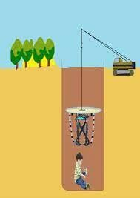

Nowadays children falling in to the bore well seems common. Frequently we hear of news on children stuck in a bore well among various parts of India. In most of the cases of children falling into bore wells seem to occur in rural India. This says something about the bore well diameters. In the cities, bore wells are dug for domestic purposes. These are lesser in diameter. So looks like the bigger bore wells are the problem. Some manufacturing companies too dig large-diameter bore wells. These might be typically located in the villages. However, this is not the primary reason - in the villages, people constantly seek groundwater. The moment a farm or company needs water , they try to dig a well. However, open wells are not always the solution (open wells are dug when you have groundwater available easily at shallow depths. Open wells are convenient. But then groundwater is not easily available - thus bore wells are due to a greater depth. Also companies need more water and wells won’t suffice). People need water and where does that come from? River or lake water supplies is not always available to all areas. Thus, groundwater is the source. And people dig to great depths to get groundwater. Groundwater for various reasons - summer, over exploitation, less recharge etc at times goes down deeper (water table). However, many of the bore wells do not yield water and are “abandoned”. The driller might have used casing and partially sealed the hole. Mostly, though the moment there is no water, the drillers pack up and leave. Vegetation takes over and these bore wells are forgotten. Someday a child wanders over and falls. in. The diameter is enough for the child to fall in. However, it takes time to realize that the lost child could have fallen into the bore well. The inside of the bore well now defunct or not used might have collapsed. Some bores are 300 feet deep (or more). The child might not always fall to the bottom but get stuck in the mud in between. This is not easy to find out as the hole is dark and deep. It is not a case of just pulling out

the child through a vertical shaft. So rescue operations begin and sometimes if the child is closer to the surface a rescuer gets in and pulls them out.

## SOFTWARE

Embedded C is a set of language extensions for the C Programming the C standards committee to address commonality issues that exist between C extensions for different embedded systems. Historically, embedded C programming requires nonstandard extensions to the C language in order to support exotic features such as fixed point arithmetic, multiple distinct memory banks and basic input output operations. In 2008, the C Standards Committee extended the C language to address these issues by providing a common standard for all implementations to adhere to. It includes a number of features not available in normal C, such as, fixed-point arithmetic, named address spaces, and basic I/O hardware addressing. Embedded C use most of the syntax and semantics of standard C, e.g., main () function, variable definition, data type declaration, conditional statements (if, switch. case), loops (while, for), functions, arrays and strings, structures and union, bit operations, macros, unions, etc.

## INTRODUCTION TO EMBEDDED C

Looking around, we find ourselves to be surrounded by various types of embedded systems. Be it a digital camera or a mobile phone or a washing machine, all of them has some kind of processor functioning inside it. Associated with each processor is the embedded software. If hardware forms the body of an embedded system, embedded processor acts as the brain, and embedded software forms its soul. It is the embedded software which primarily governs the functioning of embedded systems. During infancy

years of microprocessor based systems, programs were developed using assemblers and fused into the EPROMs. There used to be no mechanism to find what the program was doing. LEDs, switches, etc. were used to check correct execution of the program. Some ‘very fortunate’ developers had In- circuit Simulators (ICEs), but they were too costly and were not quite reliable as well. As time progressed, use of microprocessor-specific assembly-only as the programming language reduced and embedded systems moved onto C as the embedded programming language of choice. C is the most widely used programming language for embedded processors/controllers. Assembly is also used but mainly to implement those portions of the code where very high timing accuracy, code size efficiency, etc. are prime requirements. Initially C was developed by Kernighan and Ritchie to fit into the space of 8K and to write (portable) operating systems. Originally it was implemented on UNIX operating systems. As it was intended for operating systems development, it can manipulate memory addresses. Also, it allowed programmers to write very compact codes. This has given it the reputation as the language of choice for hackers too.

## EMBEDDED SYSTEMS PROGRAMMING

Embedded systems programming is different from developing applications on a desktop computers. Key characteristics of an embedded system, when compared to PCs, are as follows:

Embedded devices have resource constraints(limited ROM, limited RAM, limited stack space, less processing power)

Components used in embedded system and PCs are different; embedded systems typically uses smaller, less power consuming components.

Embedded systems are more tied to the hardware. Two salient features of Embedded Programming are code speed and code size. Code speed is governed by the processing power, timing constraints, whereas code size is governed by available program memory and use of programming language. Goal of embedded system programming is to get maximum features in minimum space and minimum time.

Embedded systems are programmed using different type of languages:

* Machine Code
* Low level language, i.e., assembly
* High level language like C, C++, Java, Ada, etc.
* Application level language like Visual Basic, Access, etc.

Assembly language maps mnemonic words with the binary machine codes that the processor uses to code the instructions. Assembly language seems to be an obvious choice for programming embedded devices. However, use of assembly language is restricted to developing efficient codes in terms of size and speed. Also, assembly codes lead to higher software development costs and code portability is not there.

## USE OF C IN EMBEDDED SYSTEMS

* It is small and reasonably simpler to learn, understand, program and debug.
* C Compilers are available for almost all embedded devices in use today, and there is a large pool of experienced C programmers.
* Unlike assembly, C has advantage of processor-independence and is not specific to any particular microprocessor/ microcontroller or any system. This makes it convenient for a user to develop programs that can run on most of the systems.
* As C combines functionality of assembly language and features of high level languages, C is treated as a ‘middle-level computer language’ or ‘high level assembly language’
* It is fairly efficient
* It supports access to I/O and provides ease of management of large embedded projects.

# CHAPTER 2

* 1. **LITERATURE REVIEW**
     + In [1] Virtual prototype realization and simulation for small – caliber deep well rescue robot [2011]
     + In order to analyze the feasibility of rescue robot, a virtual prototype of the robot was designed by using Solid works, which ensures to find the potential deficiencies during the course of robot design before the final robot design and assembling is done. The virtual prototype can show the whole process of rescue activities. Originally when the robot is put into the well and is moved accordingly to analyze the rescue position furthermore the anchorage set has fixed the robot and the stretching arm has stretched out till to the underside of the victim and the supporting bracket is applied to perform rescue operation. Draw backs: Fixed model & Risky
     + In [2] A novel design of robotic system for rescue in bore well accidents. [2016]
     + The robot is sent into the bore-well where the robot is adjusted to the size of the bore-well with the help of the rack and pinion geared mechanism. This is achieved with the help of data received from the ultrasonic sensors. This is achieved with the help of data received from the ultrasonic sensors. After firmly attaching robot to the walls of the bore well, the robot

traverses down the bore-well. If the bore-well is having tapered diameter The ultrasonic sensors in front of the wheels will sense the distance and automatically adjust the wheels beneath it with the help of the rack and pinion mechanism present in the center block. Drawback: Rescue time up to 40 hours, Risky and requires more man power

* + - In [3] Smart child rescue from bore well[2016]
    - This Smart Child Rescue System consists of PIR sensors which help to sense only human beings irrespective of the external conditions. These sensors will be placed at the top of the bore well pipeline which helps to sense the human being if he/she falls in the pipeline. These signals from the sensor will be sent to the Raspberry-pi controller. This raspberry-pi controller analyses this and immediately closes the automatic horizontal closure which is fixed at around 10 feet depth in the bore well pipeline. The top surface of the horizontal closure is well softened for safe landing of children. Drawback: Rescue time is up to 20-40 hours with more space consumption, Risky.
    - In [4] Bore well child fall safe guarding robot[2018]
    - In order to safeguard the child who has fallen into bore well, a model is designed using the temperature and gas sensor to sense the temperature and gas leakage in the particular area. Liquid crystal Display is used to display the position of the child. Here we are using the Infrared transmitter and receiver is used to sense the distance of the rope. Keypad is used to give inputs to the microcontroller, by pressing the operations to do It is erasable type of memory which is programmed and stored in internal

memory. Drawback : Requires High Rescue time up to 48 hours, Child safety at risk.

* + - In [5] Development of In-pipe Robot for assisting Bore well Rescue operations [2018]
    - The controller here is a Raspberry Pi 3. The robot's motion is actuated by DC motors with speeds of 150 rpm, which are driven by suitable drivers. The robot has three motors. 120° apart from each other. A power bank is used to power everything except the motors a separate DC supply is used for the motors. The robot has a variety of sensors to gather extensive information about the pipe in question. The controller runs a graphical user interface (GUI) for the user to communicate with it. The GUI has been developed on the Python platform. It is inherently divided into four parts i.e., live feed, data analysis, image processing and motor control. Drawback: chances of losing connectivity, child safety should be prime concern, High Rescue time, charging of power banks.
    - In [6] Rescue systematic in bore well Environment.
    - This paper describes the diameter of the narrow bore well for any adult because light goes dark inside it, the rescue task is challenging. This systematic system attaches a harness to the child using pneumatic arms for picking up the victim. A teleconferencing system is also attached to the system for communicating with the victim. Drawback: Rescue operation risky, loss of connectivity, No light.
    - In [7] Pal winder et.al proposed the rescue operation of child from bore well with a human.
    - They uses a wheeled leg mechanism, it’s taken into the bore well and legs are circumferentially and symmetrical into 1200 apart. The robot will be adjust itself according to bore well dimensions. The robot consists a gear motor, power supply, switch pad and camera. The child position is visualize using USB camera and monitored on computer. The PIC 16F877A microcontroller connecter with 16*2 LCD and LM35 temperature sensor and displayed on LCD monitor.
    - In [8] Pipeline Inspection and Bore well Rescue system An autonomous system having self moving & self sustaining capacity was designed. Wheeled leg mechanism was employed & sent inside the pipe. The legs of the system are circumferentially & spaced out 120 apart. LM- 35Temperature sensor & 16X2 LCD was interfaced with PIC 16F877A microcontroller to sense the temperature inside the bore well and to display the same respectively. Drawback: Cost effective, Fixed model, Risky.
    - In [9] Bore well Rescue System A human controlled computerized machine was developed to rescue the victim using servo motors to hold the child. This project includes series of process from development of hand drawn sketches to computer generated design. The mechanical model is sent in to bore well consisting of motor placed at the top turns a gear mechanism which in turn pushes 3 blocks arranged at 120 degrees from each other towards the side of bore well. Drawback: Mechanical model occupies more space & is cost effective, Fixed model, High rescue time.
    - In [10] Design & Construction of Rescue system A wireless controlled system using Zigbee technology & dc motor based gripper operation for systematic arm was developed. This prototype uses PIC 16F877A microcontroller in the operation of rescuing the child. The system is operated through PC using wireless zigbee technology & wireless camera for viewing both audio and video. Drawback: Connectivity, chances of camera getting damaged.

## BOREWELL

A borehole is a narrow [shaft](https://en.wikipedia.org/wiki/Shaft_mining) [bored](https://en.wikipedia.org/wiki/Boring_(earth)) in the ground, either vertically or horizontally. A borehole may be constructed for many different purposes, including the extraction of [water](https://en.wikipedia.org/wiki/Water) ([drilled water well](https://en.wikipedia.org/wiki/Water_well#Drilled_wells) and [tube well](https://en.wikipedia.org/wiki/Tube_well)), other liquids (such as [petroleum](https://en.wikipedia.org/wiki/Petroleum)), or gases (such as [natural gas](https://en.wikipedia.org/wiki/Natural_gas)). It may also be part of a [geotechnical](https://en.wikipedia.org/wiki/Geotechnical_investigation) [investigation](https://en.wikipedia.org/wiki/Geotechnical_investigation), [environmental site assessment](https://en.wikipedia.org/wiki/Phase_I_Environmental_Site_Assessment#Other_types_of_ESA), [mineral](https://en.wikipedia.org/wiki/Mineral_exploration) [exploration](https://en.wikipedia.org/wiki/Mineral_exploration), [temperature](https://en.wikipedia.org/wiki/Temperature) measurement, as a pilot hole for installing piers or underground utilities, for geothermal installations, or for underground storage of unwanted substances, e.g. in [carbon capture and storage](https://en.wikipedia.org/wiki/Carbon_capture_and_storage). [Engineers](https://en.wikipedia.org/wiki/Engineer) and [environmental consultants](https://en.wikipedia.org/wiki/Environmental_consulting) use the term borehole to collectively describe all of the various types of holes drilled as part of a [geotechnical](https://en.wikipedia.org/wiki/Geotechnical_investigation) [investigation](https://en.wikipedia.org/wiki/Geotechnical_investigation) or environmental site assessment (a so-called Phase II ESA). This includes holes advanced to collect soil samples, water samples or rock cores, to advance [in situ](https://en.wikipedia.org/wiki/In_situ) sampling equipment, or to install [monitoring](https://en.wikipedia.org/wiki/Monitoring_well) [wells](https://en.wikipedia.org/wiki/Monitoring_well) or [piezometers](https://en.wikipedia.org/wiki/Piezometer). Samples collected from boreholes are often tested in a laboratory to determine their physical properties, or to assess levels of various chemical constituents or contaminants.

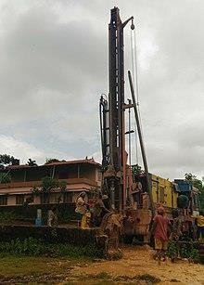

Typically, a borehole used as a [water well](https://en.wikipedia.org/wiki/Water_well) is completed by installing a vertical pipe (casing) and well screen to keep the borehole from caving. This also helps prevent surface [contaminants](https://en.wikipedia.org/wiki/Contaminants) from entering the borehole and protects any installed pump from drawing in sand and sediment. [Oil and natural gas wells](https://en.wikipedia.org/wiki/Oil_well) are completed in a similar, albeit usually more complex, manner.

As detailed in [proxy (climate)](https://en.wikipedia.org/wiki/Proxy_(climate)#Boreholes), borehole temperature measurements at a series of different depths can be effectively "[inverted](https://en.wikipedia.org/wiki/Invertible_matrix)" (a mathematical formula to solve a matrix equation) to help estimate historic surface temperatures.

Clusters of small-diameter boreholes equipped with heat exchangers made of plastic PEX pipe can be used to store heat or cold between opposing seasons in a mass of native rock. The technique is called [seasonal thermal energy storage](https://en.wikipedia.org/wiki/Seasonal_thermal_energy_storage). Media that can be used for this technique ranges from gravel to bedrock. There can be a few to several hundred boreholes, and in practice, depths have ranged from 150 to 1000 feet.

# CHAPTER 3

## COMPONENTS

* SQUARE TUBE
* GRIPPER
* ARDUINO
* RELAY
* BLUETOOTH
* PLASTIC PIPE
* BATTERY
* MOBILE APP

## SQUARE TUBE

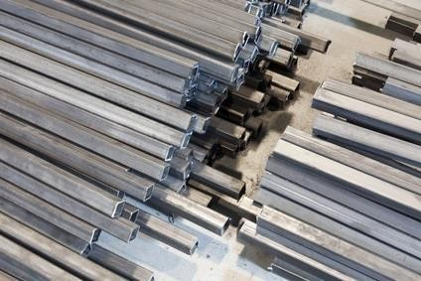

Square and rectangular tubing is also known as HSS (hollow structural steel). A hollow structural section (HSS) is a type of metal [profile](https://en.wikipedia.org/wiki/Profile_(engineering)) with a hollow [cross](https://en.wikipedia.org/wiki/Cross_section_(geometry)) [section](https://en.wikipedia.org/wiki/Cross_section_(geometry)). The term is used predominantly in the United States, or other countries which follow US construction or engineering terminology.

HSS members can be circular, square, or rectangular sections, although other shapes such as elliptical are also available. HSS is only composed of [structural](https://en.wikipedia.org/wiki/Structural_steel) [steel](https://en.wikipedia.org/wiki/Structural_steel) per code.

HSS is sometimes mistakenly referenced as hollow structural steel. Rectangular and square HSS are also commonly called tube steel or box section. Circular HSS are sometimes mistakenly called [steel pipe](https://en.wikipedia.org/wiki/Steel_pipe), although true steel [pipe](https://en.wikipedia.org/wiki/Pipe_(material)) is actually dimensioned and classed differently from HSS. (HSS dimensions are based on exterior dimensions of the profile; pipes are also manufactured to an exterior tolerance, albeit to a different standard.) The corners of HSS are heavily rounded, having a radius which is approximately twice the wall thickness. The wall thickness is uniform around the section.

In the UK, or other countries which follow British construction or engineering terminology, the term HSS is not used. Rather, the three basic shapes are referenced as CHS, SHS, and RHS, being circular, square, and rectangular hollow

sections. Typically, these designations will also relate to metric sizes, thus the dimensions and tolerances differ slightly from HSS.

## RELAY

A relay is an [electrically](https://en.wikipedia.org/wiki/Electric) operated [switch](https://en.wikipedia.org/wiki/Switch). It consists of a set of input terminals for a single or multiple control signals, and a set of operating contact terminals. The switch may have any number of contacts in multiple [contact forms](https://en.wikipedia.org/wiki/Electrical_contact#Contact_form), such as make contacts, break contacts, or combinations thereof.

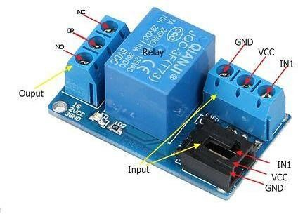

Relays are used where it is necessary to control a circuit by an independent low- power signal, or where several circuits must be controlled by one signal. Relays were first used in long-distance [telegraph](https://en.wikipedia.org/wiki/Electrical_telegraph) circuits as signal repeaters: they refresh the signal coming in from one circuit by transmitting it on another circuit. Relays were used extensively in telephone exchanges and early computers to perform logical operations.

The traditional form of a relay uses an [electromagnet](https://en.wikipedia.org/wiki/Electromagnet) to close or open the contacts, but relays using other operating principles have also been invented, such as in [solid-state relays](https://en.wikipedia.org/wiki/Solid-state_relay) which use [semiconductor](https://en.wikipedia.org/wiki/Semiconductor) properties for control without

relying on [moving parts](https://en.wikipedia.org/wiki/Moving_parts). Relays with calibrated operating characteristics and sometimes multiple operating coils are used to protect electrical circuits from overload or faults; in modern electric power systems these functions are performed by digital instruments still called [protective relays](https://en.wikipedia.org/wiki/Protective_relay).

Latching relays require only a single pulse of control power to operate the switch persistently. Another pulse applied to a second set of control terminals, or a pulse with opposite polarity, resets the switch, while repeated pulses of the same kind have no effects. Magnetic latching relays are useful in applications when interrupted power should not affect the circuits that the relay is controlling.

## BATTERY

A battery is a source of [electric power](https://en.wikipedia.org/wiki/Electric_power) consisting of one or more [electrochemical](https://en.wikipedia.org/wiki/Electrochemical_cell) [cells](https://en.wikipedia.org/wiki/Electrochemical_cell) with external connections for powering [electrical](https://en.wikipedia.org/wiki/Electricity) devices. When a battery is supplying power, its positive terminal is the [cathode](https://en.wikipedia.org/wiki/Cathode) and its negative terminal is the [anode](https://en.wikipedia.org/wiki/Anode). The terminal marked negative is the source of electrons that will flow through an external electric circuit to the positive terminal. When a battery is connected to an external electric load, a [redox](https://en.wikipedia.org/wiki/Redox) reaction converts high-energy reactants to lower-energy products, and the [free-energy](https://en.wikipedia.org/wiki/Gibbs_free_energy) difference is delivered to the external circuit as electrical energy. Historically the term "battery" specifically referred to a device composed of multiple cells; however, the usage has evolved to include devices composed of a single cell.

[Primary](https://en.wikipedia.org/wiki/Primary_battery) (single-use or "disposable") batteries are used once and [discarded](https://en.wikipedia.org/wiki/Disposable_product), as the [electrode](https://en.wikipedia.org/wiki/Electrode) materials are irreversibly changed during discharge; a common example is the [alkaline battery](https://en.wikipedia.org/wiki/Alkaline_battery) used for [flashlights](https://en.wikipedia.org/wiki/Flashlight) and a multitude of portable electronic devices. [Secondary (rechargeable) batteries](https://en.wikipedia.org/wiki/Rechargeable_battery) can be discharged and recharged multiple times using an applied electric current; the original composition of the electrodes can be restored by reverse current. Examples

include the [lead–acid batteries](https://en.wikipedia.org/wiki/Lead%E2%80%93acid_battery) used in vehicles and [lithium-ion](https://en.wikipedia.org/wiki/Lithium-ion) batteries used for portable electronics such as [laptops](https://en.wikipedia.org/wiki/Laptop) and [mobile phones](https://en.wikipedia.org/wiki/Mobile_phone).

## PLASTIC PIPE

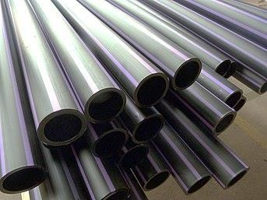

Plastic pipe is a tubular section, or hollow cylinder, made of [plastic](https://en.wikipedia.org/wiki/Plastic). It is usually, but not necessarily, of circular cross-section, used mainly to convey substances which can flow—liquids and gases (fluids), slurries, powders and masses of small solids. It can also be used for structural applications; hollow [pipes](https://en.wikipedia.org/wiki/Pipe_(fluid_conveyance)) are far stiffer per unit weight than solid members.

Plastic pipework is used for the conveyance of [drinking water](https://en.wikipedia.org/wiki/Drinking_water), [waste](https://en.wikipedia.org/wiki/Wastewater) [water](https://en.wikipedia.org/wiki/Wastewater), [chemicals](https://en.wikipedia.org/wiki/Chemical), heating fluid and [cooling fluids](https://en.wikipedia.org/wiki/Coolant), [foodstuffs](https://en.wikipedia.org/wiki/Foodstuff), ultra-pure liquids, [slurries](https://en.wikipedia.org/wiki/Slurry), [gases](https://en.wikipedia.org/wiki/Gas), [compressed air](https://en.wikipedia.org/wiki/Compressed_air), [irrigation](https://en.wikipedia.org/wiki/Irrigation), [plastic pressure pipe systems](https://en.wikipedia.org/wiki/Plastic_pressure_pipe_systems), and [vacuum system applications](https://en.wikipedia.org/wiki/Vacuum_system_application).

## MOBILE APP

A mobile application or app is a [computer program](https://en.wikipedia.org/wiki/Computer_program) or [software](https://en.wikipedia.org/wiki/Software_application) [application](https://en.wikipedia.org/wiki/Software_application) designed to run on a [mobile device](https://en.wikipedia.org/wiki/Mobile_device) such as a [phone](https://en.wikipedia.org/wiki/Smartphone), [tablet](https://en.wikipedia.org/wiki/Tablet_computer), or [watch](https://en.wikipedia.org/wiki/Smartwatch).

Mobile applications often stand in contrast to [desktop applications](https://en.wikipedia.org/wiki/Desktop_application) which are designed to run on [desktop computers](https://en.wikipedia.org/wiki/Desktop_computer), and [web applications](https://en.wikipedia.org/wiki/Web_application) which run in [mobile](https://en.wikipedia.org/wiki/Mobile_web_browser) [web browsers](https://en.wikipedia.org/wiki/Mobile_web_browser) rather than directly on the mobile device.

Apps were originally intended for productivity assistance such as email, calendar, and contact databases, but the public demand for apps caused rapid expansion into other areas such as [mobile games](https://en.wikipedia.org/wiki/Mobile_game), [factory automation](https://en.wikipedia.org/wiki/Factory_automation), GPS and [location-](https://en.wikipedia.org/wiki/Location-based_services) [based services](https://en.wikipedia.org/wiki/Location-based_services), order-tracking, and ticket purchases, so that there are now millions of apps available. Many apps require [Internet](https://en.wikipedia.org/wiki/Internet) access. Apps are generally downloaded from [app stores](https://en.wikipedia.org/wiki/App_store), which are a type of [digital distribution](https://en.wikipedia.org/wiki/Digital_distribution) platforms.

The term "app", short for "[application](https://en.wikipedia.org/wiki/Application_software)", has since become very popular; in 2010, it was listed as "[Word of the Year](https://en.wikipedia.org/wiki/Word_of_the_Year)" by the [American Dialect Society](https://en.wikipedia.org/wiki/American_Dialect_Society).[[1]](https://en.wikipedia.org/wiki/Mobile_app#cite_note-1)

Apps are broadly classified into three types: native apps, hybrid and web apps. Native applications are designed specifically for a mobile operating system, typically iOS or Android. Web apps are written in [HTML5](https://en.wikipedia.org/wiki/HTML5) or [CSS](https://en.wikipedia.org/wiki/CSS) and typically run through a browser. Hybrid apps are built using web technologies such as [JavaScript](https://en.wikipedia.org/wiki/JavaScript), CSS, and HTML5 and function like web apps disguised in a native container.

## GRIPPER

Grippers, sometimes called hand grippers, are primarily used for testing and increasing the strength of the [hands](https://en.wikipedia.org/wiki/Hands); this specific form of [grip strength](https://en.wikipedia.org/wiki/Grip_strength) has been called crushing grip, which has been defined as meaning the prime movers are the four fingers, rather than the thumb.

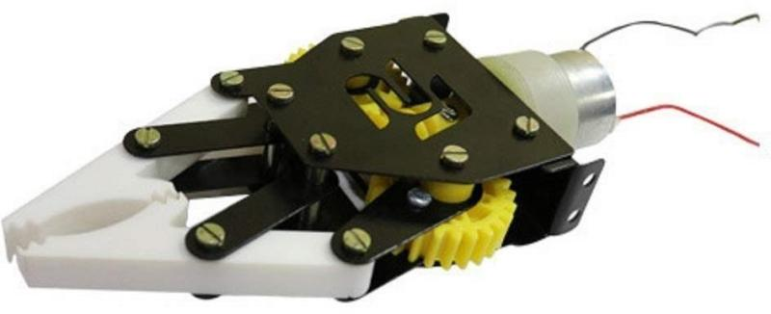

There are differences from brand to brand, but the common features of standard grippers are that they use a [torsion spring](https://en.wikipedia.org/wiki/Torsion_spring) fitted with two handles. The exact dimensions of these elements vary, as well as the materials used to make them; the springs are made from various types of [steel](https://en.wikipedia.org/wiki/Steel), and the handles are generally made from wood, [plastic](https://en.wikipedia.org/wiki/Plastic), steel or [aluminum](https://en.wikipedia.org/wiki/Aluminum).

Grippers come in a range of strengths, suitable for everyone from beginners to [World's Strongest Man](https://en.wikipedia.org/wiki/World%27s_Strongest_Man) winners, such as [Magnus Samuelsson](https://en.wikipedia.org/wiki/Magnus_Samuelsson), whose [YouTube](https://en.wikipedia.org/wiki/YouTube) video clip closing the No. 4 [Captains of Crush Gripper](https://en.wikipedia.org/wiki/Captains_of_Crush_Grippers) has been viewed over 2 million times.

In 1991, IronMind began certifying people who could close its toughest grippers under official conditions, and it maintains lists of the people certified on the Captains of Crush No. 3, Captains of Crush No. 3.5and Captains of Crush No. 4, Closing grippers of this strength level has been compared to crushing a raw potato in one's bare hand.[[18]](https://en.wikipedia.org/wiki/Grippers#cite_note-18) In 2011, IronMind began certifying women who officially closed the Captains of Crush No. 2 Gripper.

The user holds the gripper in one hand and squeezes the two handles together until they touch. Once touched, the handles are released and the movement is repeated. Variations of this basic movement include negatives [see below], and a variety of partial movements. For example, if the strength of the gripper is beyond that of the user, the user might apply maximum force, moving the handles as far as possible, even if the handles cannot be made to touch.

Another partial movement involves using two hands to squeeze the handles within approximately 19 mm (3/4 inch) of each other, releasing one hand, and then using the other hand to make the handles of the gripper touch each other. Negatives involve starting the gripper handles touching and then resisting as the gripper opens up, in an [eccentric contraction.](https://en.wikipedia.org/wiki/Eccentric_contraction)

## ARDUINO

The Arduino Uno is an [open-source](https://en.wikipedia.org/wiki/Open-source) [microcontroller board](https://en.wikipedia.org/wiki/Microcontroller_board) based on the [Microchip](https://en.wikipedia.org/wiki/Microchip_Technology) [ATmega328P](https://en.wikipedia.org/wiki/ATmega328P) microcontroller and developed by [Arduino.cc](https://en.wikipedia.org/wiki/Arduino). The board is equipped with sets of digital and analog [input/output](https://en.wikipedia.org/wiki/Input/output) (I/O) pins that may be interfaced to various [expansion boards](https://en.wikipedia.org/wiki/Expansion_board) (shields) and other circuits.[[1]](https://en.wikipedia.org/wiki/Arduino_Uno#cite_note-Makerspace-1) The board has 14 digital I/O pins (six capable of [PWM](https://en.wikipedia.org/wiki/Pulse-width_modulation) output), 6 analog I/O pins, and is programmable with the [Arduino IDE](https://en.wikipedia.org/wiki/Arduino#Software) (Integrated Development Environment), via a type B [USB cable](https://en.wikipedia.org/wiki/USB_cable). It can be powered by the USB cable or by an external [9-volt battery](https://en.wikipedia.org/wiki/9-volt_battery), though it accepts voltages between 7 and 20 volts. It is similar to the [Arduino Nano](https://en.wikipedia.org/wiki/Arduino_Nano) and Leonardo. The hardware reference design is distributed under a [Creative](https://en.wikipedia.org/wiki/Creative_Commons) [Commons](https://en.wikipedia.org/wiki/Creative_Commons) Attribution Share-Alike 2.5 license and is available on the Arduino website. Layout and production files for some versions of the hardware are also available.

The word "[uno](https://en.wiktionary.org/wiki/uno)" means "one" in [Italian](https://en.wikipedia.org/wiki/Italian_language) and was chosen to mark the initial release of [Arduino Software](https://en.wikipedia.org/wiki/Arduino_Software). The Uno board is the first in a series of USB- based Arduino boards; it and version 1.0 of the Arduino [IDE](https://en.wikipedia.org/wiki/Integrated_development_environment) were the reference versions of Arduino, which have now evolved to newer releases. The ATmega328 on the board comes pre programmed with a [bootloader](https://en.wikipedia.org/wiki/Bootloader) that

allows uploading new code to it without the use of an external hardware programmer.

While the Uno communicates using the original STK500 protocol, it differs from all preceding boards in that it does not use the FTDI USB-to-serial driver chip. Instead, it uses the Atmega16U2 (Atmega8U2 up to version R2) programmed as a [USB-to-serial converter](https://en.wikipedia.org/wiki/USB-to-serial_converter).

## PIN DIAGRAM

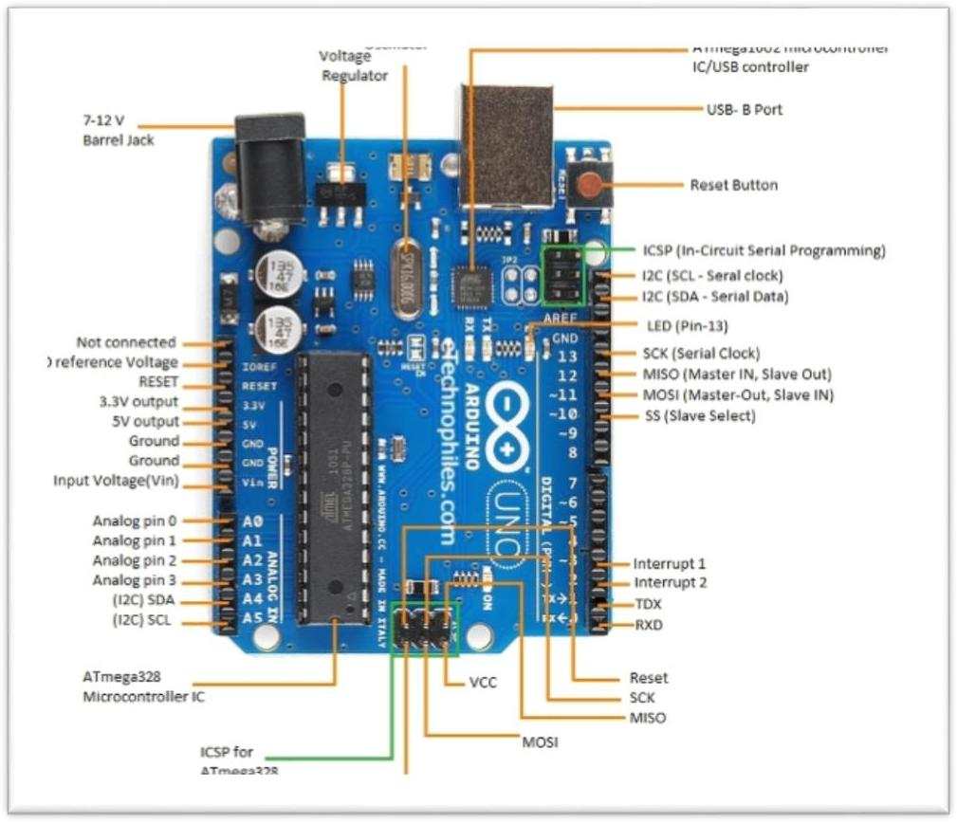

* + 1. **GENERAL PIN FUNCTIONS**
* LED: There is a built-in LED driven by digital pin 13. When the pin is high value, the LED is on, when the pin is low, it is off.
* VIN: The input voltage to the Arduino/Genuino board when it is using an external power source (as opposed to 5 volts from the USB connection or other regulated power source). You can supply voltage through this pin, or, if supplying voltage via the power jack, access it through this pin.
* 5V: This pin outputs a regulated 5V from the regulator on the board. The board can be supplied with power either from the DC power jack (7 - 20V), the USB connector (5V), or the VIN pin of the board (7-20V). Supplying voltage via the 5V or 3.3V pins bypasses the regulator, and can damage the board.
* 3V3: A 3.3 volt supply generated by the on-board regulator. Maximum current draw is 50 mA.
* GND: Ground pins.
* IOREF: This pin on the Arduino/Genuino board provides the voltage reference with which the microcontroller operates. A properly configured shield can read the IOREF pin voltage and select the appropriate power source, or enable voltage translators on the outputs to work with the 5V or 3.3V.
* Reset: Typically used to add a reset button to shields that block the one on the board.

# CHAPTER 4

## EMBEDDED SYSTEM

Embedded systems are controllers with on chip control. They consist of microcontrollers, input and output devices, memories etc., on chip and they can be used for a specific application. A small computer designed in a single chip is called a single chip microcomputer. A single chip microcomputer typically includes a microprocessor RAM, ROM, timer, interrupt and peripheral controller in a single chip. This single chip microcomputer is also called as microcontroller; These Microcontrollers are used for variety of applications where it replaces the computer. The usage of this microcomputer for a specific application, in which the microcontrollers a part of application, is called embedded systems. Embedded systems are used for real time applications with high reliability, accuracy and precision, Embedded systems are operated with Real Time Operating systems like WinCE, RT Linux, VxWorks, PSOS, etc.., Embedded systems are very popular these days Most of the Electrical, Electronics, Mechanical, Chemical, Industrial, Medical, Space and many more areas have the embedded systems in their applications

## ROLE OF EMBEDDED SYSTEM

Embedded systems are compact, smart, efficient, and economical and user friendly, they are closed systems and respond to the real world situation very fast,

closed system means, everything required for a specific application is embedded on the chip and hence, they do not call for external requirement for their functioning.

## APPLICATIONS OF EMBEDDED SYSTEM

* Robotics
* Aviation
* Telecommunication and Broadcasting
* Mobile Phones and mobiles networking
* Satellite Communication
* Blue Tooth
* Electronic sensors
* Home Appliances etc.

## PERIPHERALS

Embedded Systems talk with the outside world via peripherals, such as:

* Serial Communication Interfaces (SCI): RS-232, RS-422, RS-485 etc.
* Synchronous Serial Communication Interface: I2C, SPI, SSC and ESSI (Enhanced Synchronous Serial Interface)
* Universal Serial Bus (USB)
* Multi Media Cards (SD Cards, Compact Flash etc.)
* Networks: Ethernet, Lon Works, etc.
* Fieldbuses: CAN-Bus, LIN-Bus, PROFIBUS, etc.
* Timers: PLL(s), Capture/Compare and Time Processing Units
* Discrete IO: aka General Purpose Input/Output (GPIO)
* Analog to Digital/Digital to Analog (ADC/DAC)
* Debugging: JTAG, ISP, ICSP, BDM Port, BITP, and DP9 ports.

## PROJECT IMAGES TOP VIEW

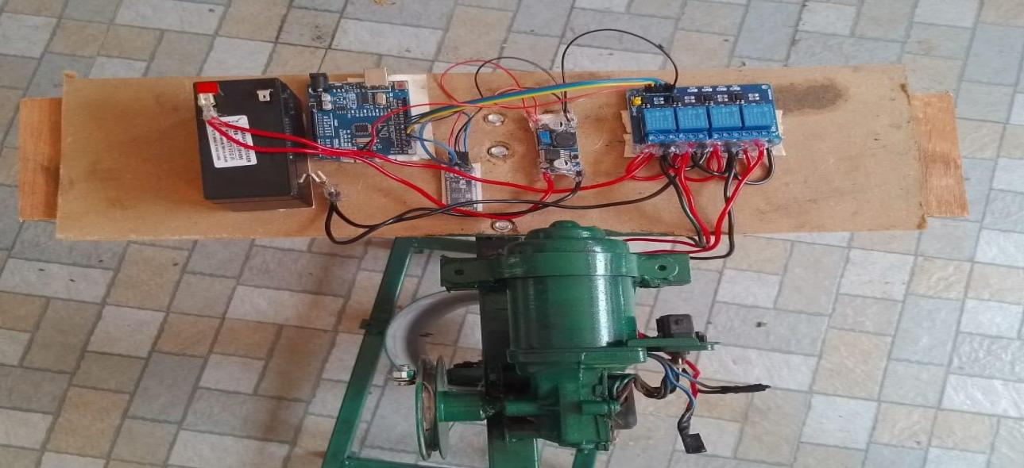

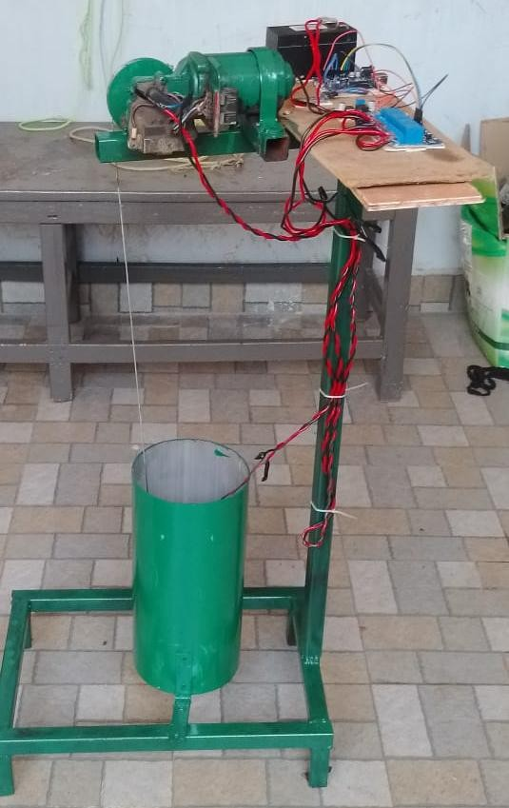**SIDE VIEW**

# CHAPTER 5 CONCLUSION

* + - A lot of lives have been lost due to falling in the bore well because it involves digging a pit beside a bore well which is a time consuming process. The proposed system is to overcome all these difficulties. This project is used to reduce human efforts for rescuing operations from bore well. It performs rescue operations in very less time as compared to traditional methods. Thus, it has been designed keeping the entire obstacle in mind that may arise during the operation. We like to conclude with the help of my research project able to rescue without any damage.

## FUTURE SCOPE

* + - In future we can use this project in several applications by adding additional components to this project. The structure is made strong enough to sustain all possible loads, though it can be flexible at the same time to adjust wider range of bore diameter and any change in the diameter of bore. We can send these robots to dangerous zones by connecting smoke sensor to the robot we can get the information related concentration of smoke or

gases in respective fields and sensor will detect the poisonous gas and it gives information to the Microcontroller and microcontroller gives the information to the transceiver from that we can get the data on the PC side.

## REFERENCES

1. G. Kavianand, K. Gowri Ganesh, P. Karthikeya, “Smart child rescue system from Borewells” (SCRS), Published in: Emerging Trends in Engineering, Technology and Science (ICETETS), International Conference on, 24-26 Feb. 2017.
2. N. M. Kurukuti, M. Jinkala, P. Tanjeri, S. R. Dantla and M. Korrapati, “A novel design of systemic system for rescue in bore well accidents”, 2016 International Conference on Systemics and Automation for Humanitarian Applications (RAHA), Kollam, 2016, pp. 1-5.doi: 10.1109/RAHA.2016.7931875 International Journal of Trend in Scientific Research and Development (IJTSRD) @[www.ijtsrd.com](http://www.ijtsrd.com/) eISSN: 2456- 6470 @ IJTSRD | Unique Paper ID - IJTSRD23847 | Volume – 3 | Issue – 4 | May-Jun 2019 Page: 642.
3. Raj Manish, P. Chakraborty, G. C. Nandi, Rescue Systemics in bore wellEnvironment, Cornell university library 5thJune,2017
4. N. Bourbakis and I. Papadakis-Ktistakis ATRC, “Design Ground Bio- inspired Micro-System Structure for Detecting Humans in disastrous region”. Wright State University, Dayton, OH 45435 and Technical University of Crete, Greece.10thJune,2017
5. K. P. Sridhar, C. R. Hema, S. Deepa Published online: “Design of a Wireless Sensor Fusion System to Analyse Conditions Inside Bore Wells”. Wireless Peers Common (2017) 94:1951–1962 DOI 10.1007/s11277-016- 3299- 4 on 12 April 2016.
6. Preedipat Sattayasoonthorn, “Battery Management for Rescue System Operation” 9th July,2017.
7. Wang Chuanjiang, and Robert Babuska. "Machine Learning Algorithms in Bipedal System Control." Systems, Man, and Cybernetics, Part C: Applications and Reviews, IEEE Transactions on 42, no. 5 (2012): 728- 743
8. Palwinder Kaur, Ravinder Kaur, Gurpreet Singh “Pipeline Inspection and Borewells Rescue System”, IEEE, VOL3, NO. 4, April 2014.
9. K. Saran, S. Vignesh, Marlon Jones Louis “Bore- well Rescue System” International journal of research aeronautical VOL 1, Issue 4, pg.61-80, April 2014.
10. B. Bharathi, B. Suchitha Samuel “Design and Construction of Rescue System and pipeline inspection Using ZigBee” International Journal of Scientific Engineering and Research (IJSER) Volume 1 Issue 1, September 2013.
11. G. Nithin, G. Gautam, G. Venkatachalam and S. Narayana “Design and stimulation of the bore-well rescue system – Advanced Asian Research Publishing Network (ARPN)” Journal of engineering and applied sciences.