**Design of text summarization based on BART**

**Shubhangi B. Mute 1, Jayant Karanjekar 2**

1Student, Wainganganga College of Engineering and Management, Nagpur, Maharashtra, India

2Professor, Wainganganga College of Engineering and Management, Nagpur, Maharashtra, India

**ABSTRACT**

Text summarization is the process of taking the most important information from a document or collection of linked papers and distilling it while retaining its key ideas. An abstractive summary is created by comprehending the main ideas in a document and then communicating those ideas in easily comprehensible everyday language. There are two types of text summaries: indicative and informative. An inductive summary merely communicates to the reader the main idea of the text. Typically, this kind of summary only covers 5 to 10% of the original text. On the other hand, informative summarising algorithms offer condensed summaries of the main points. On the other hand, informative summarising algorithms offer condensed summaries of the main points. Between 20 and 30 percent of the main text's length is taken up by the informative summary.

**Keywords:** BART, Text summarization , NLP.

1. **INTRODUCTION**

People have become overwhelmed by the vast amount of information and documents available on the internet as the internet and big data have grown in popularity. Many researchers are motivated to develop a technology solution that can automatically summaries texts as a result of this The task of compressing a piece of text into a shorter version, lowering the size of the original text while keeping crucial informational aspects and content meaning, is known as summarization. Because manual text summarizing is a time-consuming and inherently tedious activity, automating it is expanding in popularity and so serves as a powerful motivator for academic study. In the big data era, the amount of text data available from diverse sources has multiplied. This extensive body of literature has a plethora of data and expertise that needs to be properly distilled in order to be effective. Due to the increase in document availability, substantial research in the area of natural language processing (NLP) is needed for text summarization software. Automatic text summarizing is the process of creating a concise and fluid summary without a person's help while maintaining the original text's meaning. It's challenging because, in order to describe a work of literature, we often read it in its entirety to better understand it, and then we highlight its key aspects in a summary. Automatic text summarization is a difficult and time-consuming process because computers can't understand human language.

To save time and enable end users to swiftly consume material, it is essential to extract the most pertinent elements of a document, which act as a condensed highlight of its content. As manual summary becomes impracticable at such a high rate of content input, there has been an increasing demand for automatic text summarizing solutions. On-device text summarizing can help content providers display their information succinctly while limiting cloud participation to conserve bandwidth and safeguard privacy because so much of this content is accessible on mobile devices. On-device summarization techniques are still primarily investigated because of storage and processing resource constraints.

The task of compressing a piece of text into a shorter version, minimizing the size of the original text while keeping crucial informational aspects and content meaning, is known as summarization.

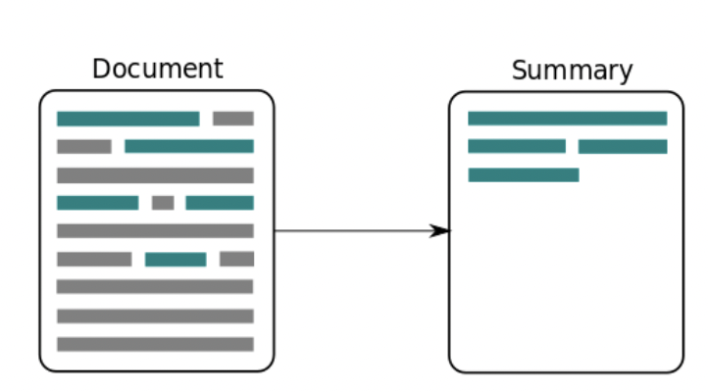

Fig. 1: Input document to summary generation

1. **LITRATURE SURVEY**

Text summary is the act of condensing a long text into a smaller, more accurate, and fluent set of phrases that is easy to grasp and provides the reader with the information they need in a limited amount of words. [1] Extractive summarization and abstractive summarization are the two primary text summarizing approaches. The summary is generated using extractive based summarization, which extracts the relevant phrases and sentences from the original text. The statistical properties of the sentences are taken into account when determining the most important sentences from the text. Abstractive summarization recognizes the major ideas in the original text and creates a summary in plain English. The linguistic qualities of the sentences are taken into account here [2].

The majority of extant text summary applications are extractive, with only a few producing abstractive summaries. For constructing multi-document summaries, graph-based algorithms for abstractive text summarizing have demonstrated to be superior to previous methods. Knowledge graphs provide a summary that is more in line with human reading patterns and has the logic of human reasoning. As a result, we suggest a possible solution to this problem by gathering crucial information from news websites and extracting only the substance in the form of an automatically created summary, allowing newsreaders to make more informed decisions in less time. [3]

A unique approach for extractive summarization with sentiment analysis for two-level text summarizing from online news sources. Important sentences from various news stories pertaining to a topic are extracted first, and individual summaries are prepared. Sentiment analysis is used to go further into the individual summaries for each topic. [4]

The combination of various material from numerous document sources to provide summaries that were informational in nature. In addition, these methods used a language generator to construct sentences from words chosen using statistical analysis methods like TF-IDF scores, noun pronoun and verb weights, etc. [5]

A collection of documents on a given subject that are important to the application or user's needs. Weighted keyword analysis [6], topic signatures [7], and statistical techniques like Latent Dirichlet Allocation [8] can all be used to do this. Probabilistic Latent Semantic Analysis and Latent Semantic Latent Indexing [9].

1. **METHODOLOGY**

This kind of model is applicable for text summarization (providing a summary of or paraphrasing a lengthy text document), question-answering (producing answers for a given question on a specific corpus), sequence classification, and machine translation (translating text from one language to another) (categorizing input text sentences or tokens).

Sentence entailment is another assignment that assesses whether two or more sentences are logical extensions of one another or logically related to a given assertion.

BART employs a typical seq2seq/machine translation architecture with a left-to-right decoder and a bidirectional encoder (like BERT) (like GPT).

In the pretraining job, the original sentences' sequence is randomly shuffled, and a new in-filling approach is used to replace long stretches of text with a single mask token.

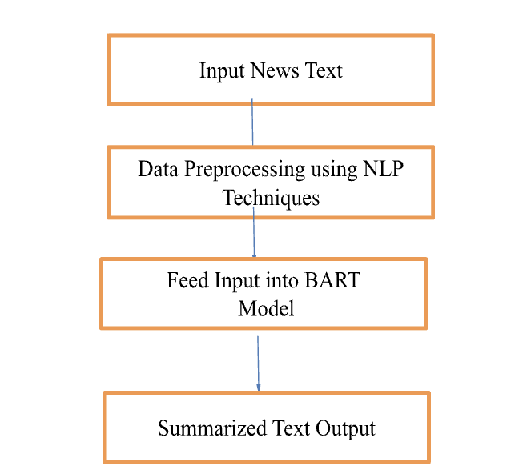

**Fig. 2 Proposed Methodology**

1. **RESULTS AND DISCUSSION**

The input text is summarizing and text data is process to make summary. Once the user puts the text in the dashboard and clicks on Summarize button ,it triggers the algorithm and summary starts getting generated as show in shown in fig 3

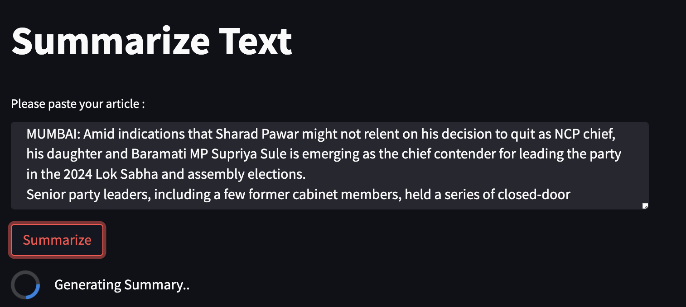

Fig 3. Input text inserted and generating summary

Fig 4. the screenshot of the dashboard to summarize text. Once the user puts the text in the dashboard and clicks on Summarize button,it triggers the algorithm and summary starts getting generated as show in the below image

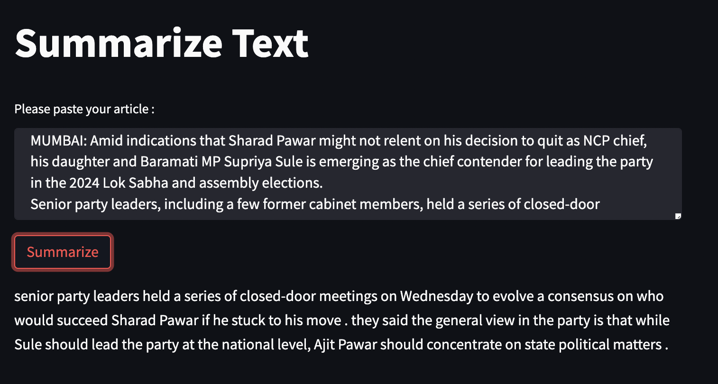

Fig 4. Input Text based summary generartion

1. **CONCLUSION**

Text summarization is one of the biggest problems in the field of natural language processing. Examples of these strategies include Deep Understanding, Sentence Extraction, Paragraph Extraction, Machine Learning, and even ones that integrate all of these methodologies with traditional NLP Techniques (Stopword Removal, Lemmatization, Bigram, Trigram Words). Despite these achievements, there is still a tonne of text summarising research to be done because it is still difficult to construct a useful summary across all fields of study and languages.

1. **REFERENCES**
2. S. Singh, A. Singh, S. Majumder, A. Sawhney, D. Krishnan and S. Deshmukh, "Extractive Text Summarization Techniques of News Articles: Issues, Challenges and Approaches," 2019 International Conference on Vision Towards Emerging Trends in Communication and Networking (ViTECoN), 2019, pp. 1-7, doi: 10.1109/ViTECoN.2019.8899706.
3. V. Alwis, "Intelligent E-news Summarization," 2018 18th International Conference on Advances in ICT for Emerging Regions (ICTer), 2018, pp. 189-195, doi:10.1109/ICTER.2018.8615590.
4. M. V. P. T. Lakshika, H. A. Caldera and W. V. Welgama, "Abstractive Web News Summarization Using Knowledge Graphs," 2020 20th International Conference on Advances in ICT for Emerging Regions (ICTer), 2020, pp. 300-301, doi: 10.1109/ICTer51097.2020.9325453.
5. T. B. Mirani and S. Sasi, "Two-level text summarization from online news sources with sentiment analysis," 2017 International Conference on Networks & Advances in Computational Technologies (NetACT), 2017, pp. 19-24, doi: 10.1109/NETACT.2017.8076735.
6. Barzilay, R. and McKeown, K. R., “Sentence fusion for multidocument news summarization”, Computational Linguistics, 31(3):297-328, 2005
7. Nenkova, A., Vanderwende, L., and McKeown, K., “A compositional context sensitive multi-document summarizer: exploring the factors that influence summarization” In Proceedings of the 29th annual international ACM SIGIR conference on Research and development in information retrieval, pages 573-580. ACM, 2006
8. Lin, C.-Y. and Hovy, E., “The automated acquisition of topic signatures for text summarization”, In Proceedings of the 18th conference on Computational linguistics-Volume 1, pages 495-501. Association for Computational Linguistics, 2000
9. Bian, J., Yang, Y., and Chua, T.-S, “Multimedia summarization for trending topics in microblogs”, In Proceedings of the 22nd ACM international conference on Conference on information & knowledge management, pages 1807-1812. ACM 2013.
10. Hennig, L. and Labor, D., “Topic-based multidocument summarization with probabilistic latent semantic analysis”, In RANLP, pages 144-149, 2009