**DETECTING WEEDS FROM CROP USING IMAGE PROCESSING AND ARDUINO**

**Velmani Ramasamy1, S.Nithyadevi2**

1 Velmani Ramasamy, Professor and Head of the Department, Department of

Computer Science and Engineering, Adithya Institude of Technology, Coimbatore, TamilNadu, India.

2 Student, Department of Computer Science and Engineering, Adithya Institude of Technology, Coimbatore, TamilNadu, India.

**ABSTRACT**

Weed detection is an important task in precision agriculture, as it can help farmers to reduce herbicide use, increase crop yields, and minimize the environmental impact of agriculture. In this paper, we present a system for weed detection using image processing and Arduino. The system consists of a camera mounted on a mobile platform, which captures images of crops and weeds in the field. The images are then processed using a computer vision algorithm to detect and classify weeds based on their color and shape characteristics. The system is controlled by an Arduino microcontroller, which communicates with the camera and processes the image data. The results of the weed detection algorithm are displayed on a graphical user interface (GUI), which allows farmers to visualize and analyze the data. We tested the system on a variety of crops and weed species, and found that it achieved a high level of accuracy and reliability in detecting weeds. The system has the potential to improve the efficiency and sustainability of agriculture, by reducing the use of herbicides and promoting more targeted and precise weed control. It is also useful for researchers and developers who are interested in exploring the potential of computer vision and Arduino in the field of precision agriculture and weed management.

**Keywords:** Aurdino, image information.

1. **INTRODUCTION**

Weed detection using image processing and Arduino is a popular application in the field of agriculture. It involves using image processing techniques to identify and locate the presence of weeds in a given area and then using an Arduino microcontroller to control a weeding machine to remove the weeds. Here are the general steps involved in the process:

1. Image Acquisition: A camera is used to capture the images of the field where the crops are grown. These images can be either RGB or grayscale.
2. Preprocessing: Preprocessing of the images involves various techniques such as noise reduction, contrast enhancement, and image segmentation.
3. Feature Extraction: In this step, the relevant features of the weed and crop are extracted using feature extraction techniques such as edge detection, texture analysis, and color segmentation.

iv. Classification: The extracted features are used to classify the image as either containing weed or not.

1. Control: Finally, an Arduino microcontroller is used to control the weeding machine to remove the identified weeds.

Some of the image processing libraries that can be used for this application include OpenCV, Matlab, and Python. The Arduino microcontroller can be programmed using Arduino IDE, which is an open-source software used for developing and uploading code to the Arduino board. Overall, weed detection using image processing and Arduino is a promising solution for weed control in agriculture, as it can help reduce the use of herbicides and improve crop yields.

1. **METHODOLOGY**

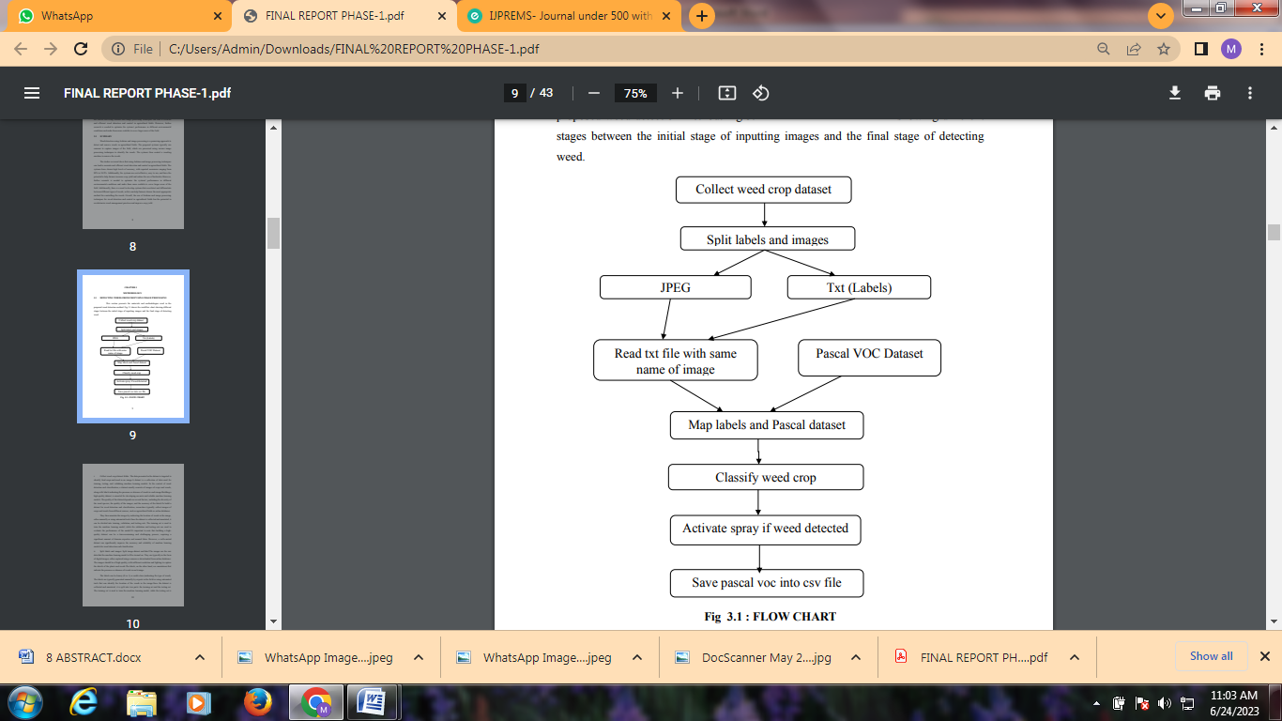

**Fig 2.1: flow chart**

This section presents the materials and methodologies used in the proposed weed detection method. Fig 2.1 shows the workflow chart showin i. Collect weed crop dataset folder: The data presented in the dataset is targeted to identify food crops and weed in an image.A dataset is a collection of data used for training, testing, and validating machine learning models. In the context of weed detection and classification, a dataset usually consists of images of crops and weeds, along with labels indicating the presence or absence of weeds in each image.Building a high-quality dataset is essential for developing accurate and reliable machine learning models. The quality of the dataset depends on several factors, including the diversity of the weed species, the quality of the images, and the accuracy of the labels.To build a dataset for weed detection and classification, researchers typically collect images of crops and weeds from different sources, such as agricultural fields or online databases. They then annotate the images by indicating the location of weeds in the image, either manually or using automated tools.Once the dataset is collected and annotated, it can be divided into training, validation, and testing sets. The training set is used to train the machine learning model, while the validation and testing sets are used to evaluate the performance of the model.It's important to note that building a highquality dataset can be a time-consuming and challenging process, requiring a significant amount of domain expertise and manual labor. However, a well-curated dataset can significantly improve the accuracy and reliability of machine learning models for weed detection and classification. ii. Split labels and images: Split image dataset and label.The images are the raw data that the machine learning model will be trained on. They are typically in the form of digital images, either captured using a camera or downloaded from online databases. The images should be of high quality, with sufficient resolution and lighting to capture the details of the plants and weeds.The labels, on the other hand, are annotations that indicate the presence or absence of weeds in each image. The labels can be binary (0 or 1) or multi-class (indicating the type of weed). The labels are typically generated manually by experts in the field or using automated tools that can identify the location of the weeds in the image.Once the dataset is collected and annotated, it is split into two parts: the training set and the testing set. The training set is used to train the machine learning model, while the testing set is 11 used to evaluate the performance of the model.It's important to ensure that the training and testing sets are representative of the overall dataset, meaning that they contain a diverse range of images and labels. iii. JPEG: JPEG is a commonly used method of lossy compression for digital images, particularly for those images produced by digital photography. JPEG stands for Joint Photographic Experts Group, which is a widely used image compression format. It is designed to compress digital images by reducing their file size, while preserving the visual quality of the image as much as possible.JPEG uses lossy compression, which means that some data is lost during compression. This data loss is achieved by removing certain frequencies of the image that are not easily perceived by the human eye. This allows for a reduction in the file size while maintaining an acceptable level of image quality. JPEG images are widely used in digital photography, as they can produce highquality images with a relatively small file size. They are also commonly used in web design and graphic design, as they can be quickly downloaded and displayed on websites without causing significant delays in page load times.One of the limitations of JPEG compression is that it is not suitable for images with sharp edges or high contrast boundaries, as this can result in visible artifacts in the image. Additionally, repeatedly compressing and decompressing JPEG images can lead to a gradual loss of quality over time, which is known as generational loss.Overall, JPEG is a popular and widely used image compression format that can be used to reduce the file size of digital images without significantly sacrificing image quality. iv. Txt (Labels): is a kind of computer file that is structured as a sequence of lines of electronic text.In the context of machine learning and computer vision, labels refer to annotations or metadata that describe the content of an image or data point. For example, in a dataset for weed detection and classification, the label for each image would indicate whether the image contains a weed or not.Labels are essential for training machine learning models, as they provide the ground truth that the model uses to learn how to make accurate predictions. In the case of weed detection and 12 classification, the labels provide information about which images contain weeds and what type of weed is present. In some cases, bounding boxes or segmentation masks may be used to indicate the location of the weed within the image.Generating accurate and reliable labels is essential for building a high-quality dataset. Labels can be generated manually by experts in the field, or using automated tools that can identify the location of the weeds in the image. It's important to ensure that the labels are consistent across the entire dataset, and that they accurately reflect the content of the images.In summary, labels are annotations or metadata that describe the content of an image or data point. v. Pascal VOC Dataset: Provides standardized image data sets for object class recognition; Provides a common set of tools for accessing the data sets.The PASCAL VOC dataset is a widely used image recognition dataset for object detection and classification tasks. It was created by the Visual Object Classes (VOC) challenge, a series of annual competitions that ran from 2005 to 2012. The dataset contains images of various objects, including animals, vehicles, and household items, with annotations that indicate the presence and location of objects within the image. The PASCAL VOC dataset contains over 11,000 images, each with multiple annotations that indicate the presence of specific objects within the image. The annotations include the object class, bounding box coordinates, and segmentation masks for the object. The dataset includes a variety of object classes, including people, animals, vehicles, and household items.The PASCAL VOC dataset has been used as a benchmark dataset for evaluating object detection and classification algorithms. It has also been used as a training dataset for machine learning models,.While the original PASCAL VOC challenge has ended, the dataset remains widely used and has been updated with new annotations and additional image sets. The most recent version of the dataset is VOC2012, which includes over 17,000 annotated images and over 21,000 object instances.Overall, the PASCAL VOC dataset is a valuable resource for researchers and practitioners in the field of computer vision and machine learning. It provides a diverse set of images and annotations that can be used to train and evaluate object detection and classification models.g different stages between the initial stage of inputting images and the final stage of detecting weed.

* 1. **ARDUINO**

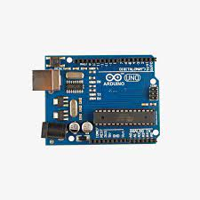

**Fig 2.1: ARDUINO**

Arduino is an open-source project that created microcontroller-based kits for building digital devices and interactive objects that can sense and control physical devices. The project is based on microcontroller board designs, produced by several vendors, using various microcontrollers. These systems provide sets of digital and analog input/output (I/O) pins that can interface to various expansion boards (termed shields) and other circuits. The boards feature serial communication interfaces, including Universal Serial Bus (USB) on some models, for loading programs from personal computers. For programming the microcontrollers, the Arduino project provides an integrated development environment (IDE) based on a programming language named Processing, which also supports the languages C and C++.

1. **MODELING AND ANALYSIS**

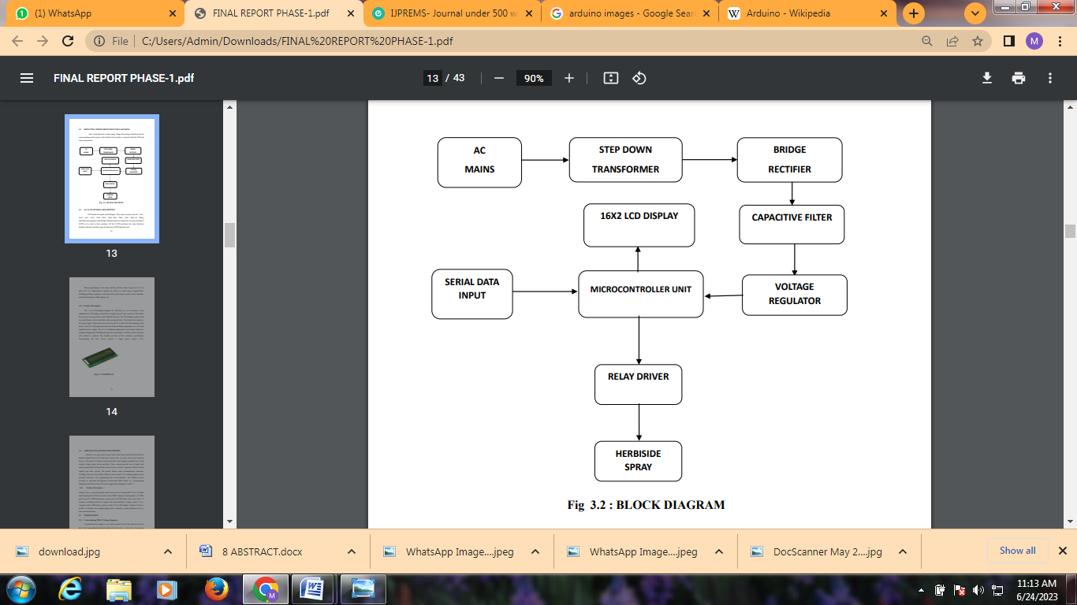

**Figure 1:**Block diagram

Here weed detection is done using Image Processing simulation and the corresponding result is given to the Arduino Uno which is connected with the LCD and water pump motor. At the beginning of the project, we loaded the data sets and trained them using Image Processing. The image is then retrained and categorized as images and lables are then created after the data are verified. By loading an image from the source and detecting edges, this algorithm prepares it for more advanced processing. A method for separating the crop from the background is color segmentation. An image's edges can be identified using edge detection, which prepares the image for filtering. After colour segmentation, the required image has both crop and weed, making it suitable for the next step in the process, edge detection. A curve in an image that follows a route of rapid change in image intensity is called an edge. The borders of items in a scene are frequently linked with edges. Edge detection is a technique for identifying the edges in an image and preparing it for the next step, filtering.

1. **RESULTS**

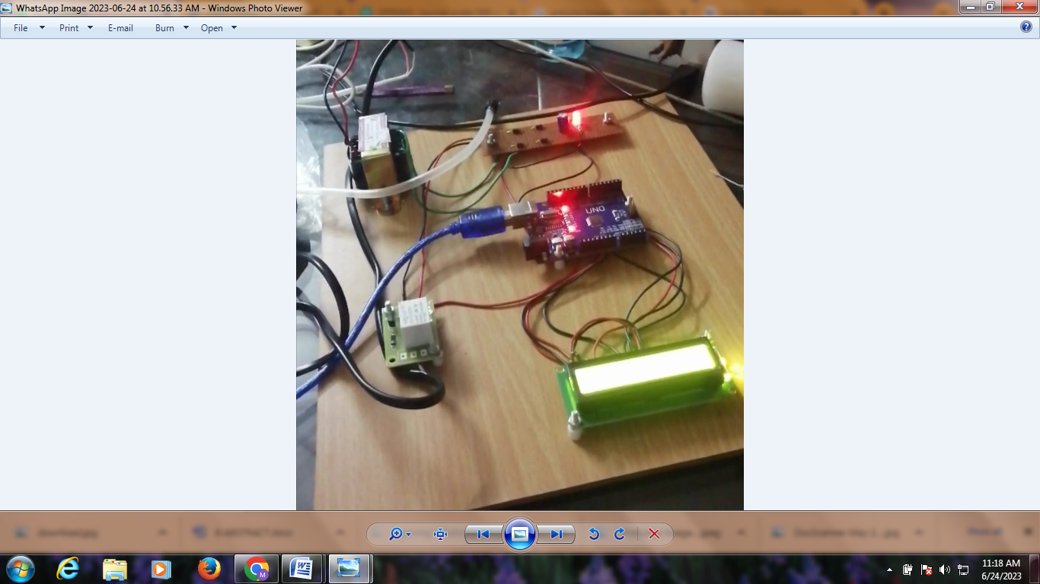

1. **CONCLUSION**

The use of Arduino and image processing for weed detection has shown promising results. By combining image processing algorithms with an Arduino microcontroller, it is possible to accurately detect and classify different types of weeds in real-time. One advantage of using an Arduino is that it is an affordable and accessible platform that can be used for a variety of applications. It is also relatively easy to program and can be integrated with different sensors and modules to enhance its functionality. Image processing algorithms, on the other hand, allow for the extraction of important features from images, which can then be used to identify different types of weeds. These algorithms can be optimized to improve detection accuracy, speed, and efficiency. Overall, the combination of Arduino and image processing has the potential to revolutionize the way we approach weed control in agriculture. It can help reduce the use of herbicides, increase crop yields, and promote more sustainable farming practices. However, it is important to note that further research and development are needed to optimize these technologies for practical applications in the field.

1. **REFERENCES**

[1] W. S. Lee, V. Alchanatis, C. Yang, M. Hirafuji, D. Moshou, and C. Li, ‘‘Sensing technologies for precision specialty crop production,’’ Comput. Electron. Agricult., vol. 74, no. 1, pp. 2–33, Oct. 2010.

[2] A. Wang, W. Zhang, and X. Wei, ‘‘A review on weed detection using ground-based machine vision and image processing techniques,’’ Comput. Electron. Agricult., vol. 158, pp. 226–240, Mar. 2019.

[3] J. Gao, W. Liao, D. Nuyttens, P. Lootens, J. Vangeyte, A. Pižurica, Y. He, and J. G. Pieters, ‘‘Fusion of pixel and object-based features for weed mapping using unmanned aerial vehicle imagery,’’ Int. J. Appl. Earth Observ. Geoinf., vol. 67, pp. 43–53, May 2018.

[4] E. Hamuda, M. Glavin, and E. Jones, ‘‘A survey of image processing techniques for plant extraction and segmentation in the field,’’ Comput. Electron. Agricult., vol. 125, pp. 184–199, Jul. 2016.