**A SYSTEMATIC REVIEW OF WIRELESS CHARGING TECHNIQUES FOR ELECTRIC VEHICLES**

**Dr.K.M Mahesh Kumar1, Sukanya H N2, Mohammed Najath3, Meghana N4, Nayana N P5,**

**Rakesh D H6**

1Assistant Professor & Head of the Department, Department of Electrical and Electronics, PES College of Engineering, Mandya, Karnataka, India.

2Assistant Professor, Department of Electrical and Electronics, PES College of Engineering, Mandya, Karnataka, India.

3,4,5,6Student, Department of Electrical and Electronics, PES College of Engineering, Mandya, Karnataka, India.

**ABSTRACT**

Electric vehicles are now the only zero-emission form of transportation, and they are seen as the automotive industry's future. In order to operate the car, the batteries must be charged. The current way of charging an electric vehicle is through a plug-in system, in which a charging station charges the battery. Wireless Power Transfer, which can be used as a Static or Dynamic charging system, is an alternate technique for recharging an electric vehicle's battery. When an electric vehicle is parked in static mode, a static charging system can be used to recharge the batteries for charging while the car is in motion, a dynamic charging technology can be used. This system for wirelessly charging electric vehicles uses inductive power transfer, in which the magnetic fields of the transmitter and receiver coils are mutually inducted to communicate power wirelessly. Battery Management System (BMS) monitors the battery's condition. The purpose of this paper is to review the differences between plug-in and wireless vehicle charging, the wireless charging operational principle, a variety of charging systems, static and dynamic wireless charging, the various topologies deployed during wireless electric vehicle charging, and some of the drawbacks of wireless electric vehicle charging.

**Keywords**: Electric Vehicle Wireless Power Transfer, Plug –In Charging, Static and Dynamic Charging systems, ZVS Topology.

1. **INTRODUCTION**

A vehicle that operates on electricity rather than an internal combustion engine, that yields power by igniting fuel and gases, is referred to as an electric vehicle (EV). In order to tackle the issues of rising pollution, global warming, the depletion of natural resources, etc., such a vehicle is seen as a potential replacement for current generation cars. Over the past decade, the advancement of electric vehicles has accelerated significantly. Nicola Tesla experimented with wireless power transmission over a century ago. In order to accelerate the adoption of electric products in our daily lives, wireless power Transfer (WPT) has been the subject of substantial research in recent decades. Smartphones that can charge through a wireless connection electric vehicle (EVs), robotics, implanted medical devices, and home appliances are typical examples. Usually, an electromagnetic field (EMF) is used to transmit the power. Over the past decade, the growth of electric vehicles has accelerated significantly. Given the increased worldwide urbanization, some of this is due to cities' desire to move away from petrol-diesel based vehicles to help offer cleaner cities, and some of it is also because electric vehicles are becoming more effective and competitively priced. The vehicles' batteries, however, may be wirelessly charged without being plugged in. With wireless charging devices built into cars, it will be less likely that people will charge their cars via a plug-in technique. To charge the battery of the car, the commuter merely needs to park over a coil that has been laid out on the ground. Wireless charging systems have an advantage over plug-in charging systems in terms of dependability, simplicity, and adaptability. With the help of this mechanism, the battery can be charged both when the car is still and while it is moving. The numerous types of topologies used to charge the electric vehicles are briefly explained in this Paper. The way of charging the battery of the vehicle when it is stationary is known as static charging, and when it is moving it is known as dynamic charging.

1. **METHODOLOGY**

**2.1 Plug – In Charging Of EV**

The main method of plugging in V-2G technology for electric vehicles is to use a bi-directional charger to switch between the home network and the grid network. Using the AC outlet, the vehicle gets charged. The AC is transformed into DC in order to create the DC source. Through BMS and other converters, the converter DC current is delivered to a battery.

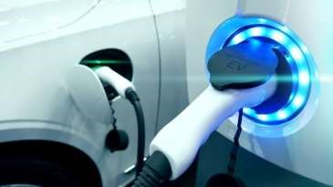

Fig 1: Plug In Charging

Compared to vehicles powered by conventional internal combustion engines, plug-in electric automobiles provide a number of advantages. Although recharging takes longer than refueling and is heavily dependent on adequate charging infrastructures to remain operationally practical, all-electric vehicles have lower operating and maintenance costs and produce little to no air pollution when in all-electric mode, thereby (depending on the electricity source) reducing societal dependence on fossil fuels and significantly decreasing greenhouse gas emissions. The negative aspect of this procedure is that it necessitates manual handling and direct contact in order to enable electric vehicle charging and discharging.

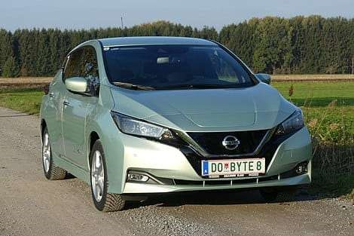

Fig 2: Electric Car

# **2.2.** **Wireless Charging** **of EV**

The fundamental workings of wireless charging are comparable to those of a transformer. The transmitter and receiver coils of a wireless charging system have inbuilt AC-DC and DC-AC converters. The grid's AC mains are transformed into high frequency AC, which is then sent through the transmitter coil. This creates an alternating magnetic field that cuts the receiving coil and allows the receiver coil to produce AC power. However, it's crucial to keep in mind that the resonance frequency between the transmitter and receiver coil must be preserved for effective wireless charging. At both ends of the system, compensation networks are included to maintain the resonant frequencies. The AC power is rectified and filtered at the receiver side to create stable DC, which is then used to continue charging the battery.

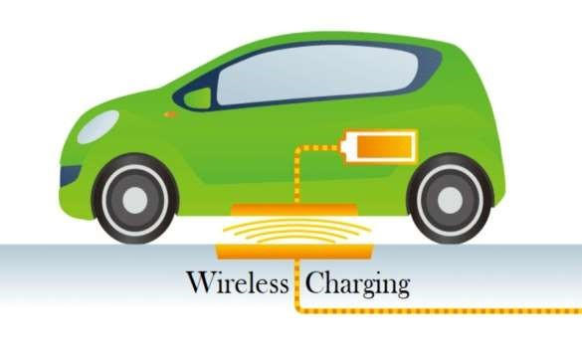

Fig 3: Wireless Charging

* 1. **Advantages Of Wireless Electric Charging**

1. Simple, safe, and high transfer efficiency.
2. Long transmission distance, no radiation.
3. Very high transmission efficiency over a long distance.
4. Maintenance cost is low.
5. Through this method it extends the life of the battery.
   1. **Comparison Of Wireless Charging and Plug In Technology**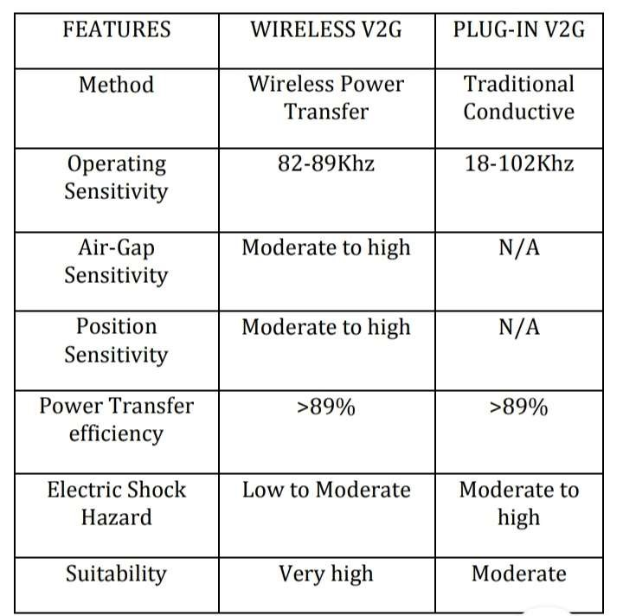
6. **MODELING AND ANALYSIS**

An electric vehicle's wireless charging system transfers energy to the vehicle by charging it through an electromagnetic field. This method of recharging an electric car falls into one of two categories:

1. Static Wireless charging. 2. Dynamic Wireless charging

# **STATIC WIRELESS CHARGING**

In this form of wireless charging system, additional power converters and their circuitry are buried underground together with the transmitter surrounded with the primary coil, allowing the vehicle's batteries to be charged autonomously while it is being driven or parked in static mode. Here, the transmitter coil is transmitting an extremely high frequency AC. The secondary coil and receiver coil are positioned on the underside of the car, where the receiver coil receives the AC. Using the power converter, the received energy is changed from AC to DC and sent to the battery bank. The receiver coil is protected by a battery management system (BMS), power control, and a wireless communication network to collect any feedback from the primary side for safety measurements. The size of the charging pads, the intensity of the power supply, and the distance (air gap) between the transmitter and the receiver all affect how long it takes an electric vehicle to charge. Between 150 and 300 millimeters is the estimated distance between the transmitter and the receiving coil. The utilization of this wireless charging technology in parking lots at malls, garages, office buildings, etc., can be well suited for mass transit applications. An automatic guiding system that assists the driver in aligning the vehicle directly above the primary charging pad can be installed in the vehicle as part of the implementation of this system. Data can be exchanged between the receiver coil of the vehicle and the transmitter end of the charging station via an inductive link or other short-range communication techniques.

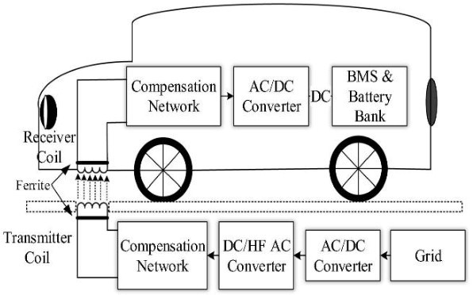

Fig 4: Static Wireless Charging

1. **DYNAMIC WIRELESS CHARGING**

While driving, the EV is charged using dynamic wireless charging. There's no need to wait around while the battery charges. J. G. Bolger et al. presented this idea in 1978, according to which energy is transmitted to the vehicle as it is moving. A research team at KAIST has been leading the development of dynamic wireless charging since 2009. This project has addressed numerous significant issues, including continuous power transmission, high frequency current regulated inverters, and various EMF characteristics. A helpful analysis of OLEV has been provided by Choi et al. Most of the issues with electric vehicles, including range anxiety, battery capacity, and expense, are resolved with dynamic wireless charging. Dynamic wireless charging devices now in use rely on inductive wireless power transfer. This method depends on the magnetic coupling between a pickup coil installed in the EV and coils installed beneath the road surface that are supplied with an electromagnetic field that generates high-frequency current. The block diagram of DWC is shown in the figure below.

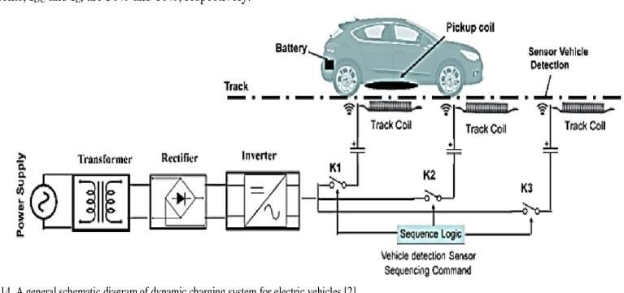

Fig 5: Dynamic Wireless Charging

**3.1 Classification of Wireless Power Transfer (WPT):**

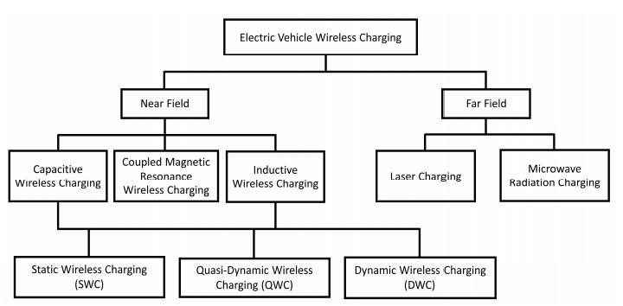

**3.2 CAPACITIVE WPT SYSTEM**

Figure shows the capacitive power transfer (CPT) system, also known as the near-field electric field-coupled WPT system, in which power is transferred between two pairs of plates. Capacitive power transfer (CPT)'s transmitting component is made up of the power grid, rectifier, high-frequency inverter, and primary capacitive plate. A secondary capacitive plate, a rectifier, and a battery make up the receiving component of CPT, which is included into the EV. In traffic signals or parking spaces, the primary capacitive plate, including the transmitting section, is buried underground. The electric vehicle retains the secondary, receiving capacitive plate. A number of CPT topologies have been addressed in, where it was demonstrated that several kilowatts (or roughly 2.4 kW) of power may be generated at a 150 mm air gap. In comparison to magnetic field-coupled wireless power transfer systems, the CPT system offers lightweight, inexpensive couplers and less sensitive power transfer due to misalignment, but its power transfer capability is limited by the low capacitance between the road and conductive vehicle plates. The latter needs a high frequency in order to transfer electricity efficiently. By lowering the impedance of the power flow channel with a high operating frequency, this problem can be resolved.

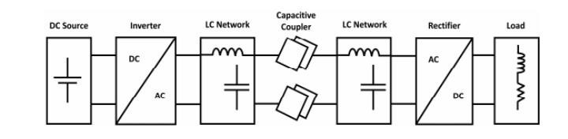

Fig 6: Capacitive WPT System

* 1. **INDUCTIVE WPT SYSTEM**

Lenz and Faraday's laws of magnetic induction are used in inductive wireless charging to convey electricity from one medium to another. Inductive charging has a strong track record in low-power operating applications. The most extensively used and researched wireless power transfer system is near-field magnetic field-coupled WPT (IPT). The following Figure shows the IPT block diagram. This WPT's transmitting and receiving coils continue to be spaced far apart, making it a loosely coupled transformer. The magnetic field is produced by the primary transmitting coils in magnetic linked WPT. The generated field is picked up by the receiving coils, and after being rectified AC-DC, the power is then sent to the load. . The magnetic field coupled was found to be the most popular method for wireless power charging when these three WPTs were compared in terms of controllability, efficiency, affordability, and safety. However, the inductive WPT systems are bulkier and more expensive since they need ferrite cores for magnetic flux guiding and shielding.

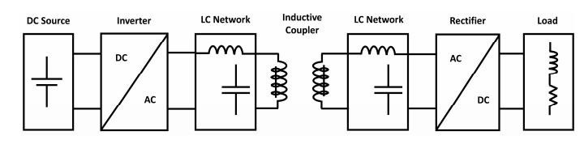

Fig 7: Inductive Charging System

* 1. **COMPENSATION NETWORKS**

As previously mentioned, because of the separation between the transmitting and receiving coils and plates, IPT and CPT can be regarded as weakly linked transformers and capacitors. This results in a loss in power transfer because only a portion of the magnetic/electric flux from the transmitting coils/plates is linked to the receiving coils/plates due to the air gap. As a result of the high leakage and high circulating reactive power brought on by a big air gap, passive components and switching devices experience higher electric stress. Due to the need for a local channel, a compensation network made up of one or more passive elements is necessary to stop the circulation of reactive power through a power source.

* + 1. **Capacitive Power Transfer Compensations:**

The many types of capacitor power transfer (CPT) compensations, including LC, LCL, LCLC, and LCL, are shown in the image below with vertically stacked coupling plates.

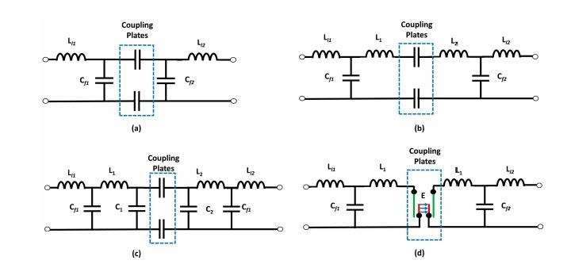

Fig 8: Capacitive Compensating Networks

Due to the inverse relationship between the coupling between plates and system power, LC and LCL compensations cannot increase the system efficiency for high-power operations. Therefore, it is thought that double-sided LCLC compensation is a good choice to tackle this problem. Additionally, a comparison of the compensating capacitive wireless power transfer systems LCL, LCLC, and CLLC was examined and discussed. Due to its many great benefits, including unity power factor, high power, high efficiency, etc., the LCLC compensation CPT is the best-suited topology for wireless charging of electric vehicles. The figure below shows a typical structure for a capacitive wireless power transfer system with LCLC compensation. With the help of some thorough examples, the discussion of capacitive WPT systems with LCLC compensation architecture compensations demonstrated that this compensation method primarily focuses on lowering hardware complexity and boosting power transfer capability. Due to the lack of extensive CPT Field practices, there is no consensus over whether CPT compensation is best suited for high-power systems. Because of the trade-off between transmission efficiency and the coil/plate size of the wireless power transfer system, the design of the WPT control scheme is more complicated than that of typical conductive charging systems. Therefore, a closed-loop control based on a phase shift control scheme was presented to achieve bidirectional power flow, degrees of freedom in terms of design, and a good performance against misalignment for an LCLC compensating capacitive wireless power transfer topology. An adaptive multi-loop control scheme and a decoupled-dual-loop strategy-based control scheme are two other useful control systems that can be used to manage the capacitive WPT system. The decoupled dual-loop strategy-based control technique can offer dynamic reactive compensation and output power recovery under misalignment conditions. Furthermore, a dual-loop control technique can handle the coupling change without high-frequency sensing.

* + 1. **Inductive Power Transfer Compensations:**

There are two categories of inductive power transfer (IPT) compensation technologies: (i) single-element compensations and (ii) multi-element compensations. Four different systems, such as Series-Series (SS), Series-Parallel (SP), Parallel-Series (PS), and Parallel-Parallel (PP), can be used to classify conventional single-element compensation technology. Figure following shows single element compensation systems.

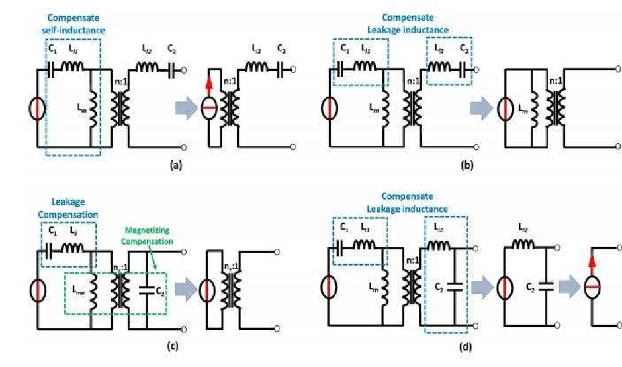

Fig 9: Inductive Compensation Networks

Self-inductance-compensated SS, leakage inductance-compensated SS, hybrid-compensated SP, and leakage inductance-compensated SP are four single-element IPT compensation techniques. Furthermore, both primary and secondary sides can be compensated using a variety of methods. Because a parallel capacitor cannot be used as compensation on the transmitting side due to the usage of voltage sources for driving high-power converters, only series compensation was used in the above illustration. Figure 18 shows an example of a full-bridge inverter-rectifier circuit that resembles an inductive wireless power transfer system with SS compensation. L11 and L12 are leakage inductances, and M is the mutual inductance between the transmitting and receiving coils of the loosely coupled transformer. Furthermore, because to its ease of use, effectiveness, and reliability, conventional SS compensation is the most widely used high-power wireless charging method. But let's say the primary side's voltage or current source remains constant. In that instance, depending on the source, the SS compensation displays a current- or voltage-source behavior. Therefore, an extra control method should be employed to regulate the current through the primary winding in order to avoid the overcurrent’s that are induced by the secondary current's operation at low levels.

1. **RESULTS AND DISCUSSION**

In some situations, the LCL compensation system is more frequently employed than the others since it may entirely isolate output voltage from the load. Figure below shows the usual structure of an inductive wireless power transmission system with LCL multiple-element compensation. Multiple-element compensations have many advantages, including low reactive power that is uncoupled from load and coupling conditions and output characteristics that are load independent for constant current and voltage. However, the complexity, price, and size of the multiple-element compensation increase due to the addition of more electronic parts, and the output remains dependent on the coupling factor. As a result, compared single and multielement compensation IPT topologies, series-series single-element compensation is the best. Due to the IPT system's circuit complexity, multiple-element compensatory IPT topologies require more sophisticated control scheme designs than single-element IPT topologies. In order to build a control method for multi-element topologies, additional consideration must be given. To control the LCL multiple-element compensation IPT architecture, a new design strategy with symmetric voltage cancellation (SVC) control technique has been presented and investigated in response to the described challenge. The authors have demonstrated that, in addition to an effective switching method, the suggested scheme can lower harmonics and total costs. Therefore, by utilizing the suggested control system, the LCL compensation topology can obtain more harmonics filtering capabilities, higher efficiency, and more steady current source features. A PWM feedback loop-based novel control technique for controlling LCC multiple-element IPT architecture was designed, examined, and demonstrated to be capable of withstanding high-power levels and achieving zero voltage switching for the converter.

1. **CONCLUSION**

Electric car wireless charging has the potential to revolutionize the automobile industry's approach to road transportation. By the end of the next decade, wireless charging technology is anticipated to grow dramatically along with the development of electric car technology. The primary goal of this study is to provide a summary of the numerous wireless charging methodologies, of which inductive wireless transmission has emerged as the most effective methodology. The application of static and dynamic wireless charging as well as the significance of the battery in electric vehicles are also reviewed in this study. Here, wireless charging methods have an impact on battery size, lowering the overall cost of the electric car. As the battery capacity of electric vehicle batteries decreases, they will charge more quickly compared to how long it used to take to charge them to their rated value. However, ease of use and requiring the least amount of driver involvement are crucial aspects that consistently outperform the competition. When these attributes are combined with excellent power transfer efficiency, wireless charging of electric vehicles is a successful strategy.

1. **REFERENCES**
2. Poriferae, A.; Narimani, M.; Emadi, A. A Review of

Multilevel Inverter Topologies in Electric Vehicles: Current Status and Future Trends. IEEE Open J. Power Electron. 2021, 2, 155–170.

1. Sources of Greenhouse Gas Emissions. 2020. Available online: https://www.epa.gov/ghgemissions/sourcesgreenhouse-gasemissions (accessed on 18 December 2022).
2. Xu, S.; Guo, Y.; Su, W. A proof-of-concept demonstration for the transportation electrification education. In Proceedings of the 2014 IEEE Conference and Expo Transportation Electrification Asia-Pacific (ITEC Asia-Pacific), Beijing, China, 31 August–3 September 2014; pp. 1–5.
3. Meintz, A.; Zhang, J.; Vijaya Gopal, R.; Kreutzer, C.

Ahmed, S.; Bloom, I.; Burnham, A.; Carlson, R.B.; Dias, F.; Tanim, T.; et al. Enabling fast charging-vehicle considerations. J. Power Sour. 2017, 367, 216–227.

1. Ronanki, D.; Kelkar, A.; Williamson, S.S. Extreme Fast Charging Technology—Prospects to Enhance Sustainable Electric Transportation. Energies 2019, 12, 3721.

1. Chakraborty, S.; Vu, H.-N.; Hasan, M.M.; Tran, D.-D.; El

Baghdadi, M.; Hegazy, O. DC-DC Converter Topologies for Electric Vehicles, Plug-in Hybrid Electric Vehicles and Fast Charging Stations: State of the Art and Future Trends. Energies 2019, 12, 1569.

1. Ahmad, A.; Alam, M.S.; Chabaan, R. A Comprehensive

Review of Wireless Charging Technologies for Electric

Vehicles. IEEE Trans. Transp. Electrify. 2018, 4, 38–63.

1. Bradley, T.H.; Frank, A.A. Design, demonstrations and sustainability impact assessments for plug-in hybrid electric vehicles. Renew. Sustain. Energy Rev. 2009, 13, 115–128.3.
2. Emadi, A.; Lee, Y.J.; Rajashekara, K. Power Electronics and Motor Drives in Electric, Hybrid Electric, and Plug-In Hybrid Electric Vehicles. IEEE Trans. Ind. Electron. 2008, 55, 2237–2245.
3. Ehsani, M.; Gao, Y.; Miller, J.M. Hybrid Electric Vehicles: Architecture and Motor Drives. Proc. IEEE 2007, 95, 719–728.
4. Quinn, C.; Zimmerle, D.; Bradley, T.H. The effect of communication architecture on the availability, reliability, and eco-nomics of plug-in hybrid electric vehicle-to-grid ancillary services. J. Power Sources 2010, 195, 1500–1509.
5. Reimers, J.; Dorn-Gomba, L.; Mak, C.; Emadi, A.

Automotive Traction Inverters: Current Status and Future

Trends. IEEE Trans. Veh. Technol. 2019, 68, 3337–3350.

1. Chakraborty, S.; Hasan, M.M.; Abdur Razzak, M. Transformer-less single-phase grid-tie photovoltaic inverter topologies for residential application with various filter circuits. Renew. Sustain. Energy Rev. 2017, 72, 1152–1166.
2. Lin, J.; Schofield, N.; Emadi, A. External-Rotor Switched Reluctance Motor for an Electric Bicycle. IEEE Trans. Transp. Electrify. 2015, 1, 348–356.
3. Lee, W.; Li, S.; Han, D.; Sarlioglu, B.; Minav, T.A.

Pietola, M. A Review of Integrated Motor Drive and Wide-

Bandgap Power Electronics for High-Performance Electro Hydrostatic Actuators. IEEE Trans. Transp. Electrify. 2018, 4, 684–693.

1. Feng, H.; Tavakoli, R.; Onar, O.C.; Panic, Z. Advances in

High-Power Wireless Charging Systems: Overview and Design Considerations. IEEE Trans. Transp. Electrify. 2020, 6, 886–919.

1. Tomaszewska, A.; Chu, Z.; Feng, X.; O’Kane, S.; Liu, X.

Chen, J.; Ji, C.; Endler, E.; Li, R.; Liu, L.; et al. Lithium-ion battery fast charging: A review. transportation 2019, 1, 100011. Forecasting 2023, 5 67

1. Ahmad, F.; Alam, M.S.; Asaad, M. Developments in xEVs charging infrastructure and energy management system for smart microgrids including xEVs. Sustain. Cities Soc. 2017, 35, 552–564.