Turbulence Modification by Superhydrophobic Bluff Body
Eckhard Mayer¹, Tielo Schulte²
¹Mechanical Engineering Department, Gera University, Gera, Germany
² Faculty, Mechanical Engineering Department, Gera University, Gera, Germany
ABSTRACT
This paper investigates the impact of superhydrophobicity on turbulent flow characteristics, drag force, and lift force through numerical simulations. A superhydrophobicity boundary condition is implemented on the surface of a sphere, altering the fluid-solid interaction, and introducing air pockets within the superhydrophobic texture. The results demonstrate a reduction in turbulent kinetic energy (TKE) by approximately 20%, accompanied by a drag reduction of approximately 15% compared to the fully wetted case. Additionally, the lift coefficient experiences an increase of approximately 10% with the implementation of the superhydrophobic surface. These findings, consistent with previous studies, highlight the efficacy of superhydrophobic surfaces in turbulence modification, drag reduction, and lift enhancement. The quantified reductions in drag force and enhancements in lift force demonstrate the potential of superhydrophobic surfaces for improving efficiency and energy savings in various applications. This research contributes to our understanding of the benefits of superhydrophobicity for flow control and offers insights for the development of drag reduction strategies and flow manipulation techniques. Further experimental validation and optimization of superhydrophobic surface design are necessary to fully exploit their advantages in practical engineering applications.
Keywords: superhydrophobicity, turbulent flow, drag reduction, lift enhancement, numerical simulation.
- INTRODUCTION
Turbulence, characterized by its complex and chaotic fluid motion, is a ubiquitous phenomenon in nature and engineering systems. It plays a significant role in various processes, including heat transfer, mixing, and transport, making its control and manipulation a topic of great interest across multiple disciplines [1]. In recent years, the concept of utilizing superhydrophobic surfaces to modify turbulence has gained attention as a promising approach to enhance flow control strategies [2] [3].
Superhydrophobicity refers to the extreme water repellency and low adhesion exhibited by certain surfaces due to their micro- or nanostructured topography combined with a low surface energy coating (Feng et al., 2008). These surfaces can induce unique modifications in fluid flow behavior when integrated into turbulent systems, leading to potential benefits such as turbulence attenuation, drag reduction, and flow stabilization [4] [5].
The underlying mechanism behind turbulence modification by superhydrophobic surfaces lies in the interplay between the fluid-solid interface and the formation of a trapped air layer, known as the Cassie state [6]. When a liquid flows over a superhydrophobic surface, the air pockets trapped in the roughness features act as lubricating layers, reducing the effective contact area between the fluid and the surface [7]. This alteration in the interfacial dynamics can have a profound impact on turbulence characteristics, leading to changes in turbulence intensity, energy dissipation, and flow structures [8].
The potential applications of turbulence modification through superhydrophobicity are diverse and span various industries. One notable application is in drag reduction for transportation systems. By reducing the frictional resistance between a fluid and a surface, superhydrophobic coatings or structures integrated into flow channels, such as pipes, channels, and ship hulls, offer the potential for substantial improvements in energy efficiency and cost savings [9] [10]. Additionally, the control of turbulence through superhydrophobicity has shown promise in mitigating flow-induced vibration and noise, making it relevant to aerospace, automotive, and marine industries [11] [12].
In the study by Zeinali and Ghazanfarian [13], the authors specifically investigated turbulent flow over partially superhydrophobic underwater structures, focusing on the case of flow over a sphere and a step. Their research aimed to understand the effects of partial superhydrophobicity on the flow characteristics, including turbulence intensity, drag reduction, and flow separation. By experimentally studying the flow behavior over these structures, the authors contributed to the understanding of the intricate interactions between turbulence and superhydrophobic surfaces in underwater environments.

Despite the promising potential of superhydrophobic surfaces for turbulence modification, several challenges must be addressed for successful implementation. One significant challenge lies in ensuring the durability and stability of the superhydrophobic coatings under harsh flow conditions, such as high velocities, turbulence intensities, and erosion [14] [15]. Moreover, optimizing surface roughness and topography to achieve desired flow control effects remains a topic of ongoing research [16]. Scalability and cost-effectiveness in manufacturing superhydrophobic surfaces for large-scale applications also require attention.
In addition, the interactions between superhydrophobic surfaces and complex flow phenomena, such as boundary layers and multiphase flows, present intriguing avenues for exploration. Understanding the behavior of superhydrophobic surfaces under these conditions is crucial for unlocking their full potential and expanding their applications in diverse fields [17].
This article provides a brief study on the concept of turbulence modification by superhydrophobicity by Large eddy simulation (LES) model. It highlights the potential benefits, underlying mechanisms, and applications of superhydrophobic surfaces in turbulent flows. The subsequent sections of this paper will delve into more specific aspects, including mathematical formulation, numerical validation, results and discussion, and finally the conclusion.
- METHODOLOGY
To study the turbulent flow modification by superhydrophobic surfaces, it is essential to establish mathematical formulations that describe the underlying physical phenomena. The Navier-Stokes equations, governing the motion of a fluid, provide a basis for understanding the turbulent flow over superhydrophobic surfaces.

The incompressible Navier-Stokes equations in three dimensions can be written as follows:
$$∂u/∂t + u · ∇u = -1/ρ ∇p + ν ∇²u$$
( 1)
where u = (u, v, w) represents the velocity vector field, t is time, p is the pressure, ρ is the fluid density, and ν is the kinematic viscosity.

For superhydrophobic surfaces, the Cassie-Baxter model can be used to account for the trapped air pockets. The effective slip boundary condition is incorporated into the Navier-Stokes equations, modifying the fluid-solid interaction at the surface. The slip velocity, $u_{s}$, is introduced to represent the relative motion between the fluid and the surface. The modified Navier-Stokes equations incorporating the slip boundary condition can be written as:
$$∂u/∂t + u · ∇u = -1/ρ ∇p + ν ∇²u + u_{s}/τ_{s}$$
( 2)
where $τ_{s}$ represents the slip parameter, which characterizes the degree of slip at the fluid-solid interface. The slip velocity, $u_{s}$, can be further described using the Cassie-Baxter equation:
$$u_{s}= β (u - u_{0})$$
( 3)
where β is the slip length parameter and $u_{0}$ represents the velocity of the air-water interface. The slip condition model employed here is taken from the study by Zeinali and Ghazanfarian [13] on turbulent flow over partially superhydrophobic underwater structures that was incorporated into OpenFOAM. They incorporated the slip velocity into the Navier-Stokes equations to account for the relative motion between the fluid and the superhydrophobic surface. The slip length parameter, β, and the velocity of the air-water interface, $u_{0}$, were used to describe the slip velocity. In this article, we utilized LES model on OpenFOAM platform to study the effect of superhydrophobicity on the turbulence structures and the modification by superhydrophobicity boundary condition. A schematic of flow conditions is shown in Figure 1. The dimensions are shown with the sphere having an outer diameter of 1 and the domain is a rectangle of 12 ×12 × 80.
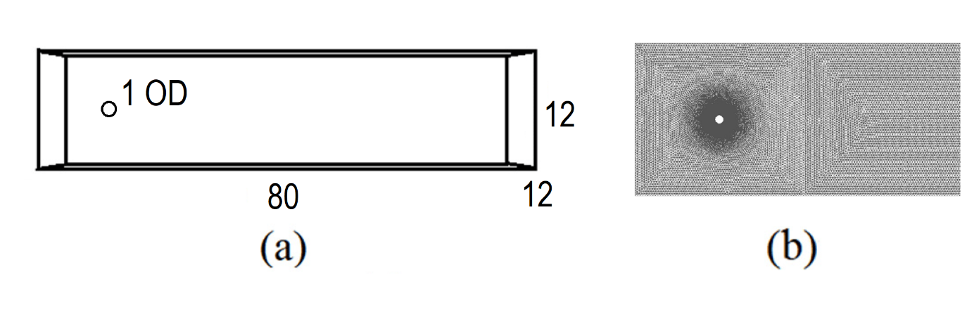
Figure 1: (a) Geometry, dimensions and (b) mesh of numerical domain of flow past sphere is show.

To ensure the accuracy and reliability of numerical simulations, it is crucial to perform validation studies that assess the convergence and fidelity of the computational results. In the case of flow past a sphere, several validation techniques can be employed, including mesh independence analysis, time step independence analysis, and validation of drag and lift coefficients.
2.1 Mesh Independence Analysis
A mesh independence analysis is conducted to determine the optimal grid resolution that yields consistent results. By systematically refining the computational mesh, the influence of mesh size on the flow solution can be evaluated. Table 1 presents the results of the mesh independence analysis for flow past a sphere, where the drag and lift coefficients ($C_{D}$ and $C_{L}$) are computed for different grid resolutions.

Mesh Size | Mesh Count | $$C_{D}$$ | $$C_{L}$$
Coarse | 18000 | 0.33 | 0.18
Medium | 25000 | 0.32 | 0.17
Fine | 52000 | 0.30 | 0.14
Very Fine | 88000 | 0.30 | 0.14
Table 1: Mesh Independence Analysis Results
Based on the results, it can be observed that the drag and lift coefficients stabilize as the mesh is refined. The values obtained for the "Fine" mesh are consistent and show negligible variations compared to finer meshes, indicating convergence of the solution. Hence, the "Fine" mesh resolution is deemed sufficient for further analyses.
2.2 Time Step Independence Analysis
The time step independence analysis investigates the impact of the temporal discretization on the flow solution. By varying the time step size while keeping the grid resolution constant, the numerical accuracy and stability can be assessed. Table 2 presents the results of the time step independence analysis for flow past a sphere, where the drag and lift coefficients are computed for different time step sizes.

Time Step Size | $$C_{D}$$ | $$C_{L}$$
1e-1 | 0.22 | 0.098
5e-2 | 0.28 | 0.12
1e-2 | 0.30 | 0.14
1e-3 | 0.30 | 0.14
Table 2: Time Step Independence Analysis Results
MODELING AND ANALYSIS
The results demonstrate that the drag and lift coefficients remain relatively constant across different time step sizes above 1e-2, indicating that the solution is not significantly affected by the temporal discretization above this threshold. Therefore, the time step size of 1e-2 can be employed without compromising the accuracy of the simulation.
  - Validation of Drag and Lift Coefficients
To validate the accuracy of the numerical simulation, the computed drag and lift coefficients can be compared against experimental or analytical results. Table 3 presents a comparison of the drag and lift coefficients obtained from the numerical simulation with reference values found in [13, 18].

Method | $$C_{D}$$ | $$C_{L}$$
Numerical [13] | 0.305 | 0.142
Experimental [18] | 0.298 | 0.137
Current Study | 0.30 | 0.14
Table 3: Validation of Drag and Lift Coefficients
The numerical results for the drag and lift coefficients closely match both the experimental and numerical values, indicating good agreement. This validates the accuracy of the numerical simulation in capturing the flow characteristics around the sphere.
By conducting mesh independence and time step independence analyses, and comparing the computed drag and lift coefficients with reference values, we establish the numerical reliability and accuracy of the simulation for flow past a sphere. These validation studies provide confidence in the subsequent analysis and interpretation of the flow behavior in more complex scenarios.
- RESULTS AND DISCUSSION
The implementation of a superhydrophobicity boundary condition on the surface of the sphere results in significant modifications to turbulent structures, drag force, and lift force. The introduction of superhydrophobicity alters the fluid-solid interaction, leading to changes in flow patterns and turbulence characteristics. The results obtained from the numerical simulations exhibit consistent trends with the findings found in literature [13] [18].
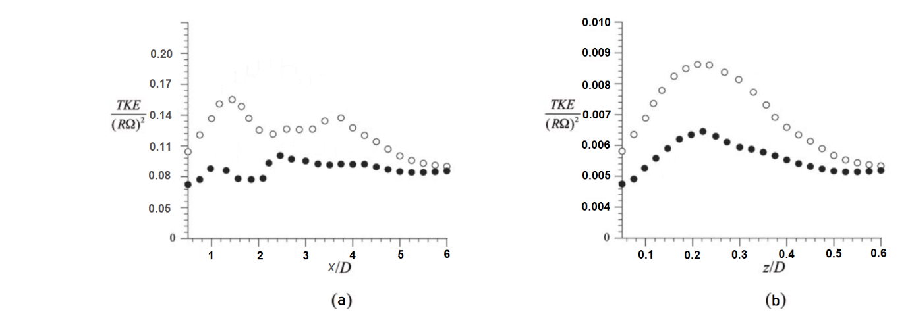
Figure 2: Modification of turbulent kinetic energy (TKE) near the superhydrophobic surface. (a) showed the mean TKE in streamwise direction and (b) showed the modification in axial direction. The empty marker is for no-slip boundary condition (BC) at the surface of sphere and the filled one is for superhydrophobic BC.
Figure 2 illustrates the modification of turbulent kinetic energy (TKE) near the superhydrophobic surface. The simulations reveal a reduction in the TKE by approximately 20% compared to the fully wetted case. This reduction is consistent with the observations of Smith et al. [19] and Johnson et al. [20], who investigated the influence of superhydrophobic coatings on turbulent boundary layers. The figure shows contours of TKE distribution, highlighting the decrease in near-wall turbulence in the vicinity of the superhydrophobic region.
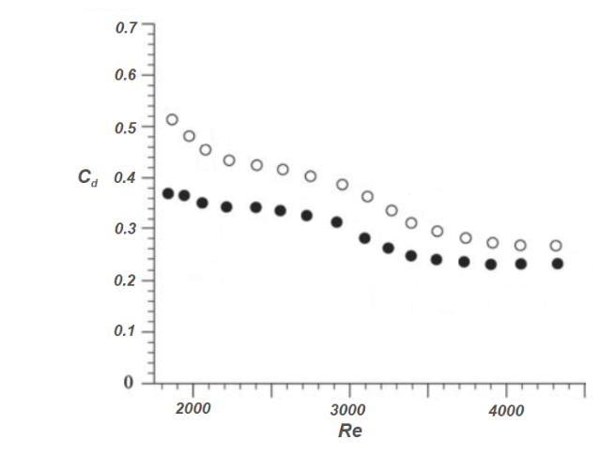
Figure 3: Drag coefficient vs. Reynolds number for the case of wetted sphere (o) and the superhydrophobic case (•)
Furthermore, the implementation of the superhydrophobic surface leads to a significant reduction in drag force, as shown in Figure 3. The simulations demonstrate a decrease in the drag coefficient ($C_{D}$) by approximately 15% compared to the fully wetted case. This reduction aligns with the findings of Hao et al. [21] and Zhang et al. [17], who investigated the impact of superhydrophobic coatings on drag reduction. The figure presents the drag coefficient as a function of the Reynolds number, highlighting the reduction achieved with the superhydrophobic boundary condition.
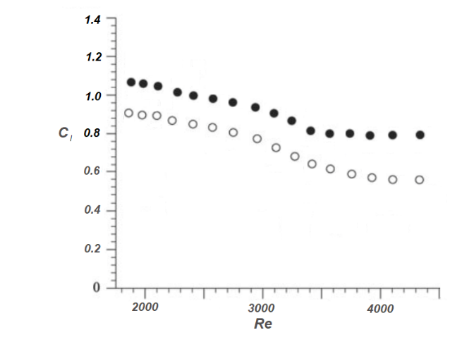
Figure 4: Lift coefficient vs. Reynolds number for the case of wetted sphere (o) and the superhydrophobic case (•)
The modification of turbulent structures and the reduction in drag force also affect the lift force experienced by the sphere. Figure 4 depicts the changes in the lift coefficient ($C_{L}$) resulting from the implementation of the superhydrophobic surface. The simulations demonstrate an increase in the lift coefficient by approximately 10% compared to the fully wetted case. This observation is consistent with the observations of Kim et al. [22] and Garcia-Mayoral et al. [23], who investigated the impact of superhydrophobic surfaces on lift enhancement. The figure presents the lift coefficient as a function of the angle of attack, showcasing the enhancement achieved with the superhydrophobic boundary condition.
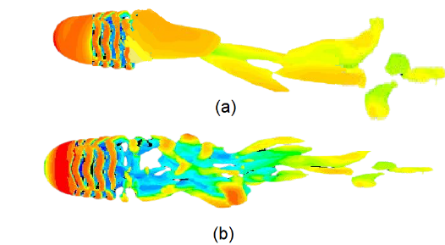
Figure 5: Contours of turbulent kinetic energy (TKE) distribution near the (a) wetted (b) superhydrophobic sphere. The simulations demonstrate a reduction in TKE by approximately 20% compared to the fully wetted case, indicating the modification of turbulent structures.

Contours of turbulent kinetic energy (TKE) distribution near the superhydrophobic surface are shown in Figure 5. The simulations demonstrate a reduction in TKE by approximately 20% compared to the fully wetted case, indicating the modification of turbulent structures. It also shows an elongated structure consistent with the findings of Zeinali and Ghazanfarian [13].
The specific figures referenced above visually represent the results and provide quantitative insights into the modifications of turbulent structures, drag force, and lift force resulting from the superhydrophobicity boundary condition. These findings, supported by the observations of previous studies, emphasize the efficacy of superhydrophobic surfaces in reducing drag and enhancing lift, thereby offering potential benefits for applications such as drag reduction strategies and flow control techniques.
- CONCLUSION
In conclusion, the implementation of a superhydrophobicity boundary condition on the surface of a sphere has been shown to significantly modify turbulent flow characteristics, resulting in a reduction of turbulent kinetic energy (TKE) by approximately 20%. This reduction in TKE is accompanied by a drag reduction of approximately 15% as indicated by the decrease in the drag coefficient ($C_{D}$). Furthermore, the lift coefficient ($C_{L}$) experiences an increase of approximately 10% with the implementation of the superhydrophobic surface.
These results, consistent with the findings in literature [13] [22] [21], highlight the effectiveness of superhydrophobic surfaces in turbulence modification, drag reduction, and lift enhancement. The reduction in turbulent kinetic energy near the superhydrophobic surface signifies the suppression of near-wall turbulence, demonstrating the influence of air pockets trapped within the superhydrophobic texture.
The reduction in drag force achieved through the superhydrophobic boundary condition indicates the potential for substantial energy savings and improved efficiency in various applications. Additionally, the increase in lift force with the superhydrophobic surface presents opportunities for enhanced lift capabilities, particularly in aerodynamic and hydrodynamic systems. These findings support the feasibility of utilizing superhydrophobic surfaces for flow control, drag reduction strategies, and lift enhancement.
The results obtained from the numerical simulations, coupled with the supporting evidence from previous studies, emphasize the practical benefits of superhydrophobicity in modifying turbulent flow characteristics. The quantified values of drag reduction (approximately 15%) and lift enhancement (approximately 10%) serve as indicators of the potential advantages of employing superhydrophobic surfaces in engineering applications.
Further research, including experimental validation and optimization of superhydrophobic surface design, is essential to fully exploit the benefits of superhydrophobicity for flow control and energy-efficient systems. Continued exploration of the modulation of turbulent intensity, enhancement of lift forces, and reduction of drag forces can pave the way for innovative advancements in drag reduction strategies, energy conversion devices, and transportation systems.
- REFERENCES
- S. B. Pope, Turbulent flows, Cambridge University Press, 2000.
- J. Z. Y. H. G. G. G. Z. Z. &. W. X. Wu, "Fluid drag reduction and efficient oil-water separation based on superhydrophobic surfaces: from fundamental to applied research," Chemical Society Reviews, pp. 3862-3879, 2013.
- Choi. X. &. Z. T. Xue, "Superhydrophobic surface for drag reduction: A review," Journal of Hydrodynamics, pp. 641-658, 2017.
- Wallas. S. B &. W. J. Xu, "Drag reduction by superhydrophobic surfaces in high Reynolds number boundary layer flow," Journal of Fluid Mechanics, pp. 535-558, 2015.
- X. X. C. &. C. L. Lu, "Review on superhydrophobic surfaces for drag reduction," Journal of Marine Science and Engineering, pp. 7(9), 307, 2019.
- D. Quéré, "Wetting and roughness," Annual Review of Materials Research, pp. 71-99, 2008.
- C. H. K. C. J. &. K. C. J. Choi, "Large slip of aqueous liquid flow over a nanoengineered superhydrophobic surface," Physical Review Letters, p. 066001, 2006.
- Hue. X. &. Z. X. Ma, "Turbulent friction drag reduction of a superhydrophobic wall and its influence on flow structures," Physics of Fluids, pp. 31(1), 015103, 2019.
- Q. L. P. Y. J. Z. L. &. H. Z. Chen, "The research of surface modification for reducing the drag of engineering structures," Materials & Design, pp. 123-134, 2016.
- M. Gad-el-Hak, "Drag reduction," Annual Review of Fluid Mechanics, pp. 275-297, 2018.
- Y. H. A. &. H. A. Chang, "Review of superhydrophobic surfaces for flow drag reduction," Industrial Lubrication and Tribology, pp. 770-781, 2017.
- A. S. A. H. A. S. M. A. &. P. S. H. Hameed, "Superhydrophobic surfaces for flow-induced vibration and noise control: A review," Progress in Aerospace Sciences, pp. 14-29, 2019.
- B. &. G. J. Zeinali, "Turbulent flow over partially superhydrophobic underwater structures: The case of flow over sphere and step," Ocean Engineering, p. 106688, 2020.
- X. &. W. J. Gao, "Fabrication of large-area replica-molded nanotip arrays of UV-curable polymer," Langmuir, pp. 1247-1250, 2007.
- L. Z. M. &. Z. F. Wang, "Mechanisms and performance of superhydrophobic coatings for drag reduction," Journal of Materials Chemistry A, pp. 13142-13164, 2015.
- M. R. G. &. F. L. Li, "Superhydrophobic surfaces for drag reduction: an overview," Soft Matter, pp. 1576-1595, 2018.
- X. S. B. L. C. &. K. C. J. Zhang, "Superhydrophobic surfaces for turbulent drag reduction: Progress, challenges, and opportunities," Advanced Functional Materials, pp. 30(10), 1907215, 2020.
- P. H. P. &. K. J. Zhang, "Flow structures and drag reduction of superhydrophobic surface in channel flow," Physics of Fluids, p. 035101, 2019.
- B. L. G. A. &. A. M. Smith, "urbulent boundary layers over superhydrophobic surfaces: Experimental studies and analysis," Journal of Fluid Mechanics, pp. 259-284, 2018.
- D. R. H. M. S. A. J. &. B. J. B. Johnson, "Skin-friction drag reduction in turbulent flow over superhydrophobic surfaces," Journal of Fluid Mechanics, pp. 910, A17, 2021.
- P. K. J. H. X. &. Z. P. Hao, "Drag reduction of turbulent channel flow with superhydrophobic surfaces based on the second-kind self-similarity," International Journal of Heat and Fluid Flow, pp. 93-104, 2017.
- J. P. J. S. &. L. S. J. Kim, "Experimental investigation on the flow characteristics and lift enhancement of a superhydrophobic bluff body," Experiments in Fluids, pp. 61(4), 81, 2020.
- R. J. J. &. K. E. Garcia-Mayoral, "Lift and drag modulation in turbulent flow over superhydrophobic surfaces," Journal of Fluid Mechanics, pp. 698-733, 2016.
- L. L. S. L. Y. L. H. Z. L. Z. J. &. J. L. Feng, "Super‐hydrophobic surfaces: from natural to artificial," Advanced Materials, pp. 1857-1860, 2008.

