Designing a Mechanical Garbage Segregation System

¹Biswajit Das ¹Dr. Sumit Das ¹Monali Sanyal ¹Sayan Chakraborty ¹Ayan Deuty ¹Sandip Biswas ¹Mitu Roy ¹Suvadip Ghosh

¹JIS College of Engineering

Abstract— The rapid increase in amount and types of solid and hazardous waste due to constant economic growth, industrialization and urbanization, is becoming a growing problem for local and national governments to ensure effective and sustainable management of waste. Therefore we chose to approach this problem from a local level to help solve it more efficiently. In the smart bin, we have a process of identifying non- biodegradable and biodegradable material with the help of sensors and ML models built for identifying based on this data. The biodegradable material is stored in its section of storage and the non biodegradable material is further divided into landfill waste and recyclable waste.
.

Keywords— Metals, Monitoring, Servomotors, Arduino-Uno.
- INTRODUCTION
In the current situation, India is facing various challenges in the environment by the waste generated such as improper waste collection, treatment, transport, disposal. The most difficult challenge is from its inception to its disposal. Due to the increasing urban population, our country cannot survive the current system which results in environmental and public health pollution.
Waste can be solid or liquid and each type of waste will have different methods of disposal.
Waste will be a threat to human health. Proper management of waste is necessary and important to have a healthy lifestyle. An unhygienic environment will be created if flooding of the dustbins happens every day. Waste segregation i.e., separation of dry and wet waste is also important. Segregation of waste helps in the reduction of the amount of waste that gets land filled and also reduces air and water pollution. If we segregate the waste, it is easy to dispose of compared to mixed waste.

- OBJECTIVES

- The proposed system would be able to automate the solid waste monitoring process and management of the overall collection process using IOT (Internet of Things). The Proposed system consist of four main subsystems namely Smart Trash System (STS), Local Base Station (LBS), Vehicle System(VS) and Smart Monitoring and Controlling Hut(SMCH). In the proposed system, whenever the waste bin gets filled this is acknowledged by placing the waste bin, which transmits it to the receiver at the desired place in the area or spot. In the proposed system, the received signal indicates the waste bin status at the monitoring and controlling system.
- To separate waste at the houses in the society into dry waste and wet waste using a relay circuit driven by a comparator circuit. This waste is collected at the container. The container has a sonar sensor used to detect the level of the garbage collected into it. When garbage reaches a particular level, an indication to the control unit is sent using RF module. Also, an area besides the roadside garbage containers is implemented. This zonal area uses the concept of load sensor to indicate if any garbage spills out the container.
- The process of making things automatic is being exploited in almost all the major fields of life. Making things automatic reduces burden on the humans. The cost and effort used in manually controlled products is much higher than the automated systems. Considering the fact, that the problem of efficient waste management is one of the major problems of the modern times, there is an utmost need to address this problem.

- LITERATURE REVIEW
In this article paper , Author provide a thorough analysis of the Automatic Waste Segregation .
Many sub conveyors which protrude to a main conveyor. At the starting portion of each sub conveyor a trash bin is kept. Wastes are being dumped into the trash bins where infrared sensors are kept at the top level[1]. In this paper, Author provide a thorough analysis of the Automatic Garbage Segregation .The Automatic Waste Segregator System is driven by the Microcontroller Arduino UNO. All the components that are connected to Arduino UNO are programmed using the Arduino IDE[2].

In this literature, Author provides a thorough analysis of the Automatic Garbage Segregation.
Rapid increase in volume and types of solid and hazardous waste due to continuous economic growth, urbanization and industrialization, is becoming a burgeoning problem for national and local governments to ensure effective and sustainable management of waste[3].In this paper, Author provide a thorough analysis of the Automatic Garbage Segregation. The sequence of the work carried out is represented by a flow chart in Figure1.The project work commenced from identifying the problem followed by collecting the available relevant work through literature survey[4].In this essay, Author provide a thorough analysis of the Automatic Garbage Segregation .

Waste respectively. The whole system is controlled by Micro controller. Each and every component is interfaced to the microcontroller board[5]. In this literacy, Author provide a thorough analysis of the Automatic Garbage Segregation. The Automatic Waste Segregator System is driven by the Microcontroller Arduino UNO. All the components that are connected to Arduino UNO are programmed using the Arduino IDE[6].

In this essay, Author provides a thorough analysis of the Automatic Garbage Segregation.
The Automatic Waste Segregator System is driven by the Microcontroller Arduino UNO. All the components that are connected to Arduino UNO are programmed using the Arduino IDE[7] In this paper, Author provide a thorough analysis of the Automatic Garbage Segregation . Automatic Waste Segregator has been successfully implemented for the segregation of waste into metallic, dry and wet waste at a domestic level[8]. In this paper, Author provide a thorough analysis of the Automatic Garbage Segregation . It is an IoT based Waste Segregation and monitoring system which is an innovative way to keep the cities clean and healthy. This paper presents a smart and cost effective solution for waste segregation. When the waste enters the conveyer belt motor turns on and the conveyer belt starts moving [9] .
- METHODOLOGIES
In this proposed system, the two bins were used to store dry and wet waste; these bins are replaceable for cleaning purposes. The waste is placed on the dry wet sensor. The dry wet sensor is set with a threshold value of moisture. This senses the moisture content; the relay helps in the rotation of the servo motor in both clockwise and anticlockwise directions hence it moves waste into its respective bins. The IR sensors are used to know the level of the garbage in the bin and intimate the message to the municipality. The MQ sensor is used to detect the odor and the concentration of different gases. All the sensed data from Arduino UNO using sensors are sent to the cloud using node MCU. The program would be coded in embedded C. Thus, messages will be displayed to the users in the LCD, and obtained status will be notified to the authorized people via MQTT protocol for sending bin status.

  - MQ sensor
The MQ sensor gas sensor is a highly sensitive sensor used to detect gases like ammonia, smoke, sulphur, and other harmful gases. It used to detect toxic substance and explosive gasses and measure gas concentration. Here it is used to detect the odor of waste and sends an SMS to municipal department if there is strong concentration of odor. Hence helps to have good environmental condition. NodeMCU is an integrated chip that provides full internet connectivity to the embedded circuit in which it is present. It is mapped through the USB port using Arduino IDE. It contains 30 pins of which 9 pins are digital pins while 1 pin is an analog pin. It has low power consumption.
4.2 Dry wet sensor
The moisture sensor has been used to detect the type of waste being placed on it. Here the sensor classifies the waste into dry and wet based on the moisture content on it.; if the moisture content is above a preset threshold value, then the waste is declared as wet waste else it is declared as dry waste.
  - Infrared sensor
An infrared sensor emits to sense the surroundings. It is used to detect the amount of waste in each dustbin. Thus, it helps in preventing overflow of bins.
  - Arduino-Uno & NodeMCU
The ArduinoUno is an open-source micro-controller. The board is provided with digital and analog I/O pin sets. It contains fourteen digital I/O pins in which 6 of PWM output, Six analog I/O pins, and is programmable with the Arduino Uno. It might be turned on with the help of a USB cable or with help of external 9 volt battery, it can accept voltage from7 to 20 volt.
  - Servomotor
A servomotor is an electric motor. It is controlled with the help of servomechanism. A servo motor is an electrical device, that spins the parts of a machine with high efficiency and with great precision. In our project servo motor moves both bidirectional clockwise and anticlockwise at an appropriate angle to dispose of the trash at a particular place.
  - Segregation System Prototype

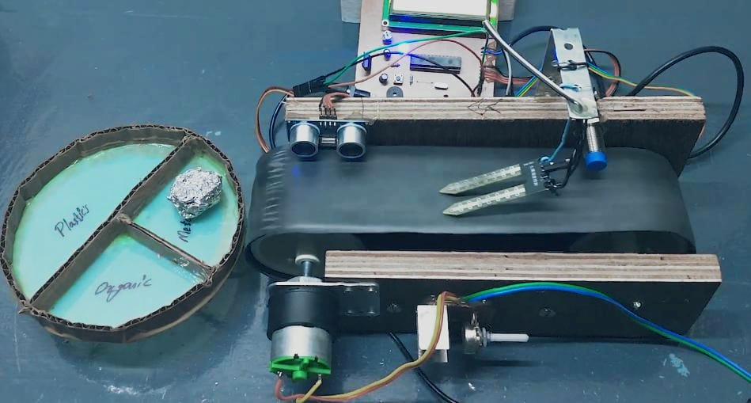

Fig. 1: Segregation System Prototype

In this Fig 1 , we make a segregation system which is use to divide the Plastic , Organic and Metal Wastes to Each other. IR sensor identifies the objects, moisture and metal sensors detects the wet and metal waste. Ultrasonic sensor observes the levels of bin. The Bin consists of three partitions inside, were each partition collects particular waste respectively.
  - Process of This System

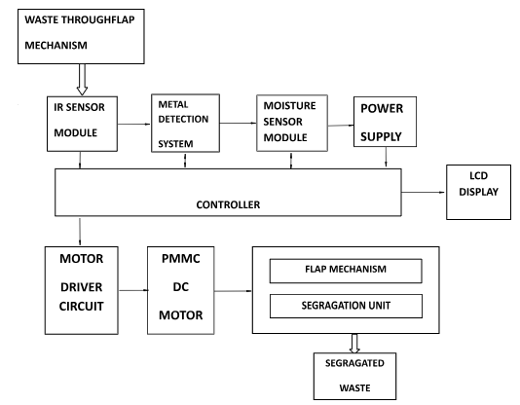

Fig. 2: Process of this system
- When the waste enters the conveyer belt motor turns on and the conveyer belt starts moving.
- The microcontroller, all the motors, and sensors are turned on.
- The waste is sensed by the inductive proximity sensor to detect if it is a metal or no.

- If the waste is metal waste then the waste is pushed into the metal waste bin.
- If not a metallic waste then it comes in contact with the moisture sensor that decides whether the waste is a wet waste or dry waste by checking the moisture content of the waste.
- If the waste has some humidity it is detected as wet waste is pushed into the wet waste bin.
- If not a wet waste is kept on and then the waste is dropped into the dry waste bin placed at the end of the conveyer belt.
- Finally the wastes are dropped into the respective bins and the segregation process is completed.

- RESULT AND DISCUSSION

To collect the dry and wet waste separately, we are considering 2 bins connected by a common lid. Lid is covered up with aluminum foil. When an obstacle i.e. garbage is placed on a lid, the IR sensor detects it. After detection of the object, the moisture content is sensed by the moisture sensor and if it’s dry, the lid flips towards dry side and vice versa. This flipping of lid is done with the help of servomotor. As the trash gets detected and sensed, out LCD used will display whether the trash placed is dry or wet and it also gives us the count of the trash. We have used 2 ultrasonic sensor in order to detect whether the trash bin is full or not. When this ultrasonic sensor senses that the bin is full, then there goes a buzzer in order to inform people not to dump garbage furthermore. Meanwhile the GSM module of 900Hz sends the SMS to authority saying that the bin is full and it needs to be disposed. The waste gets segregated automatically as wet and dry based on the moisture content present. By this the primary level of segregation is successfully done.

- CONCLUSION

This paper enhances the cleanliness of the smart cities by the practical application of “Automatic waste management and segregation system using IOT”. With urbanization and increasing population, disposal of waste is a major concern. This proposed system is an effective waste segregation system that has no human intervention or interference to separate dry and wet waste. It provides timely collection and disposal. The proposed system can be deployed on a domestic scale in a household or a large scale in public places.

- ACKNOWLEDGEMENT

We acknowledge the diverse R&D resources provided by management, JIS College of Engineering, and JIS Group.

- REFERENCES

[1] “Automatic Waste Segregation | IEEE Conference Publication | IEEE Xplore.” https://ieeexplore.ieee.org/document/8663148 (accessed May 21, 2023).
[2] C. Agarwal, C. Jagadish, and B. Yewale, “Automatic Waste Segregation and Management,” International Journal of Engineering Research, vol. 9, no. 06.
[3] B. S. Susha, R. M. Shanbog, and S. Hussain, “AUTOMATIC SEGREGATION OF WASTE USING ROBOTIC ARM,” vol. 9, no. 7, 2021.
[4] K. A. Nishanth, “AUTOMATED WASTE SEGREGATION SYSTEM,” vol. 8, no. 8, 2021.
[5] “Automatic Waste Segregation System | Advanced Mechanical Project,” Nevon Projects, Oct. 14, 2019. https://nevonprojects.com/automatic-waste-segregation-system/ (accessed May 21, 2023).
[6] “AUTOMATIC WASTE SEGREGATOR SYSTEM,” 2021.
[7] R. M. Gimonkar, “AUTOMATED WASTE SEGREGATOR,” vol. 06, no. 01, 2021.
[8] K. K. Jha, H. Singh, and P. Choudhary, “Automatic Waste Segregation System”.
[9] M. A. Sharanabasappa, “AUTOMATED WASTE SEGREGATOR,” vol. 08, no. 04, 2021.

