A RESEARCH STUDY ON THE IMPACT OF MARKETING STARTEGIES ON ORGANIZATIONAL AND BUSINESS PERFORMANCE

AMMAN ARUL R¹, Mrs. KAVITHA K
Student¹, Assistant Professor²
DEPARTMENT OF MANAGEMENT STUDIES,
KARPAGAM COLLEGE OF ENGINEERING,
COIMBATORE – 641 032.

Abstract
The purpose of this study is to investigate the impact of marketing strategies on organizational performance; A study of how push technology, including production strategy, pricing strategy, promotion strategy, and location strategy, ultimately influences marketing strategy in terms of performance. Marketing strategy has become central to organizations and a tool for achieving overall business performance. Our research contributes to current research on marketing strategy by supporting the relationship between factors of marketing strategy and overall company performance. Inference from existing literature helps to build a conceptual model that explains the overall performance of the company. Promotion, pricing, distribution, standardization, and product adaptation have an impact on companies' sales, customers, and financial performance. Research shows that impact is mediated by the successful implementation of a marketing strategy.
Keywords: Marketing, Strategy, organizational and performance.

I. INTRODUCTION
A successful marketing strategy must tell an organization where they would want to be on a long-term basis that is why it is often said that marketing strategy is a continuous process.

Marketing strategy is seen as the marketing logic by which the business will hope to achieve its marketing objectives. In the business organization, there is safely no activity where the marketer must not therefore make the right decision about the four components of the marketing mix - price, product, place/distribution and promotion through the employment of marketing strategy. These key components must be coordinated and moved into a unified effective strategy if the product must perform well in the market. It consists of specific strategies for target markets, marketing mix and marketing budget. The recent globalization market has made companies to view the internationalization of their activities and events as a way to remain competitive in the market. Marketing strategy has become a relevant tool in the world for any organization to remain in the competitive market environment and become stronger.

  - MARKETING STARTEGY
A marketing strategy is a long-term plan for achieving a company's goals by understanding the needs of customers and creating a distinct and sustainable competitive advantage. It encompasses everything from determining who your customers are to deciding what channels you use to reach those customers.
With a marketing strategy, you can define how your company positions itself in the marketplace, the types of products you produce, the strategic partners you make, and the type of advertising and promotion you undertake.
Having a marketing plan is essential to the success of any business. Read on to learn how to create a successful marketing strategy for your company.
Marketing is about connecting your company with potential customers and connecting those customers with your products. It involves understanding customer needs, translating those needs into products and services, packing and pricing those products and services, and then convincing customers that they need to buy those products and services.
To put it simply, marketing is the entire cycle from identifying potential customers to satisfying those customers' needs with the products you produce.
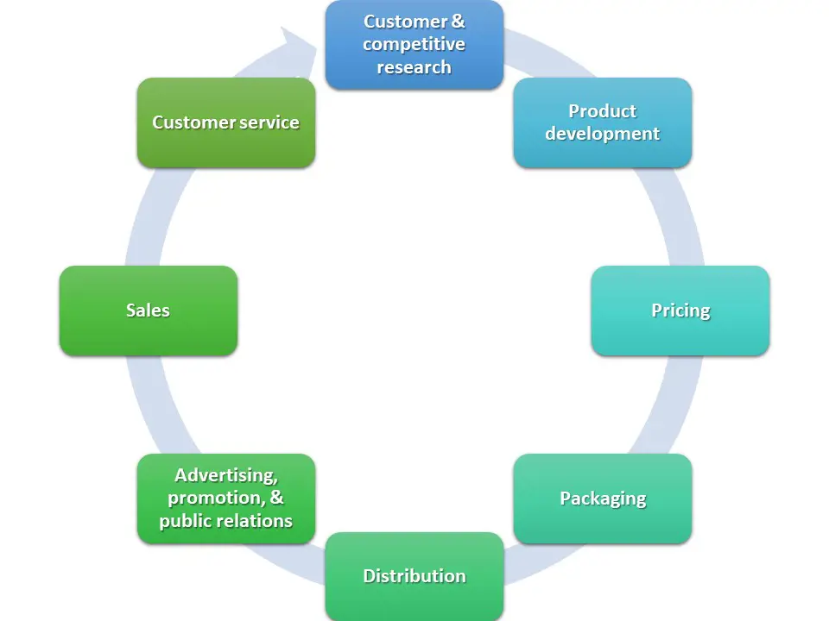

II. REVIEW OF LITERATURE
Marketing strategy is a process that can enable an organization to focus its limited resources on the best opportunities to increase sales and gain a sustainable competitive advantage. Any organization that wants to successfully exchange its products or services in the marketplace must have a strategic marketing plan to guide the allocation of its resources. A strategic marketing plan is often rooted in an organization's overall business strategy and serves as a guide to specific marketing programs and policies. Marketing strategy based on case analysis – a detailed assessment of the current marketing conditions facing the company, its product line or its individual brand. From this situational analysis, assert develops an understanding of the market and the various opportunities it presents, the competition, and the market segments or target markets the company wants to pursue. A marketing strategy is a comprehensive and unbeatable plan specifically designed to achieve the marketing goals of a company/business unit. Marketing objectives indicate what the company wants to achieve; Marketing strategies provide designed to reach them. For example, if a business unit's marketing objective states that next year it is expected to reach Rs. 1,000 in revenue and a net profit of 15% of sales, then the marketing strategy should dictate how knowledge and location of sales and where this profit will come from, which product line/product/brand will accomplish this task. Marketing strategy is an integral part of the marketing plan. A marketing strategy is most effective when it is an integral part of a business strategy that determines how the organization will succeed in attracting customers, potential customers and competitors in the market. It stems in part from the company's broader strategies, its mission, and its goals. Since customers are the source of a company's revenue, marketing strategy is closely linked to sales. An important part of a marketing strategy is often linking marketing to the company's overall mission statement.

3.1 Conceptual framework of marketing strategy
The word strategy was originally used in a military context before being adopted by many other fields. A strategy is a long-term plan of action designed to achieve a specific goal. It differs from tactics in that tactics refer to immediate action using available resources. When applied in a business context, strategy refers to a set of management decisions and actions intended to differentiate a company from its competitors and maintain a competitive advantage. A company's strategy must be tailored to its mission, resources, and environment. Accordingly, a marketing strategy can be defined as a plan by a company to positively differentiate itself from its competitors, using its relative strength to better meet the needs of customers. Customer needs in a given environment (Jain, 2004). Marketing strategies involve a set of actions designed to achieve competitive advantage and achieve above-average results through intelligent and realistic selection between alternatives that lead to that advantage. (Shane, 2000).

3.2 Product Strategy
Kotler and Armstrong (2006) define a product as anything that can be offered to a market for attention, acquisition, use, or consumption that might satisfy a want or need. They further define a consumer product as the product bought by the final consumer for personal consumption. Consumers buy products frequently, with careful planning, and by comparing brands based on price, quality and style. Borden, (1984) sees a product as about quality, design, features, brand name and sizes. Mohammad et al, (2012) also say that product is the physical appearance of the product, packaging, and labeling Information, which can also influence whether consumers notice a product in-store, examine it, and purchase it. Previous researchers have clearly suggested that product influence has a significant impact on firm performance (Kazemand Heijden, 2006; Kemppainen et al., 2008; Ogunmokun and Esther, 2004; Owomoyela et al. events, 2013). In marketing, the product is an important part of the marketing mix. It determines the existence or demise of the organization. Developing the “right” product is not an easy task due to the dynamic nature of consumer needs and attitudes. The goods and/or services that people buy at any given time are determined by their immediate needs and other external stimuli. According to Busch and Houston (1985), a product is anything that is capable of satisfying a consumer's want or need. It can take many different forms, including a physical object, service, place, organization, idea, or personality. Kotler (1991) defined a product as anything that can be offered to the market for attention, purchase, or consumption; it includes physical objects, services, personalities, places, organizations and ideas. In the traditional approach, a product is considered as the complete set of utilities provided by a marketer to the market. This package contains the partial satisfaction that comes from the tangible and objective properties of the product. Satisfaction also stems from the intangible and subjective characteristics of the product. This explains why some people may prefer to buy more expensive products over their cheaper products. Functionally, products may serve the same purpose, but that is not enough for the ego-conscious consumer. Products can also be viewed from the perspective of the benefits they bring, in fact, the market is divided into segments based on benefits that reflect the needs and wants of each segment. Marketers should always strive to identify the primary and secondary benefits their product can potentially bring to consumers and turn them into a Unique Selling Proposition (USP).

3.3 Promotion strategy
Promotion is the function of informing, persuading and influencing the purchase decision of consumers. It can be defined as any communication activity that has the purpose of promoting a product, idea or service through the marketing circuit to reach the end consumer. Promotions influence the knowledge, attitudes and behavior of the recipient. Ads typically provide the target audience with all the precise information they need to help them make a decision to visit a particular destination/place. Information must be accurate, timely and not distorted to satisfy customers and create

III. OBJECTIVES OF THE STUDY
The main objective of the study is to examine the effects of marketing strategies on the organizational performance.
Other specific objectives of the study are:
- To study about the marketing strategies and its impact
- To examine the degree at which product strategy improves the level of profit.
- To determine the extent at which promotional strategy influences the sales volume.
- Suggesting some of the marketing strategies which helps in further growth of the company.

IV. RESEARCH METHODOLOGY

Type of research: Descriptive research
Descriptive research includes fact-based polls and surveys of different types. The main feature of this method is that the researcher cannot control the variables; he can only report what happened or is happening.

DATA SOURCES
There are two types of data. The primary data source for this study was collected through a questionnaire and answered by consumers. Secondary data was collected from journals, books and internet searches.
- Primary data
Data collected directly by someone for the purpose of supporting research is called primary data. So, in this study, data was collected from the respondents through a questionnaire.
- Secondary data
For company information, I used secondary data like brochures, company website, etc. The method I use is survey method because the research done is descriptive research.

RESEARCH INSTRUMENTS
The instrument of choice for data collection for the survey is the questionnaire.
- SAMPLE UNIT
100 respondents of different age groups, different professions and different genders.
- SAMPLE DESIGN
Convenient sampling.
- SAMPLE TOOLS
Pie chart, average chart, ratio analysis chart.

RESEARCH SCOPE
- To conduct this study, the target audience is middle-aged men and women.
- Target geographic area Coimbatore, a sample of 132 people was taken.
- 132 people received a questionnaire, the questionnaire is a combination of closed and open questions.
- Some agents were also interviewed for their views
- Finally, the collected data is analyzed and aggregated to arrive at conclusions and recommendations.

V. FINDINGS AND RESULTS
Hypothesis one was tested using Pearson’s product moment correlation to examine the degree at which product strategy improves the level of profit. With a computed result (r = 0.682; F= 332.632; t= 14.223; p < 0.05). The null hypothesis was accepted and alternate hypothesis was rejected resulting in the conclusion that there is no significant relationship between product strategy and level of profit.
Hypothesis two was tested with Pearson’s product moment correlation in order to determine the extent at which promotional strategy influences the sales volume with a computed result (r = 0.716; p < 0.05), the null hypothesis was accepted and alternate hypothesis was rejected resulting in the conclusion that there is no significant relationship between promotional strategy and sales volume.

VI. SUGGESTIONS
In view of the findings, the following recommendations are made:
i. Company should as a matter of urgency embark on more aggressive product strategies so as to drive its products and services to the target market and to further improve the firm’s level of profit.
ii. Company should invest more in promotional activities to create awareness of its products and services and enable the products sell in the market so as to increase the sales volume of the company.
VII. CONCLUSIONS
- This study concluded that marketing strategies (product, promotion, price and place strategies) does not have important role and impact on organizational performance. In essence, marketing strategies (product, promotion, and price and place strategies) are not useful tools for survival, sustenance and expansion.
- The study revealed that there is no significant relationship between product strategy and the level of profit, there is no significant relationship between promotional strategy and the sales volume, there is no significant relationship between price strategy and the market share and lastly there is no significant relationship between place strategy and the level of customer loyalty.
- The study revealed that the utilization of product strategies enhances the level of profit, product is anything that can be offered to a market for attention, acquisition, use, or consumption that might satisfy a want or need, product is about quality, design, features, brand name and sizes and these influences the level of profit of the company, the use of promotional strategies enhances sales volume in the company and also that promotion usually provides target audiences with all the accurate information they need to help them take decision.
- Further conclusions of the study are that promotional media such as the use of television, radio, newspapers and magazines facilitate an increase in sales volume in Nigeria Bottling Company, promotion is not the function of information, persuading and influencing the consumers` purchase decision, haphazard pricing techniques can not confuse and alienate customers and endanger the company's market share, price is important because it regulates the economic system and influences the prices paid for all factors of production, price is an important factor in building long-term relationships with customers, price is a signal of a product's or service's value to an individual and different customers assign different values to the same goods and services, place strategy influences customer loyalty of Company products, place strategy encompasses all decisions and tools which relate to making products and services available to customers and also that place strategy calls for effective distribution of products among the marketing channels such as the wholesalers or retailers.

VIII. REFERENCE
- Ambler, T., Kokkinaki, F., &Puntoni, S. (2004).Assessing marketing performance: Reasons for metrics selection.Journal of Marketing Management, (20), 475-498.
- Amine, L. S., and Cavusgil, S. T. (2001). Export marketing strategies in the British clothing industry.
- European Journal of Marketing, 20(7), 21-33.
- Aremu M.A and Lawal A.T, (2012).Exploring marketing strategy as a catalyst for performance in Nigerian telecommunication industry.IJMBS 2 (4), 65 – 71.
- Armstrong S. and Kesten C. Greene (2007)."Competitor-oriented Objectives: The Myth of Market Share". International Journal of Business.12 (1): 116–134. ISSN 1083-4346
- Borden, Neil. H. (1984) the concept of marketing mix, Journal of Advertising Research, 1 (9), 2-7.
- Chris Fill, (2006). Marketing Communication Engagement, Strategies and Practice.4th Edition.Prentice Hall.Financial Times.
- Farris, Paul W.; Neil T. Bendle; Phillip E. Pfeifer; David J. Reibstein (2010).Marketing Metrics: The Definitive Guide to Measuring Marketing Performance. Upper Saddle River, New Jersey: Pearson Education, Inc. ISBN 0137058292.
- Frances and Stephen (2006).Principle of Marketing. Fourth Edition, Prentice Hall, London.
- Goi, C. L. (2005). Marketing Mix: A Review of „P‟.Journal of Internet Banking and Commence,
- Grönroos, C. (1999). From Marketing Mix to Relationship Marketing: Towards A Paradigm Shift in
- Marketing Management Decision, 32(2), 4-20
- Jain K. (2004) “SME Definition & Statistical Issues” Journal of Enterprising Culture 11(3): 173 –337. SEMs in the food industry.S.A.M.Advanced Management Journal, 71(3), 21-33.
- Kemppainen, K., Vepsäläinen, A. P. J., &Tinnilä, M. (2008).Mapping the structural properties of production process and product mix.International Journal of Production Economics, 111(2), 713-728.
- Kotler P (2007). Marketing: An introduction, New Jersey: Pearson Education Inc.
- Kotler, P. and Armstrong, G (2006).Principles of Marketing, New Jersey, Pearson Education Inc., 10th Edition
- Li, T., and Calantone, R. J. (2000). The impact of market knowledge competence on new product advantage: Conceptualization and empirical examination. Journal of Marketing, 62, October, 13-29.
- Michael P. (2002). Consumer Behavior: Buying, Having and Being. 8th Edition Pearson International Edition.
- Michael R. S., Greg W. M. & Elnora W. S. (1997). Marketing: Real People, Real Choice. Fourth Edition.Pearson Prentice Hall UK.
- Ogunmokun, G. O., and Esther, L. L. (2004). Product development process and performance of export ventures: a study of exporting companies in the People‟s Republic of China. Journal of Asia Pacific Marketing, 3(2), 84-98.
- Owomoyela S.K, Oyeniyi K.O and Ola O.S, (2013).Investigating the impact of marketing mix elements on consumer loyalty: An empirical study on Nigerian Breweries Plc. Interdisciplinary Journal of Contemporary Research in Business. 4 (11), 485 –496.
- Shane (2003): “Prior Knowledge & the Discovery of Entrepreneurial Opportunities Organization Science” 11, 44 – 469.
- Shane (2003): “A General Theory of Entrepreneurship” Individual Opportunities. Nexus/Scott Shane, New Horizons in Entrepreneurship Series, Edward Elgar Pub.
- Simons, R., (1999). Levers of Control, How Managers Use Innovative Control Systems to Drive Strategic Renewal. Harvard Business School Press, Boston, MA
- Zeithaml, V.A. (1988) Consumer Perceptions of Price, Quality and Value: A Means-end Model and Synthesis of Evidence, Journal of Marketing, Vol 52 (July), pp. 2-22.

