# CHARGE AND LOAD PROTECTION IN THE SOLAR POWER MANAGEMENT

# 1 Shubham Deogade, 2 Mayur Adhau, 3 Ashutosh Khupse, 4 Ritik Thakare, 5 Badal Shende

# 6 Manjeet Sakhare, 7 Roshan Gaidhane

# 1, 2, 3, 4, 5 UG Student, 6, 7 Professor, Department of Electrical Engineering,

**Vidarbha Institute of Technology, Uti, Umrer Road, Nagpur, India.**

# ------------------------------------------------------------------------------------------------------------------------------------------------------------------

**ABSTRACT**

Renewable energy sources, particularly solar photovoltaic (PV) systems, are becoming increasingly popular as clean and sustainable alternatives for meeting our growing energy demands. To harness solar power effectively, it is essential to monitor and optimize the performance of PV systems. This paper presents an enhanced IoT-based solar power monitoring system that incorporates a battery and a solar charge controller. The system aim to optimize battery charging, prevent overcharging and deep discharging, collects and analyzes solar energy parameters to predict system performance and ensure stable power generation. Additionally, the system enables remote monitoring and control through a mobile application, enhancing the usability and convenience of solar energy management. Experimental results demonstrate the effectiveness of the proposed system in optimizing solar PV performance and ensuring reliable power generation. The integration of a battery and solar charge controller provides energy storage capabilities and improves system efficiency.

**Keywords:** Solar PV, Internet of Things (IoT), Battery charging, Solar Charge Controller, Overcharging, Deep Discharging, Energy Monitoring, Remote Control.

**1. INTRODUCTION**

Solar power systems play a crucial role in meeting our energy needs while reducing carbon emissions. However, the performance of solar PV systems can be affected by various factors, such as dust accumulation, suboptimal alignment, and fluctuations in sunlight intensity. To overcome these challenges and maximize the efficiency of solar power generation, advanced monitoring and control systems are required. This paper proposes an IoT-based solar power monitoring system that integrates a battery and a solar charge controller. The system enables real-time monitoring of solar energy parameters and provides remote control capabilities for efficient energy management.

**2. SYSTEM ARCHITECTURE**

The enhanced solar power monitoring system consists of the following components: solar panels, a battery, a solar charge controller, a microcontroller (such as NodeMCU), sensors for monitoring solar parameters, a Wi-Fi module for IoT connectivity, and a mobile application for remote monitoring and control. The system architecture facilitates seamless communication between the components and enables data transmission to a cloud platform for further analysis and visualization.

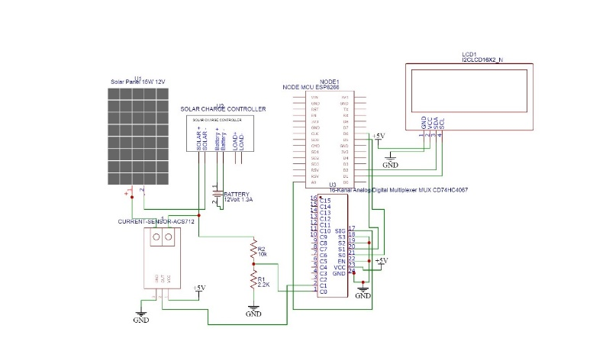

Fig. Circuit Diagram

**3. OPERATIONS AND FUNCTIONALITY**

The solar panels convert sunlight into electrical energy, which is utilized for immediate power consumption and charging the battery through the solar charge controller. The solar charge controller ensures optimal charging of the battery by regulating the charging current and voltage.

The integrated microcontroller collects data from various sensors, such as voltage and current sensors, temperature

sensors, and light sensors, to monitor solar energy parameters, battery status, and environmental conditions.

**4. IOT INTEGRATION AND REMOTE MONITORING**

The collected data is transmitted to the cloud platform through the Wi-Fi module, enabling real-time monitoring and analysis. Users can access the system remotely through a mobile application, which provides a user-friendly interface to visualize the solar energy parameters, battery status, and system performance. The mobile application also allows users to control system operations, such as switching between battery and grid power sources, setting charging/discharging thresholds, and receiving alerts for abnormal conditions.

**5. BATTERY INTEGRATION AND ENERGY MANAGEMENT**

The inclusion of a battery in the system enables energy storage for later use during periods of low solar energy generation or at night. The solar charge controller manages the charging and discharging of the battery, ensuring optimal energy utilization and preventing overcharging or deep discharging. The integration of the battery enhances the system's reliability, efficiency, and autonomy.

**6. EXPERIMENTAL RESULTS**

To validate the effectiveness of the proposed system, experimental tests were conducted using a solar PV module of 15-20 watts. The system successfully monitored solar parameters, battery status, and environmental conditions. The remote monitoring capabilities provided real-time data visualization and control through the mobile application. The integration of the battery and solar charge controller enhanced energy management and ensured continuous power availability.

**7. CONCLUSION**

The proposed IoT-based solar power monitoring system with battery and solar charge controller integration offers an efficient and reliable solution for optimizing solar PV performance and ensuring stable power generation. The system's ability to monitor solar energy parameters, store excess energy in a battery, and provide remote control

capabilities contributes to effective energy management. Future research can focus on optimizing battery charging and discharging algorithms, integrating predictive models for performance forecasting, and exploring additional

applications in residential, commercial, and industrial settings.

**REFERENCES**

[1]. Purusothaman, SRR Dhiwaakar, et al. "Implementation of Anrduino-based multi-agent system for rural Indian micro grids." 2013 IEEE Innovative Smart Grid Technologies-Asia (ISGT Asia). IEEE, 2013.

[2]. Kabalci, Ersan, Alper Gorgun, and Yasin Kabalci. "Design and implementation of a renewable energy monitoring system." Power Engineering, Energy and Electrical Drives (POWERENG), 2013 Fourth International Conference on. IEEE, 2013.

[3]. Jiju, K., et al. "Development of Android based on-line monitoring and control system for Renewable Energy Sources." Computer, Communications, and Control Technology (I4CT), 2014 International Conference on. IEEE, 2014.

[4]. Goto, Yoshihiro, et al. "Integrated management and remote monitoring system for telecommunications power plants with fully DC-powered center equipment." INTELEC 07-29th International Telecommunications Energy Conference. IEEE, 2007.

[5]. Suzdalenko, Alexander, and Ilya Galkin. "Case study on using non-intrusive load monitoring system with renewable energy sources in intelligent grid applications." 2013 International Conference-Workshop Compatibility And Power Electronics. 2013.

[6]. Nkoloma, Mayamiko, Marco Zennaro, and Antoine Bagula. "SM 2: Solar monitoring system in Malawi."

Kaleidoscope 2011: The Fully Networked Human?-

Innovations for Future Networks and Services (K-2011),

Proceedings of ITU. IEEE, 2011.

[7]. Wang, Li, and Kuo-Hua Liu. "Implementation of a web- based real-time monitoring and control system for a hybrid wind-PV-battery renewable energy system." Intelligent Systems Applications to Power Systems, 2007. ISAP 2007. International Conference on. IEEE, 2007.

[8] P. Gopi Krishna et. al. “Design and development of smart energy meter for effective use of electricity in IoT applications” International Journal of Engineering & Technology, 7 (2.8) (2018) 115-119