**Design of WSN based routing algorithm based on PSO**

**Tinu Digamber Bisen*1, Dr Bharti B. Sayankar*2, Prof. Komal Ghumde*3 ,** **Prof. Rahul Nawkhare**

*1Mtech Scholar, Electronics, Wainganga College of Engineering and Management Nagpur, Maharashtra, India.

*2Affiliation, Electronics, Wainganga College of Engineering and Management Nagpur, Maharashtra, India

*3Affiliation Electronics, Wainganga College of Engineering and Management Nagpur, Maharashtra, India

*4 (Ex- Professor, Wainganga college of engineering and management Nagpur, Maharashtra, India

**ABSTRACT**

Sensor nodes are the most important component of wireless sensor networks. Because these sensor nodes are mostly unchangeable, the network's lifetime is affected. Sensor nodes primarily collect data and transfer it to the Base Station. As a result, the majority of the energy is used in the communication process between sensor nodes and the Base Station. In this research, we suggest an enhancement to the LEACH protocol to increase network longevity. The purpose is to limit the number of transmissions between cluster heads and sink nodes. We will select the optimal number of Master Cluster Heads from the network's variation cluster heads. The simulation results suggest that our proposed method outperforms the LEACH protocol in terms of network lifetime. The Low Energy Adaptive Clustering Hierarchy (LEACH) algorithm has several drawbacks, including picking the cluster head during each round, which depletes the node's energy, and not taking into account residual energy, to name a few. As a result, academics are concentrating on ways to improve the LEACH algorithm and make it more practical for application. To make this energy efficient particle Swarm optimization is used in the algorithm which enhances the lifetime of a network.

**Keywords:** WSN, LEECH, PSO, Lifetime of Network, nodes.

1. **INTRODUCTION**

Sensors attached to hubs in Wireless Sensor Networks (WSN) monitor the environment in which they are transmitted to handle the information and relay it to the base station (BS). The vitality authority in WSN operations is a battery (Heinzelman et al., 2000), although energy plays an important role in those activities because sensor hubs are generally compelled with constrained vitality. As a result, when developing a guiding convention for WSNs, controlling vitality spread should be the primary issue (Ran et al., 2010).

In all bunches, a hub is assigned as a head and designated as CH based on several components. Cluster Heads (CHs) are chosen based on three factors: intra-cluster distance, spacing between node BS, and hub lingering energy (Prasad et al., 2017). The CH acts as the head of their group, gathering, packaging, and broadcasting the gathered information to the BS (Abdulsalam et al., 2010; Zhang et al., 2010).

WSN routing protocols are categorised into numerous types. Hierarchical routing is one of them that is used to control energy efficient routing in WSN (Yassein et al., 2009). LEACH is thought to be one of them.

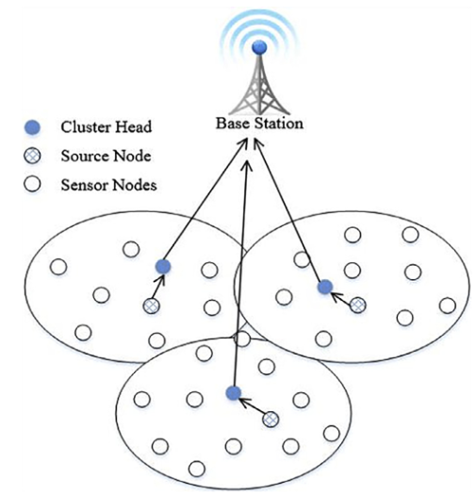

Fig. 1 LEECH CLUSTERING

LEACH has some fundamental faults, such as the fact that each hub can directly link to each other and the central terminal, which limits its applicability to tiny networks. TDMA planning for LEACH allocates schedule slots to each hub regardless of whether the hub has information to transmit or not. This results in unnecessary overhead and postponement. The concept of inert mode for hubs is not supported since LEACH requires that each hub be continually open for connection, which is impractical in an arbitrary network of sensor hubs. Because of the randomness and lack of safeguards against non-uniform distribution and concentration of CHs in a certain network segment, each protocol is very redundant. Hubs forward information to CHs in constant phase, and CHs relay information from hubs.

1. **METHODOLOGY**
2. **LEECH**

The Leach protocol is a TDMA-based MAC technology. The primary goal of this protocol is to extend the lifespan of wireless sensor networks by minimising energy consumption.

The Leach procedure is divided into two parts:

1) Initial setup

2) The steady phase

The leach protocol's operation is divided into multiple rounds, each with two parts. The Leach protocol is a common depiction of a hierarchical routing mechanism. It is self-adaptive and self-organized [2]. To save excessive energy expenses, the Leach protocol employs rounds as units, with each round consisting of a cluster setup step and steady state storage.

The following are the stages of the leach protocol:

A. Initial phase

The major purpose of the setup phase is to create clusters and choose the cluster heads for each of them by selecting the sensor node with the most energy [3].

The setup phase consists of three major steps:

1. Cluster head promotion

2. Cluster configuration

3. Development of a transmission schedule

During the first step, the cluster head sends an advertisement packet to notify the cluster nodes that they have been promoted to cluster head using the following formula:

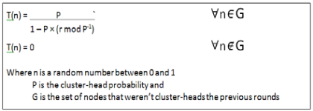

The threshold is denoted by T (n).

If the number is fewer than the threshold T (n), the node becomes the cluster head for the current round. Once a node is elected as a cluster head, it cannot be elected again until all nodes in the cluster have served as cluster heads once. This is beneficial for balancing energy use.

In the second stage, non-cluster head nodes get the cluster head advertisement and then send a join request to the cluster head, alerting the cluster head that they are members of the cluster under that cluster head. Non-cluster head nodes save a lot of

1. **PSO**

(PSO) is a population a stochastic efficiency method created by Drs. Eberhart and Kennedy in 1995, which encouraged birds in society to gather or read fish. It has a high value desirable properties, such as the fact that the algorithm is relatively simple to comprehend and utilise. The same is true for genetic and evolutionary algorithms, although they require only a modest amount of arithmetic memory and a few lines of code. Swarms are typically represented by particles in multidimensional space with space and speed. These particles travel through hyperspace (i.e. Rn,) and have two critical thinking abilities: memory for their best position and knowledge of the world or of their best neighbor.In the challenge of improvement, "best" easily signifies a region with little policy. Members reciprocate by communicating favourable positions with one another and then adjusting their position and pace based on this communication. So the character has the following information to make suitable position and speed changes:

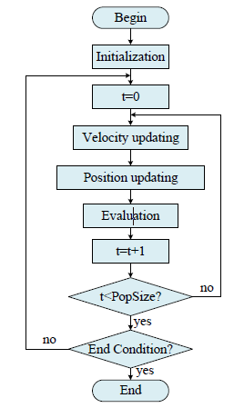

**Fig 2:** Flow chart of PSO

1. **RESULTS AND DISCUSSION**

Table 1 shows the parameter Simulation Parameters for the presented work used the above parameters for wireless sensor network with a static sink as well as wireless sensor networks with a mobile sink. The following metrics have been selected for evaluating the effect of mobile sink in order to reduce congestion and increase the lifetime of the sensor network. The comparison of the results obtained by analyzing both the LEACH and LEACH optimized. Lifetime of a Sensor Network: Lifetime is the important aspect in WSN. It is defined as the interval between the deployment of the sensor field and the time when the first sensor node fails due to complete energy dissipation.

**Table 1.**

|  |  |
| --- | --- |
| **Parameters** | **Value** |
| Area (m2) | (100 x100)m2 |
| No. of nodes | 100 |
| Initial Energy | 0.2 |
| Nodes | 100 |
| Transmitter Energy | 50Nj |
| Receiver Energy | 50Nj |
| Data compression Energy | 5Nj/bit/signal |
| EDA | 5Nj/bit/signal |

Total number of iteration required for Leach protocol is 2993 for all dead nodes. By adding PSO with the LEACH which optimizes and increase the network lifetime so it requires 3190iteration to dead all nodes. So193 more iteration it requires. Test scenario we choose total 100 nodes and 100x100 area. The result for the comparison between LEACH and LEACH with PSO is show below.

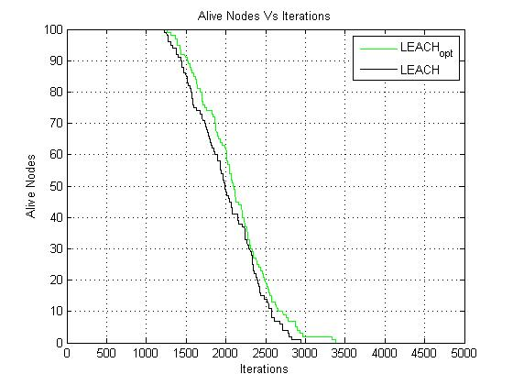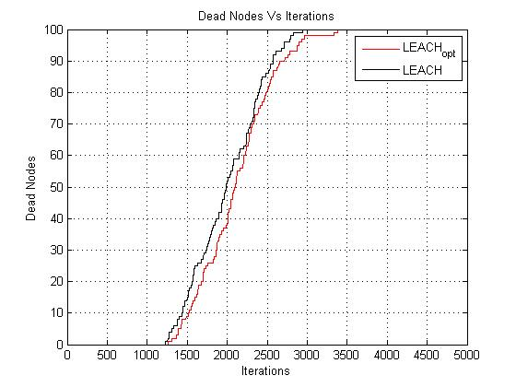 Fig. 3 Alive nodes Vs Iteration Fig.4 Dead nodes Vs Iteration

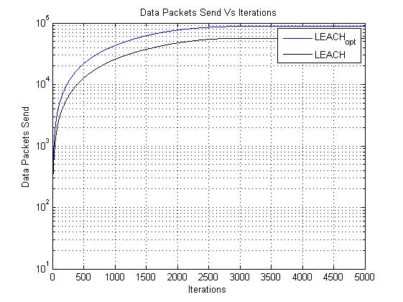

Fig 5**:** Data Packets send Vs Iteration

1. **CONCLUSION**

All the main points of the research work is to improve the lifetime of network. The use of PSO which optimizes and improve the network life. The LEECH protocol with LEECH –PSO are compared and found that with the help of LEECH –PSO it increases the lifetime of network by 197 more iteration required to dead all the nodes. The simulation is done in Matlab software. In case of future various optimizing algorithm can be used which may increase the network life.

1. **REFERENCES**

**REFERENCE**

[1] Lewis F 2004 Wireless Sensors Networks, good Environments: Technologies, Protocols, and Applications Cook DJ, Das SK, John Wiley, NY 1-18.

[2] W. R. Heinzelman, A. Chandrakasan, and H. Balakrishnan,"Energy-efficient communication protocol for wireless microsensor networks," Proceedings of the thirty-third Annual Hawaii International Conference on System Sciences, 2000, pp. 10. vol.2.

[3] M. Z. Hasan, H. Al-Rizzo; F. Al-Tudjman, “A Survey on Multipath Routing Protocols for QoS Assurances in period Wireless transmission sensing element Networks," in IEEE Communications Surveys & Tutorials, No.99, pp.1-1, 2017.

[4] B.E. Manjunath and P.V. Rao, “Trends of Recent Secure Communication System and its Effectiveness in Wireless sensing element Network” International Journal of Advanced applied science and Applications (IJACSA), Vol.7(9), pp131-139, 2016.

[5] A.K.Das, R.Chaki, and K.N.Dey, "Secure energy-efficient routing protocol for the wireless sensing element network," Foundations of Computing and call Sciences, Vol. 41, No. 1, pp.3-27, 2016.

[6] H. Krawczyk, M. Bellare, R. Canetti, "HMAC: Keyed-Hashing for Message Authentication," Network unit, Request for Comments, 2014 • Manjunath.B.E and Dr.P.V.Rao, ”Balancing Trade-off between knowledge Security and Energy Model for Wireless sensing element Network“ International Journal of Electrical and

laptop Engineering (IJECE) Vol. 8, No. 2, April 2018, pp. 1048~1055.

[7] International Journal of Innovative analysis in laptop and Communication Engineering Vol.2, Special Issue one, March 2014 by K.SyedAliFathima, T.Sumitha.

[8] International analysis Journal of Engineering and Technology Vol.4 Issued on seventh July 2017 by Miss.Divya Garg, Dr.Pradeep Kumar, and Miss.Kapal.

[9] 2nd International Conference on electronics and telecommunication engineering 2018 by K.Jayashankar Reddy, K.Karthikeya Yadav, and BKSP Kumar.