Response Sharing Platform

Aravind Suresh*1, Chithra V H*2, Drisik*3, Francina Joy*4 , Jinsu Mariam Jacob *5,

Krishnaveni V V *6

*6 Guide,, Department of Computer Science and Engineering,
College of Engineering Kidangoor , Kerala, India.
*1,2,3,4,5Student, Department of Computer Science and Engineering,
College of Engineering Kidangoor , Kerala, India.

ABSTRACT

It is a platform that provides the users a stage to give their opinion on a topic and their opinions are recorded. By using machine learning we can analyse the already chosen data and options selected by the user. With this information we can predict and recommend other topics that may user like. Also, By using the same result we can suggest tips, new movies, facts, etc. so that they can get more things they like. User can follow other users by either searching them or from suggestions list. Users can give their opinion on a topic and more localized to our state. Filtering abusive language/hate speech (using ML) and Recommend Topics to users (using ML) are other features of this platform. INDEX TERMS Machine learning, hate speech detection.
Keywords: NLP-Natural Language Processing , Machine Learning

INTRODUCTION

With the advent of events which directly or indirectly affects the people, there is a need of a platform for them to express views and opinions. The Response sharing platform provides a systematic method to accomplish this. This meritocratic system ensures that interesting content rises to the top and uninteresting content falls into an abyss. As a result, This might be the birth place of most internet memes and viral sensations. The platform is a melting pot of trends, media, micro-communities, micro-cultures, and inside jokes – and that’s what makes it awesome. This platform combines web content, social news, a forum, and a social network into one giant beast of a platform. Registered members can respond to the contents published by admins with content such as images, text and links. All content on the site can be has their own reaction options for the users to react upon

PROPOSED SYSTEM

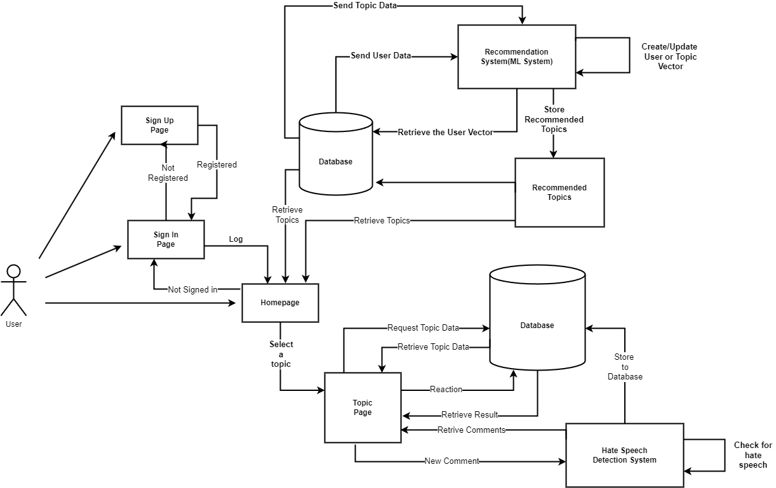

Figure 2.1: System Architecture

The user sign's up if he or she doesn't have an account on the site using a username and password ,if the user has already an account then the user can access the site by using the user name and password, which are verified .Once accessed user can select from the various topics present on the site home page,uploaded by the admins and can then give their opinion as comments on the selected topic. The comments by the user on a topic are checked to see are profanity using machine language techniques if they are then that comment doesn't get stored onto the database where regular comments are stored and thus don't get presented onto the comments section of the topic.The user frequented topics are stored onto the database and using machine language techniques we can predict the user's interested topics and can display that particular topics of interest for the user

METHODOLOGY

System Design and Implementation

Project has been mainly divided into seven modules.

3.1 Module 1 : User Module:

User Module: In the user module, user can create an account which has a

unique user id and they can set up their own password.Once they set up an account they

can search and select a topic they are interested in and can react to that selected topics

(each topic will have their own options).Their interaction is not limited to simple react

options they can give their views on the topics as comments.declarative approach simplifies the development process and reduces the chances of introducing bugs or inconsistencies in the UI.

3.2 Module 2 : Admin

The admins has the power to post new topics on the platform as well as manage the users

comments as to keep the users in check.They also have the power to edit the posted topics

as to show only relevent topics as well as delete topics .

3.3 Module 3: Topic

It is responsible for storing all the posted topics as well as details

associated with each topics such as titles, descriptions and views for each topic.

3.4 Module 4: Poll

In this module, users reaction for each topic is stored. These reactions are

options which vary with each topic, which helps use to understand the overall stand of the

users in relation to a matter. These reactions can be done for all topics in the platform .Each

user reaction for a topic are stored as such.

3.5 Module 5: Comment

In this module ,the main focus is the comments of each users for

each topics. These comments are stored as in relation with a corresponding topic for which

the user has commented.

3.6 Module 6: Recommendation

We achieve recommendations system for the responses sharing platform using content based filtering algorithm. Where there is a vector for each user which stores the types of content the user has been consuming and another vector table for topics which to a particular topic type and it stores number of user's viewed. We process the above vectors and predict the interested topics of a particular user.

3.7 Module 7: Profanity Filter

Profanity filter is implemented using scikit learn library and a dataset(Hate Speech and Offensive Language Dataset)containing profanity words obtained from kaggle we create a decision tree model which helps t classify the comments as hate speech, offensive and normal

RESULTS AND ANALYSIS

Machine learning algorithms analyze their behavior and preferences. This includes factors such as the types of responses they engage with, the topics they explore, and their interactions with other users. By analyzing this data, the system gains valuable insights into the user's interests and can generate personalized recommendations.

Machine learning models are trained on large datasets that contain examples of hate speech, offensive language, and non-offensive content. These datasets are carefully curated and annotated by human reviewers to provide the algorithms with accurate labels for learning. The models then analyze various linguistic and contextual features of the text, such as the choice of words, sentence structure, and semantic meaning, to identify patterns indicative of hate speech.

The platform has the provision of adding comments to Topics users can contribute their perspectives, ask questions, or provide further context to the original response. The inclusion of polls adds another layer of interactivity to the platform.

CHALLENGES

Designing a response sharing platform can be a complex task, as there are several challenges that need to be addressed. Here are some key challenges you may encounter:

5.1 User Engagement: Encouraging users to actively participate and contribute responses can be challenging. You need to design the platform in a way that motivates users to share their insights, knowledge, and experiences.

5.2 Content Quality: Maintaining the quality of responses is crucial. You need to establish mechanisms to filter out low-quality or irrelevant responses. Implementing user ratings, peer reviews, or a moderation system can help ensure that the platform maintains a high standard of content.

5.3 Trust and Credibility: Users must trust the responses they receive on the platform. Addressing concerns about authenticity, credibility, and bias is important. You can achieve this by verifying user credentials, implementing reputation systems, or providing transparency about the source of information.

5.4 Personalization: Every user has unique preferences and requirements. Designing a system that can provide personalized responses based on individual needs can be challenging. Consider incorporating user profiling, machine learning algorithms, or recommendation systems to enhance the personalization of responses.

By addressing these challenges thoughtfully, you can design a response sharing platform that provides value to users and fosters a thriving community of knowledge sharing.

CONCLUSION

The main focus is to create a healthy and friendly social media platform. They provide the users with topics that is favorable and liked by the user. It aims to provide the contents and comments in multiple language .Expressing views ,opinion and thoughts on a topic prevailing in community is one basic need .As a result, this platform helps one to share their views from their comfort of their comfort of their finger tips.Since,the topics are added by respective admins , the probability of getting an irrelevant topic is very less. Also users can provide admins with suggestions to add new topics.

REFERENCES

[1J. Tadesse, Michael M., et al. "Personality predictions based on user behavior on the facebook social media platform." IEEE Access 6 (2018): 61959-61969.

[2] Islam, Md Manowarul, et al. "Cyberbullying detection on social networks using machine learning approaches." 2020 IEEE Asia-Pacific Conference on Computer Science and Data Engineering (CSDE). IEEE, 2020.

[3] Mameli, Marco, et al. "Deep learning approaches for fashion knowledge extraction from social media: a review." IEEE Access 10 (2021): 1545-1576.

[4] Watanabe, Hajime, Mondher Bouazizi, and Tomoaki Ohtsuki. "Hate speech on twitter: A pragmatic approach to collect hateful and offensive expressions and perform hate speech detection." IEEE access 6 (2018): 13825-13835.

[5] Shi, Lei-Lei, et al. "Event detection and user interest discovering in social media data streams." IEEE access 5 (2017): 20953-20964

[6] Almazro, Dhoha, et al. "A survey paper on recommender systems." arXiv preprint arXiv:1006.5278 (2010).

[7] Bafna, Prafulla B., and Jatinderkumar R. Saini. "Hindi multi-document word cloud based summarization through unsupervised learning." 2019 9th International Conference on Emerging Trends in Engineering and Technology-Signal and Information Processing (ICETET-SIP-19). IEEE, 2019.

